12th Gen Intel(R) Core(TM) i7-12700H 2.30 GHz

16.0 GB (15.6 GB usable)

Windows 11 Home 22H2

Step 1. Installing Prerequisites

Step 2 Configuring Android Studio SDK

Step 3. Add “ANDROID_HOME” to “Control Panel\User Accounts\User Accounts\Change My Environment Variables”



Step 3.5 Verify it was added through powershell

Step 4. Add the path to \Android\SDK\platform-tools to “PATH” under “Control Panel\User Accounts\User Accounts”



Run “npx react-native@latest init “Project-Name” to create the project

Step 5. Have an android emulator ready

Step 6. Open command prompt and change directory to the new project folder.

Step 6.5 Enter “npm start” to start the Metro Bundler

Step 7. In a separate command prompt use change directory to the project folder.

Step 7.5 Use “npm run android”

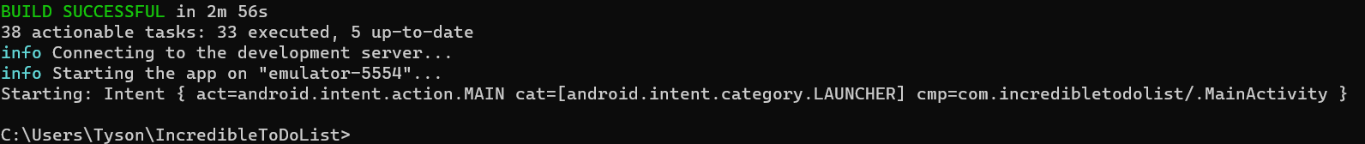

If errors are occurring: In a command prompt terminal navigate to the project folder and enter “npx react-native doctor”

Detailed Documentation: https://reactnative.dev/docs/environment-setup?guide=native

