**EDUC 6050 Name (5 points): ______________________________**

**Mid-Term Exam: Key**

***Directions****: You have an hour and half to complete the exam. Fill out each question, showing your work/reasoning (yes, even for multiple choice questions as it gives you an opportunity to get partial credit). In each case, pick the best answer. You may use your notes and homework on this exam (no textbook). The entire exam is worth 100 points. Have fun (or at least try to enjoy it)!*

**Section I**: Multiple Choice (75 points possible, 5 per question)

1. A sports psychologist ranks swimmers according to their finishing place in a 100-m race (i.e., first, second, third). What scale of measurement was used for finishing place? What scale of measurement was used if the psychologist collected finishing time (e.g., 35 seconds, 76 seconds)?
   1. Interval/Ratio, Nominal
   2. Nominal, Ordinal
   3. **Ordinal, Interval/Ratio**
   4. These words are all made up so what is the point?!
2. On a difficult exam, some people did well but most scored 60% or lower. How is this distribution skewed?
   1. **Positively skewed**
   2. Negatively skewed
   3. No skew
   4. Kurtosis
3. What is sampling error?
   1. The difference between qualitative and quantitative data
   2. **The difference between a sample statistic and a population parameter**
   3. The difference between an inferential statistic and a descriptive statistic
   4. The difference between a good sample and a failed sample
4. What is the median for this set of scores: 1, 3, 3, 4, 7, 8, 9
   1. **4**
   2. 6
   3. 3
   4. 8
5. Which of the following statements is the best interpretation of a standard deviation?
   1. The typical distance deviation scores are from the population
   2. The typical distance scores are from each other
   3. The typical distance scores are from the deviation scores
   4. **The typical distance scores are from the mean**
6. Scores on an IQ test are normally distributed with a mean of 100 and standard deviation of 15. What is the z score for an IQ score of 130?
   1. 1.5
   2. -1.5
   3. **2.0**
   4. -2.0
7. A student received an exam score of z = 1.5. How well did the student do in comparison to other students in the class?
   1. **Great!**
   2. About average
   3. Below average
   4. Not enough information to answer this question in a way that I feel most comfortable
8. If a distribution of scores is very skewed (i.e., not close to being normally distributed), which of the following cannot be done?
   1. Find the median
   2. Convert raw scores into z scores
   3. **Use the unit normal table to identify the probability of scores**
   4. All the above can be done with a skewed distribution
9. When do we use the Standard Error of the Mean ($SE_{M}$)?
   1. To know where an individual is in relation to other individuals in the distribution
   2. To find the z score for a sample mean
   3. To understand the typical distance between the sample mean and the population mean
   4. **Both b and c**
10. If $M=20, SD=10, μ=19, SE_{M}=2$ what is the z-score for the sample mean?
    1. **0.5**
    2. 0.37
    3. -0.37
    4. 1.0
11. In the example above, if we did not know $σ$, then what approach would we use to test if the sample mean is different than the population mean?
    1. Strange you ask because I was wondering the same thing
    2. **Single sample t-test**
    3. Single sample Confidence Interval
    4. Single sample effect size
12. Which of the following interpretations of 95% confidence intervals is correct?
    1. All values within a confidence interval are equally likely
    2. **If the study were repeated, the population mean would be in the confidence interval 95% of the time**
    3. A set of plausible values for a population parameter
    4. If the mean is in the confidence interval, you can reject the null hypothesis
13. If we repeatedly measure a sample of 10 individuals so that we have pre-test data and post-test data (before and after an intervention). Which approach can we use?
    1. Single sample t-test
    2. Independent Samples t-test
    3. One-way ANOVA
    4. **Repeated sample t-test**
14. If we randomly assigned individuals in our sample into 3 independent groups and assess the impact of an intervention (just posttest scores) based on those groups, what approach can we use?
    1. Single sample t-test
    2. Independent Samples t-test
    3. **One-way ANOVA**
    4. Repeated sample t-test
15. Would you rather:
    1. Be impervious to pain and injury
    2. Be able to read minds
    3. Neither, they both sound ridiculous
    4. Both, but I know that selecting this would be cheating so I’ll select just one

**Section II:** Applied Statistics (20 points possible)

*You are conducting a study that looks at the self-reported pain of individuals with hearing loss in physical therapy situations based on whether they received a specialized care treatment or were given “treatment as usual.” With n = 20 split evenly in these 2 groups (n = 10 per group), we want to know if posttest scores for the specialized care treatment is better (lower) than treatment as usual.*

Step 1: Examine Variables to Assess Statistical Assumptions

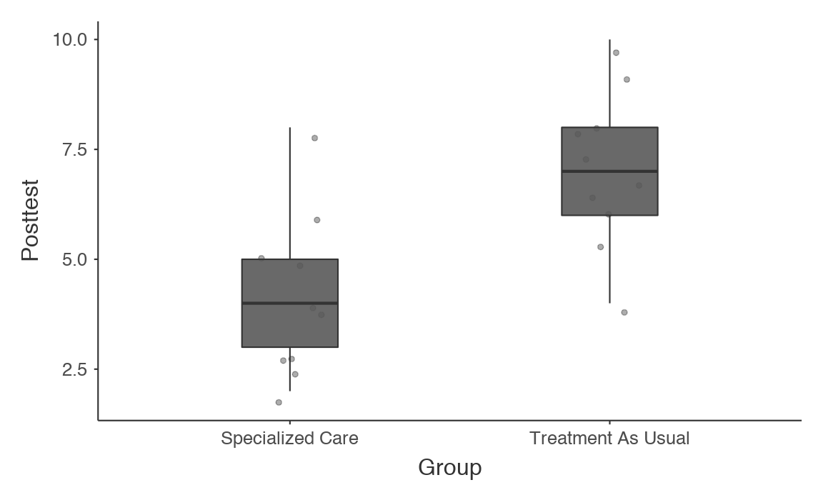

| **Group Descriptives** | | | | | | | | | | | | | |
| --- | --- | --- | --- | --- | --- | --- | --- | --- | --- | --- | --- | --- | --- |
|  |  |  |  |  |  |  |  |  |  |  |  |  |  |
|  | | **Group** | | **N** | | **Mean** | | **Median** | | **SD** | | **SE** | |
| Posttest |  | Specialized Care |  | 10 |  | 4.20 |  | 4.00 |  | 1.87 |  | 0.593 |  |
|  | | Treatment As Usual |  | 10 |  | 7.00 |  | 7.00 |  | 1.83 |  | 0.577 |  |
|  | | | | | | | | | | | | | |

| **Test of Normality (Shapiro-Wilk)** | | | | | |
| --- | --- | --- | --- | --- | --- |
|  |  |  |  |  |  |
|  | | **W** | | **p** | |
| Posttest |  | 0.966 |  | 0.663 |  |
| Note. A low p-value suggests a violation of the assumption of normality | | | | | |
|  | | | | | |

| **Test of Equality of Variances (Levene's)** | | | | | | | |
| --- | --- | --- | --- | --- | --- | --- | --- |
|  |  |  |  |  |  |  |  |
|  | | **F** | | **df** | | **p** | |
| Posttest |  | 0.00677 |  | 1 |  | 0.935 |  |
| Note. A low p-value suggests a violation of the assumption of equal variances | | | | | | | |
|  | | | | | | | |

  Do we meet the assumptions of normality and homogeneity of variance?

Yes.

Step 2: State the Null and Research Hypotheses (two-tailed)

$$H_{0}: μ_{newtreat}= μ_{oldtreat}$$

$$H_{A}: μ_{newtreat}≠ μ_{oldtreat}$$

Null: There is no difference between the treatments.

Research: There is a difference between the treatments.

Step 3: Define Critical Regions

$$α= .05$$

$$t_{c}(18)=2.101$$

If the p-value is below .05 or observed t is above 2.101 we will reject the null hypothesis.

Step 4: Compute the Test Statistic & Compare to Critical Region

Step 5: Compute an Effect Size and Describe It

| **Independent Samples T-Test** | | | | | | | | | | | | | | | | | | | |
| --- | --- | --- | --- | --- | --- | --- | --- | --- | --- | --- | --- | --- | --- | --- | --- | --- | --- | --- | --- |
|  | | | | | | | | | | | | | | | | **95% Confidence Interval** | | | |
|  | |  | | **statistic** | | **df** | | **p** | | **Mean difference** | | **SE difference** | | **Cohen's d** | | **Lower** | | **Upper** | |
| Posttest |  | Student's t |  | -3.38 |  | 18.0 |  | 0.003 |  | -2.80 |  | 0.827 |  | -1.51 |  | -4.54 |  | -1.06 |  |
|  | | | | | | | | | | | | | | | | | | | |

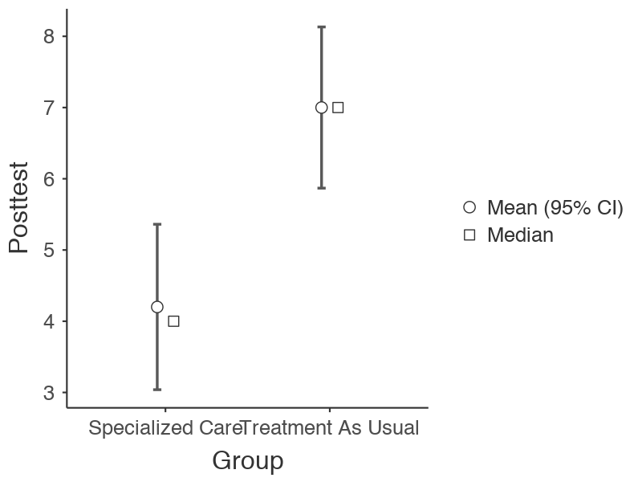

What is the effect size equal to? Is this a small, moderate, or large effect?

d = -1.51, large effect

Step 6: Interpret the results (include the interpretation of the t-test, the effect size, and the confidence intervals)

t(18) = -3.38, p = .003, d = -1.51

The specialized care group showed lowered levels of pain (M = 4.20) than the treatment as usual (M = 7.00). The estimated mean difference was -2.80 (95% CI = -4.54, -1.06).