**Linear Regression**

**HW #4**

***Directions:*** *Please complete all of the sections. You get half of your points for finishing/turning it in on time and the other half for correctness. For the Jamovi section, please print the output from Jamovi and staple the two documents together. Have fun!*

**Section I: ANOVA**

1. a) What are the assumptions of the One-Way ANOVA?

b) Does the following table and figure provide evidence that our assumptions hold?

| **Test for Homogeneity of Variances (Levene's)** | | | | | | | |
| --- | --- | --- | --- | --- | --- | --- | --- |
|  |  |  |  |  |  |  |  |
| **F** | | **df1** | | **df2** | | **p** | |
| 0.574 |  | 2 |  | 27 |  | 0.570 |  |
|  | | | | | | | |

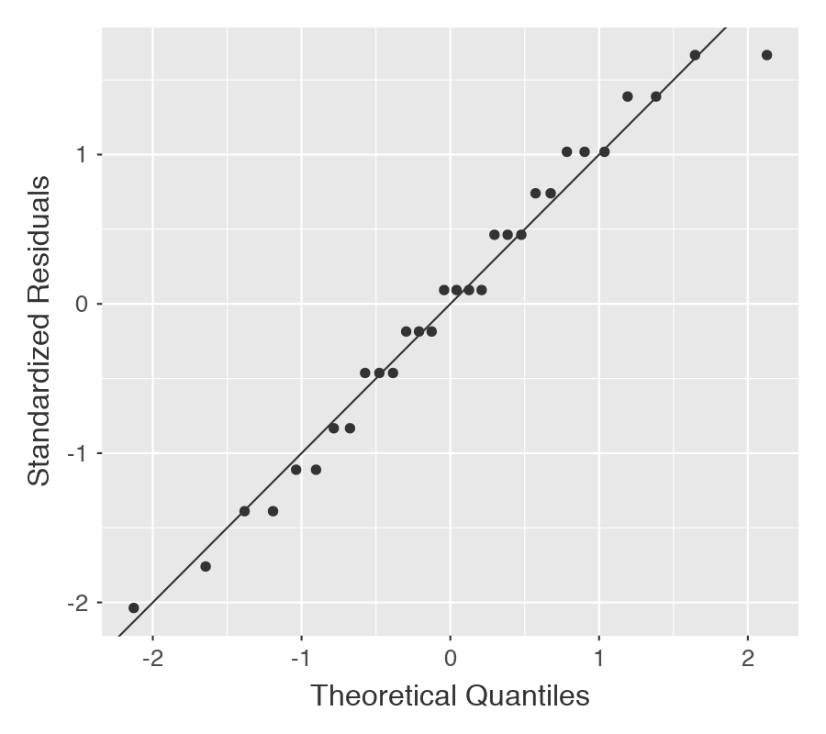

1. If we have three groups, write the null and research hypotheses.
2. What is the critical F value if $α= .05$ and $n=30$?
3. If the output from Jamovi looked like this, is it significant?

| **ANOVA** | | | | | | | | | | | | | |
| --- | --- | --- | --- | --- | --- | --- | --- | --- | --- | --- | --- | --- | --- |
|  |  |  |  |  |  |  |  |  |  |  |  |  |  |
|  | | **Sum of Squares** | | **df** | | **Mean Square** | | **F** | | **p** | | **η²** | |
| Group |  | 98.5 |  | 2 |  | 49.23 |  | 38.0 |  | < .001 |  | 0.738 |  |
| Residuals |  | 35.0 |  | 27 |  | 1.30 |  |  |  |  |  |  |  |

1. What is the effect size from the table? Is this effect small, moderate, or large?
2. Using page 382 as a guide, write the interpretation of the results.

**Section II: Jamovi**

Download the data set “HW3_Data.omv” from Canvas. In it, there are three variables: 1) Group, 2) Pretest, and 3) Posttest. The Group is a randomly assigned condition (1 = new treatment, 2 = old treatment, 3 = control), the Pretest is the child’s exam score before the intervention, and Posttest is the exam score after the intervention. We want to see if the pretest scores are different across the three groups. With this information and the data set, do the following:

1. Import the data into Jamovi.
2. Tell Jamovi that Group is a nominal variable and label the levels.
3. Make sure both Pretest and Posttest are scale variables.
4. Check assumptions of the type of test that you want to use to test whether the groups were the same at pretest or not ($H_{0}: μ_{1}= μ_{2}, μ_{1}= μ_{3}$).
5. After checking the assumptions, define the critical region for this test.
6. Compute the test statistic, the effect size, and confidence intervals.
7. Interpret the results in the context of the study.
8. Paste or print out the Jamovi output from this study and write the interpretation of the results below.