Test Bank

Chapter 2: Central Tendency

Multiple Choice
1. What does µ represent?
A. the sample mean
B. the population mean
C. the sum of the scores
D. the deviation score
Ans: B
Learning objective: Compute and interpret the mean

2. What does M represent?
A. the sample mean
B. the population mean
C. the sum of the scores
D. the deviation score
Ans: A
Learning objective: Compute and interpret the mean

3. What does ∑X represent?
A. the sample mean
B. the population mean
C. the sum of the scores
D. the deviation score
Ans: C
Learning objective: Compute and interpret the mean

4. Compute the mean for this population of scores: 20, 6, 8, 26, 29, 30, 14.
A. 18.7
B. 19
C. 16.98
D. 20
Ans: B
Learning Objective: Compute and interpret the mean

5. Find the median for this population of scores: 20, 6, 8, 26, 29, 30, 14.
A. 26
B. 20
C. 28
D. 27.5
Ans: B
Learning Objective: Compute and interpret the median

6. Compute the mean for this sample of scores: 100, 50, 65, 90, 82.
A. 77.4
B. 65.00
C. 78.2
D. 68.78
Ans: A
Learning Objective: Compute and interpret the mean

7. Find the median for this sample of scores: 88, 76, 53, 99, 67, 78, 80.
A. 78
B. 99
C. 80
D. 79
Ans: A
Learning Objective: Compute and interpret the median

8. Find the mean for this sample of scores: 88, 76, 53, 99, 67, 78, 80.
A. 78.21
B. 77.53
C. 78.11
D. 77.29
Ans: A
Learning Objective: Compute and interpret the median

9. Find the median for this population of scores: 5, 7, 8, 9, 11, 13, 14, 18.
A. 9
B. 10
C. 11
D. 12
Ans: B
Learning Objective: Compute and interpret the median

10. Find the median for this sample of scores: 15, 17, 18, 19, 21, 34, 35, 50.
A. 19
B. 20
C. 21
D. 22
Ans: B
Learning Objective: Compute and interpret the median

11. The following frequency table was created from peoples’ responses to the question, “how much do you like country music?” on a scale of 1–9 (1 = not at all and 9 = a lot). What score is the median of this distribution?
X |  | Frequency | Percent | Valid Percent | Cumulative Percent
  1.00
  2.00
  3.00
  4.00
  5.00
  6.00
  7.00
  Total
  4
  2
  5
  1
  3
  2
  3
  20
  20.0
  10.0
  25.0
  5.0
  15.0
  10.0
  15.0
  100.0
  20.0
  10.0
  25.0
  5.0
  15.0
  10.0
  15.0
  100.0
  20.0
  30.0
  55.0
  60.0
  75.0
  85.0
  100.0
A. 1
B. 2
C. 3
D. 4
E. 5
F. 6
G. 7
Ans: C
Learning Objective: Compute and interpret the median

12. The following frequency table was created from peoples’ responses to the question, “how much do you like country music?” on a scale of 1–9 (1 = not at all and 9 = a lot). What score is the mode of this distribution?
X |  | Frequency | Percent | Valid Percent | Cumulative Percent
  1.00
  2.00
  3.00
  4.00
  5.00
  6.00
  7.00
  Total
  4
  2
  5
  1
  3
  2
  3
  20
  20.0
  10.0
  25.0
  5.0
  15.0
  10.0
  15.0
  100.0
  20.0
  10.0
  25.0
  5.0
  15.0
  10.0
  15.0
  100.0
  20.0
  30.0
  55.0
  60.0
  75.0
  85.0
  100.0
A. 1
B. 2
C. 3
D. 4
E. 5
F. 6
G. 7
Ans: C
Learning Objective: Compute and interpret the mode

13. The following frequency table was created from peoples’ responses to the question, “how much do you like country music?” on a scale of 1–9 (1 = not at all and 9 = a lot). What is the mean of this distribution?
X |  | Frequency | Percent | Valid Percent | Cumulative Percent
  1.00
  2.00
  3.00
  4.00
  5.00
  6.00
  7.00
  Total
  4
  2
  5
  1
  3
  2
  3
  20
  20.0
  10.0
  25.0
  5.0
  15.0
  10.0
  15.0
  100.0
  20.0
  10.0
  25.0
  5.0
  15.0
  10.0
  15.0
  100.0
  20.0
  30.0
  55.0
  60.0
  75.0
  85.0
  100.0
A. 3.52
B. 2.86
C. 4.00
D. 3.75
Ans: D
Learning Objective: Compute and interpret the mean

14. Compute the mean for this sample of test scores
X | f
90 | 6
80 | 3
70 | 5
60 | 0
50 | 2
A. 70.00
B. 75.00
C. 76.88
D. 72.35
E. 72.50
Ans: C
Learning Objective: Compute and interpret the mean

15. Find the median for this sample of test scores
X | f
90 | 6
80 | 3
70 | 5
60 | 0
50 | 2
A. 80
B. 75.00
C. 70
D. 72.50
Ans: A
Learning Objective: Compute and interpret the median

16. Find the mode for this sample of test scores
X | f
90 | 6
80 | 3
70 | 5
60 | 0
50 | 2
A. 90
B. 80
C. 70
D. 60
E. 50
Ans: A
Learning Objective: Compute and interpret the mode

17. The data in the frequency table below came from the question, “What is your age?” What score is the median of the distribution?
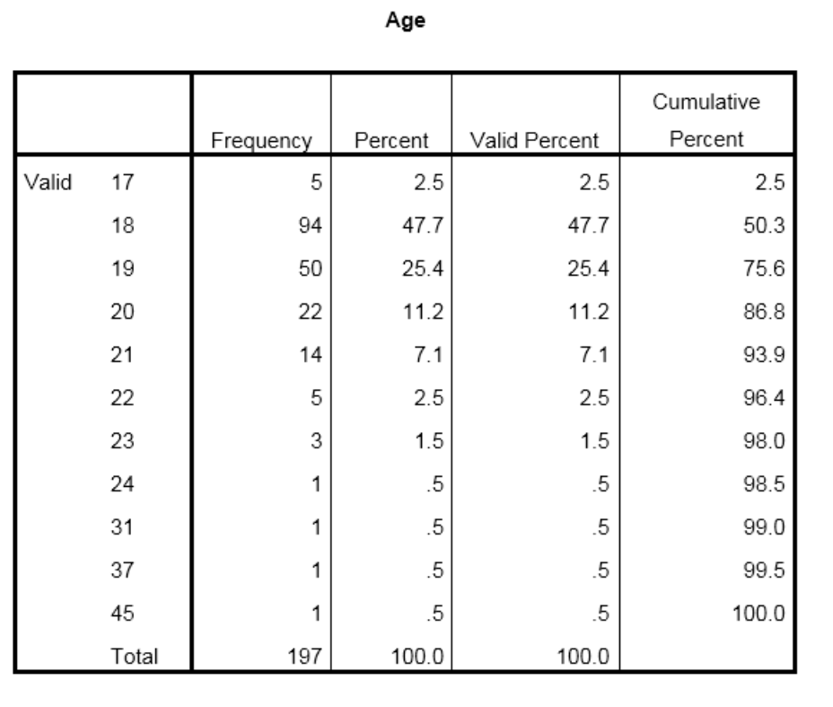

A. 17
B. 18
C. 19
D. 20
E. 21
Ans: B
Learning Objective: Compute and interpret the median

18. The data in the frequency table below came from the question, “What is your age?” What score is the mode of the distribution?

A. 17
B. 18
C. 19
D. 20
E. 21
Ans: B
Learning Objective: Compute and interpret the mode

19. The data in the following table came from the question, “On a scale of 1–6 (1 = not at all and 6 = a lot), how much do you like eating yogurt for breakfast?” What score is the MODE of this distribution?
X | f | Percent | Cumulative frequencies | Cumulative percentages
6 | 3 | 30 | 10 | 100
5 | 4 | 40 | 7 | 70
4 | 2 | 20 | 3 | 30
3 | 1 | 10 | 1 | 10
2 | 0 | 0 | 0 | 0
1 | 0 | 0 | 0 | 0
A. 1
B. 2
C. 3
D. 4
E. 5
F. 6
Ans: E
Learning Objective: Compute and interpret the mode

20. The data in the following table came from the question, “On a scale of 1–6 (1 = not at all and 6 = a lot), how much do you like eating yogurt for breakfast?” What score is the median of this distribution?
X | f | Percent | Cumulative frequencies | Cumulative percentages
6 | 3 | 30 | 10 | 100
5 | 4 | 40 | 7 | 70
4 | 2 | 20 | 3 | 30
3 | 1 | 10 | 1 | 10
2 | 0 | 0 | 0 | 0
1 | 0 | 0 | 0 | 0
A. 1
B. 2
C. 3
D. 4
E. 5
F. 6
Ans: E
Learning Objective: Compute and interpret the median

21. The data in the following table came from the question, “On a scale of 1–6 (1 = not at all and 6 = a lot), how much do you like eating yogurt for breakfast?” What score is the mean of this distribution?
X | f | Percent | Cumulative frequencies | Cumulative percentages
6 | 3 | 30 | 10 | 100
5 | 4 | 40 | 7 | 70
4 | 2 | 20 | 3 | 30
3 | 1 | 10 | 1 | 10
2 | 0 | 0 | 0 | 0
1 | 0 | 0 | 0 | 0
A. 4.90
B. 3.50
C. 4.5
D. 2.50
Ans: A
Learning Objective: Compute and interpret the mean

22. You asked several classmates how many times they texted their parents over the weekend. Compute the mean of these sample data.
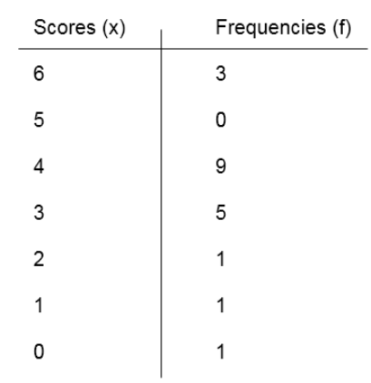
A. 3.38
B. 3
C. 3.6
D. 3.14
Ans: C
Learning Objective: Compute and interpret the mean

23. You asked several classmates how many times they texted their parents over the weekend. Find the score that is the mode of these sample data.
A. 6
B. 9
C. 3
D. 4
Ans: D
Learning Objective: Compute and interpret the mode

24. You asked several classmates how many times they texted their parents over the weekend. Find the score that is the median of these sample data.
A. 6
B. 9
C. 3
D. 4
Ans: D
Learning Objective: Compute and interpret the median

25. When data are measured on a nominal scale, what measure of central tendency should you use?
A. mode
B. median
C. mean
Ans: A
Learning Objective: Identify when to use the mean, the median, or the mode when describing a distribution’s central tendency

26. When data are measured on an ordinal scale, what measure of central tendency should you use?
A. mode
B. median
C. mean
Ans: B
Learning Objective: Identify when to use the mean, the median, or the mode when describing a distribution’s central tendency

27. When data are measured on a nominal scale, what measure of central tendency should you use?
A. mode
B. median
C. mean
Ans: A
Learning Objective: Identify when to use the mean, the median, or the mode when describing a distribution’s central tendency

28. When data are measured on an interval/ratio scale but there are outliers, what measure of central tendency should you use?
A. mode
B. median
C. mean
Ans: B
Learning Objective: Identify when to use the mean, the median, or the mode when describing a distribution’s central tendency

29. What measure of central tendency is most influenced by outliers?
A. mode
B. median
C. mean
Ans: B
Learning Objective: Identify when to use the mean, the median, or the mode when describing a distribution’s central tendency

30. When data are measured on an interval/ratio scale and the data are normally distributed, what measure of central tendency should you use?
A. mode
B. median
C. mean
Ans: C
Learning Objective: Identify when to use the mean, the median, or the mode when describing a distribution’s central tendency

31. Professor Williams gives an exam and records the number of questions each student got right. She finds that the results are negatively skewed. What measure of central tendency should she report?
A. mode
B. median
C. mean
Ans: B
Learning Objective: Identify when to use the mean, the median, or the mode when describing a distribution’s central tendency

32. Scores on a Physics exam are normally distributed. What is the best measure of central tendency for these scores?
A. mode
B. median
C. mean
Ans: C
Learning Objective: Identify when to use the mean, the median, or the mode when describing a distribution’s central tendency

33. The following is a histogram of an interval/ratio measure of introspection (labeled “IN”). What measure of central tendency should you use?
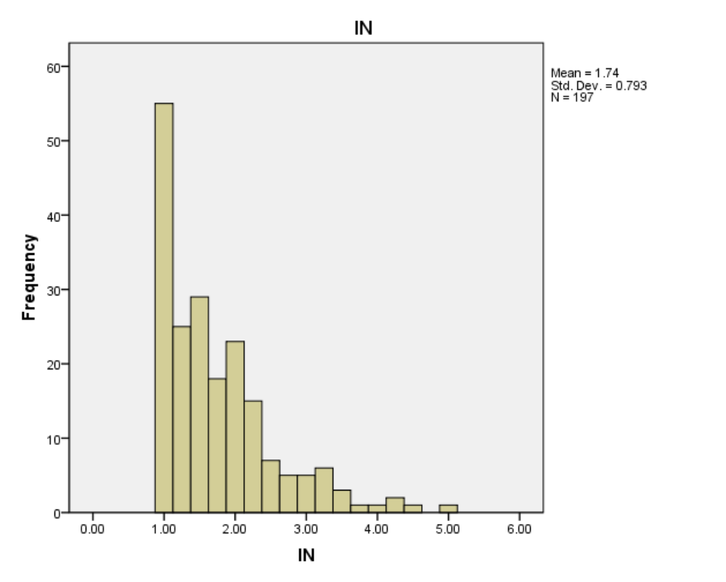
A. mean
B. median
C. mode
Ans: B
Learning Objective: Identify when to use the mean, the median, or the mode when describing a distribution’s central tendency

34. A reviewer determined whether or not job applicants had the necessary experience for a job or not (yes or no). What measure of central tendency should you use?
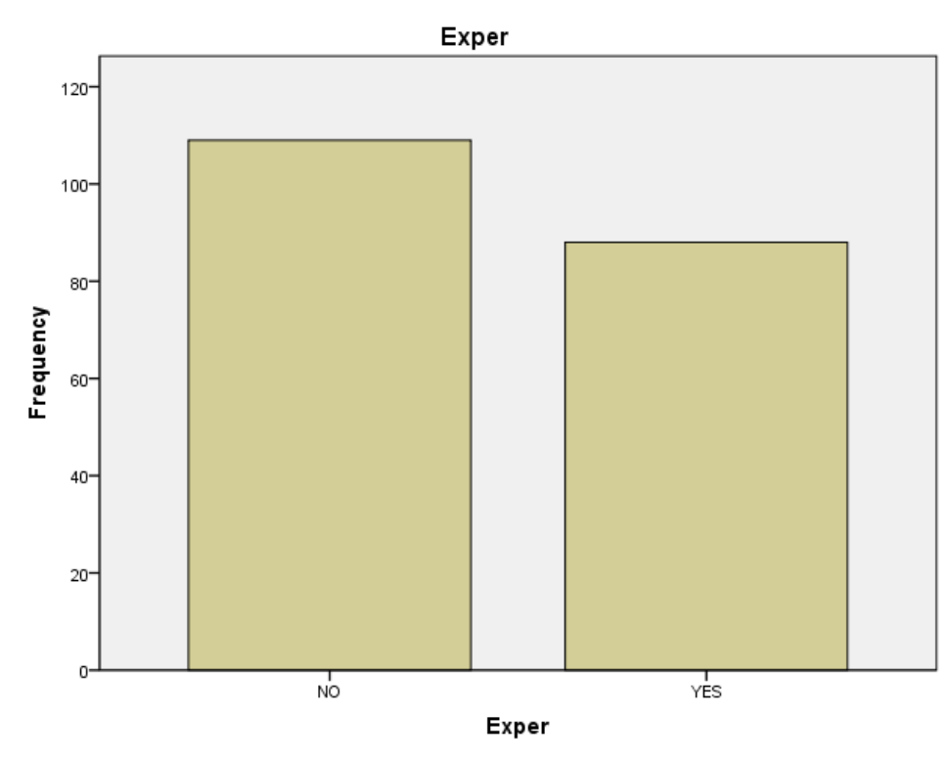
A. mean
B. median
C. mode
Ans: C
Learning Objective: Identify when to use the mean, the median, or the mode when describing a distribution’s central tendency

35. The following is a histogram of a Creative Work Survey (CWS) measured on an interval/ratio scale. What measure of central tendency should you use?
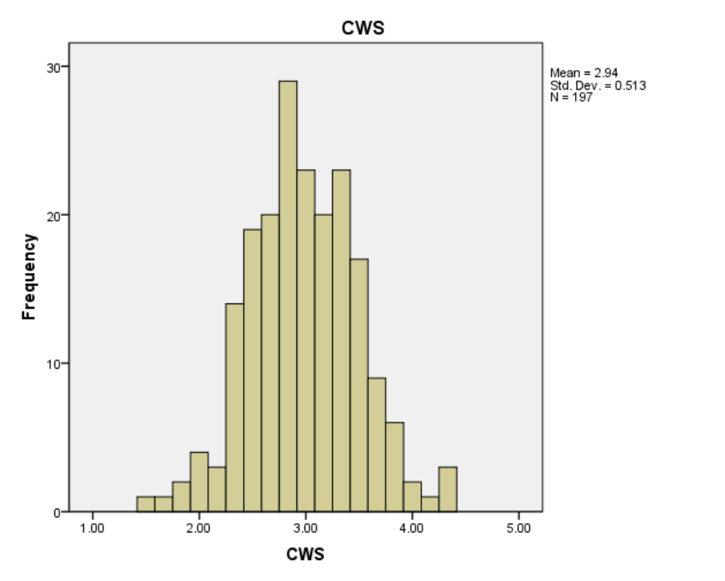
A. mean
B. median
C. mode
Ans: A
Learning Objective: Identify when to use the mean, the median, or the mode when describing a distribution’s central tendency

36. The variable below is people’s response to, “What is your religion?” What measure of central tendency should you use?
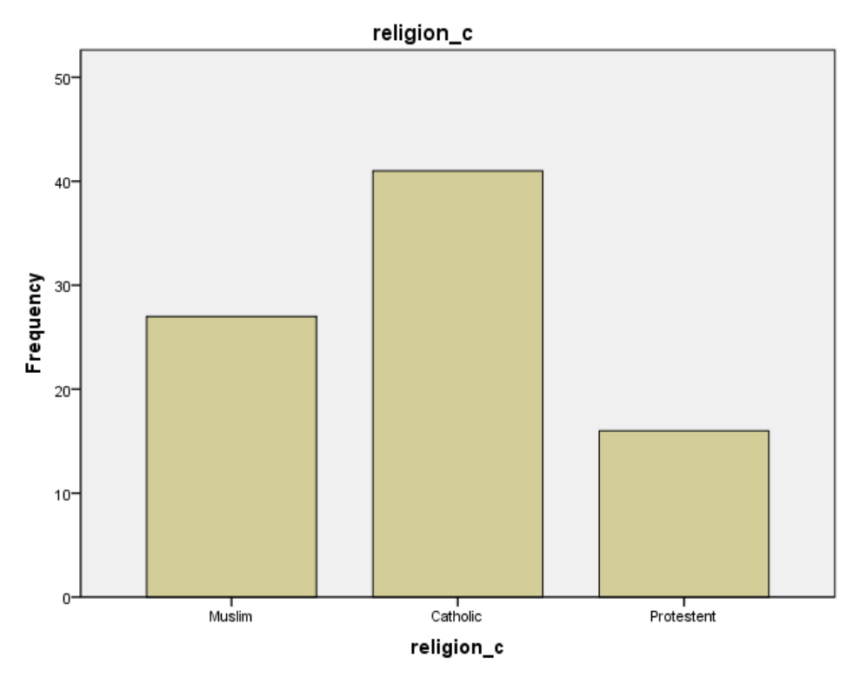
A. mean
B. median
C. mode
Ans: C
Learning Objective: Identify when to use the mean, the median, or the mode when describing a distribution’s central tendency

37. Which measure of central tendency should you use in the following situation? You asked students to indicate how many hours a week they work using the following scale:
______ 0–5 hr
______ 6–10 hr
______ 11–15 hr
______ 16–20 hr
______ over 20 hr
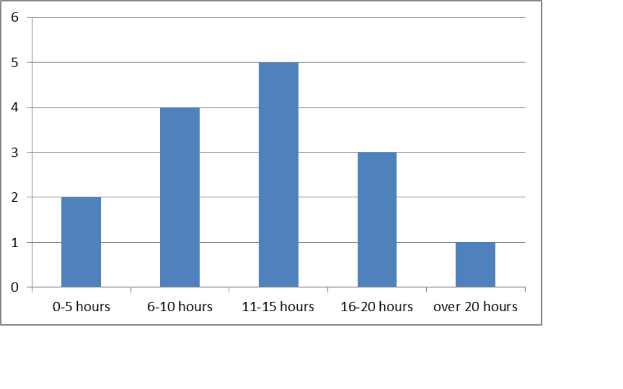
A. mode
B. median
C. mean
Ans: B
Learning Objective: Identify when to use the mean, the median, or the mode when describing a distribution’s central tendency

38. Which measure of central tendency should you use in the following situation? You record student’s scores on a 10-point quiz.
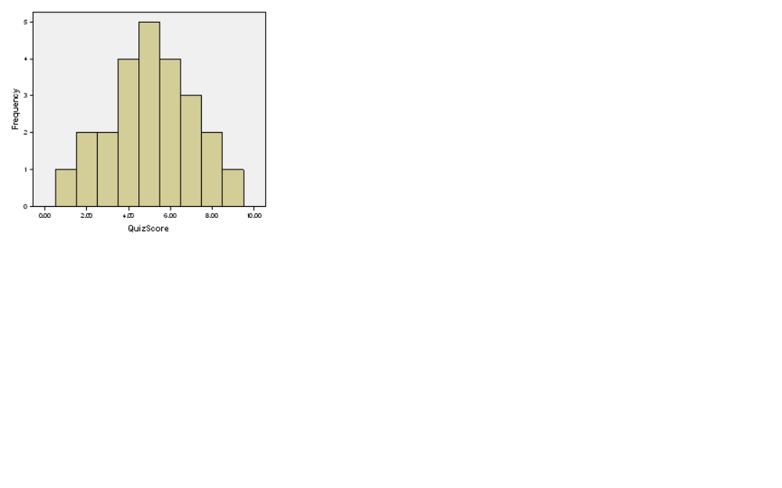
A. mode
B. median
C. mean
Ans: C
Learning Objective: Identify when to use the mean, the median, or the mode when describing a distribution’s central tendency

39. Which measure of central tendency should you use in the following situation? You ask people to report their favorite type of food and obtain the following results:

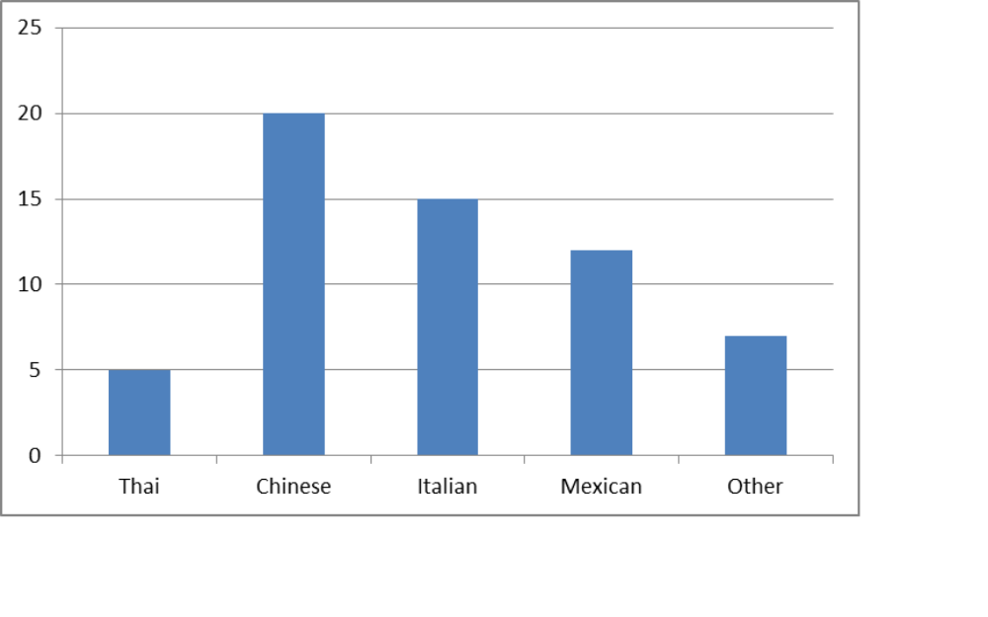
A. mode
B. median
C. mean
Ans: A
Learning Objective: Identify when to use the mean, the median, or the mode when describing a distribution’s central tendency

40. Which measure of central tendency should you use in the following situation? You asked students to guess how old Professor Youngblood is and obtained the following data:

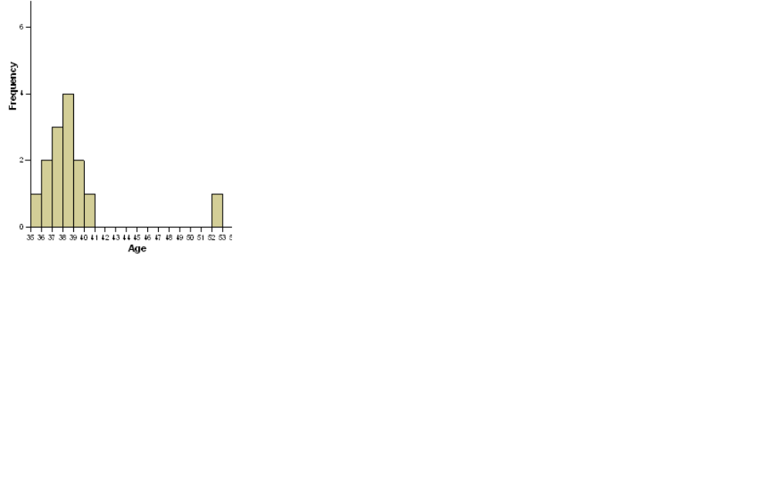
A. mode
B. median
C. mean
Ans: B
Learning Objective: Identify when to use the mean, the median, or the mode when describing a distribution’s central tendency

41. Scores on an exam have a mean of 75 and a standard deviation of 12. A student received a 78 on the exam. What is the deviation score for that student’s test score?
A. 0
B. 3
C. −3
D. 66
E. +66
Ans: B
Learning Objective: Explain how the mean perfectly balances positive and negative deviation scores.

42. The average salary for new employees at a software company is US$50,000 with a standard deviation of US$10,600. Amy is hired in at US$48,000. What is Amy’s deviation score?
A. 0
B. 2,000
C. −2,000
D. 10,600
Ans: C
Learning Objective: Explain how the mean perfectly balances positive and negative deviation scores.

43. A positive deviation score means that:
A. the raw score was above the mean.
B. the raw score was below the mean.
C. the mean was negative.
D. the mean was positive.
Ans: A
Learning Objective: Explain how the mean perfectly balances positive and negative deviation scores.

44. A negative deviation score means that:
A. the raw score was above the mean.
B. the raw score was below the mean.
C. the mean was negative.
D. the mean was positive.
Ans: B
Learning Objective: Explain how the mean perfectly balances positive and negative deviation scores.

45. What is the sum of the deviation scores for the data in the frequency distribution table below?
A. 100
B. 0
C. 197
D. 1
Ans: B
Learning Objective: Explain how the mean perfectly balances positive and negative deviation scores.

46. On an exam with a mean of 75 and a standard deviation of 12, the professor computes the deviation scores for every student in the class. What will be the sum of the deviation scores?
A. 0
B. 1
C. 12
D. 75
E. 87
F. You can’t answer this question without knowing all of the deviation scores.
Ans: A
Learning Objective: Explain how the mean perfectly balances positive and negative deviation scores.

True/False
1. The mean is computed the same way for a population and for a sample.
Ans: T
Learning Objective: Compute and interpret the mean

2. A mean can never be negative.
Ans: F
Learning Objective: Explain how the mean perfectly balances positive and negative deviation scores.

3. A deviation score can never be negative.
Ans: T
Learning Objective: Explain how the mean perfectly balances positive and negative deviation scores.

4. The number of scores above the mean will always be equal to the number of scores below the mean.
Ans: F
Learning Objective: Explain how the mean perfectly balances positive and negative deviation scores.

