Test Bank

Chapter 10: Independent Samples t-Test

Multiple Choice
1. Which of the following is the best description of the normality assumption?
A. The distributions of sample means for all interval/ratio variables must be normally shaped.
B. The distributions of sample means for all variables must be normally shaped.
C. All scores must be measured on an interval/ratio scale that is normally shaped.
D. The sample data must have a normal shape.
Ans: A
Learning Objective: Assumptions

2. Which of the following is the best description of the independence assumption?
A. The distribution of sample means for interval/ratio data must be independent.
B. The scores within any condition are independent of other scores in the condition.
C. Only one score per person can be used in a study.
Ans: B
Learning Objective: Assumptions

3. A student completing a senior project decides to investigate stress levels among college students. Specifically, she wants to know if freshmen or seniors experience more stress. To assess stress levels she asks 12 freshmen and 12 seniors to complete a survey designed to measure stress levels. Scores on the stress survey are normally distributed and measured on an interval scale where higher numbers indicate greater levels of stress. The data are as follows:
Freshmen: 20, 43, 56, 76, 45, 87, 12, 34, 65, 58, 42, 100
Seniors: 90, 30, 80, 60, 64, 37, 84, 27, 87, 54, 38, 92
Which fact below suggests that the normality assumption was probably met?
A. stress scores are normally distributed in the population
B. the two SDs are similar
C. Each student took the test alone
D. The study clearly defined two samples and measured stress levels on an interval/ratio scale
Ans: A
Learning Objective: Assumptions

4. A student completing a senior project decides to investigate stress levels among college students. Specifically, she wants to know if freshmen or seniors experience more stress. To assess stress levels she asks 12 freshmen and 12 seniors to complete a survey designed to measure stress levels. Scores on the stress survey are normally distributed and measured on an interval scale where higher numbers indicate greater levels of stress. The data are as follows:
Freshmen: 20, 43, 56, 76, 45, 87, 12, 34, 65, 58, 42, 100
Seniors: 90, 30, 80, 60, 64, 37, 84, 27, 87, 54, 38, 92
Which fact below suggests that the homogeneity of variance assumption was probably met?
A. stress scores are normally distributed in the population
B. the two SDs are similar
C. Each student took the test alone
D. The study clearly defined two samples and measured stress levels on an interval/ratio scale
Ans: B
Learning Objective: Assumptions

5. A student completing a senior project decides to investigate stress levels among college students. Specifically, she wants to know if freshmen or seniors experience more stress. To assess stress levels, she asks 12 freshmen and 12 seniors to complete a survey designed to measure stress levels. Scores on the stress survey are normally distributed and measured on an interval scale where higher numbers indicate greater levels of stress. The data are as follows:
Freshmen: 20, 43, 56, 76, 45, 87, 12, 34, 65, 58, 42, 100
Seniors: 90, 30, 80, 60, 64, 37, 84, 27, 87, 54, 38, 92
Which fact below suggests that the data independence assumption was probably met?
A. stress scores are normally distributed in the population
B. the two SDs are similar
C. each student took the test alone
D. the study clearly defined two samples and measured stress levels on an interval/ratio scale
Ans: C
Learning Objective: Assumptions

6. A student completing a senior project decides to investigate stress levels among college students. Specifically, she wants to know if freshmen or seniors experience more stress. To assess stress levels she asks 12 freshmen and 12 seniors to complete a survey designed to measure stress levels. Scores on the stress survey are normally distributed and measured on an interval scale where higher numbers indicate greater levels of stress. The data are as follows:
Freshmen: 20, 43, 56, 76, 45, 87, 12, 34, 65, 58, 42, 100
Seniors: 90, 30, 80, 60, 64, 37, 84, 27, 87, 54, 38, 92
Which fact below suggests that the appropriate measurement of variables assumption was probably met?
A. Stress scores are normally distributed in the population.
B. The two SDs are similar.
C. Each student took the test independently.
D. The study clearly defined two samples and measured stress levels on an interval/ratio scale.
Ans: D
Learning Objective: Assumptions

7. A student completing a senior project decides to investigate stress levels among college students. Specifically, she wants to know if freshmen or seniors experience more stress. To assess stress levels she asks 12 freshmen and 12 seniors to complete a survey designed to measure stress levels. Scores on the stress survey are normally distributed and measured on an interval scale where higher numbers indicate greater levels of stress. The data are as follows:
Freshmen: 20, 43, 56, 76, 45, 87, 12, 34, 65, 58, 42, 100
Seniors: 90, 30, 80, 60, 64, 37, 84, 27, 87, 54, 38, 92
Select the two-tailed null hypotheses for this statistical analysis.
A. Stress levels for freshmen are significantly lower than the stress levels of seniors.
B. Stress levels for freshmen are not significantly different from the stress levels of seniors.
C. Stress levels for freshmen are significantly different from the stress levels of seniors.
D. Stress levels for freshmen are not significantly higher than the stress levels of seniors.
E. Stress levels for freshmen are significantly higher than the stress levels of seniors.
F. Stress levels for freshmen are not significantly lower than the stress levels of seniors.
Ans: B
Learning Objective: Null hypothesis

8. A student completing a senior project decides to investigate stress levels among college students. Specifically, she wants to know if freshmen or seniors experience more stress. To assess stress levels, she asks 12 freshmen and 12 seniors to complete a survey designed to measure stress levels. Scores on the stress survey are normally distributed and measured on an interval scale where higher numbers indicate greater levels of stress. The data are as follows:
Freshmen: 20, 43, 56, 76, 45, 87, 12, 34, 65, 58, 42, 100
Seniors: 90, 30, 80, 60, 64, 37, 84, 27, 87, 54, 38, 92
Select the two-tailed research hypotheses for this statistical analysis.
A. Stress levels for freshmen are significantly lower than the stress levels of seniors.
B. Stress levels for freshmen are not significantly different from the stress levels of seniors.
C. Stress levels for freshmen are significantly different from the stress levels of seniors.
D. Stress levels for freshmen are not significantly higher than the stress levels of seniors.
E. Stress levels for freshmen are significantly higher than the stress levels of seniors.
F. Stress levels for freshmen are not significantly lower than the stress levels of seniors.
Ans: A
Learning Objective: Research hypothesis

9. A student completing a senior project decides to investigate stress levels among college students. Specifically, she wants to know if freshmen or seniors experience more stress. To assess stress levels she asks 12 freshmen and 12 seniors to complete a survey designed to measure stress levels. Scores on the stress survey are normally distributed and measured on an interval scale where higher numbers indicate greater levels of stress. The data are as follows:
Freshmen: 20, 43, 56, 76, 45, 87, 12, 34, 65, 58, 42, 100
Seniors: 90, 30, 80, 60, 64, 37, 84, 27, 87, 54, 38, 92
Select the two-tailed null hypotheses for this statistical analysis.
A. µ₁≠ µ₂
B. µ₁= µ₂
C. µ₁ ≤ µ₂
D. µ₁ ≥ µ₂
E. µ₁ < µ₂
F. µ₁ > µ₂
Ans: B
Learning Objective: Null hypothesis

10. A student completing a senior project decides to investigate stress levels among college students. Specifically, she wants to know if freshmen or seniors experience more stress. To assess stress levels she asks 12 freshmen and 12 seniors to complete a survey designed to measure stress levels. Scores on the stress survey are normally distributed and measured on an interval scale where higher numbers indicate greater levels of stress. The data are as follows:
Freshmen: 20, 43, 56, 76, 45, 87, 12, 34, 65, 58, 42, 100
Seniors: 90, 30, 80, 60, 64, 37, 84, 27, 87, 54, 38, 92
Select the two-tailed research hypotheses for this statistical analysis.
A. µ₁≠ µ₂
B. µ₁ = µ₂
C. µ₁ ≤ µ₂
D. µ₁ ≥ µ₂
E. µ₁ < µ₂
F. µ₁ > µ₂
Ans: A
Learning Objective: Research hypothesis

11. A student completing a senior project decides to investigate stress levels among college students. Specifically, she wants to know if freshmen or seniors experience more stress. To assess stress levels she asks 12 freshmen and 12 seniors to complete a survey designed to measure stress levels. Scores on the stress survey are normally distributed and measured on an interval scale where higher numbers indicate greater levels of stress. The data are as follows:
Freshmen: 20, 43, 56, 76, 45, 87, 12, 34, 65, 58, 42, 100
Seniors: 90, 30, 80, 60, 64, 37, 84, 27, 87, 54, 38, 92

Locate the critical region (α = .05).
A. reject H0 if t > 2.0639 or t < −2.0639
B. reject H0 if t > 2.2010 or t < −2.2010
C. reject H0 if t > 2.0739 or t < −2.0739
D. reject H0 if t > 2.0796 or t < −2.0796
Ans: C
Learning Objective: Critical region

12. A student completing a senior project decides to investigate stress levels among college students. Specifically, she wants to know if freshmen or seniors experience more stress. To assess stress levels she asks 12 freshmen and 12 seniors to complete a survey designed to measure stress levels. Scores on the stress survey are normally distributed and measured on an interval scale where higher numbers indicate greater levels of stress. The data are as follows:
Freshmen: 20, 43, 56, 76, 45, 87, 12, 34, 65, 58, 42, 100
Seniors: 90, 30, 80, 60, 64, 37, 84, 27, 87, 54, 38, 92

Compute the independent samples t.
A. −0.85
B. 10.35
C. 7.53
D. 2.01
E. −0.35
Ans: A
Learning Objective: Computing test statistic

13. A student completing a senior project decides to investigate stress levels among college students. Specifically, she wants to know if freshmen or seniors experience more stress. To assess stress levels she asks 12 freshmen and 12 seniors to complete a survey designed to measure stress levels. Scores on the stress survey are normally distributed and measured on an interval scale where higher numbers indicate greater levels of stress. The data are as follows:
Freshmen: 20, 43, 56, 76, 45, 87, 12, 34, 65, 58, 42, 100
Seniors: 90, 30, 80, 60, 64, 37, 84, 27, 87, 54, 38, 92
Should you reject or fail to reject the null hypothesis?
A. reject
B. fail to reject
Ans: B
Learning Objective: Rejecting null

14. A student completing a senior project decides to investigate stress levels among college students. Specifically, she wants to know if freshmen or seniors experience more stress. To assess stress levels, she asks 12 freshmen and 12 seniors to complete a survey designed to measure stress levels. Scores on the stress survey are normally distributed and measured on an interval scale where higher numbers indicate greater levels of stress. The data are as follows:
Freshmen: 20, 43, 56, 76, 45, 87, 12, 34, 65, 58, 42, 100
Seniors: 90, 30, 80, 60, 64, 37, 84, 27, 87, 54, 38, 92
Compute the effect size for this study.
A. −.85
B. .10
C. .89
D. .55
E. −.35
Ans: E
Learning Objective: Computing effect size

15. A student completing a senior project decides to investigate stress levels among college students. Specifically, she wants to know if freshmen or seniors experience more stress. To assess stress levels, she asks 12 freshmen and 12 seniors to complete a survey designed to measure stress levels. Scores on the stress survey are normally distributed and measured on an interval scale where higher numbers indicate greater levels of stress. The data are as follows:
Freshmen: 20, 43, 56, 76, 45, 87, 12, 34, 65, 58, 42, 100
Seniors: 90, 30, 80, 60, 64, 37, 84, 27, 87, 54, 38, 92
How large is this effect?
A. small
B. small–medium
C. medium
D. medium–large
E. large
Ans: B
Learning Objective: Interpreting effect size

16. A student completing a senior project decides to investigate stress levels among college students. Specifically, she wants to know if freshmen or seniors experience more stress. To assess stress levels she asks 12 freshmen and 12 seniors to complete a survey designed to measure stress levels. Scores on the stress survey are normally distributed and measured on an interval scale where higher numbers indicate greater levels of stress. The data are as follows:
Freshmen: 20, 43, 56, 76, 45, 87, 12, 34, 65, 58, 42, 100
Seniors: 90, 30, 80, 60, 64, 37, 84, 27, 87, 54, 38, 92
Which of the following is the best summary of the results?
A. Seniors report significantly more stress than freshmen.
B. Freshmen report significantly more stress than seniors.
C. There is no difference between the reported stress levels between freshmen and seniors.
Ans: A
Learning Objective: Summarizing results

17. When is a two-tailed test more appropriate choice than a one-tailed test?
A. when a researcher was more concern about minimizing Type I errors than Type II errors
B. when a researcher was more concern about maximizing Statistical power than reducing Type I errors
C. when a researcher does not have a clear prediction about which group would have higher scores
D. when a researcher does not have a clear prediction about what the mean difference would be if the null hypothesis was true
Ans: C
Learning Objective: One-tailed versus two-tailed tests

18. A researcher used an α value of .05 and rejected the null. What is the probability that this researcher made a Type I error?
A. 0
B. .05
C. .025
D. .01
Ans: A
Learning Objective: Type I error

19. A different research reads the results of the acupuncture study described above and thinks that it is possible that the participants rated their back pain as less severe after acupuncture simply because of the placebo effect. To test this possibility, he conducts a different study with two separate groups. One group receives acupuncture. The other group receives “placebo acupuncture” and needles are inserted into areas that are not thought to be related to back pain. If the acupuncture is effective, he expects the acupuncture group to have lower levels of reported back pain that the placebo group. Was the homogeneity of variance assumption violated?
The SPSS output follows:
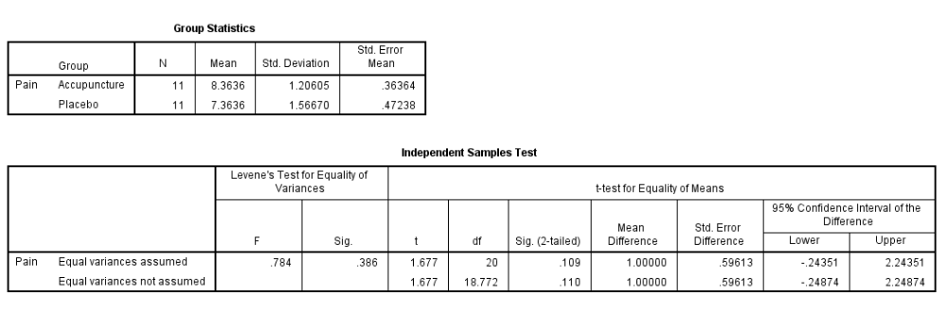
A. Yes
B. No
Ans: B
Learning Objective: SPSS homogeneity assumption

20. A different research reads the results of the acupuncture study described above and thinks that it is possible that the participants rated their back pain as less severe after acupuncture simply because of the placebo effect. To test this possibility, he conducts a different study with two separate groups. One group receives acupuncture. The other group receives “placebo acupuncture” and needles are inserted into areas that are not thought to be related to back pain. If the acupuncture is effective, he expects the acupuncture group to have lower levels of reported back pain that the placebo group. Choose the correct APA style summary for this study.
The SPSS output follows:
A. People who received acupuncture reported significantly less back pain (M = 8.36, = 1.21) than people who received the placebo treatment (M = 7.36, SD = 1.57), t(20) = 1.67, p < .05, one tailed, d = .72
B. People who received acupuncture reported more back pain (M = 8.36, SD = 1.21) than people who received the placebo treatment (M = 7.36, SD = 1.57), t(20) = 1.67, p > .05, one tailed, d = .72
C. People who received acupuncture did not report less back pain (M = 8.36, SD = 1.21) than people who received the placebo treatment (M = 7.36, SD = 1.57), t(20) = 1.67, p > .05, one tailed, d = .72
Ans: A
Learning Objective: SPSS reporting results

21. A researcher reads studies on acupuncture and thinks that it is possible that the participants rated their back pain as less severe after acupuncture simply because of the placebo effect. To test this possibility, he conducts a different study with two separate groups. One group receives acupuncture. The other group receives “placebo acupuncture” and needles are inserted into areas that are not thought to be related to back pain. If the acupuncture is effective, he expects the acupuncture group to have lower levels of reported back pain that the placebo group. The researcher decided to do a one-tailed test. What is the p value for a one tailed test?
The SPSS output follows:
A. .109
B. .110
C. .0545
D. .055
Ans: C
Learning Objective: SPSS interpreting results

22. A different research reads the results of the acupuncture study described above and thinks that it is possible that the participants rated their back pain as less severe after acupuncture simply because of the placebo effect. To test this possibility, he conducts a different study with two separate groups. One group receives acupuncture. The other group receives “placebo acupuncture” and needles are inserted into areas that are not thought to be related to back pain. If the acupuncture is effective, he expects the acupuncture group to have lower levels of reported back pain that the placebo group. SPSS provides the 95% confidence interval around the mean difference. Which of the following is the best interpretation of this interval?
The SPSS output follows:
A. We are 95% confident that he sample mean is between the upper and lower bounds of the CI
B. We are 95% confident that the population mean difference between the two conditions would be between the upper and lower bounds.
C. We are 95% confidence that the range of individual scores are within one standard deviation of the sample mean
D. We are 95% confident that the of range of individual scores in the population is withing one standard deviation of the population mean
Ans: B
Learning Objective: Interpreting Cis

23. Researchers obtained a sample of 36 college students who all have the same history instructor this semester. Half of the students were shown a 2-min video that claimed the purpose of education was to help students “learn how to learn” so that they can enjoy a lifetime of learning after college. The other half of students were shown a 2-min video that claimed the purpose of education was to teach facts to students. After watching the 2-min videos, the students were asked to rate their history instructor using a 10-point scale, 1 = very bad teacher to 10 = very good teacher. The mean and standard deviations for each group of 18 students are provided below. Use the provided information to answer the next four questions. Use an α of .05, two tailed.
“learn to learn” Group 1: M₁ = 5.9, SD₁ = 1.8, n₁ = 18
“learn facts” Group 2: M₂ = 7.2, SD₂ = 1.7, n₂ = 18

Which fact suggests that the homogeneity of variance assumption was met?
A. Students’ rating were not influenced by other students’ ratings.
B. The ratings of teachers are normally distributed.
C. The study clearly defined how the two groups were different and the ratings were measured on an interval/ratio scale.
D. The two sample SDs are similar.
Ans: D
Learning Objective: Assumptions

24. Researchers obtained a sample of 36 college students who all have the same history instructor this semester. Half of the students were shown a 2-min video that claimed the purpose of education was to help students “learn how to learn” so that they can enjoy a lifetime of learning after college. The other half of students were shown a 2-min video that claimed the purpose of education was to teach facts to students. After watching the 2-min videos, the students were asked to rate their history instructor using a 10-point scale, 1 = very bad teacher to 10 = very good teacher. The mean and standard deviations for each group of 18 students are provided below. Use the provided information to answer the next four questions. Use an α of .05, two tailed.

“learn to learn” Group 1: M₁ = 5.9, SD₁ = 1.8, n₁ = 18
“learn facts” Group 2: M₂ = 7.2, SD₂ = 1.7, n₂ = 18

Which fact suggests that the normality assumption was met?
A. Students’ rating were not influenced by other students’ ratings.
B. The ratings of teachers are normally distributed.
C. The study clearly defined how the two groups were different and the ratings were measured on an interval/ratio scale.
D. The two sample SDs are similar.
Ans: B
Learning Objective: Assumptions

25. Researchers obtained a sample of 36 college students who all have the same history instructor this semester. Half of the students were shown a 2-min video that claimed the purpose of education was to help students “learn how to learn” so that they can enjoy a lifetime of learning after college. The other half of students were shown a 2-min video that claimed the purpose of education was to teach facts to students. After watching the 2-min videos, the students were asked to rate their history instructor using a 10-point scale, 1 = very bad teacher to 10 = very good teacher. The mean and standard deviations for each group of 18 students are provided below. Use the provided information to answer the next four questions. Use an α of .05, two tailed.

“learn to learn” Group 1: M₁ = 5.9, SD₁ = 1.8, n₁ = 18
“learn facts” Group 2: M₂ = 7.2, SD₂ = 1.7, n₂ = 18

Which fact suggests that the approprate measurement assumption was met?
A. Students’ rating were not influenced by other students’ ratings.
B. The ratings of teachers are normally distributed.
C. The study clearly defined how the two groups were different and the ratings were measured on an interval/ratio scale.
D. The two sample SDs are similar.
Ans: C
Learning Objective: Assumptions

26. Researchers obtained a sample of 36 college students who all have the same history instructor this semester. Half of the students were shown a 2-min video that claimed the purpose of education was to help students “learn how to learn” so that they can enjoy a lifetime of learning after college. The other half of students were shown a 2-min video that claimed the purpose of education was to teach facts to students. After watching the 2-min videos, the students were asked to rate their history instructor using a 10-point scale, 1 = very bad teacher to 10 = very good teacher. The mean and standard deviations for each group of 18 students are provided below. Use the provided information to answer the next four questions. Use an α of .05, two tailed.

“learn to learn” Group 1: M₁ = 5.9, SD₁ = 1.8, n₁ = 18
“learn facts” Group 2: M₂ = 7.2, SD₂ = 1.7, n₂ = 18

Which fact suggests that the data independence assumption was met?
A. Students’ rating were not influenced by other students’ ratings.
B. The ratings of teachers are normally distributed.
C. The study clearly defined how the two groups were different and the ratings were measured on an interval/ratio scale.
D. The two sample SDs are similar.
Ans: A
Learning Objective: Assumptions

27. Researchers obtained a sample of 36 college students who all have the same history instructor this semester. Half of the students were shown a 2-min video that claimed the purpose of education was to help students “learn how to learn” so that they can enjoy a lifetime of learning after college. The other half of students were shown a 2-min video that claimed the purpose of education was to teach facts to students. After watching the 2-min videos, the students were asked to rate their history instructor using a 10-point scale, 1 = very bad teacher to 10 = very good teacher. The mean and standard deviations for each group of 18 students are provided below. Use the provided information to answer the next four questions. Use an α of .05, two tailed.

“learn to learn” Group 1: M₁ = 5.9, SD₁ = 1.8, n₁ = 18
“learn facts” Group 2: M₂ = 7.2, SD₂ = 1.7, n₂ = 18

Select the two-tailed null and research hypotheses for this statistical analysis.
A. H0: µ₁ ≠ µ2; H₁: µ₁ = µ2
B. H0: µ₁ = µ₂; H₁: µ₁ ≠ µ₂
C. H0: µ₁ > µ₂; H₁: µ₁ ≤ µ₂
D. H0: µ₁ ≤ µ₂; H₁: µ₁ > µ₂
Ans: B
Learning Objective: Null and research hypotheses

28. Researchers obtained a sample of 36 college students who all have the same history instructor this semester. Half of the students were shown a 2-min video that claimed the purpose of education was to help students “learn how to learn” so that they can enjoy a lifetime of learning after college. The other half of students were shown a 2-min video that claimed the purpose of education was to teach facts to students. After watching the 2-min videos, the students were asked to rate their history instructor using a 10-point scale, 1 = very bad teacher to 10 = very good teacher. The mean and standard deviations for each group of 18 students are provided below. Use the provided information to answer the next four questions. Use an α of .05, two tailed.

“learn to learn” Group 1: M₁ = 5.9, SD₁ = 1.8, n₁ = 18
“learn facts” Group 2: M₂ = 7.2, SD₂ = 1.7, n₂ = 18

Compute the df and find the critical value.

A. −2.1009
B. −2.8784
C. −2.0322
D. −2.7284
E. −2.1098
F. −2.8982
Ans: C
Learning Objective: Critical region

29. Researchers obtained a sample of 36 college students who all have the same history instructor this semester. Half of the students were shown a 2-min video that claimed the purpose of education was to help students “learn how to learn” so that they can enjoy a lifetime of learning after college. The other half of students were shown a 2-min video that claimed the purpose of education was to teach facts to students. After watching the 2-min videos, the students were asked to rate their history instructor using a 10-point scale, 1 = very bad teacher to 10 = very good teacher. The mean and standard deviations for each group of 18 students are provided below. Use the provided information to answer the next four questions. Use an α of .05, two tailed.

“learn to learn” Group 1: M₁ = 5.9, SD₁ = 1.8, n₁ = 18
“learn facts” Group 2: M₂ = 7.2, SD₂ = 1.7, n₂ = 18

Compute the independent t-test
A. −1.27
B. −2.17
C. −2.24
D. −3.07
E. −0.58
F. −0.74
G. −0.34
Ans: C
Learning Objective: Computing test statistic

30. Researchers obtained a sample of 36 college students who all have the same history instructor this semester. Half of the students were shown a 2-min video that claimed the purpose of education was to help students “learn how to learn” so that they can enjoy a lifetime of learning after college. The other half of students were shown a 2-min video that claimed the purpose of education was to teach facts to students. After watching the 2-min videos, the students were asked to rate their history instructor using a 10-point scale, 1 = very bad teacher to 10 = very good teacher. The mean and standard deviations for each group of 18 students are provided below. Use the provided information to answer the next four questions. Use an α of .05, two tailed.

“learn to learn” Group 1: M₁ = 5.9, SD₁ = 1.8, n₁ = 18
“learn facts” Group 2: M₂ = 7.2, SD₂ = 1.7, n₂ = 18
The researchers in this study should:
A. reject the null hypothesis
B. fail to reject the null hypothesis
Ans: A
Learning Objective: Rejecting null

31. Researchers obtained a sample of 36 college students who all have the same history instructor this semester. Half of the students were shown a 2-min video that claimed the purpose of education was to help students “learn how to learn” so that they can enjoy a lifetime of learning after college. other half of students were shown a 2-min video that claimed the purpose of education was to teach facts to students. After watching the 2-min videos, the students were asked to rate their history instructor using a 10-point scale, 1 = very bad teacher to 10 = very good teacher. The mean and standard deviations for each group of 18 students are provided below. Use the provided information to answer the next four questions. Use an α of .05, two tailed.

“learn to learn” Group 1: M₁ = 5.9, SD₁ = 1.8, n₁ = 18
“learn facts” Group 2: M₂ = 7.2, SD₂ = 1.7, n₂ = 18

Compute the effect size of this study.
A. 6.13
B. 4.93
C. 2.04
D. 3.07
E. 0.58
F. 0.74
G. 0.34
Ans: F
Learning Objective: Computing effect size

32. Researchers obtained a sample of 36 college students who all have the same history instructor this semester. Half of the students were shown a 2-min video that claimed the purpose of education was to help students “learn how to learn” so that they can enjoy a lifetime of learning after college. The other half of students were shown a 2-min video that claimed the purpose of education was to teach facts to students. After watching the 2-min videos, the students were asked to rate their history instructor using a 10-point scale, 1 = very bad teacher to 10 = very good teacher. The mean and standard deviations for each group of 18 students are provided below. Use the provided information to answer the next four questions. Use an α of .05, two tailed.

“learn to learn” Group 1: M₁ = 5.9, SD₁ = 1.8, n₁ = 18
“learn facts” Group 2: M₂ = 7.2, SD2 = 1.7, n₂ = 18

How large is the effect size?
A. small
B. small–medium
C. medium
D. medium–large
E. large
Ans: E
Learning Objective: Interpreting effect size

33. Researchers obtained a sample of 36 college students who all have the same history instructor this semester. Half of the students were shown a 2-min video that claimed the purpose of education was to help students “learn how to learn” so that they can enjoy a lifetime of learning after college. The other half of students were shown a 2-min video that claimed the purpose of education was to teach facts to students. After watching the 2-min videos, the students were asked to rate their history instructor using a 10-point scale, 1 = very bad teacher to 10 = very good teacher. The mean and standard deviations for each group of 18 students are provided below. Use the provided information to answer the next four questions. Use an α of .05, two tailed.

“learn to learn” Group 1: M₁ = 5.9, SD₁ = 1.8, n₁ = 18
“learn facts” Group 2: M₂ = 7.2, SD₂ = 1.7, n₂ = 18

Compute 95% CI for the mean difference between the “learn how to learn” and “teach facts” groups.
A. [−2.49, −0.11]
B. [−2.06, 0.54]
C. [−2.29, −0.31]
D. [0, 2.60]
E. [−3.38, −0.77]
Ans: A
Learning Objective: Computing CI
34. It is known that children with autism spend less time looking at other people’s eyes when interacting with them than children without autism. A researcher wonders if the children with autism are less likely to look at the eyes of their mother than are children without autism. To test this hypothesis, the researcher recruited 30 children between the ages 3 and 4 with autism and 30 children of the same age without autism to participate in a study. Each child was shown a picture of his or her own mother. An eye tracker was used to determine how much time (in milliseconds) each child spent looking at the eyes of their mother. Is the assumption of homogeneity of variance met? In other words, should you use the “equal variances assumed” or “equal variances not assumed” values? The output file from the SPSS analysis is presented below:
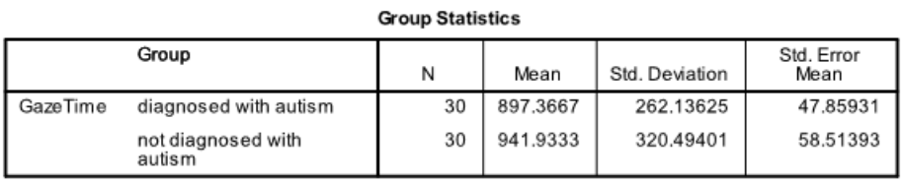
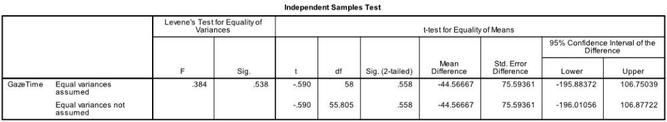A. Equal variances are assumed.
B. Equal variances are not assumed.
Ans: A
Learning Objective: SPSS homogeneity assumption

35. What is the value of sampling error in SPSS output below?
A. 47.85931
B. 58.51393
C. 75.59361
D. −44.56667
E. −0.590
Ans: C
Learning Objective: Interpreting SPSS output

36. Based on the SPSS output below, should the null hypothesis be rejected or not. Use a two-tailed test with an alpha of .05.
A. reject the null
B. fail to reject the null
Ans: B
Learning Objective: Interpreting SPSS output

37. What are the lower and upper bounds for the 95% CI for the mean difference in this output?
A. LB = −195.88, UB = 106.75039
B. LB = −196.01056, UB = 106.8772
C. LB = 897.3667, UB = 941.9333
Ans: A
Learning Objective: Interpreting SPSS output

38. Which of the following is the 95% CI in the following SPSS output estimating?
A. The mean for the group with autism
B. The mean for the group without autism
C. The difference between the means for autistic and not autistics children
Ans: C
Learning Objective: Interpreting SPSS output

39. If 95% CI were computed and a 99% CI were computed for the same data, the 99% CI would be ______ than the 95% CI
A. narrower
B. wider
Ans: B
Learning Objective: Logic of CIs

40. A Valpo statistics student wanted to know if the psychological health of Valpo psychology professors was significantly different from Valpo nursing professors. The student collected data from 10 psychology professors and 10 nursing professors. What is the exact p value for the t-test used to determine if the two means are significantly different?
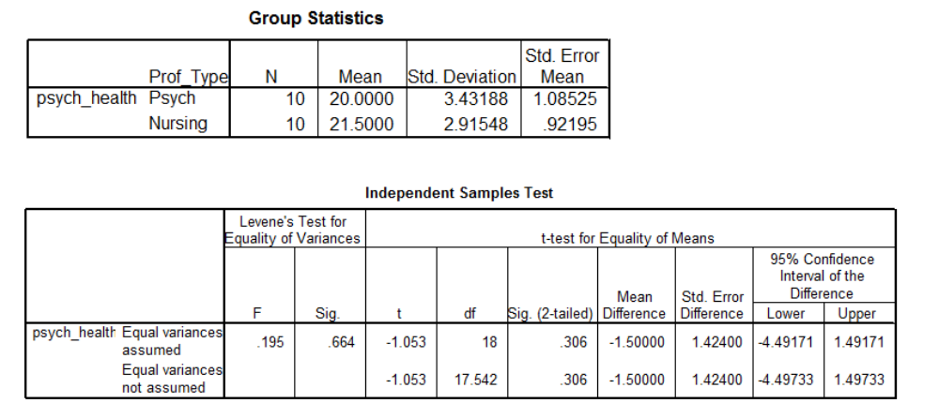A. 0.306
B. 0.664
C. −1.053
D. 0.195
Ans: A
Learning Objective: Intepreting SPSS output—p value

41. Should you reject the null hypothesis? Use a two-tailed test with an α of .05.
A. Yes
B. No
Ans: B
Learning Objective: Intepreting SPSS output—rejecting null

42. Compute the effect size (d) for this comparison
A. 10.13
B. 1.05
C. 0.47
D. 0.82
E. 0.63
Ans: C
Learning Objective: Computing effect size

43. Which of the following is the best one sentence summary of these results in APA style.
A. The psychological health of the Valpo psychology professors (M = 20) and the Valpo nursing professors (M = 21.5) is not significantly different, t(18) =−1.05, p > .05.
B. The psychological health of the Valpo psychology professors (M = 20) and the Valpo nursing professors (M = 21.5) is significantly different, t(18) = −1.05, p < .05.
C. The psychological health of the Valpo psychology professors (M = 20) is significantly lower than the psychological health of the Valpo nursing professors (M = 21.5) is significantly different, t(18) = −1.05, p < .05.
D. The psychological health of the Valpo psychology professors (M = 20) is significantly different than the psychological health of the Valpo nursing professors (M = 21.5), t(18) = −1.05, p < .05. Post hoc tests will be needed to determine which group had higher psychological health.
Ans: A
Learning Objective: Summarizing SPSS output

44. Which of the following data files was used for an independent measures t-test?
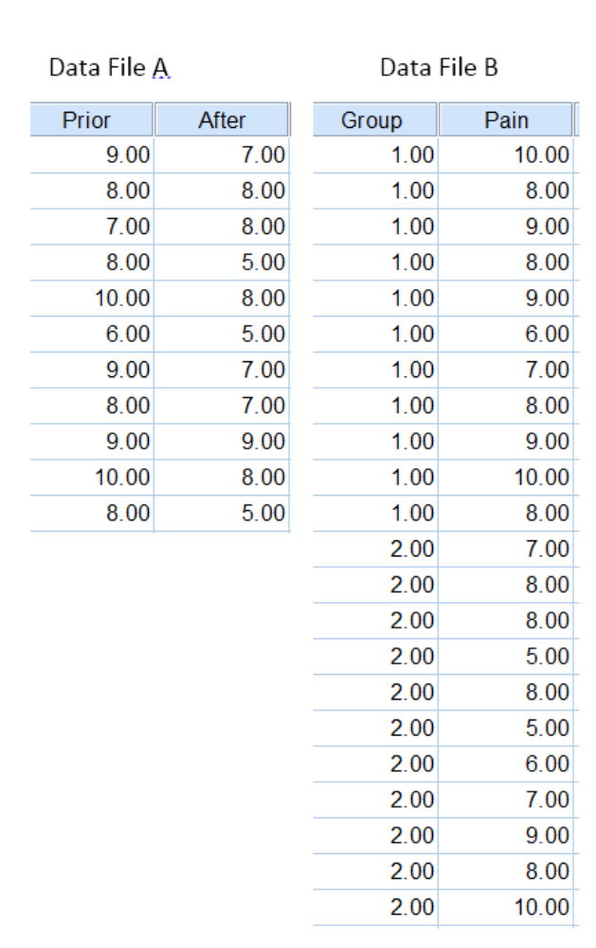
A. Data file A was used for an independent measures t.
B. Data file B was used for an independent measures t.
Ans: B
Learning Objective: SPSS data entry

45. Which of the following data files was used for a repeated measures t-test?
A. Data file A was used for an independent measures t.
B. B. Data file B was used for an independent measures t.
Ans: A
Learning Objective: SPSS data entry
46. Which of the following data files is for a related samples t-test? 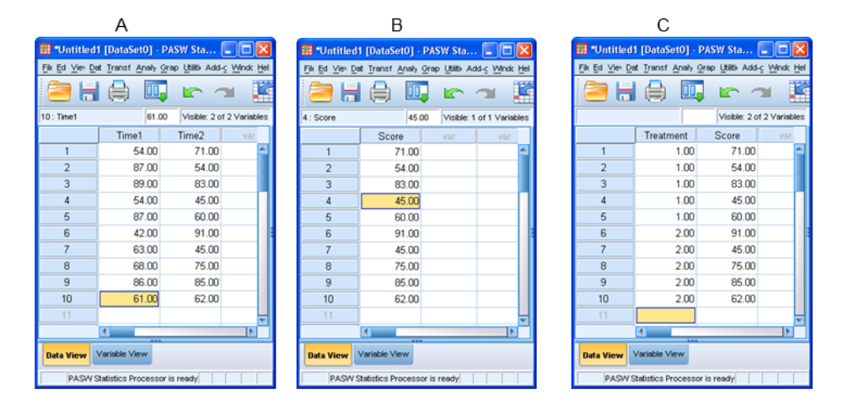
A. Data File A
B. Data File B
C. Data File C
Ans: A
Learning Objective: SPSS data entry

47. Which of the following data files is for a single sample t-test?
A. Data File A
B. Data File B
C. Data File C
Ans: B
Learning Objective: SPSS data entry

48. Which of the following data files is for an independent samples t-test?

A. Data File A
B. Data File B
C. Data File C
Ans: C
Learning Objective: SPSS data entry

49. A research has the following data from an experiment with two treatment conditions: Treatment 1: 9, 8, 7, 6, 5
Treatment 2: 1,2,3,4,5
If the experimenter wanted to use an independent measures t-test, how should the data be entered? (Chose from the options below A, B, or C)
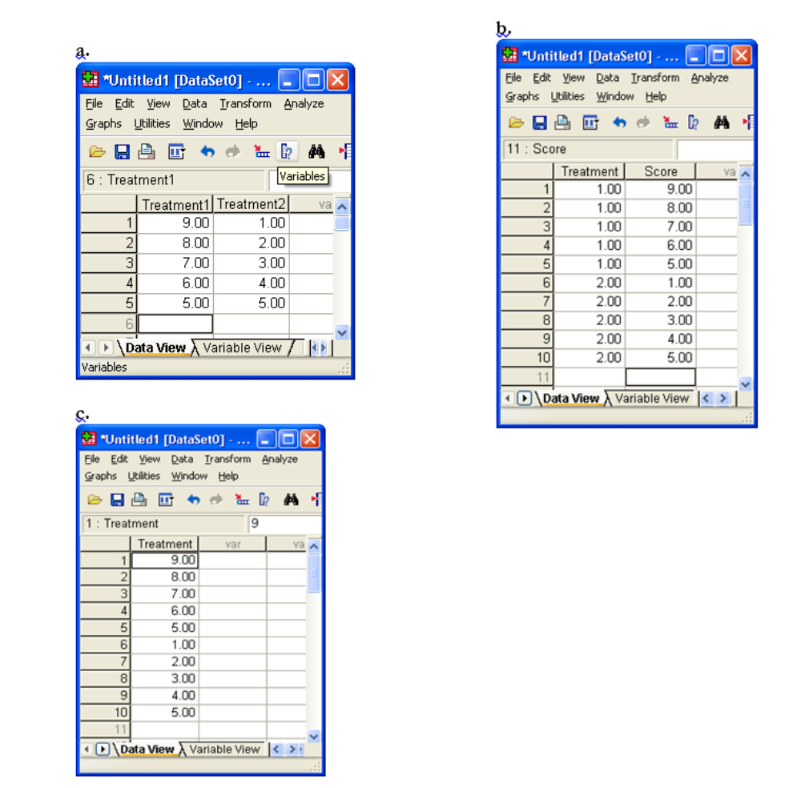
A. A
B. B
C. C
Ans: B
Learning Objective: SPSS data entry

50. If the experimenter wanted to use a repeated measures t-test, how should the data be entered? (Chose from the options above A, B, or C)
A. A
B. B
C. C
Ans: A
Learning Objective: SPSS data entry

51. A study was done to determine if men are more competitive than women. The null hypothesis was that men were equally competitive or less competitive than women. The research hypothesis was that men were more competitive than women.
Suppose that the researcher concluded that the men are more competitive than women when men really are NOT more competitive. Which of the following would best describe this decision?
A. power
B. Type I error
C. Type II error
D. Correctly failing to reject the null.
Ans: B
Learning Objective: Type I error

52. Suppose that the researcher concluded that the men are NOT more competitive than women when men really are more competitive. Which of the following would best describe this decision?
A. power
B. Type I error
C. Type II error
D. Correctly failing to reject the null.
Ans: C
Learning Objective: Type II error

