Reading Questions

Chapter 3: Variability

1. Why is the range a poor measure of variability?
*a. It uses only two values rather than all of the values in the distribution.
b. It is overly sensitive to changes in the middle of the data.
2. What characteristic of a distribution of scores does a standard deviation describe?
a. How far scores are from the mean
b. How spread out the scores are
c. The variability of scores in a distribution
*d. All of the above
3. The smallest standard deviation that is possible is ____ because this would mean that ______.
a. −1; all of the scores are negative
*b. 0; all of the scores are the same
c. 1; all of the scores are positive
4. What measure of variability should be used when the data are ordinal?
a. Standard deviation
*b. Range
5. A deviation score measures:
a. the typical distance all of the scores are from the mean.
*b. the distance of an individual score from the mean.
6. Statisticians square each derivation score so that:
*a. when they sum them they will not sum to zero.
b. the standard deviation will be larger.
7. SS stands for the:
a. standard deviation.
*b. sum of the squared deviation scores.
c. sum of the deviation scores.
8. The definitional method for finding the SS and the computational method for finding the SS will ALWAYS provide the same value but in most situations the __________ method is faster and will not produce any rounding error.
a. Definitional Method, 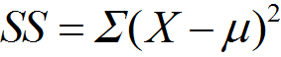
*b. Computational method, 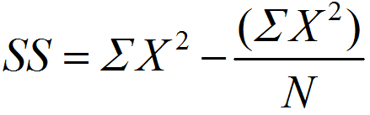
9. The variance (σ2) is the:
*a. typical squared deviation from the mean.
b. typical deviation from the mean.
10. The standard deviation (σ) is:
a. how far all of the scores are from the mean.
*b. the typical distance of all the scores from the mean, some scores will be further away and some closer but this is the typical distance.
11. What symbol represents the standard deviation of a population?
a. SS
*b. σ
c. σ2
12. Which equation defines the sum of the squared deviation scores?
*a.
b.
c. 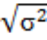
13. Which equation is used for computing the SS?
a. 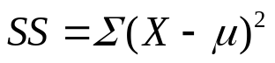
*b. 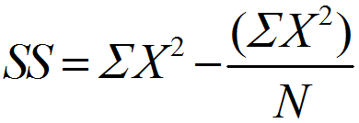
c. 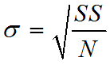
14. In order for two data sets to have the same standard deviation, they must have the same mean.
True
*False
15. When you are using a sample to estimate a population’s standard deviation you are doing ________ statistics.
a. descriptive
*b. inferential
16. When computing a sample’s standard deviation there _________ to the computation process relative to when you are computing a population’s standard deviation.
a. are many changes
*b. is one change
17. The SS is computed in exactly the same way for a sample and a population.
*True
False
18. When using a sample to estimate a population’s variability the SS is divided by N − 1 rather than N to correct for a sample’s tendency to:
a. overestimate the variability of a population.
*b. underestimate the variability of a population.
19. What symbol represents the standard deviation of a sample?
*a. SD
b. SD2
c. SS
20. When computing the variance of an entire population, you are performing _____________ so divide the SS by ___.
*a. descriptive statistics, N
b. inferential statistics, N – 1
21. When estimating
the variance of a population from a sample, you are performing _____________ so divide the SS by _____.
a. descriptive statistics, N
*b. inferential statistics, N – 1
22. What is the standard deviation of these data?
a. 3
b. 2
*c. 2.08
23. SPSS can only be used to compute the standard deviation of a sample, not a population.
*True
False

