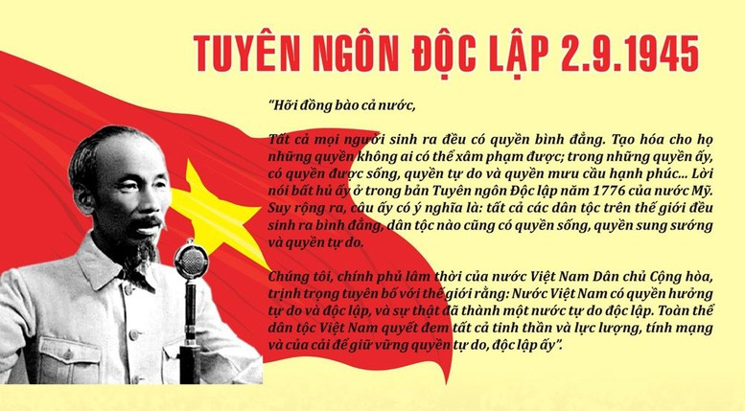

gia-tri-truong-ton-cua-tuyen-ngon-doc-lap-1.jpg

<https://www.angiang.dcs.vn/Lists/ChinhTri/DispForm.aspx?ID=191>

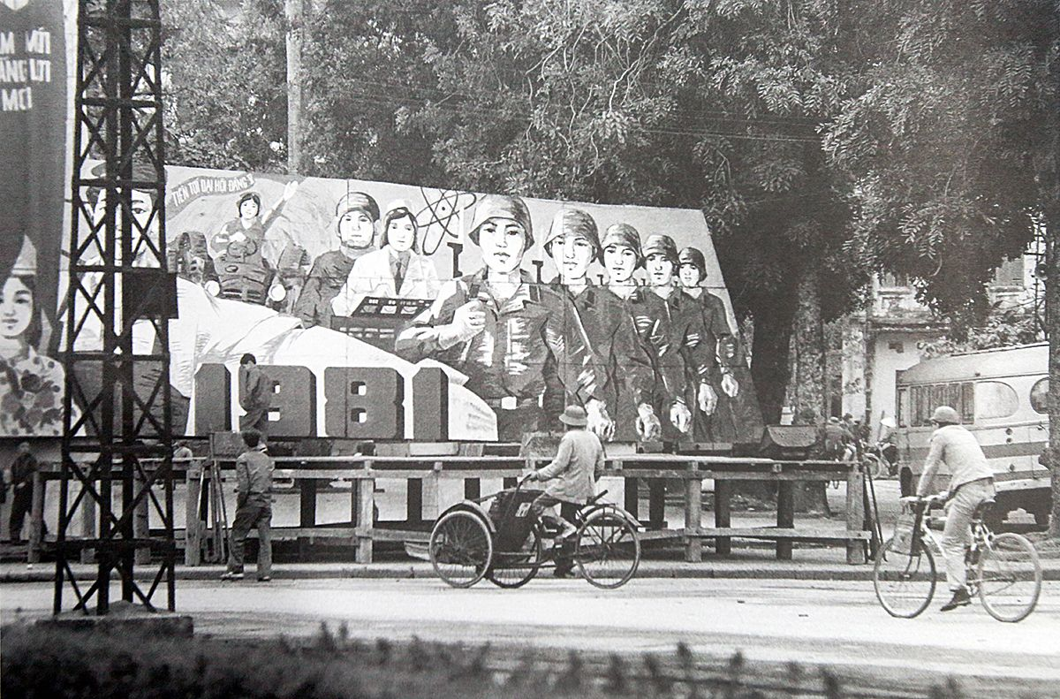

Vietnam in 1980 DOIMOI

*Photo by John Ramsden.*

<https://saigoneer.com/vietnam-heritage/8834-photos-early-1980s-hanoi-on-the-brink-of-doi-moi>

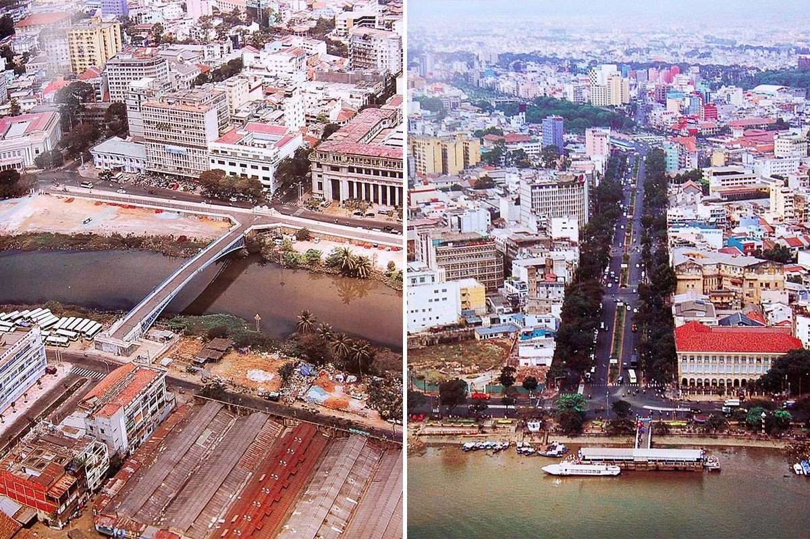

Vietnam in 2000



Vietnam in 2024

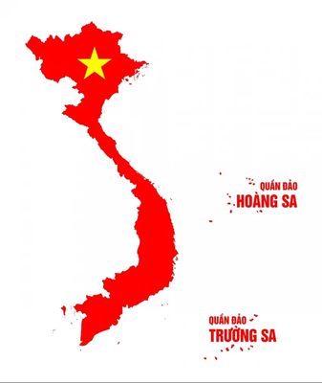

Vietnam map

https://piklab.vn/san-pham/ban-do-vietnam