EqualizIR

# Introduction

## What does it do?

The *EqualizIR* MATLAB application converts audio calibration data (usually from the *NICal* application) into a set of digital filter coefficients that can be used to equalize (a.k.a. pre-emphasis, compensation…) auditory stimuli so that the output more closely matches the original waveform.

The filter can be applied to stimuli stored in .WAV format from within the application (“Apply to WAV” menu item) or from the command line using the *ApplyFilterToWAV* function. Alternatively, the MATLAB *filt* or *filtfilt* functions can be used with a little more programming knowledge (*filtfilt* is used in the *ApplyFilterToWav* function).

Note that in its current implementation, the correction only operates on the **magnitude**of the signal and does not correct for **phase**. Future implementations might expand the correction to include phase. Or not…

## Where Can I find it?

*EqualizIR* is part of the *TytoLogy* project housed at **github**:

<https://github.com/TytoLogy/EqualizIR>

Be sure to download/pull the ‘installed’ branch of code – other branches may (or may not) work!

## What else is needed?

EqualizIR makes heavy use of other tools from the TytoLogy project.

The following toolboxes are needed:

<https://github.com/TytoLogy/AudioToolbox>

<https://github.com/TytoLogy/UtilitiesToolbox>

<https://github.com/TytoLogy/PlotTools>

as well as the MATLAB *Signal Processing Toolbox*

For acquisition of the calibration data, *NICal* (https://github.com/TytoLogy/NICal) can be used on systems with National Instruments DAQ cards. TDT hardware users can use the *TytoLogy* calibration programs in the *Calibrate* package (https://github.com/TytoLogy/Calibrate) or *SpeakerCal* (<https://github.com/TytoLogy/SpeakerCal)>.

## How does it do it?

At its heart, EqualizIR uses the *invfreqz* MATLAB function to compute a minimum phase FIR filter. The filter so designed equalizes the magnitude of the signal while (hopefully) leaving the phase unaltered. The algorithm, as described by the author of invfreqz, Julius O. Smith at Stanford’s CCRMA, is:

“1. Interpolate the amplitude response samples from 0 to half the sampling rate, if necessary, and resample to a uniform "FFT frequency axis", if necessary. Denote the real, sampled amplitude response by S(k).

2. Perform an inverse FFT of log(S) to obtain the real cepstrum of s, denoted by c(n).

3. Fold the noncausal portion of c(n) onto its causal portion.

4. Perform a forward FFT, followed by exponentiation to obtain the minimum phase frequency response Sm(k), where now sm(n) is causal, and |Sm(k)|=S(k).”[1]

# EqualizIR in Use

## Start:

Launch the EqualizIR application by navigating to the EqualizIR directory and entering:

>> EqualizIR

You should then see the EqualizIR application window:

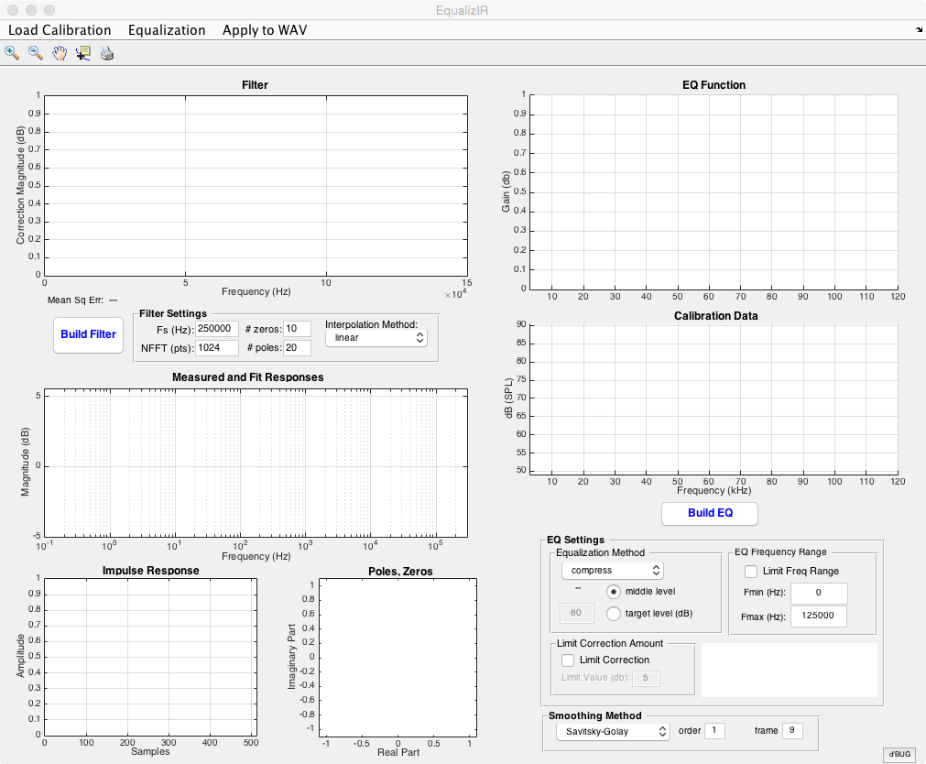

## Load Calibration Data:

The first thing to do is load your calibration data. Click on the “Load Calibration” menu and you’ll be asked to select a .cal file. Locate your file and open it.

After selecting your calibration data file, the calibration magnitude data will be displayed in the (surprise!) “Calibration Data” graph:

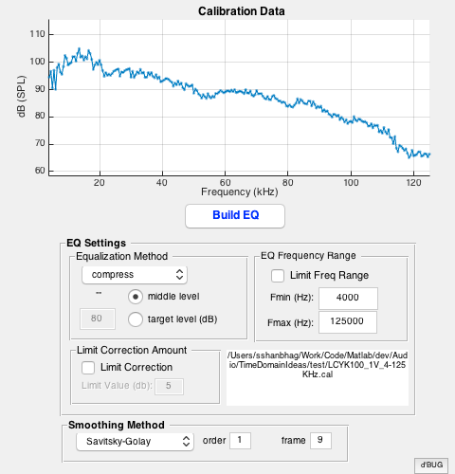

## Build the Equalization Function:

Before creating the equalization filter, the calibration data need to be preprocessed.

This involves:

1. smoothing the calibration data to remove small dips/variations which can cause messy behavior by the filter
2. specifying the frequency range for the equalization filter to act upon
3. choosing an equalization method
4. (optional) limiting the correction amount

### Smoothing Method

Two methods are available for smoothing the calibration data.

Savitsky-Golay filter (default)

Two parameters set the filter:

order higher values = less smoothing

values must be less than the frame size value

frame higher values = more smoothing

values must be odd and greater than the order

Moving Window

Only parameter is window size

### EQ Frequency Range

When selected, allows the filter to be limited to a range of frequencies smaller than the full range of the calibration data

### Equalization Method

Three methods are available:

compress

atten

boost

for the compress methods, a target level may be specified (instead of the calculated middle range) by selecting the “target level” option and entering a target dB level in the edit box.

### Limit Correction Amount

More than 15 dB of correction can run into problems. A hard limit can be set by selecting “Limit Correction” and entering a limit value

### *Build EQ*

Finally, click the Build EQ button.

Some calculations will occur and the plots will be updated.

The Calibration Data plot will show an overlay of the smoothed calibration data in red:

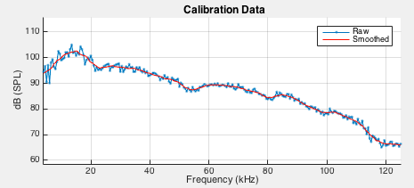

and the EQ Function graph will show the equalization curve:

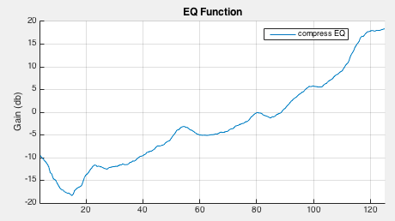

1. https://ccrma.stanford.edu/~jos/pasp/Converting_Desired_Amplitude_Response.html