NICal

## Software manual

version 0.0

Sharad Shanbhag

sshanbhag@neomed.edu

# Getting Started

### Launching NICal

To launch NICal, first start Matlab. Then, type the following in the command window (command prompt is “>>” or, for student versions of Matlab, “EDU>>”):

>> NICal

You should then see messages like the following:

NICal: checking paths

NICal: paths ok, launching programn

.

.

*(other diagnostic text….)*

.

.

.

>>

At this point, you should see the main NICal window:

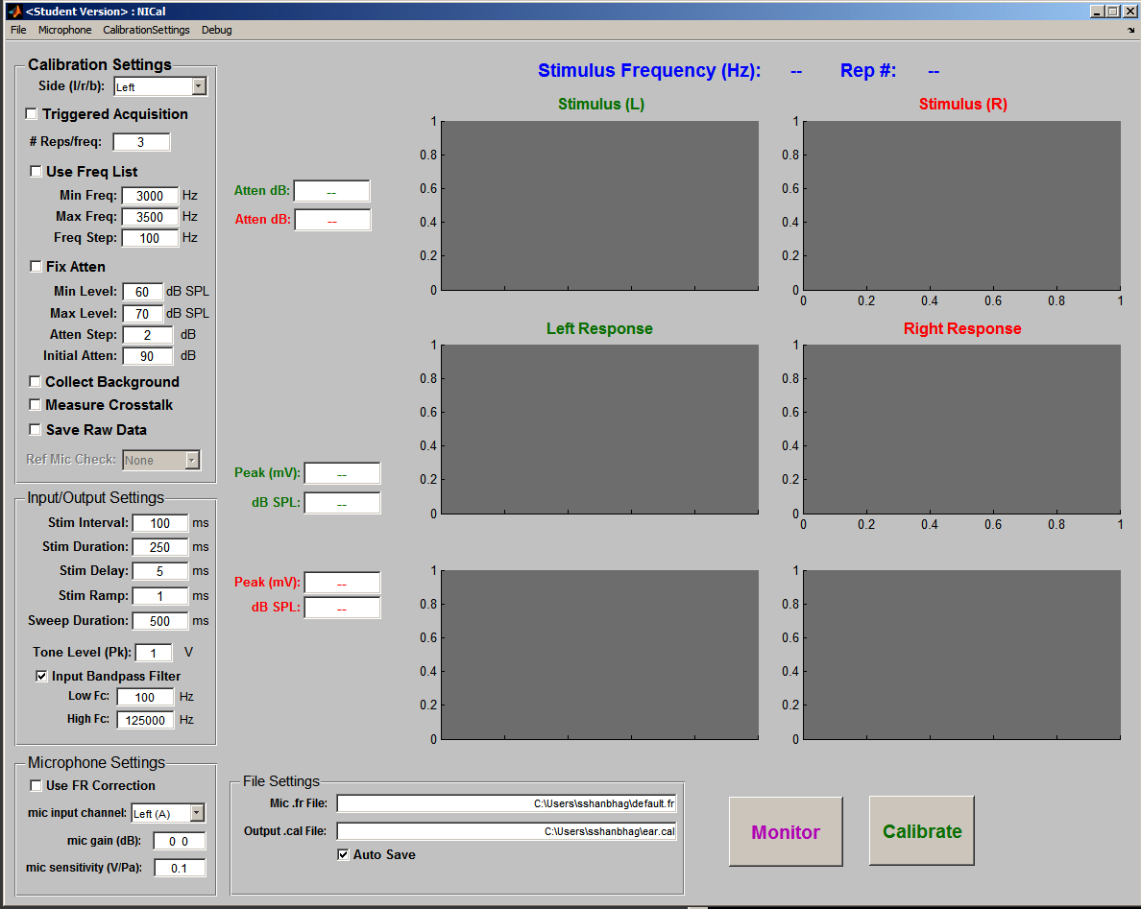

If you receive an error that the NICal program is not found:

>> NICal

Undefined function or variable ‘NICal’.

change to the NICal program directory using the **cd** (***c****hange* ***d****irectory*) command,

>> cd c:\TytoLogy\Calibration\NICal

and launch the NICal program from there:

>> NICal

# Calibration Using NICal: NICal-generated tones

## Setup

### Connections

### Calibration Settings

### Input/Output settings

### Microphone Settings

## Running Calibration

# Calibration Using NICal: Externally-generated tones

## Setup

### Connections

### Calibration Settings

### Input/Output settings

### Microphone Settings

## Running Calibration

# Characterizing Microphones (building *.fr* files)

## Setup

### Connections

### Calibration Settings

### Input/Output settings

### Microphone Settings

## Running Calibration

# Using Non-reference Microphones

## Setup

### Connections

### Calibration Settings

### Input/Output settings

### Microphone Settings

## Running Calibration

# Other Details

## Setup

### Connections

### Calibration Settings

### Input/Output settings

### Microphone Settings

## Running Calibration

# GUI

## Overview

Apart from the menu, there are 6 sections of the GUI (graphical user interface):

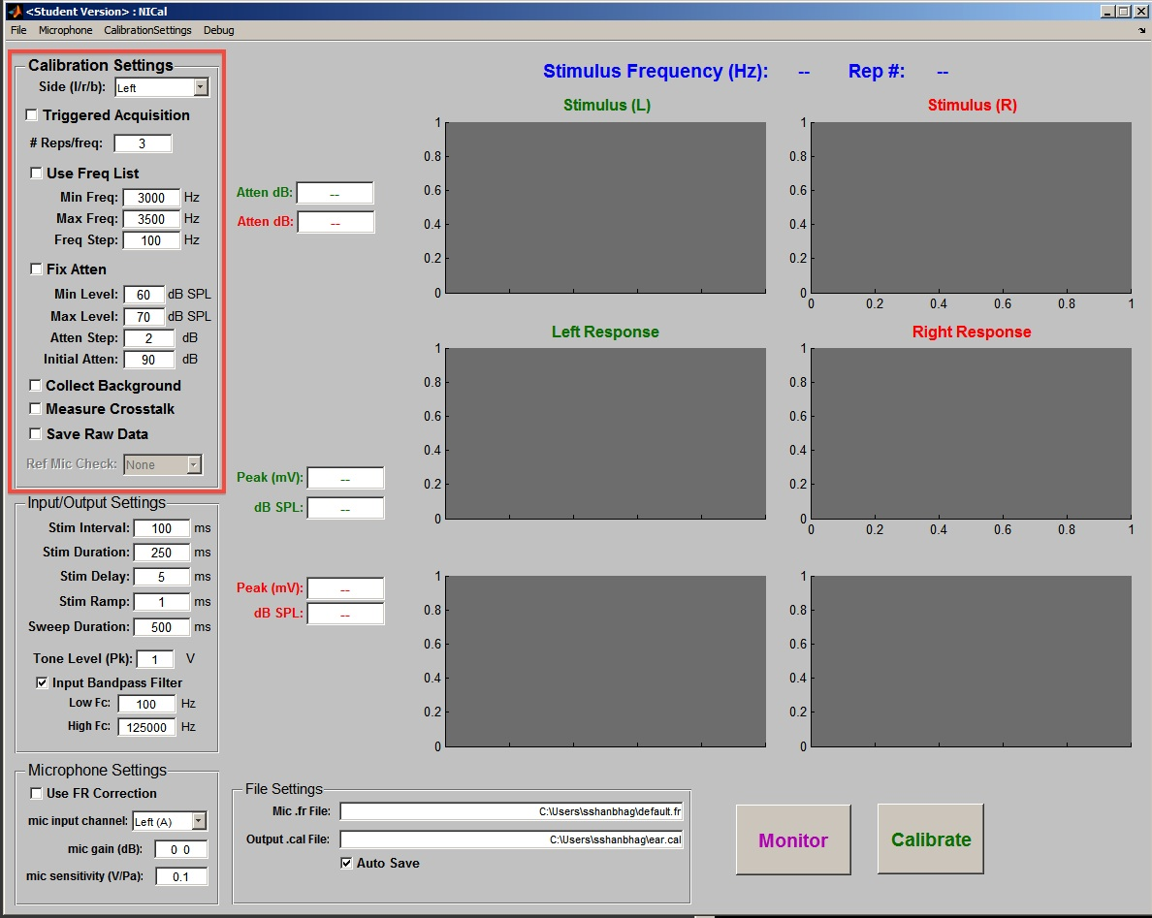

#### Calibration Settings

Parameters for the calibration, including frequency range, calibration output stimulus level.

#### 

#### Input/Output Settings

Stimulus and sweep duration

#### 

#### Microphone Settings

Microphone sensitivity, gain

#### 

#### File Settings

*.fr file, output .cal file

#### 

#### Plots

Displays of stimulus, recorded response ; feedback about current frequency, output level

#### 

#### Action Buttons:

##### Monitor

Used to troubleshoot/check microphone and input system. Does not store data.

##### Calibrate

Initiates calibration routine. While calibration is running, clicking on this button will terminate the calibration sequence.

## Calibration Settings

### Macintosh HD:Users:sshanbhag:Work:Code:Matlab:dev:TytoLogy:Calibration:NICal:Documentation:CalibrationSettingsPanel.jpg

Controls features of the calibration

### Side

Left, Right, Both

*Side* determines which channels will be calibrated. *Left* corresponds to the NI channel 0, *Right* is channel 1, and *Both* will use both channels.

### Triggered Acquisition

on/off

If triggered Acquisition is selected, the calibration system will wait for a TTL-level (5 Volt) pulse on the PF1 Trigger Input channel of the BNC-2110.

In this mode, a recording sweep of duration *Stim Duration* (see *Input/Output Settings*) will be triggered whenever a TTL-level signal is detected on the PF1 input. Data from the input channels will be streamed to disk and saved in xxxx.daq files. After each triggered sweep, the system will wait for a duration of xxx seconds (see *Menu->Settings*). If a trigger is not detected within this timeout period, the system will stop acquisition.

Note that since the input signal is unknown (presumably generated by the system under test), the calibration signal options (e.g. Frequency, Attenuation) will be disabled.

### # Reps/freq

[1 , 100]

# of times to repeat each test frequency. Not enabled under *Triggered Acquisition*.

### Use Freq List

on/off

When selected, NICal will ask for a text file that specifies a list of frequencies. The text file should have a *.txt* filename extension.

The format of the .txt file is a single column of test frequencies. The order in which the frequencies are listed in the text file will correspond to the order in which they are presented through the system. Selecting this will disable the frequency controls.

### Min Freq

[1, Max Freq] Hz

Minimum frequency to test, in units of Hz. Can have value from minimum of 1 Hz to maximum of *Max Freq*.

### Max Freq

[Min Freq, Sample Rate / 2] Hz

Maximum frequency to test, in Hz. Minimum value is *Min Freq*, maximum value is A/D (and D/A) sampling rate / 2 (a.k.a. Nyquist frequency).

### Freq Step

[1, (Max Freq – MinFreq)] Hz

Frequency step to use in going from *Min Freq* to *Max Freq,* in units of Hz. Minimum value is 1 Hz, maximum value is *(Max Freq – Min Freq)* Hz.

### Fix Atten

on/off

When selected, a fixed attenuation value, in units of dB, will be used. Otherwise, the signal will be attenuated in order to keep the output signal level within the range [Min Level, Max Level]/

### Max Level

[Min Level, 120] dB SPL

### Atten Step

[1, Max Level – Min Level] dB

### Initial Atten

[0, 120] dB

Starting attenuation level in units of dB. At the start of the calibration run, the signal will be attenuated by Initial Atten value and the attenuation will then be adjusted to achieve an output signal level within the range of [*Min Level, Max Level*]

### Collect Background

on/off

When selected, a sweep without a stimulus will be collected before each frequency and the background level at that frequency will be computed.

### Measure Crosstalk

on/off

If selected, the amount of crosstalk from AI0 to AI1 and from AI1 to AI0 will be measured.

### Save Raw Data

on/off

*Save Raw Data* will write the raw input data to a binary file (see *Raw Data Format* for file format information). The program will prompt the user for an output raw data file name when the *Calibrate* button is clicked to start the calibration sequence.

### Ref Mic Check

***not implemented

## Input/Output Settings

### Macintosh HD:Users:sshanbhag:Work:Code:Matlab:dev:TytoLogy:Calibration:NICal:Documentation:InputOutputSettings.jpg

### Stim Interval

[1, 10000] milliseconds

Time between calibration stimulus sweeps. Note that this time period depends on the system clock and is subject to some variation due to load on the system/CPU.

### Stim Duration

[1, 10000] milliseconds

Duration of the calibration stimulus.

### Stim Delay

[1, Sweep Duration] milliseconds

Delay between start of sweep and start of calibration stimulus.

### Stim Ramp

[1, Stim Duration] milliseconds

duration of onset/offset amplitude ramp to minimize onset and offset transients. NICal uses a squared-cosine ramp.

### Sweep Duration

[1, 10000] milliseconds

Total sweep duration. Must be greater than *StimDuration* + *StimDelay*.

### Tone Level (pk)

[0, 10] V

Peak level of output signal. This will need to be adjusted based upon the capabilities of the system being calibrated. The National Instruments hardware can produce a maximum peak output of 10 Volts (20 Volts, peak-to-peak). However, most consumer-level audio amplifiers and hardware has a maximum level of 1 V peak (0.7 V rms). Check your hardware capabilities before calibration! Alternatively, you can always perform an initial, trial calibration run using a small tone level (e.g., 0.1 V peak) and increase the level if no problems are encountered.

### Input Bandpass Filter

on/off

Enables (on) or disables (off) the software bandpass filter that is applied to the analog input signal. When enabled, the Low pass and high pass cutoff frequencies (Fc) can be specified below. This is not to be confused with the hardware-based antialiasing filter that must be placed between the input signal and the BNC-2010 input.

### Low Fc

[1, High Fc] Hz

High pass cutoff frequency

### High Fc

[lo Fc, SampleRate / 2] Hz

Lowpass cutoff frequency

## Microphone Settings

### Macintosh HD:Users:sshanbhag:Work:Code:Matlab:dev:TytoLogy:Calibration:NICal:Documentation:MicrophoneSettings.jpg

### Use FR Correction

on/off

When selected, NICal will assume that a non-reference microphone is being used as the calibration microphone. A microphone frequency-response calibration file (*\*.fr*), specified in the *Mic .fr file* field within the *File Settings* box, will be used to convert the response of the non-reference microphone to db SPL.

### mic input channel

left, right, both

specifies the input channel to use for the calibration microphone. *Left* will specify channel AI 0, *Right* will specify channel AI 1 and *Both* will indicate that microphones attached to both inputs AI 0 and AI 1 are to be used for input.

### Mic Gain

[<AI 0 gain> <AI 1 gain>], units = dB

Specifies the gain, in dB, applied to the microphone input for channels AI 0 and AI 1. Usually, this is set to 0 when using the Bruel and Kjaer NEXUS amplifier.

### Mic Sensitivity

[<AI 0 mic sensitivity> <AI 1 mic sensitivity>], units = Volts/Pascal

Specifies sensitivity of the microphone in V/Pa. For the Bruel and Kjaer NEXUS amplifier, this is set from the front panel controls or by the BK control software via the serial port. Note that when using the NEXUS amplifier, this value is NOT the microphone sensitivity indicated on the microphone specification sheet (usually in units of mV/Pa).

## File Settings

### Macintosh HD:Users:sshanbhag:Work:Code:Matlab:dev:TytoLogy:Calibration:NICal:Documentation:FileSettings.jpg

### Mic .fr file

path\<filename>.fr

indicates the microphone calibration file that will be used when calibrating with a non-reference microphone. The file is typically a Matlab MAT file with an .fr extension

### Output .cal file

ppath\<filename>.cal

Specifies the output calibration data file.

# Menu

## File

### Save Data Ctrl-s

Save calibration data to *.cal* file.

### Close Ctrl-q

Closes NICal program.

## Microphone

Routines to enable use of a non-reference microphone for calibration.

### Load Microphone FR Data Ctrl-f

Loads calibration data for microphone from *.fr* file.

### Calibrate Microphone

Performs calibration of non-reference microphone using a reference microphone. Data will be stored in a *.fr* file

## CalibrationSettings

Allows storage and retrieval of calibration settings.

### Load Calibration Settings ctrl-l

Loads calibration settings from file.

### Save Calibration Settings ctrl-k

Stores current calibration settings.

### Edit Calibration Settings

Enables editing of elements of the *cal* settings structure.

### Save Current Settings As Default

Stores current settings as the default settings.

### Reload Default Settings

Reloads current default settings

## Debug

### Dump Handles

Stores all GUI handles in a *.mat* file.

### Dump NI Settings

Stores all National Instruments settings in *.mat* file.

# Hardware

Signals get into and out from the calibration computer via a *BNC-2110* breakout box that connects to a National Instruments *PCIe-6351* PCI-Express multifunction input/output card located within the calibration computer.

Input from the microphone should be routed through an antialiasing filter (low pass filter) with a cutoff frequency of less than 250 kHz (default sampling rate for NICal is 500 kHz).

## Signal mapping:

### Output Channels:

**Hardware Label** **NICal name**

*AO 0* Left channel

*AO 1* Right channel

### Input Channels:

**Hardware Label** **NICal name**

*AI 0* Left channel

*AI 1* Right channel

### TTL Trigger Input:

*PFI 0*

Allows external triggering of acquisition via a TTL (+5 V) pulse.

## Antialiasing Filter for A/D inputs

A USB-controlled filter (*USBPBP-S1*) from Alligator Technologies is part of the calibration rig and should be used if other filters (e.g., TDT FT6) are not available. Failure to use an antialiasing filter prior to analog-to-digital conversion may lead to calibration errors.

The Alligator filter is a bandpass filter with programmable highpass and lowpass cutoff frequencies. Gain is also programmable.

### Connections

Connect the power cable to the *USBPBP-S1* and plug it in. Then, connect the *USBPBP-S1* to the computer using a USB cable.

### Programming the *USBPBP-S1*

Once the *USBPBP-*S1 is connected to the computer and to the power supply, launch the *SystemViewUSBPxxS1* application by either

(1) clicking on the Alligator quicklaunch icon (highlighted in red):

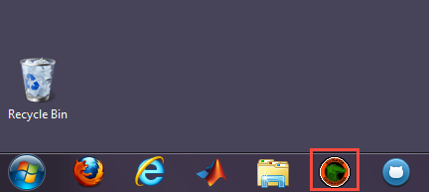

or,

(2) selecting *All Programs* ➔ *Alligator Technologies* ➔ *SystemViewUSBPxxS1.Release 4* ➔ *SystemViewUSBPxxS1*:

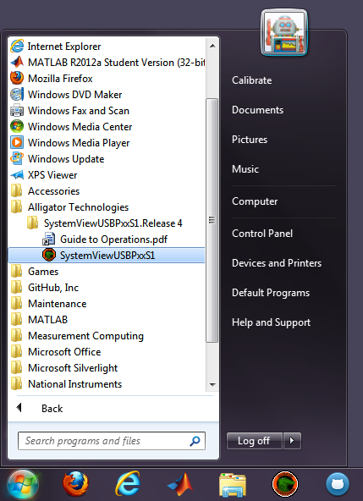

### AlligatorUSBPBxx Software

Upon launch of the *SystemViewUSBPxxS1* application, two windows will appear, one titled “Channel 0”, the other “SystemViewUSBPxx”:

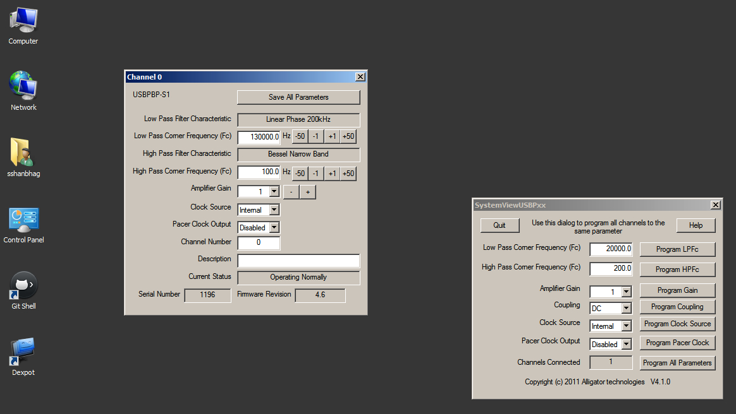

To inspect and set the filter cutoff frequencies and gain value, use the “Channel 0” panel:

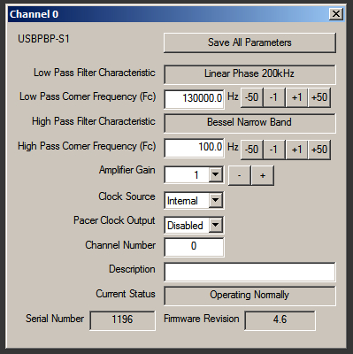

The *Low Pass Corner Frequency* and *High Pass Corner Frequency* may be adjusted by entering a new value in the edit box or by clicking on the buttons to the right of the edit box.

Gain may be adjusted using the *Amplifier Gain* pulldown menu or -/+ buttons.

The values must be written to the device by clicking on the *Save All Parameters* button. Failure to do so will result in no change to the filters or gain on the filter module.

### Default Settings for *USBPBP-S1* Filter

The default settings are:

*Low Pass Corner Frequency (Fc)* 130000.0 Hz

*High Pass Corner Frequency (Fc)* 100.0 Hz

*Amplifier Gain*  1

***Important!***

Please reset the filter to the default values if you are using the filter with settings that are different from the default.