TytoLogy

Users Manual
(beta version)

TytoLogy scripts originally written by Sharad J. Shanbhag.
This document written by Sharad J. Shanbhag, Harsh Mishra, and Go Ashida.
Edited by Go Ashida.
January 2011.

Aim of this document - What is TytoLogy?

This is a users manual for the TytoLogy scripts, which were written by Sharad J. Shanbhag at the Albert Einstein College of Medicine (AECOM) of Yeshiva University (Bronx, NY).

TytoLogy is designed to replace XDPHYS and XCALIBUR, which were written by Chris Malek in Mark Konishi’s lab (Caltech, CA) in 1980’s. While XDPHYS and XCALIBUR run in a UNIX/Linux computer along with the TDT System II signal processing systems (Tucker-Davis Technologies, Alachua, FL), TytoLogy works with the TDT System 3 using Matlab (Mathworks, Natick, MA) as an interface.

TytoLogy provides tools for neurophysiological experiments, including microphone/earphone calibration, stimulus sound generation, and data collection.

This document gives instructions on how to install and use the TytoLogy scripts.

Contact information (Nov. 2010)

* Sharad J. Shanbhag, Ph.D.
Northeastern Ohio Universities College of Medicine (NEOUCOM)
4209 State Route 44, Rootstown, OH 44272, USA
Phone #: 330-325-6549, 646-633-7289 (cell)
sshanbhag@neoucom.edu

* Go Ashida, Ph.D.

Department of Biology, University of Maryland
1210 Biology-Psychology Building, University of Maryland, College park, MD, 20742, USA.
Phone #: 301-357-9966 (cell)
ashida@umd.edu

Table of contents

* Aim of this document – What is TytoLogy?
* Contact information
* Table of contents

PART 1: Introduction

* Basic structure of TytoLogy
* System requirements
* Example: Carr lab’s configuration
* How to install TytoLogy
* Modifications to fit Carr lab’s configuration

PART 2: How to use TytoLogy

* How to calibrate microphones (MicrophoneCal)
* How to calibrate earphones (HeadphoneCal)
* Neurophysiology using TytoLogy (HPSearch)

PART 3: How to analyze data recorded by TytoLogy

* Data structure of TytoLogy
*

PART 1:

Introduction

Basic structure of TytoLogy

Below is a schematic figure of the basic structure of the setup.
* TytoLogy provides a Matlab interface and enables you to control the sound stimulus and to record the neural activity.
* The ActiveX interface of the TDT system 3 enables Matlab to talk with RPvdsEx.
* RPvdsEx controls the TDT system 3 hardware via the optical interface.
* TDT system 3 generates sound stimulus and receives neural data.

Animal
TDT 3
Matlab
You
RPvdsEx
Active X
Active X
Neural activity
TytoLogy
TytoLogy
Sound stimulus
Optical interface
Optical interface

System requirements

Computer and Software

* Windows XP computer
- Windows Vista and Windows 7 are not supported.

* Matlab R14
- Not all the versions are supported: R14 (ver. 7.0) and R2007a (ver. 7.4) are confirmed OK.
- It is NOT recommended that you use the very latest version of Matlab because it may not be fully compatible with older versions.

* Matlab Signal Processing Toolbox
* Matlab Statistics Toolbox

TDT System 3

* RX8 (multi-channel I/O DSP processors)
* PA5 (Programmable attenuator) -- need 2 x PA5 for left and right
* PO5 (Optical PCI card for high speed gigabit interface)
* ACTX (Active X programming interface software)
* RPvdsEx Software (Real-time Processor Visual Design Studio)

Example: Carr lab’s configuration

#### Notice ####
This section is mainly for the Carr lab (University of Maryland).

Computer and Software

* Dell Optiplex 755 Minitower
- CPU: Intel Core 2 Duo E8500 / 3.16GHz
- Memory: 4 GB (2 x 2 GB)
- HDD: 500 GB (2 x 250 GB)
- DVD+/-RW drive
- Windows XP Professional (SP3)

* Matlab R2007a (ver. 7.4) + Signal Processing Toolbox + Statistics Toolbox

TDT System 3

* RX8-2 (2 DSP Processor with 12 Channels of I/O): $3750
* PA5 (Programmable attenuator): 2 x $725 = $1450
* HB7 (headphone buffer): $275
* PO5 (Optical PCI card for high speed gigabit interface): $675
* CAD-OptGB (Device caddie with PS25 and optical gigabit): 2 x $800 = $1600
* CAD-NI (Device caddie with power supply, no interface): $325
* PP24 (Patch panel for RX processors): $325
* ACTX (ActiveX programming interface software): $675
* RPvdsEx (open Ex software): $0
-- Total: US$9075

Other hardware

* Brüel & Kjær 4134 Microphone
* Axoclamp 2B (electrophysiology amp)
* HumBug (noise canceller)
* Newport ESP300 (motion controller)
* Grass S48 (stimulus generator)
* Tektronix oscilloscope
* Microphone amplifier (Caltech)

Wiring diagram

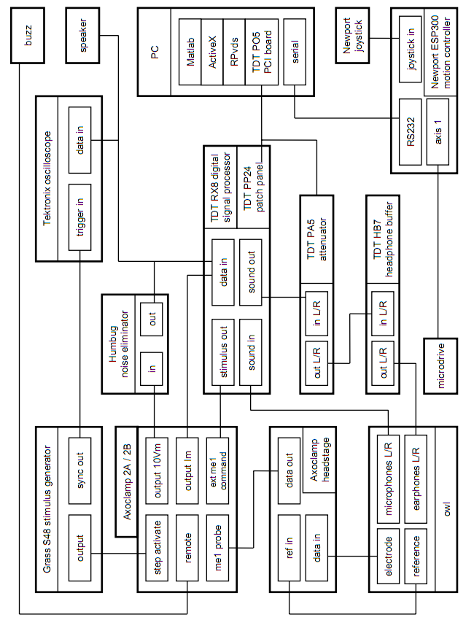

How to install TytoLogy

Before installing TytoLogy

Before introducing TytoLogy to your computer, make sure that Matlab and TDT software (including drivers, RPvdsEx and ActiveX) are already installed. It is strongly recommended that you install the TDT software in C:\TDT. Otherwise, you need to modify some of the TytoLogy scripts so that all the functions are properly called.

Installation of TytoLogy

No installer is provided. Just copy the entire TytoLogy CD-R contents to C:\TytoLogy. If you install TytoLogy into a different location, you will need to modify some of the scripts so that all the functions are properly called.

Setting PATH

Matlab has an internal list of folders (directories). When you use some function, Matlab automatically searches it in the directory list and executes it. This list is called “path”. In order to use the TytoLogy functions, you need to add the TytoLogy folders to the Matlab path. Otherwise, Matlab generates an error saying “undefined function or variable”, whenever you use TytoLogy.

Setting the path is easy. Just launch your Matlab, go to C:\TytoLogy, and call setrigpath2.

>> cd C:\TytoLogy
>> setrigpath2

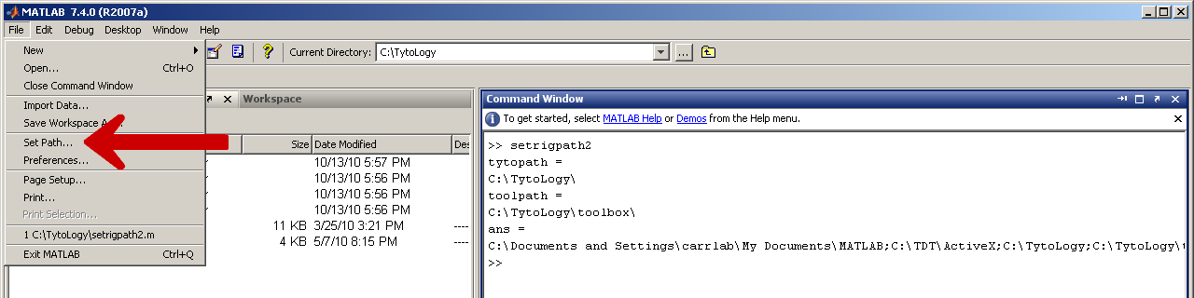

Next click [File] in the top menu and then click [Set Path...] (see screenshot above).

If you find C:\TDT\ActiveX, C:\TytoLogy and its subfolders in the list (screenshot below), the path has been properly set. Click [Save] and [Close]. Now you can use TytoLogy.

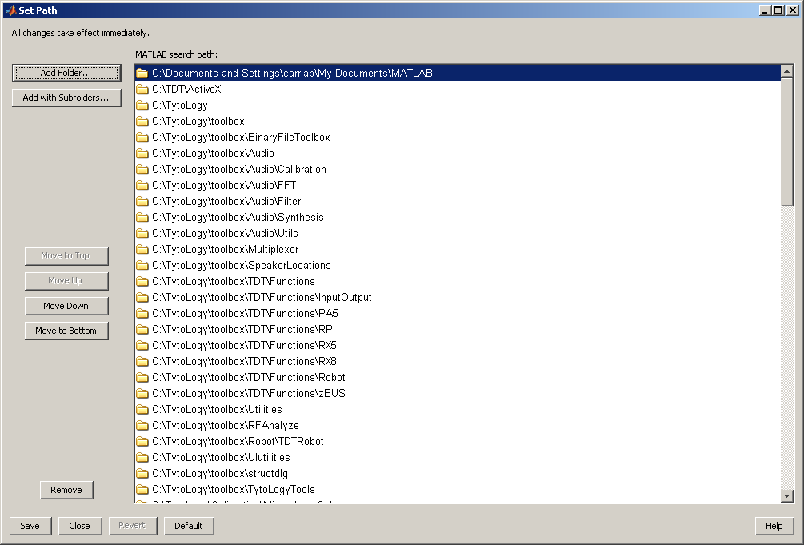

#### Notice ####
The original setrigpath.m overwrites your Matlab path --- any former path settings will be destroyed. If you want to add TytoLogy directories keeping your current path, you should use setrigmath2.m.

Modifications to fit Carr lab’s configuration

#### Notice ####
This section is mostly for the Carr lab (University of Maryland).
You may need to modify your settings according to your TDT hardware configuration.

Overview

Sharad Shanbhag’s original setup has two RX8, while the Carr lab has only one RX8. Therefore, the device number (Dnum) needs to be changed.

Microphone Calibration

C:\TytoLogy\Calibration\MicrophoneCal\MicrophoneCal_settings.m

### Line 81 ###
[Original ]
iodev.Circuit_Path = 'H:\Code\TytoLogy\toolbox\TDT\Circuits\RX8_2\50KHz\;
[Change to]
iodev.Circuit_Path = 'C:\TytoLogy\toolbox\TDT\Circuits\RX8_2\50KHz\';

### Line 88 ###
[Original ] iodev.Dnum=2;
[Change to] iodev.Dnum=1;

Headphone Calibration

C:\TytoLogy\Calibration\HeadphoneCal\HeadphoneCal_settings.m

### Line 92 ###
[Original ]
iodev.Circuit_Path = 'H:\Code\TytoLogy\toolbox\TDT\Circuits\RX8_2\50KHz\;
[Change to]
iodev.Circuit_Path = 'C:\TytoLogy\toolbox\TDT\Circuits\RX8_2\50KHz\';

### Line 100 ###
[Original ] iodev.Dnum=2;
[Change to] iodev.Dnum=1;

HPSearch

C:\TytoLogy\Experiments\HPSearch\Functions\HPSearch_init.m

### Lines 481, 549, 560, 571 ###
[-Original--] out.Dnum=2;
[-Changed to] out.Dnum=1;

C:\TytoLogy\Experiments\HPSearch\HPSearch.m

### Line 570 ###
[-Original--] errorbar(curvedata.depvars_sort, ...
[-Changed to] errorbar(mean(curvedata.depvars_sort’), ...

Note: This modification fixes an error associated with the incompatibility of the size of matrices.

PART 2:

How to use TytoLogy

How to calibrate microphones (MicrophoneCal)

Overview

In order to control sound properly, you need to calibrate your microphones and earphones. You should calibrate your microphones first, because you will calibrate your earphones using your calibrated microphones. This section explains how to calibrate your microphones using TytoLogy.

What you need

In order to calibrate your microphones, you need the following hardware.
* Microphone amplifier.
* Reference microphone and power supply (such as B&K).
* Earphone (almost any commercial earphones would do).

Wiring

Wire your BNC cables into your patch panel (TDT PP24) as following:

* Earphone: Channel 17 (left)
* Microphone: Channel 1 (left) and 2 (right)
* Reference microphone: Channel 3

Graphical User Interface: overview

In order to calibrate your microphones, launch your Matlab and call MicrophoneCal, and the graphical user interface (GUI) pops up (screenshot in the next page).

>> MicrophoneCal

If you have the error saying “undefined function or variable”, probably your PATH is not set properly (see page 9, “How to install TytoLogy”). If you have other errors, you may have to check if the device numbers and circuit paths are set properly (see page 11).

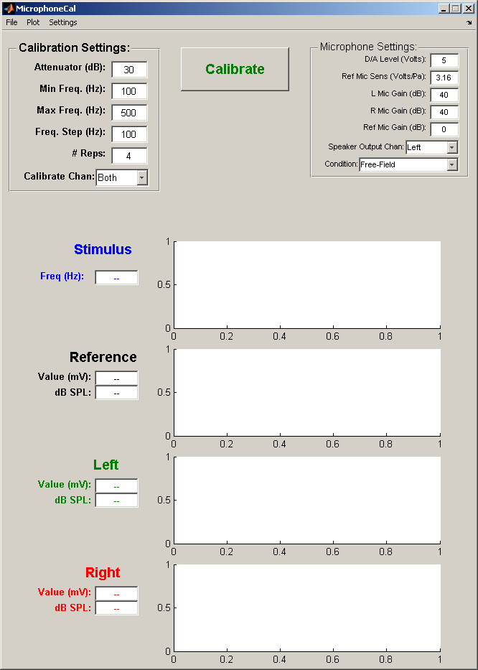

The MicrophoneCal GUI has 5 parts (from top left to bottom right):
* Menu bar ([File], [Plot], [Settings])
* ‘Calibration Settings’ fields
* [Calibrate] button
* ‘Microphone Settings’ fields
* Data display and plots (Stimulus, Reference, Left, Right)

Menu bar

Generally, you do not have to use the top menus if you just calibrate your microphones.

* [File] has two submenus.
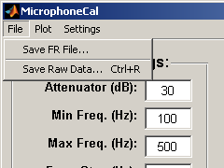
If you want to save analogue waveforms used in calibration, use [Save Raw Data].

* [Plot] has one submenu.
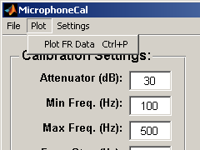
If you want to replot calibration results, use [Plot FR Data].

* [Settings] has two submenus.
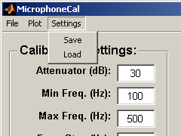
If you want to save your calibration settings, hit [Save] and specify a file name.
If you want to load your calibration settings, hit [Load] and specify a file name.

Calibration Settings fields

* Attenuator (dB): constant attenuation level of the earphone output.

* Min Freq. (Hz): Minimum frequency of the stimulus tone.
* Max Freq. (Hz): Maximum frequency of the stimulus tone.
* Freq. Step (Hz): Frequency step size.
If you choose Min Freq=1000, max Freq=3000 and Freq Step=500, for example, then frequencies of 1000, 1500, 2000, 2500, and 3000 Hz will be used.

* # Reps: Number of repetitions for each frequency.

* Calibrate Chan: Microphone channels to be calibrated (Left, Right or Both).
Pick ‘Both’ if you want to calibrate your left and right microphones simultaneously.

Microphone Settings fields

* D/A Level (Volts): Enter the max D/A level.
Generally, you do not need to change it from 5 Volts.

* Ref Mic Sens (Volts/Pa): Enter the sensitivity of your reference microphone (see note below).

* L Mic Gain (dB): Enter the gain level of your amplifier of the left microphone.
* R Mic Gain (dB): Enter the gain level of your amplifier of the right microphone.
* Ref Mic Gain (dB): Enter the gain level of your amplifier of the reference microphone.
If there is no amplification, enter 0 (zero).

* Speaker Output Chan: Choose the sound output channel (Left or Right).

* Condition: Choose ‘Free-Field’ or ‘Pressure-Field’.
If you plan to use your microphones placed in the ear canals of your animal, you should choose ‘Pressure-Field’. If you use your microphones in the out in the air, you should choose ‘Free-Field’.

### Note: how to find your reference microphone sensitivity ###

The microphone calibration scripts assume that the reference microphone has a flat frequency response. For example, microphones by Brüel & Kjær show flat responses typically between 20 and 10000 Hz (chart below).

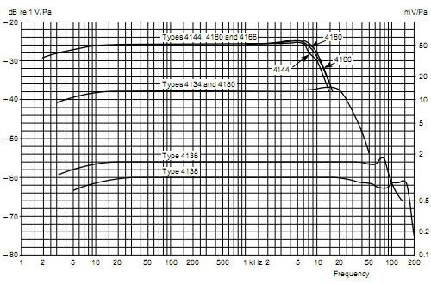

Your reference microphone should be accompanied by a small piece of paper named Calibration Chart, in which the microphone sensitivity level can be found (red arrow below). Divide the mV/Pa value by 1000 and enter it to the Ref Mic Sens (V/Pa) field (beware the units!). For example, the sensitivity of the microphone below is 51.3 (mV/Pa), so you should enter 0.0513 (V/Pa).

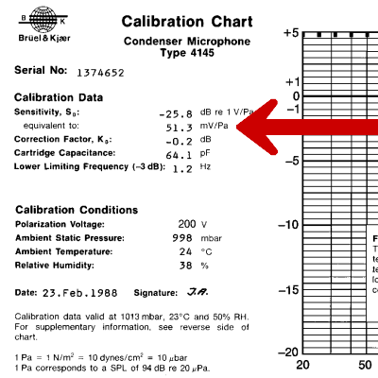

Calibrating microphones

(1) Make sure that all the hardware is properly set and wired.

(2) Place the left, right and the reference microphones properly with the sound-delivering earphone in your sound attenuating chamber.

(3) Make sure that all the setting parameters are properly entered.

(4) Hit the [Calibrate] button.
The calibration process takes a few to ten minutes depending on your calibration settings.
The stimulus sound waveform (blue), the responses of the reference (black), left (green) and right (red) microphones are shown in the plotting area (screenshot below). Stimulus frequency and response amplitudes are also shown in the text areas.

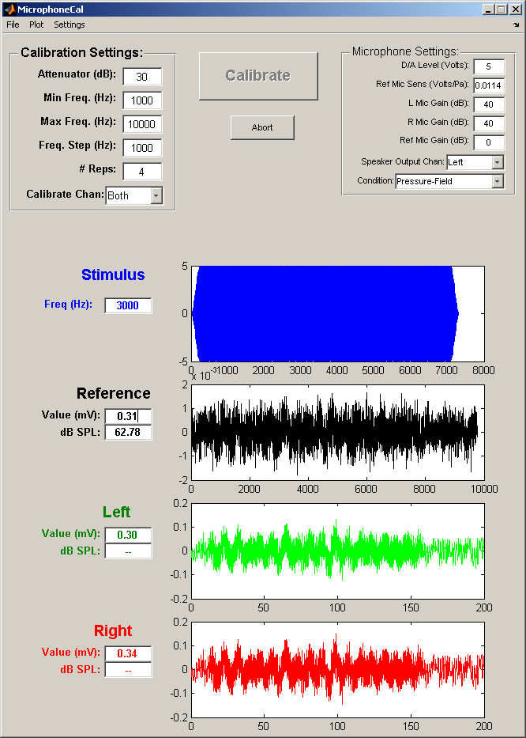

(5) When calibration is done, you will be asked to enter the name of the file in which the calibration data is saved (screenshot below). This ‘_fr.mat’ file will be used when you calibrate your earphones using the calibrated microphones (seen next section for how to calibrate earphones). It is recommended to write down and keep the names of the file and the directory, so that you will be able to find it when you calibrate your earphones.

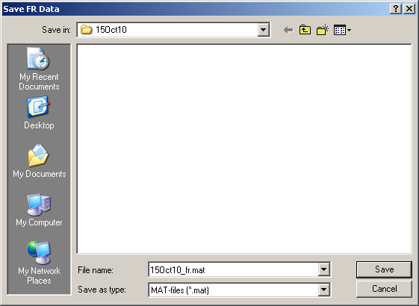

Result plots

After calibration is properly done, three figure windows appear.

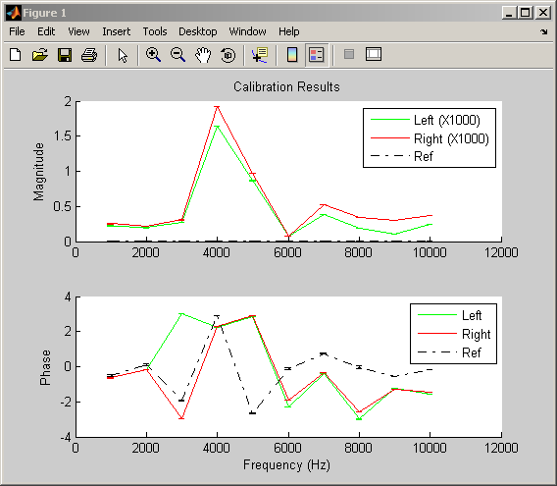

Figure 1 (above) shows the recorded amplitudes and phases of the left, right and reference microphones. If the left and right responses show large differences, you may need to check if everything is wired and set properly.
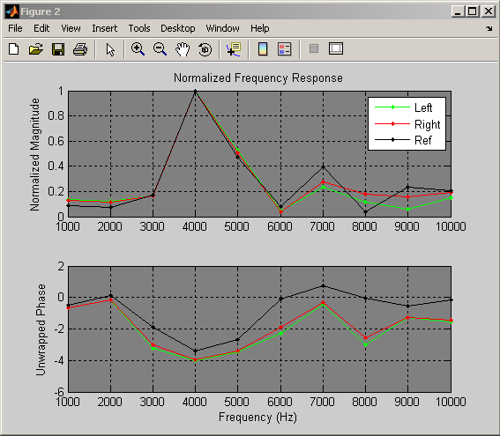

Figure 2 (above) shows the normalized amplitude and unwrapped phases of the left, right and reference microphones. The amplitudes are normalized by the maximum amplitude recorded.

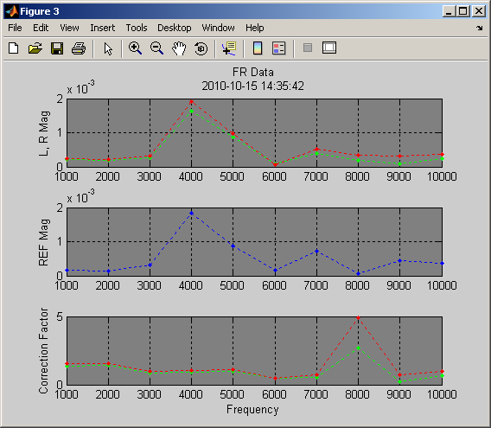

Figure 3 (above) shows the response amplitudes of left and right microphones (top), the amplitude of the reference microphone (middle), and the resulting correction factor (bottom). The correction factor is obtained by dividing the response amplitude of each microphone tested (left or right) by the amplitude of the reference microphone. Thus the correction factor indicates how much differences in the responses there are between the tested microphone and the reference microphone.

How to calibrate earphones (HeadphoneCal)

Overview

In order to control output sounds properly, you need to calibrate your microphones and earphones. To calibrate your earphones, you need a set of microphones which are already calibrated (see the preceding section for how to calibrate your microphones). This section explains how to calibrate your earphones using TytoLogy.

What you need

In order to calibrate your earphones, you need the following hardware.
* Microphone amplifier for your calibrated microphones.

You do not need a reference microphone any more. Calibrated microphones will be used instead.

Wiring

Wire your BNC cables into your patch panel (TDT PP24) as following:

* Earphones: Channel 17 (left) and 18 (right)
* Microphone: Channel 1 (left) and 2 (right)

Graphical User Interface: overview

In order to calibrate your microphones, launch your Matlab and call HeadphoneCal, and the graphical user interface (GUI) pops up (screenshot in the next page).

>> HeadphoneCal

If you have the error saying “undefined function or variable”, probably your PATH is not set properly (see page 9, “How to install TytoLogy”). If you have any other errors, you may have to check if the device numbers and circuit paths are set properly (see page 11).

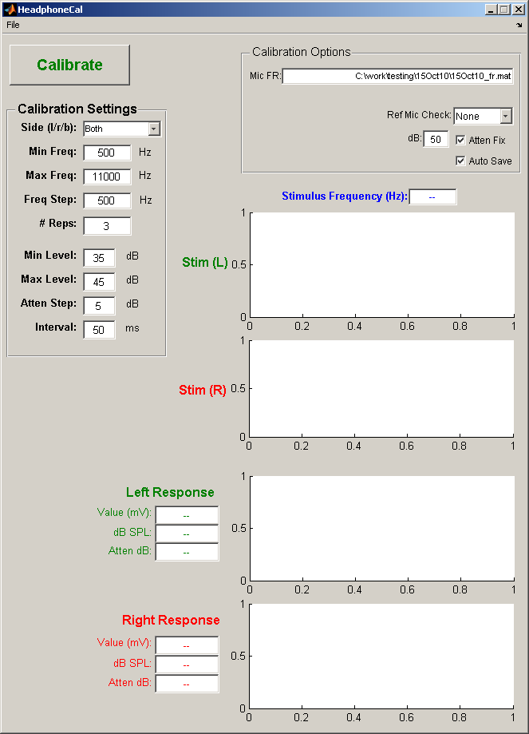

The HeadphoneCal GUI has 5 parts (from top left to bottom right):
* Menu bar ([File])
* [Calibrate] button
* ‘Calibration Settings’ fields
* ‘Calibration Options’ fields
* Data display and plots (Stim (L), Stim (R) Left Response, Right Response)

Menu bar
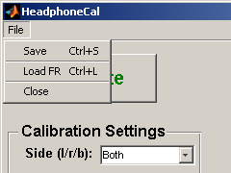
[Save] is used to save the calibration data (see “Calibration earphones” subsection, in the next page).
[Load FR] is used to set the file which contains your microphone calibration data (see “calibration Options” in the next page).

Calibration Settings fields

* Side (l/r/b) specifies which earphones to be calibrated.
If you want to calibrate left and right earphones simultaneously, choose ‘Both’.

* Min Freq. (Hz): Minimum frequency of the stimulus tone.
* Max Freq. (Hz): Maximum frequency of the stimulus tone.
* Freq. Step (Hz): Frequency step size.
If you choose Min Freq=1000, max Freq=3000 and Freq Step=500, for example, then frequencies of 1000, 1500, 2000, 2500, and 3000 Hz will be used.

### Caution ###
Min Freq must be equal to or larger than the Min Freq value used in MicrophoneCal.
Max Freq must be equal to or smaller than the Max Freq value used in MicrophoneCal.

* # Reps: Number of repetitions for each frequency.

* Min Level (dB): Minimum sound level to be used.
* Max Level (dB): Maximum sound level to be used.
* Atten Step (dB): Step size used to find the proper sound level.
If you choose Min Level=50, Max Level=60, Atten Step=5, foe example, then TytoLogy automatically adjusts the sound level between 50 and 60 dB using a step size of 5 dB.

* Interval (ms): time interval of two consecutive sound stimuli.

Calibration Options fields

* Mic FR specifies the microphone calibration data file.
If you want to change the file name, hit [File] in the top menu bar and choose [Load FR].

* Ref Mic Check: Choose ‘None’ if you do not use a reference microphone. Choose ‘Left’, ‘Right’ or ‘Both’ if you use a reference microphone along with your microphones. Generally, you do not need a reference microphone, as long as you use calibrated microphones (therefore, use ‘None’ here).

* Atten Fix: Check this box if you want to use a constant attenuation level.
* dB is the attenuation level if you check the Atten Fix box.
If the Atten Fix box is checked, TytoLogy will fix the attenuation level instead of using Min Level, Max Level and Atten Step to adjust the sound level. If you want TytoLogy to control the sound level automatically, leave this box unchecked.

* Auto Save: Check this box if you want to save the data automatically.
If this box is checked, the output data file will be saved by updating the ‘ear_cal.mat’ file of the current directory. If you do not want to overwrite the ‘ear_cal.mat’ file, leave this box unchecked and save the data afterwards (see next subsection (5) for detail).

Calibrating earphones

(1) Make sure all the hardware is properly set and wired.

(2) Place the left earphone along with the left microphone, the right earphone along with the right microphone in your sound attenuating chamber.

(3) Make sure all the setting parameters are properly entered.

(4) Then hit the [Calibrate] button.
The calibration process takes a few to ten minutes depending on your calibration settings.
The stimulus sound waveforms and the responses of microphones are shown in the plotting area (screenshot in next page). Stimulus frequency (Hz) and response amplitudes (mV, dB SPL) are also shown in the text areas.

(5) When calibration is done, the “Result Plots” window pops up (see next subsection for detail). If the Auto Save box is checked, the calibration results will be automatically saved as ‘ear_cal.mat’. If the box is not checked, you will have to save the data manually. Hit [File] in the top menu bar and choose [Save], and you will be asked to enter the name of the file in which the calibration data is saved.

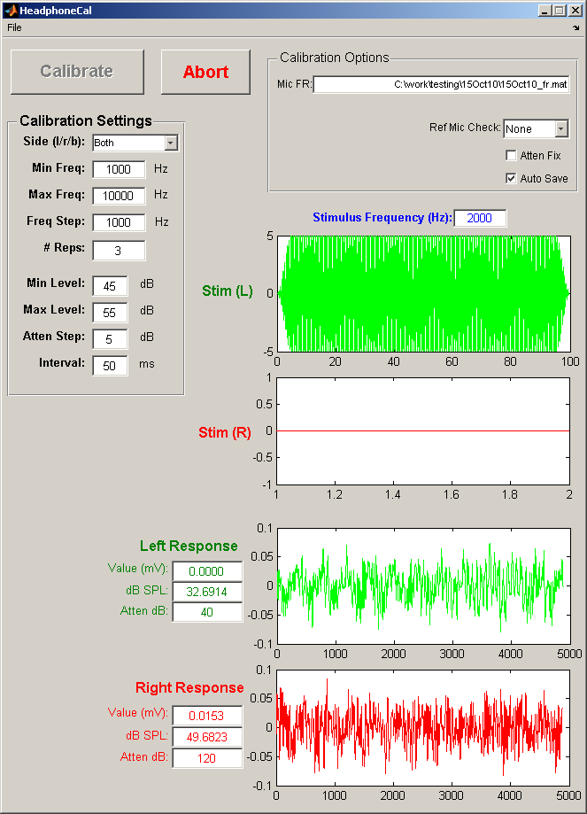

Result plots

When calibration is properly done, a blank figure window appears (below). Hit the [Update] button to show the calibration results.
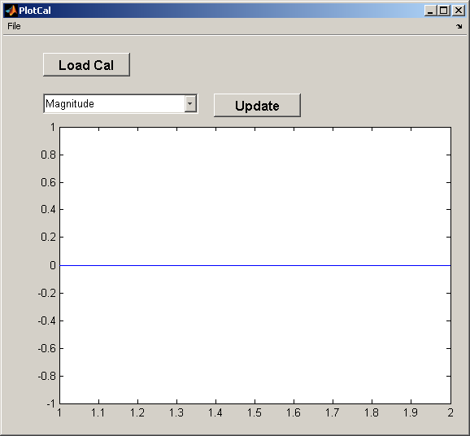
The PlotCal figure window shows ‘Magnitude’, ‘Phase’, ‘Distortion’, ‘Leak magnitude’, etc (screenshot below). For example, by choosing ‘Magnitude’, the highest possible sound level delivered by the earphones will be shown. If the left and right magnitudes differ by an order of 10 dB, you may need to check if the earphones and the microphones are placed properly.

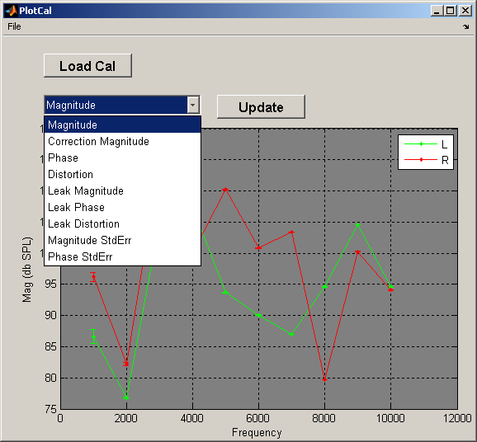

If you want to see other calibration data, hit [Load Cal] and choose the file.

If you want to see the calibration results after closing the plotting window, just call PlotCal in your Matlab command window.

>> PlotCal

Neurophysiology using TytoLogy (HPsearch)

Overview

HPSearch is the main program for auditory-neurophysiological recordings. This program enables you to control search stimuli, to record neural responses to auditory stimuli varying the frequency, ITD, ILD, ABI, etc. This section explains how to do recordings using TytoLogy.

HPSearch is designed to replace XDPHYS. Most of the features of XDPHYS have been implemented in HPSearch, but some have not been done yet (including clicks and monaural stimulation).

What you need

In order to use HPSearch, you need the following hardware in addition to the TDT system 3.
* General physiology setup, such as amplifiers for neural recordings, etc.

Wiring

Wire your BNC cables into your patch panel (TDT PP24) as following:

* Earphones (sound output): Channel 17 (left) and 18 (right)
* Neural data (data input): Channel 3 (choose ‘Channel’ in the plotting area)

Graphical User Interface: overview

In order to do neurophysiology using TytoLogy, launch your Matlab and call HPSearch, and the graphical user interface (GUI) pops up (screenshot in the next page).

>> HPSearch

If you have the error saying “undefined function or variable”, probably your PATH is not set properly (see page 9, “How to install TytoLogy”). If you have any other errors, you may have to check if the device numbers and circuit paths are set properly (see page 11).

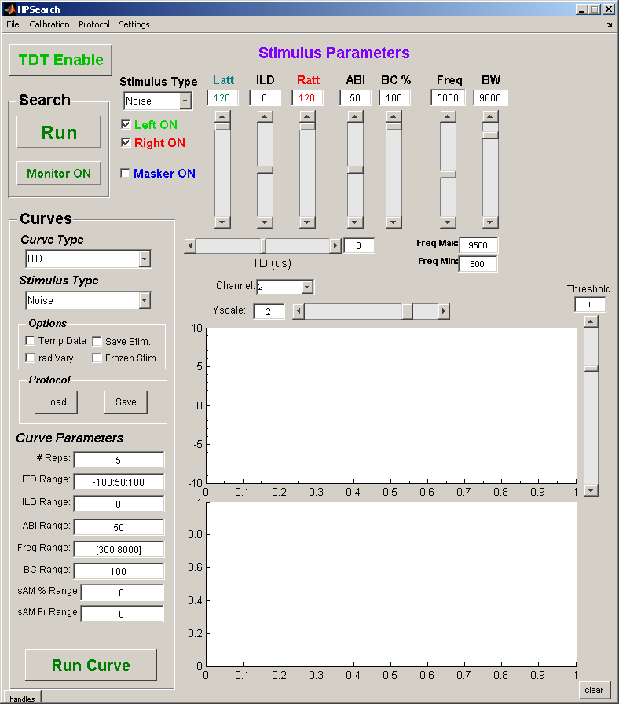

The HPSearch GUI has 6 parts (from top left to bottom right):
* Menu bar ([File], [Calibration], [Protocol], [Settings])
* [TDT Enable] button
* Search buttons ([Run] and [Monitor ON])
* ‘Stimulus Parameters’ area
* ‘Curves’ area
* Data plotting area

Menu bar

* [File] has one submenu.
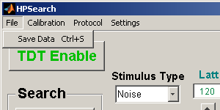
This submenu is not functioning yet.

* [Calibration] has two submenus.
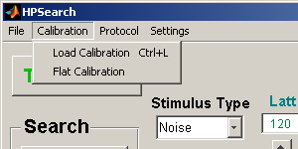
If you want to load an earphone calibration data, use [Load Calibration] to specify the calibration data file. Otherwise, the property of the earphones is assumed to be flat.
If you want TytoLogy to assume the earphone to be flat, click [Flat Calibration].

* [Protocol] has two submenus.
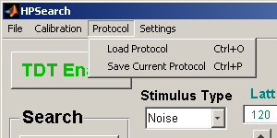
You can save and load the settings shown in the ‘Curves’ area (see ‘Curves area’ section for detail). This setting is called “Protocol”.
If you want to save the protocol you are currently using, hit [Save Current Protocol].
If you want to load a protocol that was previously saved, hit [Load Protocol].
You may also save and load protocols by hitting [Save] or [Load] button in the ‘Curves’ area (see screenshot in page 39).

* [Settings] has five submenus.
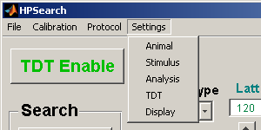
These submenus enable you to set parameters and variables that are not shown in the main window.

- By hitting [Animal], you will be able to set the information of the animal number, date of experiment, electrode positions, etc.
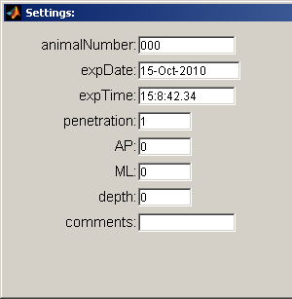

- By hitting [Stimulus], you will be able to set stimulus variables.
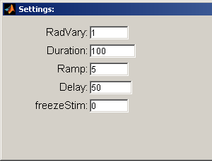
If ‘RadVary’ is 1, the initial phase of the tonal stimulus is randomized.
If ‘Radvary’ is 0, the initial phase of the tonal stimulus is fixed.

‘Duration’ is the length of the sound stimulus in milliseconds.

### Notes ###
‘Duration’ here in the [Stimulus] menu sets the same parameter as ‘StimDuration’ in the [TDT] menu. If ‘Duration’ is changed, ‘StimDuration’ is also changed at the same time, and vice versa.

‘Ramp’ (in milliseconds) is the length of the linear ramps in the beginning and the ending of the stimulus.

‘Delay’ is the time delay (in milliseconds) between the beginning of the sweep period and the beginning of the stimulus sound.
If Duration=100 and Delay=50, for example, the sound stimulus begins at 50 ms and ends at 150 ms.

By hitting [Analysis], you will be able to set the parameters used in spike analyses.
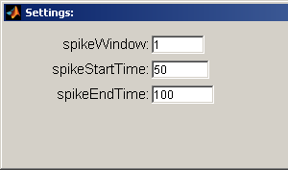
‘spikeWindow’: This is used to eliminate multiple spiking. Any multiple threshold crossings that occur within a length of time equal to spikeWindow (in msec) will be ignored. If there are two spikes detected in the window, for example, only the second spike will be counted.

Spikes that are recorded between ‘spikeStartTime’ and ‘spikeEndTime’ will be analyzed. These start and end times are shown by green and red vertical bars, respectively, in the plotting window.

By hitting [TDT], you will be able to set the parameters used in recordings.
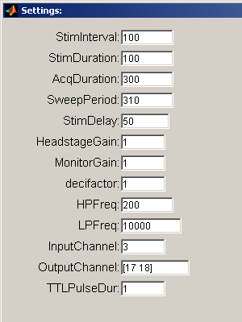
‘StimInterval’ is the interstimulus interval (in msec).
‘StimDuration’ is the duration of the stimulus sound (in msec).
‘AcqDuration’ is the data acquisition time per stimulus presentation/recording sweep (in msec).
‘SweepPeriod’ is the total duration of the stimulus presentation/recording sweep (in msec).
(Caution: ‘SweepPeriod’ should be greater than ‘AcqDuration’. This allows some flexibility in data transfer time from the TDT system to the host computer.)
‘StimDelay’ is the delay between the start of recording and the start of the stimulus sound.
‘HeadstageGain’ is a gain factor applied to the incoming signal and is also applied to the stored values. This feature is provided by the TDT virtual circuit and you can think of it as a software "gain knob" for the system. The stored data in the ‘.dat’ file will be in units of ‘Volts * HeadstageGain’.
‘MonitorGain’ is a gain factor applied to the signal that is sent to the BNC connector on the RX5 for monitoring the signal on an oscilloscope and/or audio monitor. If you do not use RX5, this parameter does not affect anything.
‘decifactor’ is the downsampling factor to enable fast plotting. If ‘decifactor’ is 10 and the sampling rate is 50 kHz, for example, the plotted data on the screen will be downsampled to 50/10 = 5 kHz. This does not affect the data stored in the ‘.dat’ file, which is always sampled at the full rate.
‘HPFreq’ is the cutoff frequency of the high-pass filter within the RPvdsEx circuit.
‘LPFreq’ is the cutoff frequency of the low-pass filter within the RPvdsEx circuit.
‘InputChannel’ is the channel to which neural data is delivered.
‘OutputChannel’ is the channels (L and R) to which sound data is delivered.
‘TTLPulseDur’ is the duration of the triggering pulse (in msec).
(GA) If the analogue data saved in ‘***.dat’ is a filtered waveform, or a raw waveform?
(SJS) The analogue data saved in the .dat file is filtered - with the noise levels we've been getting, saving the unfiltered data wasn't useful. Also, since the data are filtered in the RPvD acquisition circuit, it was easiest to do it this way. If you want to save the unfiltered data, let me know and I can make some changes to the circuit.

By hitting [Display], you will be able to set display parameters.
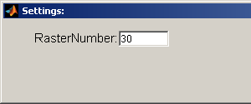
‘RasterNumber’ is the number of trials shown in the raster plot.

TDT enable button

The TDT system 3 needs to be initialized before you use it. By hitting the [TDT enable] button, TytoLogy initializes and begins talking with the system. If you want to close the connection between TytoLogy and TDT, hit [TDT disable].

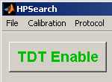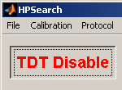

Search buttons

By hitting [Run], search stimulus starts. See next subsection for how to control stimulus parameters.
By hitting [Stop], search stimulus stops.

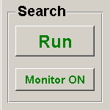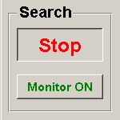

The [Monitor ON] button enables the circuit for recording and sends the monitored electrode channel to the front panel BNC connector on the RX5 without playing or recording any other signals. Data will not be stored. This enables you to listen to the electrode signal while lowering the electrode into the brain without any stimuli being presented. This feature is for the RX5 processor only. If you do not use RX5, this button does nothing.

Stimulus parameters area

The ‘Stimulus Parameters’ area is a copy of the ‘RIG’ module of XDPHYS, which was used to search auditory targets. You can set parameters of the search stimulus, which starts when you hit the [Run] button (see above).

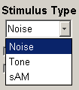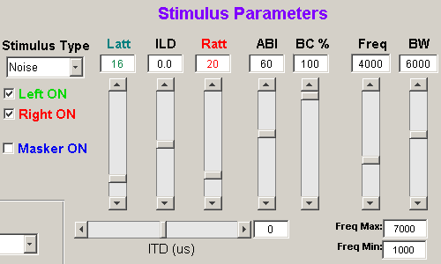

‘Stimulus Type’: You can choose broadband noise (‘Noise’), pure tone (‘Tone’), or sinusoidal amplitude modulation (‘sAM’).
If ‘Noise’ is chosen, ‘BC %’, ‘Freq’ and ‘BW’ will be used (see below).
If ‘Tone’ is chosen, ‘Freq’ will be used.
If ‘sAM’ is chosen, ‘Freq’, ‘sAM %’ and ‘sAM Freq’ will be used (see also next page).

‘Left ON’: This check box is reserved for monaural stimulation, which has not been implemented.
‘Right ON’: This check box is reserved for monaural stimulation, which has not been implemented.

‘Masker ON’: If this box is checked, a separate masking noise will be turned on.

‘Latt’: Attenuation level of the TDT PA5 attenuator for the left sound stimulus.
‘Ratt’: Attenuation level of the TDT PA5 attenuator for the right sound stimulus.

‘ILD’: Interaural intensity difference (dB) = intensity difference between left and right.
ILD ranges from +20 to -20. Increase in ILD will decrease Ratt and increase Latt, therefore increasing intensity in the right headphone and decreasing it in the left headphone. The opposite occurs as you decrease ILD.

‘ABI’: Average binaural intensity = [ left (dB) + right (dB) ] / 2
As you increase the ABI, the attenuation decreases. In the current version of TytoLogy, you cannot directly control ‘Latt’ and ‘Ratt’. Use ‘ILD’ and ‘ABI’ instead. It is important to check that when you change ‘ILD’ and ‘ABI’, the attenuation values (‘Latt’ and ‘Ratt’) stay within their range (0-120). Otherwise there is an error.

‘BC %’: Binaural correlation of the noise stimulus.
If BC=100%, identical noise will be presented to both left and right.

‘ITD (us)’: Interaural time difference in microseconds.

‘Freq’: Frequency of the stimulus sound.
If ‘Tone’ in the ‘Stimulus Type’ list is chosen, pure tone of this frequency will be generated.
If ‘Noise’ in the ‘Stimulus Type’ list is chosen, this frequency will be the center frequency of the broadband noise.
If ‘sAM’ in the ‘Stimulus Type’ list is chosen, this frequency will be the carrier frequency.

‘BW’: Bandwidth of the broadband noise. If ‘Tone’ is chosen, this value will not be used.
‘Freq Max’: Maximum frequency of the broadband noise.
‘Freq Min’: Minimum frequency of the broadband noise.
If Freq=5000, BW=8000, for example, Freq Max will be 5000+8000/2 = 9000 Hz, and Freq Min will be 5000-8000/2 = 1000 Hz. Therefore, in this case, a broadband noise containing frequency components of 1000-9000 Hz will be presented.

‘sAM %’: Modulation amplitude of the sAM signal.
‘sAM Freq’: Modulation frequency of the sAM signal.
These two slide bars (below) appear only when the Stimulus Type is ‘sAM’.

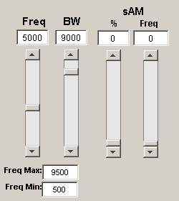

Curves area

The ‘Curves’ area is a copy of the ‘GEN’ module of XDPHYS, which was used to record from the auditory target you found. You can set the parameters of the stimulus sound, which starts when you hit the [Run Curve] button.

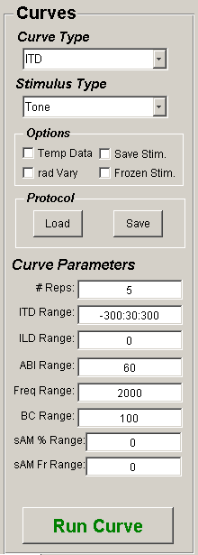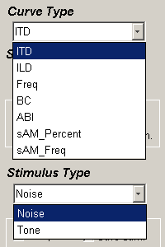

‘Curve Type’
You can specify the main variable changed in the recording.
If you choose ‘ITD’, for example, recorded spike numbers will be plotted against ITD which is given in the ‘ITD Range’ box in ‘Curve Parameters’. If you choose ‘Freq’, spike numbers will be plotted against frequency instead.

‘Stimulus Type’
You can select ‘Noise’ or ‘Tone’.

‘Options’
If ‘Temp Data’ is checked, the output data is saved in temporary files named ‘temp.mat’ and ‘temp.dat’.
If ‘rad vary’ is checked, the initial phase of the tonal stimulus is randomized. Otherwise, the initial phase is fixed.
If ‘Save Stim.’ is checked, the sound stimulus information is saved in a ‘***_stim.mat’ file.
If ‘Frozen Stim.’ is checked, an identical stimulus is presented in each trial. Namely, if you select ‘Noise’ in the ‘Stimulus Type’ menu and check this ‘Save Stim.’ box, the same noise stimulus will be used. If you do not check this box, the waveform of the noise stimulus will differ from trial to trial.

‘Protocol’
You can save and load the settings shown in the ‘Curves’ area. This setting is called “Protocol”.
If you want to save the protocol you are currently using, hit [Save].
If you want to load a protocol that was previously saved, hit [Load].
Each protocol is saved as a Matlab data file named ‘***_protocol.mat’.
You may also save and load protocols by using [Save Current Protocol] or [Load Protocol] in the menu bar.

‘Curve Parameters’
Each variable here should be a single number or in the “start:step:end” format.
For example, if you enter -300:30:300 in the ‘ITD Range’ field, ITDs of -300, -270, -240, ..., -30, 0, 30, ..., 240, 270, 300 μsec will be used. If you enter “100” instead, ITD will be fixed to 100 μsec.

‘# Reps’: Number of repetitions for each stimulus variable.
‘ITD Range’: Interaural time difference in μsec.
‘ILD Range’: Interaural level difference in dB.
‘ABI Range’: Average binaural intensity in dB.
‘BC Range’: Binaural correlation %. This variable is used only when ‘Noise’ stimulus is chosen.
‘sAM % Range’: Modulation amplitude of the AM signal.
‘sAM Fr Range’: Modulation frequency of the AM signal.

Data plotting area

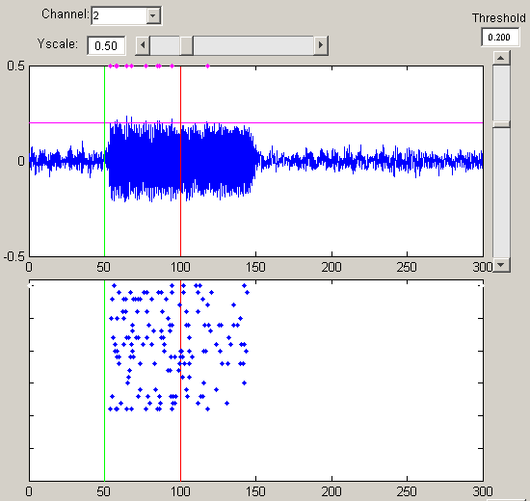

Channel: Input channel.
If 1 is chosen, for example, data obtained through the input channel 1 on the patch panel will be recorded and used for further analyses.

Yscale: Scaling of the Y-axis of the trace plot. (in mV?)
(SJS) I think so, but I will have to double-check on this.

Threshold: Threshold level used for spike discrimination (pink horizontal line in the trace plot).
A spike is counted when the recorded trace crosses this threshold level.

Trace plot (top): Recorded data trace.

Raster plot (bottom): Raster plot of spikes detected by threshold crossing.

The green and red vertical bars, respectively, correspond to ‘spikeStartTime’ and ‘spikeEndTime’ set in the [Analysis] submenu of [Settings] in the menu bar.
Searching your auditory target

(1) Make sure all the hardware is properly set and wired. Set Channel to the right channel number which the neural data comes into.

(2) Hit [Calibration] in the top menu bar, select [Load Calibration], and choose your earphone calibration data file to be used.

(3) Hit the [TDT Enable] button.
TytoLogy initializes and begins talking with the TDT hardware.

(4) Set the Stimulus Type and Stimulus Parameters, and hit the [Run] button in the ‘Search’ area. Recorded voltage waveform and detected spikes will be shown in the plotting area.

(5) Move your recording electrode towards your auditory target. Change the Stimulus Parameters, Yscale and Threshold so that spikes are properly detected.

Recording from your auditory target

(1) Stop the search stimulus by hitting the [Stop] button in the Search area before recording.

(2) Load a protocol by hitting the [Load] button, or manually set the parameters in the Curves area.

(3) Hit the [Run Curve] button at the bottom to start recording.

(4) You will be asked to enter the information of the current recording.
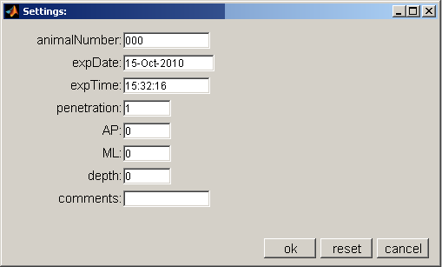
By hitting [ok], you will be asked to enter the file name in which recorded data will be stored.
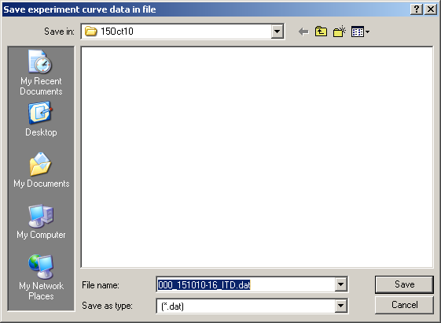
Then once you hit [Save] button, data recording starts.

The default file name is in the ‘AAA_DDMMYY-SS_TTT.dat’ format, where AAA is the animal number, DD is the date, MM is the month, YY is the year, SS is the seconds of the clock when you hit the [Run Curve] button, and TTT is the Curve Type you chose (such as ITD, ILD, etc.).

Since the seconds is determined somewhat arbitrarily, it is recommended to change or add some numbers (or letters) to the default name to differentiate the files.
If you permanently change the format used for creating the default file name, modify the Matlab function file ‘HPCurve_buildOutputDataFileName.m’ in the ‘C:\TytoLogy\Experiments\HPSearch\Functions\’ directory.

(5) When recording starts, the small ‘stop-pause’ window (below) pops up. If you want to break recording, press either button. If you hit [STOP], recording will be aborted. If you hit [Pause], recording will make a pause, but you can resume it by hitting the [PAUSED] button again.
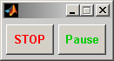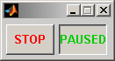
You should stop recording before adjusting Yscale and Threshold used in spike discrimination.

(6) When recording finishes, recorded spike numbers will be plotted against the variable specified in the Curve Type list. If you chose ITD, the x-axis of the plot will be ITD (below left). If you chose
Freq, the x-axis will be frequency.

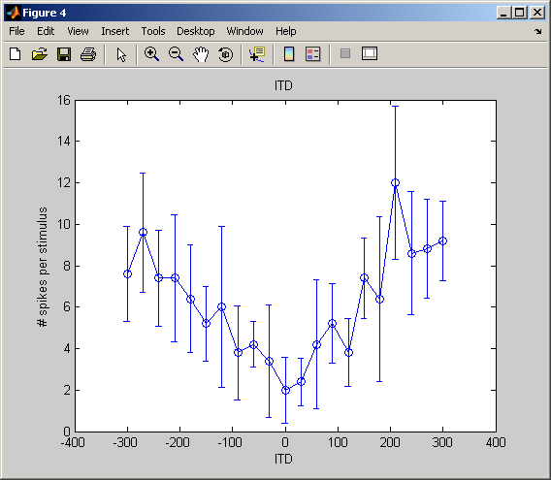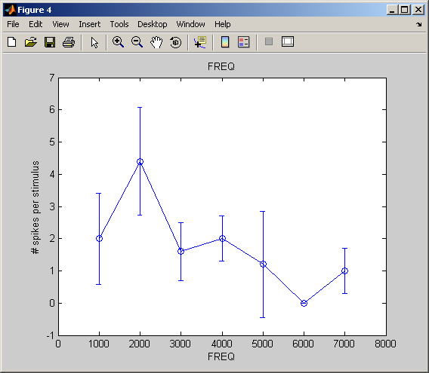

(7) The recorded data has been stored in ‘***.mat’ and ‘***.dat’ files. The ‘.mat’ file contains information on the stimulus and detected spike timings, while the ‘.dat’ file contains the recorded waveforms. Spike discriminator settings do NOT affect the waveform data stored in the ‘.dat’ file.

If you checked the ‘Save Stim.’ box, stimulus data is also saved in the ‘***_stim.mat.’ file.

How to analyze recorded data will be explained in the next part.

PART 3:

How to analyze data recorded by TytoLogy

Data structure of TytoLogy

TytoLogy data files: Overview

HPSearch creates two data files, ‘***.mat’ and ‘***.dat’, for each recording trial. If you checked the ‘Save Stim.’ box in the HPSearch GUI, ‘***_stim.mat’ file is also created. In this part, how to analyze these data will be explained, assuming that you have data files ‘example.mat’, ‘example.dat’, and ‘example_stim.mat’.

‘example.mat’ contains information on the stimulus sound, the varied parameters (such as ITD, frequency, etc.), and the spike timings. Generally, this is a small file (typically a few tens of kilobytes). If you are satisfied with the spike data generated by the threshold-crossing detector of HPSearch, you can use this file for your analyses. Otherwise (if you want to re-analyze the data using a different spike detector, for example), you will need to use the ‘example.dat’ file instead (see below).

‘example.dat’ contains recorded waveforms in addition to the information on the stimulus sound and the varied parameters (such as ITD, frequency, etc.). You should always use this file if you want to re-analyze the waveform data. Generally, this is a large file (typically some tens of megabytes, depending on the number of recording repetitions).

‘example_stim.mat’ contains additional information on the stimulus sound. You may need to refer to this file if you want to know in detail what kind of stimulus was used. Generally, this is a small file (typically a few tens of kilobytes).

To be written soon....

