EBU6304 Software Engineering Group Project

2025-26
Group number | 7
member 1 | QM no: 231220390 | Name: Yuxiang Tu
member 2 | QM no: 231220253 | Name: Maiyuan Cao
member 3 | QM no: 231220714 | Name: Mandan Dong
member 4 | QM no: 231222279 | Name: Hao Qin
member 5 | QM no: 231221663 | Name: Chang Ge
member 6 | QM no: 231222899 | Name: Zixuan Wang

First report

Requirements
1.1 Fact-Finding Techniques
To identify the requirements of the TA recruitment system, the team used four fact-finding techniques: background reading, interviewing, questionnaire survey, and observation of an existing system. These methods were chosen because they provide different types of evidence. Together, they helped the team understand user needs, common recruitment requirements, and suitable interface design.

1.1.1Background Reading (Market Research)
To better understand the typical requirements for teaching assistants, several real job advertisements from online recruitment platforms were analysed (see Appendix: Figure 1 and Figure 2). The purpose of this analysis was to identify the common requirements for TA applicants and determine what information should be collected in the TA application form of the system. The analysis showed that TA applicants are typically expected to have an appropriate educational background (usually a bachelor’s degree or above), good communication skills, relevant teaching or tutoring experience, and a responsible and patient attitude when working with students. Based on these findings, the TA recruitment system should collect key applicant information including the applicant’s name, student ID, educational background, and skills or relevant experience, so that module organisers can effectively review applications and select suitable teaching assistants.

1.1.2 Interviewing
A short online interview was conducted with a university student who is interested in applying for TA positions. The interview indicated that students expect the system to provide clear information about available TA positions and an easy way to submit application materials such as CVs and transcripts. The interviewee also mentioned that in many current application processes it is difficult to track the status of applications after submission, so an application status tracking feature would be valuable. In addition, the interviewee suggested that notification functions such as deadline reminders and status updates would help applicants better manage the application process.

1.1.3 Questionnaire Survey
A questionnaire survey was conducted among university students across different academic levels, including undergraduate, master’s and PhD students. The purpose of the survey was to understand what information students usually provide when applying for TA positions, what skills are considered important for TAs, and what functions users expect from a TA recruitment system. The results show that most respondents expect the system to provide features such as document upload for application materials, clear display of available TA positions, application status tracking, and deadline reminders. These findings helped identify the core functional requirements of the system.

1.1.4 Observation of Existing Systems
To understand how online application systems are typically designed, an existing online registration form used for campus recruitment events was observed. Although the system is designed for event registration rather than TA recruitment, it follows a similar application workflow and therefore provides useful insights for interface design. The system requires users to fill in personal information such as name, phone number, email, and university, and to select options such as city, graduation year, and education level before submitting the form. The interface uses common interaction elements including text input fields, radio buttons, checkboxes, and a submit button. From a workflow perspective, users first enter personal information, then select relevant options, and finally submit the form. This observation highlights the importance of structured application forms and simple submission workflows, which can be applied to the design of the TA recruitment system.
1.2 Iteration Planning
1.2.1 Iteration Strategy
This project follows an Agile development approach in which the system is developed through short iterations. In each iteration, analysis, design, implementation, and testing are carried out together rather than being separated into distinct phases as in the waterfall model. Each iteration delivers a working increment of the system that can be evaluated by users, and their feedback is then used to improve the next iteration. In this project, the development is organised into four iterations, each implementing a group of related user stories. A typical iteration cycle involves selecting user stories, breaking them into tasks, developing and testing the features, releasing the software, and collecting user feedback. This iterative process enables incremental development and continuous improvement of the system.
1.2.2 Iteration 1 – Core System Functions
Objective: The objective of Iteration 1 is to establish the core system foundation, including user access, applicant profile creation, basic job viewing functions, job setup, and text-file data storage.
User Stories Included: US1, US2, US3, US4, US8, US11, US12, US22, US23, US24, US35
Iteration Outcome: At the end of this iteration, the system provides the essential foundation for operation. Users can register and log in, role-based access is available, applicants can create profiles and upload CVs, and both applicants and organisers can access basic job information. The system also supports initial job posting setup and text-file data storage, forming the basis for later development.
1.2.3 Iteration 2 – Job Application Process
Objective: The objective of Iteration 2 is to implement the core job application process and ensure that applications are submitted in a controlled and valid way.
User Stories Included: US14, US15, US16, US17, US18, US19, US20, US36
Iteration Outcome: At the end of this iteration, applicants can complete the main application process through the system. Applications can be submitted, submission time is recorded, duplicate applications are prevented, and profile and CV checks are enforced before submission. Applicants can also view their application list and status details, while password security improves account protection.
1.2.4 Iteration 3 – Recruitment Management
Objective: The objective of Iteration 3 is to improve applicant information management and support recruitment review and decision-making.
User Stories Included: US5, US21, US26, US27, US28, US29, US30, US31, US37, US39
Iteration Outcome: At the end of this iteration, the system better supports recruitment management. Module Organisers can review applicants in detail and make decisions such as accepting or rejecting applications, while applicants can update basic information and view updated results. Responsive form validation and improved error handling also enhance system usability and reliability.
1.2.5 Iteration 4 – System Enhancement
Objective: The objective of Iteration 4 is to add supporting, optimisation, and advanced features to improve the overall usability and intelligence of the system.
User Stories Included: US6, US7, US9, US10, US13, US25, US32, US33, US34, US38, US-C1, US-C2, US-C3
Iteration Outcome: At the end of this iteration, the system is enhanced with several advanced features. Applicants can better manage their profiles by updating skills, availability, and CV information, while organisers and administrators gain improved management tools such as job editing, workload monitoring, and workload warnings. Additional improvements in search functionality, system performance, and skill matching further enhance the overall usability and reliability of the platform.
1.3 Prioritisation
In Agile development, the MoSCoW method is used to prioritise user stories in the backlog. Requirements are divided into four categories: Must have, Should have, Could have, and Want to have. Must have refers to essential features without which the system would not work. Should have represents important features that can be omitted if time or resources are limited. Could have includes features that enhance the system but are not critical. Want to have refers to optional features that provide limited business value.
1.3.1 MoSCoW Priority Classification
Based on the priority settings in the backlog, user stories are divided into four categories. Must have includes the core functions of the system, such as User Registration, User Login, Create Applicant Profile, Upload CV, View Available Job List, and Submit Job Application. These functions form the basic application workflow and are essential for the system to operate. Should have features improve the system’s management efficiency and usability, such as Edit Job Posting and View Overall TA Workload. These functions are important but can be implemented in later iterations if time is limited. Could have features enhance the system’s capabilities, such as Skill Match Score and Skill Gap Alert for Applicants. These functions provide additional assistance but do not affect the core workflow. Want have features are optional functions that may be implemented if time and resources allow, such as Auto-Suggest Jobs for TA and Export Workload Report. These features improve user convenience but are not essential for the core operation of the system.
1.3.2 Basis for Prioritisation
In this project, the prioritisation of user stories is determined by business value and system usability. Functions that directly support the core business process are classified as Must have. Features that improve efficiency or management convenience are classified as Should have. Functions that enhance system capabilities or provide decision support are classified as Could have. Want have features are optional functions with lower priority that may be implemented if time and resources allow.This approach ensures that the most critical features are implemented first while allowing the system to be gradually improved in later iterations.
1.4 Estimation
The backlog was estimated using story points rather than time-based estimation, as story points are more suitable for measuring the relative size of a user story in terms of effort, complexity, and uncertainty. This is appropriate in agile development, where exact time estimates are often unreliable at an early stage.
In this project, simpler stories were assigned lower points, while more complex stories were given higher points. For example, Role-based Access, Record Application Submission Time, Check Applicant Profile Before Application, and View Updated Application Result were estimated at 1 story point because they involve limited logic. Stories such as User Login, View Job Details, Set Job Requirements, Set Workload and Deadline, and Password Security were estimated at 2 story points, while stories such as User Registration, Create Applicant Profile, Upload CV, View Application List, Data Storage in Text Files, View Overall TA Workload, and System Performance were estimated at 3 story points because they require more steps and broader data interaction.
The most complex stories were estimated at 5 story points, including View Available Job List, Create Job Posting, Submit Job Application, Search Jobs by Keyword, Edit Job Posting, Accept Applicant, View Assigned Workload of Each TA, Skill Match Score, Skill Gap Alert for Applicants, Workload Balance Warning for Admin, and US43: Auto-Suggest Jobs for TA. US44: Export Workload Report remains a Want story and may be estimated later depending on the final reporting scope.
Overall, story points reflect relative difficulty rather than development time and help the team plan iterations more realistically.

Supporting material
1.Market Research
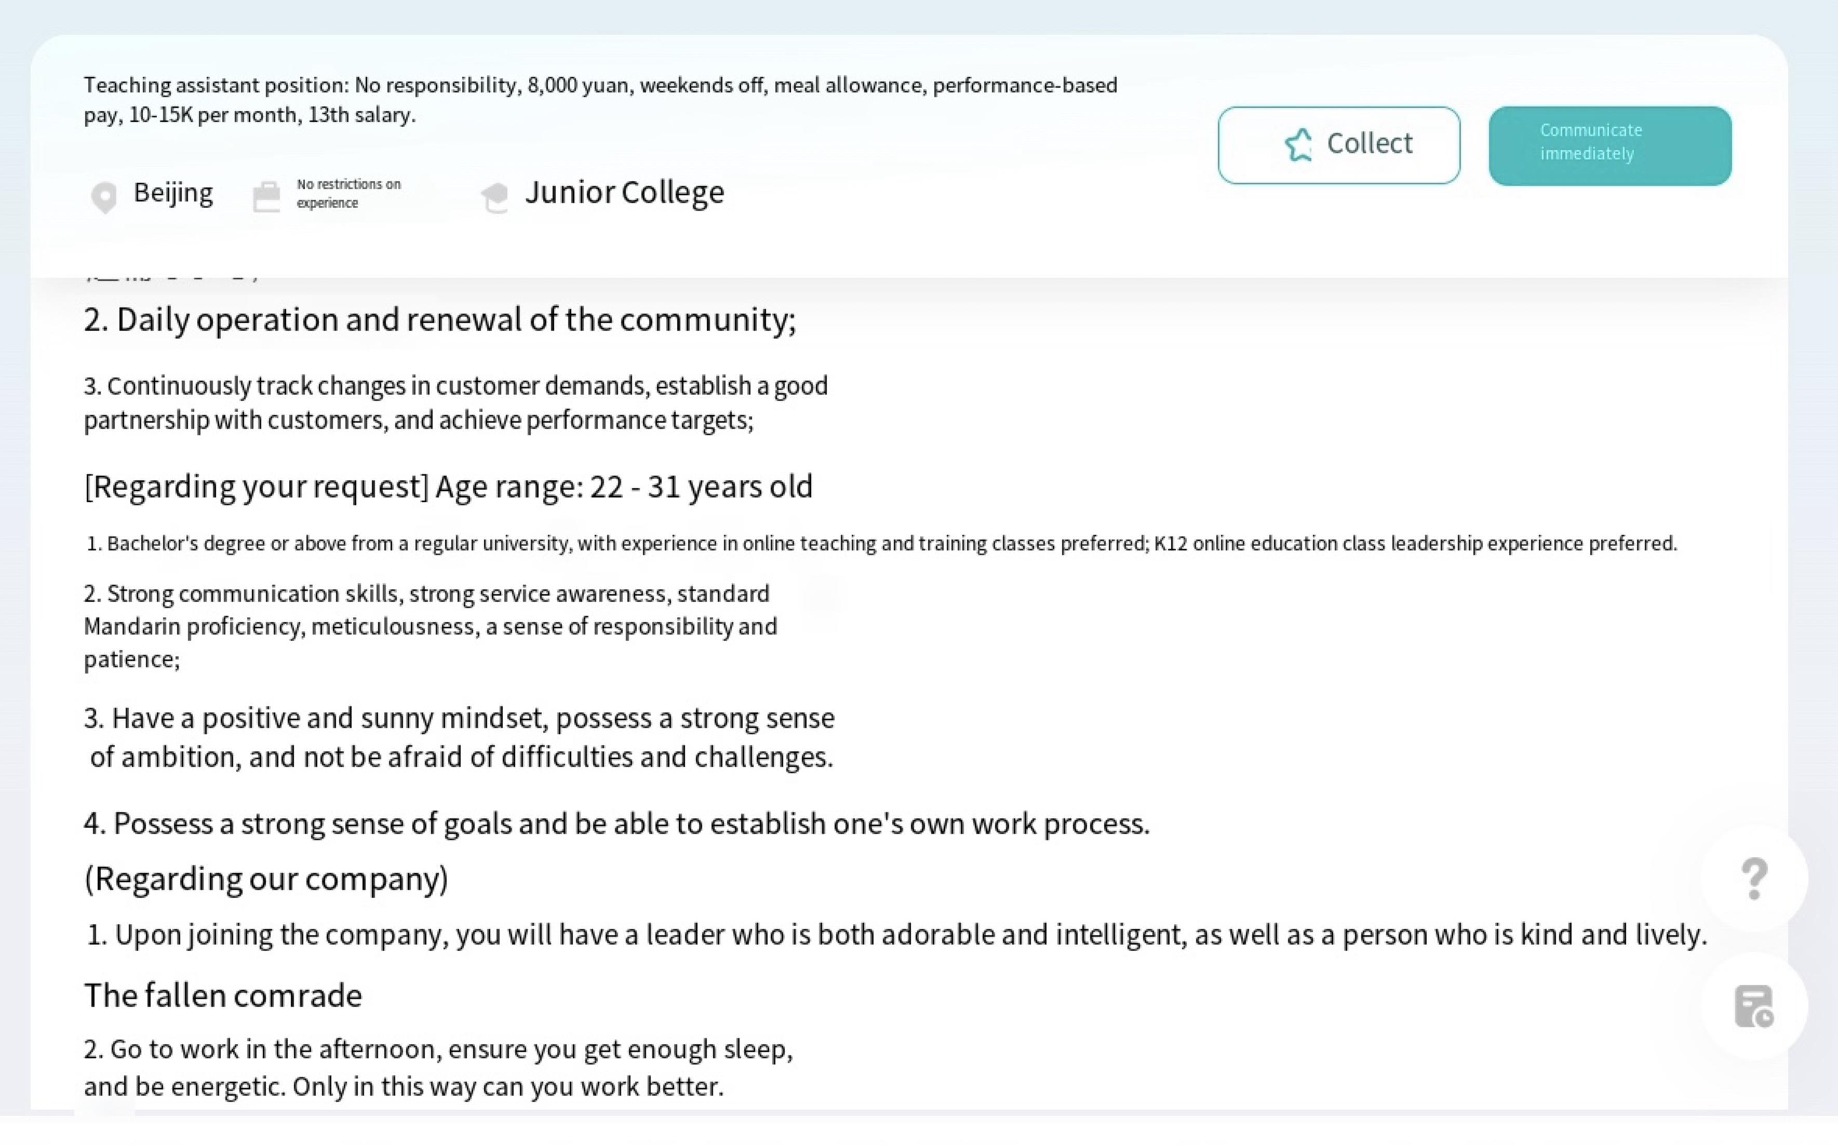

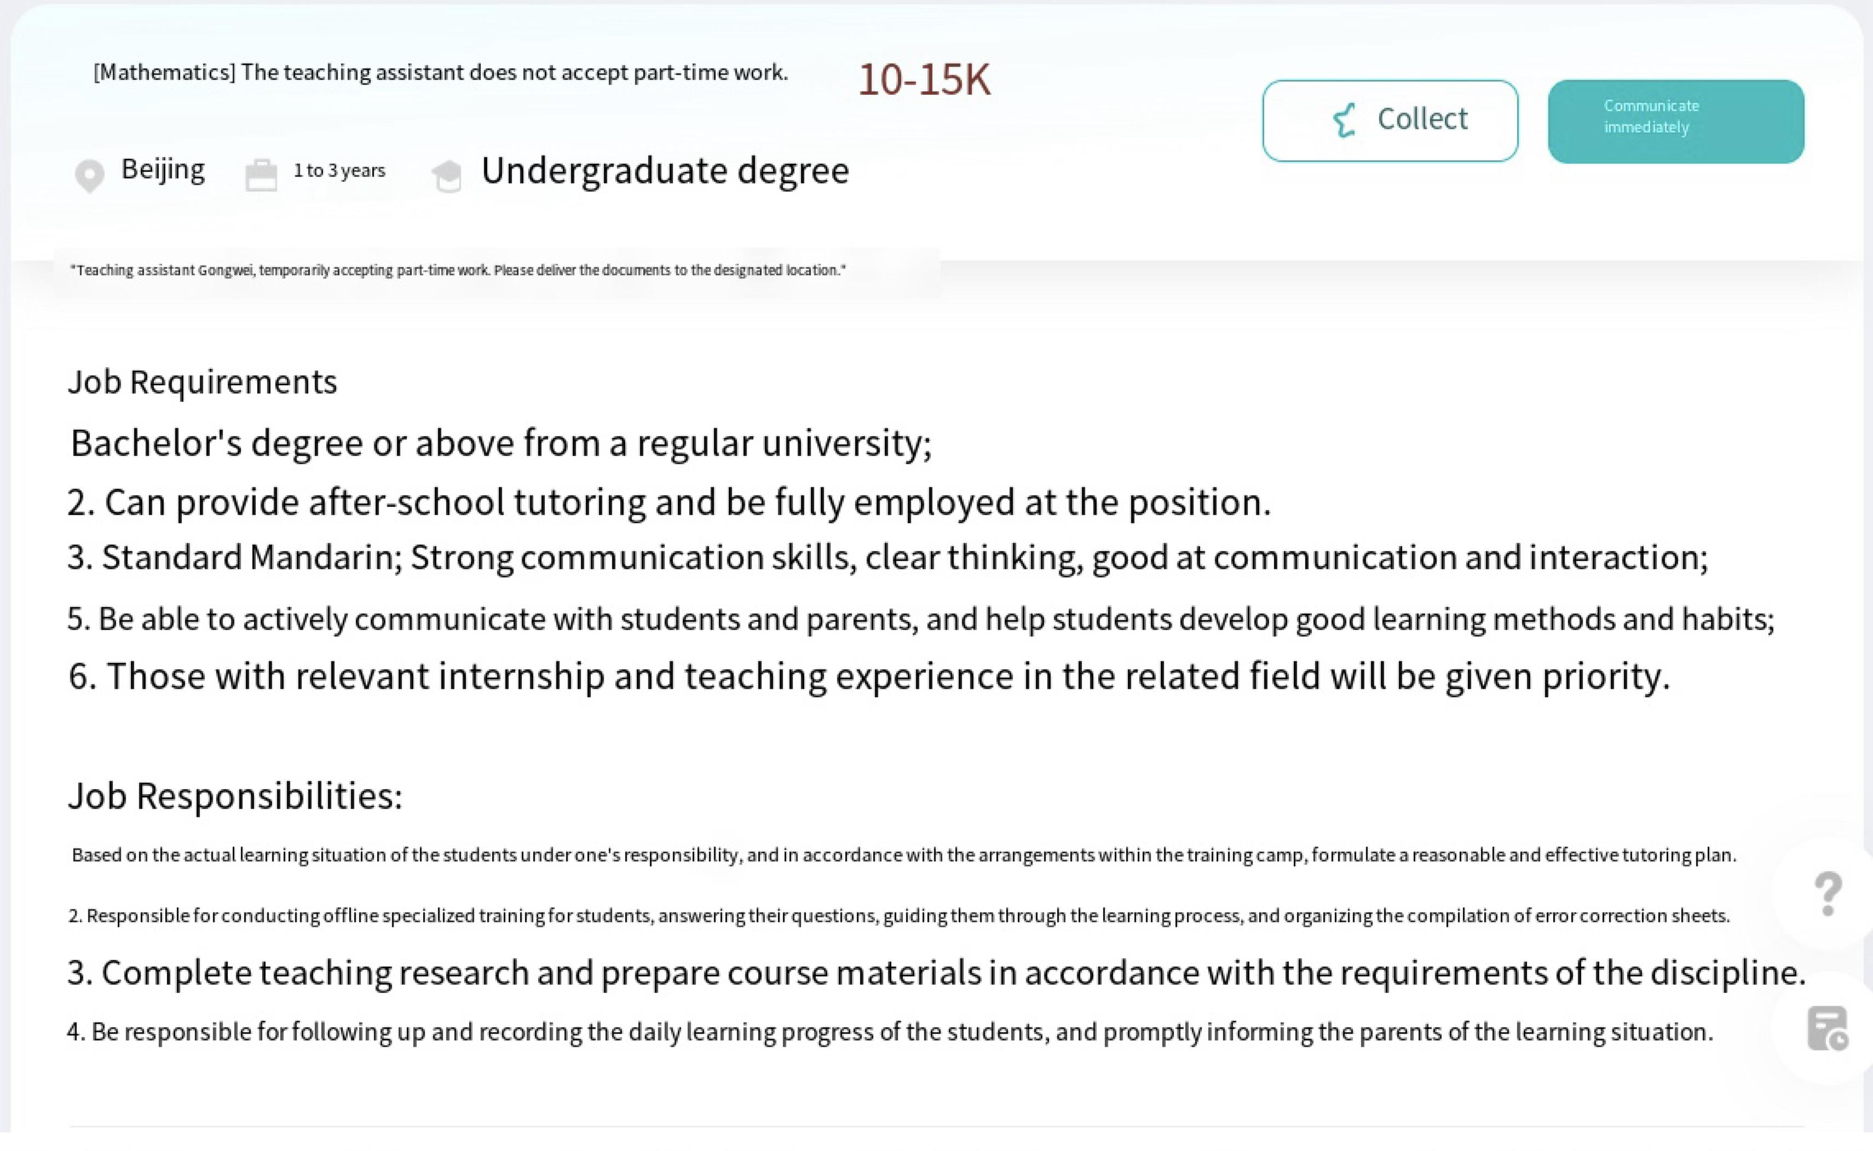

2.Questionnaire Survey

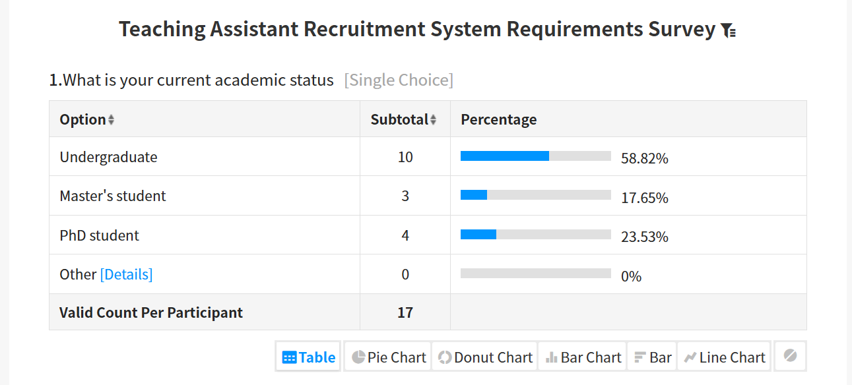

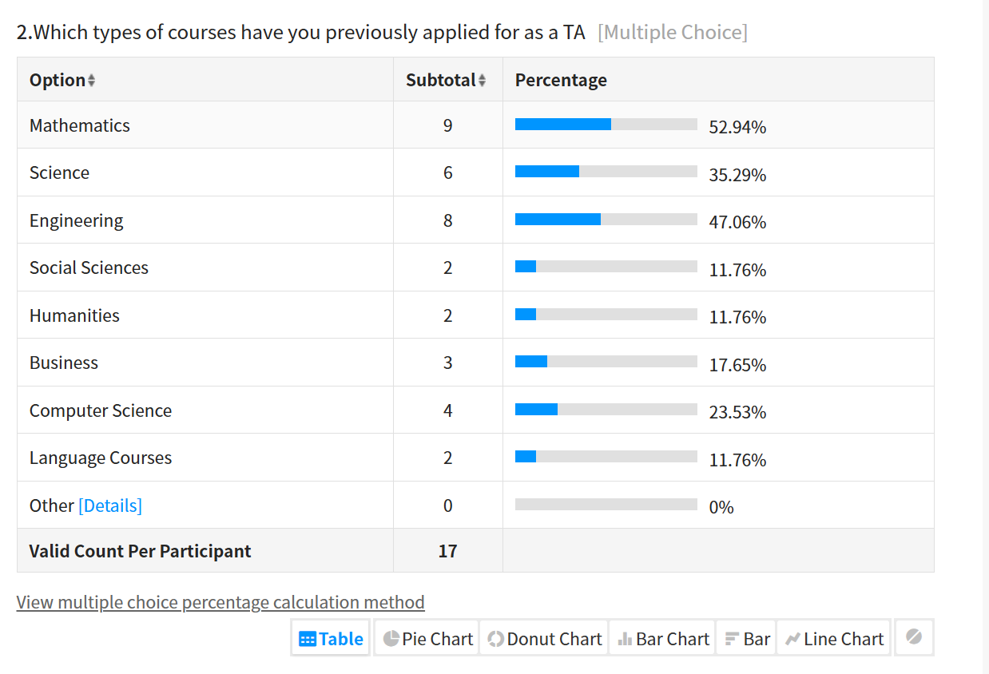

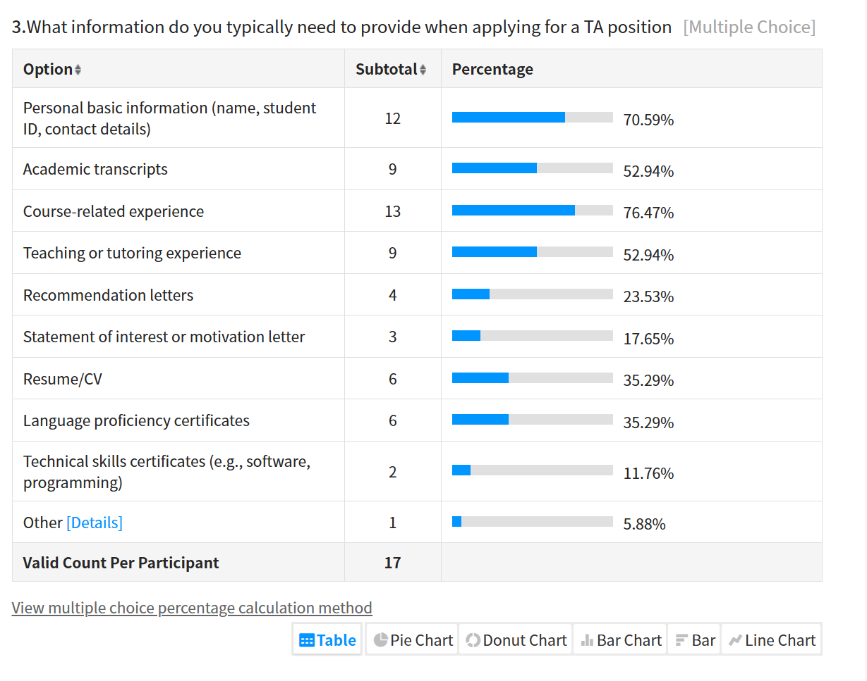
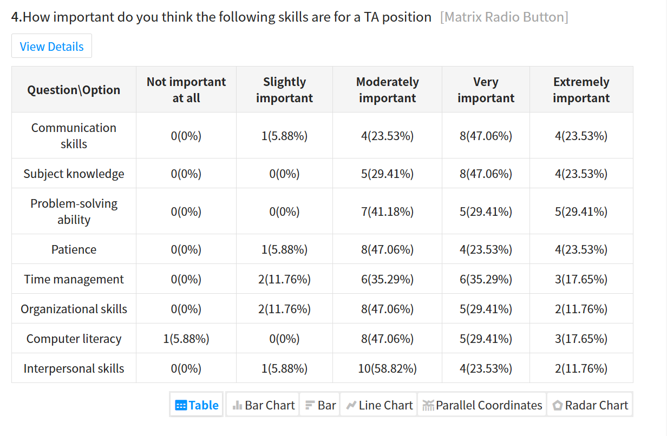
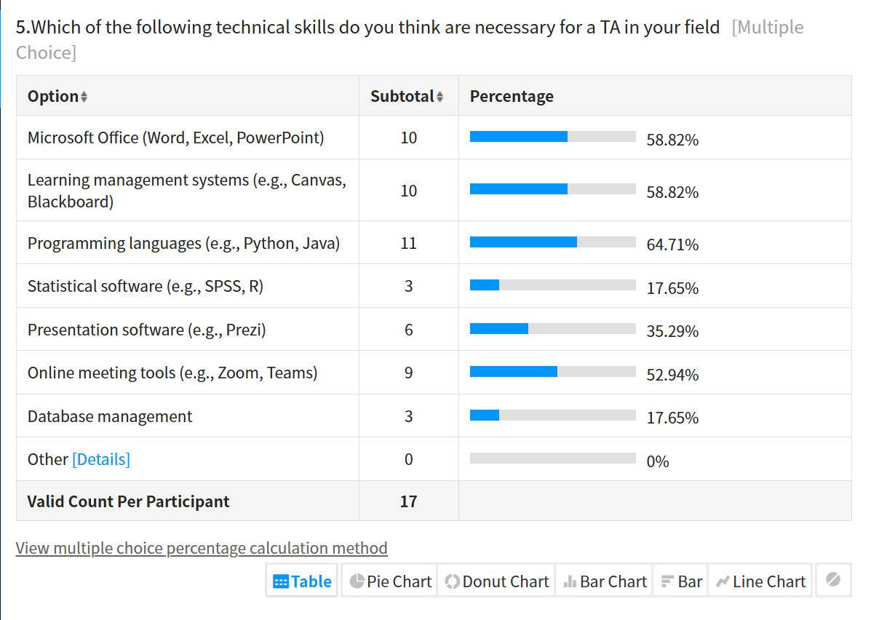

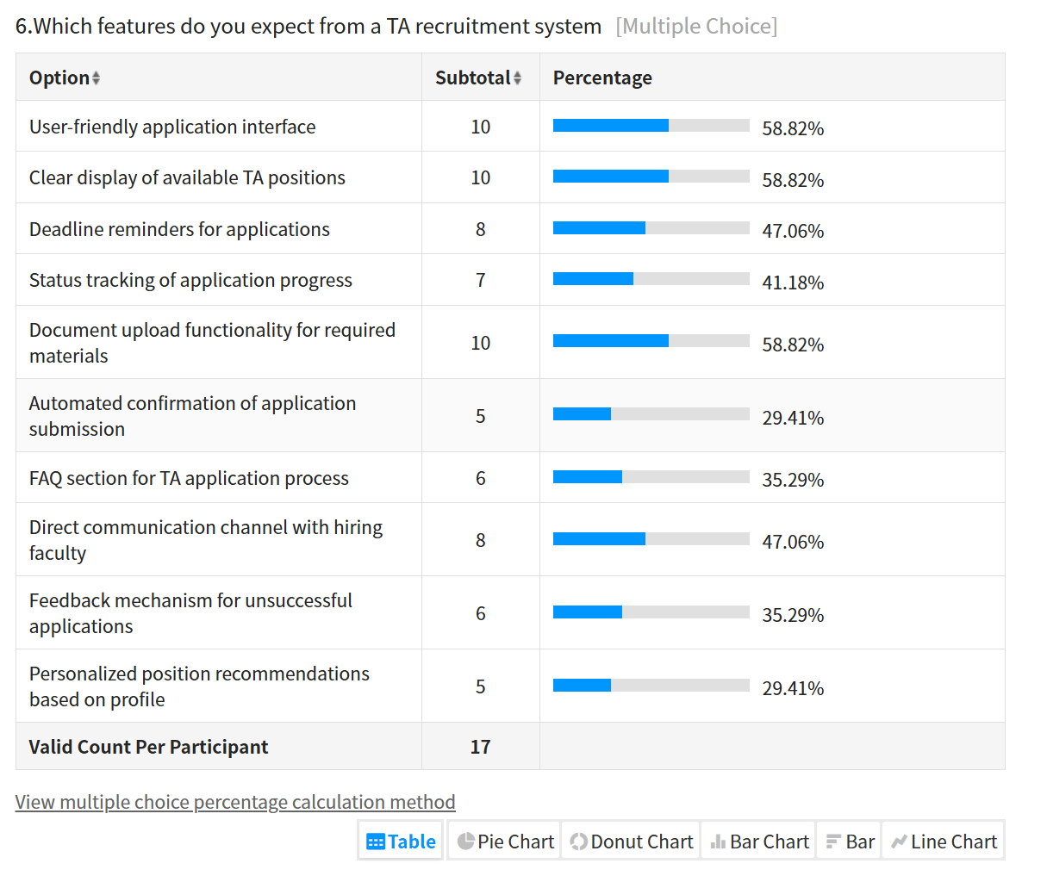
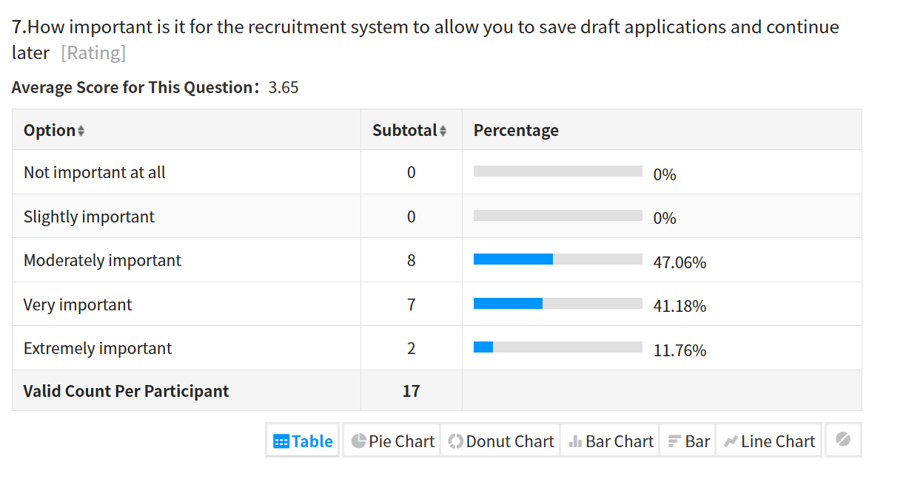

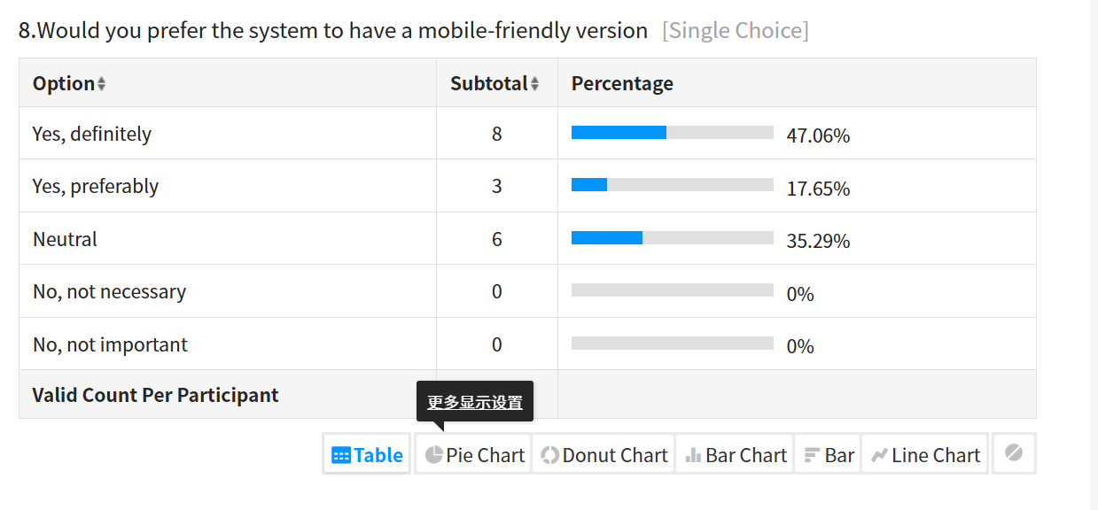

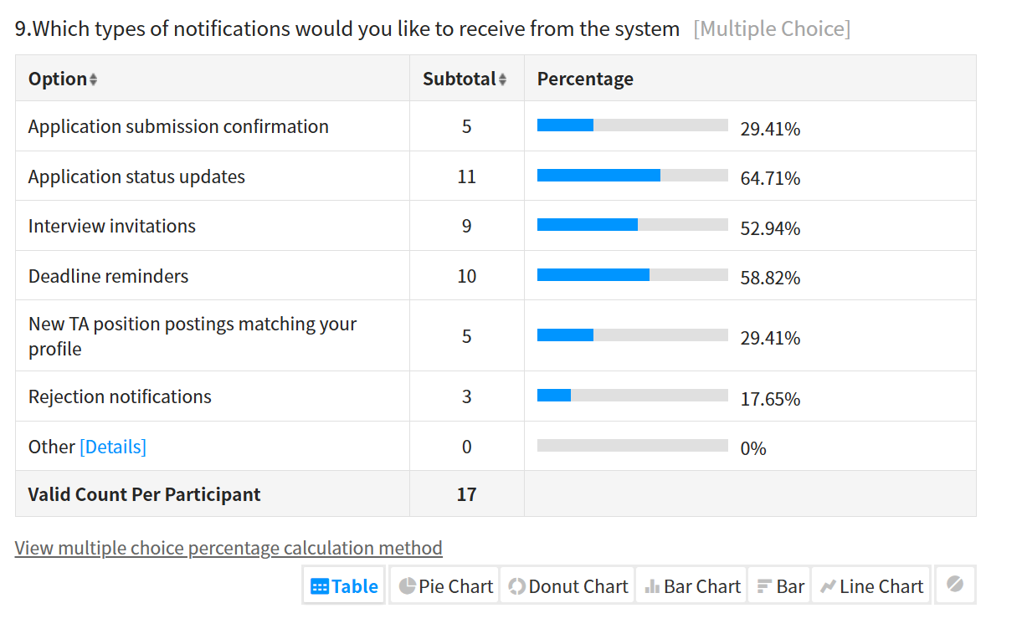
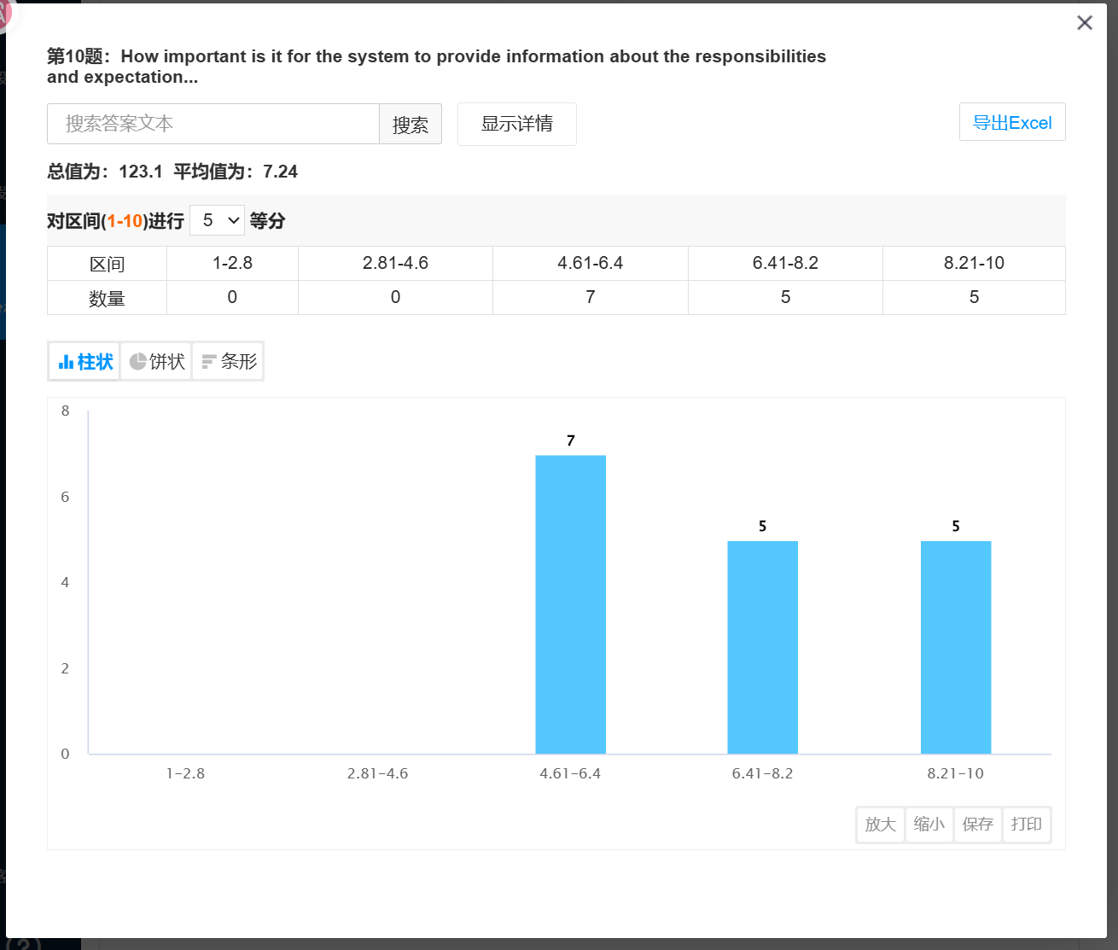

3.Observation of Existing Systems
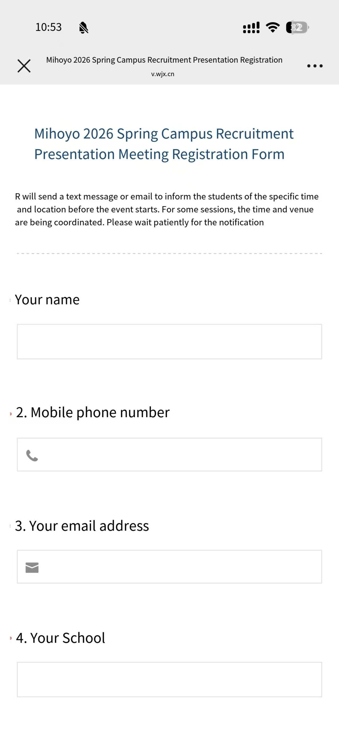
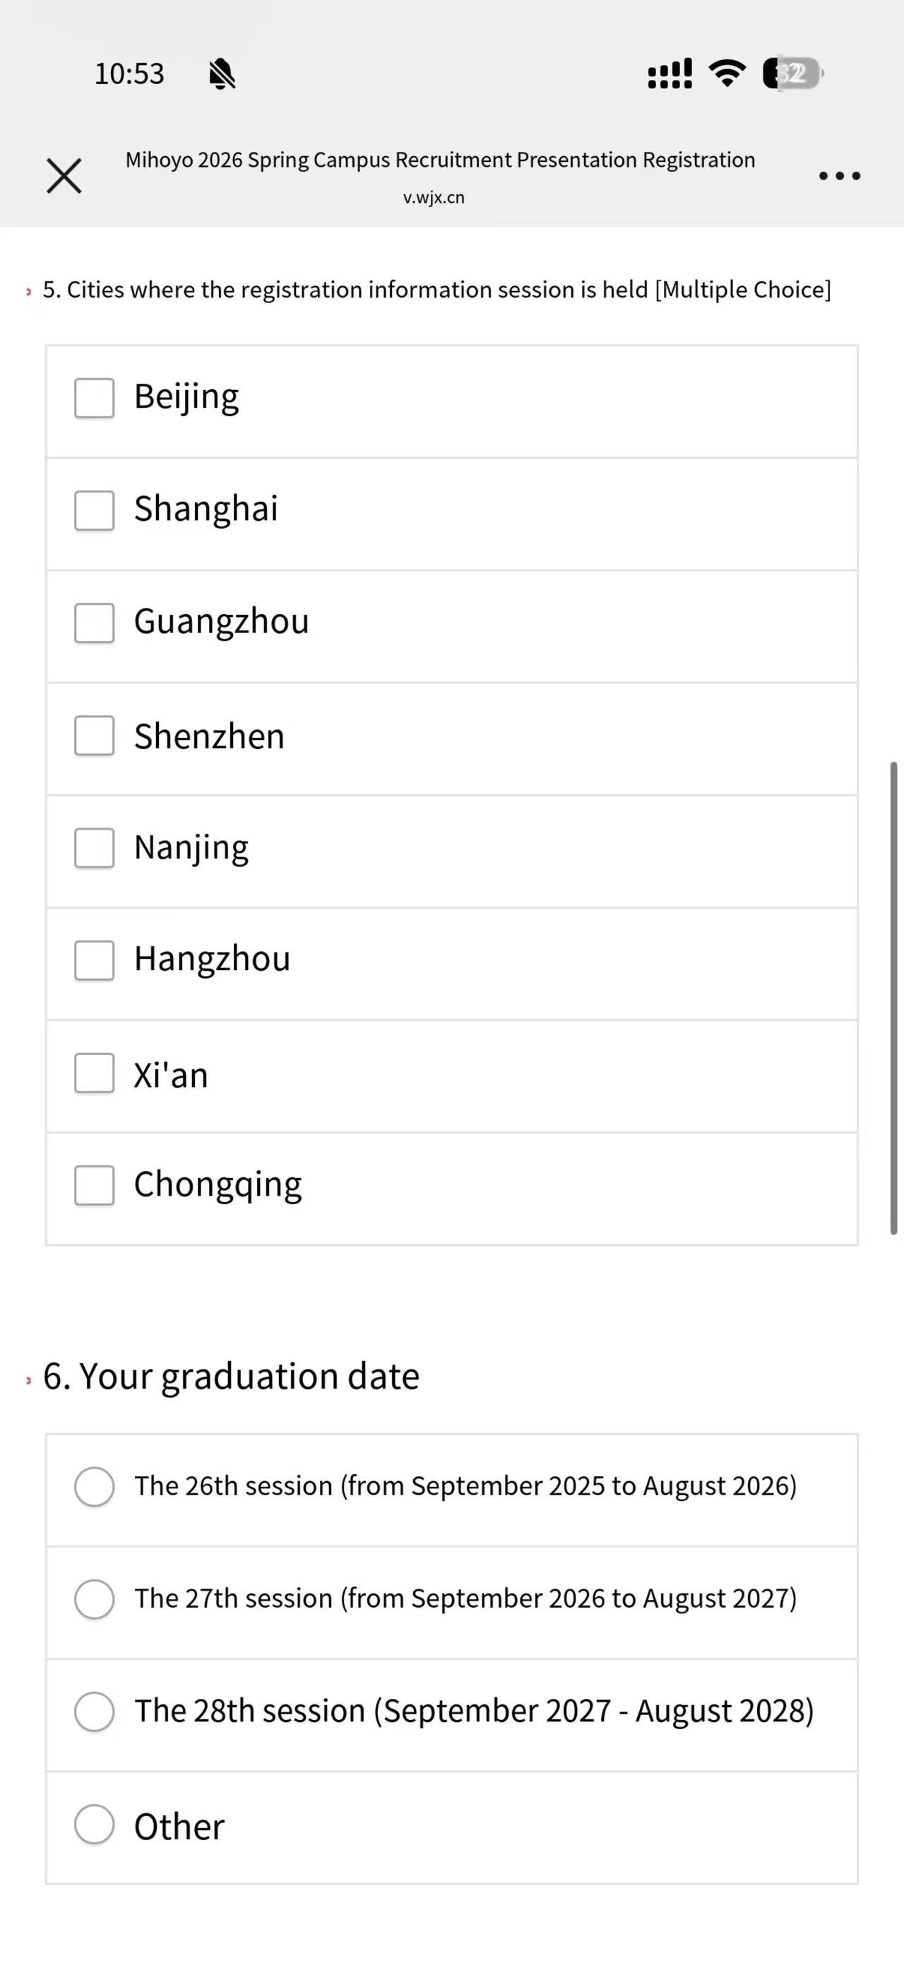
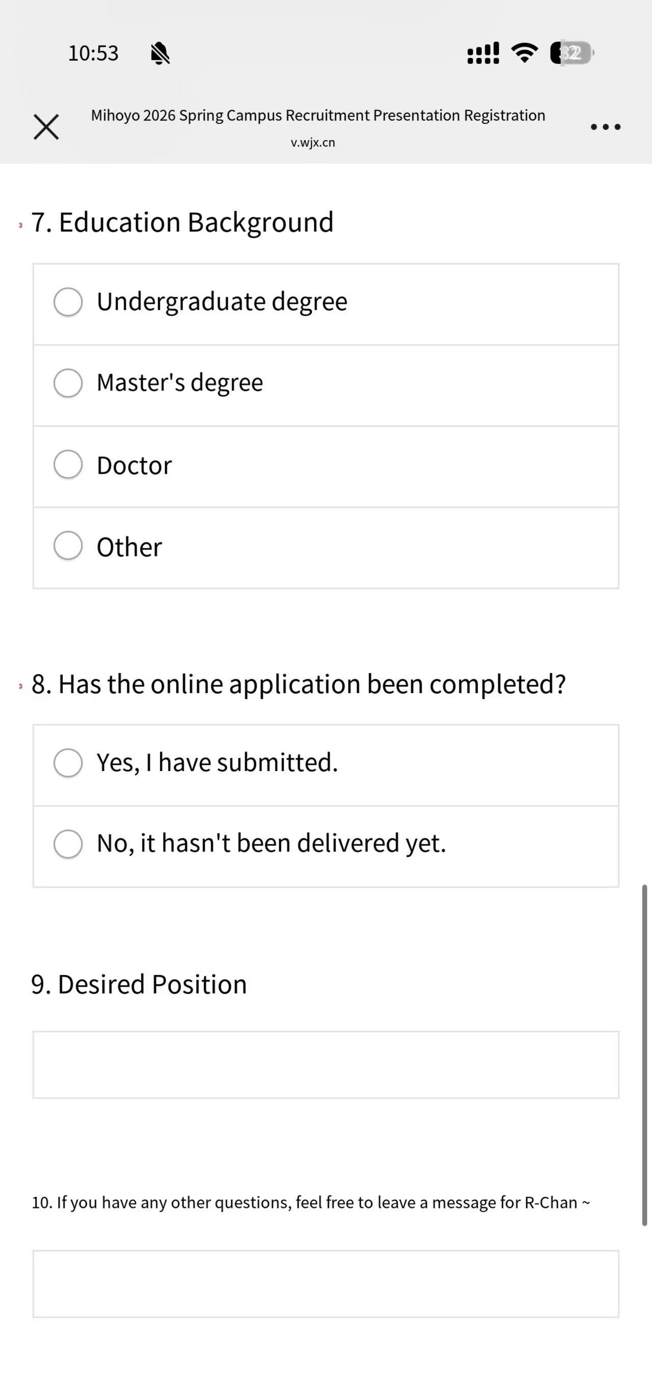
4.Interview Record

