Travis Waggoner

Southern New Hampshire University

GM-207

05/15/2022

Side Scroller

Changing the name of the text was simple when accessing it from the would outline and changing it with in that system.

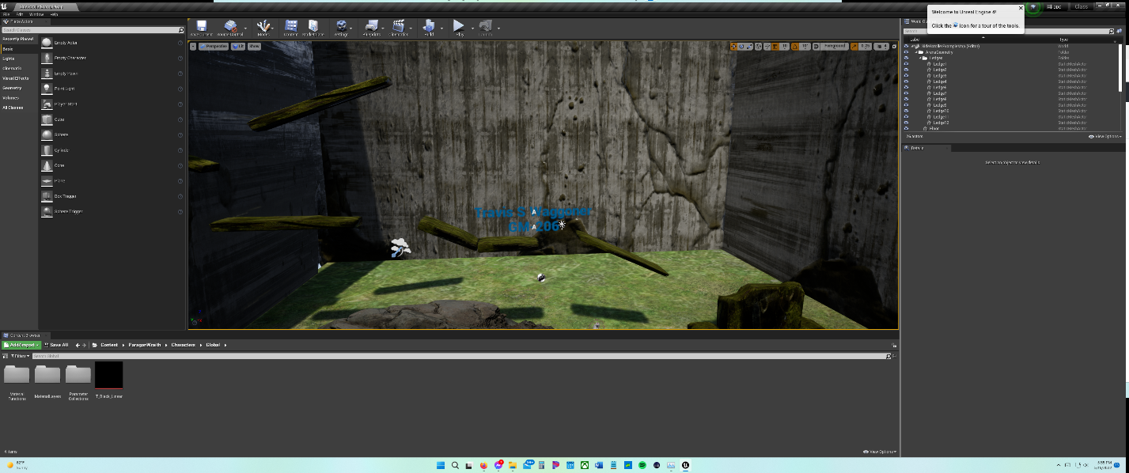

The inputs for the side scroller are set up for a joystick with the WASD being set up in the place of the joystick as well. There is also room for the space bar to be the jump button as well. Looking at the mouse there are no properties set up for the mouse.