**Documentation**

GitHub Link:

The solution that we used is using the object detection model specifically **YOLOv8.** The solution will cover data labelling, deployment and output. The programming language used is **Python**.

## Data Labelling

To train the model, we must label the data such as the object that we want the model to detect. In this case, the object that we want to label are people and label (tag). The tool that I used for data labelling is **Roboflow.**

For the label, we draw a bounding box to label it as ‘label’.

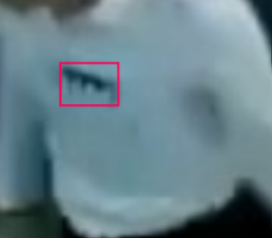

Figure 1: Label Labelling

**For the people, I assume that only the people who face forward will be useful for staff detection. This is because the label will appear in front of the chest. The label won't be seen for those people who have their backs turned to the camera Hence, the labelling for people will focus on these five people who show their chests mostly in the video.**

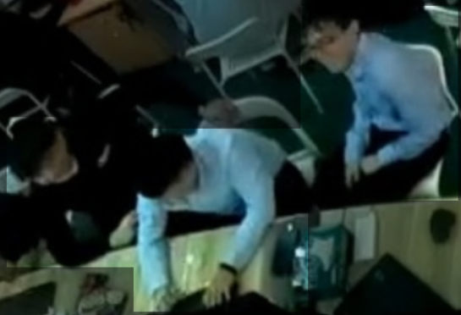 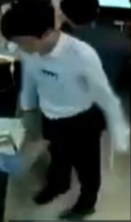

Figure 2 People Labelling

After finishing data labelling, I use Google Colab for model training as it provides free GPU.

## Deployment

In the deployment, I use the trained model in thescript. The video is looped inside the script using the OpenCV library and the model will detect the objects that have been trained in the video. Bounding boxes will be plotted around the object.

The task today is to identify the staff who wear the tag. **We can say that if the entire bounding box of the label is inside the people bounding box, then the people will be the staff.**

For the YOLO model, the coordinates of the bounding box for the top right corner and bottom left corner will be provided. Hence, we can determine whether the entire bounding box of the label is inside the people bounding box.

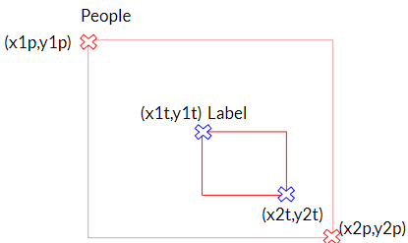

Figure 3: Example of Staff Identification

From the figure above, we can see that label is inside the people and the people is a staff. We can calculate using the coordinates provided.**If x1t is larger than the x1p, x2t is smaller than x2p, y1t is larger than y1p, y2t is smaller than y2p, then we can know that the bounding box of the label is inside the bounding box of people. Then, we change the label of the people to staff.** The output looks as below:

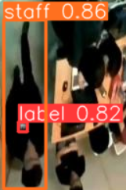

Figure 4: Example of Staff

## Output

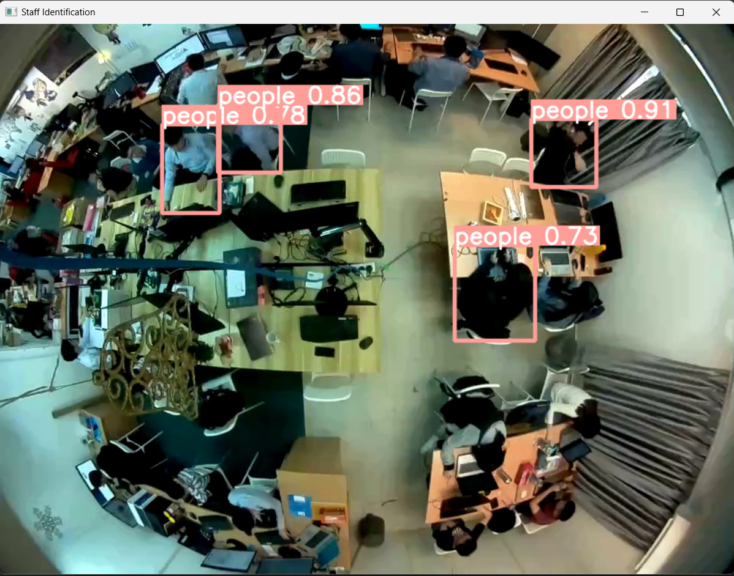

Figure 5 Output Window and Coordinates of Staff

The output is shown above. The staff will be identified for each frame and coordinates will be print out in terminal when staff is identified. **The confidence score can be manipulated in the code below.**



Figure 6: Detect Function