**LAB NO : 04**

***Name: Shahzaib Qadir***

***Subject: Software Engineering***

***Roll No : 2018-CS-150***

***6th Semester Batch 2018***

***SECTION : ‘6C’***

**EXECERCISE**

***Creating Data Flow Diagram***

1. Examine the following outline and then draw the diagram you think will model the situation. When a patient arrives at ABC Surgery with a repeat prescription request, the receptionist checks the prescription file and writes out a prescription. This has to be authorized by the doctor before being passed to the resident chemist for dispensing. The chemist then gives the prescription to the patient. If the patient is entitled to free prescriptions, the chemist verifies this and fills in the appropriate details on a form, which is filed in the free prescriptions file. Otherwise the chemist takes the appropriate amount of money from the patient and gives them a receipt.

**SOLVE:**

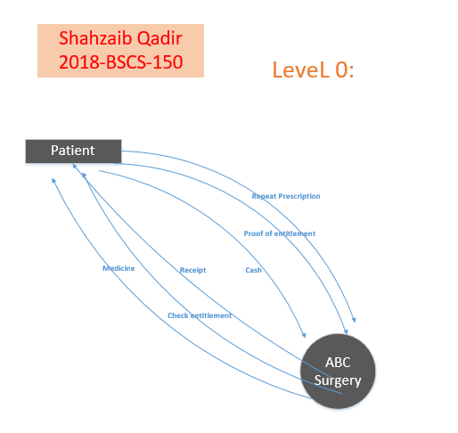

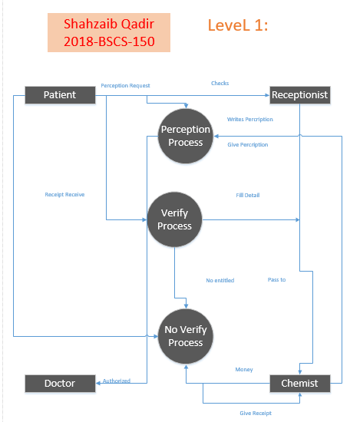

1. Suppose you are given the details of a small mail order catalogue system that allows people to shop from home. When a customer receives the catalogue and wants to buy something, they can telephone, fax or email their order to the company. The company gets the order and sends the goods and an invoice. When the customer receives the goods with a delivery note, they send payment and receive a receipt for their payment.

**SOLVE:**

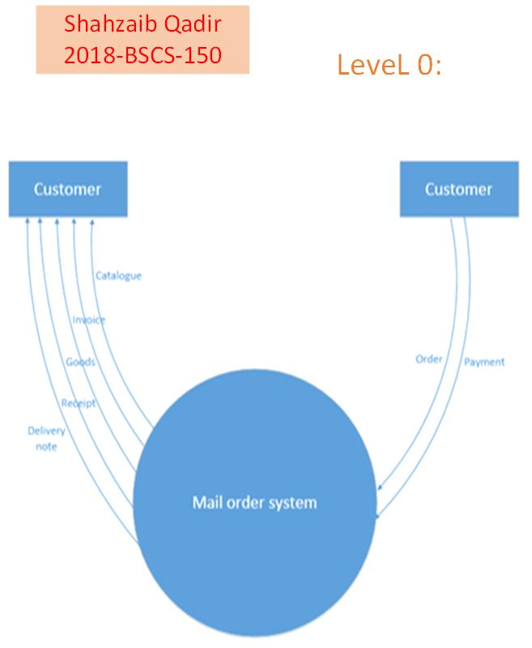

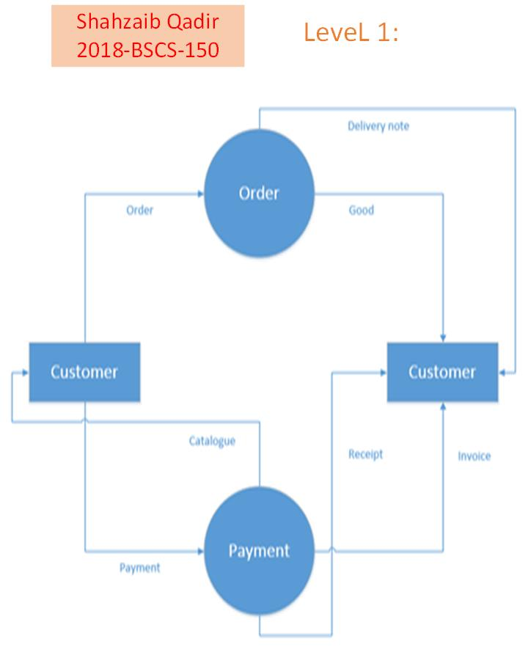

1. When FlashIT are interviewing and selecting new employees for their company, they ask applicants to send their application forms and their CVs to personnel. The personnel department then checks these forms for completeness and, if found to be complete, they are stored in the applications file. Otherwise these forms are returned to applicants for resubmission. Any candidates not considered suitable for the post are sent a refusal letter. Suitable candidates are requested to come in for interview. After interviews have taken place, a decision on the most suitable candidate is taken and they are offered the post. The interviewees who have been unsuccessful are sent a refusal letter.

**SOLVE:**

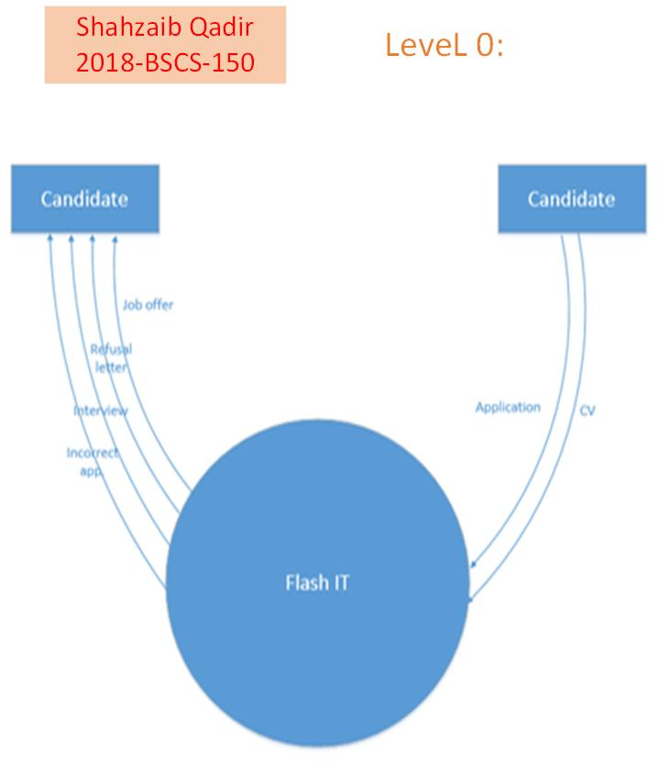

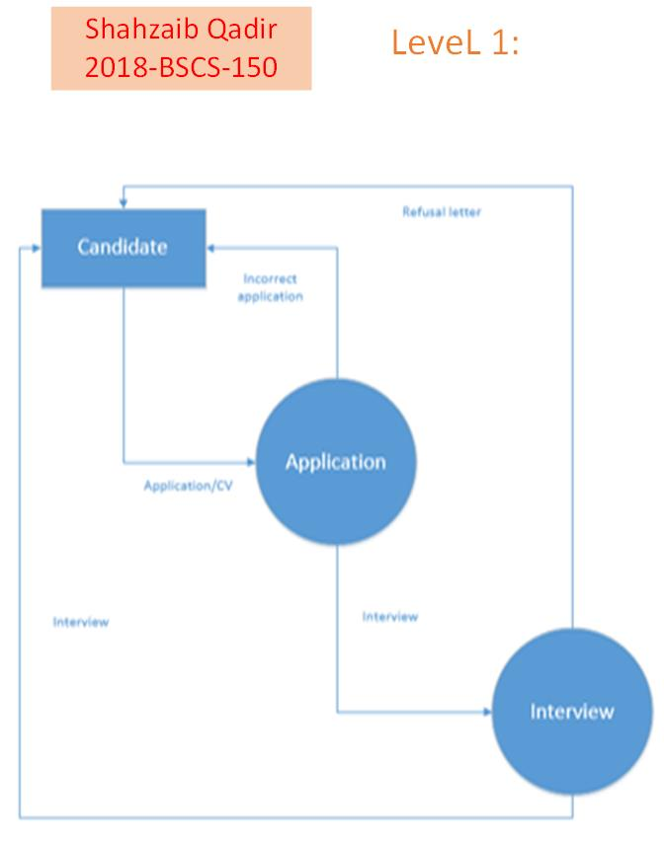

1. XYZ High School has a library that lends books to staff and students. Students are allowed to borrow six books and teachers are allowed to borrow ten. When someone borrows a book the library book file is updated, as is the borrower file. Everyone issued with a book has it for a period of one month, after which time they are sent a reminder. If, after six months, they haven't returned the book, they are sent a bill for the cost of recovery of the book.

**SOLVE:**

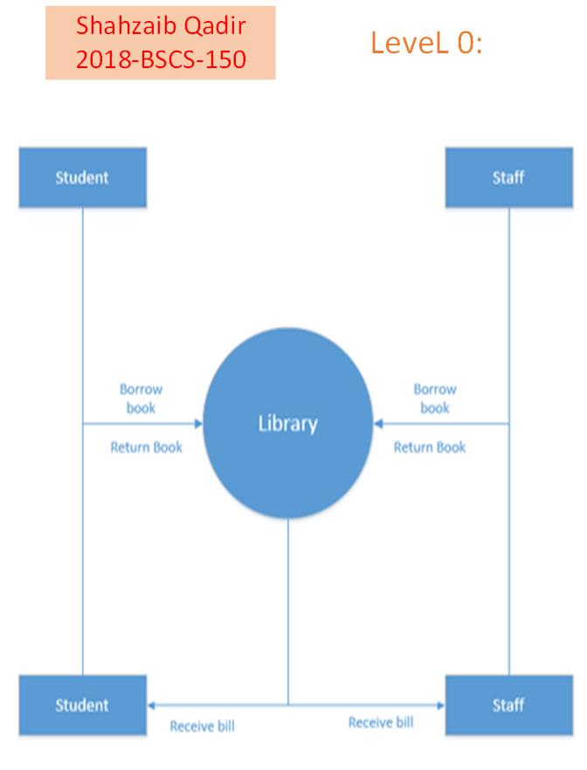

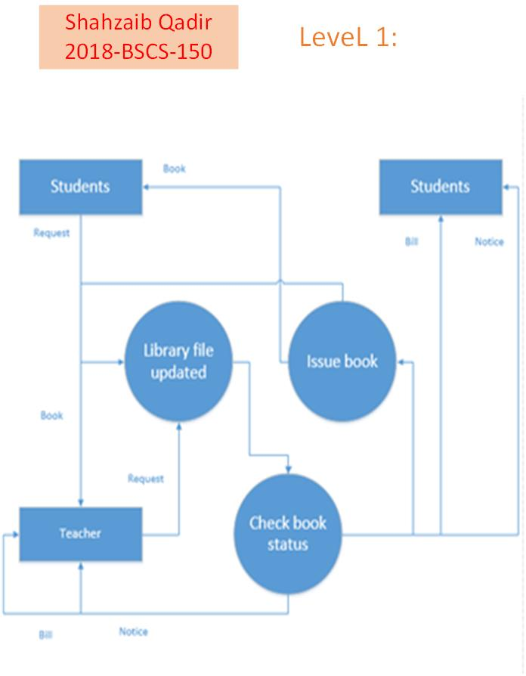

1. A system is required which allows a user to input an unordered list of integer numbers into a computer. The system will store these numbers in the main store of the computer where they are to be sorted by the system into ascending numeric order and re-stored. Finally the system is to print out the list for the user.

**SOLVE:**

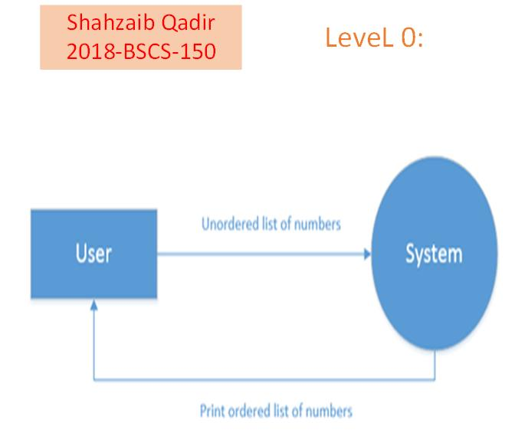

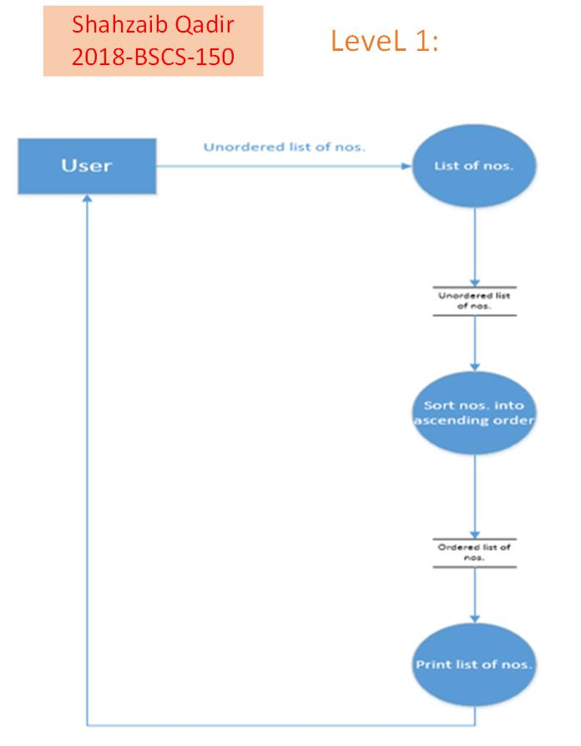

1. Draw the DFD for Education University. The enrolment process works as follows:

Students send in an application form containing their personal details and their desired course The University checks that the course is available and that the student has necessary academic qualifications. If the course is available the student is enrolled in the course, and the university confirms the enrolment by sending a confirmation letter to the student. If the course is unavailable the student is sent a rejection letter.

**SOLVE:**

