LAB # 03
Objectives
- Introduction to ERD.
- Entity Relationship Diagrams: discovering and design the cases.
The Entity Relationship Diagrams (ERD)
An Entity Relationship Diagram (ERD) is a visual representation of different data using conventions that describe how these data are related to each other.
For example, the elements writer, novel, and consumer may be described using ER diagrams this way:
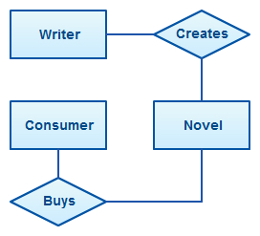
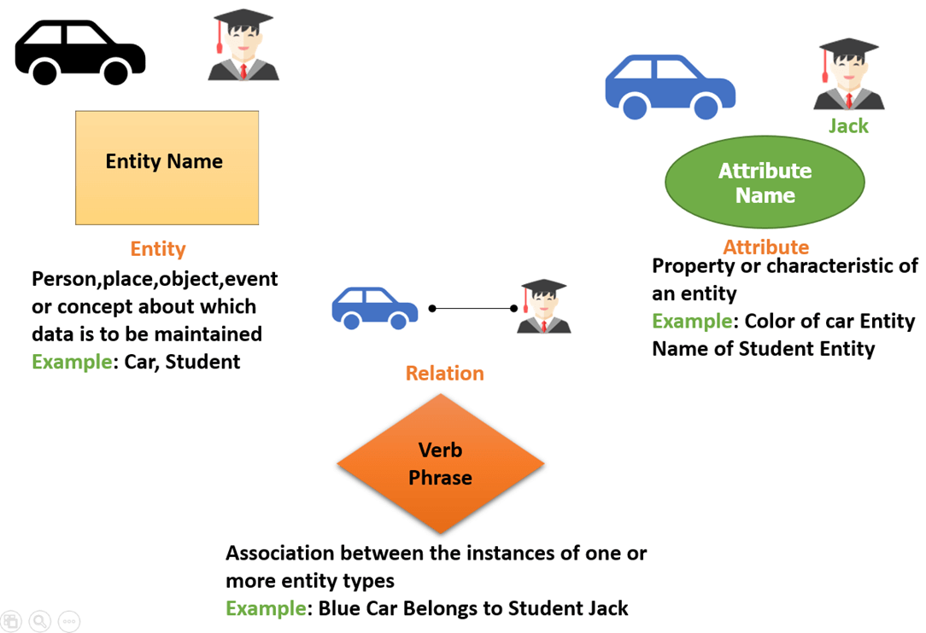
ENTITY RELATIONAL (ER) MODEL is a high-level conceptual data model diagram. ER modeling helps you to analyze data requirements systematically to produce a well-designed database. The Entity-Relation model represents real-world entities and the relationship between them. It is considered a best practice to complete ER modeling before implementing your database.
ER DIAGRAMS USAGE While able to describe just about any system, ER diagrams are most often associated with complex databases that are used in software engineering and IT networks. In particular, ER diagrams are frequently used during the design stage of a development process in order to identify different system elements and their relationships with each other. For example, an inventory software used in a retail shop will have a database that monitors elements such as purchases, item, item type, item source and item price. Rendering this information through an ER diagram would be something like this:
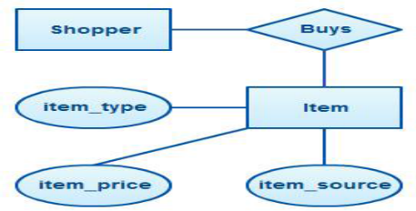
ER diagram example with entity having attributes
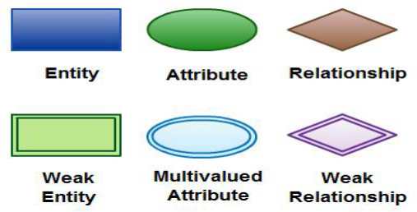
In the diagram, the information inside the oval shapes are attributes of a particular entity.

Use of ER Diagrams.
Here, are prime reasons for using the ER Diagram
- Helps you to define terms related to entity relationship modeling
- Provide a preview of how all your tables should connect, what fields are going to be on each table
- Helps to describe entities, attributes, relationships
- ER diagrams are translatable into relational tables which allows you to build databases quickly
- ER diagrams can be used by database designers as a blueprint for implementing data in specific software applications
- The database designer gains a better understanding of the information to be contained in the database with the help of ERP diagram
- ERD is allowed you to communicate with the logical structure of the database to users

Components of the ER Diagram

This model is based on three basic concepts:

Entities

Attributes

Relationships

Entities
An entity can be a person, place, event, or object that is relevant to a given system. For example, a school system may include students, teachers, major courses, subjects, fees, and other items. Entities are represented in ER diagrams by a rectangle and named using singular nouns.
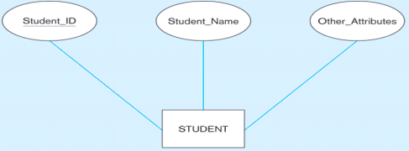

Example

For example, in a University database, we might have entities for Students, Courses, and Lecturers. Student’s entity can have attributes like roll no, Name, and Dept. ID. They might have relationships with Courses and Lecturers.
Examples of entities:
Person: Employee, Student, Patient
Place: Store, Building
Object: Machine, product, and Car
Event: Sale, Registration, Renewal
Concept: Account, Course

Attribute
An attribute is a property, trait, or characteristic of an entity, relationship, or another attribute. For example, the attribute Inventory Item Name is an attribute of the entity Inventory Item. An entity can have as many attributes as necessary. Meanwhile, attributes can also have their own specific attributes. For example, the attribute “customer address” can have the attributes number, street, city, and state. These are called composite attributes. Note that some top level ER diagrams do not show attributes for the sake of simplicity. In those that do, however, attributes are represented by oval shapes.

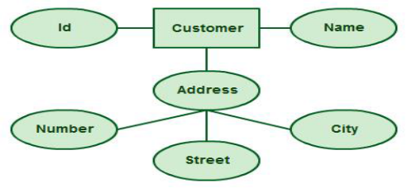

Relationship
A relationship describes how entities interact. For example, the entity “carpenter” may be related to the entity “table” by the relationship “builds” or “makes”. Relationships are represented by diamond shapes and are labeled using verbs.
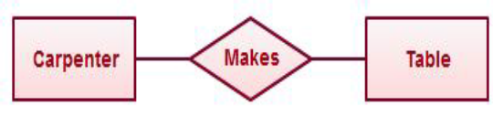

ER Diagrams Usage
While able to describe just about any system, ER diagrams are most often associated with complex databases that are used in software engineering and IT networks. In particular, ER diagrams are frequently used during the design stage of a development process in order to identify different system elements and their relationships with each other. For example, an inventory software used in a retail shop will have a database that monitors elements such as purchases, item, item type, item source and item price. Rendering this information through an ER diagram would be something like this:

Example-1
Student and College relationship

We have two entities Student and College and their relationship. The relationship between Student and College is many to one as a college can have many students however a student cannot study in multiple colleges at the same time. Student entity has attributes such as Stu_Id, Stu_Name & Stu_Addr and College entity has attributes such as Col_ID & Col_Name.

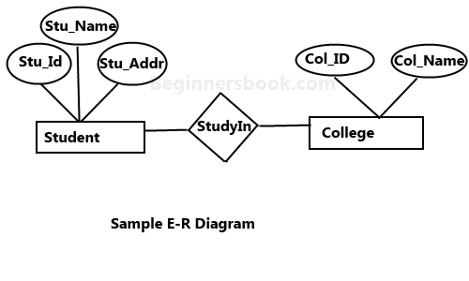

Example -2

A company database needs to store information about employees (identified by ssn, with salary and phone as attributes), departments (identified by dno, with dname and budget as attributes), and children of employees (with name and age as attributes).
Employees work in departments; each department is managed by an employee; a child must be identified uniquely by name when the parent (who is an employee; assume that only one parent works for the company) is known. We are not interested in information about a child once the parent leaves the company.

First, we shall design the entities and relationships. o “Employees work in departments…” o “…each department is managed by an employee…” o “…a child must be identified uniquely by name when the parent (who is an employee; assume that only one parent works for the company) is known.”

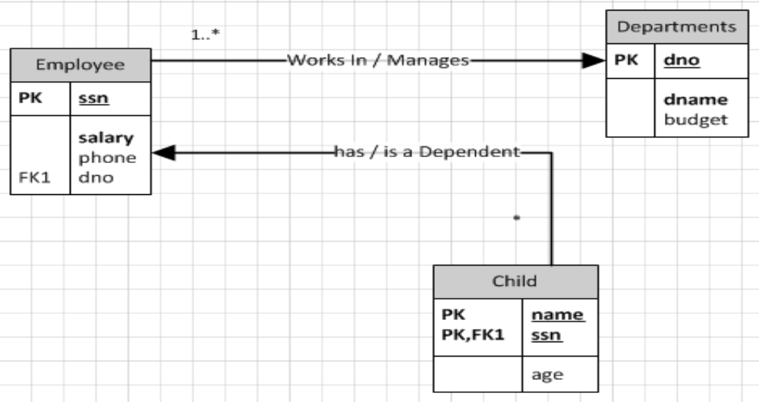

Example -3

ERD for a car dealership.

The dealership sells both new and used cars, and it operates a service facility (see Figure B.2). Base your design on the following business rules:
- A salesperson may sell many cars, but each car is sold by only one salesperson.
- A customer may buy many cars, but each car is bought by only one customer.
- A salesperson writes a single invoice for each car he or she sells.
- A customer gets an invoice for each car he or she buys.
- A customer may come in just to have his or her car serviced; that is, a customer need not buy a car to be classified as a customer.
- When a customer takes one or more cars in for repair or service, one service ticket is written for each car.
- The car dealership maintains a service history for each of the cars serviced. The service records are referenced by the car’s serial number.
- A car brought in for service can be worked on by many mechanics, and each mechanic may work on many cars.
- A car that is serviced may or may not need parts (e.g., adjusting a carburettor or cleaning a fuel injector nozzle does not require providing new parts).

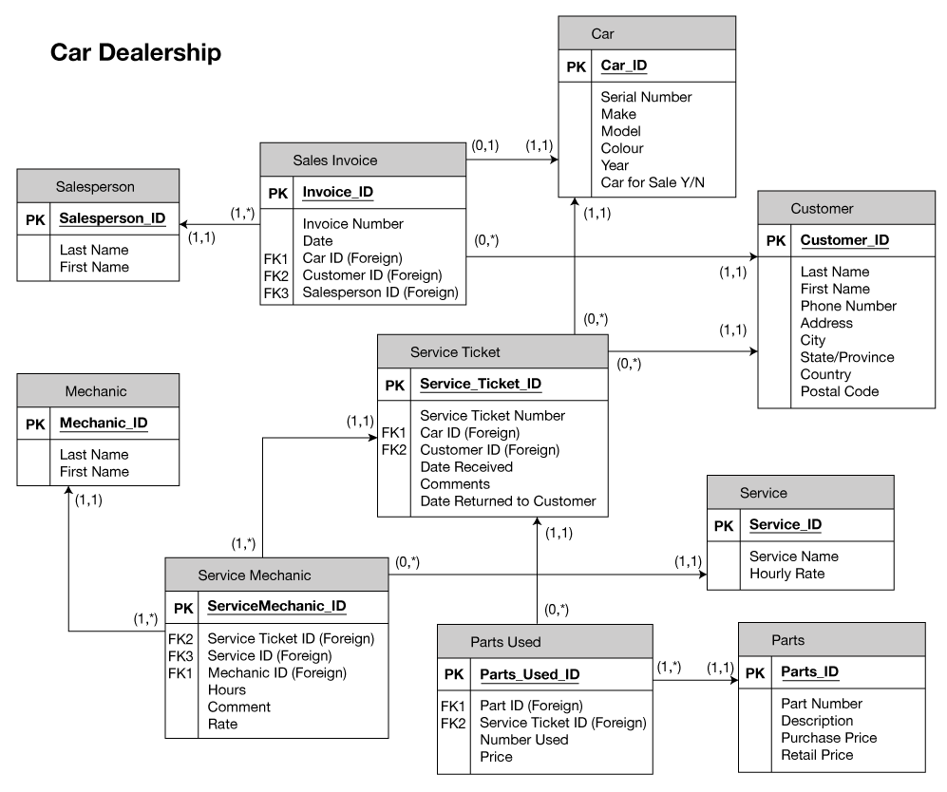

Exercise

Q.1
Draw an ERD for the following description:Each department has a unique name, aunique number, and a particular employe who manages the department. We keep track of the start date when that employee began managing the department. A department may have several locations.

Q2
Draw an ERD for the following description:A department controls a number of projects,each of which has a unique name, a unique number, and a single location.

Q3
Draw an ERD for the following description:
We store each employee’s name (first, last, MI), Social Security number (SSN), street address, salary, sex (gender), and birth date. An employee is assigned to one department, but may work on several projects, which are not necessarily controlled by the same department.
We keep track of the current number of hours per week that an employee works on each project. We also keep track of the direct supervisor of each employee (who is another employee).

Q4
Draw an ERD for the following description:We want to keep track of the dependents ofeach employee for insurance purposes. Wekeep each dependent’s first name, sex, birth date, and relationship to the employee. February 11,

Q5
Define the ERD.

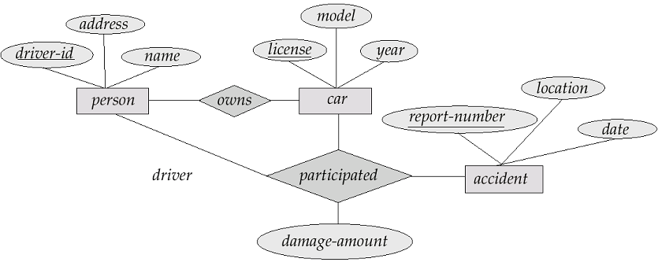

Q5
- A company database needs to store information about employees (identified by ssn, with salary and phone as attributes), departments (identified by dno, with dname and budget as attributes), and children of employees (with name and age as attributes).

- Employees work in departments; each department is managed by an employee; a child must be identified uniquely by name when the parent (who is an employee; assume that only one parent works for the company) is known. We are not interested in information about a child once the parent leaves the company.
- Draw an ER diagram that captures this information.

- Employees work in departments; each department is managed by an employee; a child must be identified uniquely by name when the parent (who is an employee; assume that only one parent works for the company) is known. We are not interested in information about a child once the parent leaves the company.
- Draw an ER diagram that captures this information.

Hint
- First, we shall design the entities and relationships.
- “Employees work in departments…”
- “…each department is managed by an employee…”
- “…a child must be identified uniquely by name when the parent (who is an employee; assume that only one parent works for the company) is known.”

Hint
- Now, we will design the constraints.
- “…each department is managed by an employee…”
- “…a child must be identified uniquely by name when the parent (who is an employee; assume that only one parent works for the company) is known. “
- “We are not interested in information about a child once the parent leaves the company.”

Q.6
Although you always wanted to be an artist, you ended up being an expert on databases because you love to cook data and you somehow confused database with data baste. Your old love is still there, however, so you set up a database company, ArtBase, that builds a product for art galleries. The core of this product is a database with a schema that captures all the information that galleries need to maintain.

- Galleries keep information about artists, their names (which are unique), birthplaces, age,and style of art. For each piece of artwork, the artist, the year it was made, its unique title, its type of art (e.g., painting, lithograph, sculpture, photograph), and its price must be stored. Pieces of artwork are also classified into groups of various kinds, for example, portraits, still lifes, works by Picasso, or works of the 19th century; a given piece may belong to more than one group.

- Each group is identified by a name (like those just given) that describes the group. Finally, galleries keep information about customers. For each customer, galleries keep that person’s unique name, address, total amount of dollars spent in the gallery (very important!), and the artists and groups of art that the customer tends to like.
- Draw the ER diagram for the database.

Hint
- Like before, we begin with the entities and relationships.
- “…artists, their names (which are unique), birthplaces, age, and style of art.”
- “For each piece of artwork, the artist, the year it was made, its unique title, its type of art … and its price must be stored.”

Hint
- “Pieces of artwork are also classified into groups of various kinds, … Each group is identified by a name (like those just given) that describes the group. “

- For each customer, galleries keep that person’s unique name, address, total amount of dollars spent in the gallery (very important!), and the artists and groups of art that the customer tends to like.

Hint
- Now we look at constraints.

- Although not explicitly mentioned in the problem, we assume that each piece of artwork had to be painted by an artist.

- We also assume that each piece of artwork was created by exactly one artist.

Hint
- Suppose we had several piece of artwork with the same title, and we told them apart by artist?
- Example: “What is Love?” by Cheryl D, “What is Love?” by Joe Brown, etc.
Q.7
Consider the scenario from Exercise 2.4, where you designed an ER diagram for a company database. Write SQL statements to create the corresponding relations and capture as many of the constraints as possible. If you cannot capture some constraints, explain why.

Hint
- First we begin with the entities “Employees” and “Departments.
- Translating these to SQL is straightforward.

