**LAB # 03**

**Software engineering**

***Entity Relationship Diagrams (ERD)* :-**

**Exercise**

Q.1) Draw an ERD for the following descriptions Each department has a unique name, a unique number, and a particular employee who manages the department. We keep track of the start date when that employee began managing the department. A department may have several locations.

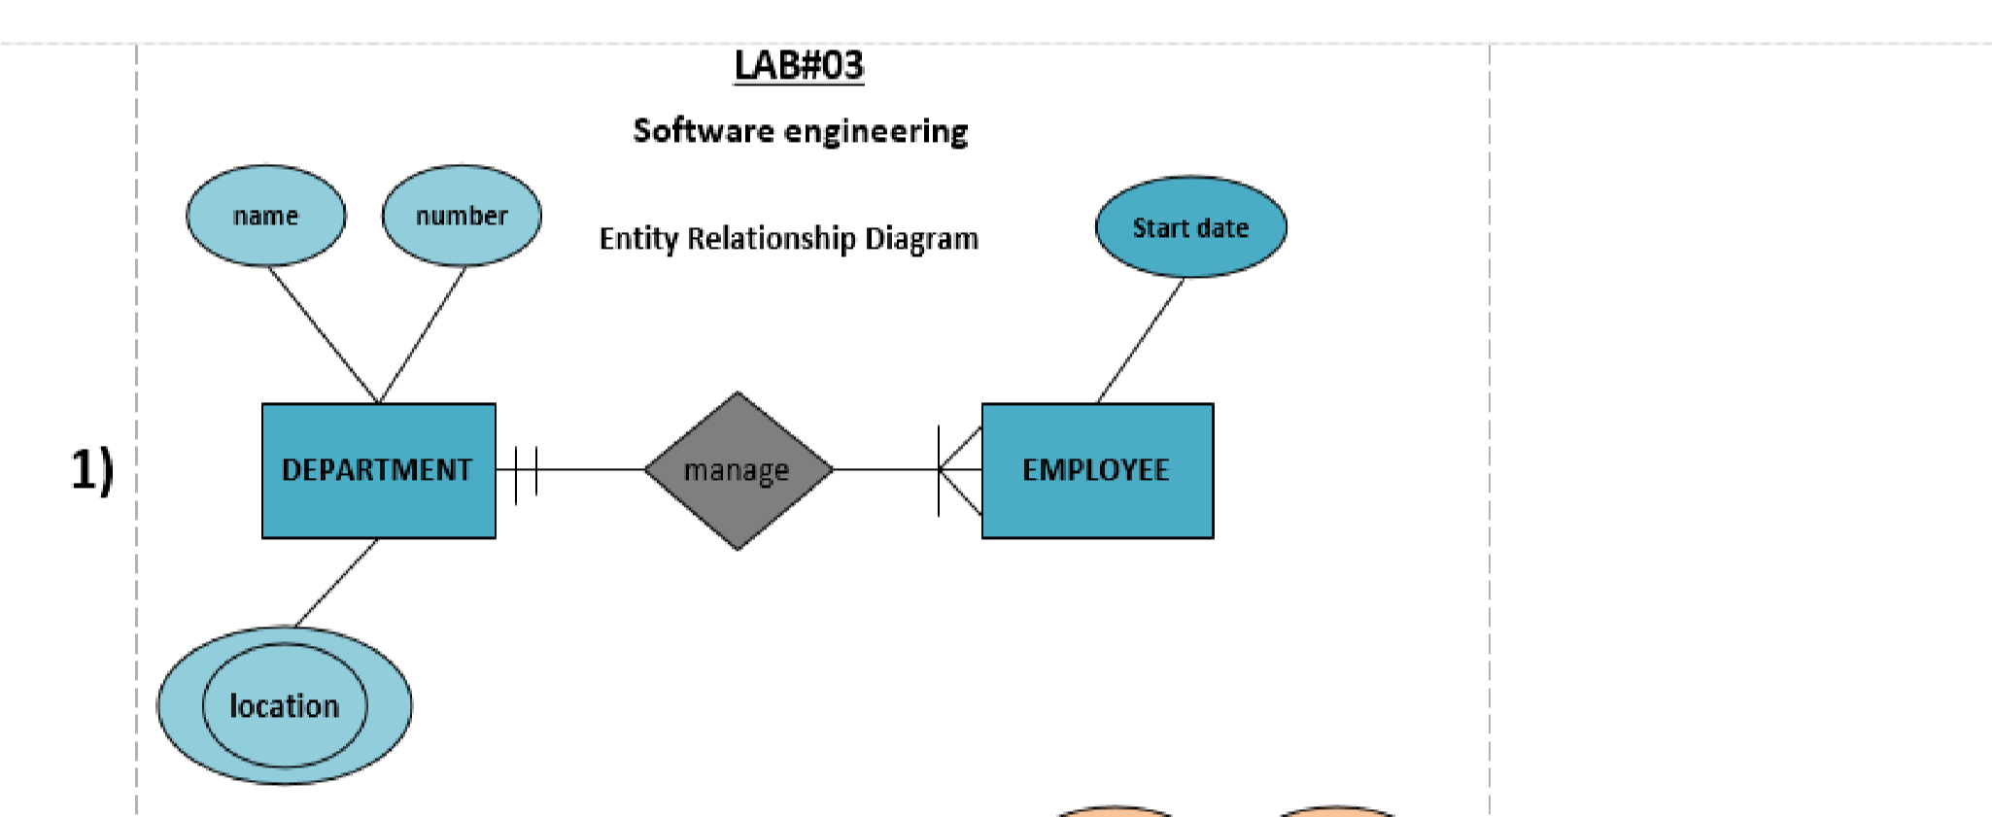

Q2) Draw an ERD for the following descriptions. A department controls a number of projects, each of which has a unique name, a unique number, and a single location.

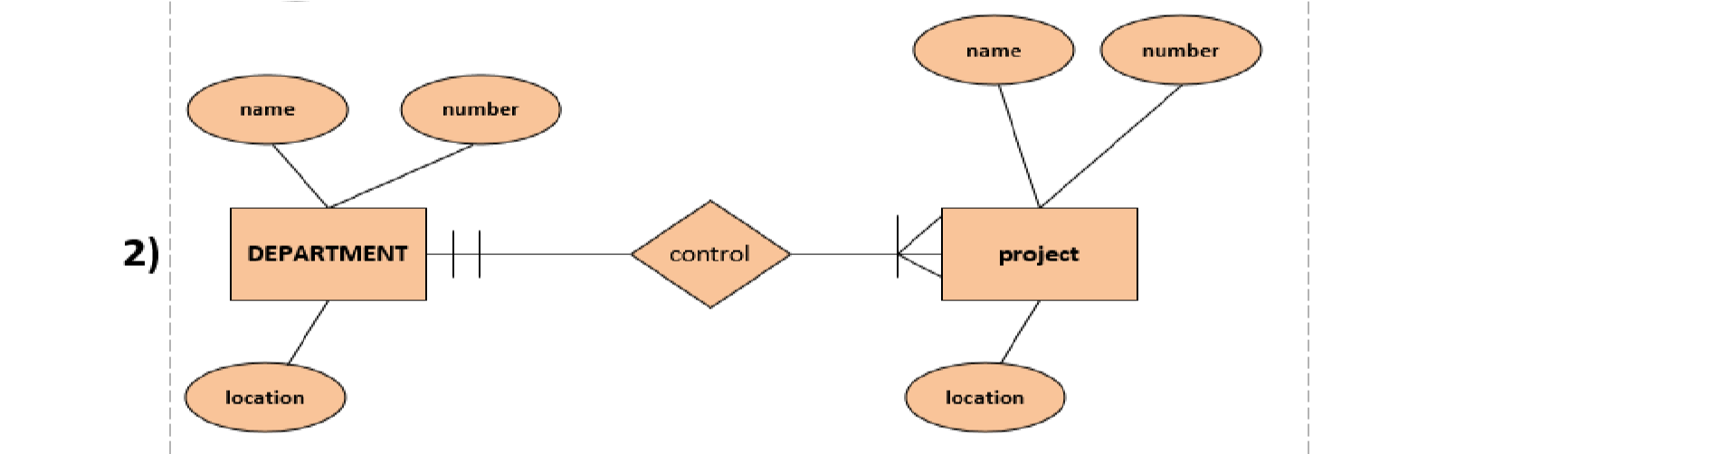

Q3) Draw an ERD for the following description:

We store each employee’s name (first, last, MI), Social Security number (SSN), street address, salary, sex (gender), and birth date. An employee is assigned to one department, but may work on several projects, which are not necessarily controlled by the same department.

We keep track of the current number of hours per week that an employee works on each project. We also keep track of the direct supervisor of each employee (who is another employee).

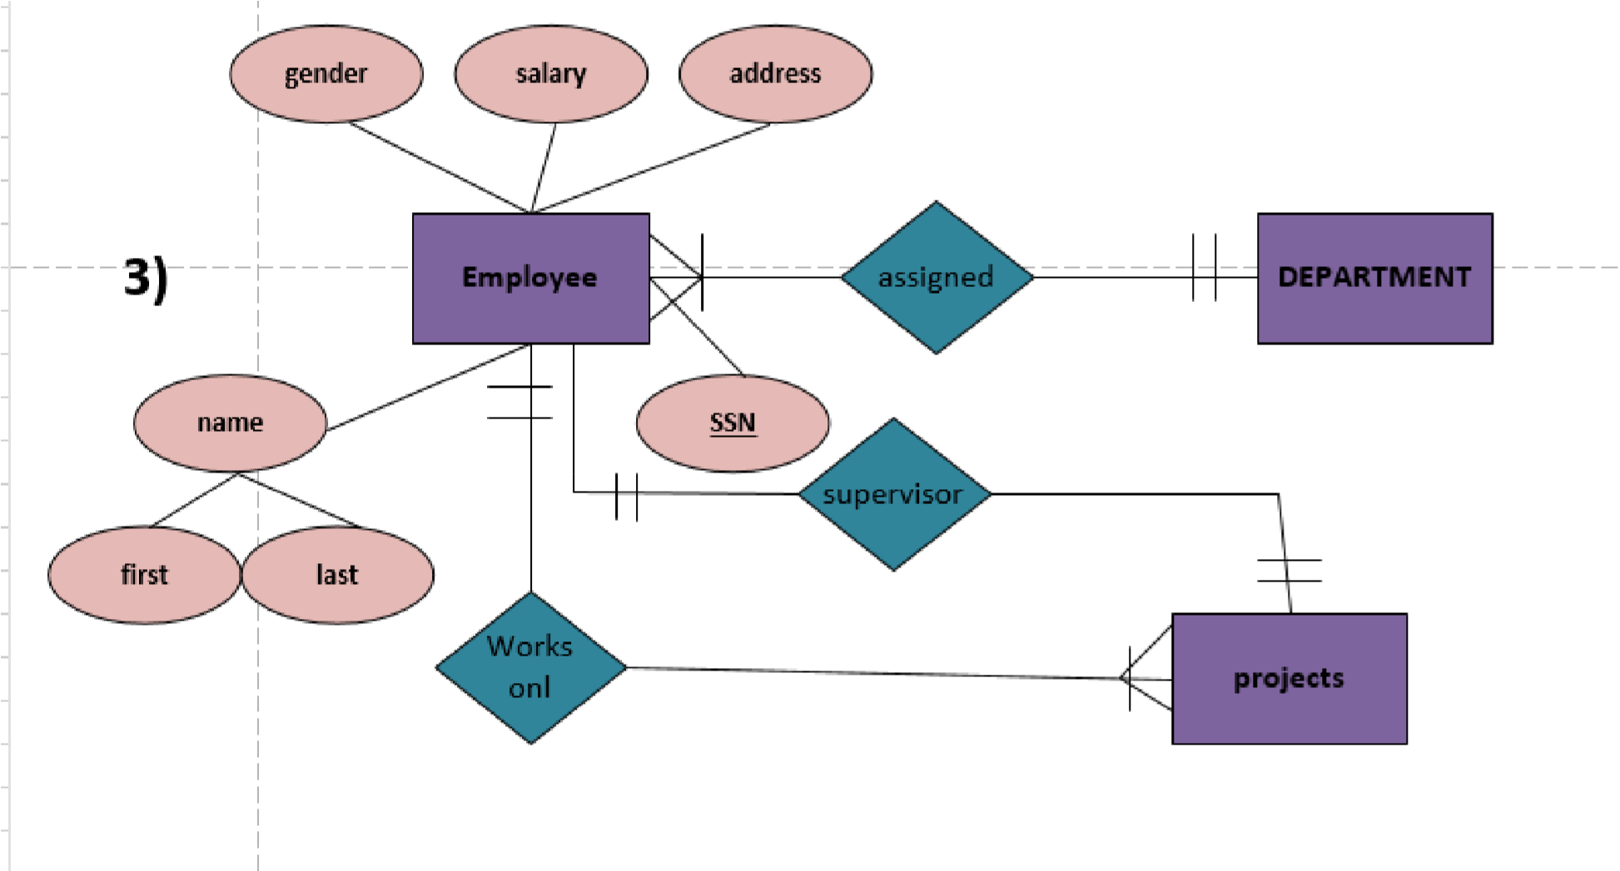

Q4) Draw an ERD for the following description: We want to keep track of the dependents of each employee for insurance purposes. We keep each dependent’s first name, sex, birth date, and relationship to the employee. February 11,

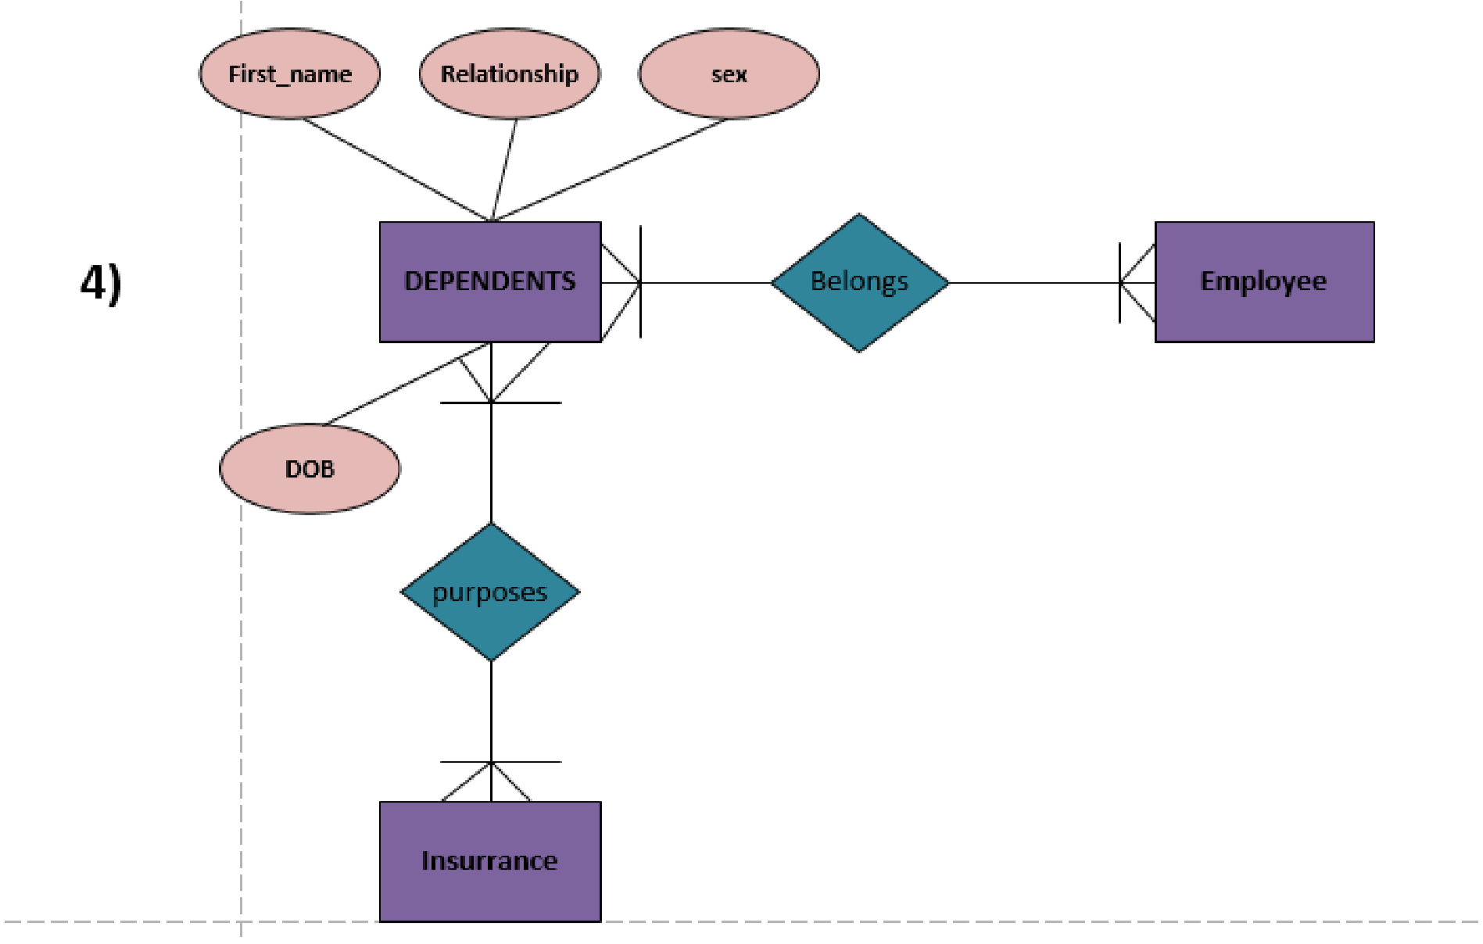

Q5)

* A company database needs to store information about employees (identified by *ssn, with salary and phone as attributes), departments (identified by dno,* with *dname and budget as attributes), and children of employees (with name and age* as attributes).

* Employees *work in departments; each department is managed by an* employee; a child must be identified uniquely by *name when the parent (who is an* employee; assume that only one parent works for the company) is known. We are not interested in information about a child once the parent leaves the company.
* Draw an ER diagram that captures this information.

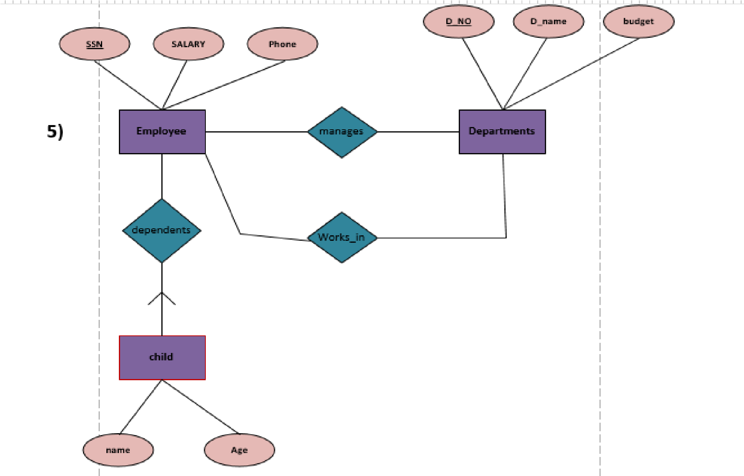

Q.6)

Although you always wanted to be an artist, you ended up being an expert on databases because you love to cook data and you somehow confused *database* with *data baste. Your old love is still there, however, so you set up a database company,* ArtBase, that builds a product for art galleries. The core of this product is a database with a schema that captures all the information that galleries need to maintain.

* Galleries keep information about artists, their names (which are unique), birthplaces, age,and style of art. For each piece of artwork, the artist, the year it was made, its unique title, its type of art (e.g., painting, lithograph, sculpture, photograph), and its price must be stored. Pieces of artwork are also classified into groups of various kinds, for example, portraits, still lifes, works by Picasso, or works of the 19th century; a given piece may belong to more than one group.

* Each group is identified by a name (like those just given) that describes the group. Finally, galleries keep information about customers. For each customer, galleries keep that person’s unique name, address, total amount of dollars spent in the gallery (very important!), and the artists and groups of art that the customer tends to like.
* Draw the ER diagram for the database.

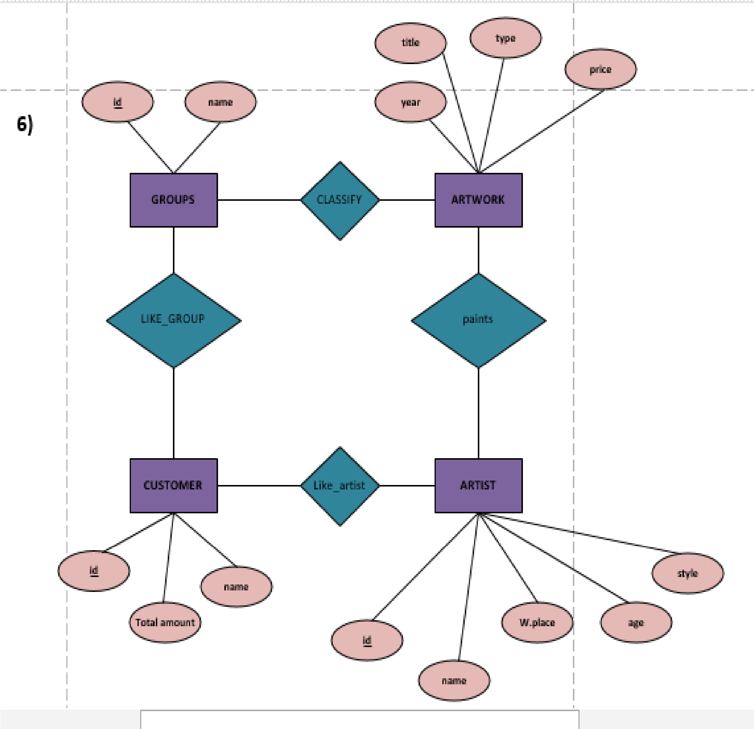

Q.7)

Consider the scenario from Exercise 2.4, where you designed an ER diagram for a company database. Write SQL statements to create the corresponding relations and capture as many of the constraints as possible. If you cannot capture some constraints, explain why.

