**Lab Number 03**

ERD

**TASK 1:**

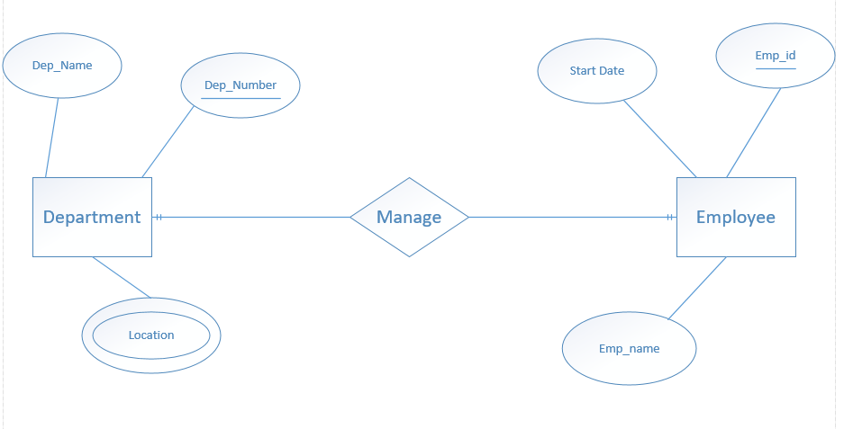

**TASK 2:**

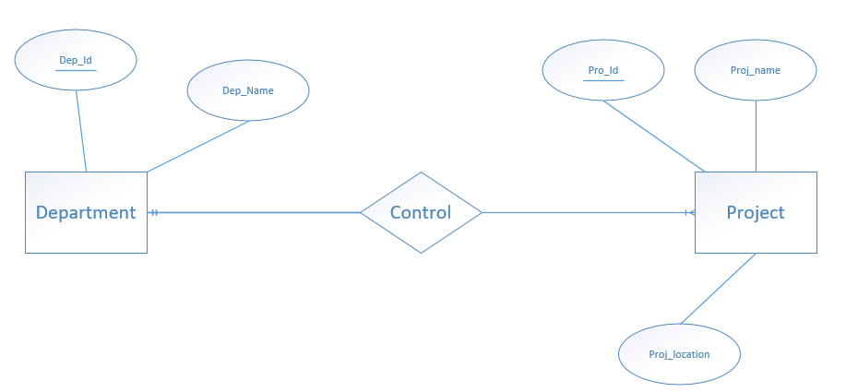

**TASK 3:**

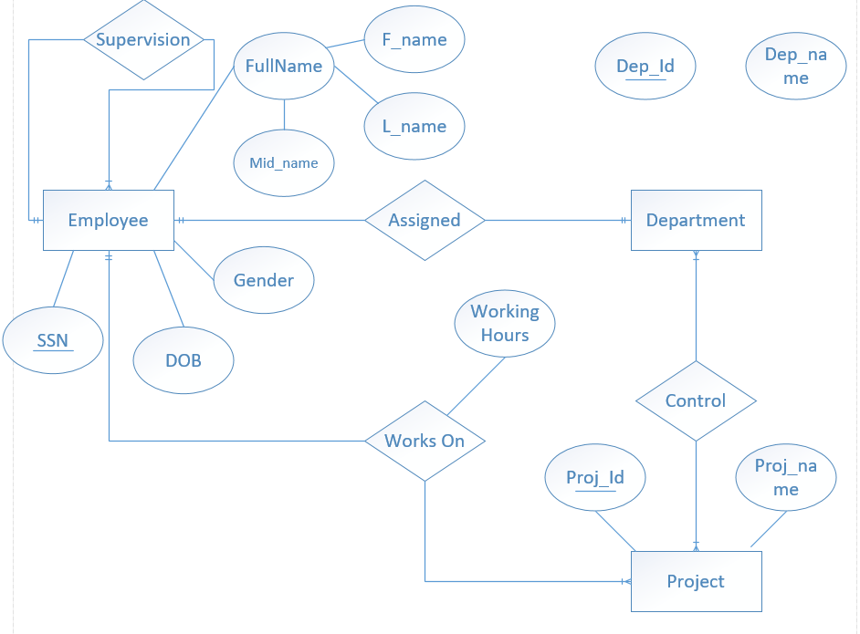

**TASK 4:**

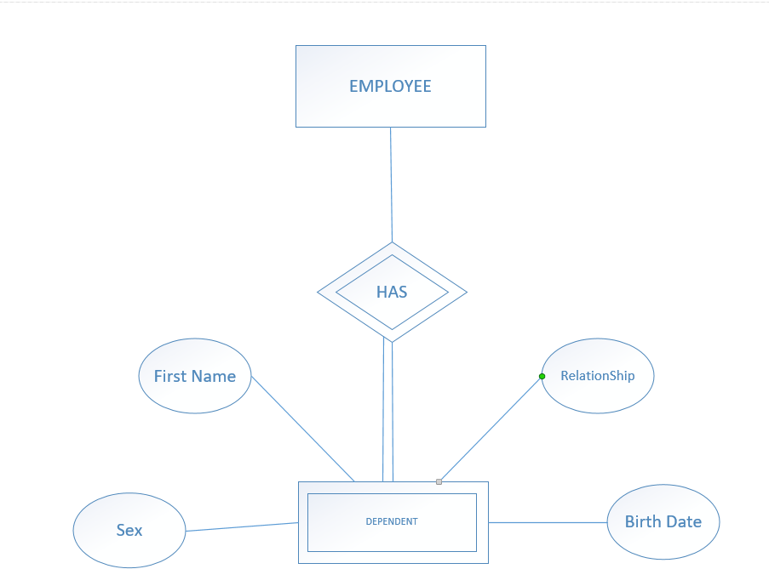

**TASK 5:**

DESCRIBING ERD:

A persons owns a car and he had a accident and participated in a accident. A car owner take a huge damage amount on a car accident and car participated in a damage.

A person has Driver-id, name, address.  
A car has license, model number, and year.  
A accident entity report_number, date, location.

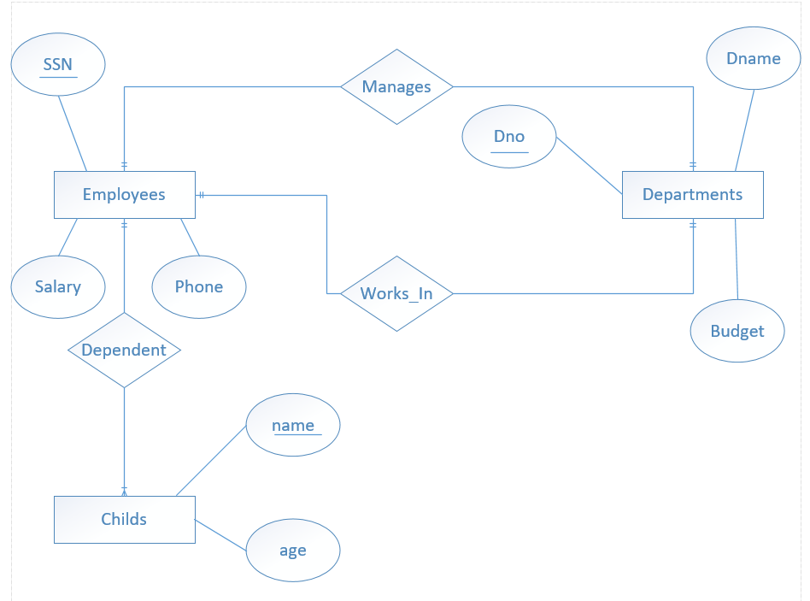

**TASK 6:**

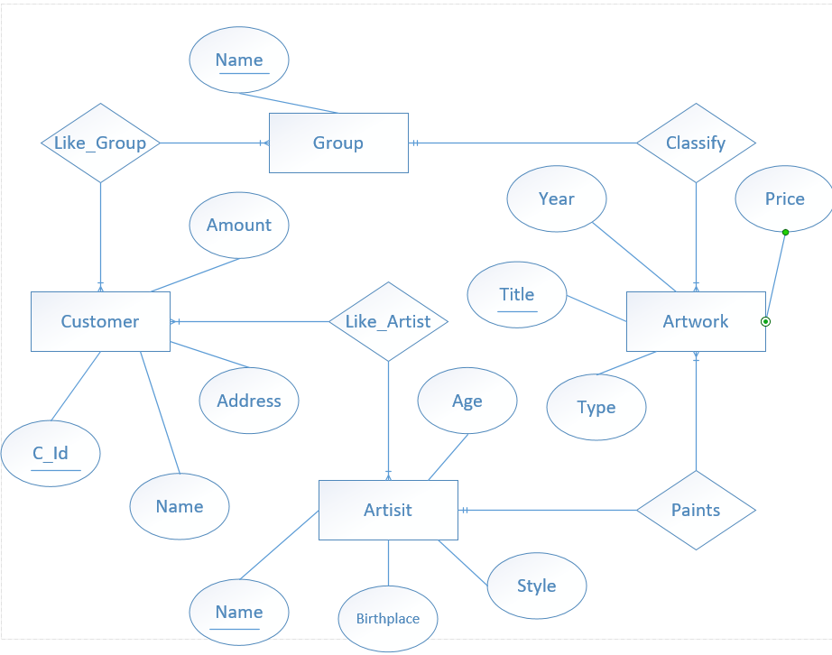

**TASK 7:**

