LAB NO : 03

NADEEM NASRUDDIN  
2018-CS-147

***Question No: 01***

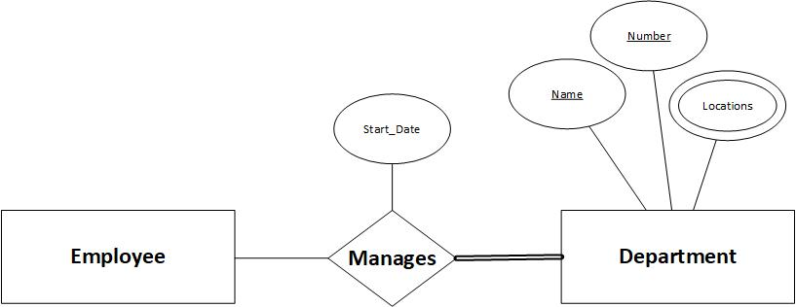

***Question No :02***

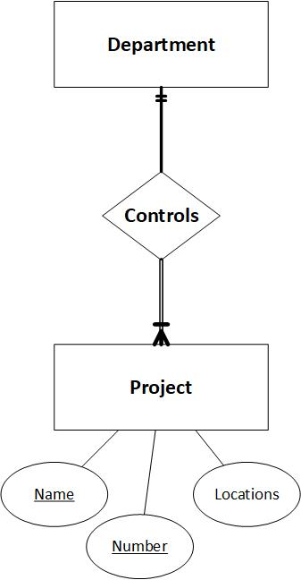

***Question no : 03***

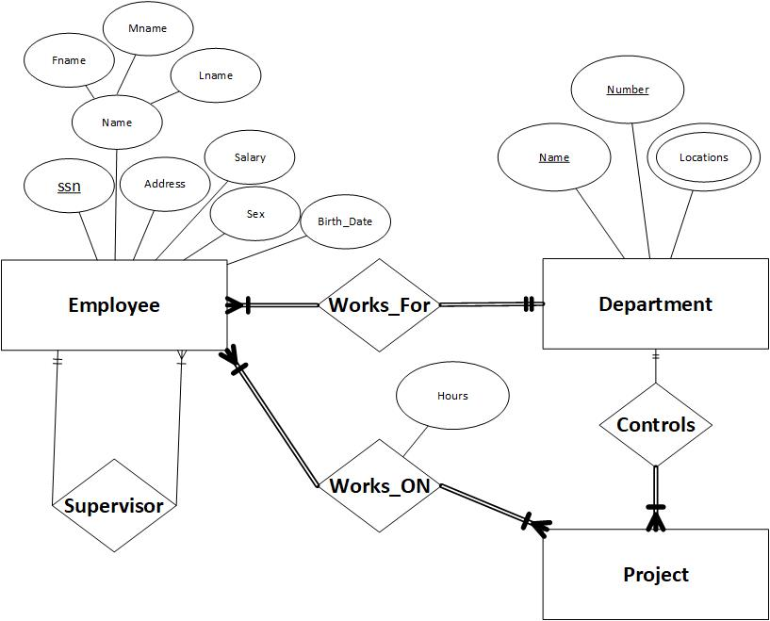

***Question no :04***

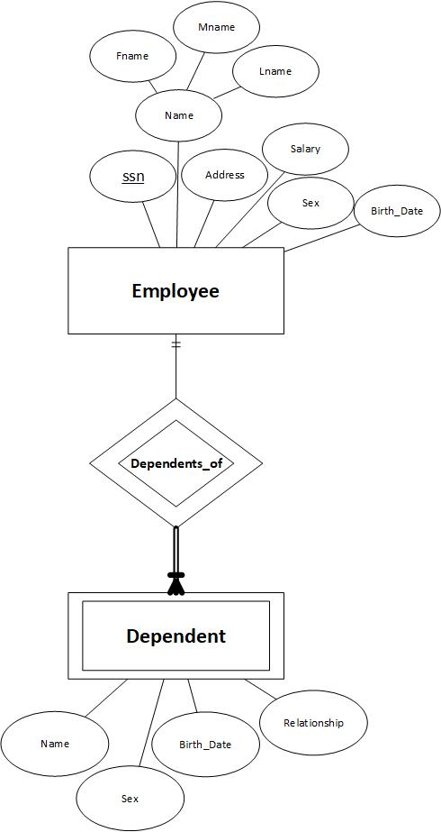

***Question no :05***

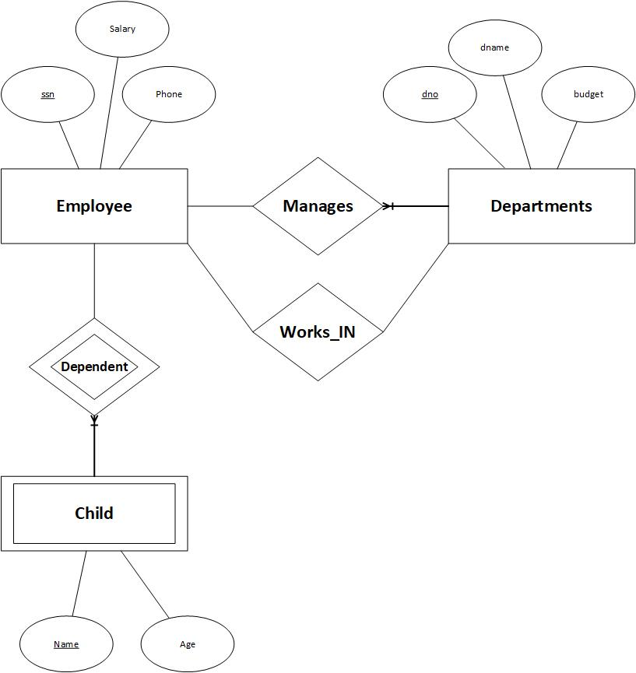

**Question no :07 )**

