Syed Muhammad Mehmaam

2018-CS-155

Section C

**LAB # 03**

**Objectives**

* ***Introduction to ERD.***
* ***Entity Relationship Diagrams: discovering and design the cases.***

**Q1.** 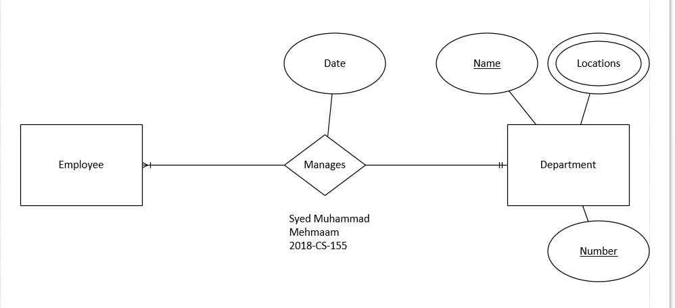

**Q2.**



**Q3.**

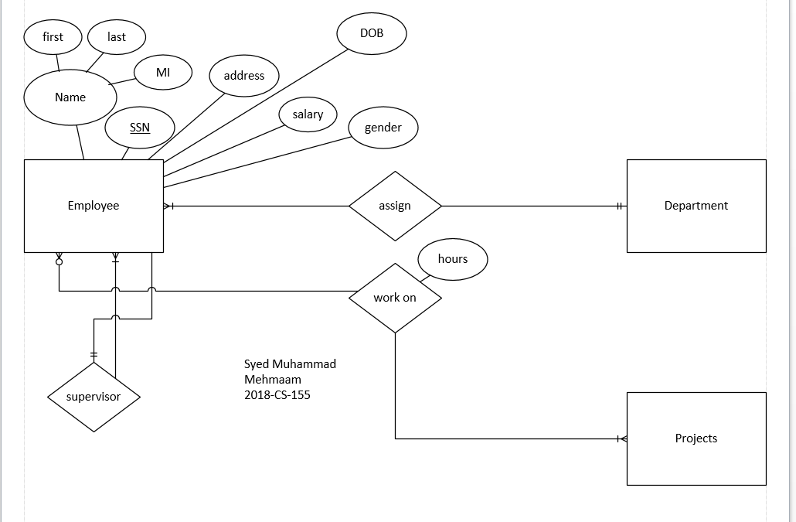

**Q4.**

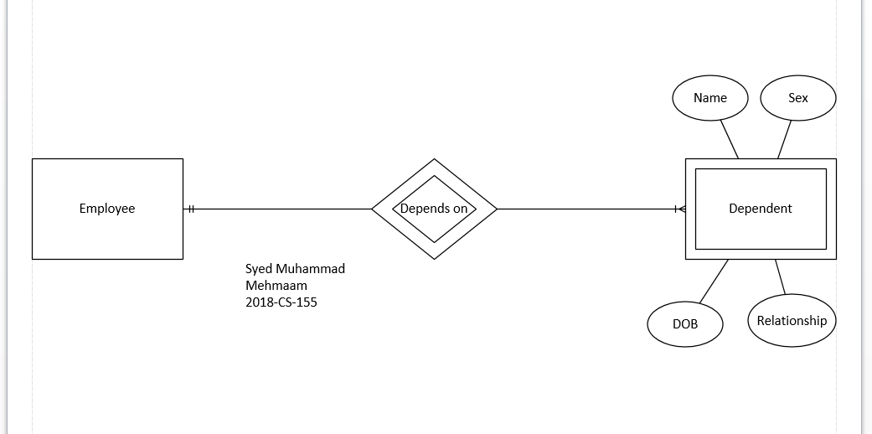

**Q5. Define ERD**

Person own a car , person have their address,name and driver id.and car has a model ,year and alicense,car will be participated in an accident by a person with damage amount and allocate an accident date, location and specially a reort number.

Draw an ERD.

**Q5.** 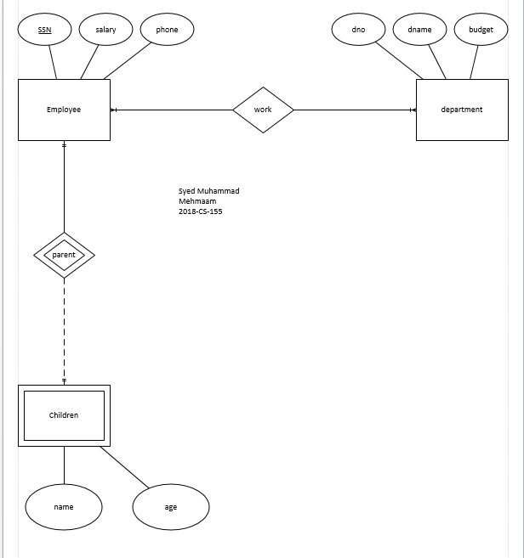

**Q6.**

