2. Design a class diagram for the transactions of bank (Considering only checking balance, withdraw cash and deposit cash for the sake of simplicity.

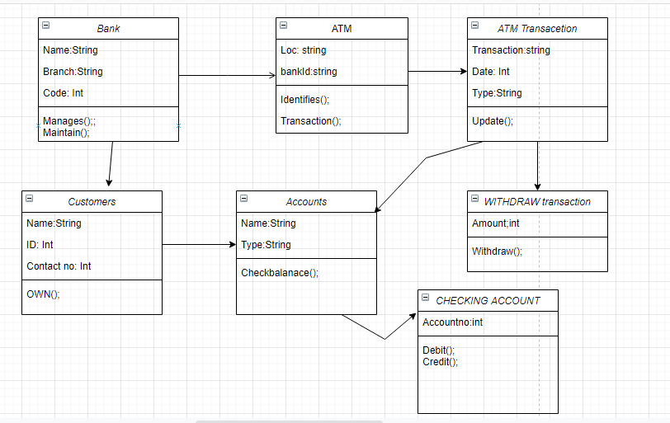

1. Design a class diagram of an Order System of an application. So it describes a particular aspect of the entire application. Draw class diagram considering all the points mentioned below:

· First of all Order and Customer are identified as the two elements of the system and they have a one to many relationship because a customer can have multiple orders.

· We would keep Order class is an abstract class and it has two concrete classes (inheritance relationship) SpecialOrder and NormalOrder.

· The two inherited classes have all the properties as the Order class. In addition they have additional functions like dispatch () and receive ().

