# ***Name: Umme Hani***

# ***Roll number: 2018-CS-159***

# ***Section: C***

***Lab-03***

**QUESTION 01**

Draw an ERD for the following description: Each department has a unique name, a unique number, and a particular employee who manages the department. We keep track of the start date when that employee began managing the department. A department may have several locations.

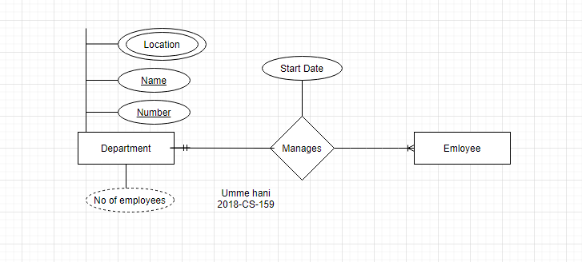

**QUESTION 02**

Draw an ERD for the following description: A department controls a number of projects, each of which has a unique name, a unique number, and a single location.

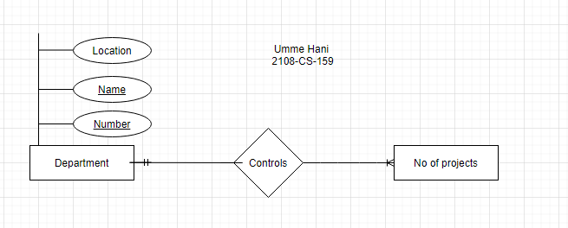

**QUESTION 03**

Draw an ERD for the following description:

We store each employee’s name (first, last, MI), Social Security number (SSN), street address, salary, sex (gender), and birth date. An employee is assigned to one department, but may work on several projects, which are not necessarily controlled by the same department.

We keep track of the current number of hours per week that an employee works on each project. We also keep track of the direct supervisor of each employee (who is another employee).

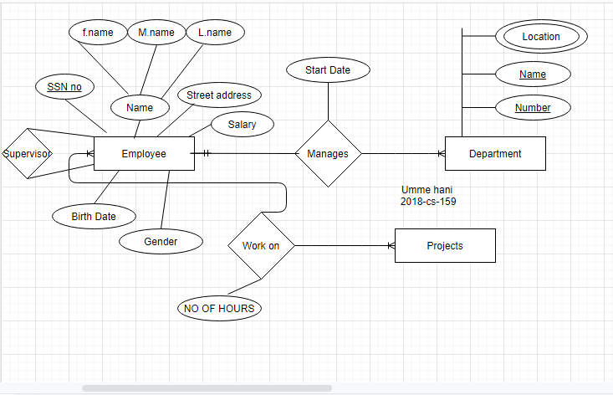

**QUESTION 04**

Draw an ERD for the following description: We want to keep track of the dependents of each employee for insurance purposes. We keep each dependent’s first name, sex, birth date, and relationship to the employee. February 11.

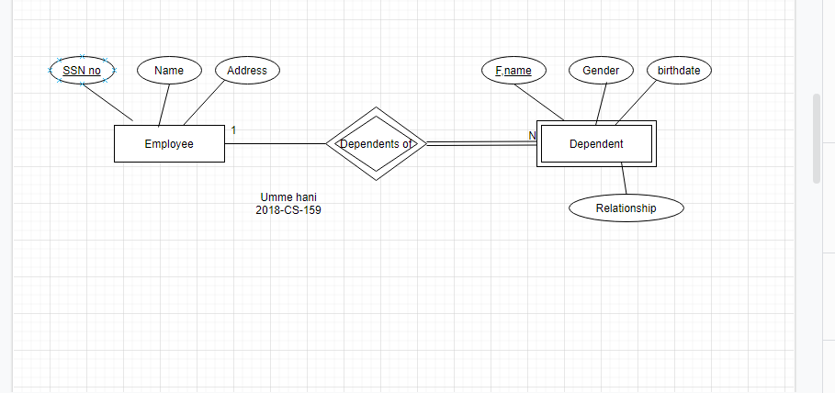

**QUESTION 05**

· A company database needs to store information about employees (identified by ssn, with salary and phone as attributes), departments (identified by dno, with dname and budget as attributes), and children of employees (with name and age as attributes).

· Employees work in departments; each department is managed by an employee; a child must be identified uniquely by name when the parent (who is an employee; assume that only one parent works for the company) is known. We are not interested in information about a child once the parent leaves the company.

· Draw an ER diagram that captures this information.

· Employees work in departments; each department is managed by an employee; a child must be identified uniquely by name when the parent (who is an employee; assume that only one parent works for the company) is known. We are not interested in information about a child once the parent leaves the company.

· Draw an ER diagram that captures this information.

