This program implements a customer information management system at a night club.

The system can store and search customers information using various properties.

There are 3 types of customers: Person, Student and Soldier. Where Student and Soldier are a type of Person.

The input for adding a new **Person** is as follows:

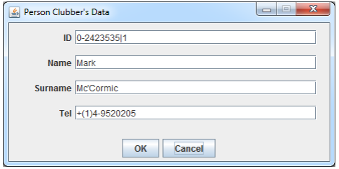

Where the fields are:

**ID field:** digit, followed by character -, followed by 7 digits, followed by

character |, followed by a non-zero digit (e.g. 0-2423535|1).

**Name field:** capital letter, followed by at least one lower-case letter (e.g.

Zohar);

**Surname field:** capital letter, followed by 0 or more lowercase letters,

followed by 0 or 1 occurrences of: character ' or character - . This entire

pattern must be matched at least once (e.g.: Mc’Cormic, Deutsch, O’Brian,

Landau-Mc’Donalds, Dor-, M’, Mc’).

**Tel field:** international phone/mobile-number, e.g.: +(1)4-9520205,

+(44)206-8208167, +(972)50-6663210. First digit after left-bracket must be

non-zero (this digit is compulsory!); number of digits inside the brackets

should be at most 3; first digit after the right-bracket must be non-zero;

number of digits between the right-bracket and the dash character - should be

at most 3; first digit after the dash character – must be non-zero; number of

digits after the dash character - should be 7.

The input for adding a new **Student** is as follows:

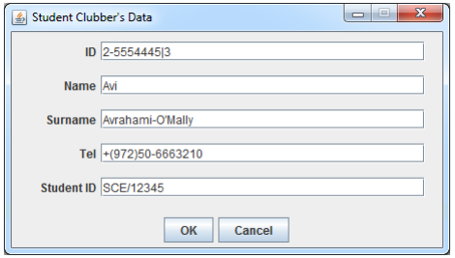

Where the fields are the same as Persons fields in addition to:

**StudentID field:** 3 capital letters (representing the institution name shortcut), followed by slash /, followed by 5 digits (first digit must be non-zero). E.g. RUP/12345, HIT/56098, SCE/14606.

The input for adding a new **Soldier** is as follows:

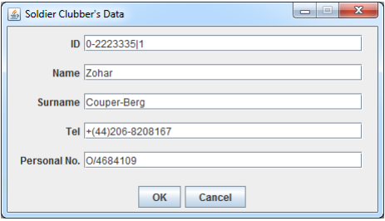

Where the fields are the same as Persons fields in addition to:

**Personal No field:** one capital letter of either of the 3 letters: R, O, or C (shortcut for: Rank, Officer or Chief, (followed by the character /, followed by 7 digits (first digit must be non-zero). E.g. O/4684509, C/5044789