Healthcare Lab User Handbook (English)
Document status: v1.1.1 released-image operator handbook Released image baseline: 54e60d0e69d25c256474d9d0a5c790b1d9b7599e Last updated: 2026-07-27 The v1.1.1 image has passed public publication and an isolated clean full-stack installation. Unrelated protocol, recovery, support, and physical-device boundaries remain explicit in Appendix G.

Part I: Understand and Start Healthcare Lab

Chapter 1 — About This Handbook
This handbook helps Healthcare Lab operators install, configure, start, stop, verify, and troubleshoot the system and complete ECG order/result workflows using HL7 v2, FHIR R4, GDT 2.1, and DICOM/dcm4chee.
It is intended for healthcare integration testers, application specialists, healthcare IT engineers, system operators, and demonstration operators. Source-code knowledge is not required.
This handbook applies to the v1.1.1 Docker distribution model. It excludes source builds and development setup. First-time installers should read Chapters 3–6; UI operators may begin with Chapters 7–9; protocol users may go directly to Chapters 10–13; troubleshooting begins in Chapter 14.

Chapter 2 — Healthcare Lab Overview
Healthcare Lab is an operations platform for a trusted local or internal healthcare integration lab. Its typical workflow is:
Create Patient
-> Create ECG Order
-> Send, sync, or export Order
-> AP (QHAP) processes Order
-> Return, import, or reconcile Result
-> Inspect status, result, and operation history
The Healthcare Lab UI and backend manage the local workflow. OIE routes HL7 v2; Medplum stores and queries FHIR R4 resources; GDT Bridge exchanges files through a shared folder; dcm4chee provides MWL, a DICOM archive, and DICOMweb; AP (QHAP) obtains orders and returns results.
The main sidebar pages are Dashboard, Patient, Order, OIE, GDT, Medplum, and dcm4chee. These names match the recorded 2026-07-22 RC browser pass; unverified actions and limitations are called out in the relevant chapters.

System Architecture
Browser -> Healthcare Lab (lab-app:5000)
|-> OIE (HL7 v2 / MLLP)
|-> Medplum (FHIR R4 / OAuth)
|-> GDT Bridge shared folder
`-> dcm4chee (HL7 ADT, MWL, QIDO/WADO)
AP (QHAP) <-> OIE / GDT shared folder / dcm4chee
Pending RC verification: replace this text diagram with the final deployment diagram and verify every connection, direction, protocol, and port.

Chapter 3 — Prerequisites
The v1.1.1 support boundary is a trusted local machine or internal lab running linux/amd64 containers. Windows uses Docker Desktop in Linux container mode. An equivalent Linux Docker host remains pending formal release verification.

Verified RC host environment
On 2026-07-22, the RC lab-app started, passed its Docker health check, and returned HTTP 200 in the environment below. This is a tested environment, not a minimum requirement.
Item | Verified value
Host OS | Windows 11 64-bit
Host hardware | 16 logical CPUs, approximately 16 GB RAM
PowerShell | Windows PowerShell 5.1
Docker Desktop | 4.75.0
Docker Engine | 29.5.2, Linux/amd64
Docker Compose | v5.1.3
Docker VM resources | 16 CPUs, approximately 8 GB RAM
RC image | healthcare-lab:verify-fd0e38f

Pre-installation checks
Run:
docker version
docker compose version
docker info --format 'Server={{.ServerVersion}} OSType={{.OSType}} Arch={{.Architecture}} CPUs={{.NCPU}} Memory={{.MemTotal}}'
Confirm that Docker Server information is present, OSType=linux, and the architecture is x86_64/amd64. If only Docker Client information appears, start Docker Desktop or correct the current Docker context and daemon permissions.
Also confirm that:
- The host can access GHCR and third-party image registries.
- Default host ports 5000, 6600, 6661, 8080, 8443, 8103, 3000, 8082, 11112, and 2575 are not used by another process.
- Medplum project access is available so an OAuth ClientApplication can be created when FHIR sync is required.
- The Docker host IP, firewall rules, and required external AP (QHAP) endpoints are known when applicable. The wrapper prepares the default GDT host folder; only a custom AP share must be planned separately.
- Only virtual test data will be used.
Pending RC verification: minimum CPU, memory, and storage requirements; supported browser versions; and a clean installation on an equivalent Linux host.

Chapter 4 — Installing the Released Docker Image
The release model combines a fixed Healthcare Lab image, a versioned deployment bundle, and compatible OIE, Medplum, and dcm4chee images. The normal local installation is zero-edit: it does not require an .env, a YAML edit, or manual GDT folder preparation. Application connections and credentials belong in the browser-based Settings page. An optional .env is an Advanced deployment control for image selection, published host ports, bind paths, service-database hardening, and startup policy; it is not part of the immutable image.

v1.1.1 installation procedure
- Download and extract the v1.1.1 deployment bundle.
- Open PowerShell in the bundle root.
- Start the supported stack with one command:
- .\deploy\lab.ps1 start
- The wrapper pulls the pinned public images, creates the bounded default instance\gdt-bridge host root, and starts persistent services. dcm4chee-storage-init is a one-shot initialization service; Exited (0) is its expected completed state.
- Verify the application and open the guided setup:
- .\deploy\lab.ps1 status
Invoke-WebRequest http://127.0.0.1:5000/ -UseBasicParsing
- Open http://127.0.0.1:5000. If setup is incomplete, use the Dashboard action to open the authoritative Settings section. Enter application endpoints, credentials, protocol identities, and runtime behavior there, save them, then use the section's connection or diagnostic check. Typed profiles persist in lab-app-instance and remain authoritative after restart and container recreation.
- Create an optional .env only for an Advanced deployment override:
- Copy-Item .env.example .env
- Review only the deployment values you intend to own, such as LAB_APP_IMAGE, a published host port, GDT_BRIDGE_HOST_PATH, service-database hardening, or startup policy. The wrapper automatically passes the repo-root .env when it exists.
The root page should return HTTP 200 and required containers should be running/healthy. Confirm the actual image rather than relying on the container name:
.\deploy\lab.ps1 inspect lab-app
docker compose --env-file .env -f deploy\docker-compose.yml config --images
The Image value reported by inspect must be the immutable Healthcare Lab tag selected for this installation. Container health does not prove that a protocol workflow is complete.

Completed v1.1.1 image verification
An isolated Compose project verified healthcare-lab:verify-fd0e38f during this documentation round. The container became healthy, the root page returned HTTP 200, Gunicorn listened on container port 5000, and a marker in /app/instance survived force recreation. All seven container release contract tests passed.
Release workflow 30242203066 and the isolated full-stack run validate anonymous public pull, immutable readiness, and clean installation of ghcr.io/tzu-huang/healthcare-lab:1.1.1 on linux/amd64.
Completed release verification: the v1.1.1 tag, unauthenticated public pull, revision label, clean installation, and first-time initialization passed.

Chapter 5 — Configuration
Configuration has three owners:
- Settings: application connections, write-only application secrets, protocol identities, timeouts, and runtime behavior. Persisted typed profiles are authoritative across restart and container recreation.
- Advanced deployment (.env and Compose): immutable image choice, host-published ports, host bind paths, service-database/security hardening, and startup policy.
- External systems: Medplum OAuth clients, OIE users and certificates, dcm4chee AEs, and physical AP/device configuration.
For existing installations only, eligible legacy application variables may seed a missing typed profile once. This bootstrap is create-only: after a profile is saved in Settings, later environment changes do not overwrite it.
Important address contexts:
Context | Example | Purpose
Browser/host | http://127.0.0.1:5000 | Operate Healthcare Lab
Docker service | http://medplum:8103/fhir/R4 | lab-app accesses Medplum
External device | <Docker-host-IP>:6661 | AP (QHAP) sends results to OIE
After changing an Advanced deployment value, recreate the affected service, normally with .\deploy\lab.ps1 restart <service>. The wrapper's restart action runs up -d --force-recreate; it is not a process-only restart. Saving a Settings profile does not imply the same activation action: use the specific Save-and-test, listener Retry, or managed-Channel Preview/Apply guidance shown by its section.
Before applying configuration, run:
docker compose --env-file .env -f deploy\docker-compose.yml config --quiet
This verifies that Compose can resolve the configuration. It does not validate credentials, network connectivity, or a protocol workflow.
Keep deployment secrets in an untracked .env or approved secret store. Enter application secrets in Settings; they are write-only and are not copied into .env, Compose, browser storage, command output, or diagnostics. Never place either class of secret in documentation, screenshots, tickets, or version control.

Create and connect a Medplum ClientApplication
- Open the local Medplum Web UI at http://127.0.0.1:3000, sign in to the intended local Medplum project, and create a ClientApplication from that project's client/application administration area.
- Give it an operator-recognizable name such as Healthcare Lab local. Create a client secret for that application and copy the displayed client ID and newly issued secret into your approved temporary secret-handling workflow. Do not use a personal user password and do not paste either value into this handbook, a screenshot, ticket, or Git.
- In Healthcare Lab, open Settings → Medplum. Keep the Compose-internal FHIR URL as http://medplum:8103/fhir/R4; keep the browser URL operator-facing at http://127.0.0.1:3000. Enter the ClientApplication ID in OAuth client ID and the issued secret in Replace OAuth client secret. Leave scope and token URL at their defaults unless the Medplum project requires explicit values.
- Save and run Save-and-test. Review metadata reachability, OAuth token acquisition, and authenticated read as separate stages. A successful metadata request alone does not prove the client credentials work.
- After saving, Healthcare Lab reports only that the secret is configured. The secret field clears because it is write-only. Leaving the replacement field blank on a later save preserves the stored secret.
To rotate the secret, issue a replacement for the same ClientApplication in Medplum, enter the non-blank replacement under Settings → Medplum, save, and repeat Save-and-test before revoking the old secret. If the test fails, correct the client/project association, scope, token endpoint, or replacement value; do not expose the secret in diagnostic evidence.

Chapter 6 — Starting, Stopping, and Verifying Healthcare Lab
Run these commands from the deployment bundle root:
.\deploy\lab.ps1 inspect lab-app
.\deploy\lab.ps1 status
.\deploy\lab.ps1 start all
.\deploy\lab.ps1 smoke all
.\deploy\lab.ps1 logs oie -Lines 200
.\deploy\lab.ps1 restart lab-app
.\deploy\lab.ps1 stop all
Action | Actual purpose
inspect | Emits JSON containing container, image, state, port, and Compose metadata
status | Runs docker compose ps to list running services
start | Runs docker compose up -d, optionally for one service
smoke | Currently lists Compose ps state; it does not run HTTP or protocol tests
logs | Displays the last N log lines for the selected service
restart | Force recreates a service; a selected service uses --no-deps
stop | Stops a selected service or the full stack without removing named volumes
gdt-bridge, hl7tester, and gdt-hospital are logical wrapper names mapped to the lab-app container. medplum maps to both the Medplum API and Web UI.
Default interfaces are Healthcare Lab at http://127.0.0.1:5000, OIE HTTP at http://127.0.0.1:8080, Medplum UI at http://127.0.0.1:3000, and dcm4chee UI at http://127.0.0.1:8082/dcm4chee-arc/ui2.

Ready-for-use verification
- Run .\deploy\lab.ps1 inspect lab-app and verify the image tag, state, ports, and restart count.
- Run .\deploy\lab.ps1 status and verify that the expected services are listed.
- Run Invoke-WebRequest http://127.0.0.1:5000/ -UseBasicParsing and confirm HTTP 200.
- Open the required OIE, Medplum, and dcm4chee interfaces.
- Run the relevant service connectivity check.
- Run the required protocol workflow from Chapters 10–13.
Verification has four levels: container running, service health, service-to-service connectivity, and complete workflow. Only the last proves that the Patient, Order, and Result workflow completed. The current .\deploy\lab.ps1 smoke all performs only first-level state listing.

Startup troubleshooting
- Docker shows Client but no Server: start Docker Desktop and verify the context.
- A port is already in use: stop the conflicting service or select a free host port in .env, then recreate the affected service.
- lab-app does not become healthy: inspect .\deploy\lab.ps1 logs lab-app -Lines 200 and verify the image, volumes, and .env.
- The container uses the wrong image: compare inspect lab-app with config --images; correct LAB_APP_IMAGE and recreate lab-app.
- The container is healthy but the workflow fails: continue through network, authentication, protocol response, and identifier-matching checks instead of reinstalling repeatedly.

Part II: Use the Core Pages

Chapter 7 — Dashboard
Dashboard is the default page after startup and is titled Server Health Dashboard. It presents the container runtime summary, three primary service groups, resource usage, and recent events.
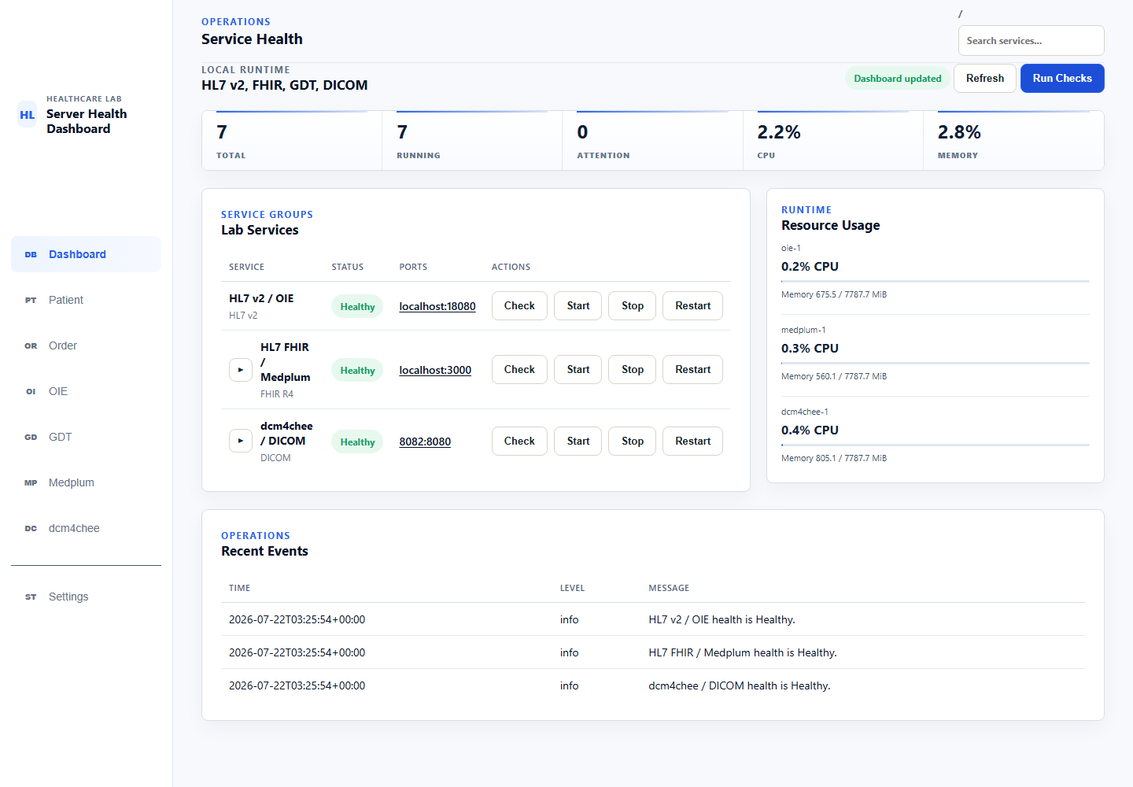

Page areas
- Top summary: TOTAL, RUNNING, ATTENTION, CPU, and MEMORY.
- Lab Services: HL7 v2/OIE, HL7 FHIR/Medplum, and dcm4chee/DICOM.
- Each group shows protocol status, its primary host port, and Check, Start, Stop, and Restart.
- Expandable groups show child services such as the Medplum database and cache.
- Resource Usage shows CPU and memory for primary containers.
- Recent Events shows the latest health-check results.

Run health checks
- Open Dashboard.
- Select Run Checks for all groups, or select Check for one group.
- Wait for Dashboard updated.
- Inspect each group status and Recent Events.
In the isolated RC test, the initial protocol statuses were Unknown. After Run Checks, OIE, Medplum, and dcm4chee passed application, process, and protocol checks and changed to Healthy. A value of 7 RUNNING does not by itself change protocol status from Unknown to Healthy.

Service operations
Start, Stop, and Restart operate real Compose services; they do not only change the Dashboard display. In a shared environment, expand the group, confirm affected services, and notify other users before executing an action. Restart can interrupt listeners, in-flight requests, or queued messages.
This round verified Run Checks but did not select Stop or Restart against the shared runtime. Degraded, Down, disabled-action reasons, Enable/Disable, and complete operation-history behavior remain pending isolated full-stack verification.

Chapter 8 — Patient
The Patient page uses one Register Patient form for HL7 v2, FHIR, GDT, and DICOM Patients. Selecting a mode changes the title, visible fields, and payload preview.
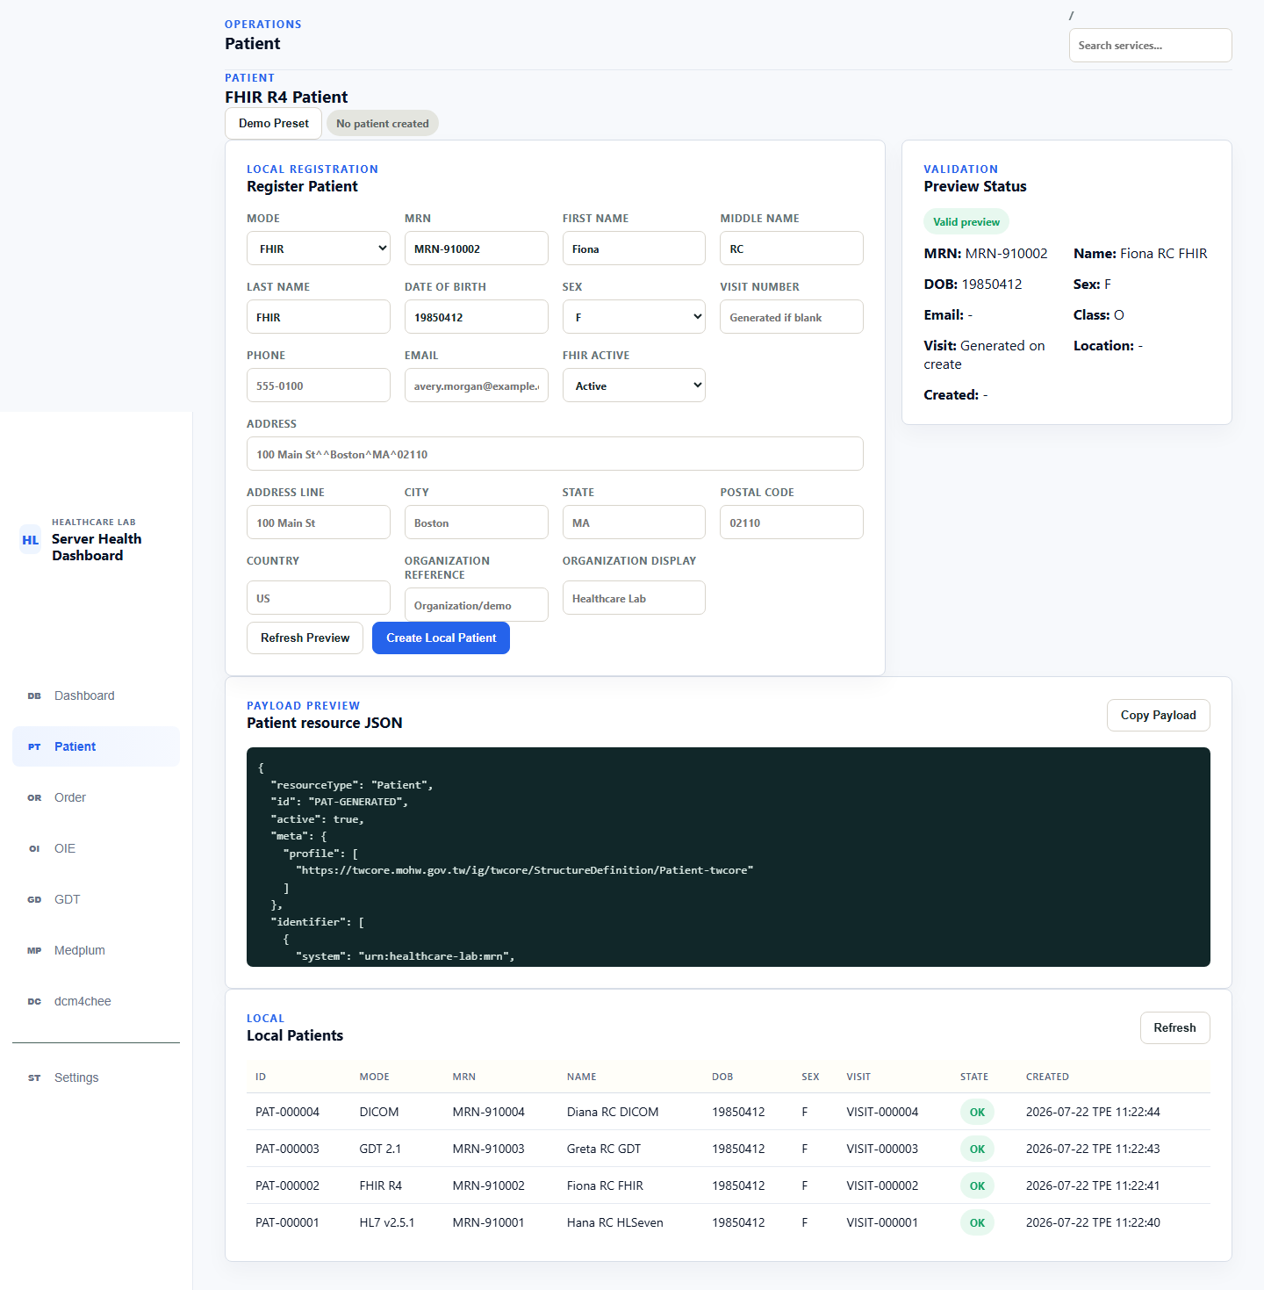

Common creation procedure
- Select Patient in the sidebar.
- Select HL7 v2, FHIR, GDT, or DICOM under MODE.
- Enter FIRST NAME, LAST NAME, and DATE OF BIRTH; DOB uses YYYYMMDD.
- Select SEX. Current values are F, M, O, and U.
- Optionally enter an MRN. If blank, the application generates the global sequence. A manual value must be MRN- followed by at least six digits, for example MRN-910001.
- Enter any additional mode-specific fields.
- Select Refresh Preview.
- Confirm that Preview Status is Valid preview, then inspect MRN, name, DOB, Sex, and the payload.
- Select Create Local Patient.
- Record PAT-xxxxxx, MRN, VISIT-xxxxxx, mode, state, and external reference.
Refresh Preview only updates the preview. It neither creates a local record nor transmits external data. Missing first name, last name, or DOB produces Needs input.

Mode-specific behavior
Mode | Additional visible fields/payload | Verified behavior on Create
HL7 v2 | Patient class, assigned location, attending provider, account number; MSH/EVN/PID/PV1 for ADT A04 | Creates a local Patient and visit; Preview does not transmit ADT
FHIR | Email, active, structured address, managing organization; FHIR R4 Patient JSON | Creates the local Patient, then attempts Medplum sync; success produces Patient/<id>, while failure preserves the local record with Error/Sync failed
GDT | Phone and address; GDT 6301 fields | Creates a local GDT Patient; the Order is created separately in the Order/GDT workflow
DICOM | Patient class, phone, and address; DICOM Patient Module attributes | Creates a local Patient and immediately performs HL7 ADT sync to dcm4chee; this round received ACK AA and displayed Synced

FHIR sync recovery
If a FHIR Patient shows Sync failed:
- Confirm that persisted Medplum server inventory uses host=medplum and baseUrl=http://medplum:8103/fhir/R4 inside Docker.
- Open Medplum.
- Select the failed Patient and inspect the error.
- Correct connectivity or credentials, then select Retry.
- Confirm Synced and record the Patient/<id> reference.

Duplicate prevention and limitations
- A noncanonical MRN produces a preview validation error and a failed Create request.
- An existing MRN does not create a second Patient; the UI reports Patient MRN ... already exists..
- This RC UI did not expose Patient edit or delete actions. Do not assume an existing record can be edited or deleted from the Patient page.

Chapter 9 — Order
The Order page creates ECG Orders. Available MODE values are HL7 v2, FHIR, GDT ECG, and DICOM MWL. The Patient selector lists only mode-compatible local Patients. A FHIR Order requires a synced Patient with a Medplum Patient reference.
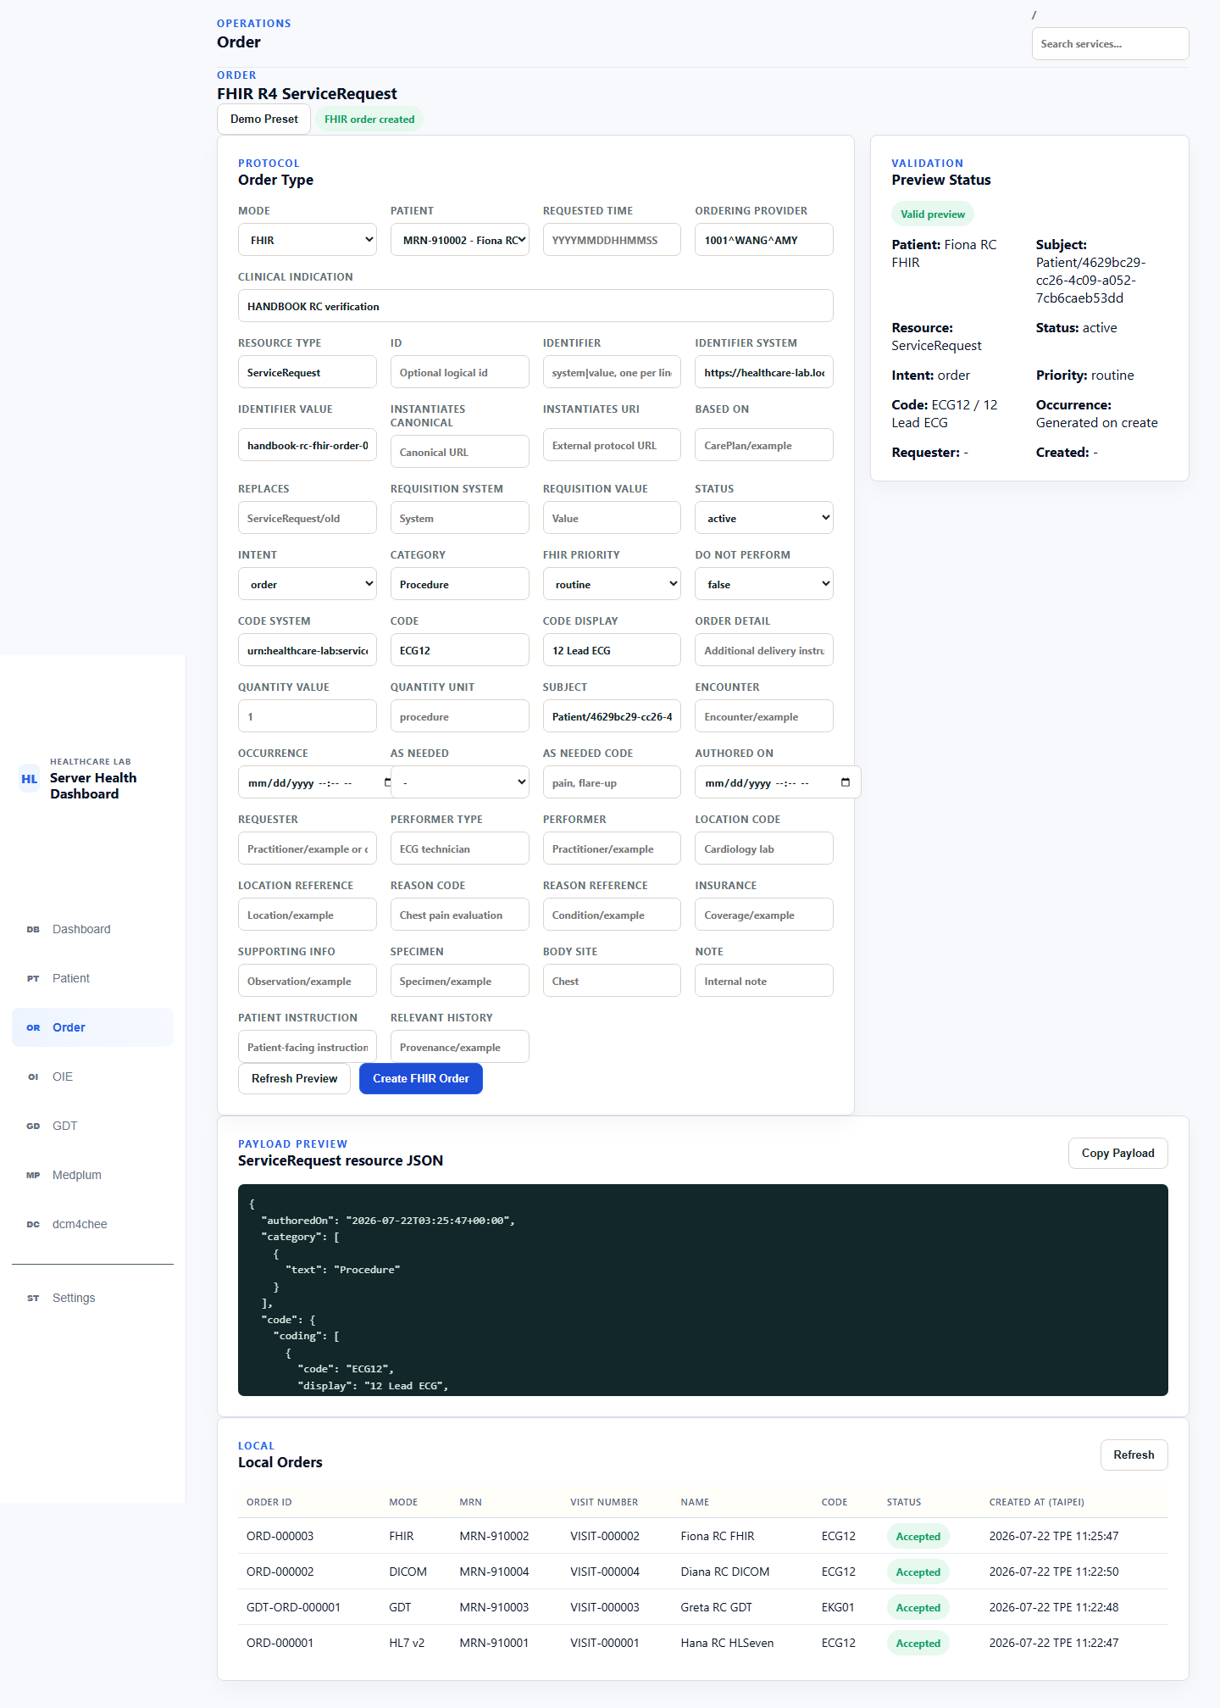

Common creation procedure
- Select Order in the sidebar.
- Select a MODE.
- Select a compatible PATIENT. If none is available, return to Patient and create or sync one first.
- Enter requested time, ordering provider, and clinical indication as needed. Generated fields are assigned during Create when left blank.
- Review mode-specific fields.
- Select Refresh Preview.
- Confirm Valid preview and compare Patient, MRN, code, priority/time, and payload.
- Select the mode-specific Create button.
- In Local Orders, record Order ID, mode, MRN, visit, code, status, and timestamp.

Mode-specific creation results
Mode | Create button | ECG definition/key identifiers | Verified result
HL7 v2 | Create Order | ECG12, alternate 93000; ORD-xxxxxx, placer Order Number, visit, account number | Creates local ORM O01; backend status is Ready to send, which does not mean OIE/AP (QHAP) received it
FHIR | Create FHIR Order | FHIR ServiceRequest, ECG12 / 12 Lead ECG; local Order ID, identifier, ServiceRequest/<id> | Requires a synced Patient; creates the local Order and immediately syncs it to Medplum; this round obtained a live ServiceRequest reference
GDT ECG | Create GDT Order | 8402=EKG01; GDT-ORD-xxxxxx, GDT Patient Number, field 6330 correlation | Creates a local 6302 message with backend status Created; this does not mean AP (QHAP) picked up the file
DICOM MWL | Create DICOM MWL Order | ECG12; LAB-ORD-*, ACC-*, Study UID, RP-*, SPS-* | Creates the local Order and performs MWL REST create/read-back; this round returned HTTP 200 and Synced, while verification remained not_verified
During this round, Local Orders displayed all four new Orders with the green summary label Accepted. This is a list summary, not a shared completion state for all protocols. Use the table above and Chapters 10–13 to inspect protocol-specific status.

Ready-for-transmission checklist
- Patient mode and Order mode are compatible.
- MRN and Patient/visit references are correct.
- Preview is Valid preview.
- ECG code and display match the selected mode.
- Local Order ID and mode-specific identifiers are recorded.
- A FHIR Patient is Synced; a DICOM Patient ADT is Synced.
- After creation, complete the protocol-specific send, export, query, result, or reconciliation steps.
This round did not verify Order edit/delete, every retry action, or complete external result return. Those remain for the end-to-end work in Chapters 10–13.

Part III: Complete the Integration Workflows

Chapter 10 — HL7 v2 / OIE Order Workflow
This workflow sends a local ECG Order as HL7 ORM^O01 through Open Integration Engine (OIE) to the AP application (QHeart-AP, also referred to as QHAP), then receives the AP result as HL7 ORU through OIE. Healthcare Lab preserves the raw result and either associates it with the Patient and Order or retains it in Unmatched Results for investigation.
ORM: Healthcare Lab -> OIE:6600 -> AP:6671
ORU: AP -> OIE:6661 -> Healthcare Lab:6665
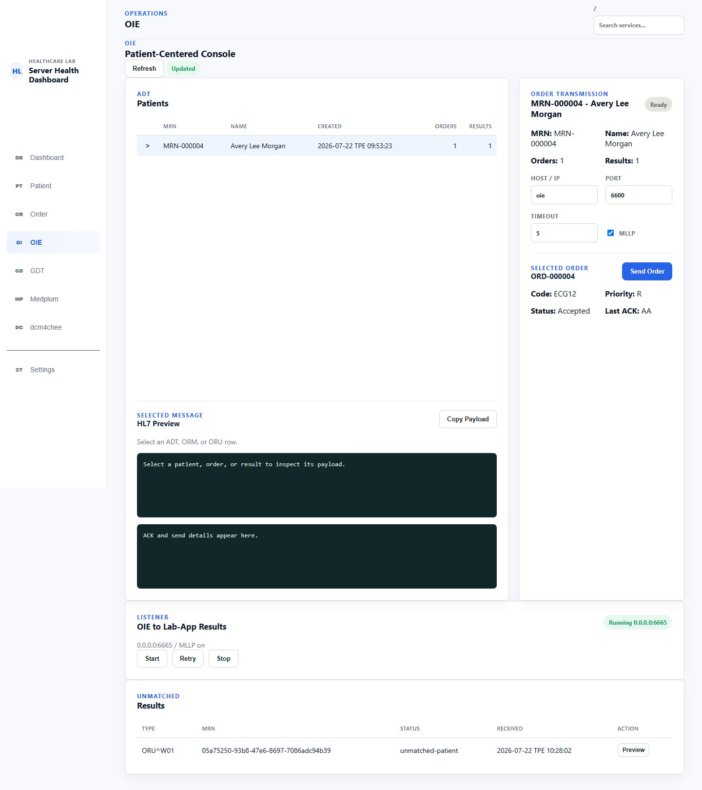

Preconditions
- On Dashboard, run health checks and confirm HL7 v2 / OIE is Healthy.
- In Settings > OIE Connection, confirm the saved Management API connection passes its connection test.
- In Settings, refresh the managed Channels and confirm both HLAB_ORM_TO_AP and HLAB_ORU_TO_HLAB are deployed. If either is missing or out of date, use its guarded Operation preview, review the exact route and diff, then execute the operation before the preview expires.
- Confirm HLAB Result Listener is running at 0.0.0.0:6665 with MLLP enabled. Saving settings does not rebind an already running listener; use the displayed restart or Retry guidance when required.
- Confirm QHeart-AP is listening on port 6671 at the destination address reachable from the OIE container.
- In the managed ORU Channel preview/read-back, verify the deployed queue, retry interval, timeout, and ACK-validation values. Do not infer live values from the template alone.
The managed routes are fixed by purpose:
Managed Channel | Source | Destination | Purpose
HLAB_ORM_TO_AP | OIE TCP Listener :6600 | AP MLLP :6671 | Deliver ECG Orders to AP
HLAB_ORU_TO_HLAB | OIE TCP Listener :6661 | lab-app:6665 | Deliver AP results to Healthcare Lab
Do not substitute 127.0.0.1 for a destination in another container. Inside OIE, loopback means the OIE container itself.

Send the ECG Order
- Create an HL7 v2 Patient as described in Chapter 8. Its ADT preview includes MSH, EVN, PID, and PV1.
- Create an HL7 v2 ECG Order as described in Chapter 9. Record the local Order ID, Patient MRN, visit/account identifiers, and placer Order number.
- Open OIE, select the Patient, and select the Order. Confirm the HOST / IP and PORT fields point to oie and 6600, the timeout is appropriate, and MLLP is selected.
- Inspect HL7 Preview. The MSH-10 message control ID must be unique for this transmission. The Patient/Order correlation identifiers must agree with the selected records; use fresh synthetic identifiers when executing a formal verification run.
- Select Send Order once. Preserve the displayed send details and ACK.
- In OIE, verify the corresponding MSH-10 has one successful source receipt and one successful destination send with no error or queued message.
- At AP, verify exactly one Order was received with the same Patient, placer Order number, and MSH-10.
An ACK code describes message acceptance at that hop:
Evidence | Meaning | Required follow-up
AA | The receiving hop accepted the HL7 message | Still verify OIE destination delivery and AP receipt
AE | Application error | Inspect the ACK error detail and OIE message state, correct the data/configuration, then retry with controlled correlation
AR | Application rejection | Treat as not delivered; inspect routing, message structure, and receiver policy
Local Orders Accepted | Healthcare Lab accepted or sent the local Order workflow step | Not proof that AP completed the examination or that an ORU returned

Receive and match the ORU result
- AP sends a new ORU message to the Docker host's published OIE port 6661.
- OIE accepts the source message and HLAB_ORU_TO_HLAB forwards it to lab-app:6665.
- Healthcare Lab returns an HL7 ACK. Confirm OIE marks the destination send successful rather than queued or errored.
- In OIE, refresh and select the Patient/result. Inspect the preserved raw HL7 and the matched Patient and Order.
- Confirm the result appears exactly once and retains its own MSH-10.
If Patient or Order correlation fails, Healthcare Lab must preserve the message under Unmatched Results; it must not attach it to an unrelated Order. Select Preview to inspect the message type, MRN, status, received time, and raw identifiers. Correct the source identifiers or workflow configuration rather than editing the preserved evidence.

Outage and recovery
When live Channel read-back confirms the verified RC contract, the managed ORU destination queues connection failures and ACK timeouts and retries every 10 seconds. A verified recovery sequence is:
- Confirm the target is the intended isolated/disposable lab Compose project. During an announced maintenance window, stop only lab-app; leave OIE and AP running.
- Send one uniquely identified ORU from AP to OIE 6661.
- Confirm OIE accepts the source message and shows the HLAB destination as queued/retryable. Do not purge or manually resend it.
- Start lab-app; confirm the 6665 listener auto-starts.
- Poll until a recorded deadline for the OIE queue to drain, then confirm Healthcare Lab persists exactly one result for that MSH-10. If the deadline expires, preserve the queue state, destination error, listener state, and timestamps; mark the run failed or blocked and investigate without purging or resending.
Do not run this test against a shared runtime merely for handbook coverage. After restoring the listener or dependency, use the HLAB Result Listener Retry control only if listener status is degraded; allow the OIE destination queue to retry automatically. Do not manually resend or purge the ORU. Preserve queue state for diagnosis.

RC verification record
The v1.0.0 RC live gate passed on 2026-07-21 with OIE 4.5.2. The witnessed run verified managed Channel create/deploy/read-back, an ORM with ACK AA and exactly one AP receipt, matched and unmatched ORU handling, managed lifecycle isolation, and queued ORU recovery with exactly one persisted result. The detailed correlation ledger is retained as a private verification artifact outside the repository.
On 2026-07-22, the browser view captured above reconfirmed the actual labels and read-only state: Order endpoint oie:6600, MLLP enabled, Status: Accepted, Last ACK: AA, listener Running 0.0.0.0:6665, and an ORU retained in Unmatched Results. No shared-runtime Stop/Restart or duplicate send was performed during this handbook pass.

Chapter 11 — FHIR R4 / Medplum Order Workflow
Healthcare Lab uses a local-first write path and a Medplum-backed read path. Creating a FHIR Patient or ECG Order first preserves local workflow intent, then immediately attempts OAuth-authenticated synchronization to Medplum. After synchronization, Medplum is the canonical source for the clinical resource JSON; the local SQLite ledger remains the source for sync state, sync/retry attempt history, errors, OperationOutcome, deterministic identifiers, and Medplum references.
Patient page -> local Patient + FHIR ledger -> Medplum Patient
Order page -> local Order + FHIR ledger -> Medplum ServiceRequest
Medplum page -> live Patient / ServiceRequest / DiagnosticReport reads
`-> related Observation / DocumentReference / Binary
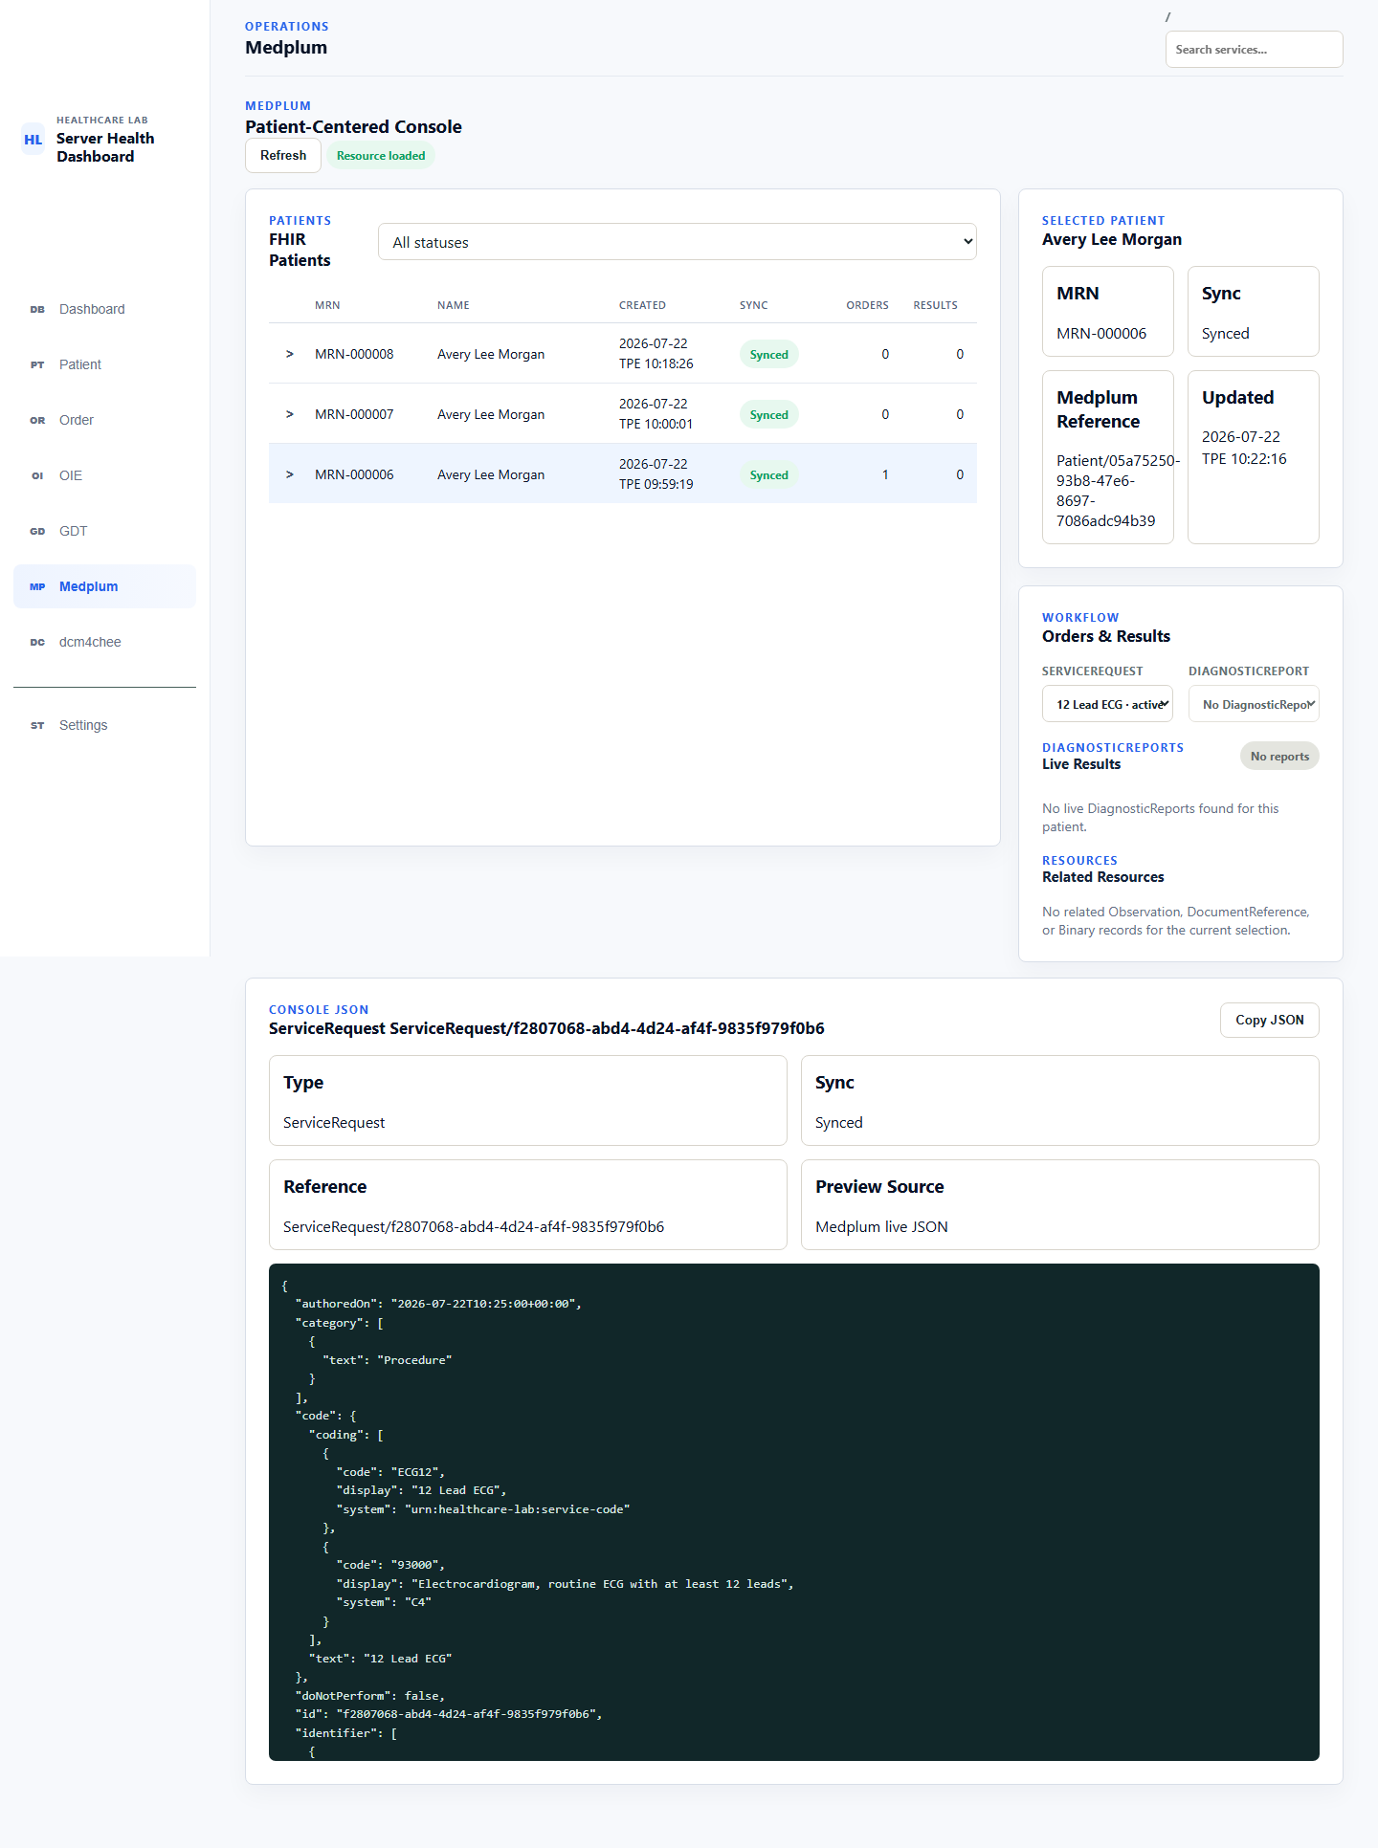

Preconditions and endpoint selection
- Run the Dashboard check and confirm HL7 FHIR / Medplum is Healthy.
- Confirm the saved Medplum server inventory record is enabled and has valid OAuth credentials.
- As documented in Chapter 5 and deploy/README.md, when lab-app runs in Docker, the persisted values must use the Compose service address:
- host = medplum
baseUrl = http://medplum:8103/fhir/R4
- Do not substitute the browser URL or MEDPLUM_PUBLIC_BASE_URL for this sync address. A smoke check can pass while Patient/Order sync fails if the persisted server baseUrl is wrong.

Create and sync the Patient and Order
- Create a FHIR Patient as described in Chapter 8. A successful write displays Synced and a Patient/<id> Medplum reference.
- Create a FHIR Order as described in Chapter 9. The Patient must already have a valid synced Patient/<id> reference.
- Healthcare Lab creates one local Order anchor and one FHIR ledger record, builds a FHIR R4 ServiceRequest, and immediately attempts Medplum sync.
- On success, confirm Synced, ServiceRequest/<id>, and the following relationship in the live JSON:
- ServiceRequest.subject.reference = Patient/<id>
- Confirm the ECG definition, including ECG12 / 12 Lead ECG, status, intent, priority, requested time, requester, and deterministic identifier.
The current workflow does not create or require a FHIR Task. ServiceRequest is the Order representation.

Use the Medplum Patient-Centered Console
- Open Medplum and select Refresh. Use the status filter to show All statuses, Synced, Pending sync, Sync failed, or Syncing records.
- Select a Patient row. The Selected Patient panel shows MRN, sync state, Medplum reference, and update time.
- Select the Patient disclosure arrow independently when inline Order/Result rows are needed. Selecting a Patient and expanding a row are separate actions.
- Under Orders & Results, select the ServiceRequest for the ECG Order.
- Inspect Console JSON. For a reachable synced resource, Preview Source must say Medplum live JSON; this is the canonical resource returned by Medplum, not merely the locally submitted payload.
- Use Copy JSON only with synthetic data. Do not place real PHI, OAuth tokens, or credentials in troubleshooting evidence.
If live preview of a known synced ledger record fails, the console may show the preserved local submitted JSON and label it as a local fallback. That fallback proves the original workflow intent was retained; it does not prove the Medplum resource is currently available or authoritative.

Discover DiagnosticReport results
DiagnosticReport discovery is selection-triggered and live. Selecting or refreshing a synced Patient causes Healthcare Lab to query Medplum; there is no background scheduler in this console workflow.
- Select a synced Patient. Healthcare Lab queries DiagnosticReport by the Patient reference.
- When a ServiceRequest is selected, Healthcare Lab prefers a based-on=ServiceRequest/<id> search.
- If Medplum rejects or does not support the based-on search with an expected query error, Healthcare Lab safely falls back to a Patient search and filters DiagnosticReport.basedOn[] server-side.
- The UI separates Order-linked results from Patient-level results. A report without a ServiceRequest reference remains visible as Patient-level; it is not silently discarded.
- Each report summary shows its code/display, status, effective or issued date, linked Order when available, result count, and attachment/reference count.
- Select Preview on the report or a related row to fetch live JSON for Observation, DocumentReference, or referenced Binary resources. Related resources are loaded lazily and are not copied into a complete local FHIR shadow store.
An empty Bundle is a valid result. No reports means Medplum was reachable and returned no matching DiagnosticReports; it must not be reported as a service outage.

Sync states, errors, and Retry
State or display | Meaning | Operator action
Pending sync | Local workflow intent exists but has not completed Medplum sync | Confirm configuration/connectivity, then use Retry
Syncing | A sync attempt is in progress | Wait for the bounded request to finish; do not submit a duplicate create
Synced | A Medplum id/reference and successful sync time are recorded | Inspect Medplum live JSON; no Retry action is shown
Sync failed | The local record remains, with a human-readable error and available response evidence | Inspect the error and OperationOutcome, correct the cause, then retry the same record
Live fetch failed; showing local JSON | A previously synced reference could not be read live | Treat the JSON as submitted fallback, not canonical current data
Fetch failed | Live DiagnosticReport/resource query failed | Check authorization, endpoint, HTTP response, and returned OperationOutcome
Retrying the same ledger record with its deterministic FHIR identifier is idempotent. Healthcare Lab searches Medplum using that identifier: if the resource already exists, it records that existing id/reference; otherwise it creates it once. Do not create a replacement local Patient or Order merely because a sync attempt failed.
FHIR errors may include a human-readable summary, HTTP status, raw response, and a FHIR OperationOutcome. Preserve a bounded, redacted projection of the issue severity, code, diagnostics, expression/location, request URL, and attempt timestamp when escalating. Remove PHI, tokens, authorization data, credentials, and sensitive query-string values; do not include unrelated resource bodies.

RC verification record
The 2026-07-22 browser pass verified successful Patient and ServiceRequest synchronization, the required persisted Docker baseUrl, failure followed by corrected inventory and Retry -> Synced, and live Medplum references. The RC view captured above shows a selected Patient with one active 12 Lead ECG ServiceRequest, Preview Source: Medplum live JSON, and No reports; the empty live result was displayed without marking Medplum unhealthy. No destructive Medplum action was exposed or performed.

Chapter 12 — GDT 2.1 Order Workflow
Healthcare Lab exchanges GDT 2.1 files with AP (QHeart-AP/QHAP) through one shared bridge root. It writes an outgoing 6302 New Test Request, then imports the returned 6310 Test Data Transfer and its artifact references. The UI names GDT-OUT and GDT-IN from Healthcare Lab's point of view.
Healthcare Lab -- GDT-OUT 6302 --> /data/gdt-bridge/inbox --> AP
Healthcare Lab <-- GDT-IN 6310 -- /data/gdt-bridge/outbox <-- AP
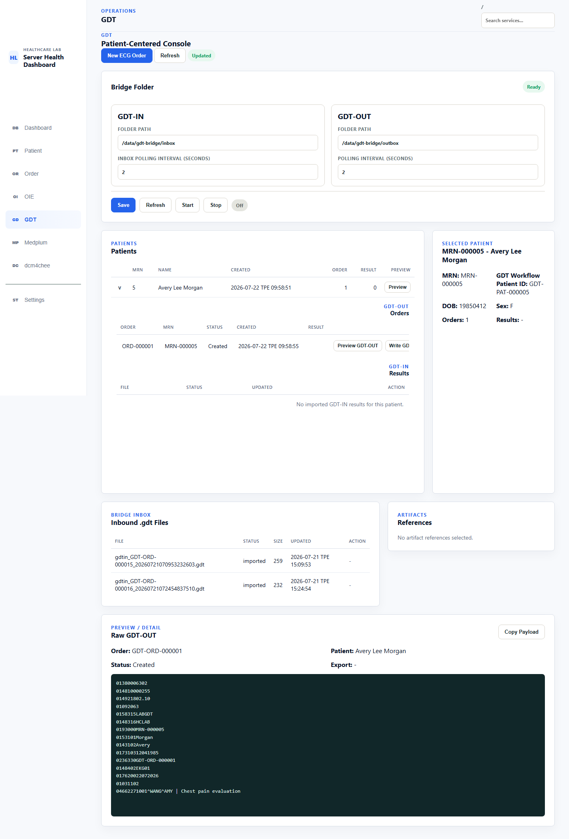

Bridge folder contract
For the default installation, .\deploy\lab.ps1 start creates the bounded Windows host root at instance\gdt-bridge, Docker mounts it at /data/gdt-bridge, and Healthcare Lab provisions the supported sibling folders. In the GDT settings, keep the application path set to the container path /data/gdt-bridge; a Windows path such as C:\...\instance\gdt-bridge is not readable inside lab-app.
For an Advanced deployment with a dedicated AP share, set GDT_BRIDGE_HOST_PATH in .env to the exact Windows host folder. The wrapper resolves and creates that safe root, rejecting filesystem and repository roots, and Compose still mounts it at /data/gdt-bridge. Pause AP exchange and recreate lab-app after changing the bind source. The resulting folder contract is:
Folder | Producer → consumer | Purpose
inbox/ | Healthcare Lab → AP | Generated 6302 requests waiting for AP
outbox/ | AP → Healthcare Lab | Returned 6310 results waiting for import
processing/ | Healthcare Lab internal | Same-volume claim while an inbound result is being imported
archive/ | Healthcare Lab internal | Successfully imported 6310 files in PoC/debug archive mode
error/ | Healthcare Lab internal | Files that could not be parsed or persisted
reports/ | AP/shared | Referenced PDF, DICOM, XML, or other result artifacts
Do not interpret the Bridge Inbox table heading as the filesystem inbox/. That table lists inbound results discovered from AP's outbox/, plus archived/error history.

Configure the GDT Console
- Open GDT. Confirm GDT-IN > Folder Path is /data/gdt-bridge/inbox and GDT-OUT > Folder Path is /data/gdt-bridge/outbox in the current UI. Despite those field labels, the operational direction is the folder contract above.
- Set the polling intervals. The default RC values are 2 seconds; values below 0.25 seconds are not accepted.
- Select Save, then Refresh, and confirm Bridge Folder shows Ready.
- The backend supports the following inbound filename profiles, but the current RC Console does not expose a profile selector. Configure the profile, sender, and receiver through the approved deployment/API configuration before starting the watcher; do not assume Save changes them:
  - permissive: accept otherwise eligible .gdt files for lab use.
  - gdt21: accept configured legacy sender/receiver filenames and allowed numeric sequence extensions.
  - gdt35: accept <receiver>_<sender>_<sequence>.GDT using configured abbreviations.
- Stop automatic import before changing watcher configuration. Use Start to begin automatic outbox/ polling and confirm the badge changes from Off to On (<seconds>s); use Stop to leave manual import available.

Create and export a 6302 Order
- Create a GDT Patient and GDT ECG Order as described in Chapters 8 and 9. The RC test type is 8402=EKG01 (12-lead resting ECG).
- Open GDT, select the Patient, and use the disclosure arrow. The expanded Patient shows GDT-OUT > Orders and GDT-IN > Results separately.
- Select Preview GDT-OUT. Verify the byte-counted payload contains at least:
Field | Expected purpose
8000=6302 | New Test Request set type
8100 | Five-digit complete message byte length
9218=02.10 | GDT 2.1 version
3000 | Canonical Patient MRN
6330 | Local GDT Order correlation, such as GDT-ORD-000001
8402=EKG01 | ECG test code
8315 / 8316 | Receiver and sender identifiers
- Confirm each record's three-digit length includes the length digits, four-digit field code, content, and trailing CRLF. Do not edit the rendered file manually; an incorrect record or total byte length is rejected.
- Select Write GDT-OUT once. Healthcare Lab writes a temp file and atomically renames it into /data/gdt-bridge/inbox using a name such as:
- gdtin_GDT-ORD-000001_<timestamp>.gdt
- Confirm the Order retains its local identity, export path/status, and event even if the filesystem write fails. AP should consume the completed file rather than a partial/temp file.
Created means the local Order and raw 6302 exist. It does not prove the file was written, AP consumed it, or a result returned.

Import and match a 6310 result
AP writes the completed result file into /data/gdt-bridge/outbox. Import it either manually from Bridge Inbox with Import GDT-IN or automatically with the watcher.
The importer:
- Skips hidden, .tmp, .temp, and internally managed processing files.
- Waits for file size/timestamp stability during watcher scans.
- Processes eligible files FIFO by creation time when reliable, otherwise by deterministic timestamp/filename order.
- Claims one file with a same-volume rename into processing/ before parsing.
- Parses only a valid byte-counted 6310, preserves raw GDT and parsed fields, and continues to later files if one file fails.
Order matching gives precedence to an unambiguous Order identifier carried in fields such as 6330 or 6200. A known 3000 Patient number without a supported Order identifier may preserve Patient context, but the result remains unmatched/review-needed; Healthcare Lab must not attach it to the latest Order merely because the Patient matches.
For a matched result, expand the Patient and select Preview GDT-IN. The current detail panel shows Match, result Status, a measurement summary, artifact references, and raw 6310. Use the raw payload and persisted API/repository evidence to verify:
- result status and interpretation from 8418, 6220, 6227, and 6228;
- canonical measurements such as HR, PR, QRS, QT, and QTC from repeated 8410/8420/8421 groups;
- the matched Patient and local GDT Order;
- preserved raw 6310 text and import/match events.

Artifact references
A 6310 may describe artifacts through repeated 6302–6305 groups. The current result coordinator normalizes format, description, reference/path/URL, role, and availability status. Missing or unverifiable targets are retained with warning status and do not invalidate an otherwise parseable result. The current RC Console offers Open for safe HTTP(S) URLs and Copy for references; it does not provide a general local-file download action. DICOM remains reference-only and is not rendered.
Use artifact open/download actions only when the reference is safe and expected. Copyable paths, URLs, and raw payload evidence may contain patient identifiers; use synthetic data and redact host/user paths before sharing.

Archive, delete, error, and duplicate behavior
Outcome | File disposition | Durable evidence
Success with archive | Move from processing/ to collision-safe archive/ path | Raw GDT, canonical result, match, attachments, and events remain in SQLite
Success with delete | Delete exchange file after persistence succeeds | The same persisted result evidence remains; this is closer to GDT read-and-delete behavior
Parse/persist failure | Move to error/ when possible | The current import/watcher result exposes diagnostics; other files continue
Claim/stability/binding skip | Leave for a later scan or operator correction | Skip reason appears in watcher/import result
Archive mode is the PoC/debug default. Changing to delete mode removes the successfully processed exchange file, so confirm evidence and backup expectations before enabling it.
Do not copy an already processed 6310 back into outbox/. Archive/delete disposition prevents the original exchange file from being scanned again, but the current RC has not demonstrated durable idempotency when an operator or device reintroduces the same filename/content.

Troubleshooting checklist
- Bridge Folder not ready: verify the host path exists, is mounted, contains sibling inbox/ and outbox/, and is writable by the container.
- Order remains Created: use Write GDT-OUT, then inspect export status/path; do not infer AP receipt.
- File does not appear for import: verify it is in AP's outbox/, has a supported stable filename, and matches the configured binding profile/sender/receiver.
- Import error: validate 8000=6310, 8100, 9218=02.10, required 3000 and 8402, and byte lengths.
- Result is unmatched: compare 6330/6200 with the local GDT-ORD-*; do not force a Patient-only match.
- Watcher cannot be reconfigured: select Stop, update the approved deployment/API configuration, refresh the Console, then start it again.

RC verification record
The 2026-07-22 browser pass confirmed the actual Patient-Centered Console labels, /data/gdt-bridge/inbox and /data/gdt-bridge/outbox, 2-second poll fields, watcher Off, expanded GDT-OUT and GDT-IN sections, the local identifiers MRN-000005, GDT-PAT-000005, and GDT-ORD-000001, and a valid raw 6302 containing 8000=6302, 9218=02.10, 6330=GDT-ORD-000001, and 8402=EKG01. This handbook pass did not write another shared-folder file, start the watcher, manufacture a 6310, or alter archived shared evidence; 6310 import/recovery behavior is covered by the repository's GDT integration/runtime tests and the persisted imported-file history shown in the console.
Two RC defects remain release blockers for this chapter: canonical measurement objects currently render as [object Object] in the GDT-IN summary, and durable duplicate prevention has not been demonstrated for a previously processed 6310 that is reintroduced into outbox/. The result detail also does not yet surface interpretation/comments or import/match events outside the raw payload. Fix and browser-reverify these items before treating the GDT SOP as final v1.0.0 behavior.

Chapter 13 — DICOM / dcm4chee Order Workflow
This workflow first synchronizes a DICOM Patient to dcm4chee through HL7 ADT and then creates a Modality Worklist (MWL) item. AP (QHAP) queries MWL, performs the examination, and C-STOREs the images. Healthcare Lab then discovers the result through QIDO/WADO and reconciles it. Healthcare Lab owns Patient and Order intent plus the mapping ledger; dcm4chee is authoritative for MWL, Studies, and DICOM artifacts.
Patient -> ADT :2575 -> dcm4chee
Order -> MWL REST (WORKLIST) -> automated read-back
AP -> DIMSE :11112 (DCM4CHEE) query / C-STORE
Archive -> QIDO/WADO (DCM4CHEE) -> reconciliation
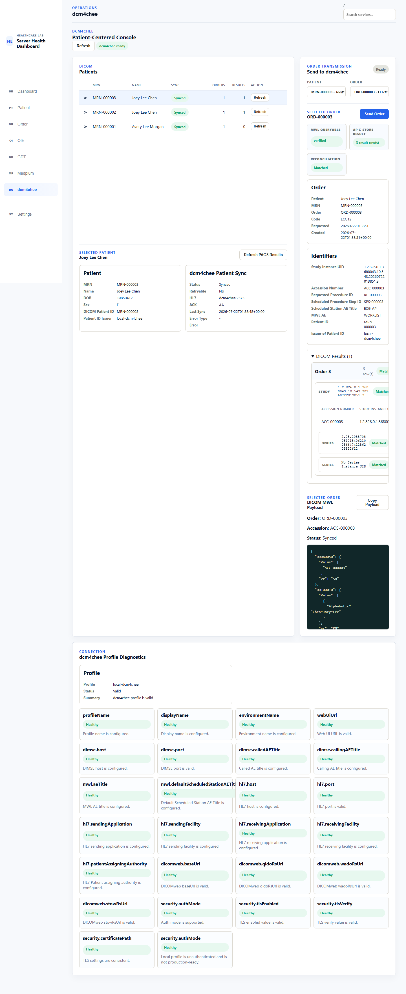

Prerequisites and AE/endpoints
- Run the Dashboard health checks and confirm dcm4chee / DICOM is Healthy.
- Open the dcm4chee Console and confirm profile diagnostics are Healthy/Valid.
- Confirm the AE Titles: archive/AP DIMSE called AE DCM4CHEE, Healthcare Lab calling AE HEALTHCARE_LAB, MWL REST surface WORKLIST, and scheduled station/AP calling AE ECG_AP.
- Select the address for the caller:
Caller | Endpoint/AE | Purpose
Healthcare Lab container | dcm4chee:2575 | Patient ADT
Healthcare Lab automated verification | /aets/WORKLIST/rs/mwlitems | MWL REST create/read-back
Healthcare Lab archive discovery | /aets/DCM4CHEE/rs | QIDO/WADO
Physical AP | <Docker-host-IP>:11112, called AE DCM4CHEE, calling AE ECG_AP | DIMSE MWL query and C-STORE
Browser | http://127.0.0.1:8082/dcm4chee-arc/ui2 | dcm4chee UI
- Do not configure the REST surface WORKLIST as the AP's DIMSE called AE or substitute a browser URL for a container-internal address. If AP runs away from the Docker host, use a lab-host IP reachable from AP, not 127.0.0.1.
A local profile without authentication can be valid for a trusted lab. A Valid diagnostic does not make that profile production-ready.

Create and synchronize a DICOM Patient
- Create a DICOM Patient as described in Chapter 8.
- The system normally synchronizes Patient master data to dcm4chee through ADT after local creation. If it is still unsynchronized when an Order is created, MWL preflight first attempts Patient synchronization and must not POST MWL if that attempt fails.
- On the Patient row, confirm ADT Sync: Synced, ACK: AA, and the endpoint. AA means the receiver accepted this ADT; AE, AR, or a timeout is not a successful synchronization.
- The Patient must be Synced before a subsequent MWL Order can be treated as available to AP.

Create a DICOM MWL Order
- As described in Chapter 9, select a synchronized DICOM Patient and create a DICOM MWL Order.
- Record the local Order ID, Accession Number, Study Instance UID, Requested Procedure ID, Scheduled Procedure Step ID, DICOM Patient ID (normally mapped from MRN in this lab), and the issuer separately.
- Confirm MWL create/read-back completes. Green Accepted in Local Orders is only a local summary; MWL Sync: Created means the worklist item was created; MWL Queryable: Verified only proves that the configured WORKLIST REST surface returned a strong-identifier match. It does not prove a physical AP completed a DIMSE query.
- Query/read back before retrying. If an item already exists with the same deterministic identifiers, retain its mapping and do not POST a duplicate MWL item.

AP query, C-STORE, and result reconciliation
- From AP, connect to reachable <Docker-host-IP>:11112 and run a DIMSE MWL query with calling AE ECG_AP and called AE DCM4CHEE. Verify Patient ID/issuer, Accession Number, Requested Procedure ID, SPS ID, scheduled time, and station AE. This step is the live AP pickup proof.
- After the examination, C-STORE DICOM instances to archive called AE DCM4CHEE; do not send them to WORKLIST.
- In the Healthcare Lab dcm4chee Console, select the Patient/Order and refresh. Confirm AP C-STORE Result reports the discovered result-row count.
- Confirm Reconciliation: Matched. The system prefers a strong Study Instance UID match, then Accession Number in the same server/profile namespace, and then RP ID plus SPS ID. Weak identifiers, cross-Patient conflicts, or multiple candidates must remain unresolved/ambiguous and must not be attached to an arbitrary Order.
- Expand the Study, Series, and Instance hierarchy. Verify Study/Series/SOP Instance UIDs, modality, instance count, and times. Open Viewer inspects archive content; Copy Retrieve copies the retrieval reference. Neither action changes reconciliation.
If AP reports C-STORE returned unknown status: 0x110, 0x110 is DICOM 0x0110 Processing Failure. It only establishes that archive processing failed and does not by itself mean that the AE was unauthorized. Inspect errorComment/Caused by in the dcm4chee server log at the same timestamp. java.nio.file.AccessDeniedException: /storage/fs1 means dcm4chee accepted the Association and C-STORE request, but WildFly could not write the archive storage. In contrast, an AE policy/authorization failure normally rejects the Association before C-STORE or explicitly returns 0x0124 Refused: Not Authorized; use the actual AP and server-log response as evidence. Compose now runs dcm4chee-storage-init at startup to correct the configured storage directory. After correction, resend the instance; a successful response is status=0H.

State interpretation and recovery
Display | Meaning | Action
ADT Synced / ACK AA | dcm4chee accepted the Patient ADT | Continue with Order creation
MWL Created, query unverified | Automated REST create/read-back verification is incomplete | Inspect the configured WORKLIST REST target
MWL Query Verified | WORKLIST REST returned the expected strong-identifier match | AP must still DIMSE-query DCM4CHEE:11112
No result / query failed | No matching QIDO result exists, or the archive query failed | Distinguish an empty result from connectivity/authentication failure; do not recreate the Order
Unresolved / ambiguous | Strong identifiers are missing or multiple candidates exist | Compare Patient, Study UID, Accession, and RP/SPS; preserve evidence for review
Matched | One result is linked uniquely to the Order | Verify the hierarchy and viewer/retrieve actions
Duplicate | The SOP/Study was already processed | Do not resend or create another mapping; inspect AP retry or archive ingest history
Never guess a match for a wrong-Patient, missing-accession, or unlinked Study by choosing the newest Order. Correct source identifiers or mapping configuration and query/reconcile again. Do not delete the original Study or recreate a Patient/Order merely to turn the UI green.
For the repeatable simulated-AP path, PDF/DICOM evidence artifact, simulated_ap_return source label, or evidence API, follow docs/dcm4chee-production-e2e-verification.md in an isolated environment. Simulated evidence can verify mapping and UI behavior, but it cannot replace physical-AP DIMSE pickup/C-STORE proof. Label captured evidence as live or simulated and use synthetic Patients only.

RC verification record
The 2026-07-22 browser pass read existing synthetic MRN-000003/ORD-000003 evidence without mutating the shared workflow: Patient ADT was Synced, ACK was AA, and the endpoint was dcm4chee:2575; MWL creation was complete and REST query verification was Verified; preserved AP C-STORE evidence showed 3 result row(s); reconciliation was Matched. The UI also read back the Study/Series/Instance hierarchy, viewer/retrieve actions, raw MWL JSON, and valid profile diagnostics. This pass did not re-witness physical-AP DIMSE pickup/C-STORE, create another Patient or Order, or stop/restart the shared runtime.

Part IV: Operate and Recover the System

Chapter 14 — Operations and Troubleshooting
This chapter covers routine checks, layered diagnosis, controlled recovery, and pre-upgrade backup. Preserve evidence first, then diagnose in this order: container → service health → network/port → authentication → protocol response → workflow state → identifier matching → UI presentation. Do not jump from a UI symptom to data deletion or reinstallation.

Routine checks
- Open Dashboard and confirm TOTAL, RUNNING, ATTENTION, CPU, and memory have no unexpected changes.
- Refresh only reloads current state. Use Run Checks for real protocol probes, or Check only the target group.
- Confirm the states of HL7 v2 / OIE, HL7 FHIR / Medplum, and dcm4chee / DICOM; expand groups to inspect child services.
- Inspect Recent Events, protocol-console diagnostics, listener/watcher state, and incomplete workflows.
- Use a synthetic smoke Patient/Order for the required path. All containers running does not prove an end-to-end workflow.
The 2026-07-22 read-only browser pass showed seven services running, zero attention, and all three protocol groups Healthy. It also confirmed the Refresh, Run Checks, group-level Check/Start/Stop/Restart, and Recent Events labels. No runtime control action was executed.

Preserve safe incident evidence first
Before correction, record the timestamp and timezone, synthetic Patient/MRN, local Order ID, protocol, external reference, current state, last successful step, error summary, HTTP/HL7 ACK status, container image/tag, and relevant bounded logs. For an OIE queue incident, also preserve Channel ID/revision, destination state, retry timeline, and MSH-10; never purge or manually resend merely to clear the evidence.
Before sharing, remove PHI, OAuth tokens, passwords, Authorization/Cookie headers, complete credentials, sensitive query strings, unbounded upstream bodies, and private host/user paths. Raw HL7, FHIR JSON, GDT, DICOM metadata, and screenshots may all contain Patient identifiers; use synthetic data only.
Common read-only checks:
.\deploy\lab.ps1 status
.\deploy\lab.ps1 inspect lab-app
.\deploy\lab.ps1 logs lab-app -Lines 200
.\deploy\lab.ps1 logs oie -Lines 200
Invoke-WebRequest http://127.0.0.1:5000/ -UseBasicParsing

Layered diagnosis
Layer | Question | Next action
Container | Is a service not running/healthy, is restart count increasing, or is the image wrong? | Inspect status, inspect, and bounded logs; verify Docker daemon, volume, and image tag
Service health | Is the container normal while Dashboard is Unknown, Degraded, or Down? | Run the target Check, read each probe and Recent Events; do not rely only on container health
Network/port | Is there a timeout, refused connection, wrong host, or wrong published port? | Distinguish browser/host, Docker service name, and external-AP endpoints; inspect firewall and port collisions
Authentication | Is there HTTP 401/403 or an OAuth/OIE-management failure? | Verify credential presence, scope/expiry, and TLS mode; never paste secrets into logs
Protocol response | Is there HL7 AE/AR, FHIR OperationOutcome, GDT parse failure, or DICOM query/C-STORE failure? | Preserve bounded protocol diagnostics and correct payload, routing, or receiver policy
Workflow state | Does a local record exist while sync/export/query/result is incomplete? | Use that protocol's state and Retry; do not create a replacement Patient/Order
Identifier matching | Is the result unmatched, ambiguous, or duplicate? | Compare MRN/issuer, Order ID, MSH-10, ServiceRequest, GDT 6330, and Study UID/Accession/RP/SPS
UI presentation | Is backend evidence correct while the page is blank, stale, or malformed? | Refresh, inspect browser console/API response, and preserve a screenshot; do not alter authoritative data to fit the UI

Protocol quick triage
Symptom | Inspect first | Safe recovery
OIE Order has no ACK / ORU is queued | oie:6600, AP 6671, OIE ingress 6661, HLAB listener lab-app:6665, Channel deployed state, and queue | Restore the dependency and allow destination auto-retry. Use listener Retry only when the listener is degraded; never purge/manually resend
FHIR Sync failed | Persisted Medplum baseUrl, OAuth, and OperationOutcome; Docker requires http://medplum:8103/fhir/R4 | Correct inventory/credential and Retry the same ledger record; do not create a duplicate resource
GDT file is not imported | Bridge mount, inbox//outbox/ direction, filename profile, watcher, byte lengths, and processing/archive/error disposition | Wait for file stability, then manual-import or start watcher; preserve raw 6310 and never replay a processed file
DICOM Patient/MWL fails | ADT ACK, dcm4chee:2575, WORKLIST REST read-back, and stable identifiers | Repair Patient sync first; query/read back before MWL retry to avoid a duplicate POST
AP C-STORE returns 0x0110/110H | dcm4chee server.log, errorComment/Caused by at the same timestamp; inspect the configured storage directory when AccessDeniedException appears | 0x0110 is a general processing failure, not proof of AE denial. For /storage/fs1 permission failure, confirm dcm4chee-storage-init is Exited (0) and the directory is wildfly:wildfly, 0775; resend after correction and never delete the archive volume
DICOM result is unmatched | Patient ID/issuer, Study UID, Accession, RP/SPS, and server/profile namespace | Correct mapping, then refresh/reconcile; never guess the newest Order

Select the smallest recovery action
Action | Actual effect | Use when
Refresh/Check | Does not change workflow data; reloads state or runs probes | First action
Protocol Retry | Retries the same persisted record/listener | The cause is corrected and the state is explicitly retryable
Start/Stop | Starts or stops the selected Compose service/group | In a maintenance window after checking affected services, queues, and other users
restart wrapper | Runs up -d --force-recreate, replacing the container and applying Compose/env | After image, environment, published-port, or runtime-configuration changes
Reinstall | Redeploys the full bundle | Only when installation content is unrecoverable and a backup/rollback plan exists
Reset/delete/purge | May permanently remove workflows, queues, or data | Not a routine handbook action; requires an explicit maintenance procedure and verified backup
Dashboard Stop/Restart controls the real runtime. Before using it, expand the target group and confirm affected services, listeners, in-flight requests, OIE queues, and the GDT watcher. If only a managed OIE Channel destination, queue, timeout, or ACK validation changed, Preview, Apply, and redeploy the Channel; Channel redeploy cannot change a Compose-published port.

Backup, upgrade, and rollback
Before upgrade, schedule a maintenance window: stop new operations, allow in-flight workflows to finish, and pause AP reads/writes against the GDT shared folder. Stopping lab-app makes SQLite quiescent; it does not prevent an external AP from changing GDT files while they are copied.
First preserve a release manifest: record inspect lab-app, config --images, the current immutable LAB_APP_IMAGE, Compose bundle version, and backup timestamp. Preserve the effective .env separately in access-controlled secret storage so rollback can reconstruct configuration; never put it in screenshots, tickets, ordinary logs, or a publishable backup artifact.
Then create an operator-controlled backup and stop only lab-app. The following Copy-Item applies only to the default GDT_BRIDGE_HOST_PATH=instance\gdt-bridge:
New-Item -ItemType Directory -Force backup\v1.0.0
.\deploy\lab.ps1 stop lab-app
docker compose --env-file .env -f deploy\docker-compose.yml cp lab-app:/app/instance backup\v1.0.0\instance
Copy-Item -Recurse instance\gdt-bridge backup\v1.0.0\gdt-bridge
If GDT_BRIDGE_HOST_PATH is a custom AP share, resolve and verify its actual absolute host path, then copy that exact folder to the backup. Do not copy the default path and claim completion. Confirm AP remains quiesced, the backup contains the instance database and evidence from the actual GDT bridge, and both can be read back from controlled storage. Do not include .env, secrets, or real Patient data in a backup artifact intended for publication.
Set LAB_APP_IMAGE in .env to the target immutable tag, then:
docker compose --env-file .env -f deploy\docker-compose.yml pull lab-app
.\deploy\lab.ps1 restart lab-app
Invoke-WebRequest http://127.0.0.1:5000/ -UseBasicParsing
After upgrade, rerun Dashboard checks and the required protocol smoke workflow. Resume AP exchange only after they pass.
This release does not yet provide a fully verified named-volume restore command, so this section is not an executable destructive-rollback SOP. If rollback is required, keep AP exchange quiesced, stop lab-app, preserve the failed-upgrade instance separately, and retain the release manifest and logs. Restore the complete matching instance backup and configuration only under a controlled restore runbook or release-maintainer direction; verify the restore target, schema compatibility, and recoverability before selecting the previous immutable LAB_APP_IMAGE and recreating. Never merge a backup into an unknown or non-empty instance, and never switch only the image: image rollback may not reverse a database migration.

Upgrade or incident completion criteria
- Dashboard and target-protocol diagnostics have returned to the expected state.
- The same failed workflow succeeds without a duplicate Patient, Order, message, resource, or Study mapping.
- OIE queues drain through normal retry; GDT processing/error disposition is explainable; FHIR/DICOM external references read back.
- The before/after timeline, smallest action taken, verification result, and remaining limitations are recorded.
- If completion is impossible, mark the run failed/blocked and preserve evidence; never close it by deleting data, purging a queue, or fabricating a green state.

Appendix A — Command Quick Reference
Run these PowerShell commands from the deployment-bundle root, where deploy\docker-compose.yml is present. .env is optional and is needed only for an Advanced deployment override. Use the wrapper for routine operations so service aliases and Compose arguments remain consistent. A successful command proves only the stated layer; complete the ready-for-use or protocol verification in Chapters 6 and 10–13 before declaring the system operational.

Host and Compose checks
Purpose | Command | Expected evidence / boundary
Check Docker client and server | docker version | Both Client and Server sections are available.
Check Compose | docker compose version | A Compose v2-compatible command is available.
Check the Docker host | docker info --format 'Server={{.ServerVersion}} OSType={{.OSType}} Arch={{.Architecture}} CPUs={{.NCPU}} Memory={{.MemTotal}}' | OSType=linux; v1.0.0 RC was verified on amd64.
Validate effective Compose configuration | docker compose -f deploy\docker-compose.yml config --quiet | Exit code 0 validates interpolation and Compose structure, not credentials or connectivity. Compose automatically reads .env when present.
List effective images | docker compose -f deploy\docker-compose.yml config --images | Compare every image with the release matrix; use an immutable application tag.

Routine lifecycle and inspection
Purpose | Command | Actual effect / caution
Inspect lab-app | .\deploy\lab.ps1 inspect lab-app | Returns Compose container metadata in JSON, including image, state, ports, and restart count.
Show the whole stack | .\deploy\lab.ps1 status | Runs Compose ps; it does not test application or protocol behavior.
Show one logical service | .\deploy\lab.ps1 status <service> | Accepts oie, medplum, medplum-postgres, medplum-redis, medplum-app, dcm4chee, dcm4chee-db, ldap, lab-app, gdt-bridge, hl7tester, or gdt-hospital. The last three map to lab-app.
Start the whole stack | .\deploy\lab.ps1 start all | Runs Compose up -d. Use a service name instead of all to limit scope.
Stop the whole stack | .\deploy\lab.ps1 stop all | Stops containers without deleting named volumes. Pause AP exchange and drain or record in-flight work first.
Recreate one service | .\deploy\lab.ps1 restart <service> | Runs up -d --force-recreate --no-deps; this replaces the selected container and applies image, environment, and Compose changes. It is not an in-process restart.
Run the wrapper smoke check | .\deploy\lab.ps1 smoke all | Runs Compose ps only. Follow with HTTP, Dashboard, connectivity, and workflow checks.
Read recent logs | .\deploy\lab.ps1 logs <service> -Lines 200 | Reads the last 200 lines. Treat output as sensitive: redact PHI, credentials, tokens, payloads, paths, and identifiers before sharing.
Use the smallest service scope that solves the problem. restart all recreates the entire stack; confirm dependencies, queues, listeners, other users, and the maintenance window before doing so. stop, restart, and Dashboard lifecycle actions affect the real runtime.

Installation and HTTP verification
.\deploy\lab.ps1 start
.\deploy\lab.ps1 status
Invoke-WebRequest http://127.0.0.1:5000/ -UseBasicParsing
The wrapper creates the default GDT host root and passes .env only when one exists. HTTP 200 verifies only the Healthcare Lab web endpoint. Complete guided setup in Dashboard and Settings, then run the required end-to-end protocol workflow before use.

Backup and application-image upgrade
Before these commands, stop new operations, finish or record in-flight workflows, and pause all AP reads and writes against the GDT exchange folder. Preserve inspect lab-app, config --images, the immutable LAB_APP_IMAGE, the bundle version, and the backup timestamp. Store the effective .env separately in controlled secret storage.
For the default GDT_BRIDGE_HOST_PATH=instance\gdt-bridge only:
New-Item -ItemType Directory -Force backup\v1.0.0
.\deploy\lab.ps1 stop lab-app
docker compose --env-file .env -f deploy\docker-compose.yml cp lab-app:/app/instance backup\v1.0.0\instance
Copy-Item -Recurse instance\gdt-bridge backup\v1.0.0\gdt-bridge
If GDT_BRIDGE_HOST_PATH is custom, resolve and verify its absolute host path and copy that exact folder instead. Read back and verify both backup trees before upgrading. Then set LAB_APP_IMAGE to the target immutable tag and run:
docker compose --env-file .env -f deploy\docker-compose.yml pull lab-app
.\deploy\lab.ps1 restart lab-app
Invoke-WebRequest http://127.0.0.1:5000/ -UseBasicParsing
Resume AP exchange only after Dashboard and the required protocol smoke workflow pass. This release has no fully verified named-volume restore command; Appendix A therefore does not provide a direct rollback command. Follow the controlled rollback boundary in Chapter 14.

Appendix B — URLs and Port Matrix
Use Docker service names and container ports for traffic between Compose services. Use the Docker-host address and published port for a browser or physical AP outside the Compose network. Values below are release defaults; .env may override published ports. Confirm the effective configuration instead of assuming the defaults:
docker compose -f deploy\docker-compose.yml config --quiet
docker compose --env-file .env -f deploy\docker-compose.yml ps
docker compose --env-file .env -f deploy\docker-compose.yml port <service> <container-port>

Operator, browser, and protocol endpoints
Service / flow | Docker-network endpoint | Default host / external endpoint | Setting / boundary
Healthcare Lab UI/API | http://lab-app:5000 | http://127.0.0.1:5000 | Host port: LAB_APP_PORT; HTTP only in this release.
Healthcare Lab Order → OIE | oie:6600 | <Docker-host-IP>:6600 when an external sender needs the same ingress | Host port: OIE_ORDER_INGRESS_HOST_PORT. The in-container sender continues to use oie:6600.
AP Result → OIE | oie:6661 | <Docker-host-IP>:6661 | Host port: OIE_AP_RESULT_INGRESS_HOST_PORT; Compose explicitly publishes the default on 0.0.0.0.
OIE Result → Healthcare Lab | lab-app:6665 | Not published by default | Listener: HLAB_RESULT_LISTENER_HOST / HLAB_RESULT_LISTENER_PORT; OIE reaches it through the Docker network. The deprecated OIE_MLLP_RESULT_* aliases affect this listener only.
OIE Order → AP | <AP-address>:6671 | AP-owned listener, normally <AP-IP>:6671 | The release bundle does not provide or host-publish an AP service. OIE expose: 6671 does not create the external listener.
OIE HTTP | http://oie:8080 | http://127.0.0.1:8080 | Host port: OIE_HTTP_PORT.
OIE HTTPS | https://oie:8443 | https://127.0.0.1:8443 | Host port: OIE_HTTPS_PORT; trust behavior depends on the deployed certificate.
Medplum FHIR R4 API | http://medplum:8103/fhir/R4 | http://127.0.0.1:8103/fhir/R4 | Host port: MEDPLUM_PORT. Healthcare Lab sync must use the Docker URL in its persisted server inventory, not the browser/public URL.
Medplum web app | http://medplum-app:3000 | http://127.0.0.1:3000 | Host port: MEDPLUM_APP_PORT; the browser-side API base is MEDPLUM_PUBLIC_BASE_URL.
dcm4chee web UI | http://dcm4chee:8080/dcm4chee-arc/ui2 | http://127.0.0.1:8082/dcm4chee-arc/ui2 | Host port: DCM4CHEE_HTTP_PORT; operator link: DCM4CHEE_WEB_UI_URL.
dcm4chee MWL / DICOMweb | http://dcm4chee:8080/dcm4chee-arc/aets/WORKLIST/rs | http://127.0.0.1:8082/dcm4chee-arc/aets/WORKLIST/rs | Healthcare Lab uses the Docker address in the release stack; QIDO/WADO/STOW use the configured archive AE path.
dcm4chee DIMSE / C-STORE | dcm4chee:11112 | <Docker-host-IP>:11112 | Host port: DCM4CHEE_DICOM_PORT. MWL called AE is WORKLIST; AP result C-STORE uses archive called AE DCM4CHEE.
dcm4chee HL7 ADT | dcm4chee:2575 | <Docker-host-IP>:2575 | Host port: DCM4CHEE_HL7_PORT; Healthcare Lab Patient sync inside Compose uses dcm4chee:2575.
GDT Bridge | /data/gdt-bridge in lab-app | Folder selected by GDT_BRIDGE_HOST_PATH | File exchange only; there is no GDT TCP port. AP and Healthcare Lab must use the same host folder contract.

Internal dependency endpoints
These endpoints are for Compose services, not operator or AP access. They are not host-published by the release bundle.
Dependency | Docker-network endpoint | Consumer
Medplum PostgreSQL | medplum-postgres:5432 | Medplum server
Medplum Redis | medplum-redis:6379 | Medplum server
dcm4chee PostgreSQL | dcm4chee-db:5432 | dcm4chee archive
dcm4chee LDAP | ldap:389 | dcm4chee archive
Compose defaults now distinguish container-internal and operator-facing endpoints. lab-app uses the dcm4chee service name, container ports, and http://dcm4chee:8080/...; only the browser-opened DCM4CHEE_WEB_UI_URL uses the host URL. Do not copy the browser's 127.0.0.1:8082 address into a container backend target.
127.0.0.1 in the table is the local operator URL, not proof that the published socket is loopback-only. Compose publications without an explicit host IP normally listen on all host interfaces, and AP result ingress explicitly binds 0.0.0.0. Treat every published port as reachable according to the Docker host firewall and network policy. This release provides no application authentication, TLS termination, or public-Internet ingress boundary; keep it on a trusted local machine or isolated internal lab.

Appendix C — Configuration Reference
Configuration has three different owners:
- .env and Compose define images, host publications, mounts, credentials, and process-start environment. Validate them with docker compose ... config --quiet, then recreate the affected service.
- Persisted Healthcare Lab settings define runtime profiles such as OIE management/listener intent and the Medplum server inventory. Saving them does not necessarily restart a listener or deploy an OIE Channel.
- External systems own AP endpoints, OAuth clients, OIE users/certificates, and dcm4chee AE configuration. A locally valid value is not proof that the external system accepts it.
Required below means required for the named workflow, not for opening Healthcare Lab. <empty> means the release template intentionally leaves the value blank. Never place real credentials in documentation, screenshots, tickets, or Git.

Core, Medplum, OpenEMR, and OIE environment
Variable(s) | Required | Release default / example | Purpose | Apply action
LAB_APP_IMAGE | Yes; default supplied | ghcr.io/tzu-huang/healthcare-lab:1.1.1 | Selects the immutable application image. | pull lab-app, then recreate lab-app; verify image and health.
MEDPLUM_CLIENT_ID, MEDPLUM_CLIENT_SECRET | Legacy upgrade bootstrap only | <empty> | Fixed-allowlist, create-only seed for a missing Settings profile; the secret is sensitive. It never overwrites saved Settings. | Prefer Settings → Medplum. Existing installations may recreate once to seed a missing profile, then verify and manage it in Settings.
MEDPLUM_SCOPE, MEDPLUM_TOKEN_URL, MEDPLUM_AUTH_GRACE_SECONDS | Legacy upgrade bootstrap only | <empty>, <empty>, 300 | Create-only seed values for a missing typed Medplum profile. | Prefer Settings; after seeding, persisted values are authoritative and later environment changes are ignored.
MEDPLUM_APP_PORT | No | 3000 | Host publication for the Medplum web app. | Recreate medplum-app; update browser/public URLs if changed.
MEDPLUM_APP_BASE_URL | No | http://127.0.0.1:3000/ | Medplum server's configured web-app URL. | Recreate medplum; verify redirects.
MEDPLUM_ALLOWED_ORIGINS | No | http://127.0.0.1:3000,http://localhost:3000 | Browser origins accepted by Medplum. | Recreate medplum; verify CORS from the intended browser origin.
MEDPLUM_PUBLIC_BASE_URL | No | http://127.0.0.1:8103/ | Browser-side Medplum API base passed to medplum-app; not the lab-app sync URL. | Recreate medplum-app; verify browser requests.
MEDPLUM_RECAPTCHA_SITE_KEY, MEDPLUM_RECAPTCHA_SECRET_KEY | Environment-dependent | Template site key; secret <empty> | Medplum reCAPTCHA settings. The secret is sensitive. | Recreate both medplum and medplum-app; verify the login flow.
ECG_FILE_BASE_URL | Only for external artifact links | https://ecg.example.com | Base URL used when ECG artifacts are external. | Recreate lab-app; verify generated links without exposing PHI.
OPENEMR_DB_HOST, OPENEMR_DB_PORT | Only for the optional OpenEMR source | <empty>, 3306 | OpenEMR/MariaDB endpoint; OpenEMR is not included in the release stack. | Recreate lab-app; run a bounded connectivity check.
OPENEMR_DB_USER, OPENEMR_DB_PASSWORD, OPENEMR_DB_NAME | Only for the optional OpenEMR source | openemr, placeholder password, openemr | Database credentials and schema; password is sensitive and the template value is not a usable secret. | Recreate lab-app; verify least-privilege access.
OPENEMR_GDT_PROCEDURE_CODES | Only for OpenEMR-filtered GDT workflows | 1001 | Procedure-code allowlist/source filter. | Recreate lab-app; verify a synthetic matching and non-matching case.
HLAB_RESULT_LISTENER_HOST, HLAB_RESULT_LISTENER_PORT | For OIE result return | 0.0.0.0, 6665 | Bind address and container port of the Healthcare Lab MLLP result listener. | Recreate lab-app; then confirm or restart listener runtime and OIE destination. Changing this does not publish a host port.
OIE_AP_RESULT_INGRESS_HOST_PORT | For physical AP result ingress | 6661 | Host-published port mapped to oie:6661. | Recreate oie; update AP target/firewall and test ACK.
OIE_ORDER_INGRESS_HOST_PORT | Only for an external Order sender | 6600 | Host-published port mapped to oie:6600; internal Healthcare Lab still uses oie:6600. | Recreate oie; update external sender/firewall.
OIE_MLLP_RESULT_HOST, OIE_MLLP_RESULT_PORT | No; deprecated migration aliases | Commented 0.0.0.0, 6665 | One-release aliases used only when the corresponding HLAB_RESULT_LISTENER_* value is unset. They never control OIE host publication. | Migrate to HLAB_RESULT_LISTENER_* and recreate lab-app.

dcm4chee environment
Variable(s) | Required | Release default / example | Purpose | Apply action
DCM4CHEE_STORAGE_DIR | Required for archive storage | /storage/fs1 | LDAP archive storage path and the target initialized by dcm4chee-storage-init; it must be inside the archive volume mounted at /storage. | Decide before first deployment and do not directly change it after data exists. Persisted LDAP may not rewrite its storage configuration from an environment change, and changing the path does not move old DICOM objects. Any change requires pausing AP, taking a consistent archive-volume/database/LDAP backup, following a supported dcm4chee migration, and verifying it before resuming.
DCM4CHEE_PROFILE_NAME, DCM4CHEE_DISPLAY_NAME, DCM4CHEE_ENVIRONMENT_NAME | For DICOM workflow | local-dcm4chee, dcm4chee Local Archive, local-docker | Stable profile identity and operator labels. | Recreate lab-app; do not rename a profile casually because mappings use its namespace.
DCM4CHEE_WEB_UI_URL | For operator link | http://127.0.0.1:8082/dcm4chee-arc/ui2 | Host/browser URL only. | Recreate lab-app; verify the link from the operator host.
DCM4CHEE_DIMSE_HOST, DCM4CHEE_DIMSE_PORT | For DIMSE diagnostics/workflow | Compose default: dcm4chee, 11112; direct-host override: 127.0.0.1, 11112 | DIMSE destination from lab-app. | Correct to the caller-reachable address, recreate lab-app, and test AE connectivity.
DCM4CHEE_CALLED_AE_TITLE, DCM4CHEE_CALLING_AE_TITLE | For DIMSE | DCM4CHEE, HEALTHCARE_LAB | Archive called AE and Healthcare Lab calling AE. | Recreate lab-app; coordinate with dcm4chee AE policy.
DCM4CHEE_MWL_AE_TITLE, DCM4CHEE_DEFAULT_SCHEDULED_STATION_AE_TITLE | For MWL | WORKLIST, ECG_AP | MWL REST AE path and scheduled station/AP identity. | Recreate lab-app; verify MWL create/read-back and physical AP query.
DCM4CHEE_HL7_HOST, DCM4CHEE_HL7_PORT | For Patient ADT sync | Compose default: dcm4chee:2575; direct-host override: 127.0.0.1:2575 | dcm4chee HL7 listener reached from lab-app. | Recreate lab-app; verify ADT ACK. See the port-overload blocker below.
DCM4CHEE_HL7_SENDING_APPLICATION, DCM4CHEE_HL7_SENDING_FACILITY | For Patient ADT sync | HEALTHCARE_LAB, LAB_APP | MSH sender identity. | Recreate lab-app; coordinate with receiver routing.
DCM4CHEE_HL7_RECEIVING_APPLICATION, DCM4CHEE_HL7_RECEIVING_FACILITY | For Patient ADT sync | DCM4CHEE, DCM4CHEE | MSH receiver identity. | Recreate lab-app; coordinate with receiver routing.
DCM4CHEE_PATIENT_ASSIGNING_AUTHORITY | For stable Patient identity | local-dcm4chee | Issuer/assigning authority paired with Patient ID. | Recreate lab-app; do not change after data exists without a migration plan.
DCM4CHEE_DICOMWEB_BASE_URL | For MWL REST | Template host URL; Compose-safe value http://dcm4chee:8080/dcm4chee-arc/aets/WORKLIST/rs | MWL create/read-back base. | Recreate lab-app; verify /mwlitems create and query.
DCM4CHEE_QIDO_RS_URL, DCM4CHEE_WADO_RS_URL, DCM4CHEE_STOW_RS_URL | For archive query/retrieve/store as used | Template host URLs; Compose-safe archive base http://dcm4chee:8080/dcm4chee-arc/aets/DCM4CHEE/rs | Archive AE DICOMweb services. | Recreate lab-app; test only the operations required by the workflow.
DCM4CHEE_VIEWER_STUDY_URL_TEMPLATE | No | <empty> | Optional operator viewer link template. | Recreate lab-app; verify escaping and a synthetic Study UID.
DCM4CHEE_UID_ROOT | For generated UIDs | 1.2.826.0.1.3680043.10.543 | UID root used for generated DICOM identifiers. | Recreate lab-app; never change for existing mappings without a migration plan.
DCM4CHEE_AUTH_MODE | No for trusted local profile | none | Selects the supported authentication behavior. | Recreate lab-app; verify diagnostics and access policy.
DCM4CHEE_TLS_ENABLED, DCM4CHEE_TLS_VERIFY | Environment-dependent | false, true | Enables TLS behavior and certificate verification. | Recreate lab-app; never disable verification merely to hide a certificate error.
DCM4CHEE_USERNAME, DCM4CHEE_TOKEN_URL | When the selected auth mode requires them | <empty> | Authentication identity/token endpoint. | Recreate lab-app; test authentication without logging tokens.
DCM4CHEE_CERTIFICATE_PATH, DCM4CHEE_PRIVATE_KEY_PATH | When mutual TLS/profile requires them | <empty> | Container-readable certificate/key paths; private key is sensitive. | Mount files explicitly, recreate lab-app, and verify permissions and TLS.
The Compose runtime supplies Docker-internal dcm4chee defaults. If an Advanced deployment changes a published host port, keep the lab-app internal target on the dcm4chee service and its container port, recreate the affected service, and rerun diagnostics.

GDT environment
Variable(s) | Required | Release default / example | Purpose | Apply action
GDT_BRIDGE_HOST_PATH | Only when not using the default folder | <empty> → instance\gdt-bridge | Host folder mounted to /data/gdt-bridge. | Pause AP exchange, verify the absolute host path and folder contract, then recreate lab-app.
GDT_BRIDGE_IMPORT_SUCCESS_MODE | No | archive | Successful-file disposition. | Recreate lab-app; verify with a synthetic 6310.
GDT_BRIDGE_FILENAME_PROFILE | No | permissive | Filename validation policy. | Recreate lab-app; verify accepted and rejected filenames before tightening.
GDT_BRIDGE_RECEIVER_ID, GDT_BRIDGE_SENDER_ID | Profile-dependent | <empty> | Optional GDT party-ID validation/generation values. | Recreate lab-app; coordinate exact IDs with AP.
GDT_BRIDGE_WATCH_POLL_SECONDS, GDT_BRIDGE_STABLE_SECONDS | No | 2, 1 | Watch interval and minimum file-stability window. | Recreate lab-app; verify complete files are not read while still being written.

Persisted UI settings
UI area | Fields / default source | Save effect | Additional action required
OIE Management connection | Base URL, username, replacement password, timeout (UI fallback 10 seconds), TLS verification mode | Save Connection Settings persists the profile; an empty password field preserves the configured password. | Test Connection uses saved settings only. A certificate or credential failure must be corrected, not bypassed.
Healthcare Lab result listener | Host, port, MLLP framing, auto-start | Save Listener Settings saves intent only and explicitly does not restart runtime. | Use Start/Stop/Retry as appropriate. If the Compose container port/publication changed, update .env and recreate first.
Managed OIE Channels | Desired Healthcare Lab-owned source/destination fields for each managed Channel | Save desired fields updates desired state only. | Refresh inventory, Preview the single target, review owned-field differences, then Apply. Save/Preview alone does not change OIE.
Medplum server inventory | host=medplum, port=8103, baseUrl=http://medplum:8103/fhir/R4, protocol FHIR, enabled | Persists the sync target used by Patient/Order workflows. | Test connectivity/OAuth, then Retry the same ledger item. Do not replace it with MEDPLUM_PUBLIC_BASE_URL.
GDT Console runtime profile | Bridge path/mount visibility, disposition, filename profile, party IDs, watch timing | Displays or updates application runtime intent where the UI permits. | In Docker, changing the host folder still requires .env mount correction and lab-app recreation; pause AP exchange first.
dcm4chee Console profile | Config-derived profile, AEs, HL7/DIMSE/DICOMweb endpoints, auth/TLS diagnostics | Primarily reports the effective profile and workflow state. | Correct .env/external AE configuration, recreate lab-app, rerun diagnostics, then Retry the same Patient/Order mapping.
After any change, record the previous value without secrets, the owner, reason, affected services, apply action, verification result, and rollback boundary. A green syntax check is not a connectivity or workflow test.

Appendix D — Data, Folders, and Backup
Container images are replaceable software; volumes, bind mounts, external systems, and controlled configuration storage hold state. Container recreation must preserve mounted state, but it is not a backup and does not prove that the state can be restored.

Data ownership and persistence matrix
Data / Compose storage | Mounted location / authority | Contains | Backup classification and boundary
lab-app-instance | lab-app:/app/instance | Healthcare Lab SQLite database (healthcare-lab.db by default), local Patients/Orders, protocol ledgers, mappings, attempts, results, OIE settings, and runtime history | Critical for Healthcare Lab recovery. Stop lab-app before copying so SQLite is quiescent.
GDT host bind mount | ${GDT_BRIDGE_HOST_PATH:-instance\gdt-bridge} → lab-app:/data/gdt-bridge | 6302/6310 exchange files, processing/error/archive history, and referenced reports | Critical when GDT is used. AP and Healthcare Lab jointly mutate it; pause both sides before copying. Copy the actual configured absolute host path.
oie-appdata | oie:/opt/connect/appdata | OIE application data, Derby-backed state in the default profile, Channels/configuration, and message/queue evidence as retained by OIE | Critical for OIE recovery. The application-only backup command does not include it; use an OIE-aware, quiesced backup procedure.
medplum-postgres | medplum-postgres:/var/lib/postgresql/data | Canonical Medplum FHIR resources and server database state | Critical for FHIR recovery. Requires a PostgreSQL-consistent backup/restore procedure; filesystem copy while running is not an approved database backup.
medplum-redis | medplum-redis:/data | Medplum Redis runtime/cache state | Operational dependency. Treat according to the pinned Medplum recovery procedure; never infer that deleting it is harmless merely because Redis is often used as a cache.
dcm4chee-archive | dcm4chee:/storage | DICOM object storage | Critical and sensitive. Must be protected together with matching archive database and LDAP configuration.
dcm4chee-db-data | dcm4chee-db:/var/lib/postgresql/data | dcm4chee archive database, metadata, and indexes | Critical. Requires a PostgreSQL-consistent procedure and must remain aligned with DICOM object storage.
dcm4chee-ldap, dcm4chee-ldap-config | LDAP data and /etc/openldap/slapd.d | dcm4chee device, AE, connection, and LDAP configuration | Critical for reconstructing the verified archive/AE topology; back up as a coordinated dcm4chee set.
.env and external secret material | Operator-controlled storage outside images and publishable artifacts | Image selection, ports, endpoints, OAuth/database credentials, certificates, and private-key paths | Required to reconstruct configuration, but highly sensitive. Preserve separately in access-controlled secret storage; do not add it to a normal data backup or Git.
Medplum / dcm4chee / AP external state | External authoritative systems | FHIR resources, Studies/instances, AP workflow state, and device-held artifacts | Not owned by the Healthcare Lab SQLite backup. Use each system's supported backup and reconciliation procedure.
lab-gdt-bridge and dcm4chee-db are declared named volumes in the current Compose file but are not mounted by any service. They are not the active GDT bridge or dcm4chee database backup source. Do not select a volume by a similar name; confirm effective mounts with docker inspect or rendered Compose configuration.

GDT folder contract
Folder | Writer / direction | Recovery meaning
inbox/ | Healthcare Lab → AP | Generated 6302 Orders waiting for or visible to AP.
outbox/ | AP → Healthcare Lab | Returned 6310 results waiting for import.
processing/ | Healthcare Lab internal | Same-volume claim for an inbound file being processed; investigate before moving anything manually.
archive/ | Healthcare Lab internal | Successfully imported raw files when success mode is archive.
error/ | Healthcare Lab internal | Files that failed parsing or persistence and require bounded investigation.
reports/ | AP/shared | Referenced result artifacts such as PDF, XML, or DICOM. A reference in SQLite is not a copy of the artifact.
Preserve the complete sibling-folder tree rather than only inbox/ and outbox/. Do not replay an archived or processed 6310 to test a restore: durable duplicate prevention for reintroduced content is not yet proven.

Application-image upgrade backup
This procedure protects Healthcare Lab local state and the GDT bridge for a lab-app image upgrade. It is not a full-stack OIE/Medplum/dcm4chee backup.
- Schedule a maintenance window. Stop new Healthcare Lab operations, let in-flight work finish or record it as incomplete, stop the GDT watcher, and pause all AP reads/writes to the shared folder.
- Record the timestamp/timezone, release/bundle version, immutable LAB_APP_IMAGE, inspect lab-app, config --images, effective mount source for /data/gdt-bridge, and affected workflow states. Store .env separately as a secret.
- For the default GDT_BRIDGE_HOST_PATH=instance\gdt-bridge only, run:
- New-Item -ItemType Directory -Force backup\v1.0.0
.\deploy\lab.ps1 stop lab-app
docker compose --env-file .env -f deploy\docker-compose.yml cp lab-app:/app/instance backup\v1.0.0\instance
Copy-Item -Recurse instance\gdt-bridge backup\v1.0.0\gdt-bridge
- If GDT_BRIDGE_HOST_PATH is custom, resolve and verify its actual absolute host path, then copy that exact tree instead. Never copy the default folder and report success.
- Verify the backup while lab-app remains stopped: confirm the instance tree contains the expected database, confirm all required GDT sibling folders and artifacts were copied, record file counts/sizes and a controlled integrity manifest, and read representative synthetic files from the backup location.
- Protect the backup using access control and encryption appropriate to its contents. It may contain PHI, raw protocol payloads, credentials embedded in evidence, private paths, and DICOM metadata. Apply a documented retention and secure-disposal policy.
Do not publish this backup, attach it to a ticket, or use real Patient data as release evidence. A release-evidence bundle should contain only bounded, redacted metadata and synthetic artifacts.

Full-stack backup and restore boundary
A full-stack recovery point must coordinate at least Healthcare Lab, GDT exchange, OIE, Medplum PostgreSQL, and the dcm4chee database/object-store/LDAP set. Independent copies taken at unrelated times may restore successfully at the filesystem level yet leave missing FHIR references, mismatched DICOM metadata, duplicated messages, or irreconcilable Patient/Order mappings.
The v1.0.0 RC does not provide verified commands for backing up or restoring every named volume, nor a verified named-volume restore command for lab-app-instance. Therefore:
- the commands above are not a direct rollback or disaster-recovery SOP;
- do not use docker compose down -v, delete/recreate volumes, copy into a live database volume, or merge a backup into a non-empty target;
- do not restore only SQLite when external canonical data changed after the backup, and do not restore only an old image when schema migration may have occurred;
- preserve the failed-upgrade state separately, keep AP exchange quiesced, and use a version-matched controlled restore runbook or release-maintainer direction;
- verify target identity, emptiness, schema/application compatibility, secret/configuration match, ownership/permissions, and recoverability before any destructive restore;
- after restore, verify database integrity, Dashboard health, OIE queues/listeners, GDT disposition, Medplum references, dcm4chee Studies, and one synthetic end-to-end workflow before resuming AP exchange.
Until a restore has been executed in an isolated environment and the recovered workflows have passed reconciliation, the backup is only a backup candidate—not proven recoverability.

Appendix E — Status and Error Reference
A status belongs to one layer. Do not treat Created, HTTP 200, ACK AA, Synced, and matched as interchangeable: they may respectively prove a local write, an HTTP exchange, HL7 application acceptance, external persistence, and result reconciliation. Read the latest attempt, timestamp, identifier/reference, and error evidence with the status.

Dashboard and runtime states
Status | Meaning | Operator action
Healthy | The checks executed for that process/application/protocol layer met their current criteria. | Continue to the required workflow check; health is not end-to-end proof.
Degraded | The service is reachable or partially usable, but an optional/secondary check or expected data condition needs attention. | Expand child checks and read the specific message; do not restart blindly.
Down | A required check failed, a process is stopped, or the endpoint is unreachable/invalid. | Identify whether the failure is runtime, network, application, or protocol before using the smallest recovery action.
Unknown | No usable endpoint/result exists, a check has not run, or a dependent check was skipped. | Run checks and correct missing configuration; do not report Unknown as Healthy or Down without evidence.
Running / Stopped | Container or listener runtime state, not workflow health. | A Running process can still be unhealthy; a saved listener configuration can remain Stopped until Start/Retry.
Dashboard summaries aggregate child states. Always expand the group: one green container count does not prove OIE routing, Medplum OAuth, GDT folder direction, or dcm4chee reconciliation.

Local Patient, Order, and HL7 v2 states
Status / ACK | Meaning | Operator action
Created / local record present | Healthcare Lab persisted local intent. It does not prove transmission or external acceptance. | Continue the protocol-specific send/sync/export step and record the local ID.
Ready to send | An HL7 Order exists locally and is eligible for the send action. | Verify Patient/Order identifiers, OIE destination, and listener readiness; send once.
Accepted | The latest HL7 Order send received an accepting application ACK and was recorded as accepted. | Preserve ACK/control ID and verify OIE destination/queue evidence; acceptance is not proof that AP completed the examination.
Error | The send or application processing failed without a more specific projected state. | Inspect bounded error/ACK details, correct the cause, and retry the same Order only when safe.
Rejected | The receiver rejected the application message, normally corresponding to ACK AR. | Correct routing, structure, identifiers, or receiver policy; do not create a replacement Order.
Transport error | No valid application acceptance was obtained because connection, timeout, framing, or transport failed. | Check endpoint/listener/network and OIE queue state; preserve correlation before retry.
ACK AA | HL7 application accepted the message. | Correlate MSH-10/ACK control ID and verify the intended destination, not merely source receipt.
ACK AE | Application error: the receiver handled the message but reported an application failure. | Inspect ACK error detail and receiver logs; correct data/configuration before controlled retry.
ACK AR | Application rejection: the receiver did not accept the message for processing. | Treat as not delivered; correct routing/message/policy before retry.
Result order-matched | The inbound result correlated to a known local Order. | Verify Patient and identifiers, then inspect the persisted result.
Result patient-only | The result correlated to a Patient but not a specific Order. | Use stable Order identifiers; do not attach it to the newest Order by guess.
Result unmatched-patient / unmatched | No safe Patient/Order correlation was found. | Preserve in unmatched results and repair identifiers/mapping; never fabricate a match.
Duplicate result ignored | The listener recognized a duplicate result and did not create a second result row. | Keep the ACK/evidence and investigate upstream resend behavior; do not purge the original.

FHIR synchronization states
Raw/UI status | Meaning | Operator action
Pending sync | Local Patient/ServiceRequest intent exists but external synchronization has not completed. | Confirm persisted http://medplum:8103/fhir/R4, OAuth, and connectivity, then Retry the same record.
Syncing | A synchronization attempt is in progress or recorded as active. | Wait for the bounded operation deadline; if stale, inspect the latest attempt before retrying.
Synced | Medplum accepted/persisted the resource and Healthcare Lab holds a valid Patient/<id> or ServiceRequest/<id> reference. | Read back the live resource and continue; keep local ledger/reference correlation.
Sync failed | Local intent remains, but the latest Medplum attempt failed. | Inspect HTTP status, safe error summary, and OperationOutcome; fix configuration/data and Retry the same ledger item.
Local only | UI has local context without a usable live Medplum reference/result. | Do not represent it as Medplum-backed; synchronize or select a valid synced Patient.
No reports | Medplum query succeeded and returned no matching DiagnosticReports. | This is a valid empty result, not an outage. Confirm search identifiers and wait/requery as appropriate.
Never create a second Patient or Order to clear Pending sync or Sync failed. A failed retry must preserve deterministic identifiers and attempt history.

GDT states and file disposition
State | Meaning | Operator action
Order Created | Local 6302 intent exists; the exchange file may not yet have been written or consumed. | Use Write GDT-OUT once and verify the atomic file in inbox/.
Order Result received | A 6310 was imported and correlated to the Order. | Inspect raw/canonical result, artifacts, and match evidence.
Bridge file pending | A stable candidate is visible in AP's outbox/ and can be imported. | Validate filename/profile and import once, manually or through the watcher.
Parse accepted | The GDT message passed parsing/validation sufficiently to be persisted. | Continue to match/artifact review; accepted does not itself mean Order matched.
Match order-matched | 6330/other supported identifiers correlated to a local GDT Order. | Verify MRN/Patient context and result content.
Match unmatched | No unique local GDT Order correlation was found. | Preserve the result and identifiers; correct the mapping, not the raw evidence.
Success mode archive | The processed source file moved to collision-safe archive/. | Retain according to policy; do not copy it back to outbox/.
Success mode delete | The processed exchange file was deleted after successful persistence. | Confirm SQLite result/evidence before relying on this mode; raw source is no longer in the bridge.
processing/ | Healthcare Lab claimed the inbound file with a same-volume rename. | If stale, preserve state and investigate watcher/import failure before manual movement.
error/ | Parse or persistence failed and the file was moved aside when possible. | Inspect bounded diagnostics and raw synthetic data; correct the cause before a controlled re-import procedure.
Artifact available | A referenced local path was found. | Verify it is the intended artifact; availability is not content validation.
Artifact reference-only | A non-local or HTTP(S) reference is retained without proving target content. | Use Open only for safe URLs or Copy the reference; apply access controls.
Artifact warning / missing-reference | Target cannot be found/verified or the reference is empty. | Preserve the warning and correct artifact delivery; other parseable result content may remain valid.
The current RC has not proved durable idempotency when an already processed 6310 is reintroduced. File disposition prevents the original file from being rescanned; it is not a guarantee against operator/device replay.

dcm4chee Patient and MWL states
Raw status | UI display | Meaning and action
Patient Pending sync | Pending sync | Local Patient exists but ADT acceptance is incomplete; verify dcm4chee:2575 and Retry the same Patient.
Patient Synced | Synced | ADT received ACK AA; continue to MWL while retaining Patient ID/issuer.
Patient Sync failed | Sync failed | ADT did not complete successfully; inspect ACK/transport and fix before MWL creation.
MWL Pending sync | Retry needed when retryable, otherwise Pending | Create/read-back is incomplete; query first, then retry only if no existing MWL item is found.
MWL Created | Synced | MWL create/read-back mapping succeeded. This does not prove physical AP query or examination completion.
MWL Sync failed | Retry needed when retryable, otherwise Failed | Latest create/read-back failed; inspect error type/HTTP response and query before retrying to avoid duplicate POST.
MWL Patient missing | Failed | dcm4chee could not resolve the Patient required by MWL.
MWL verification is separate from mapping status:
Verification status | Meaning | Operator action
not_verified | No completed query/read-back proof exists. | Query using stable identifiers.
verified | Exactly the expected MWL item was read back. | Record identifiers and continue to physical AP verification.
verification_failed | Read-back did not prove the expected item or the query failed. | Inspect response/error and mapping; do not issue an unconditional create.
verification_ambiguous | More than one candidate or insufficiently unique evidence exists. | Resolve identifiers/duplicates; never choose the newest candidate by guess.

dcm4chee result reconciliation states
Status | Meaning | Operator action
matched | Study/result identifiers safely correlate to the selected Patient and Order. | Verify Study/Series/SOP hierarchy and preserve evidence.
no_result | QIDO completed successfully but returned no matching result. | Valid empty state; wait/requery and confirm identifiers.
ambiguous | Multiple candidates prevent a safe unique match. | Compare Patient ID/issuer, Accession, Study UID, RP/SPS; do not guess.
duplicate | The same Study/SOP/result was already processed or duplicated in discovery. | Inspect AP/archive resend history; do not create another mapping.
wrong_patient | Candidate identifiers conflict with the selected Patient. | Quarantine from automatic matching and correct upstream identity/mapping.
missing_accession | Required Accession correlation is absent. | Repair AP/MWL/DICOM identifiers; do not match only by time.
unlinked | Result exists but is not linked to a local Order. | Preserve it and reconcile using stable identifiers.
query_failed | Archive query failed; this is not an empty result. | Correct endpoint/auth/TLS/network and repeat the query without recreating the Order.

OIE management error categories
Category | Meaning / first action
authentication, unauthenticated | Credentials/session missing or rejected; correct the saved account/session without exposing secrets.
permission | Account authenticated but lacks required authority; grant only the necessary OIE permission.
tls | Certificate verification or TLS negotiation failed; correct trust/certificate/hostname, never silently disable verification.
connection, timeout | Endpoint unreachable or deadline expired; check address, port, firewall, runtime, and bounded timeout.
revision-conflict | Channel changed after Preview or expected revision. Refresh inventory and request a fresh Preview; do not force stale mutation.
validation | Local request/settings/owned fields are invalid. Correct the input before contacting OIE again.
unsupported-version | OIE version is outside the verified 4.5.2 contract. Stop mutation and verify compatibility.
server | OIE returned a server-side failure. Preserve safe status/timing and inspect OIE logs.
unexpected-response | Response was empty, malformed, oversized, or structurally unexpected. Preserve a bounded redacted summary; do not log the entire body.
For every failure, preserve the same local record, correlation identifiers, latest-attempt time, safe error category, and external reference. Retry only after correcting the cause and confirming the state is retryable; never delete, purge, or fabricate a green status to close an incident.

Appendix F — Test Data and Workflow Checklists
Use only synthetic Patients created for the isolated lab. Never copy a real person's name, MRN, date of birth, address, phone, email, ECG, FHIR resource, HL7/GDT payload, or DICOM metadata into a verification run. A successful simulated workflow proves the simulator/mapping path only; label it simulated and do not present it as physical-AP proof.

Reusable synthetic dataset
Reserve a fresh six-digit run range before testing. The examples below are syntactically valid but must be changed if they already exist. Create a separate local Patient for each mode because the Patient selector and external identifiers are mode-specific.
Workflow | Example MRN | Synthetic name | DOB / sex | ECG definition | Additional values
HL7 v2 / OIE | MRN-910101 | Avery Testhl7 | 19850101 / F | ECG12, alternate 93000, priority R | Patient class O; synthetic location/provider/account values
FHIR / Medplum | MRN-910102 | Blake Testfhir | 19850202 / M | ECG12 / 12 Lead ECG; FHIR status active, intent order | Synthetic email/address if those fields are exercised
GDT 2.1 | MRN-910103 | Casey Testgdt | 19850303 / O | 8402=EKG01 | Allow generated GDT Patient/Order numbers; record field 6330
DICOM / dcm4chee | MRN-910104 | Devon Testdicom | 19850404 / U | ECG12, priority R | Patient class O; issuer/profile local-dcm4chee; station AE ECG_AP
Use a requested/scheduled time generated during the run in YYYYMMDDHHMMSS form. Do not reuse an MSH-10, local Order number, GDT filename/correlation identifier, Accession Number, Study Instance UID, Requested Procedure ID, or Scheduled Procedure Step ID from a previous run. Keep MRNs stable within one run; do not repair a failure by creating another Patient.

Verification record template
Create one record per workflow and one row per attempt. Use Taipei time with an explicit +08:00 offset and include UTC when evidence comes from systems using UTC.
Field | Required content
Run identity | Unique run ID, test type (live-physical-AP, live-service, or simulated), release/tag/digest, bundle revision, date, tester
Environment | Host OS/architecture, Docker/Compose versions, effective image list, relevant profile/server/Channel revision; no secrets
Patient | Synthetic name, MRN, local Patient ID, mode, external Patient reference/ID and issuer
Order | Local Order ID, protocol, requested time, code, and protocol identifiers: placer/filler, ServiceRequest, 6330, Accession/Study/RP/SPS as applicable
Result | Result/message ID, DiagnosticReport/Observation reference, GDT source filename/artifact reference, or Study/Series/SOP UIDs as applicable
Attempts | Start/end timestamps, action, pre-state, post-state, HTTP/ACK/status, safe error category, and whether Retry was used
Evidence | Bounded screenshots/log excerpts, query/read-back proof, file disposition, queue/listener state, and evidence location/checksum; redact secrets/private paths
Outcome | PASS, FAIL, or BLOCKED; last successful step, unmet criterion, remaining limitation, cleanup/retention decision
PASS requires every mandatory criterion for that test type. FAIL means an executed criterion produced the wrong result. BLOCKED means a required external dependency or authorized action was unavailable; it is not a pass. Never change a status, delete a record, purge a queue, replay a processed file, or manufacture evidence to obtain PASS.

Common preflight and completion checklist
Check | Pass criterion
Scope and authority | Test type, systems/AP in scope, allowed mutations, maintenance window, and stop condition are recorded.
Synthetic data | All Patient/result content is demonstrably synthetic and the MRNs are unused in this environment.
Release identity | inspect lab-app and config --images match the intended immutable release matrix.
Runtime | Required containers/listeners are Running and Dashboard child checks have been inspected.
Configuration | Effective internal/external endpoints, credentials-present state, profile/AE/Channel identifiers, and GDT mount are verified without recording secrets.
Evidence safety | Capture location is access-controlled; PHI, tokens, passwords, cookies, Authorization headers, query strings, and private host paths will be redacted.
Correlation | Fresh Patient/Order/message/file/Study identifiers are recorded before transmission.
Completion | Final state is read back from the authoritative system and reconciled to exactly one local Patient/Order; no unexplained queue/file/result remains.
After each run, rerun the relevant Dashboard check and record whether AP exchange/listeners/watchers were returned to their intended state. Preserve failed evidence according to policy; cleanup must not destroy the information required to diagnose the failure.

HL7 v2 / OIE checklist
Step | Pass criterion / evidence
Create | HL7-mode Patient and Order are created once; Order is Ready to send; preview contains the selected MRN, visit/account, ECG12/93000, and a fresh MSH-10.
Route readiness | OIE management connection and result listener are healthy; managed Channel destination is oie:6600 for the in-container sender path and the AP target is the intended reachable listener.
Send ORM | One Send action returns ACK AA; local Order becomes Accepted; OIE shows one source receipt and one successful destination send for the same MSH-10, with no unexplained error/queued duplicate.
AP proof | For live-physical-AP, AP records receipt of the same Patient/Order identifiers. A simulator ACK alone cannot satisfy this criterion.
Return ORU | AP sends one valid synthetic ORU through <Docker-host-IP>:6661; OIE forwards it to lab-app:6665; Healthcare Lab returns ACK and persists one result.
Reconcile | Result is order-matched to the intended MRN/Order; raw result and control identifiers agree; unmatched and duplicate lists contain no unexplained new item.
Recovery check | If testing outage recovery, preserve queued/error state, correct the cause, wait to a recorded deadline, and prove normal retry drains the queue without manual resend or duplicate result.

FHIR / Medplum checklist
Step | Pass criterion / evidence
Preconditions | Persisted server inventory is host=medplum, port=8103, baseUrl=http://medplum:8103/fhir/R4; OAuth is configured without exposing credentials.
Create Patient | FHIR-mode Patient is created once, reaches Synced, and has one live Patient/<id> reference that reads back with the expected synthetic identifier.
Create Order | The synced Patient is selected; one ServiceRequest is created with ECG12, active, order, priority/time/requester, and a deterministic identifier.
Verify Order | Local status is Synced; one live ServiceRequest/<id> reads back from Medplum and references the intended Patient.
Discover result | Patient-Centered Console queries live resources. A matching DiagnosticReport is correctly linked, or a successful empty Bundle is recorded as No reports, not an outage.
Recovery check | Induce only an approved safe failure, preserve Sync failed/OperationOutcome, correct the cause, and Retry the same ledger item to Synced without a duplicate Patient/ServiceRequest.

GDT 2.1 checklist
Step | Pass criterion / evidence
Folder readiness | Effective /data/gdt-bridge mount is writable and contains sibling inbox/, outbox/, processing/, archive/, error/, and reports/; AP uses the same host folder and agreed direction.
Create | GDT-mode Patient and one Order are created; raw 6302 includes 8000=6302, 9218=02.10, the expected 3000, fresh 6330, and 8402=EKG01.
Export | Write GDT-OUT is selected once; a complete collision-safe file appears atomically in inbox/; record filename, size, timestamp, and checksum without replaying it.
AP proof | For a physical-AP run, AP reads that exact file and returns a stable valid 6310 to outbox/. A hand-created file is acceptable only for a separately labelled simulated test using a validated fixture.
Import | Manual import or watcher claims the file through processing/, parse status is accepted, match is order-matched, and Order becomes Result received.
Result/artifacts | Raw/canonical result, measurements, 6330, and artifacts agree; each artifact is available, expected reference-only, or has an explained warning.
Disposition | Source moves to archive/ or is deleted according to configured success mode; parse/persist failure moves to error/ when possible and is recorded as FAIL.
Replay boundary | No processed 6310 is copied back to outbox/. Durable replay protection remains unverified and cannot be marked PASS.

DICOM / dcm4chee checklist
Step | Pass criterion / evidence
Profile | Diagnostics confirm intended profile, dcm4chee:2575, MWL REST WORKLIST, archive AE DCM4CHEE, calling AE HEALTHCARE_LAB, station/AP AE ECG_AP, and caller-appropriate host/internal URLs.
Create Patient | DICOM-mode Patient is created once; ADT receives ACK AA; status is Synced; Patient ID and issuer read back consistently.
Create MWL | One DICOM MWL Order is created with recorded Accession, Study UID, Requested Procedure ID, SPS ID, Patient ID/issuer, code, and scheduled time.
Verify MWL | REST create succeeds and a query/read-back returns exactly the expected item; mapping displays Synced and verification is verified, not ambiguous.
Physical AP proof | AP queries MWL using its real network path/AE, selects the intended item, performs the synthetic examination, and C-STOREs instances to called AE DCM4CHEE. Simulated return must be labelled and cannot satisfy this row.
Discover | QIDO finds the expected Study; Study/Series/SOP UIDs, Patient ID/issuer, Accession, modality, instance count, and times agree. WADO/viewer actions reference the same Study.
Reconcile | Result is matched to exactly one intended local Order; there is no unexplained wrong_patient, missing_accession, ambiguous, duplicate, or unlinked row.
Empty/failure distinction | An empty successful query records no_result; connectivity/auth/TLS failure records query_failed. Neither condition causes a replacement Order.

Negative and recovery coverage
Run negative tests only in an isolated environment and only when the failure is reversible without destructive cleanup.
Case | Required observation
Duplicate MRN | Create is rejected and no second Patient row appears.
Invalid Patient/Order input | Preview/Create reports validation failure and sends no external message/resource/file.
HL7 AE/AR or transport failure | Exact layer and correlation are preserved; retry occurs only after correction.
FHIR OAuth/configuration failure | Local ledger remains with safe error/OperationOutcome; corrected Retry creates no duplicate resource.
GDT invalid/unstable file | Watcher does not read a changing/temp file; invalid stable input is isolated with diagnostics and does not block other files.
DICOM Patient missing/ambiguous query | MWL/result is not guessed or blindly recreated; identifiers and retryability are reported correctly.
A release claim must list omitted or blocked cases. Automated repository tests, simulated AP tests, browser checks, and physical-AP verification are separate evidence classes; none silently substitutes for another.

Appendix G — Version Compatibility
Compatibility is defined by the complete release matrix, not by one component version. Replacing any pinned image, changing platform/architecture, or connecting an unverified AP/device creates a deployment outside the verified v1.1.1 matrix until the relevant checks in Appendix F pass.

Current release gate
The v1.1.1 image publication and isolated clean-install gate is COMPLETE. The overall operational support claim remains BLOCKED on the unrelated boundaries listed below; documentation must not silently turn an unverified item into supported behavior.
Gate area | Status / remaining evidence
Publication and clean installation | Complete for v1.1.1: public immutable tag, anonymous pull, revision label, first-time initialization, Settings readiness, and isolated clean full-stack installation passed on linux/amd64.
Deployment configuration | Correct the host-facing dcm4chee values in .env.example; separate the dcm4chee host-published HL7 port from the lab-app internal target; repeat clean-install and ADT/MWL/DICOMweb verification.
GDT operator workflow | Fix [object Object] measurement rendering, demonstrate durable duplicate prevention for reintroduced 6310 content, expose the documented result details, and browser-reverify the final behavior.
Recovery | Provide and successfully exercise a controlled named-volume restore runbook, including lab-app-instance; current backup candidates do not prove recoverability.
Support declaration and architecture | Publish minimum CPU/memory/storage and supported browser versions; replace the text topology with the final verified deployment diagram.
External/control coverage | Complete or explicitly exclude the remaining physical-AP four-protocol E2E cases and isolated Dashboard Stop/Restart/Enable/Disable/degraded/down/history behavior.

Evidence levels
Level | Meaning
RC-verified | Exercised in the recorded 2026-07-22 RC host/browser/workflow pass or container verification described in this handbook.
Contract-tested | Enforced by repository tests or static release/Compose contracts, but not necessarily exercised against every external implementation.
Digest-pinned | Exact image content is fixed by repository digest; no additional upstream version claim is made unless a tag is also present.
Unverified | Not covered by completed release evidence. It must not be described as supported merely because configuration fields exist.

Application and container matrix
Component | v1.1.1 contract | Evidence / compatibility boundary
Healthcare Lab | Pinned by the release bundle; confirm with config --images | Immutable semantic release tag; anonymous pull, revision label, readiness smoke, and isolated clean full-stack installation passed on linux/amd64.
Application runtime | python:3.11-slim; Flask >=3.0,<4.0; Gunicorn >=23.0,<24.0; python-dotenv >=1.0,<2.0; PyMySQL >=1.1,<2.0 | Built into the application image. Operators must not install host Python packages into the released container. One Gunicorn worker is required by current single-process listener ownership.
OIE | nextgenhealthcare/connect:4.5.2@sha256:4afa295cfe7c5ffd596efee69594157fea87202e33d66bb4a98a52db4598f836 | RC/contract target is OIE 4.5.2. Managed Channel APIs/templates are version-sensitive; another OIE version requires management, Channel preview/apply, queue, ACK, and E2E re-verification.
Medplum server | medplum/medplum-server@sha256:4d2c8e926fe536176a88a7e24555f97f92226e39f171bd0b5f0c7f667d0bf9f0 | Exact content is digest-pinned. The repository does not provide a reliable human-readable Medplum release version; do not invent one.
Medplum app | medplum/medplum-app@sha256:79f162f7124a8932c2a76fc2c7c72df4b080d5fef43496c64bc34ad68e65ca56 | Must stay paired with the pinned server/public-base configuration unless compatibility is reverified.
Medplum PostgreSQL | postgres:16-alpine@sha256:e013e867e712fec275706a6c51c966f0bb0c93cfa8f51000f85a15f9865a28cb | PostgreSQL major 16, exact image digest. Database downgrade/restore compatibility is not implied by an image rollback.
Medplum Redis | redis:7-alpine@sha256:6ab0b6e7381779332f97b8ca76193e45b0756f38d4c0dcda72dbb3c32061ab99 | Redis major 7, exact image digest; use with the pinned Medplum matrix.
dcm4chee database | dcm4che/postgres-dcm4chee:16.13-35@sha256:1fced918fa507a133ec98db6ad2af92be2db0399c4061d5d59a4405ac445cd70 | Version/tag and digest are paired with archive/LDAP images; independent replacement is unverified.
dcm4chee LDAP | dcm4che/slapd-dcm4chee:2.6.13-35.0@sha256:ca45eaf70d92c4008612ab345a566e06c13b553b079ccf6c652ceda4c9a98b98 | Must remain aligned with the archive configuration and AE topology.
dcm4chee archive | dcm4che/dcm4chee-arc-psql:5.35.0@sha256:20a195c0c53336e1d0c7bdc30536d46611a939f0a2e25dec3318c8d99d7fba29 | dcm4chee archive 5.35.0, exact digest. Reverify ADT, MWL REST, DIMSE C-STORE, QIDO/WADO, and reconciliation after any change.
Moving tags 1, 1.1, latest, and edge are not acceptable substitutes for the immutable 1.1.1 release tag in a reproducible verification or rollback record. A sha-<commit> image is traceable development evidence, not automatically a stable release.

Protocol compatibility matrix
Protocol / surface | v1.1.1 contract | Verified scope and limitations
HL7 v2 | HL7 2.5.1; ADT A04, ORM O01, ORU R01/W01 as implemented; MLLP | Contract/live evidence covers current payloads, ACK AA/AE/AR, OIE routing, result listener, and correlation. This is not a general claim for every HL7 profile, optional segment, encoding, or receiver policy.
FHIR | FHIR R4 REST; Patient, ServiceRequest, DiagnosticReport, Observation, and required supporting references | Verified against the pinned Medplum images and OAuth flow. Vendor-specific R4 behavior, unsupported search parameters, other FHIR versions, subscriptions, bulk data, and arbitrary resources are outside the claim.
GDT | GDT 02.10 / GDT 2.1; 6301, 6302, 6310; ECG test 8402=EKG01 | Contract covers the documented byte-counted subset, folder exchange, matching, and artifact references. It is not a claim of full GDT implementation or compatibility with every filename/device profile. Physical-QHAP version and durable replay protection remain unverified.
DICOM / DIMSE | Patient identity/ADT integration, MWL workflow, AP C-STORE to archive AE DCM4CHEE | Verified contract covers the documented AEs/identifiers and current dcm4chee matrix. No general DICOM device conformance statement, TLS profile, transfer-syntax matrix, or modality-vendor certification is provided.
DICOMweb | MWL REST under WORKLIST; QIDO-RS/WADO-RS/STOW-RS archive surface under DCM4CHEE | Current paths and reconciliation are version/profile-specific. Browser viewer availability does not prove QIDO/WADO/STOW or physical DIMSE behavior.
OpenEMR source | Optional MariaDB procedure-order source | Not provisioned by default Compose and not part of the final v1.0.0 integrated compatibility claim unless separately verified.
AP / QHAP | HL7, GDT, or DICOM peer depending on workflow | Product/version, supported profiles, network behavior, and physical-device E2E remain unverified unless a release evidence record explicitly identifies and proves them.

Host and client matrix
Area | Verified / supported boundary | Not yet verified or supported
Container platform | Release images and integrated stack target linux/amd64. | ARM/arm64, Windows containers, non-Linux container mode.
Recorded RC host | Windows 11 64-bit; Windows PowerShell 5.1; Docker Desktop 4.75.0; Docker Engine 29.5.2; Docker Compose v5.1.3; Docker VM 16 CPUs/8 GB RAM. | These are the recorded environment, not declared minimum hardware/software versions.
Equivalent Linux host | Docker Compose on a trusted local/internal linux/amd64 host is the intended support boundary. | Final clean-install verification on an equivalent standalone Linux host remains pending.
Browser | The 2026-07-22 RC browser pass confirms the captured UI behavior in its test environment. | Minimum/supported Chrome, Edge, Firefox, Safari, and mobile browser versions have not been published.
Deployment topology | Trusted local machine or isolated internal lab; single lab-app replica/worker ownership model. | Public Internet, regulated production healthcare, multi-replica/multi-worker listener ownership, HA, public ingress, built-in authentication, or TLS termination.
Recorded CPU/memory values prove one successful environment only. Minimum CPU, memory, storage, retention capacity, and performance/concurrency limits remain unverified and must not be inferred from that host.

Compatibility-change rule
Before changing any component or protocol peer:
- Record the current complete image/digest matrix, schema/data backup boundary, AP/device version, profile/AE/Channel configuration, and successful baseline workflow.
- Change one compatibility dimension at a time. A digest change under the same tag is still a component change.
- Recreate the affected service and run configuration, health, persistence, negative/retry, and required physical/simulated workflow checks from Appendix F.
- Compare identifiers, payloads, status transitions, error categories, external read-back, and result reconciliation with the baseline.
- Mark the combination verified only when all required evidence passes. Otherwise restore through a controlled, version-compatible runbook; do not call an image-only switch a rollback.
The matrix is a tested combination, not a semantic-version promise between independently upgraded components.

Appendix H — Glossary
Terms use the meaning defined here when the same word could refer to several layers. Capitalized Patient and Order normally refer to workflow records/resources; lowercase patient/order may describe the general concept.
Term | Meaning in this handbook
ACK | HL7 acknowledgement returned by the receiving application. AA means accepted, AE application error, and AR application rejection. An ACK proves the receiver's response at that hop, not completion of the clinical workflow.
Accession Number | DICOM/RIS-style Order identifier used to correlate MWL and Study results. It must remain stable for one Order and must not be replaced by “the newest Study.”
ADT | HL7 Admit/Discharge/Transfer message family. Healthcare Lab uses an ADT Patient message for the documented Patient registration/synchronization path.
AE Title | Application Entity Title: the configured name of a DICOM application endpoint. In this stack, DCM4CHEE, WORKLIST, HEALTHCARE_LAB, and ECG_AP have distinct roles.
AP / QHAP | Application partner (QHeart-AP/QHAP) that obtains ECG Orders and returns results through the configured HL7, GDT, or DICOM path. AP product/version compatibility is not implied unless evidence identifies it.
AP exchange | All AP reads/writes or network sends/receives for the tested workflow. “Pause AP exchange” includes the GDT shared folder, not only Healthcare Lab UI activity.
Assigning authority / issuer | Namespace paired with a Patient identifier. The same Patient ID under a different issuer may identify a different Patient.
Backup candidate | A copied data set whose contents were checked but whose restore/reconciliation has not been successfully exercised. It is not proven recoverability.
Bind mount | A host file/folder mounted into a container, such as GDT_BRIDGE_HOST_PATH at /data/gdt-bridge. Its data is owned at the actual host path, not by a similarly named Docker volume.
Canonical data | Normalized workflow representation used for consistent processing. It does not replace preserved raw protocol evidence or the external system's authoritative resource/object.
C-STORE | DICOM DIMSE service used by AP to send DICOM instances to archive called AE DCM4CHEE. It is different from DICOMweb STOW-RS.
Container | One runtime instance of an image. Recreating a container replaces that runtime instance while preserving correctly mounted volumes/bind mounts.
Correlation | Linking messages/resources/files/Studies to the intended Patient and Order using stable identifiers. Time proximity or “latest record” is not safe correlation.
DICOM | Standard and data model used for medical imaging objects and related workflows. This handbook covers a bounded Patient/MWL/Study-result integration, not full DICOM conformance.
DICOMweb | HTTP REST services for DICOM workflows, including QIDO-RS, WADO-RS, and STOW-RS. It is separate from DIMSE networking.
DiagnosticReport | FHIR resource that represents a diagnostic report and may reference Observations and the originating ServiceRequest.
Digest | Content-addressed image identifier such as sha256:.... A pinned digest fixes exact image content even when a human-readable version tag is absent.
DIMSE | DICOM Message Service Element protocol family, including MWL query and C-STORE operations over DICOM networking.
Docker Compose | Tool/model that defines and operates the multi-container stack, networks, publications, and mounts. Compose syntax success is not workflow verification.
Endpoint | A reachable address plus protocol context. Browser URL, Docker service endpoint, host-published port, and physical-device target may be different endpoints for the same service.
External reference | Identifier or URL/path pointing to data owned outside the local SQLite record, such as a Medplum resource, GDT report, or DICOM Study. A reference is not necessarily a local copy.
FHIR | Fast Healthcare Interoperability Resources. This release uses the documented FHIR R4 REST subset with Medplum.
GDT | Geräte-Datenträger, a file-based healthcare/device exchange protocol. The release implements the documented GDT 2.1 (02.10) subset and folder contract.
Health check | A bounded probe of a process, application, or protocol layer. Healthy does not automatically mean end-to-end workflow success.
HL7 v2 | Delimited healthcare messaging standard. The current contract uses documented HL7 v2.5.1 ADT/ORM/ORU payloads over MLLP.
Immutable tag | Release tag that must not move to different content, such as 1.1.1. Moving aliases such as latest are not immutable rollback evidence.
Instance / Series / Study | DICOM hierarchy: a Study contains Series, and a Series contains SOP Instances. All relevant UIDs must agree during reconciliation.
Ledger | Persisted local history of workflow intent, identifiers, attempts, states, errors, and external references. It supports retry/reconciliation but is not always the canonical clinical data store.
Live | Evidence produced by an actual configured external service or physical AP path during the recorded run. It must identify which external hop was genuinely exercised.
Local intent | Patient/Order/workflow record preserved in Healthcare Lab before or independently of successful external synchronization. Created or Pending sync may represent local intent only.
MLLP | Minimal Lower Layer Protocol framing commonly used to transport HL7 v2 over TCP. TCP reachability alone does not prove valid MLLP or application ACK.
MRN | Medical Record Number used as the canonical local Patient identifier. Manual test MRNs must use MRN- plus at least six digits and must remain synthetic.
MWL | DICOM Modality Worklist. Healthcare Lab creates/reads the documented worklist item; physical AP query remains a separate verification step.
Named volume | Docker-managed persistent storage referenced by name, such as lab-app-instance. A declared but unmounted volume is not an active data source.
OAuth 2.0 | Authorization framework used for lab-app server-to-server Medplum access. Client secrets and tokens must never appear in shared evidence.
Observation | FHIR resource containing a measurement or observation that may be referenced by a DiagnosticReport.
OIE | Open Integration Engine (the NextGen Connect-based integration engine in this release) used to receive, route, queue, and forward HL7 messages.
OperationOutcome | FHIR resource describing issues returned by a FHIR operation. Preserve only the bounded, redacted diagnostic projection needed for investigation.
ORM | HL7 Order message family. The documented ECG Order workflow uses ORM O01.
ORU | HL7 Observation Result message family. The documented result paths include ORU R01/W01 profiles as implemented.
Patient | Local workflow record or FHIR Patient resource representing the synthetic person under test. Mode-specific local Patients are not interchangeable.
PHI | Protected Health Information. Raw messages, FHIR JSON, GDT files, DICOM metadata, screenshots, logs, URLs, and filenames may contain PHI.
Preview | Read-only rendering/validation of intended payload or configuration change. Preview does not create/send data or Apply an OIE Channel mutation.
QIDO-RS | DICOMweb query service used to discover Studies/Series/Instances. A successful empty query is no_result; a failed query is query_failed.
Quiesced | State in which new writes/exchange are paused and in-flight work is finished or explicitly recorded, allowing a consistent maintenance operation.
Reconciliation | Comparing local intent/mappings with authoritative external data and linking a result to exactly the intended Patient/Order.
Recreate | Replace a container from current image/Compose/environment using up -d --force-recreate. It is not merely restarting a process inside the same container.
Requested Procedure / RP | DICOM identifier/concept for the requested procedure associated with an Order. It is one of the stable MWL correlation values.
Retry | Reattempt the same persisted workflow record after correcting the cause. Retry must preserve identifiers/history and must not mean creating a replacement Patient or Order.
ServiceRequest | FHIR resource representing the requested ECG service/examination. It references the intended Patient and carries stable request identifiers.
Simulated | Evidence generated by a controlled fixture/simulator rather than the physical AP hop. It is valid only for the explicitly labelled simulated scope.
SOP Instance UID | Globally unique identifier of one DICOM SOP Instance. It participates in duplicate detection and retrieval/reconciliation.
Scheduled Procedure Step / SPS | DICOM MWL step describing the scheduled work, including station AE and SPS identifier.
STOW-RS | DICOMweb store service. It is an HTTP alternative for storing DICOM objects and is not the AP DIMSE C-STORE proof required by this handbook.
Synthetic data | Deliberately fictional Patient, Order, result, and artifact data created for testing and not derived from a real person.
WADO-RS | DICOMweb retrieve service used to obtain Study/Series/Instance content or retrieval references. Viewer success alone is not complete WADO verification.
Watcher | Healthcare Lab background GDT poller that waits for stable files in AP's outbox/, claims them through processing/, and applies configured disposition.

