Ex1 Given:
boolean log3 = (5.0 != 6.0) && (4 != 5);//true
boolean log4 = (4 != 4) || (4 == 4);//true System.out.println("log3:" + log3 + "\nlog4" + log4); What is the result?

A.
log3:false log4:true

B.
log3:true log4:true

C.
log3:true log4:false

D.
log3:false log4:false

B
Ex2
Given the following code for the classes MyException and Test:
MyException.java
public class MyException extends RuntimeException{

}
Test.java
public class Test {

public static void main(String[] args) { try {
method1();
} catch (MyException ne) { System.out.print("A");
}
}

public static void method1() { // line n1 try {
throw Math.random() > 0.5 ? new MyException() : new RuntimeException();

} catch (RuntimeException re) { System.out.print("B");
}
}
}
What is the result?

- A
- B
- Either A or B
- A B
- A compile time error occurs at line n

B

random()的return值>=0.0<0.1之間的double
沒有前後關係，在method裡就已經跑完第一個catch
然後也沒有new出myException
Ex3 Given:
package p1; public class Test {
static double dvalue; static Test ref;

public static void main(String[] args) { System.out.println(ref); System.out.println(dvalue);
}
}
What is the result?

A.
p1.Test.class 0.0

B 0.000000

C.
null 0.0

D. Compilation fails

E. A NullPointerException is thrown at runtime

C

static field會被初始化
Ex4 Given:
class StaticField {

static int i = 7;
}

class Test{

public static void main(String[] args) { StaticField obj = new StaticField(); obj.i++;
StaticField.i++; obj.i++;
System.out.println(StaticField.i + " " + obj.i);
}
}

What is the result?

A. 10 10
B. 8 9
C. 9 8
D. 7 10

A
Ex5 Given:
class Mid {

public int findMid(int n1, int n2) { return (n1 + n2) / 2;
}
}

public class Calc extends Mid {

public static void main(String[] args) { int n1 = 22, n2 = 2;
// insert code here System.out.print(n3);
}
}

Which two code fragments, when inserted at // insert code here, enable the code to compile and print 12?

A.
Calc c = new Calc();
int n3 = c.findMid(n1, n2);

B.
int n3 = super.findMid(n1, n3);

C.
Calc c = new Mid();
int n3 = c.findMid(n1, n2);

D.
Mid m1 = new Calc();
int n3 = m1.findMid(n1, n2);

E.
int n3 = Calc.findMid(n1, n2);

AD
Ex6 Given:
public class SuperTest {

public static void main(String[] args) {
// statement1
// statement2
// statement3
}
}

class Shape {

public Shape() {
System.out.println("Shape: constructor");
}

public void foo() { System.out.println("Shape: foo");

}
}
class Square extends Shape { public Square() {
super();
}

public Square(String label) { System.out.println("Square: constructor");
}

public void foo() { super.foo();
}

public void foo(String label) { System.out.println("Square: foo");
}
}
What should statement1, statement2, and statement3, be respectively, in order to produce the result?

Shape: constructor Square: foo Shape: foo

A.
Square square = new Square("bar"); square.foo("bar");
square.foo();

B.
Square square = new Square("bar"); square.foo("bar");
square.foo("bar");

C.
Square square = new Square(); square.foo();

square.foo(bar);

D.
Square square = new Square(); square.foo();
square.foo("bar");

E.
Square square = new Square(); square.foo();
square.foo();

F.
Square square = new Square(); square.foo("bar");
square.foo();

F
Ex7
Given the code format:
class DBConfiguration {

String user;
String password;
}
And,

public class DBHandler {
DBConfiguration configureDB(String uname, String password) {
// insert code here
}
}

class Test{
public static void main(String[] args) { DBHandler r = new DBHandler();
DBConfiguration dbConf = r.configureDB("manager", "manager");
}
}
Which code fragment must be inserted at line 6 to enable the code to compile? A.
DBConfiguration f;

return f; 尚未初始化故無法顯示

B.
return DBConfiguration;找不到該物件

C.
return new DBConfiguration();

D.
retutn 0; 無法轉換為 DBCCon的類別

C
Ex8 Given:
interface Pet {
}

class Dog implements Pet {
}

public class Beagle extends Dog {
}
Which three are valid?

A.
Pet a = new Dog();

B.
Pet b = new Pet();

C.
Dog f = new Pet();

D.
Dog d = new Beagle();

E.
Pet e = new Beagle();

F.
Beagle c = new Dog();

ADE
Ex9
class Series {

private boolean flag;

public void displaySeries() { int num = 2;
while (flag) {
if (num % 7 == 0) { flag = false;
}
System.out.print(num); num += 2;
}
}
}

class Test{

public static void main(String[] args) { new Series().displaySeries();
}
}

What is the result?

- 2 4 6 8 10 12
- 2 4 6 8 10 12 14
- Compilation fails
- The program prints multiple of 2 infinite times
- The program prints nothing

E
new時初始值false
Ex10
Given:

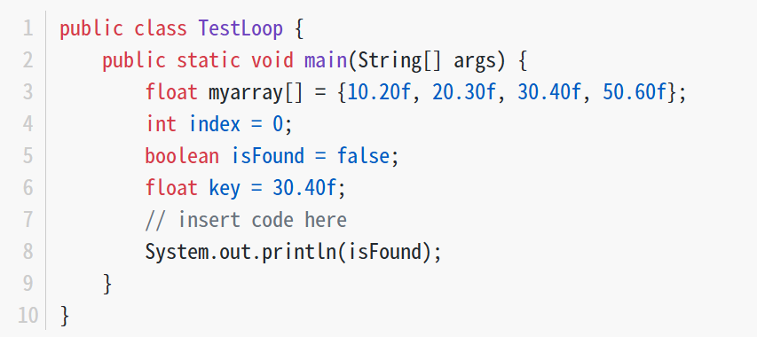
Which code fragment, when inserted at line 7, enables the code print true? A. false因為第一次就停了
while(key == myarray[index++]){ isFound = true;
}

B. 一直在while迴圈因為++不會被執行
while(index <= 4){
if(key == myarray[index]){ index++;
isFound = true; break;
}
}

C. indexoutofbound
while(index++ < 5){
if(key == myarray[index]){ isFound = true;
}
}

D.
while(index < 5){
if(key == myarray[index]){

isFound = true; break;
}
index++;
}

D

