**Groupwork 2**

Please design tests to satisfy PC (predicate coverage), CC(clause coverage), and CACC(correlated active clause coverage) for Themostat class and your proposed project (if TDD with no implementation, design tests on the requirements or specifications)

ThemostatTest.java 執行結果：

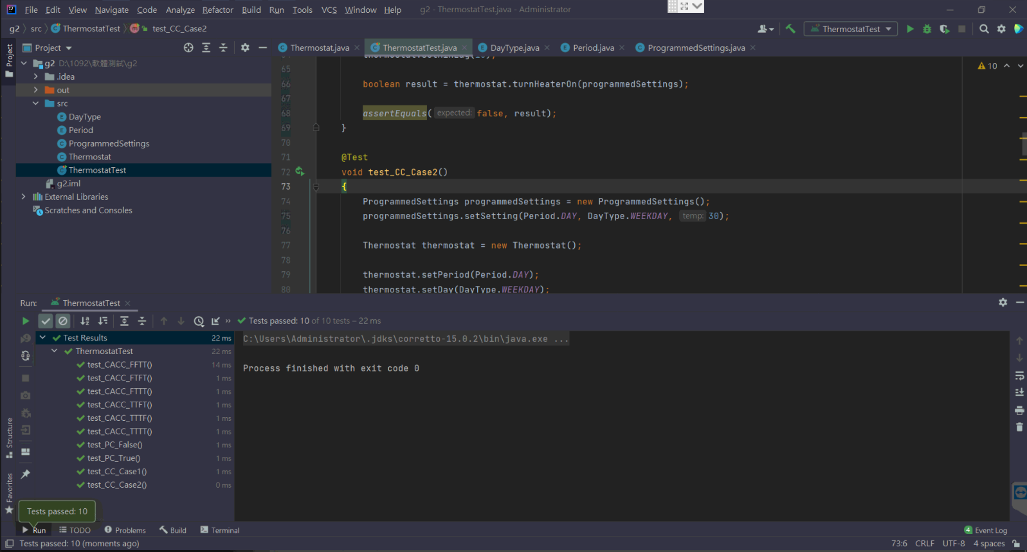

1. Complete and run the tests to satisfy PC for the Thermostat class and your project.

* Thermostat

|  |  |  |  |  |
| --- | --- | --- | --- | --- |
| Predicate | curTemp < dTemp - thresholdDiff | override | curTemp < overTemp - thresholdDiff | timeSinceLastRun > minLag |
|  | A | B | C | D |
| True | T | T | T | T |
|  | curTemp = 20  dTemp = 30  thresholdDiff = 5 | override = True | curTemp = 20  overTemp = 30  thresholdDiff = 5 | timeSinceLastRun = 20  minLag = 10 |
| False | F | T | F | F |
|  | curTemp = 40  dTemp = 30  thresholdDiff = 5 | override = True | curTemp = 40  overTemp = 30  thresholdDiff = 5 | timeSinceLastRun = 5  minLag = 10 |

Predicate True:

curTemp = 20

dTemp = 30

thresholdDiff = 5

override = True

overTemp = 30

timeSinceLastRun = 20

minLag = 10

Predicate False:

curTemp = 40

dTemp = 35

thresholdDiff = 5

override = True

overTemp = 40

timeSinceLastRun = 5

minLag = 10

* muParser.cpp

|  |  |  |  |
| --- | --- | --- | --- |
| Predicate | iEnd == (stringstream_ type::pos_type) - 1 | mu::TypeInfo<mu::value_ type>::IsInteger() | fEpsilon == 0 |
|  | A | B | C |
| True | T | T | T |
|  | iEnd = 2  stringstream_type::pos_type = 1 | mu::TypeInfo<mu::value_ type>::IsInteger() = True | fEpsilon = 0 |
| False | F | F | F |
|  | iEnd = 3  stringstream_type::pos_type = 1 | mu::TypeInfo<mu::value_ type>::IsInteger() = False | fEpsilon = 1 |

Predicate True:

iEnd = 2

stringstream_type::pos_type = 1

mu::TypeInfo<mu::value_ type>::IsInteger() = True

fEpsilon = 0

Predicate False:

iEnd = 3

stringstream_type::pos_type = 1

mu::TypeInfo<mu::value_ type>::IsInteger() = False

fEpsilon = 1

1. Complete and run the tests to satisfy CC for the Thermostat class and your project.

* Thermostat

|  |  |  |  |  |
| --- | --- | --- | --- | --- |
| Predicate | curTemp < dTemp - thresholdDiff | override | curTemp < overTemp - thresholdDiff | timeSinceLastRun > minLag |
|  | A | B | C | D |
| Case1 | T | F | T | F |
|  | curTemp = 20  dTemp = 30  thresholdDiff = 5 | override = False | curTemp = 20  overTemp = 30  thresholdDiff = 5 | timeSinceLastRun = 5  minLag = 10 |
| Case2 | F | T | F | T |
|  | curTemp = 40  dTemp = 30  thresholdDiff = 5 | override = True | curTemp = 40  overTemp = 30  thresholdDiff = 5 | timeSinceLastRun = 20  minLag = 10 |

Case1:

curTemp = 20

dTemp = 30

thresholdDiff = 5

override = False

overTemp = 30

timeSinceLastRun = 5

minLag = 10

Case2:

curTemp = 40

dTemp = 30

thresholdDiff = 5

override = True

overTemp = 40

timeSinceLastRun = 20

minLag = 10

* muParser.cpp

|  |  |  |  |
| --- | --- | --- | --- |
| Predicate | iEnd == (stringstream_ type::pos_type) - 1 | mu::TypeInfo<mu::value_ type>::IsInteger() | fEpsilon == 0 |
|  | A | B | C |
| True | T | F | T |
|  | iEnd = 2  stringstream_type::pos_type = 1 | mu::TypeInfo<mu::value_ type>::IsInteger() = False | fEpsilon = 0 |
| False | F | T | F |
|  | iEnd = 3  stringstream_type::pos_type = 1 | mu::TypeInfo<mu::value_ type>::IsInteger() = True | fEpsilon = 1 |

Case1:

iEnd = 2

stringstream_type::pos_type = 1

mu::TypeInfo<mu::value_ type>::IsInteger() = False

fEpsilon = 0

Case2:

iEnd = 3

stringstream_type::pos_type = 1

mu::TypeInfo<mu::value_ type>::IsInteger() = True

fEpsilon = 1

1. Complete and run the tests to satisfy CACC for the Thermostat class and your project.

* Thermostat

|  |  |  |  |  |
| --- | --- | --- | --- | --- |
| Predicate | curTemp < dTemp - thresholdDiff | override | curTemp < overTemp - thresholdDiff | timeSinceLastRun > minLag |
|  | A | B | C | D |
| Pa | T | T | F | T |
|  | T | F | T | T |
|  | T | F | F | T |
|  |  |  |  |  |
|  | F | F | T | T |
|  | F | T | F | T |
|  | F | F | F | T |
|  |  |  |  |  |
| Pb | F | T | T | T |
|  | F | F | T | T |
|  |  |  |  |  |
| Pc | F | T | T | T |
|  | F | T | F | T |
|  |  |  |  |  |
| Pd | T | T | T | T |
|  | T | T | F | T |
|  | T | F | T | T |
|  | T | F | F | T |
|  | F | T | T | T |
|  |  |  |  |  |
|  | T | T | T | F |
|  | T | T | F | F |
|  | T | F | T | F |
|  | T | F | F | F |
|  | F | T | T | F |

選擇上述紅線的集合，2重覆，共6筆測資。

|  |  |  |  |  |
| --- | --- | --- | --- | --- |
| Pa | T | T | F | T |

curTemp = 20

dTemp = 30

thresholdDiff = 5

override = True

overTemp = 40

timeSinceLastRun = 20

minLag = 10

|  |  |  |  |  |
| --- | --- | --- | --- | --- |
| Pa | F | T | F | T |

curTemp = 40

dTemp = 30

thresholdDiff = 5

override = True

overTemp = 40

timeSinceLastRun = 20

minLag = 10

|  |  |  |  |  |
| --- | --- | --- | --- | --- |
| Pb | F | T | T | T |

curTemp = 40

dTemp = 30

thresholdDiff = 5

override = True

overTemp = 20

timeSinceLastRun = 20

minLag = 10

|  |  |  |  |  |
| --- | --- | --- | --- | --- |
| Pb | F | F | T | T |

curTemp = 40

dTemp = 30

thresholdDiff = 5

override = False

overTemp = 20

timeSinceLastRun = 20

minLag = 10

|  |  |  |  |  |
| --- | --- | --- | --- | --- |
| Pc | F | T | T | T |

curTemp = 40

dTemp = 30

thresholdDiff = 5

override = True

overTemp = 20

timeSinceLastRun = 20

minLag = 10

|  |  |  |  |  |
| --- | --- | --- | --- | --- |
| Pc | F | T | T | T |

curTemp = 40

dTemp = 30

thresholdDiff = 5

override = True

overTemp = 20

timeSinceLastRun = 20

minLag = 10

|  |  |  |  |  |
| --- | --- | --- | --- | --- |
| Pd | T | T | T | T |

curTemp = 20

dTemp = 30

thresholdDiff = 5

override = True

overTemp = 20

timeSinceLastRun = 20

minLag = 10

|  |  |  |  |  |
| --- | --- | --- | --- | --- |
| Pd | T | T | T | F |

curTemp = 20

dTemp = 30

thresholdDiff = 5

override = True

overTemp = 20

timeSinceLastRun = 5

minLag = 10

* muParser.cpp

|  |  |  |  |
| --- | --- | --- | --- |
|  | iEnd == (stringstream_ type::pos_type) - 1 | mu::TypeInfo<mu::value_ type>::IsInteger() | fEpsilon == 0 |
|  | A | B | C |
| Pa | T | T | T |
|  | F | T | T |
| Pb | T | T | T |
|  | T | F | T |
| Pc | T | T | T |
|  | T | T | F |

(T , T , T)皆重覆。共4筆測資。

|  |  |  |  |
| --- | --- | --- | --- |
| Pa,Pb,Pc | T | T | T |

iEnd = 2

stringstream_type::pos_type = 3

mu::TypeInfo<mu::value_ type>::IsInteger() = True

fEpsilon = 0

|  |  |  |  |
| --- | --- | --- | --- |
| Pa | F | T | T |

iEnd = 3

stringstream_type::pos_type = 3

mu::TypeInfo<mu::value_ type>::IsInteger() = True

fEpsilon = 0

|  |  |  |  |
| --- | --- | --- | --- |
| Pa | T | F | T |

iEnd = 3

stringstream_type::pos_type = 3

mu::TypeInfo<mu::value_ type>::IsInteger() = False

fEpsilon = 0

|  |  |  |  |
| --- | --- | --- | --- |
| Pa | T | T | F |

iEnd = 3

stringstream_type::pos_type = 3

mu::TypeInfo<mu::value_ type>::IsInteger() = False

fEpsilon = 1