

**COLLEGE OF ENGINEERING AND TECHNOLOGY**

University of Bohol, City of Tagbilaran

**PERPETUAL CALENDAR**

Bachelor of Science in Computer Engineering

Submitted by:

Clint Autor

Josh Belgica

John Carlo Abaton

Manuel Joshua Responso

Kian Amper

Submitted to:

Engr. Liduvina Namocatcat

**ABSTRACT**

The group created a program designed that shows all the date you want to know like a perpetual calendar, a program that shows all the months of the given year that includes the leap year also, and a program that specify the months and the number of days in the given year and months, lastly a program that shows the specific day of the date you want to know.

**MAJOR REQUIREMENTS**

To create the program, the designers had to understand the concept of “if else statement, switch case statement, and for loop”. In our program, one of the uses of if-else statement is it commands the code to determine whether it’s a leap year or not. The switch case statement we implement helps to determine the spacing where the date starts and it also provides how many days in that specific month. We also implemented different formulas to determine the specific year and so on.

**PROBLEM**

The problem we encountered in our program is that it can’t add the leap year, the additional day every 4 years. This was fixed by adding the if-else statement that determines the leap year. We also encountered problems in the number of days because in our output it doubles the 1 in our month so instead of 1,2,3 and so on it shows 1,1. This was also fixed by adjusting the formula for determining the number of days in a week. Another problem is how can we merge all our codes because we divide our codes into 3 parts to lessen the confusion. We fixed it by applying all the compatible codes and removing unnecessary or unsuitable code. Lastly how we solve all the minor errors in our programs. We tried to debug it one by one to solve this problem.

**ANALYSIS**

The team gathers their ideas about what kind of planning will make during the first week. During the first week also, the team agreed to divide the group into two to be more facilitated. The problem we encountered first is we don’t know where to find the right schedule for a group meeting for codes because some of us are busy to attend to the given schedule. Since we divide our group into two and assigned different tasks in the project, members also evaluate their completed tasks before submitting and merging the codes and we double-checked each program we make and debug some errors in it. Our program which is Perpetual Calendar should have an accurate result which is why all members of the team should research so that they would understand how the concept works.

**DESIGN OF THE PROJECT**

This part states the creation of the idea of what the project looks like. Our project consists of 3 options. In the first option, we declare the number of days in a month and its day and use the if-else statement to determine the leap year and the formula to determine the year and daycode. In option two we use a switch case statement to determine the how many days in the specific month and its spacing, for loop and if else statement again is also being implemented to determine the months and year. And in the third option we also just used the if-else statement and switch case statement to determine the specific day the user wants to know. After that, the team assigned to work and study with the functions, debug, adjust, and modify the necessary.

**ALGORITHM**

Prompt the user, asking for what number (option) wants to command.

If he/she chooses option 1, prompt the user, asking which year he wants to know all the months in the given year

If he/she chooses option 2, prompt the user, asking to enter the year and month if he/she wants to know the specific month.

If he/she chooses option 3, prompt the user, asking to enter the year and month, and day if he/she wants to know the day and if it’s a weekend or weekday just like this:

Date: 12/12/2001

weekday = Wednesday

**FLOWCHART**

START

END

Display the asked input

Scans and processed the input

User will type a specific date

Asks for a valid choice

Input correct?

Choose which specific calendar to be used.

NO

YES

Input being processed

The user will input the calendar

**OPTION 1:**

**IMPLEMENTATION**

**Sample Output**

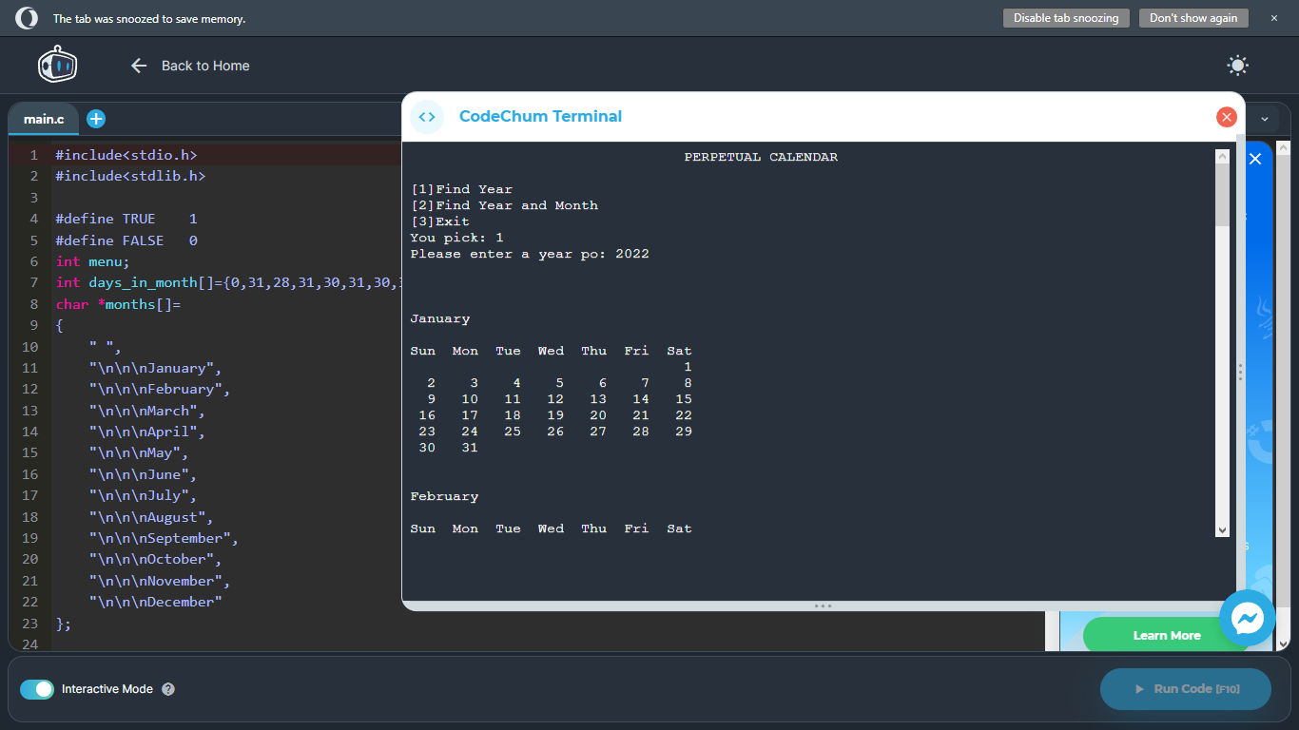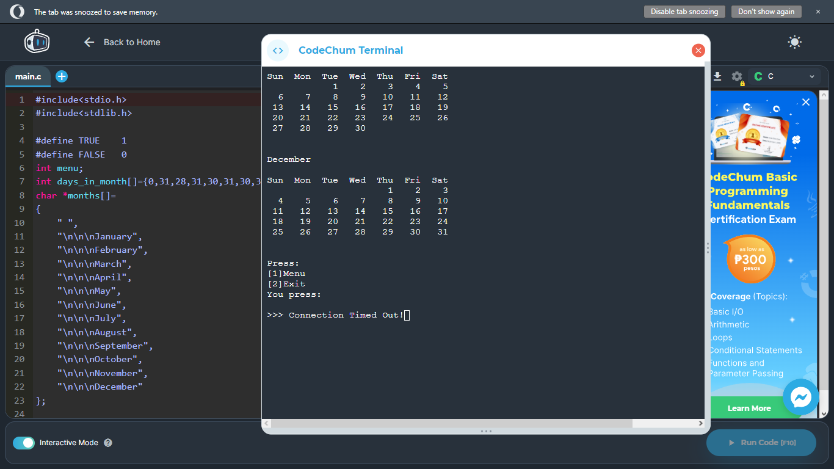

**OPTION 2:**

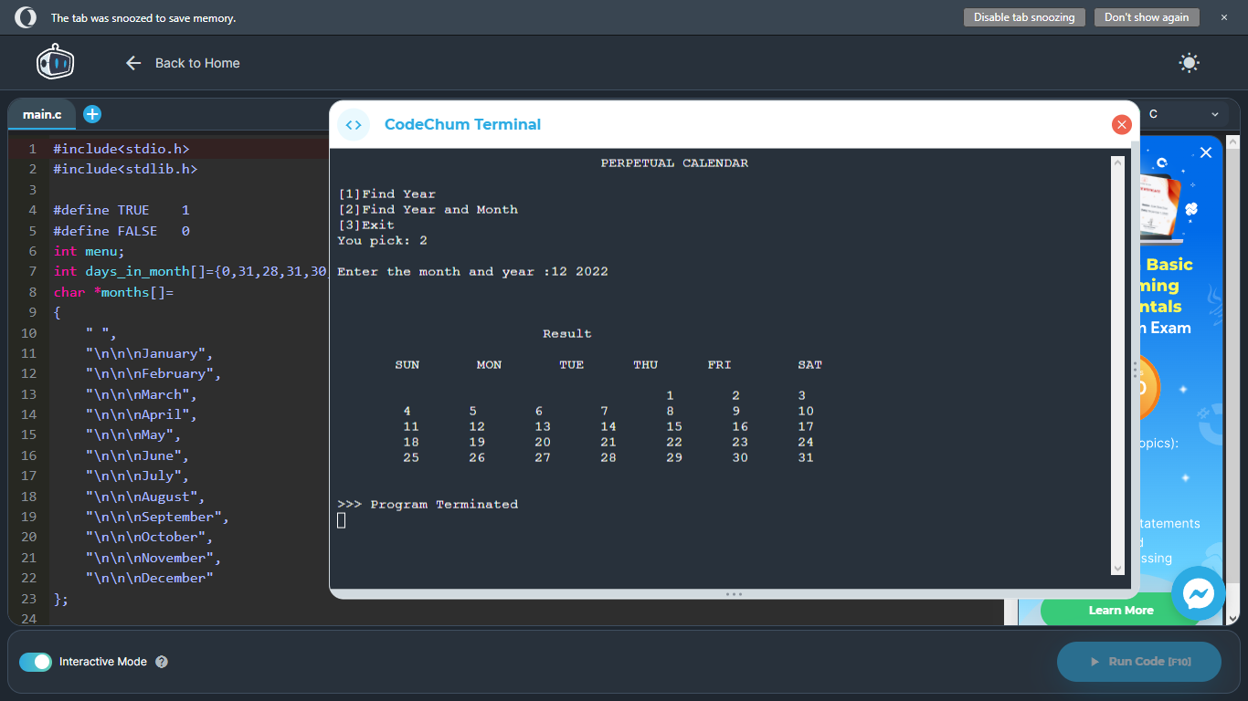

**OPTION 3:**

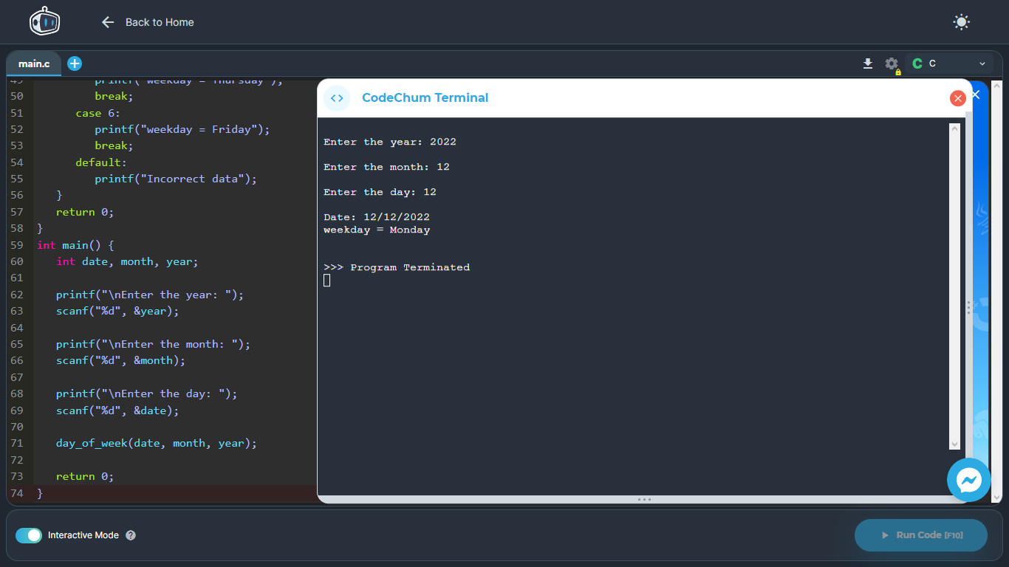

**CURRICULUM VITAE**

**Name:** Clint Autor

**Sex:** Male

**Age:** 20 years old

**Birthdate:** December 15, 2001

**Contact Number:** 09064555823

**Official Address:** San Pedro St. Bingag, Dauis, Bohol

**Nationality:** Filipino

**Religion:** Roman Catholic

**Google mail:** [nlai58730@gmail.com](mailto:nlai58730@gmail.com) & cautor@universityofbohol.edu.ph

**EDUCATION**

**Tertiary Level:** University of Bohol College of Engineering and Technology, Tagbilaran City (2022-2023)

**Senior High School Graduate:** University of Bohol Senior High School Department, Tagbilaran City (2019-2020)

**Junior High School Completer:** Tabalong, National Highschool

**Elementary Graduate:** Bingag, Elementary School

**CURRICULUM VITAE**

**Name:** Arbie Josh Nian Belgica

**Sex:** Male

**Age**: 18

**Birthdate:** 12/12/2003

**Contact number:** 09060338147

**Official Address:** Villa Garcia, Sierra Bullones, Bohol

**Nationality:** Filipino

**Religion:** Roman Catholic

**Email:** crspynoodles@gmail.com

**EDUCATION**

**Tertiary Level:** University of Bohol

**Senior High School Graduate:**

Sierra Bullones Technical Vocational High School

**Junior Highschool Completer:**

Sierra Bullones Technical Vocational High School

**Elementary Graduate:** Villa Garcia Elementary School

**CURRICULUM VITAE**

**Name:** 𝙹𝚘𝚑𝚗 𝙲𝚊𝚛𝚕𝚘 𝙰𝚋𝚊𝚝𝚘𝚗

**Sex:** 𝙼𝚊𝚕𝚎

**Age:** 𝟷𝟾

**Birthdate:** 𝙹𝚞𝚗𝚎 𝟸𝟶, 𝟸𝟶𝟶𝟺

**Contact number:** 𝟶𝟿𝟼𝟻𝟼𝟽𝟿𝟹𝟹𝟶𝟾

**Official Address:** 𝙿𝚞𝚛𝚘𝚔 𝟻, (𝟼𝟹𝟹𝟿) 𝚃𝚘𝚝𝚘𝚕𝚊𝚗 𝙳𝚊𝚞𝚒𝚜 𝙱𝚘𝚑𝚘𝚕, 𝙿𝚑𝚒𝚕𝚒𝚙𝚙𝚒𝚗𝚎𝚜

**Nationality:** 𝙵𝚒𝚕𝚒𝚙𝚒𝚗𝚘

**Religion:** 𝙲𝚑𝚞𝚛𝚌𝚑 𝚘𝚏 𝙲𝚑𝚛𝚒𝚜𝚝

**Email:** 𝙹𝚌𝚝𝚊𝚋𝚊𝚝𝚘𝚗@𝚞𝚗𝚒𝚟𝚎𝚛𝚜𝚒𝚝𝚢𝚒𝚏𝚋𝚘𝚑𝚘𝚕. 𝚎𝚍𝚞.𝚙𝚑

**EDUCATION**

**Tertiary Level:** 𝚄𝚗𝚒𝚟𝚎𝚛𝚜𝚒𝚝𝚢 𝚘𝚏 𝙱𝚘𝚑𝚘𝚕

**Senior High School Graduate:** 𝙳𝚛. 𝙲𝚎𝚌𝚒𝚕𝚒𝚘 𝙿𝚞𝚝𝚘𝚗𝚐 𝙽𝚊𝚝𝚒𝚘𝚗𝚊𝚕 𝙷𝚒𝚐𝚑 𝚂𝚌𝚑𝚘𝚘𝚕.

**Junior Highschool Completer:** 𝙳𝚛. 𝙲𝚎𝚌𝚒𝚕𝚒𝚘 𝙿𝚞𝚝𝚘𝚗𝚐 𝙽𝚊𝚝𝚒𝚘𝚗𝚊𝚕 𝙷𝚒𝚐𝚑 𝚂𝚌𝚑𝚘𝚘𝚕

**Elementary Graduate:** 𝙲𝚘𝚐𝚘𝚗 𝙴𝚕𝚎𝚖𝚎𝚗𝚝𝚊𝚛𝚢 𝚂𝚌𝚑𝚘𝚘𝚕.

**CURRICULUM VITAE**

Name:Joshua Joseph R. Manuel

Sex:Male

Age:19

Birthdate:Nov.7,2003

Contact number:09501240258

Official Address:Purok 1,Tawala,Panglao

Nationality:Filipino

Religion:Pentecostal

Email:mkuanghua@gmail.com

EDUCATION

Tertiary Level:

Senior High School Graduate:Lourdes National HighSchool

Junior Highschool Completer:Lourdes National HighSchool

Elementary Graduate:Davao Zhong Hua HighSchool

**CURRICULUM VITAE**

Name:Kian Jaymark Amper

Sex: male

Age: 20

Birthdate: oct 4 2002

Contact number:09264346966

Official Address:B.inting st tagbilaran city

Nationality:filipino

Religion: Catholic

Email:kian44@gmail.com

EDUCATION

Tertiary Level:

Senior High School Graduate:Dr.cecilio Putong national highschool

Junior Highschool Completer:Dr.cecilio putong national highschool

Elementary Graduate:Tagnilaran city central elementary school