**Android GPS Record and Playback Application**

1. **Application Description**

The Android SDK provides methods for retrieving data from the integrated GPS on the phone. The application should do the following:

• Record the following data to a file named “GPS_data.log”

o Time stamp

o Longitude

o Latitude

o Heading

o Speed

• Playback the data from the recorded file The application will have the following user interface:

• A button to start/stop recording GPS data

• A button to start/stop playing back GPS data

• A series of display where the GPS data being recorded or played back is displayed

• An indicator that recording or playback is occurring

The diagram above provides the expected layout of the application.

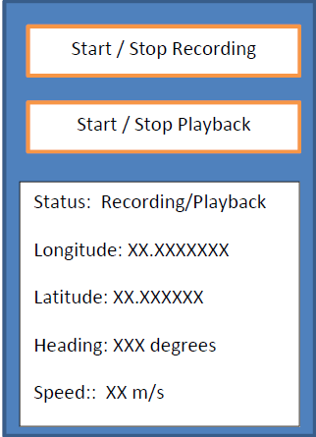

The two buttons are toggles that switch between start and stop depending on the current status. If recording is occurring, the playback button should be disabled. Similarly, if playback is occurring,

the recording button should be disabled. The application should only deal with one error condition. The condition is if no GPS signal or data is available to the application. In that situation, a pop-up message should be shown to the user with the following message:

“No GPS data is available. Please check your phone.”

2**. Bonus Task**

If time permits, the application should display the playback data on a map. As the position changes, an icon on the map should be updated.

3. **Development Environment**

The application should be developed on Android version 2.2 or newer, using Eclipse development environment. Make sure that the code conforms to Android development convention and should

work on the emulator. Finally, the code should also be well commented and structured so that it is easy to understand.