**Question 2:**

**a.**

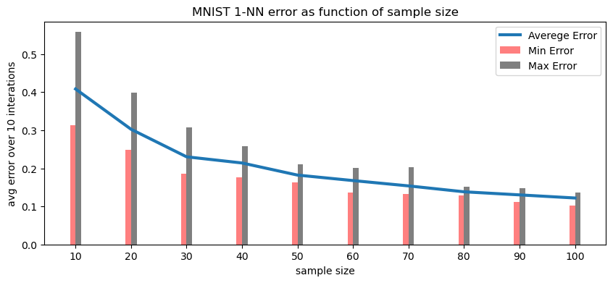

**b.**

yes. The average error over 10 random sample decreases as the sample size increase This trend stems from the fact the when supplied with more examples and data, NN algorithm can make more precise generalization for the distribution based on the sample and thus generate a better rule.

**c.**

yes. we can see the difference between maximum and minimum error for each fixed sample size. this is because the algorithm learns and then tested each time on different samples so the prediction rule it generates changes.

**d.**

yes. We can see the gap between the maximum and minimum error shrinks as the sample size grows. When the algorithm sees more examples it can generate a better generalization on the distribution and even for special cases makes smaller errors.

**e.** 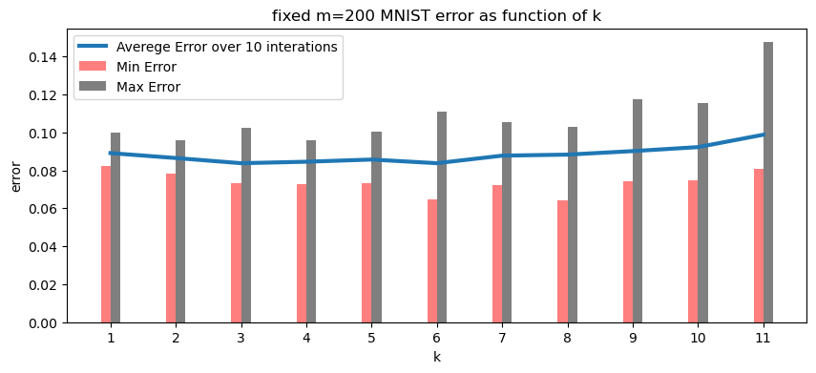

**Question 3:**

a.

proof:

with the assumption the D has a Bayes-error of zero we know that there’s that for every input the output of will be the right label for .

we know of D is c-Lipschitz with respect to the Euclidean distance.

therefore, by definition

Lemma:

, WLOG and D has Bayes-error of zero and therefore D has deterministic labels

main proof:

b.

Suppose for some there’s such as and

.

)

We know that covers the space of points in in balls size such that for every ball there is some pair which satisfies .

so

We also know that D is c-Lipschitz with respect to the Euclidean distance.

So and oppose to c-Lipschitz that

The support of D does not include two points with different  
labels that are less than -far.

**Question 4:**

a.

we can represent each rabbit as vector in since we only consider the parameters age and weight. it’s also known rabbits are limited to live 48 month and weigh 4kg, hence .

we would like to predict if rabbit is black or white so we can let or wh ere means black rabbit.

b.

c.

d.

let be hypothesis such that:

Note that since there are only possible:

if then

if then

if then

e.

f.

=

g.

0.0883641

The formula we learned in class was based on the assumption that D has a deterministic label conditioned on the example, and the distribution D is nondeterministic.

**Question 5:**

a.

sample complexity

b.

suppose

. also, we know that thus

then:

c.

suppose we run some ERM algorithm and the output classifier has returned,

let such that we know is the threshold and for that

Lemma :

*proof: assume in contradiction then is not the prediction rule that minimizes because we know that oppose to that is the output of the ERM algorithm*

so there’s some such that

also, .

hence and from previous section we conclude

d.

First, the probability that there does not exist a such that

proof:

as described above the marginal distribution of D on is uniform on [0,1] so

so the distribution there does not exist a such that is

.

note that we only use the length of the interval hence the proof applies for as well.

let

from the sub-question we know that

In section (c) we proved that if there exists some such that then

e.

let

for we get

f.

Lemma 1:

proof:

assume .

for some .

we will define an equivalent linear predicator

(We will use the labels instead of shown in class)

let and

we will show

as defined in class:

Lemma 2:

proof:

since every shattered set in is shattered set in