2.

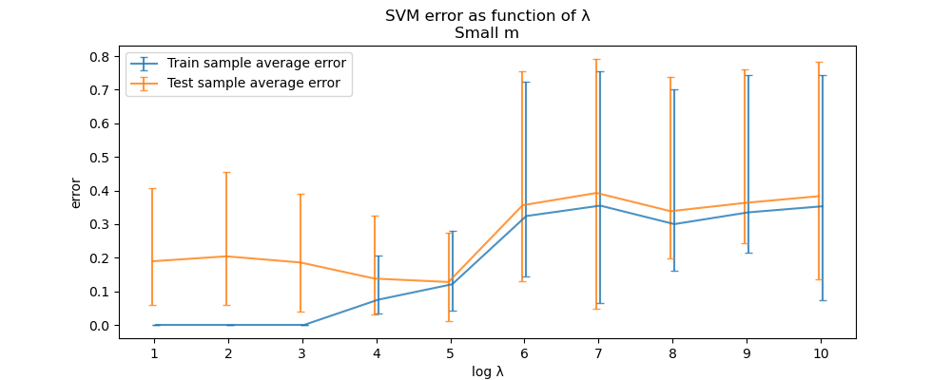(a)

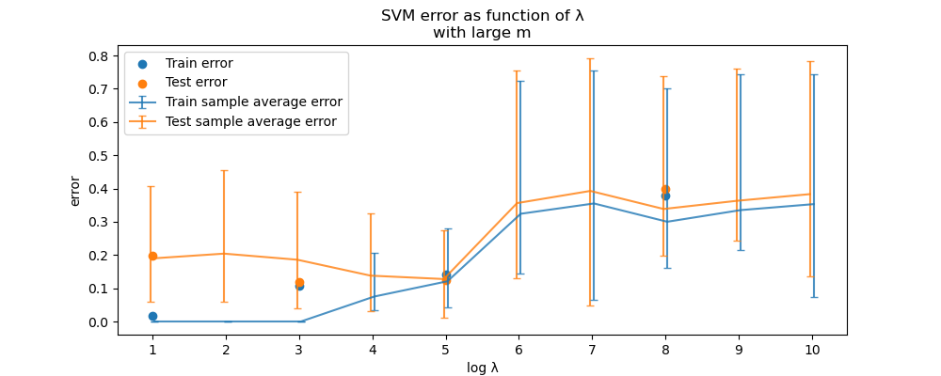(b)

(c)

*Based on what we learned in class, what would you expect the results to look like? Do the results you got match your expectations? In your answer address the following issues: • Which sample size should get a smaller training error? What about test error? Do the results match your expectations? • What should be the trend in the training error as a function of λ (decreasing/increasing/other)? Why? Do the results (for the small sample size) match your expectations? • What should be the trend in the test error as a function of λ (decreasing/increasing/other)? Why? Do the results (for the small sample size) match your expectations?*

4.

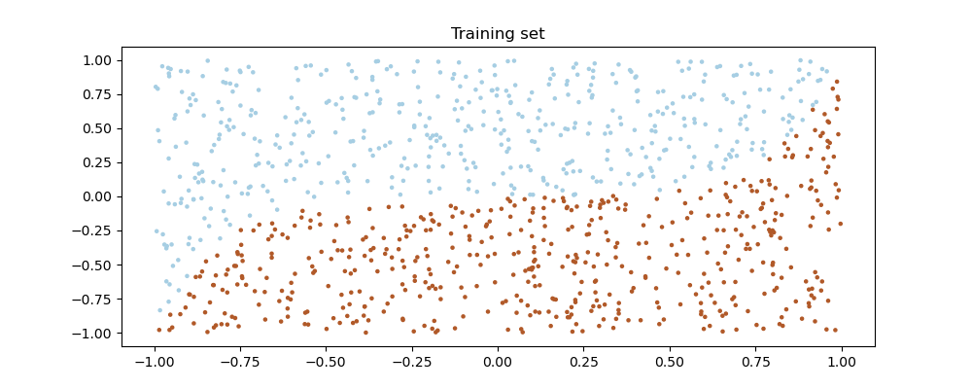(a)

5.

Let be the set of all undirected graphs over n vertices numbered 1,…,n with degree at most 7.

as the described function

(a)

--TODO-- what do you mean in “smallest dependence on plz respond

(b)

Let us calculate the size of the hypothesis class:

Any labeled undirected graph size n can have different edges as the way to pick 2 vertices

and for any graph we can choose between assign a specific edge or not

thus we got labeled graphs with n vertices, also we should leave the graph with no edges because .

In conclusion

As we showed in class the PAC-learning upper bound for the sample complexity of learning H is:

הערה של עמית שגר בארמון:

קצת קשה להבין אם מדובר במקרה הrealizable או במקרה האגנוסטי כשהם לא תיארו את השאלה,

לקבוצת האיקסים הנתונה לנו כל פונקציה תחזיר 1 רק עבור x בודד מבין כל האפשריים, אבל לא ברור לי מתי זה שגיאה או לא... בגלל זה רשמתי פה את שניהם.

For the realizable case:

For the agnostic case:

(c)

For any such that we can only label but there’s no such that and thus we cannot shutter any group size 2,

Thus the VC dimension of H is 1

As we showed in class the better upper bound for the sample complexity of learning H depends on the VC dimension of H is:

הערה:

קרא הערה סעיף (b)

For the realizable case:

For the agnostic case:

6.

For

We showed in class the Preceptron performs at most updates.

Thus we should find of the Sample S.

We also showed in class Hard-SVM algorithm with input S return which is a maximal-margin separator.

Now we can describe the algorithm who returns an upper bound on Preceptron number of updates:

**Input**: a labeled sample S of labeled examples from X × Y

**Output**: an upper bound on the number of updates that the Perceptron algorithm would require if it was run on this sample.

1. runs Hard-SVM on sample S
   1. if Hard-SVM gets an error while running then the algorithm returns -1
   2. else w Hard-SVM output
      1. R sample with max norm between all samples
      2. Dxmin
      4. Return

**complexity:** Hard-SVM has polynomial runtime complexity

thus we get **polynomial runtime complexity**

7. (a)

In order to express the problem

in terms of

,

we will define variable and rewrite the problem as

,

(b)

since we only need sum of squares of , we don’t need to use , we can compile it into :

8. (a)

9.(a)

To prove that cannot be a kernel function for any feature mapping, we need to show such that .

from inner products property: . Hence:

even though for we get that

which means for some , in contradiction to inner product properties. Hence, no such exists.

(b)

Assume in contradiction that

Thus, for

for we get .

we assumed that such that and got contradiction, hence no such exists and cant be a kernel function.

(c)

let

we found some that satisfy , hence can be a kernel function.