1.

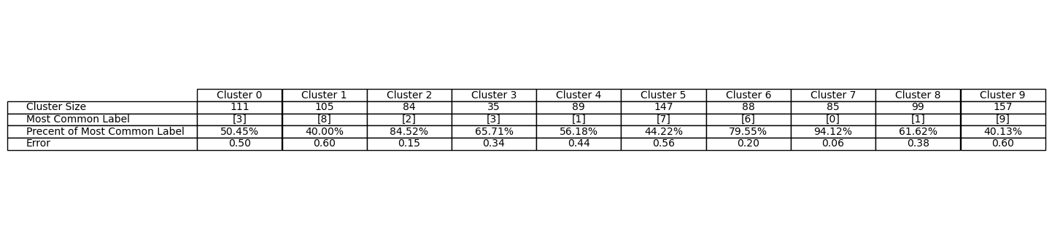(c)

The error on cluster is calculated by taking the number of wrong labels in the cluster and dividing it by the cluster size

By this calculation we can deduct that the algorithm classified correctly wrong about 419 samples, therefore the error is

$$\frac{419}{100}=0.419=41.9\%$$

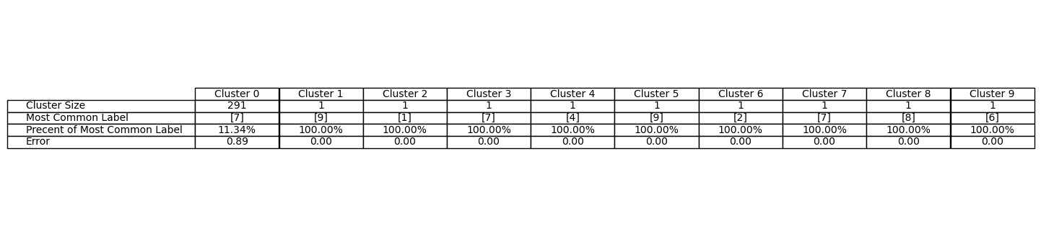(d)

The same way we calculated the error before, now we get that the error is $\frac{258}{300}=0.863.. ≈86.3\%$

Clearly k-means worked better for this problem.

(e)

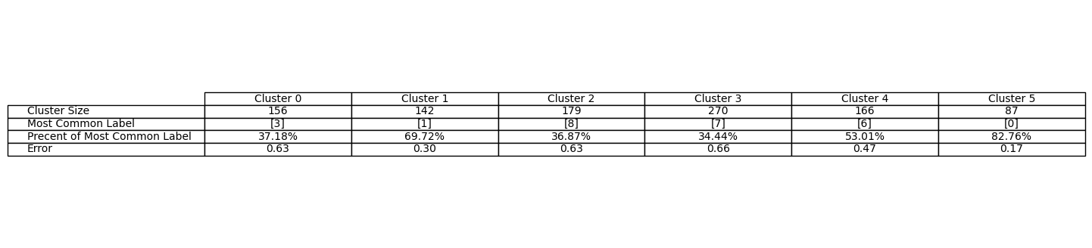Kmeans:

Error: $\frac{524}{1000}=0.524=52.4\%$

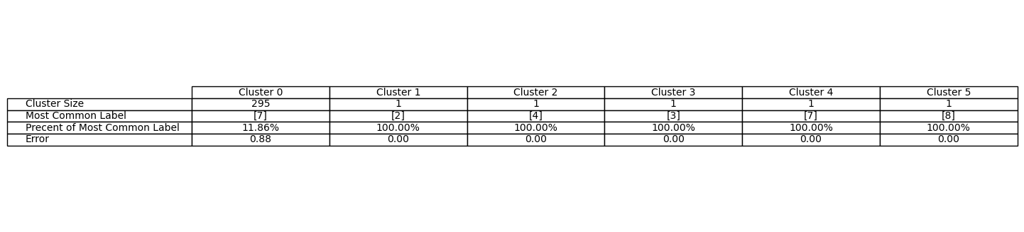Single-linkage

Error: $\frac{260}{300}=0.866..≈86.6\%$

We can see that the k means algorithm got better results for k=10. It makes sense since we know the data is originally divided into 10 sets, each represent a digit.

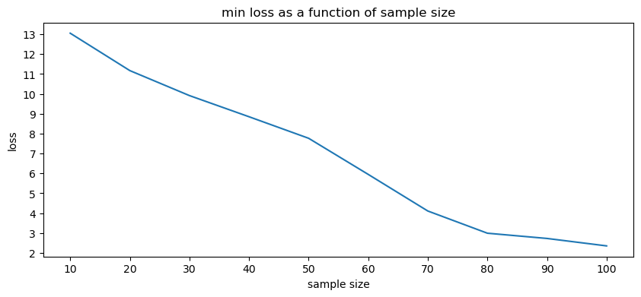2.(a)

(b)

As the training set grows, we expected the loss on the distribution to reduce. Based on what we’ve seen in class: $l\left(h, D\right)≤l\left(h,S\right)+O\left(\frac{\left(B^{2}R^{2}\right)}{\sqrt{m} }\right)$. we used the $λ$ that minimizes $l\left(h,S\right)$ and as $m$ grows, $\left(\frac{\left(B^{2}R^{2}\right)}{\sqrt{m} }\right)$ gets smaller.

(c) yes, we can see it in the plot.

(d)

3.(a)

According to GD algorithm:

$$w^{(t+1)}=w^{\left(t\right)}-η∇f(w^{\left(t\right)})$$

Let $g\left(w\right):=λ\left\|w\right\|$

$$z_{i}\left(w\right)≔{\left(〈w,x_{i}〉-y_{i}\right)}^{2}$$

$$f\left(w\right)≔g\left(w\right)+Σ_{i=1}^{m}z_{i}(w)$$

we will find $∇f\left(w\right).$

$∇g\left(w\right)=\frac{λ}{2}*\frac{1}{\sqrt{2}}*\frac{1}{\sqrt{w}}$ =

$$∇z_{i}\left(w\right)=2\left(〈w,x_{i}〉-y_{i}\right)*x_{i}$$

$$∇f\left(w\right)=∇g\left(w\right)+Σ_{i=1}^{m}∇z_{i}\left(w\right)= \frac{λ}{2}*\frac{1}{\sqrt{2}}*\frac{1}{\sqrt{w}}+ Σ_{i=1}^{m}2\left(〈w,x_{i}〉-y_{i}\right)*x_{i}$$

Hence, $w^{(t+1)}=w^{\left(t\right)}-η\left( \frac{λ}{2}*\frac{1}{\sqrt{2}}*\frac{1}{\sqrt{w^{\left(t\right)}}}+ Σ_{i=1}^{m}2\left(〈w^{\left(t\right)},x_{i}〉-y_{i}\right)*x_{i}\right)$

(b)

$$w^{(t+1)}=w^{\left(t\right)}-η\left( \frac{λ}{2}*\frac{1}{\sqrt{2}}*\frac{1}{\sqrt{w^{\left(t\right)}}}+ 2\left(\left\langle w^{\left(t\right)} | x_{i}\right\rangle -y_{i}\right)*x_{i}\right)$$

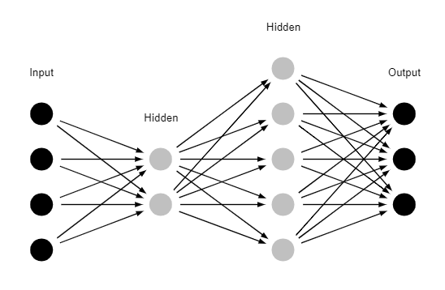4.(a)

(b).

Since the input layer has 4 neurons, $X=R^{4}$

(c)

Since $ψ\left(o_{1}, o_{2}, o_{3}\right)=argmax_{i∈\left[k\right]}o_{i}$, $Y=\{1,2,3\}$

(d)

$$\left|w\right|=4*2+2*5+5*3 =33⇒w∈R^{33}$$

$$H=\left\{h_{w}\left(x\right) | w∈R^{33}\right\}$$

Then $h_{w}\left(\left(x_{1},x_{2}, x_{3}, x_{4}\right)\right)=$

$\underset{12≤i≤14}{argmax}\left(\sum_{j=7}^{11}{w_{j,i}⋅σ\left(\sum_{k=5}^{6}{w_{m,j}⋅σ\left(\sum_{l=1}^{4}{w_{t,m}⋅x_{t}}\right)}\right)}\right)$

5.(a)

For each sample $x$ there are $d$ attributes, and we can test 3 options for $θ$, hence there are $3d+2$ options for inner vertex (+2 for label). In a tree of depth $n$ there are at most $2^{n+1}$ nodes, thus $\left|{\overline{H}}_{n}\right|≤{\left(3d+2\right)}^{2^{n+1}}$

(b)

Danny is wrong, since ID3 is heuristic algorithm and not ERM it does not guarantee minimal error. After performing pruning, we can’t guarantee we will get minimal error. Thus PAC assumption on the sample size does not apply.

6.(a)

The assumption **does not hold**.

Naïve bayes assumption is $P\left[X=x | Y=y\right]=Π_{i=1}^{n}P[X_{i}=x_{i}|Y=y]$

But in the given distribution,

$P\left(x_{1}=-1 | Y=-1\right)=\frac{5}{60}+0$ and $P\left(x_{2}=+1 | Y=-1\right)=\frac{4}{60}+0$

$$⇒ P\left(x_{1}=-1 | Y=-1\right)*P\left(x_{2}=+1 | Y=-1\right)>0$$

And $P\left[X=\left(-1,+1\right) \right| Y=-1]= \frac{P\left[Y=-1 | X=\left(-1,+1\right)\right]*P\left[X=\left(-1,+1\right)\right]}{P\left[Y=-1\right]}=\frac{\frac{0}{\frac{24}{60}+0 }*P\left[X=\left(-1,+1\right)\right]}{\frac{5}{60}+0+\frac{11}{60}+\frac{4}{60}}=0$

Which means $0=\left[X=x | Y=y\right]≠ Π_{i=1}^{n}P\left[X_{i}=x_{i} | Y=y\right]>0$ for some $X, Y$

(b)

$$P\left[Y=1\right]=\frac{6}{60}+\frac{24}{60}+\frac{2}{60}+\frac{8}{60}=\frac{2}{3}⇒P\left[Y=-1\right]=\frac{1}{3}$$

From previous section, we know we can’t use the naïve bayes assumption.

Hence $h_{bayes}=\underset{y∈Y}{argmax} \left(P\left[Y=y\right]*P\left[X=x | Y=y\right]\right)$

$$=\underset{y∈Y}{argmax} \left(P\left[Y=y\right]*\frac{P\left[X=x∩Y=y\right]}{P[Y=y]}\right)=\underset{y∈Y}{argmax(} P\left[X=x∩Y=y\right])$$

For $x=\left(-1, -1\right)$ we get:

$P\left[X=x∩Y=1\right]=\frac{6}{60}> P\left[X=x∩Y=-1\right]=\frac{5}{60}⇒$ for $x=\left(-1, -1\right)$ the predictor will return $1.$

For $x=\left(-1, 1\right)$ we get:

$P\left[X=x∩Y=1\right]=\frac{24}{60}> P\left[X=x∩Y=-1\right]=0⇒$ for $x=\left(-1, 1\right)$ the predictor will return $1.$

For $x=\left(1,- 1\right)$ we get:

$P\left[X=x∩Y=1\right]=\frac{2}{60}< P\left[X=x∩Y=-1\right]=\frac{11}{60}⇒$ for $x=\left(1,- 1\right)$ the predictor will return $-1$

For $x=\left(1, 1\right)$ we get:

$P\left[X=x∩Y=1\right]=\frac{8}{60}> P\left[X=x∩Y=-1\right]=\frac{4}{60}⇒$ for $x=\left(1, 1\right)$ the predictor will return $1$

Therefore ,

$$h_{bayes}\left(x\right)= \left\{\begin{aligned}-1, x=(1,-1) \\ 1, else\end{aligned}\right.$$

7.(a)

From the definition of $x_{t}$ we can see that there’s a linear dependence between the first and second coordinates to the third and fourth coordinates, hence the degree of $X$ is 2 and therefore the degree of $X^{T}X$ is 2 as well. Since $X^{T}X∈M_{4×4}$ and the degree of $X^{T}X$ is 2, therefore it has 2 eigenvalues 0.

it has kernel of dimension 2, and from the dimension theorem ($suppose A∈M_{n×n} we get n=\dim\left(image\left(A\right)\right)+\dim\left(\ker\left(A\right)\right)$

we know that the eigenvalues of $X^{T}X$ are non-negative. thus, the 2 smallest eigenvalues of $X^{T}X$ are both 0 and the distortion is $0+0=0$

(b)

Let $x_{1}≔\left(1, 0, 1, 0\right)$, $x_{2}≔\left(0,1,1,1\right), x_{3}≔(2,1,5,9)$ $x_{4}=(2,0,4,4)$

Note that $x_{1}, x_{2},x_{3}, x_{4}$ all satisfy $x_{t}\left(3\right)={\left(x_{t}\left(1\right)\right)}^{2}+{\left(x_{t}\left(2\right)\right)}^{3}∧ x_{t}\left(4\right)={\left(x_{t}\left(3\right)-x_{t}\left(1\right)\right)}^{2}$

For $m=3, X= \left(\begin{matrix}[x_{1}] \\ [x_{2}] \\ [x_{3}] \\ \left[x_{4}\right]\end{matrix}\right)= \left[\begin{matrix}1 & 0 & 1 & 0 \\ 0 & 1 & 1 & 1 \\ 2 & 1 & 5 & 9 \\ 2 & 0 & 4 & 4\end{matrix}\right]⇒X^{T}X= \left[\begin{matrix}9 & 2 & 19 & 26 \\ 2 & 2 & 6 & 10 \\ 19 & 6 & 43 & 62 \\ 26 & 10 & 62 & 98\end{matrix}\right]$

After performing gaussian elimination on $X^{T}X$ we get $\left[\begin{matrix}1 & 0 & 0 & 0 \\ 0 & 1 & 0 & 0 \\ 0 & 0 & 1 & 0 \\ 0 & 0 & 0 & 1\end{matrix}\right]$

We got all the eigenvalues are 1, therefore the distortion is sum of positives and $>0$.

8.

Let $χ=\left\{1,2,3\right\}$ (there’s a mistake in the question for the definition of $P_{Χ\sim D_{θ}}$ so we defined $χ$ as followed) and $Θ⊆{\left[0,1\right]}^{3} such that for θ\left(1\right)+θ\left(2\right)+θ\left(3\right)=1$

(a)

Let $Θ^{'}=\left\{θ∈Θ \right| θ\left(1\right)=3θ(2)\}$

Thus we can represent $θ∈Θ'$ as:

$$θ=\left(3θ_{2},θ_{2},1-4θ_{2}\right)$$

We define for $1≤i≤3$: $k_{i}≔Σ_{j=1}^{m}I[x_{j}=i]$

Thus

$$P_{S^{'}\sim D_{θ}}\left[S^{'}=S\right]=Π_{i=1}^{m}P_{X\sim D_{θ}}\left[X=x_{i}\right]=Π_{i=1}^{m}\left(3θ_{2}I\left[x_{i}=1\right]+θ_{2}I\left[x_{i}=2\right]+\left(1-4θ_{2}\right)I\left[x_{i}=3\right]\right)$$

= $Π_{x_{i}=1}3θ_{2}Π_{x_{i}=2}θ_{2}Π_{x_{i}=3}\left(1-4θ_{2}\right)={\left(3θ_{2}\right)}^{k_{1}}{\left(θ_{2}\right)}^{k_{2}}{\left(1-4θ_{2}\right)}^{k_{3}}$

Thus,

$L\left(S,θ\right)=log⁡P_{S^{'}\sim D_{θ}^{m}}[S^{'}=S$] $=\log\left({\left(3θ_{2}\right)}^{k_{1}}{\left(θ_{2}\right)}^{k_{2}}{\left(1-4θ_{2}\right)}^{k_{3}}\right)$

$$=\log\left({\left(3θ_{2}\right)}^{k_{1}}{)+log⁡(\left(θ_{2}\right)}^{k_{2}}\right){+log⁡(\left(1-4θ_{2}\right)}^{k_{3}})=\log\left(3^{k_{1}}\right)+\log\left(θ_{2}^{k_{1}}\right)+\log\left(θ_{2}^{k_{2}}\right)+\log\left({\left(1-4θ_{2}\right)}^{k_{3}}\right)$$

$$=\log\left(3^{k_{1}}\right)+k_{1}\log\left(θ_{2}\right)+k_{2}\log\left(θ_{2}\right)+k_{3}\log\left(1-4θ_{2}\right)$$

And

$$\frac{D\left(L\left(S,θ\right)\right)}{Dθ_{2}}=\frac{k_{1}}{θ_{2}}+\frac{k_{2}}{θ_{2}}-\frac{4k_{3}}{1-4θ_{2}}$$

Now, we’ll demand the derivative to be 0 to find maximum value

$$\frac{D\left(L\left(S,θ\right)\right)}{Dθ_{2}}=0$$

$$\frac{k_{1}+k_{2}}{θ_{2}}-\frac{4k_{3}}{1-4θ_{2}}=0$$

$$\frac{\left(k_{1}+k_{2}\right)\left(1-4θ_{2}\right)}{θ_{2}\left(1-4θ_{2}\right)}-\frac{4k_{3}θ_{2}}{θ_{2}(1-4θ_{2})}=0$$

$$k_{1}-4θ_{2}k_{1}+k_{2}-4θ_{2}k_{2}-4k_{3}θ_{2}=0$$

$$4θ_{2}k_{1}+4θ_{2}k_{2}+{4θ}_{2}k_{3}=k_{1}+k_{2}$$

$$θ_{2}\left(4k_{1}+4k_{2}+{4k}_{3}\right)=k_{1}+k_{2}$$

$$θ_{2}=\frac{k_{1}+k_{2}}{\left(4k_{1}+4k_{2}+4k_{3}\right)}=\frac{k_{1}+k_{2}}{\left(4k_{1}+4k_{2}+k_{3}\right)}=\frac{k_{1}+k_{2}}{4\left(k_{1}+k_{2}+k_{3}\right)}\underset{k_{1}+k_{2}+k_{3}=m}{=}\frac{k_{1}+k_{2}}{4m}$$

(b)

$$Θ(σ_{1}^{2},…,σ_{k}^{2}, p_{1},…,p_{k}$$

$$X\sim D\left(p_{1},…,p_{k},σ_{1}^{2},…,σ_{k}^{2}\right)$$

$$f\left(x\right)=Σ_{i=1}^{k}p_{i}\frac{1}{\sqrt{2πσ^{2}}}e^{-\frac{{\left(x-1\right)}^{2}}{2σ_{i}^{2}}}$$

$$L\left(S,p_{1},…,p_{k},σ_{1}^{2},…,σ_{k}^{2}\right)=Σ_{i=1}^{m}\log\left(Σ_{i=1}^{k}\frac{p_{i}}{\sqrt{2πσ_{i}^{2}}}e^{-\frac{{\left(x-1\right)}^{2}}{2σ_{i}^{2}}}\right)$$

We will define $Z=\left(z_{1},…,z_{m}\right)$ as a latent variables

$$g_{p_{1},…,p_{k},σ_{1}^{2},…σ_{k}^{2}}\left(x,z_{j}\right)=p_{z_{j}}\frac{1}{\sqrt{2πσ_{z_{j}}^{2}}}e^{\frac{{\left(x-1\right)}^{2}}{2σ_{z_{j}}^{2}}}$$

Then,

$$L\left(S,Z,Θ\right)=Σ_{j=1}^{m}\left(\log\left(p_{z_{j}}\frac{1}{\sqrt{2πσ_{z_{j}}^{2}}}\right)+\log\left(e^{\frac{{-\left(x-1\right)}^{2}}{2σ_{z_{j}}^{2}}}\right)\right)$$

We define for $1≤i≤k$: $k_{i}≔Σ_{j=1}^{m}I[z_{j}=i]$

Thus,

$$L\left(S,Z,Θ\right)=Σ_{i=1}^{k}\log\left({\left(p_{i}\frac{1}{\sqrt{2πσ_{i}^{2}}}\right)}^{k_{i}}\right)+\log{Σ_{j=1}^{m}\left(e^{\frac{{-\left(x_{j}-1\right)}^{2}}{2σ_{i}^{2}}}\right)}=Σ_{i=1}^{k}k_{i}\log\left(p_{i}\frac{1}{\sqrt{2πσ_{i}^{2}}}\right)+Σ_{j=1}^{m}\log\left(e^{\frac{{-\left(x_{j}-1\right)}^{2}}{2σ_{i}^{2}}}\right)$$

$$=Σ_{i=1}^{k}k_{i}\left(\log\left(p_{i}\frac{1}{\sqrt{2πσ_{i}^{2}}}\right)\right)-Σ_{j=1}^{m}\log\left(e^{\frac{{-\left(x_{j}-1\right)}^{2}}{2σ_{i}^{2}}}\right)=Σ_{i=1}^{k}k_{i}\left(\log\left(p_{i}\right)-\log\left(\sqrt{2πσ_{i}^{2}}\right)\right)-Σ_{j=1}^{m}\frac{{\left(x_{j}-1\right)}^{2}}{2σ_{j}^{2}}$$

For each $σ_{i}$ we will calculate the MLE:

$$\frac{DL\left(S,Z,Θ\right)}{Dσ_{i}}=k_{i}($$