

KORESPONDENČNÍ ÚKOL Č. 3

PŘÍRODOVĚDECKÁ FAKULTA OU

**2021/22**

Formátoval: Jan Sonnek Studentské číslo: R19332

Předmět: 7MDSN Datum: 10. 4. 2021

zadání

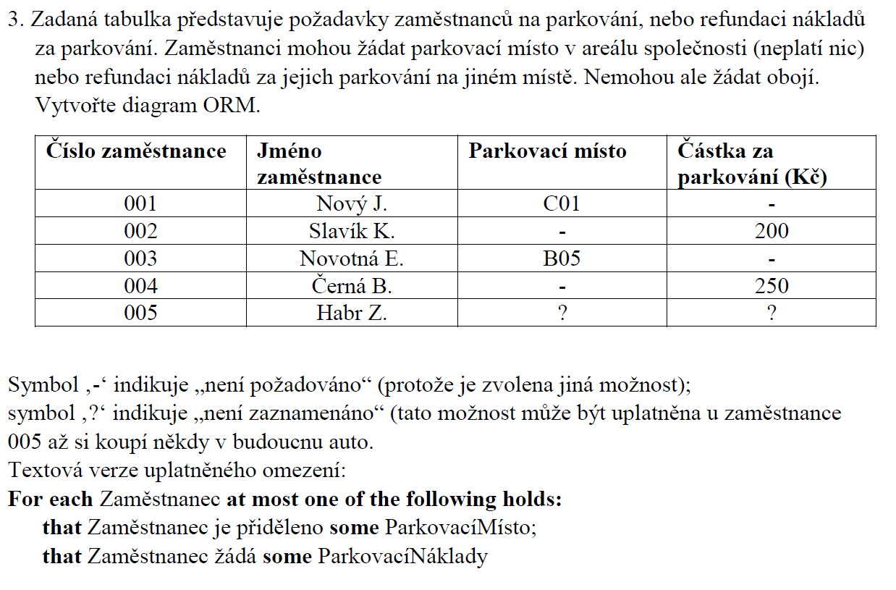

NORMA

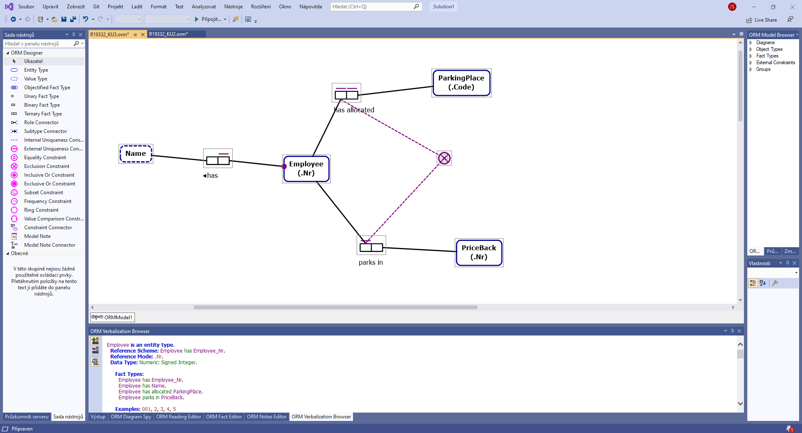

ORM Verbalization browser

[Employee](elementid:d9128eb7-9baf-4057-abf3-e4eb2b45f87a) is an entity type.  
Reference Scheme: [Employee](elementid:d9128eb7-9baf-4057-abf3-e4eb2b45f87a) [has](elementid:8b3ce739-9a7d-4db6-86bc-ae700b01380a) [Employee_Nr.](elementid:882f9a09-cf71-471d-8477-d9ea66686294)  
Reference Mode: .Nr.  
Data Type: Numeric: Signed Integer.  
  
Fact Types:  
[Employee](elementid:d9128eb7-9baf-4057-abf3-e4eb2b45f87a) [has](elementid:8b3ce739-9a7d-4db6-86bc-ae700b01380a) [Employee_Nr.](elementid:882f9a09-cf71-471d-8477-d9ea66686294)  
[Employee](elementid:d9128eb7-9baf-4057-abf3-e4eb2b45f87a) [has](elementid:1b500f21-13ab-4a67-8916-c5030caebe2a) [Name.](elementid:eb86f3ad-5f99-48ad-8976-c7babe093398)  
[Employee](elementid:d9128eb7-9baf-4057-abf3-e4eb2b45f87a) [has allocated](elementid:84b1e270-e0e5-4480-9eb4-bfade0edfb80) [ParkingPlace.](elementid:74d89653-4816-4d3a-8be8-1373fb85c94b)  
[Employee](elementid:d9128eb7-9baf-4057-abf3-e4eb2b45f87a) [parks in](elementid:1e1d727a-18a8-4296-9bd7-7a95b6ec5653) [PriceBack.](elementid:156ed029-59bf-4d37-bbf6-950bff270409)  
  
Examples: 001, 2, 3, 4, 5

[Name](elementid:eb86f3ad-5f99-48ad-8976-c7babe093398) is a value type.  
Data Type: Text: Variable Length (0).  
  
Fact Types:  
[Employee](elementid:d9128eb7-9baf-4057-abf3-e4eb2b45f87a) [has](elementid:1b500f21-13ab-4a67-8916-c5030caebe2a) [Name.](elementid:eb86f3ad-5f99-48ad-8976-c7babe093398)  
  
Examples: 'Nový J.', 'Slavík K.', 'Novotná E.', 'Černá B.', 'Habr Z.'

[ParkingPlace](elementid:74d89653-4816-4d3a-8be8-1373fb85c94b) is an entity type.  
Reference Scheme: [ParkingPlace](elementid:74d89653-4816-4d3a-8be8-1373fb85c94b) [has](elementid:7b0d9d09-164d-4f77-8f82-1eb815fb91be) [ParkingPlace_Code.](elementid:7fd1893d-236a-4f62-bcd8-8cb73db370a4)  
Reference Mode: .Code.  
Data Type: Text: Fixed Length (0).  
  
Fact Types:  
[ParkingPlace](elementid:74d89653-4816-4d3a-8be8-1373fb85c94b) [has](elementid:7b0d9d09-164d-4f77-8f82-1eb815fb91be) [ParkingPlace_Code.](elementid:7fd1893d-236a-4f62-bcd8-8cb73db370a4)  
[Employee](elementid:d9128eb7-9baf-4057-abf3-e4eb2b45f87a) [has allocated](elementid:84b1e270-e0e5-4480-9eb4-bfade0edfb80) [ParkingPlace.](elementid:74d89653-4816-4d3a-8be8-1373fb85c94b)  
  
Examples: 'C01', 'B05'

[PriceBack](elementid:156ed029-59bf-4d37-bbf6-950bff270409) is an entity type.  
Reference Scheme: [PriceBack](elementid:156ed029-59bf-4d37-bbf6-950bff270409) [has](elementid:7c7c82c1-2c01-450f-902f-a9af21b9a6cf) [PriceBack_Nr.](elementid:fc12b96c-847f-4082-a3c7-39d0edb6bd00)  
Reference Mode: .Nr.  
Data Type: Numeric: Signed Integer.  
  
Fact Types:  
[PriceBack](elementid:156ed029-59bf-4d37-bbf6-950bff270409) [has](elementid:7c7c82c1-2c01-450f-902f-a9af21b9a6cf) [PriceBack_Nr.](elementid:fc12b96c-847f-4082-a3c7-39d0edb6bd00)  
[Employee](elementid:d9128eb7-9baf-4057-abf3-e4eb2b45f87a) [parks in](elementid:1e1d727a-18a8-4296-9bd7-7a95b6ec5653) [PriceBack.](elementid:156ed029-59bf-4d37-bbf6-950bff270409)  
  
Examples: 200, 250

[Employee](elementid:d9128eb7-9baf-4057-abf3-e4eb2b45f87a) [has](elementid:1b500f21-13ab-4a67-8916-c5030caebe2a) [Name.](elementid:eb86f3ad-5f99-48ad-8976-c7babe093398)  
Each [Employee](elementid:d9128eb7-9baf-4057-abf3-e4eb2b45f87a) [has](elementid:1b500f21-13ab-4a67-8916-c5030caebe2a) exactly one [Name.](elementid:eb86f3ad-5f99-48ad-8976-c7babe093398)  
It is possible that more than one [Employee](elementid:d9128eb7-9baf-4057-abf3-e4eb2b45f87a) [has](elementid:1b500f21-13ab-4a67-8916-c5030caebe2a) the same [Name.](elementid:eb86f3ad-5f99-48ad-8976-c7babe093398)  
  
Examples:   
[Employee](elementid:d9128eb7-9baf-4057-abf3-e4eb2b45f87a) 001 [has](elementid:1b500f21-13ab-4a67-8916-c5030caebe2a) [Name](elementid:eb86f3ad-5f99-48ad-8976-c7babe093398) 'Nový J.'.  
[Employee](elementid:d9128eb7-9baf-4057-abf3-e4eb2b45f87a) 2 [has](elementid:1b500f21-13ab-4a67-8916-c5030caebe2a) [Name](elementid:eb86f3ad-5f99-48ad-8976-c7babe093398) 'Slavík K.'.  
[Employee](elementid:d9128eb7-9baf-4057-abf3-e4eb2b45f87a) 3 [has](elementid:1b500f21-13ab-4a67-8916-c5030caebe2a) [Name](elementid:eb86f3ad-5f99-48ad-8976-c7babe093398) 'Novotná E.'.  
[Employee](elementid:d9128eb7-9baf-4057-abf3-e4eb2b45f87a) 4 [has](elementid:1b500f21-13ab-4a67-8916-c5030caebe2a) [Name](elementid:eb86f3ad-5f99-48ad-8976-c7babe093398) 'Černá B.'.  
[Employee](elementid:d9128eb7-9baf-4057-abf3-e4eb2b45f87a) 5 [has](elementid:1b500f21-13ab-4a67-8916-c5030caebe2a) [Name](elementid:eb86f3ad-5f99-48ad-8976-c7babe093398) 'Habr Z.'.

[Employee](elementid:d9128eb7-9baf-4057-abf3-e4eb2b45f87a) [has allocated](elementid:84b1e270-e0e5-4480-9eb4-bfade0edfb80) [ParkingPlace.](elementid:74d89653-4816-4d3a-8be8-1373fb85c94b)  
Each [Employee](elementid:d9128eb7-9baf-4057-abf3-e4eb2b45f87a) [has allocated](elementid:84b1e270-e0e5-4480-9eb4-bfade0edfb80) at most one [ParkingPlace.](elementid:74d89653-4816-4d3a-8be8-1373fb85c94b)  
For each [ParkingPlace](elementid:74d89653-4816-4d3a-8be8-1373fb85c94b), at most one [Employee](elementid:d9128eb7-9baf-4057-abf3-e4eb2b45f87a) [has allocated](elementid:84b1e270-e0e5-4480-9eb4-bfade0edfb80) that [ParkingPlace.](elementid:74d89653-4816-4d3a-8be8-1373fb85c94b)  
  
Examples:   
[Employee](elementid:d9128eb7-9baf-4057-abf3-e4eb2b45f87a) 001 [has allocated](elementid:84b1e270-e0e5-4480-9eb4-bfade0edfb80) [ParkingPlace](elementid:74d89653-4816-4d3a-8be8-1373fb85c94b) 'C01'.  
[Employee](elementid:d9128eb7-9baf-4057-abf3-e4eb2b45f87a) 3 [has allocated](elementid:84b1e270-e0e5-4480-9eb4-bfade0edfb80) [ParkingPlace](elementid:74d89653-4816-4d3a-8be8-1373fb85c94b) 'B05'.

[Employee](elementid:d9128eb7-9baf-4057-abf3-e4eb2b45f87a) [parks in](elementid:1e1d727a-18a8-4296-9bd7-7a95b6ec5653) [PriceBack.](elementid:156ed029-59bf-4d37-bbf6-950bff270409)  
Each [Employee](elementid:d9128eb7-9baf-4057-abf3-e4eb2b45f87a) [parks in](elementid:1e1d727a-18a8-4296-9bd7-7a95b6ec5653) at most one [PriceBack.](elementid:156ed029-59bf-4d37-bbf6-950bff270409)  
It is possible that more than one [Employee](elementid:d9128eb7-9baf-4057-abf3-e4eb2b45f87a) [parks in](elementid:1e1d727a-18a8-4296-9bd7-7a95b6ec5653) the same [PriceBack.](elementid:156ed029-59bf-4d37-bbf6-950bff270409)  
  
Examples:   
[Employee](elementid:d9128eb7-9baf-4057-abf3-e4eb2b45f87a) 2 [parks in](elementid:1e1d727a-18a8-4296-9bd7-7a95b6ec5653) [PriceBack](elementid:156ed029-59bf-4d37-bbf6-950bff270409) 200.  
[Employee](elementid:d9128eb7-9baf-4057-abf3-e4eb2b45f87a) 4 [parks in](elementid:1e1d727a-18a8-4296-9bd7-7a95b6ec5653) [PriceBack](elementid:156ed029-59bf-4d37-bbf6-950bff270409) 250.

For each [Employee](elementid:d9128eb7-9baf-4057-abf3-e4eb2b45f87a), at most one of the following holds:   
that [Employee](elementid:d9128eb7-9baf-4057-abf3-e4eb2b45f87a) [has allocated](elementid:84b1e270-e0e5-4480-9eb4-bfade0edfb80) some [ParkingPlace](elementid:74d89653-4816-4d3a-8be8-1373fb85c94b);   
that [Employee](elementid:d9128eb7-9baf-4057-abf3-e4eb2b45f87a) [parks in](elementid:1e1d727a-18a8-4296-9bd7-7a95b6ec5653) some [PriceBack.](elementid:156ed029-59bf-4d37-bbf6-950bff270409)