Traduzi tudo e alterei o Inglês. Está com 2539 words e na formação deles, já deve cumprir as 6 páginas. Faltam as referências e ajustes nas tabelas (seria importante ter as tabelas em Inglês). De resto, acho que está feito. Obrigado

Estimating the socio-environmental impacts of car substitution by bicycle and public transit using open tools

*Combining public transit and cycling for the first and last mile in metropolitan areas can replace private car trips. This paper estimates the potential for cycling + PT as a substitute for car trips in the Lisbon metropolitan area. It assesses its socio-environmental impacts using open data and open-source tools. A decision support tool that facilitates the design and development of a metro cycling network was developed (biclaR). A scenario of intermodality was introduced, and its socio-environmental impacts were assessed using the HEAT for Cycling and the HEAT as a Service tool. The impacts of shifting car trips to PT were also estimated and monetized. The results indicate that 20% of the current trips can be made with the bicycle + PT combination. Shifting to cycling for the first and last mile can reduce annual CO2eq emissions from 6,000 tons/day, and the 10-year socio-environmental benefits account for €230 million. For the PT leg, the transfer from the car avoids at least 8,500 tons of CO2eq emissions per year. The information on socio-economic benefits can support policymakers in prioritizing interventions to reduce the reliance on individual motorized transportation and effectively communicate their decisions.*

# Introduction

According to the latest mobility survey conducted in 2018 (IMOB, 2018), the LMA registered 5.3 million daily trips, with only 0.5% by bicycle. Car modal share was 58.4%, while PT accounted for 15.5% of trips. The number of intra-municipal trips with an origin and destination in the same municipality amounts to 3.5 million trips, exceeding the number of inter-municipal trips (1.8 million trips) involving travel between different municipalities. Cars and public transport are the most used modes for intercity trips, with cars being the predominant choice for all journeys.

To achieve the cycling targets set by the Portuguese national cycling strategy (ref?) for 2025 and 2030 (4% and 10%, respectively), Lisbon's Metropolitan public transport company introduced biclaR. This decision support tool facilitates the design and development of a metropolitan cycling network (Ref? – website?). The biclaR tool aims to estimate the social and environmental impacts associated with the cycling potential of the scenarios analyzed.

Combining public transportation (PT) and cycling for the first and last mile in metropolitan areas can significantly replace private car trips. This approach requires interventions and programs to make bicycling more appealing, and the resulting public investments can have significant social and environmental benefits. This paper estimates the potential for combining cycling and PT to substitute car trips in the Lisbon metropolitan area (LMA). After presenting the methods used, it assesses its socio-environmental impacts using open data and open-source tools.

# Methods

## Modeling the origins and destinations of trips

The data collection of IMob is the basis for this project and defines the base scenario. Despite being conducted in the pre-pandemic period (2017), this dataset represents the most comprehensive and up-to-date information on urban mobility in Portuguese metropolitan areas (Lisbon and Porto).

We used a method for disaggregating the origins and destinations of trips between the centroids of two parishes to ensure that a parish is not solely characterized by a single point of origin and destination for its trips. Aggregating all trips into centroids renders the exercise less realistic, as it excludes a significant portion of short-distance trips, a prevalent characteristic of active mode travel (ref2?). The OD Jittering method breaks down a single point (i.e., the centroid of an area) into multiple random points on the existing and neighboring road network, using OpenStreetMap as a reference. This method then distributes the volume of trips within the parish among the randomly generated origin-destination pairs.

We employed a maximum disaggregation level of 100 trips per O-D pair for this project. For instance, 2,000 trips between the centroids of two parishes are randomly jittered (i.e., redistributed) into 20 sets of 100 trips, each comprising 20 origins and 20 destinations within the two parishes. Figure? illustrates the contrast between trip representation through the traditional method, which connects a single location between each parish, and the presentation achieved through the randomization and disaggregation of trips between parishes, specifically for the Lisbon metropolitan area.

(include figure)

Figure ? - Representation of OD pairs in the Lisbon metropolitan area between parishes, without jittering (left) and with jittering (right).

Although this method provides a more realistic representation of the trips undertaken compared to the traditional approach, it does not fully align with the actual O-D pairs of trips (which remain unknown due to data protection considerations defined by INE). For a better understanding of the method used, see Jittering: A Computationally Efficient Method for Generating Realistic Route Networks from Origin-Destination Data (Lovelace, Félix, and Carlino 2022).

## Modeling routes

The IMob collects the origin and destination of trips but does not include the respective routes. Modeling the realistic cycling routes between OD pairs depends on assumptions regarding the characteristics of the cycling and road networks (i.e., basic road segments' information) and the location of public transport interfaces. Other constraints regarding the behavior of potential cyclists determine the results. For example, such restrictions can favor speed, low volumes, more direct routes, and less steep paths, among others, suitable for cycling.

The route choice algorithm is the r5r package, which allows for great flexibility in configuring estimated route types. r5r can calculate routes using PT, considering their timetables, with probability and uncertainty. It enables the identification of the most direct or safest routes, using the Level of Traffic Stress (LTS) scale, ranging from 1 to 4, where one corresponds to the quietest (e.g., off-road cycle paths) and four corresponds to the least quiet (e.g., routes shared with motorized traffic). The routes were estimated for the base scenario for both types of networks: direct and safe, using LTS 4 and LTS 3, respectively.

The quietness level is another indicator estimated by CycleStreets for each section, based on factors such as the number of lanes, maximum allowed speed, tree planting, hierarchy, and traffic (when corresponding information is available on OpenStreetMap labels). Values vary on a scale of 0 to 100, where zero corresponds to the least safe level for cycling and 100 corresponds to the safest and quietest level, usually corresponding to sections that already include segregated cycling infrastructure away from motorized traffic.

A digital terrain model with a 25m spatial resolution and an average vertical altimetry error of 2.12m in Portugal from the European Space Agency's COPERNICUS mission was used to include slopes. The r5r model utilizes the OpenStreetMap road network (extracted on October 22, 2022) and the GTFS data created and validated. The number of potential cycling trips for the two ENMAC targets (4% and 10%) was estimated from the values for cycling and car trips (both as a driver and as a passenger) from the 2017 base scenario.

The journeys or routes were then overlaid and aggregated by segments, combining information from several routes overlapping specific segments (overline). For example, the estimated volumes of bicycle trips and car transfers were aggregated, and the average car speed and quietness level, weighted by the distance of the segments, were calculated.

## Modeling intermodality

The intermodality scenario considers trips combining PT and cycling for the first and last legs. In a conservative approach, we have restricted our analysis to the first and last legs with a combined length of up to 5 km. Furthermore, we have imposed restrictions on PT usage, I.e., we included only unimodal trips, although transfers may be considered in future modeling (Félix, Lovelace, and Moura, 2022). Additionally, we have only included PT modes that can easily accommodate bicycles, such as trains, ferries, trams, and inter-municipal bus lines equipped with bike racks. We omitted the underground since climbing and descending stairs with a bicycle is not practical for daily commuting.

The LMA's PT data were collected in GTFS format and underwent prior cleaning, merging, and validation. This information is crucial for determining the connections between PT terminals, their corresponding origins or destinations, and the timing of these connections. This approach ensures that we do not assume a universal interface connecting the system capable of serving all journeys, as such an assumption would not align with reality.

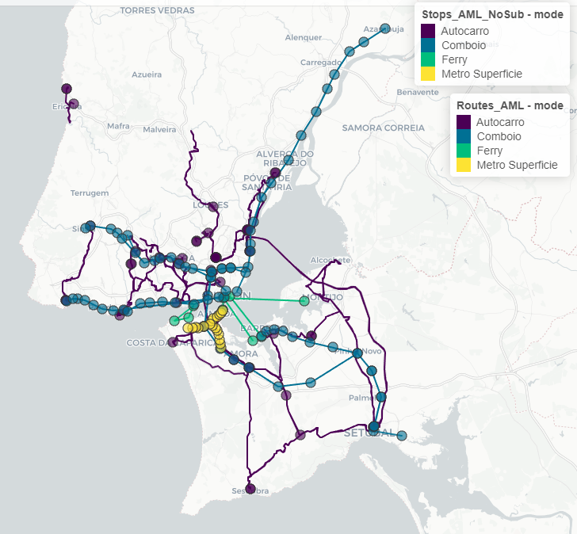

Figure ? - Interfaces and lines considered by PT mode in the LMA

We used the OpenStreetMap road network and GTFS data to obtain reliable results. The r5r R package estimated the trip duration and distance for both the original modes and the bicycle and PT combination. In contrast, the OD jittering R package estimated the OD locations using a centroid-based OD matrix.

We set up to 120 minutes (2 hours) to model the routes. In addition, we considered a maximum duration of 25 minutes for a trip by bicycle. The following figure illustrates the route obtained to access the main PT interfaces in the LMA (Figure ? ).

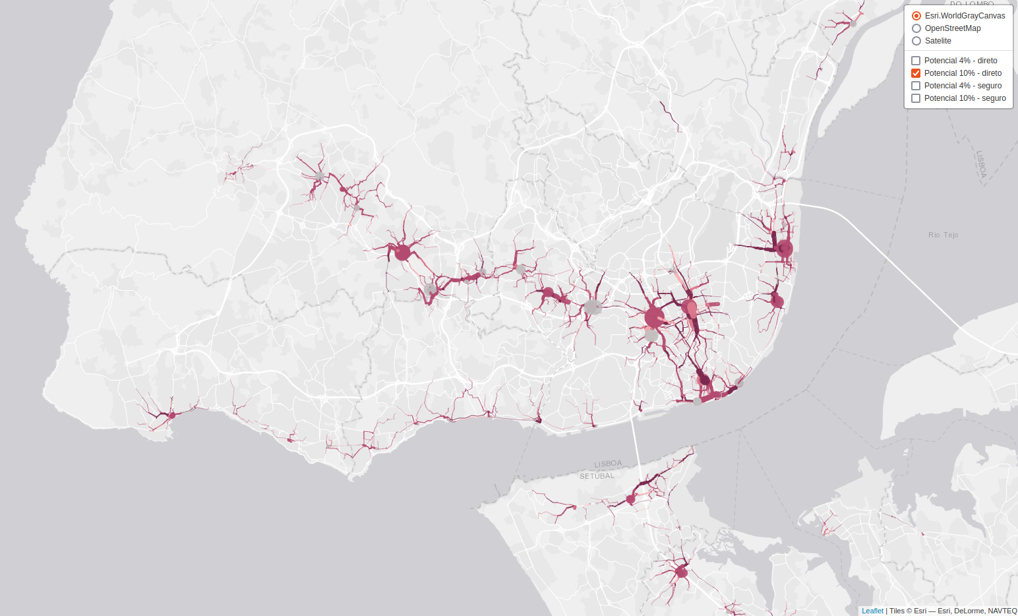

Figure ? - Bike routes with the highest potential to serve as first and last mile when replacing cycling and PT from car trips (screenshot of the interactive online tool).

## Assessing socio-environmental benefits

As the introduction mentions, the biclaR tool aims to estimate the social and environmental impacts associated with the cycling potential of the various scenarios analyzed. The time horizon considered for this analysis was the short term (i.e., one year) and the long term (i.e., ten years).

After estimating the trips shifted to bikes and PT from private cars, we assessed the socio-environmental impacts of the HEAT for Cycling and the HEAT as Service tools from the World Health Organization (WHO). For all the scenarios, HEAT estimates the social and environmental impacts of switching from car travel to cycling in terms of:

a) Social - Health, Physical Activity, Exposure to air pollution, Exposure to the risk of road accidents (measured in years of premature mortality avoided); and

b) Environmental - CO2eq gas emissions (measured in tonnes).

Additionally, we estimate the air emissions with the EMEP/EEA's COPERT Tier 3 methodology, v5.0 (Ntziachristos and Samaras 2020). Each car trip replaced (whether by bike or PT) corresponds to the equivalent emissions of an average family-sized vehicle, EURO standard, and petrol or diesel fuel type. All journeys were considered to have been made in urban driving conditions (with the respective implications for the average driving speed) and at an average speed of 15km/h during peak hour periods. Since the average distance traveled per trip influences the overconsumption and emissions from cold-start engine operation, we estimated energy and emission factors for different ranges of trips at 500-meter intervals.

Emissions are calculated for the following atmospheric pollutants: CO (carbon monoxide), NO X (Nitrogen Oxides), VOC (Volatile Organic Compounds), and PM (particulate matter). Emissions of the main greenhouse gases are also estimated: CO2 (carbon dioxide), CH4 (methane), and N2O (nitrous oxide), as well as CO2eq equivalent. For PT, we used the emission factors reported in the sustainability reports of the respective operators (Carris 2020; Metropolitano de Lisboa 2020; CP 2020, Grupo Transtejo 2014). The consumption and emission factors for cars and public transport refer to the number of passengers transported (per passenger.km) and not the vehicle (which would be vehicle.km). In the case of cars, the reference value of 1.61 passengers/car reported by the Mobility Survey (INE 2017) was used to calculate the gas emissions avoided by transferring car trips to PT.

The impacts were assessed for different territorial scales: municipal scale (for each segment) and metro area scale (for the total metro area). The conversion of avoided emissions into avoided welfare loss and respective monetary valuation was based on the EU Guide to Cost-benefit Analysis (Ref?) and the best up-to-date reference values for the various gases (Bickel et al., 2006; Nash and others, 2003; Sartori et al., 2014).

# Results and Discussion

Table 4 presents the daily trips for the baseline scenario and potential trips feasible within a 5-kilometer radius, combining bicycle and PT, classified by route type. In the secure and direct network categories, trips encompassing distances of up to 5 kilometers by bike combined with PT represent 20% of the total trips collected in the survey.

This scenario unveils the potential of bicycles as a complementary mode of PT, with the prospective to enlarge the number of PT trips within the LMA area by as much as 12% (in addition to the 825,000 reported in the IMob 2017 dataset). These findings indicate that transferring car trips to a combination of bicycle and PT could be nearly as substantial, if not equally significant, as the shift towards bicycle-only trips.

Within this scenario, we assessed the environmental consequences of sifting from cars to PT, in addition to evaluating the environmental and societal impacts of adopting bicycles as an alternative mode of transport. Table 11 provides an annual estimate of emitted and mitigated gases resulting from the transition from automobiles to various PT modes for the scenario featuring a 4% target, utilizing the "direct" cycling network.

[Table 11]

In this scenario, we estimate a reduction of 8,702 tons of CO2eq emissions by substituting motorized trips relying on fossil fuels and electricity. These estimations used an electricity production life cycle approach.

Table ?? presents the monetary valuation of emissions (in €) for scenario 3, which focuses on the latter part of the journey utilizing PT, with targets of 4% and 10%, and the utilization of both "direct" and "safe" cycling networks, over 365 days (equivalent to one year).

[Tabela 13]

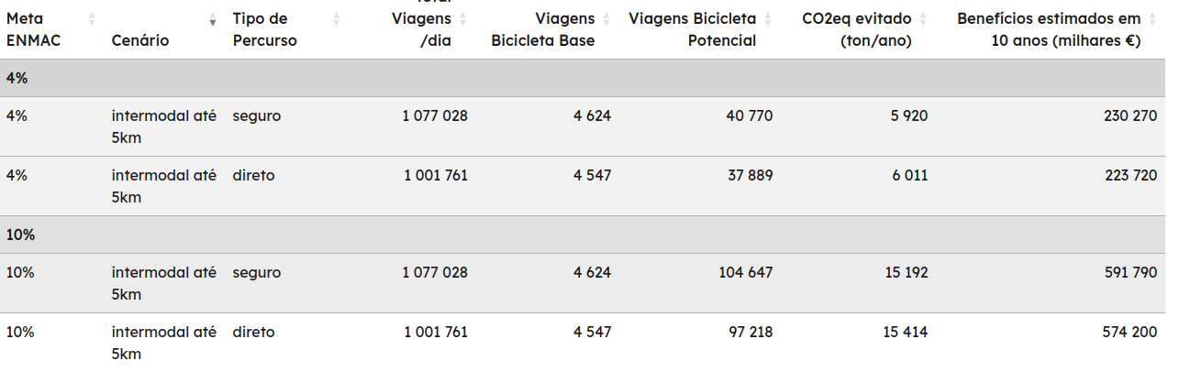

Summary of the cycling potential of intermodality scenario.

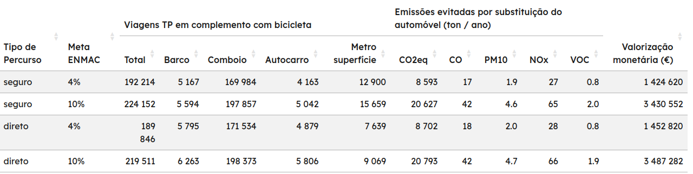

*Estimated transfer potential for each mode of public transport and estimates of CO2eq consumption avoided annually by transferring from the car.*

The estimated socio-economic impacts stemming from the avoided pollutants and greenhouse gases vary from €1.4 million to €3.5 million. Our findings suggest that a bicycle and PT combination could viably replace 20% of current trips, with an additional 12% of PT journeys prone to further substitution. The adoption of cycling for first-and-last-mile travel can curtail annual CO2 equivalent emissions by 6,000 to 15,000 tons per day. Over a decade, the resulting socio-environmental benefits could accrue to an estimated range of €230 million to €590 million, contingent upon the targeted cycling modalities. Regarding the PT segment, the shift from private car usage would lead to the mitigation of CO2 equivalent emissions to 8,500 to 20,800 tons annually, translating to a monetary value of €1.4 million to €3.5 million over a decade. Trains exhibit the highest potential for substitution, accounting for 88% of this benefit.

# Final note

By sharing the research process openly in a code repository, this study allows others to replicate similar estimates for the socio-environmental impacts when people shift from using cars to bicycles and public transportation in different cities. The information about the socio-economic benefits can help policymakers prioritize actions to reduce the use of individual cars and better communicate their decisions.

### Acknowledgments

Please place your acknowledgments at the end of the paper, preceded by an unnumbered run-in heading (i.e., 3rd-level heading).

Thomas Götshi - HAAS.

# References (test)

Félix, Rosa, Robin Lovelace, and Filipe Moura. 2022. “biclaR - Ferramenta de apoio ao planeamento da rede ciclável na área metropolitana de Lisboa.” CERIS - Instituto Superior Técnico and Transportes Metropolitanos de Lisboa. <https://biclar.tmlmobilidade.pt>.

Slifka, M. K., and J. L. Whitton. 2000. "Clinical Implications of Dysregulated Cytokine Production." *J. Mol. Med.* 78: 74–80. <https://doi.org/10.1007/s001090000086>.