

|  |
| --- |
| Business Template  **Subject areas** |
| **Logo / Image** |

Contents

1 Business Description 3

1.1 Business background 3

1.2 Problems. Current Situation 3

1.3 The benefits of implementing a database. Project Vision 3

2 Model description 3

2.1 Definitions & Acronyms 3

2.2 Logical Scheme 3

2.3 Objects 3

# 

# Business Description

## Business background

The recruitment agency connects job seekers with employers. Candidates apply for jobs, then the agency analysis job requirements, candidate skill and experience. Then agency decides if candidate is suitable for certain job. This is structured process involving job applications, interviews and job offers.

## Problems. Current Situation

This process requires database to keep information about candidates and jobs. Without database much information will be lost and process will be inefficient.

## the Benefits of implementing a database. Project Vision

With database all information will be kept and analysed. Finding best match will be faster and with better quality than without database. Also agency will get benefit to offer job to candidate who has required skills but don’t apply to job.

# Model description

## Definitions & Acronyms

* **PK (Primary Key):** Uniquely identifies a record in a table.
* **FK (Foreign Key):** Establishes relationships between tables.
* **Candidate:** A person applying for a job.
* **Agent:** A recruiter managing candidate interactions.
* **Job Application:** A candidate's request to be considered for a job.
* **Job Offer:** An offer made to a candidate for a job position.

## Logical Scheme

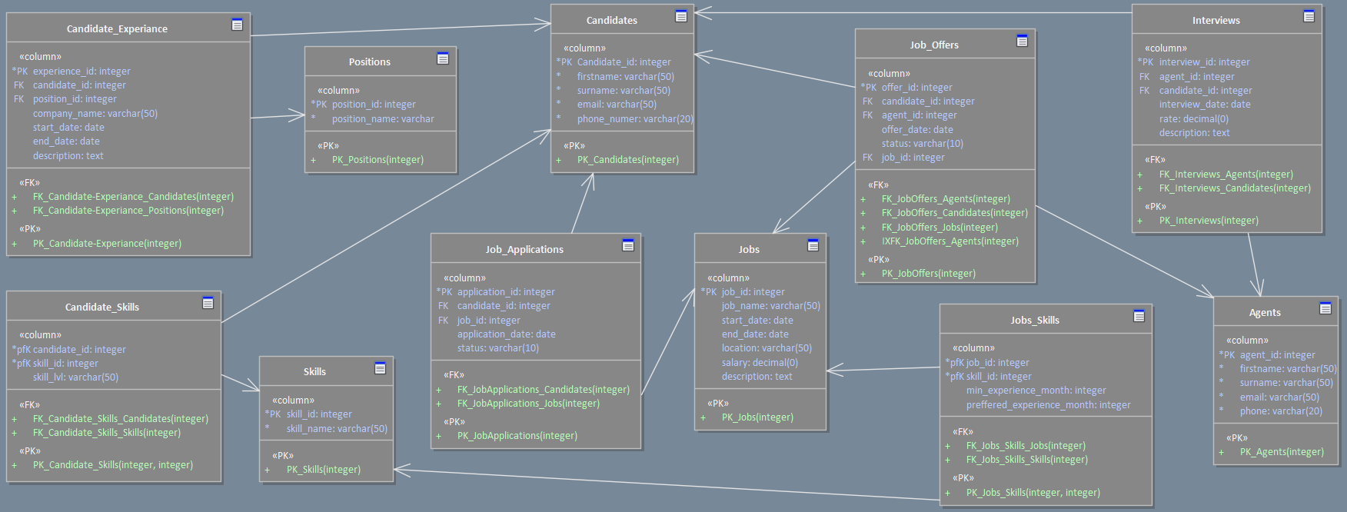

## Objects

Stores candidate personal details

|  |  |  |  |
| --- | --- | --- | --- |
| Table Name | Field name | Field Description | Data Type |
| Candidates | Candidate_id | PK,unique ID | Integer |
| firstname | Candidate’s name | Varchar(50) |
|  | surname | Candidate’s surname | Varchar(50) |
|  | email | Candidate’s email | Varchar(50) |
|  | Phone_number | Contact number | Varchar(20) |

Example with data

|  |  |  |  |  |
| --- | --- | --- | --- | --- |
| Candidate_id | firstname | surname | email | Phone_number |
| 1 | David | Snow | d.snow@gmail.com | +995 599 12 34 56 |
| 2 | Kate | Doe | kate99@gmail.com | +995 591 11 22 33 |

Track candidate work experience

|  |  |  |  |
| --- | --- | --- | --- |
| Table Name | Field name | Field Description | Data Type |
| Candidate_Experience | experience_id | PK, unique ID | Integer |
| candidate_id | FK, Candidate’s name | Integer |
|  | position_id | FK, Previous jobs position reference | Integer |
|  | company_name | Name of company | Varchar(50) |
|  | start_date | Job start date | date |
|  | end_date | Job end date | date |
|  | description | Job description | text |

Comments on table relationships

Candidates → Candidate_Experience (1:M)

One candidate can have multiple experiences.

Positions → Candidate_Experience (1:M)

One position can be associated with multiple candidate experiences.

Example with data

|  |  |  |  |  |  |  |
| --- | --- | --- | --- | --- | --- | --- |
| experience_id | candidate_id | position_id | company_name | start_date | end_date | description |
| 1 | 1 | 1 | epam | 11/05/2020 | 1/12/2022 | Led a team of developers to build a CRM system, improving client management efficiency |
| 2 | 1 | 2 | google | 4/1/2023 | present | Managed sales operations, increasing revenue by 20% in one year |

Defines job roles previously held by candidates

|  |  |  |  |
| --- | --- | --- | --- |
| Table Name | Field name | Field Description | Data Type |
| Positions | position_id | PK, unique ID | Integer |
| position_name | Job title | Varchar(50) |

Example with data

|  |  |
| --- | --- |
| position_id | position_name |
| 1 | Web designer |
| 2 | Web developer |

Records candidate skills and proficiency levels

|  |  |  |  |
| --- | --- | --- | --- |
| Table Name | Field name | Field Description | Data Type |
| Candidate_Skills | candidate_id | PK, FK, candidate reference | Integer |
| skill_id | PK, FK, skill reference | Integer |
|  | skill_lvl | Skill level | Varchar(50) |

Comments on table relationships

**Candidates ↔ Skills** (M:M) via Candidate_Skills

A candidate can have multiple skills, and a skill can belong to multiple candidates

Example with data

|  |  |  |
| --- | --- | --- |
| candidate_id | skill_id | skill_lvl |
| 1 | 1 | basic |
| 1 | 2 | advanced |

Store different skill types

|  |  |  |  |
| --- | --- | --- | --- |
| Table Name | Field name | Field Description | Data Type |
| Skills | skill_id | PK, unique ID | Integer |
| skill_name | skill name | Varchar(50) |

Example with data

|  |  |
| --- | --- |
| skill_id | skill_name |
| 1 | postgresql |
| 2 | python |

Stores job-related details

|  |  |  |  |
| --- | --- | --- | --- |
| Table Name | Field name | Field Description | Data Type |
| Jobs | job_id | PK,unique ID | Integer |
| start_date | Job start date | date |
|  | end_date | Job end date | date |
|  | location | Job location | Varchar(50) |
|  | salary | Job salary | decimal |
|  | description | Job description | text |

Example with data

|  |  |  |  |  |  |
| --- | --- | --- | --- | --- | --- |
| job_id | start_date | end_date | location | salary | description |
| 1 | 1/03/2025 | 25/03/2025 | Tbilisi | 800 | Software developer role in Tbilisi, working on web applications |
| 2 | 15/03/2025 | 20/04/2025 | Batumi | 1000 | Marketing manager position in Batumi, leading a new campaign |

Maps skills required for specific job roles

|  |  |  |  |
| --- | --- | --- | --- |
| Table Name | Field name | Field Description | Data Type |
| Jobs_Skills | job_id | PK, FK,Job reference | Integer |
| skill_id | PK, FK, Skill reference | integer |
|  | min_experience_month | Minimum experience month numbers | integer |
|  | preferred_experience_month | preferred experience month numbers | integer |

Comments on table relationships

Jobs ↔ Skills (M:M) via Jobs_Skills

A job can require multiple skills, and a skill can be required for multiple jobs.

Example with data

|  |  |  |  |
| --- | --- | --- | --- |
| job_id | skill_id | min_experience_month | preferred_experience_month |
| 1 | 1 | 6 | 12 |
| 1 | 2 | 24 | 36 |

Track candidate application for job positions

|  |  |  |  |
| --- | --- | --- | --- |
| Table Name | Field name | Field Description | Data Type |
| Job_Applications | application_id | PK, unique ID | Integer |
| candidate_id | FK, Candidate reference | Integer |
|  | job_id | FK, Job reference | Integer |
|  | application_date | Date of application | date |
|  | status | Application status | Varchar(50) |

Comments on table relationships

Candidates → Job_Applications (1:M)

One candidate can apply to multiple jobs.

Jobs → Job_Applications (1:M)

One job can have multiple applications.

Example with data

|  |  |  |  |  |
| --- | --- | --- | --- | --- |
| application_id | candidate_id | job_id | application_date | status |
| 1 | 1 | 1 | 13/03/2025 | pending |
| 2 | 1 | 2 | 5/03/2025 | pending |

Record interview details between candidates and agents

|  |  |  |  |
| --- | --- | --- | --- |
| Table Name | Field name | Field Description | Data Type |
| Interviews | interview_id | PK, unique id | Integer |
|  | agent_id | FK, agent reference | Integer |
|  | candidate_id | Candidate reference | integer |
|  | date | Interview date | date |
|  | rate | interview rating | decimal |
|  | description | Interview notes | text |

Comments on table relationships

Agents → Interviews (1:M)

One agent can conduct multiple interviews.

Example with data

|  |  |  |  |  |  |
| --- | --- | --- | --- | --- | --- |
| interview_id | agent_id | candidate_id | date | rate | description |
| 1 | 1 | 1 | 11/03/2025 | 7.5 | The candidate showed excellent communication but lacked experience in backend development. Potential fit for junior roles |
| 2 | 1 | 2 | 5/03/2025 | 8.8 | The candidate demonstrated strong problem-solving skills and clear communication. However, they need to improve their technical knowledge in database optimization. Overall, a promising candidate with potential for growth. |

Store details about job offers made to candidates

|  |  |  |  |
| --- | --- | --- | --- |
| Table Name | Field name | Field Description | Data Type |
| Job_Offers | offer_id | PK, unique id | Integer |
|  | candidate_id | FK, candidate reference | Integer |
|  | job_id | FK, job reference | integer |
|  | agent_id | Fk, agent reference | integer |
|  | offer_date | Date of offer | date |
|  | status | Offer status | Varchar(50) |

Comments on table relationships

Candidates → Job_Offers (1:M)

One candidate can receive multiple job offers.

Jobs → Job_Offers (1:M)

One job can have multiple offers.

Jobs → Job_Offers (1:M)

One job can have multiple offers.

Example with data

|  |  |  |  |  |  |
| --- | --- | --- | --- | --- | --- |
| offer_id | candidate_id | job_id | agent_id | offer_date | status |
| 1 | 1 | 1 | 1 | 14/03/2025 | Rejected by employer |
| 2 | 1 | 2 | 2 | 15/03/2025 | accepted |

Store recruiter details

|  |  |  |  |
| --- | --- | --- | --- |
| Table Name | Field name | Field Description | Data Type |
| Agents | agent_id | PK, unique id | Integer |
|  | firstname | Agent’s name | Varchar(50) |
|  | surname | Agent’s surname | Varchar(50) |
|  | email | Agent’s email | Varchar(50) |
|  | Phone_number | Contact number | Varchar(20) |

Comments on table relationships

Example with data

|  |  |  |  |  |
| --- | --- | --- | --- | --- |
| agent_id | firstname | surname | email | Phone_number |
| 1 | John | Doe | jj.doe87@gmail.com | +995 552 33 44 55 |
| 2 | Maria | Cruze | Mar.cruze@gmail.com | +995 562 16 96 25 |