Business Template

Subject areas
Logo / Image

Contents
1 Business Description 3
1.1 Business background 3
1.2 Problems. Current Situation 3
1.3 The benefits of implementing a database. Project Vision 3
2 Model description 3
2.1 Definitions & Acronyms 3
2.2 Logical Scheme 3
2.3 Objects 3

Business Description

Business background

The recruitment agency connects job seekers with employers. Candidates apply for jobs, then the agency analysis job requirements, candidate skill and experience. Then agency decides if candidate is suitable for certain job. This is structured process involving job applications, interviews and job offers.

Problems. Current Situation
This process requires database to keep information about candidates and jobs. Without database much information will be lost and process will be inefficient.

the Benefits of implementing a database. Project Vision
With database all information will be kept and analysed. Finding best match will be faster and with better quality than without database. Also agency will get benefit to offer job to candidate who has required skills but don’t apply to job.

Model description

Definitions & Acronyms
- PK (Primary Key): Uniquely identifies a record in a table.
- FK (Foreign Key): Establishes relationships between tables.
- Candidate: A person applying for a job.
- Agent: A recruiter managing candidate interactions.
- Job Application: A candidate's request to be considered for a job.
- Job Offer: An offer made to a candidate for a job position.

Logical Scheme
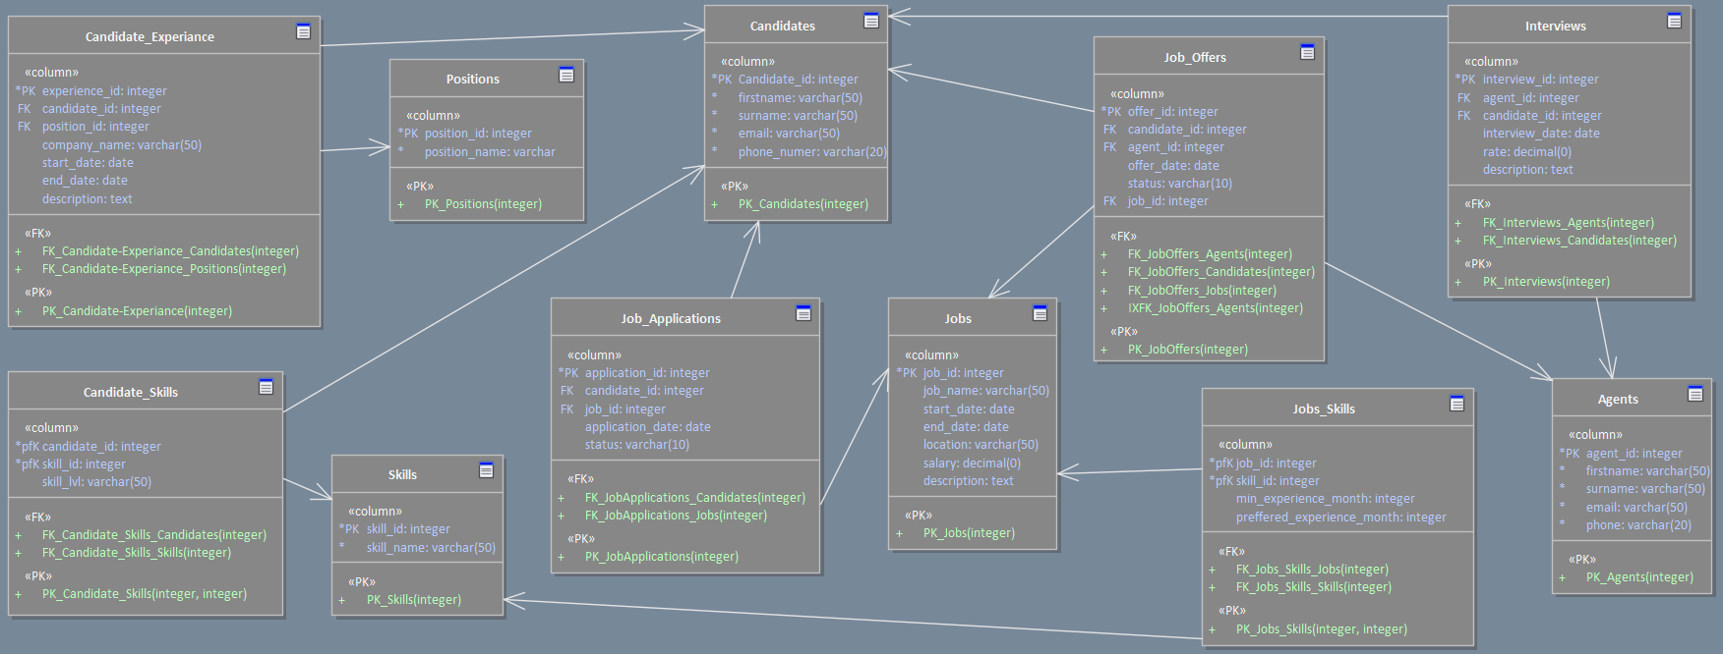

Objects

Stores candidate personal details

Table Name | Field name | Field Description | Data Type
Candidates | Candidate_id | PK,unique ID | Integer
 | firstname | Candidate’s name | Varchar(50)
 | surname | Candidate’s surname | Varchar(50)
 | email | Candidate’s email | Varchar(50)
 | Phone_number | Contact number | Varchar(20)

Example with data
Candidate_id | firstname | surname | email | Phone_number
1 | David | Snow | d.snow@gmail.com | +995 599 12 34 56
2 | Kate | Doe | kate99@gmail.com | +995 591 11 22 33

Track candidate work experience

Table Name | Field name | Field Description | Data Type
Candidate_Experience | experience_id | PK, unique ID | Integer
 | candidate_id | FK, Candidate’s name | Integer
 | position_id | FK, Previous jobs position reference | Integer
 | company_name | Name of company | Varchar(50)
 | start_date | Job start date | date
 | end_date | Job end date | date
 | description | Job description | text

Comments on table relationships
Candidates → Candidate_Experience (1:M)
One candidate can have multiple experiences.
Positions → Candidate_Experience (1:M)
One position can be associated with multiple candidate experiences.

Example with data
experience_id | candidate_id | position_id | company_name | start_date | end_date | description
1 | 1 | 1 | epam | 11/05/2020 | 1/12/2022 | Led a team of developers to build a CRM system, improving client management efficiency
2 | 1 | 2 | google | 4/1/2023 | present | Managed sales operations, increasing revenue by 20% in one year

Defines job roles previously held by candidates

Table Name | Field name | Field Description | Data Type
Positions | position_id | PK, unique ID | Integer
 | position_name | Job title | Varchar(50)

Example with data
position_id | position_name
1 | Web designer
2 | Web developer

Records candidate skills and proficiency levels

Table Name | Field name | Field Description | Data Type
Candidate_Skills | candidate_id | PK, FK, candidate reference | Integer
 | skill_id | PK, FK, skill reference | Integer
 | skill_lvl | Skill level | Varchar(50)

Comments on table relationships
Candidates ↔ Skills (M:M) via Candidate_Skills
A candidate can have multiple skills, and a skill can belong to multiple candidates

Example with data
candidate_id | skill_id | skill_lvl
1 | 1 | basic
1 | 2 | advanced

Store different skill types

Table Name | Field name | Field Description | Data Type
Skills | skill_id | PK, unique ID | Integer
 | skill_name | skill name | Varchar(50)

Example with data
skill_id | skill_name
1 | postgresql
2 | python

Stores job-related details

Table Name | Field name | Field Description | Data Type
Jobs | job_id | PK,unique ID | Integer
 | start_date | Job start date | date
 | end_date | Job end date | date
 | location | Job location | Varchar(50)
 | salary | Job salary | decimal
 | description | Job description | text

Example with data
job_id | start_date | end_date | location | salary | description
1 | 1/03/2025 | 25/03/2025 | Tbilisi | 800 | Software developer role in Tbilisi, working on web applications
2 | 15/03/2025 | 20/04/2025 | Batumi | 1000 | Marketing manager position in Batumi, leading a new campaign

Maps skills required for specific job roles

Table Name | Field name | Field Description | Data Type
Jobs_Skills | job_id | PK, FK,Job reference | Integer
 | skill_id | PK, FK, Skill reference | integer
 | min_experience_month | Minimum experience month numbers | integer
 | preferred_experience_month | preferred experience month numbers | integer

Comments on table relationships
Jobs ↔ Skills (M:M) via Jobs_Skills
A job can require multiple skills, and a skill can be required for multiple jobs.

Example with data
job_id | skill_id | min_experience_month | preferred_experience_month
1 | 1 | 6 | 12
1 | 2 | 24 | 36

Track candidate application for job positions

Table Name | Field name | Field Description | Data Type
Job_Applications | application_id | PK, unique ID | Integer
 | candidate_id | FK, Candidate reference | Integer
 | job_id | FK, Job reference | Integer
 | application_date | Date of application | date
 | status | Application status | Varchar(50)

Comments on table relationships
Candidates → Job_Applications (1:M)
One candidate can apply to multiple jobs.
Jobs → Job_Applications (1:M)
One job can have multiple applications.

Example with data
application_id | candidate_id | job_id | application_date | status
1 | 1 | 1 | 13/03/2025 | pending
2 | 1 | 2 | 5/03/2025 | pending

Record interview details between candidates and agents

Table Name | Field name | Field Description | Data Type
Interviews | interview_id | PK, unique id | Integer
 | agent_id | FK, agent reference | Integer
 | candidate_id | Candidate reference | integer
 | date | Interview date | date
 | rate | interview rating | decimal
 | description | Interview notes | text

Comments on table relationships
Agents → Interviews (1:M)
One agent can conduct multiple interviews.

Example with data
interview_id | agent_id | candidate_id | date | rate | description
1 | 1 | 1 | 11/03/2025 | 7.5 | The candidate showed excellent communication but lacked experience in backend development. Potential fit for junior roles
2 | 1 | 2 | 5/03/2025 | 8.8 | The candidate demonstrated strong problem-solving skills and clear communication. However, they need to improve their technical knowledge in database optimization. Overall, a promising candidate with potential for growth.

Store details about job offers made to candidates

Table Name | Field name | Field Description | Data Type
Job_Offers | offer_id | PK, unique id | Integer
 | candidate_id | FK, candidate reference | Integer
 | job_id | FK, job reference | integer
 | agent_id | Fk, agent reference | integer
 | offer_date | Date of offer | date
 | status | Offer status | Varchar(50)

Comments on table relationships
Candidates → Job_Offers (1:M)
One candidate can receive multiple job offers.
Jobs → Job_Offers (1:M)
One job can have multiple offers.
Jobs → Job_Offers (1:M)
One job can have multiple offers.

Example with data
offer_id | candidate_id | job_id | agent_id | offer_date | status
1 | 1 | 1 | 1 | 14/03/2025 | Rejected by employer
2 | 1 | 2 | 2 | 15/03/2025 | accepted

Store recruiter details

Table Name | Field name | Field Description | Data Type
Agents | agent_id | PK, unique id | Integer
 | firstname | Agent’s name | Varchar(50)
 | surname | Agent’s surname | Varchar(50)
 | email | Agent’s email | Varchar(50)
 | Phone_number | Contact number | Varchar(20)

Comments on table relationships

Example with data
agent_id | firstname | surname | email | Phone_number
1 | John | Doe | jj.doe87@gmail.com | +995 552 33 44 55
2 | Maria | Cruze | Mar.cruze@gmail.com | +995 562 16 96 25

