CS 4480 PA3 Progress Report—Chandler Eyre, u1410762
Figure 1: Network ip address allocation
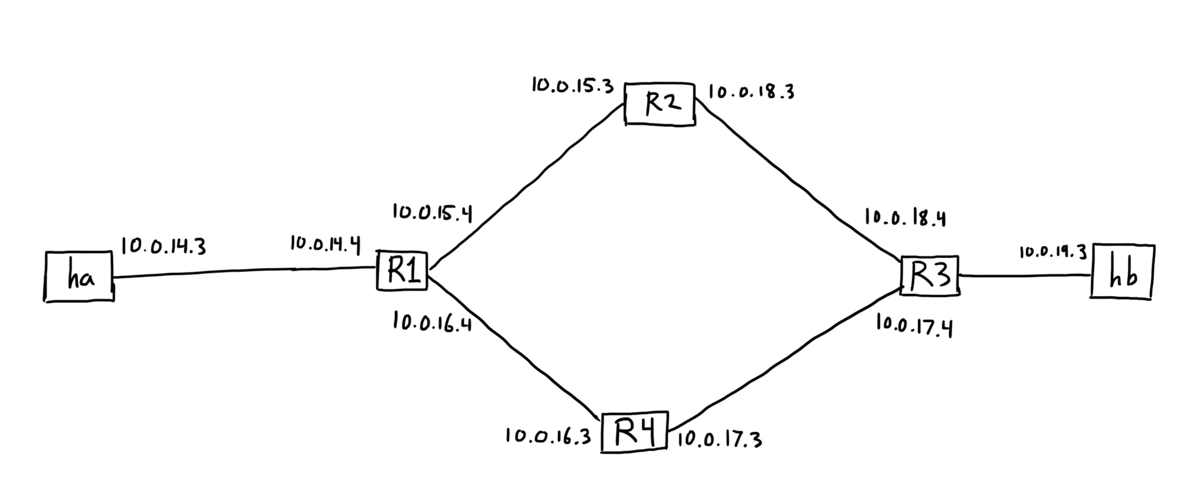

Figure 2: Screenshot from Powder
