**CIS2344 Algorithms Processes and Data**

**Logbook**

**Part 1**

Contents

Week 1 / 2 2

Task 1 2

Task 2 3

Task 3 6

Self-Assessment 9

Week 3 9

Task 1 9

Re-writing week 1&2 as Generics 13

Self-Assessment 16

Week 5 16

Task 3.4 16

Self-Assessment 19

# Week 1 / 2

## Task 1

package searcher;  
  
*/**  
 \** ***@author*** *Adam Birch  
 \** ***@version*** *October 2018  
  
 */*public class CleverSearcher extends Searcher {  
  
 CleverSearcher(int[] array, int k) {  
 super(array, k);  
 }  
  
  
 @Override  
 public int findElement() throws IndexingError {  
 */**  
 * This is the main search to be implemented  
 \** ***@return*** *kth largest element  
 \** ***@exception*** *IndexingError on bad input  
 \** ***@see*** *IndexingError  
 */* int[] array = getArray();  
 int k = getIndex();  
 if (k <= 0 || k > array.length) { // Test that k is a valid search.  
 throw new IndexingError();  
 }  
 int[] smallArray = new int[k];

// Create a small array of size k – the k'th largest is element 0  
 for (int i = 0; i < array.length; i++) {  
 int value = array[i];  
 if (value > smallArray[0]){  
 if (smallArray.length > 1){

// Only loop if there are many values in the Array.  
 int x = 0;  
 while (x < smallArray.length - 1 && value > smallArray[x+1]){  
 smallArray[x] = smallArray[x+1];  
 x++;  
 }  
 smallArray[x] = value;

// Adds the new value to the Array once it is in the correct place.  
 }  
 else {  
 smallArray[0] = value;  
 }  
 }  
 }  
 return smallArray[0];  
 }  
}

When findElement() is called it will create a small array to hold the kth largest element – and the ones higher than it. It loops through all of the elements of the initial array, and sorts it into the smallArray (if it is larger than the current element in position 0).

## Task 2

This is the created CleverSearcherTest

package searcher;  
  
*/**  
 \** ***@author*** *Adam Birch  
 \** ***@version*** *September 2018  
 */*class CleverSearcherTest extends SearcherTest {  
  
 protected Searcher createSearcher(int[] array, int index) throws IndexingError {  
 return new CleverSearcher(array,index);  
 }  
  
}

This is the extended SearcherTest

package searcher;  
  
import arrayGenerator.ArrayGenerator;  
import arrayGenerator.CleverRandomListingGenerator;  
import org.junit.jupiter.api.Test;  
  
import static org.junit.jupiter.api.Assertions.*;  
  
*/**  
 \** ***@author*** *Hugh Osborne  
 \** ***@version*** *September 2018  
 */*abstract class SearcherTest {  
  
 */**  
 * Create a searcher of the right type  
 */* abstract protected Searcher createSearcher(int[] array, int index) throws IndexingError;  
  
 */**  
 * Test that the searcher finds the correct value. The test uses a random listing*

*generator to create  
 * a random listing of the requited size. Because of the properties of random listings,*

*the kth largest  
 * element of a random listing of size n must be n-k.  
 \** ***@param*** *arraySize the size of the random listing to be generated (the "n" value)  
 \** ***@param*** *index the index (the "k" value)  
 \** ***@throws*** *IndexingError if k is out of bounds for n  
 */* private void testSearcher(int arraySize,int index) throws IndexingError {  
 ArrayGenerator generator = new CleverRandomListingGenerator(arraySize);  
 Searcher search = createSearcher(generator.getArray(), index);  
 *assertEquals*(arraySize - index, search.findElement());  
 }  
  
 private void testNegativeSize(int arraySize) {  
  
 Throwable e = *assertThrows*(IndexOutOfBoundsException.class, () -> {  
 ArrayGenerator generator = new CleverRandomListingGenerator(arraySize);  
 });  
 *assertEquals*("Array size must be larger than 1.", e.getMessage());  
  
 }  
  
 private void testLargerIndex(int arraySize, int index) throws IndexingError {  
 ArrayGenerator generator = new CleverRandomListingGenerator(arraySize);  
 Searcher search = createSearcher(generator.getArray(), index);  
 Throwable e = *assertThrows*(IndexingError.class, () -> {search.findElement();});  
  
 *assertEquals*("Index out of bounds", e.getMessage());  
  
 }  
  
 @Test  
 void test2ndIn10() throws IndexingError {  
 testSearcher(10,2);  
 }  
  
 @Test  
 void test5thIn10() throws IndexingError {  
 testSearcher(10,5);  
 }  
 @Test  
 void test3rdIn100() throws IndexingError {  
 testSearcher(100,3);  
 }  
  
 @Test  
 void test16thIn100() throws IndexingError {  
 testSearcher(100,16);  
 }  
  
 @Test  
 void test8thIn1000() throws IndexingError {  
 testSearcher(1000,8);  
 }  
  
 @Test  
 void test107thIn1000() throws IndexingError {  
 testSearcher(1000,107);  
 }  
  
 @Test  
 void test1stIn10000() throws IndexingError {  
 testSearcher(10000,1);  
 }  
  
 @Test  
 void test1003rdn10000() throws IndexingError {  
 testSearcher(10000,1003);  
 }  
  
 @Test  
 void test11thIn100000() throws IndexingError {  
 testSearcher(100000,11);  
 }  
  
 @Test  
 void test4thIn1000000() throws IndexingError {  
 testSearcher(1000000,4);  
 }  
  
 @Test // Test that a negative input throws an IndexOutOfBoundsException.  
 */**  
 \** ***@throws*** *IndexOutOfBoundsException  
 */* void testminus1(){  
 testNegativeSize(-1);  
 }  
  
 @Test // Test that a size of 0 throws an IndexOutOfBoundsException.  
 */**  
 \** ***@throws*** *IndexOutOfBoundsException  
 */* void testZero(){  
 testNegativeSize(0);  
 }  
  
 @Test // Test that a larger index throws the IndexingException  
 */**  
 \** ***@throws*** *IndexingError  
 */* void test10in1() throws IndexingError {  
 testLargerIndex(1,10);  
 }  
  
 @Test // Test the smallest value in the array.  
 void test100in100() throws IndexingError {  
 testSearcher(100,100);  
 }  
  
}

I created 2 new types of test, each with its own test method. One to test for the outcome of a negative or zero size for the array, and the other for the outcome for a search when the index is larger than the array. Both of these test the type and message of a thrown exception – IndexOutOfBoundsException and IndexingError respectively.

I also extended the tests to include a 100 in 100 search – this was to test the borderline results, where the test was most likely to fail.

## Task 3

package searcher;  
  
/*  
 A timer method that records the execution time for the Clever Searcher  
  
 @author Adam Birch  
 * @version October 2018  
 */  
  
import arrayGenerator.ArrayGenerator;  
import arrayGenerator.CleverRandomListingGenerator;  
import timer.Timer;  
  
public class CleverSearcherTimer extends CleverSearcher implements Timer {  
  
 // All timings will be done with an index of 5  
 private final static int *K* = 5;  
  
 private CleverSearcherTimer(int[] array) {  
 super(array, *K*);  
 }  
  
 @Override  
 public void timedMethod() {  
 try {  
 findElement();  
 } catch (IndexingError indexingError) {  
 // simply ignore indexing errors here  
 // with K at 5, and a minimum task size (array size) of 10, indexing errors

should not occur  
 // duirng timing  
 }  
 }  
  
 @Override  
 public long getMaximumRuntime() {  
 return 1;  
 }  
  
 */**  
 * Minimum task size (array size) is set to ten, to avoid indexing errors (index is*

*always five)  
 \** ***@return*** *minimum task size of ten  
 */* @Override  
 public int getMinimumTaskSize() {  
 return 10;  
 }  
  
 @Override  
 public int getMaximumTaskSize() {  
 return 100000000;  
 }  
  
 @Override  
 public Timer getTimer(int size) {  
 ArrayGenerator generator = new CleverRandomListingGenerator(size);  
 return new CleverSearcherTimer(generator.getArray());  
 }  
  
 public static void main(String[] args) throws IndexingError {  
 CleverSearcherTimer timer = new CleverSearcherTimer(null);  
 timer.timingSequence();  
 }  
}

My CleverSearcher implementation is much faster than the SimpleSearcher. The CleverSearcher runs out of tests before terminating, while the SimpleSearcher runs out of time.

Here are console outputs to give exact comparisons:

SimpleSearcher

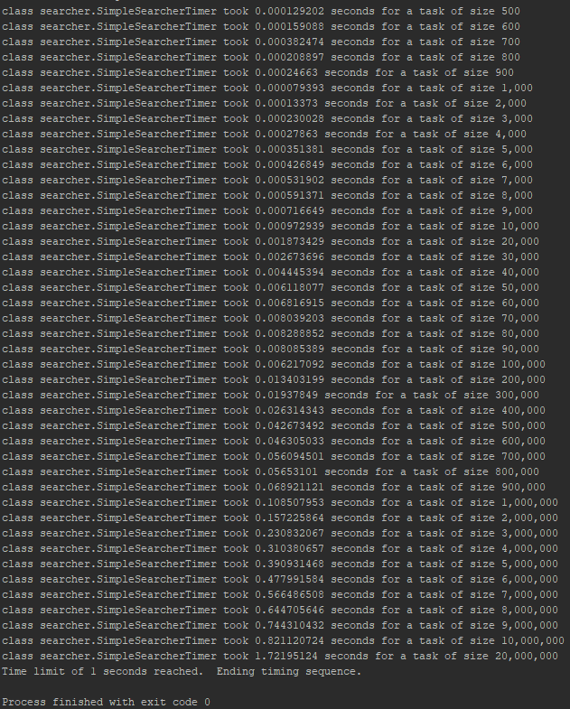

CleverSearcher

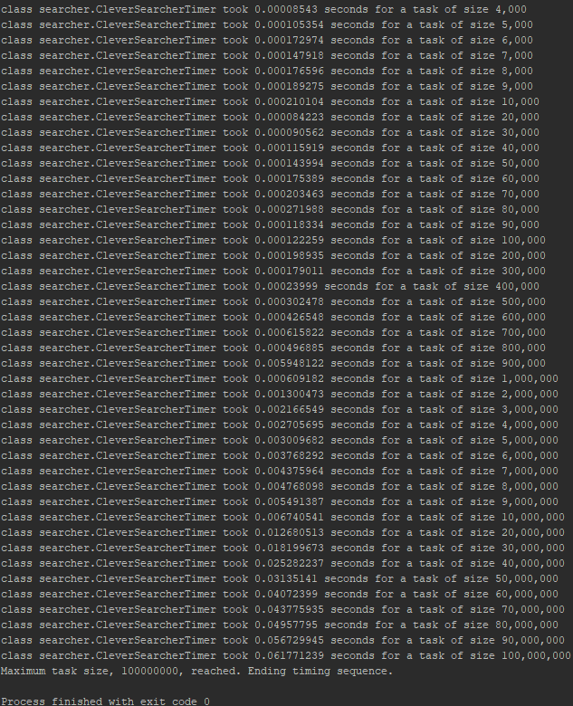

The highest successful value on SimpleSearcher – 20,000 – took 1.72 seconds to sort, while the CleverSearcher required 0.012 seconds for the same calculation.

Note. There is a possibility of inaccuracies within the test as I cannot guarantee what my machine was doing in the background. Background processes would alter the results – however the general trend would remain the same.

## Self-Assessment

Rating - 4

I would give myself a 4/5 for this work as it does exactly what is specified including suitable annotations, however it may not be the most efficient solution to the problem. A more efficient solution would include elements of both solutions, as finding the smallest in the initial array – such that k = array size – would be faster to sort than creating a new array. It would also require less memory as there would only be the one array of data, rather than two of the same.

# Week 3

## Task 1

import java.util.ArrayList;  
  
*/**  
 \** ***@author*** *Adam Birch  
 \** ***@version*** *October 2018  
  
 */*public class Swap<E> {  
  
 public ArrayList<E> Switch (ArrayList <E> array, int index1, int index2) throws

IndexOutOfBoundsException{  
 try {  
 E temp1 = array.get(index1);  
 E temp2 = array.get(index2);  
 // Find the element at the two indexes  
 array.set(index1, temp2);  
 array.set(index2, temp1);  
 //Swap the elements  
 } catch (IndexOutOfBoundsException e) {  
 System.*out*.println("Exception");  
 throw new IndexOutOfBoundsException("Index exceeds the bounds of the array. ");  
 }  
  
 return array;  
 }  
}

This is the generic function to swap the values.

import java.util.ArrayList;  
  
*/**  
 \** ***@author*** *Adam Birch  
 \** ***@version*** *October 2018  
 */*public class GenericMethods {  
  
 public ArrayList<String> strArray(Integer end, int index1, int index2) {  
 //Creating a String array and using the Swap  
 if(end >0){  
 ArrayList<String> list = new ArrayList<>(end);  
 for (int i = 0; i < end; i++){  
 list.add(Integer.*toString*(i));  
 }  
 Swap<String> swap = new Swap<>();  
 list = swap.Switch(list, index1, index2);  
 return list;  
 }  
 else {  
 throw new IndexOutOfBoundsException("Array size must be higher than 0.");  
 }  
 }  
  
 public ArrayList<Integer> intArray(Integer end, int index1, int index2) {  
 //Creating an Integer array and using the Swap  
 if(end >0){  
 ArrayList<Integer> list = new ArrayList<>(end);  
 for (int i = 0; i < end; i++) {  
 list.add(i);  
 }  
 Swap<Integer> swap = new Swap<>();  
 list = swap.Switch(list, index1, index2);  
 return list;  
 }  
 else {  
 throw new IndexOutOfBoundsException("Array size must be higher than 0.");  
 }  
 }  
}

Here is a GenericMethods class that calls the swap and supports integers and strings. This is not necessary for the swap function to work but is used to create an instance of the swap for testing.

/*  
 * @author Adam_Birch  
 * u1761249  
 */  
  
import org.junit.jupiter.api.Test;  
  
import java.util.ArrayList;  
  
import static org.junit.jupiter.api.Assertions.*;  
  
class GenericMethodsTest {  
  
  
 void TestValidString(Integer end, int index1, int index2) {  
 GenericMethods test = new GenericMethods();  
 ArrayList expected = new ArrayList<>(end);  
 for (int i = 0; i < end; i++){  
 if(i==index1){expected.add(index2);}  
 else if (i == index2){expected.add(index1);}  
 else {expected.add(i);}  
 }  
 ArrayList data = test.strArray(end,index1,index2);  
 for (int i = 0; i < 10; i++){  
 *assertEquals*(expected.get(i).toString(),data.get(i).toString());  
 }  
 }  
  
  
 void TestValidInteger(Integer end, int index1, int index2) {  
 GenericMethods test = new GenericMethods();  
 ArrayList expected = new ArrayList<>(end);  
 for (int i = 0; i < end; i++){  
 expected.add(i);  
 }  
 Object temp1 = expected.get(index1);  
 Object temp2 = expected.get(index2);  
 expected.set(index1,temp2);  
 expected.set(index2,temp1);  
 *assertEquals*(expected, test.intArray(end,index1,index2));  
 }  
  
 void TestStringException(Integer end, int index1, int index2){  
 GenericMethods test = new GenericMethods();  
 Throwable e = *assertThrows*(IndexOutOfBoundsException.class, () ->

{test.strArray(end,index1,index2);});  
 *assertEquals*("Index exceeds the bounds of the array. ", e.getMessage());  
 }  
 void TestIntegerException(Integer end, int index1, int index2){  
 GenericMethods test = new GenericMethods();  
 Throwable e = *assertThrows*(IndexOutOfBoundsException.class, () ->

{test.intArray(end,index1,index2);});  
 *assertEquals*("Index exceeds the bounds of the array. ", e.getMessage());  
 }  
 void TestStringSizeException(Integer end, int index1, int index2){  
 GenericMethods test = new GenericMethods();  
 Throwable e = *assertThrows*(IndexOutOfBoundsException.class, () ->

{test.strArray(end,index1,index2);});  
 *assertEquals*("Array size must be higher than 0.", e.getMessage());  
 }  
 void TestIntegerSizeException(Integer end, int index1, int index2){  
 GenericMethods test = new GenericMethods();  
 Throwable e = *assertThrows*(IndexOutOfBoundsException.class, () ->

{test.intArray(end,index1,index2);});  
 *assertEquals*("Array size must be higher than 0.", e.getMessage());  
 }  
  
 //Test that the program functions correctly

@Test  
 void testString(){  
 TestValidString(10,2,7);  
 }  
  
 @Test  
 void testInteger(){  
 TestValidInteger(10,2,7);  
 }  
  
 //Test that the function works when the numbers are in reverse order  
  
 @Test  
 void testReverseString(){  
 TestValidString(10,7,2);  
 }  
  
 @Test  
 void testReverseInteger(){  
 TestValidInteger(10,7,2);  
 }  
  
 //Test that the program makes no change and throws no error  
  
 @Test  
 void testSameString(){  
 TestValidString(10,5,5);  
 }  
  
 @Test  
 void testSameInteger(){  
 TestValidInteger(10,5,5);  
 }  
  
 //Test that the correct exception is thrown  
  
 @Test  
 */**  
 \** ***@throws*** *IndexOutOfBoundsException  
 */* void testStringOutOfBounds(){  
 TestStringException(10,2,70);  
 }  
  
 @Test  
 */**  
 \** ***@throws*** *IndexOutOfBoundsException  
 */* void testIntegerOutOfBounds(){  
 TestIntegerException(10,-2,7);  
 }  
  
 //Test that an exception is thrown if the input is 0.  
  
 @Test  
 */**  
 \** ***@throws*** *IndexOutOfBoundsException  
 */* void testZeroString(){  
 TestStringSizeException(0,0,0);  
 }  
 @Test  
 */**  
 \** ***@throws*** *IndexOutOfBoundsException  
 */* void testZeroInteger(){  
 TestIntegerSizeException(0,0,0);  
 }  
  
}

This is a test class that was used to test the implementation. I used integer and string values to test the swap class as these are the most likely values to be swapped within a program. As the implementation uses generics it should also work with objects and any other non-primitive type.

The following screenshot is the test results for swapping Integers and Strings.

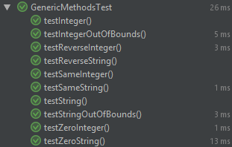

## Re-writing week 1&2 as Generics

I successfully modified the code such that the Simple Searcher and all required components run generic methods, however the Clever Searcher returns exceptions due to casting the type to allow the program to compile.

Modifying the Search algorithms to use Generics required the entire folder to be altered to use generics. This was problematic as I don’t fully understand each java class however I was able to alter the required classes to make the search compile and run correctly.

This is the generic Simple Searcher.

package searcher;  
  
/*  
 Implements the find (kth) element method by sorting and indexing.  
 */  
  
import java.util.Arrays;  
  
public class SimpleSearcher<T> extends Searcher {  
  
 SimpleSearcher(T[] array, int k) {  
 super(array, k);  
 }  
  
 */**  
 * Find the kth largest element in an array of ints using the "obvious"  
 * solution from the lecture  
 *  
 * <ul>  
 * <li> Sort the array</li>  
 * <li> Return the entry k spaces from the end</li>  
 * </ul>  
 *  
 \** ***@return*** *kth largest element of array  
 */* public T findElement() throws IndexingError {  
 T[] array = (T[]) getArray();  
 int k = getIndex();  
 if (k <= 0 || k > array.length) {  
 throw new IndexingError();  
 }  
 Arrays.*sort*(array); // sort the whole array  
 return array[array.length - k]; // desired element is kth from the end  
 } // end of obvious solution method  
}

This is the generic Clever Searcher.

package searcher;  
  
*/**  
 \** ***@author*** *Adam Birch  
 \** ***@version*** *October 2018  
  
 */*public class CleverSearcher<T extends Comparable<? super T>> extends Searcher {  
  
 CleverSearcher(Object[] array, int k) {  
 super(array, k);  
 }  
  
  
 @Override  
 public T findElement() throws IndexingError {  
 */**  
 * This is the main search to be implemented  
 \** ***@return*** *kth largest element  
 \** ***@exception*** *IndexingError on bad input  
 \** ***@see*** *IndexingError  
 */* T[] array = (T[]) getArray();  
 int k = getIndex();  
 if (k <= 0 || k > array.length) { // Test that k is a valid search.  
 throw new IndexingError();  
 }  
 T[] smallArray = (T[])new Object[k]; // Create a small array of size k - the

k'th largest is element 0  
 for (Integer i = 0; i < array.length; i++) {  
 T value = array[i];  
 T temp = smallArray[0];  
 if (value.compareTo(temp) > 0){  
 if (smallArray.length > 1){ // Only loop if there are many values in the Array.  
 int x = 0;  
 while (x < smallArray.length - 1 && value.compareTo(smallArray[x+1]) > 0){  
 smallArray[x] = smallArray[x+1];  
 x++;  
 }  
 smallArray[x] = value; // Adds the new value to the Array once it is in

the correct place.  
 }  
 else {  
 smallArray[0] = value;  
 }  
 }  
 }  
 return smallArray[0];  
 }  
}

This is the successful running for the Simple Searcher (left) and the error for the Clever Searcher(right): 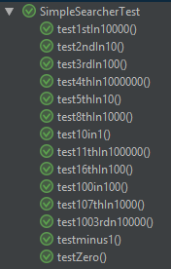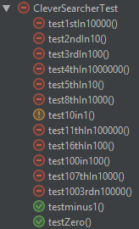

The failed tests were because:

“java.lang.ClassCastException: class [Ljava.lang.Object; cannot be cast to class [Ljava.lang.Comparable; ([Ljava.lang.Object; and [Ljava.lang.Comparable; are in module java.base of loader 'bootstrap')”

## Self-Assessment

Rating - 5

I feel like I understand the utilisation and implementation of Generics, even though I was unable to make the rewritten Clever Search algorithm function correctly. I was able to implement fully automated testing within the logbook exercises and have documented my code and testing to a reasonable level.

# Week 5

## Task 3.4

I ran tests for the Bubble, Selection and Quick sorts and recorded the time taken for an array size of: 1, 12, 1000, 2000, 10000, and 50000.

I ran this three times and used the averages to plot a graph. They are as follows (Time is recorded in milliseconds):

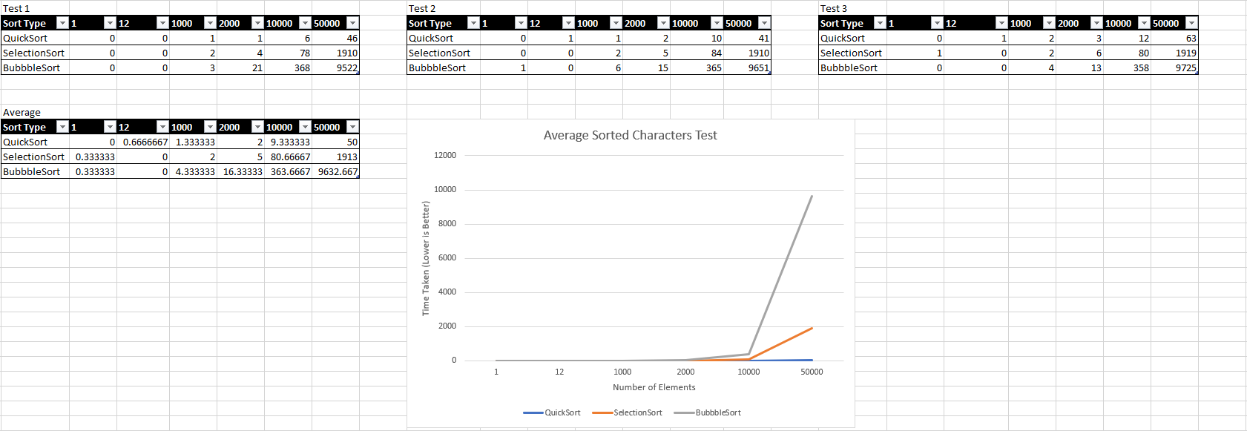

Figure 1 - Average Sorted Characters Test

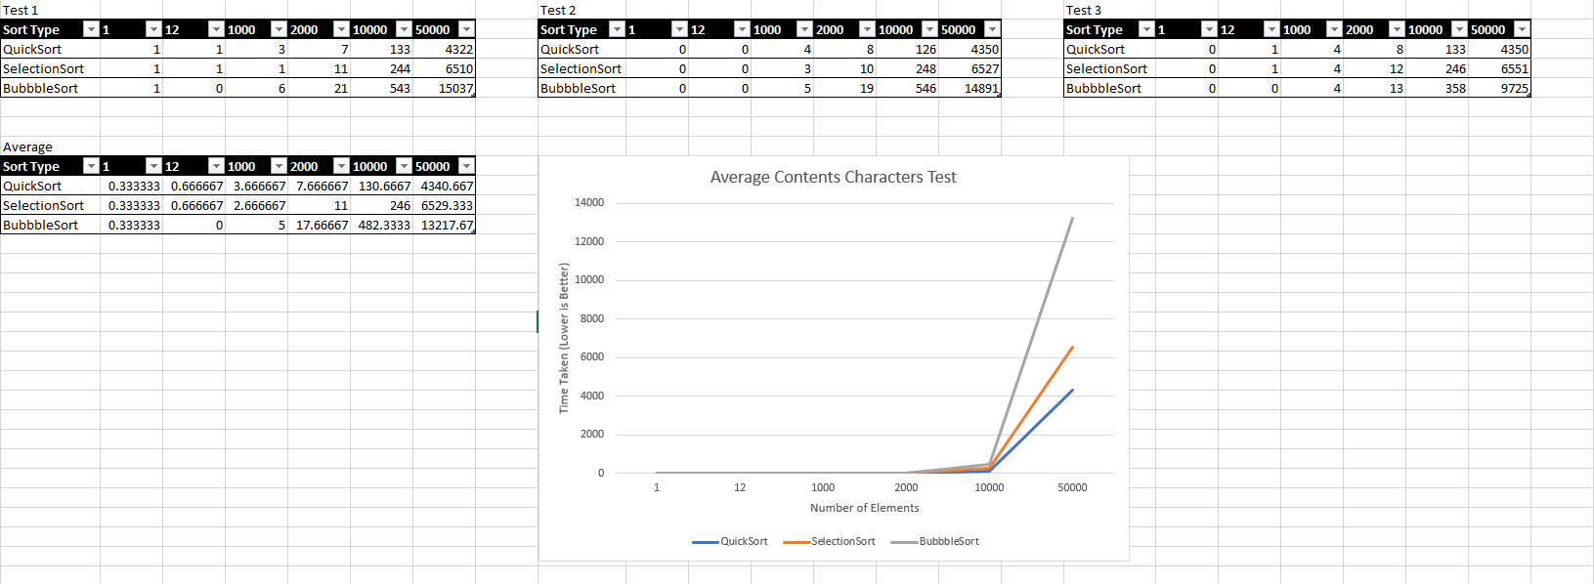

Figure 2 - Average Contents Characters Test

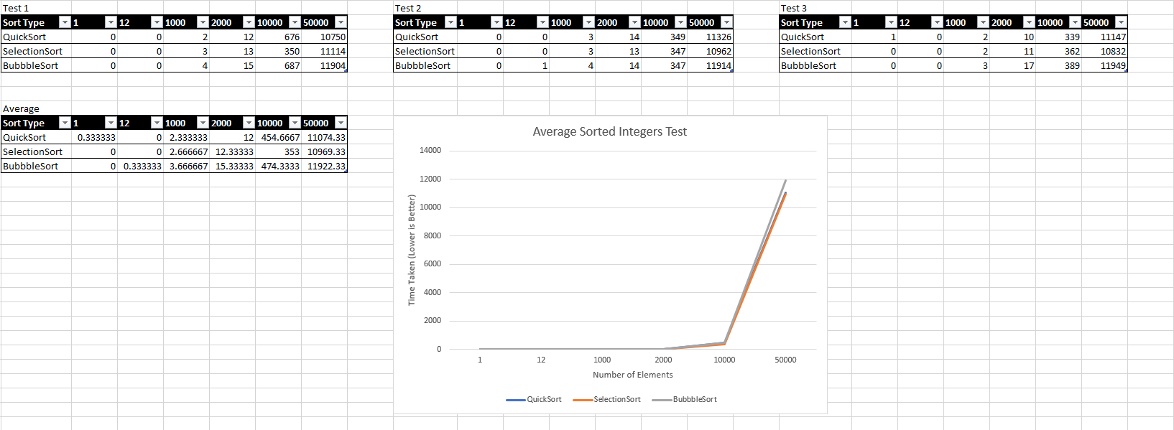

Figure 3 - Average Sorted Integers Test

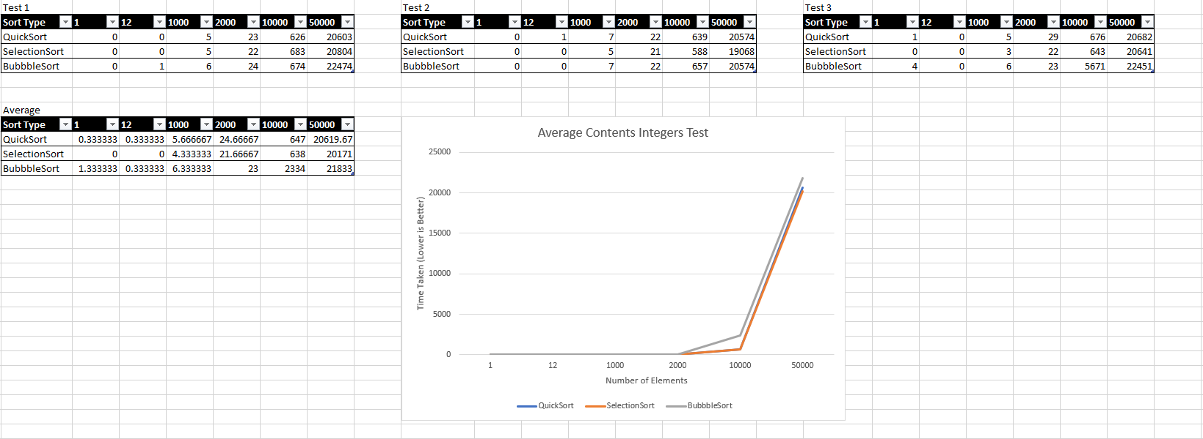

Figure 4 - Average Contents Integers Test

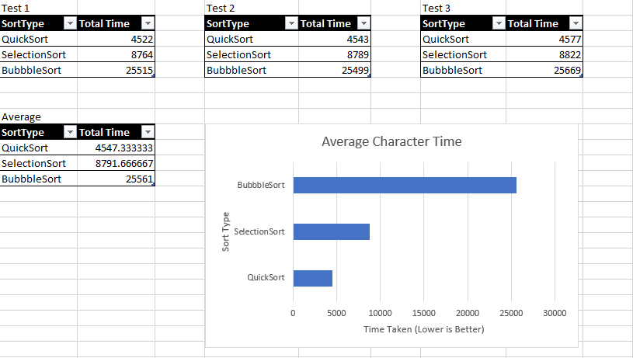

Figure 5 - Average Character Time

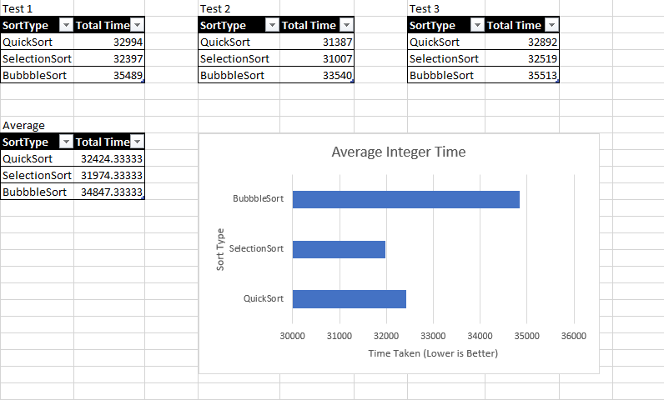

Figure 6 - Average Integer Time

From these results, I can conclude that Bubble Sort is always the slowest regardless of data types. I can also conclude that the data type does make a difference to processing time and makes Selection Sort faster than Quick Sort for Integers. The code for the Selection Sort and the Quick Sort can be found at:

[*https://stackoverflow.com/questions/12128066/selection-sort-with-generics*](https://stackoverflow.com/questions/12128066/selection-sort-with-generics)

and

[*https://github.com/chrisloy/java-algorithms/blob/master/src/uk/co/chrisloy/sandpit/sort/QuickSort.java*](https://github.com/chrisloy/java-algorithms/blob/master/src/uk/co/chrisloy/sandpit/sort/QuickSort.java)

respectively.

Selection Sort may be faster for Integers than Quick Sort as there are less possibilities (There are 10 numerical digits used while there are 26 characters used). This difference may make a large impact on the efficiency of the solutions.

Big O Notation is an algebraic expression for the efficiency of a solution. On means the code will take n cycles for n amount of data, On2 will take n2 for n amount of data, etc.

The Average case Big O Notations for Bubble, Selection, and Quick Sorts are On2, On2, and O(n log(n)) respectively.

This is calculated by the Bubble and Selection Sorts both having nested loops within, where the number of loops varies due to the number of elements in the array(n).

## Self-Assessment

Rating - 5

I would give myself 5/5 for this weeks exercises as I successfully implemented additional sorting algorithms to the code, and I have successfully tested and documented however I am unsure as to how the Selection Sort is better than the Quick Sort for sorting a large quantity of integers. It behaved as I would expect for characters but not for Integers. Due to this I feel like I am unable to award myself 5 as I cannot explain the results effectively. I have attempted to draw upon previous teaching of Big O Notation to express the efficiency of the sorting algorithms. I implemented larger data within my testing data sets, though I couldn’t use larger than I did due to running time on my machine. I have shown the difference between each sort in a controlled environment using standard scientific practices to ensure data is more consistent – this being repeating the test and using the average results.