# **CFS2143 Assignment: Configuring and Building Computer Networks**

## Information for completion and submission

This assignment forms the practical element of the Hardware and Networks Module - CFS2143

To complete this assignment you will need to install Packet Tracer on your PC.

Within each task you are asked a series of questions. Please answer all these questions providing the correct information and necessary screenshots in the spaces provided.

You will also be asked to save information in separate files.

**At the end of the assignment you should have**:

* **Part 1 (60%)**: This document annotated with your answers to the indicated questions and three network simulation files.
* **Part 2 (40%)**: A report of no more than 2500 words on your network planning.

You must submit the files in a popular text format (e.g., .pdf, .odt, .docx, etc. PDF format is preferred.). The simulations must be saved to packet tracer pkt files.

**Please submit these files (as individual files) by following the link on Unilearn.** Your file names should contain your student ID, and should be as follows (if your student ID were U7654321):

* This document annotated with your answers to the indicated questions – U7654321Ans
* The three network simulation files – U7654321OSPF.pkt, U7654321ACL.pkt, U7654321VLAN.pkt
* The report - U7654321Rep

**Hand-out date 26th January 2018 on Unilearn.**

**Hand-in date 27th April 2018 on Unilearn.**

**Feedback to be provided by 18th May 2017 on Unilearn.**

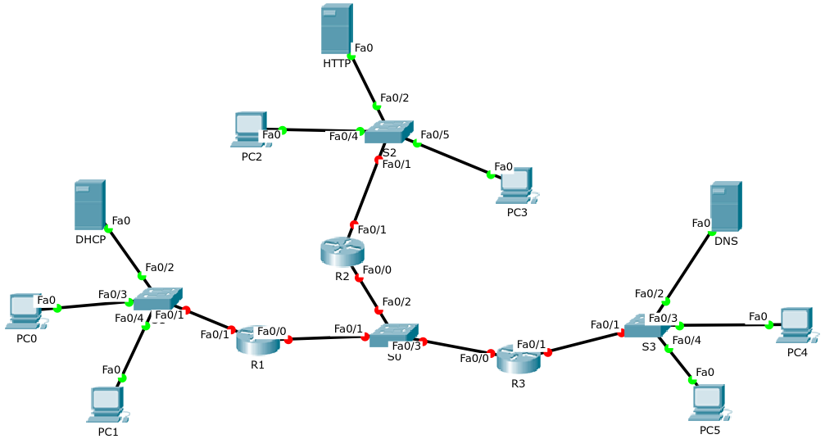

## Objectives

Completion of this assignment requires the following tasks:

* Create an addressing scheme for the hosts on the network
* Configure OSPF
* Configure Servers
* Configure ACL
* Configure VLAN
* Plan campus computer networks

Part 1: Hands-on Tasks Using Packet Tracer (60%)

A simulation file network.pkt has been provided as a starting point for working on Part 1 of this assignment.

Task 1: Create an IP Addressing Scheme for the provided network topology (10 Marks)

Create an IP addressing scheme for each of the following LANs.

R1: Fa0/1

R2: Fa0/1

R3: Fa0/1

|  |  |  |  |
| --- | --- | --- | --- |
| Network Address | First IP Address | Last **I**P Address | Broadcast Address |
| *192.168.10.0* | *192.168.10.1* | *192.168.10.254* | *192.168.10.255* |
| *192.138.20.0* | *192.138.20.1* | *192.138.20.254* | *192.138.20.255* |
| *192.168.30.0* | *192.168.30.1* | *192.168.30.254* | *192.168.30.255* |

|  |  |  |  |  |
| --- | --- | --- | --- | --- |
| Device | Interface | Network Address | IP Address | Subnet Mask |
| R1 | *Fa0/1* | *192.168.10.0* | *192.168.10.1* | *255.255.255.0* |
| R2 | *Fa0/1* | *192.168.20.0* | *192.168.20.1* | *255.255.255.0* |
| R3 | *Fa0/1* | *192.168.30.0* | *192.168.30.1* | *255.255.255.0* |

**Task 2**: Configure the routers using OSPF (20 marks)

2a: Work out suitable network schemes for all routers (5 marks)

|  |  |  |  |
| --- | --- | --- | --- |
| Device | Interface | Network Address | Wildcard Mask |
| R1 | *Fa0/0* | *10.10.10.1* | *0.0.0.255* |
| *Fa0/1* | *192.168.10.1* | *0.0.0.255* |
| R2 | *Fa0/0* | *10.10.10.2* | *0.0.0.255* |
| *Fa0/1* | *192.168.20.1* | *0.0.0.255* |
| R3 | *Fa0/0* | *10.10.10.3* | *0.0.0.255* |
| *Fa0/1* | *192.168.30.1* | *0.0.0.255* |

2b: Configure OPSF on the routers (3 Marks)

What commands have you used to configure OSPF? Please document the commands you use for configuring one router (Just pick one from among R1, R2, and R3).

*En*

*Conf t*

*Router ospf 1*

*Network 10.10.10.0 0.0.0.255 area 0*

*Network 192.168.10.0 0.0.0.255 area 0*

2c: Verify that OSPF is working correctly (3 Marks)

Please show neighbours, OSPF databases, and routing table (Please screenshot the output of one of the three routers).

What commands have you used to do this?

*Show ip route*

*Screen Clipping*

*Show ip ospf neighbour*

*Screen Clipping*

*Show ip ospf database*

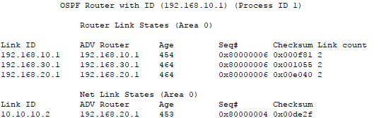

*Show ip ospf interface*

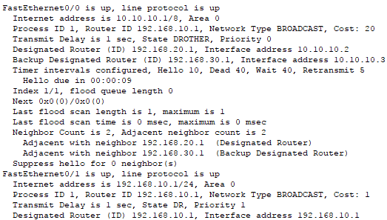

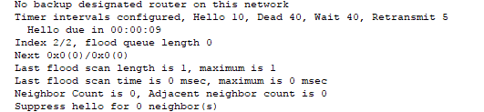

2d: Configure OSPF priorities (3 Marks)

Change the priorities to make R1 the DR, R2 the BDR and R3 the DROTHER.

What commands have you used to do this? Please provide screenshots for demonstration of the result.

*R1 R2 R1*

*Conf t conf t write*

*Int fa0/0 int fa0/0 reload*

*Ip ospf cost 10 ip ospf cost 15*

*Ip ospf priority 0 ip ospf priority 18*

*Exit Exit*

*Exit Exit*

Screen Clipping

2e: Configure OSPF cost (3 Marks)

(1): Set the cost on the R1 WAN link to a value of 20.

Screen Clipping

(2): Set the cost of the R2 WAN to a value of 100.

Screen Clipping

(3): Verify the costs in the routing table and screenshot the outputs.

*R1*

Screen Clipping

*R2*

Screen Clipping

*R3*

Screen Clipping

2f: Use cisco and class as passwords for configurations of one router (3 Marks)

What commands have you used to do this? Please screenshot the use of passwords for configuring this particular router.

*Conf t*

*Enable password class*

*Enable secret cisco1*

*Line console 0*

*Password class*

*Login*

*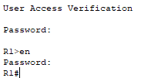First password “class”, second password “cisco”.*

**Task 3**: Configure Servers (10 Marks)

3a: Configure the HTTP Server and verify (2 Mark)

Please provide screenshots of the configuration and verification.

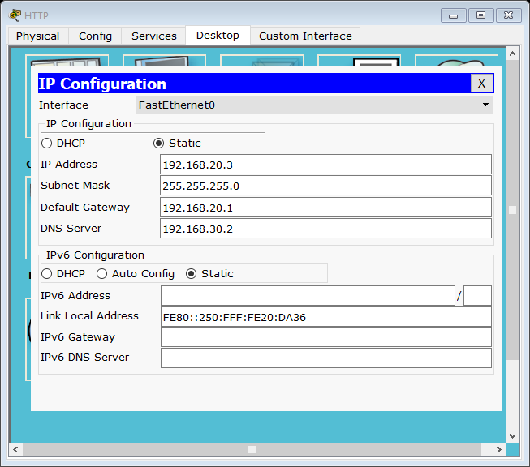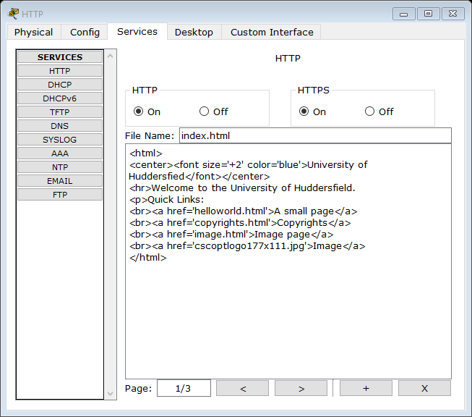

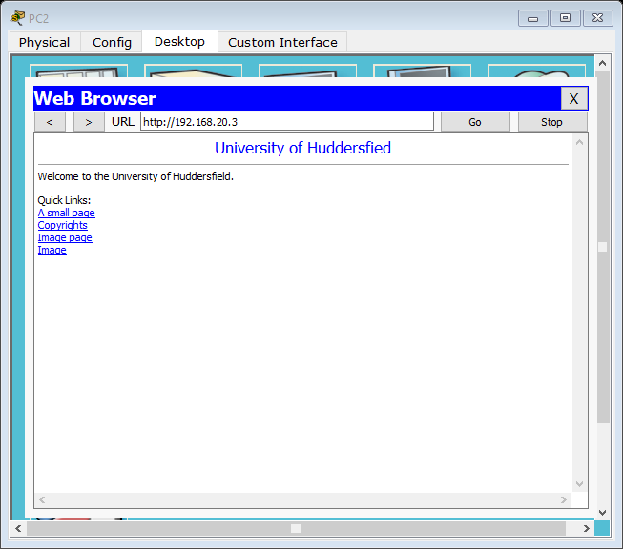

3b: Configure the DNS Server and verify (2 Mark)

Please provide screenshots of the configuration and verification.

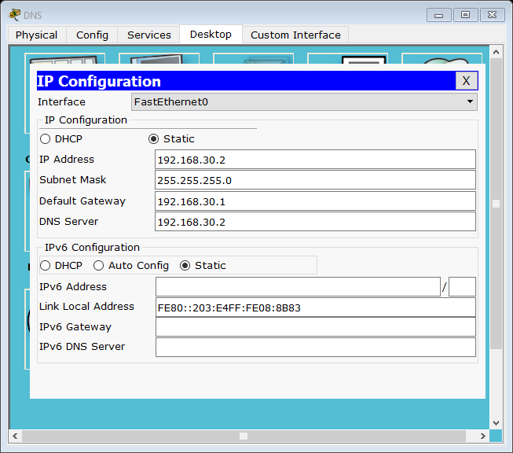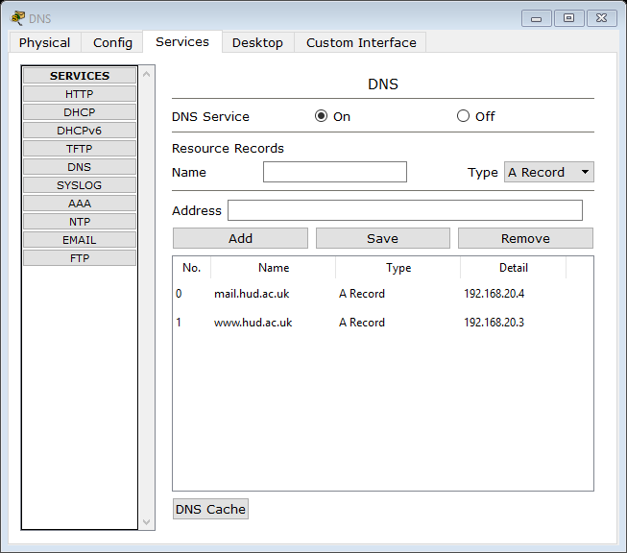

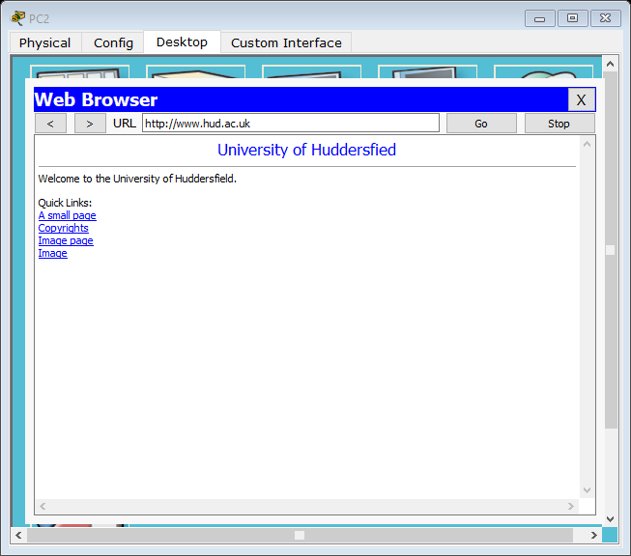

3c: Configure the DHCP Server and verify (4 Marks)

Please provide screenshots of the configuration and verification.

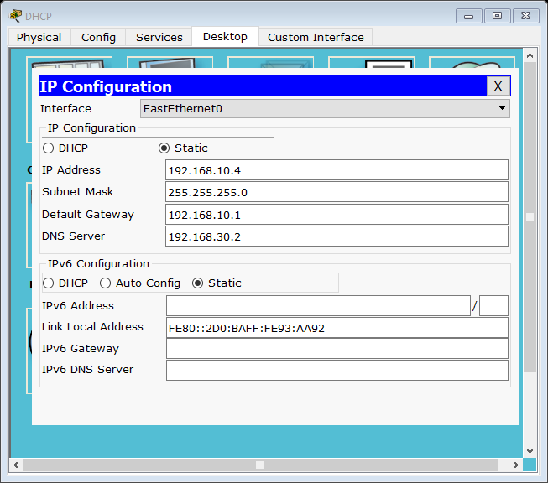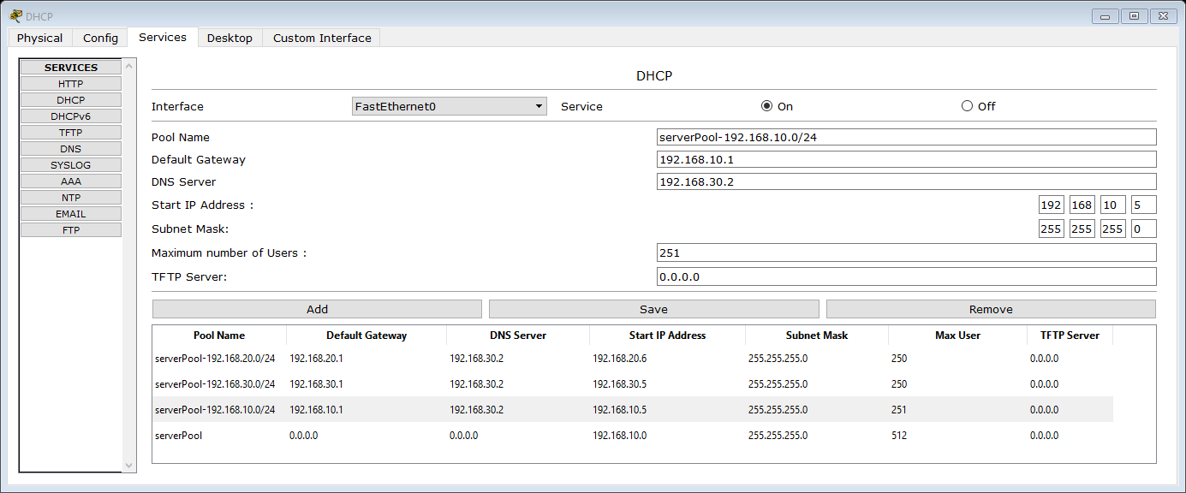

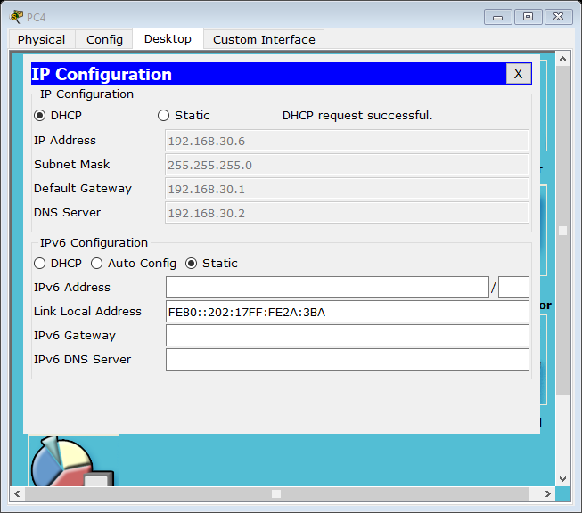

3d: Examine PDU details (2 Marks)

Please capture one packet and provide screenshots of its Inbound PDU details and Outbound PDU details.

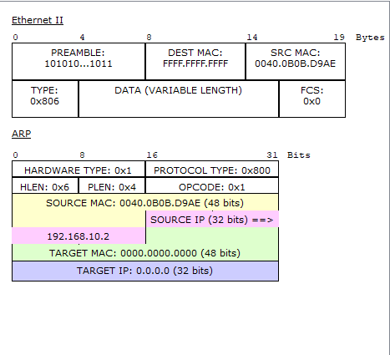*Outbound*

*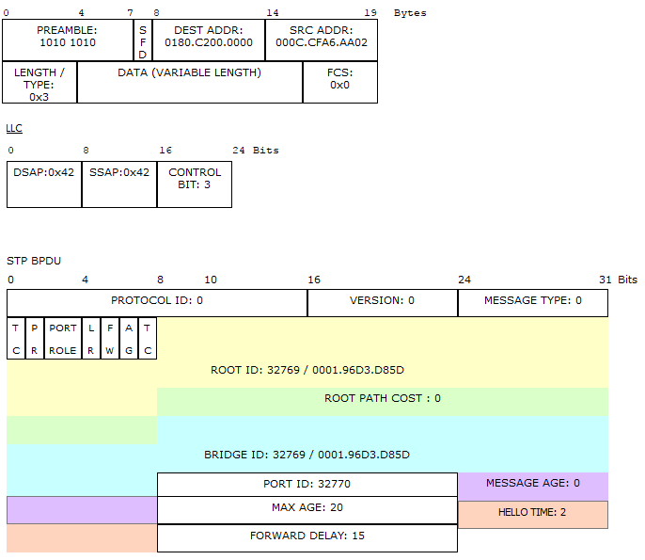Inbound*

**Important Note**: Before you start working on **Task 4** and **Task 5** of Part 1 of the assignment, please save your simulation to U7654321OSPF.pkt file on the completion of the above tasks (Please replace U7654321 with your student ID).

**Task 4**: Apply ACLs (10 Marks)

Please open your U7654321OSPF.pkt file in Packet Tracer and save it as U7654321ACL.pkt file. Then you work on this task from the U7654321ACL.pkt file.

4a: Configure PC4 with static IP addressing and then block PC4 from accessing the subnet that the DHCP server belongs to (4 Marks)

What commands have you used to do the blocking? Please provide screenshots for demonstration of the blocking result.

*Access-list 1 deny host 192.168.30.3*

*Access-list 1 permit any*

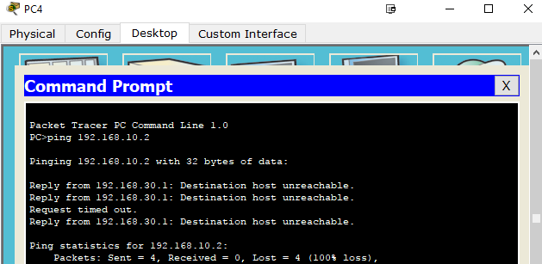

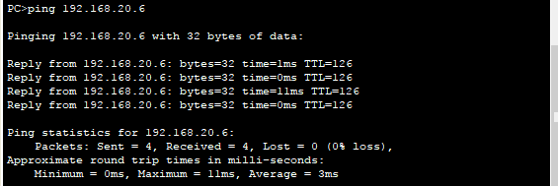

4b: Block PC5 from pinging the HTTP server but still allow PC5 to use the Server HTTP service (i.e., browsing the website running on the HTTP server) (6 Marks)

What commands have you used to do this? Please provide screenshots for demonstration of the blocking results.

*Access-list 103 permit tcp host 192.168.30.4 host 192.168.20.3 eq 80*

*Access-list 103 deny ip host 192.168.30.4 host 192.168.20.3*

*Access-list 103 permit ip any any*

*Int fa0/1*

*Ip access-group 103 in*

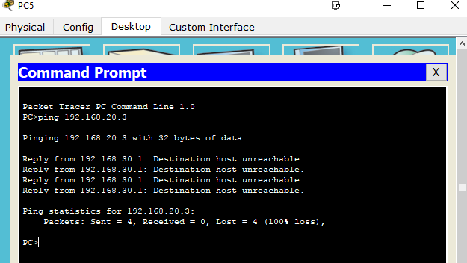

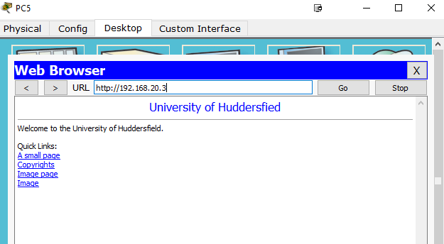

**Task 5**: Create VLANs (10 Marks)

Please open your U7654321OSPF.pkt file in Packet Tracer and save it as U7654321VLAN.pkt file. Then you work on this task from the U7654321VLAN.pkt file.

5a: Create a new IP addressing scheme by breaking down the subnet that DHCP server belongs to into two subnets, one of which is around twice larger than the other (4 Marks)

|  |  |  |  |
| --- | --- | --- | --- |
| Network Address | First IP Address | Last **I**P Address | Broadcast Address |
| *192.168.10.0 /25* | *192.168.10.1* | *192.168.10.126* | *192.168.10.127* |
| *192.168.10.192 /26* | *192.168.10.193* | *192.168.10.254* | *192.168.10.255* |

5b: Create the following two VLANs using the above subnet scheme (2 Marks)

VLAN 10: DHCP server, PC0

VLAN 20: PC1

What commands have you used to do this?

*VLAN 10*

*Exit*

*VLAN 20*

*Exit*

|  |  |  |
| --- | --- | --- |
| *Fa0/2* | *Fa0/3* | *Fa0/4* |
| *Switchport mode access* | *Switchport mode access* | *Switchport mode access* |
| *Switchport access VLAN 10* | *Switchport access VLAN 10* | *Switchport access VLAN 20* |

5c: Disable the obsolete subnet advertising on interface Fa0/1 of R1, enable communication between VLAN 10 and VLAN 20, recover DHCP service to the whole network and then advertise both local networks of VLAN 10 and VLAN 20 to other parts of the network (4 Marks)

What commands have you used to do this? Please also provide screenshots for demonstration of successful recovery of the network.

*S1 Conf t*

*Int fa0/1*

*Switchport mode trunk*

*Exit*

*Exit*

*R1 Conf t*

*Router ospf 1*

*No network 192.168.10.0 0.0.0.255 area 0*

*Exit*

*Int fa0/1*

*No ip address*

*Int fa0/1.10*

*Encapsulation dot1q 10*

*Ip address 192.168.10.0 0.0.0.128*

*Exit*

*Int fa0/1.20*

*Encapsulation dot1q 20*

*Ip address 192.168.10.129 0.0.0.192*

*Exit*

*Router ospf 1*

*Network 192.168.10.0 0.0.0.127 area 0*

*Network 192.168.10.128 0.0.0.63 area 0*

*This is how the DHCP services have been updated for the new VLAN configuration.*

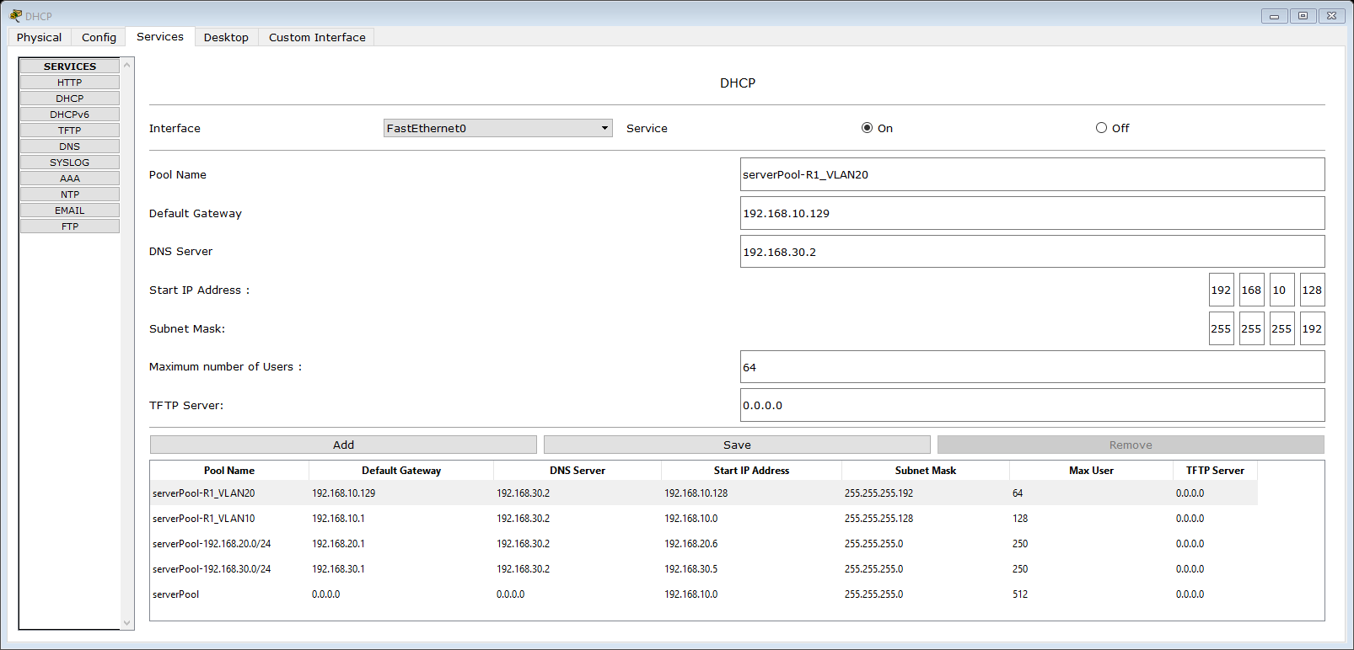

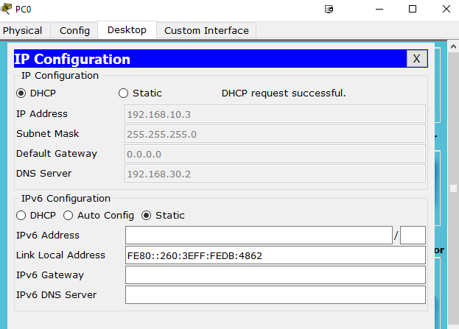

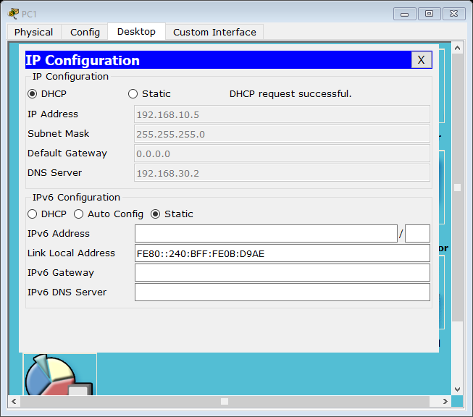

**Part 2: A Planning Report (40%)**

Suppose a newly established university, Newnet University, has two campuses, where each campus has two buildings. These two campuses are located in two different cities, which are about 40 miles away from each other. Please apply the computer networking concepts and techniques you have learned from both lectures and lab sessions to plan and build appropriate computer networks for Newnet University.

You need to produce a planning report and you are in competition with other Computer Network Services providers. Hence you should aim to convince Newnet University that you have a good plan for them and you are capable of building appropriate campus computer networks for them.

Hint: Look at LAN, IP Addressing, Switching/Routing, Ethernet, VLAN, DHCP, HTTP, DNS, VPN, and ACL, etc.

Note: You can make assumptions on the size of the networks of each campus building and on other relevant aspects (e.g., network structures for different departments, and for different teams of users, including students, academic staff, administrative staff, etc.), but you should deliver an appropriate plan against these assumptions and the above requirements.

The word count should be no more than 2500 words, not including table of contents, referencing.

This planning report is worth 40% of the overall mark.

**Note: you should now have the following files ready for submission**

* This document annotated with your answers to the indicated questions
* The three network simulation .pkt files
* A report (with necessary referencing and preferably in PDF format) of no more than 2500 words on campus computer networks planning.

**Please submit as individual files as indicated at the beginning of this specification.**