# A PROJECT ON

**“MOOD LIGHTING USING FACIAL EXPRESSION RECOGNITION”**

SUBMITTED IN

PARTIAL FULFILLMENT OF THE REQUIREMENT

FOR THE COURSE OF DIPLOMA IN BIG DATA ANALYTICS FROM CDAC



#### SUNBEAM **INFOTECH PRIVATE LIMITED**

#### Plot No. AM-4/1, Rajiv Gandhi Infotech Park,

Phase-II, Hinjewadi, Pune-411057

**SUBMITTED BY:**

Utkarsh Srivastava

**UNDER THE GUIDENCE OF:**

Mr. Shubham More

Faculty Member

Sunbeam Infotech Private Limited, Pune



CERTIFICATE

This is to certify that the project work under the title ‘Mood Lighting using Facial Expression Recognition’ is done by Utkarsh Srivastava in partial fulfillment of the requirement for award of Diploma in Big Data Analytics Course.

**Mr. Shubham More Project Guide**

Date: 30/JANUARY/2020

ACKNOWLEDGEMENT

A project showcases the ability to incorporate theoretical knowledge in practice. One can not implement a good one without some support. We avail this opportunity to express our deep sense of gratitude towards Mr. Nitin Kudale (Center Coordinator, SIPL, IT Park, Pune) and Mrs. Pradnya Dindorkar (Course Coordinator, SIPL, IT Park, Pune) and Project Guide Mr. Shubham More.

We are deeply indebted and grateful to them for their guidance, encouragement and deep concern for our project. Without their critical evaluation and suggestions at every stage of the project, this project could never have reached its present form.

Last but not the least we thank the entire faculty and the staff members of Sunbeam Infotech Private Limited, Pune for their support.

Utkarsh Srivastava

DBDA August 2019 Batch,

SIIT Pune

TABLE OF CONTENTS

1. **Introduction of Project**

1.1. Statement of the problem

1.2 Technical analysis

1.3 Biological analysis

1.4 Goal

1.5 Overview of proposed project

1.6 What’s New..??

2. **Product Overview and Summary**

2.1 Purpose

2.2 Scope

3. **Requirements and Influential Study**

3.1 Influential Study

3.2. Requirement Analysis

4. **System Design and Architecture**

4.1 Use Case Diagram

4.2. System Flow diagram

4.3 Control Flow Diagram

4.4 Proposed Algorithm

4.4.1 Support Vector Machines

4.4.2 Random Forest

4.4.3 K-nearest neighbor

5. **FINDINGS AND CONCLUSIONS**

5.1 CONCLUSION

5.2 FUTURE WORK

**1.Introduction**

Emotion is directly related to human mind, whether it shows on face or in the thoughts. Each motion of a person is related to a certain kind of expression which clearly shows up on face. Since facial expression can somehow reflect the “mood” of a person, we can do the needful to lighten or may be enhance it up. Now to begin with, first bright light, which turned up is a “light”. So, some scientists and researches do focus on this brainy game between light and mind. We are gonna alter this up a little bit. Ambient light is said to alter the thought process of how a person perceives his surrounding. For eg, say a blue light may get feel you dim with adrenaline and high on thoughts, or a gray surrounding may get eerie a bit or else a red one might get you vexed (Not a game of play though). So, by recognizing one’s mood we can try to change it through this phenomenon.

**1.1 Statement of the Problem**

Human mind is an entity which is still being studied and the results are endless as in contrast with the universe. Since we are going to alter the psychological process, we chose to teach our computer to identify one’s emotion and then controls the light in some controlled manner. This can be done if we have the definition of emotion for the computer. To achieve this, enabling the computer to learn from real examples is the best possible way and to do this we head to the concept of Machine Learning. Training, testing, validating and then performing is a common process of a student’s pursuing a course. Following this same, we now discuss the technical analysis of the project.

**1.2 Technical Analysis**

Teaching a computer can only by feeding it the data to learn from. Now, data can be available in many forms, but one’s emotion cannot be materialized. To solve this we go for image data, which clearly depict the expression portrayed by a human. But now, the challenge is to process this image data and teach the computer to extract the required information, which in our case here is the emotion of the person. The perceived image may not exactly provide information about the person behavior on the whole but the instant reaction can be easily categorized in some of the base classes a person could fall in. Using this precious information (whole idea is of “emotion”!!), we can thus tell a program to take a new input image and extracting the required information to control a set of LED’s which will act as mood lamp.

**1.3 Biological Analysis**

Influence of lighting on mood at a biological level. The indirect effects of lighting on mood are well documented. Night time release of melatonin—a pineal hormone that promotes sleepiness and lowers the body temperature—can be phase advanced or delayed with the right exposure to bright light, thereby influencing the circadian rhythm of humans. Disruptions to circadian rhythms (e.g. due to jetlag, shift work, night time light exposure) can cause sleep and mood disorders. Seasonal affective disorders (characterized by depression symptoms in the winter) are also considered to be the result of a disturbance of the circadian rhythm, caused by the failure to adapt to the shift in day length as a result of seasonal changes. Bright light therapy of 1500 lumens or more at eye level, has been shown to significantly reduce depression symptoms for people with seasonal mood disorders or sleep disorders. The wavelength of the light is also important; melatonin is especially suppressed by short wavelength light. Thapan and collegues revealed that melatonin was largely suppressed by blue light, slightly by green light and hardly or not at all by red light. This finding suggests that, at a biological level, blue light is more arousing than green light, and both are more arousing than red light. Recent research also suggests direct effects of lighting on alertness and sleepiness. Using different light spectra, studies reported the superiority of short wavelength light over long wavelength light in increasing alertness.

**1.4 Goal**

Our goal was to build an application, capable of recognizing a person’s emotion through his face and then controlling the intensity of a set of LED lights to change the ambient lighting. This change can act as environmental cognition and trigger brain cells to enhance one’s mood.

**1.5 Overview of proposed project**

I) As described earlier we have the requirement of psychological understanding between the application and the user, hence best possible way is to have the system, learn from the available data and then utilize this learning to have it done in an automated way. An Artificially trained entity on this data of images portraying their emotions is the way out for understanding similar situation in real world on its own.

II) Also, physical world entity such as light can be controlled by some filthy electronics which is able to communicate with our system parallelly and make the application interact with deep areas of human mind just by varying intensity of the bulbs(sounds cool…!!).

**1.6 What’s New..??**

Now as we see that machines are getting smarter as they have acquired an ability to learn and perform in real world based on their learning. The more we tech them and feed them with information, we get smarter systems. This application utilizes this ability to automate this process which on the other hand can only be performed by human in normal terms. Dealing with human psychology through a set pattern of expressions and incorporating it to control by means of intelligence embedded through previous learning is what we wanted to achieve through this project. We hope to have a “brighter” mood rather being “low”.

**2. Product Overview and Summary**

**2.1 Purpose**

As discussed, main goal of this application is to achieve an automated process of recognizing emotion and dealing with it to perform changes in ambiance lighting. Also, to recognize the required information we first have to teach how to recognize it, and this was blissfully done with the help of machine learning algorithms. Having done crunching with data, now we have the responsibility of deploying it in order to perform on real grounds. The prediction done, is then communicated with external circuitry to gain control on lighting part which in turn was our main goal.

**2.2 Summary**

I) Developing a machine learning model which is capable of detecting and recognizing facial human expression and categorize it in basic categories defined by us.

II) Allowing the trained model to gather information on real grounds and then based on its learning predicting its emotion to control the brightness of attached led’s.

**3. Requirements and Influential Study**

**3.1 Influential Study**

To analyze the influence that the activating and cozy ambiences had on mood (with respect to that of the neutral ambience), we monitored the evolution of the affective measures, starting from the moment the expression was changed from the lighting setting to the cozy, activating or neutral setting. The different bars represent the different ambience groups. For the physiological measures, affective change values were calculated by subtracting the median value of the signal over the last 120 seconds of the mood induction procedure from the mode value measured during the 200 values of each of the periods (i.e., A constant mood in particular). A convolutional model was tested for each pixel values (i.e., the affective change for the physiological and emotional measures).

**3.2 Requirement Analysis**

Firstly, we need a large set of images depicting various basic emotion. This was provided as CSV file containing record of emotion and corresponding values of pixles denoted in that image.

|  |  |
| --- | --- |
| Emotion | Pixels |
| 0 | 70 80 82 72 58 58 ……….. 195 186 137 101 88 101 |
| 3 | 85 84 90 121 101 102 ……….. 102 99 89 58 73 84 |
| 4 | 20 17 19 21 25 38 ……….. 85 93 97 99 107 118 |

On the whole, the dataset contains 35887 images distributed in their pixel values. We need to build the image back in its original form and to achieve this we pre-processed our dataset to extract image related to a particular emotion in its corresponding directory.

**Preprocessing the CSV File:**

**CODE - (PYTHON) :-**

import numpy as np

import pandas as pd

import os

import cv2

from pathlib import Path

import split_folders

# read data from csv

df = pd.read_csv("/home/chitransh/Documents/Project_app/fer2013.csv")

# labels of emotion

labels = np.array(df['emotion'].values)

# convert labels from [0 1 2 3 4 5 6] to ['Angry', 'Disgust', 'Fear', 'Happy', 'Sad', 'Surprise', 'Neutral']

labels = np.where(labels == 0, 'Angry', np.where(labels == 1, 'Disgust', np.where(labels == 2, 'Fear',

np.where(labels == 3, 'Happy',

np.where(labels == 4, 'Sad',

np.where(

labels == 5,

"Surprise",

"Neutral"))))))

# print(labels)

# image data

pixels = list(df['pixels'].values)

# print(pixels)

test = [] # list of images

# create image from pixel

for pixel in pixels:

images = np.array([np.fromstring(pixel, dtype='uint8', sep=' ')])

# print(images.shape)

images.shape = (1, 48, 48)

test.extend(images)

# print(images.shape)

# img = images[0]

# cv2.imshow('img', img)

# cv2.waitKey(0)

# cv2.destroyAllWindows()

# zip image and labels together

data = zip(labels, test)

# create directory to save images

if not os.path.exists('./images'):

os.mkdir('./images')

# save images as per emotion

cnt = 0

for d in data:

# print(d)

dir = Path(f'./images/{d[0]}')

if not os.path.exists(dir):

os.mkdir(dir)

cv2.imwrite(f'{dir}/img{cnt}.jpg', d[1])

cnt += 1

# split dataset into test train and validation

split_folders.ratio('./images/', output='./images/DATA', seed=12345, ratio=(0.8, 0.1, 0.1))

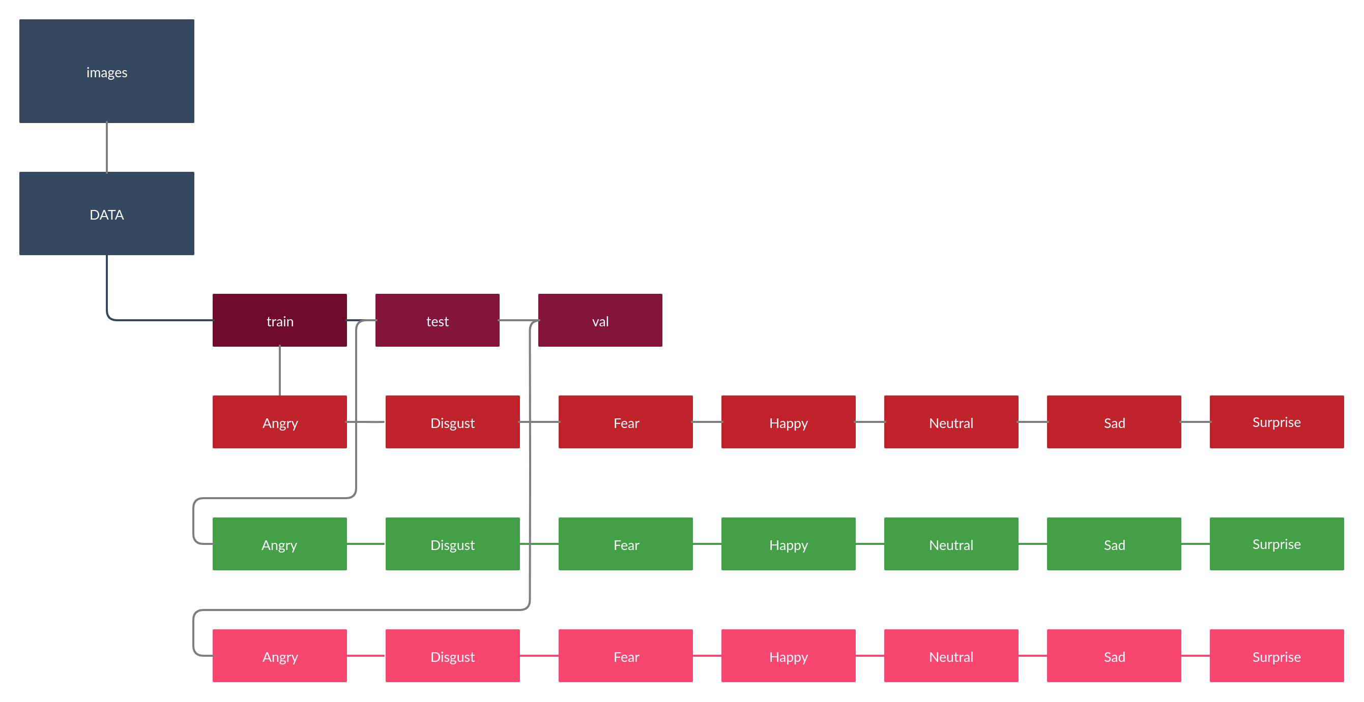**Directory Hierarchy for Processed CSV**

**Sample Image :-**



**Angry Disgust Fear Happy Neutral Sad Surprise**

Each of the image was constructed from the array of pixels from the CSV file as input and was mapped to the respective directory. Here we have divided the dataset into Training, Testing and Validation dataset incorporating the ratio of 0.8, 0.1 & 0.1 respectively.

**4. System Design and Architecture**

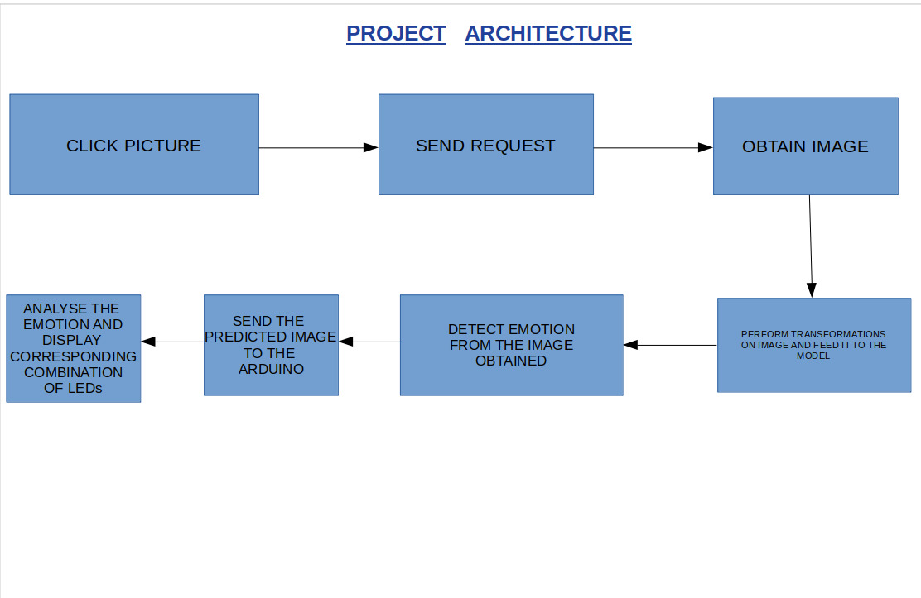**The Architectural behaviour of Application**