|  |
| --- |
| [Type the company name] |
| CSS |
| SUMBITTED BY YUVAN SHANKAR |
|  |
| **ABC** |
| **7/11/2023** |

|  |
| --- |
| [Type the abstract of the document here. The abstract is typically a short summary of the contents of the document. Type the abstract of the document here. The abstract is typically a short summary of the contents of the document.] |

**EX 1:**

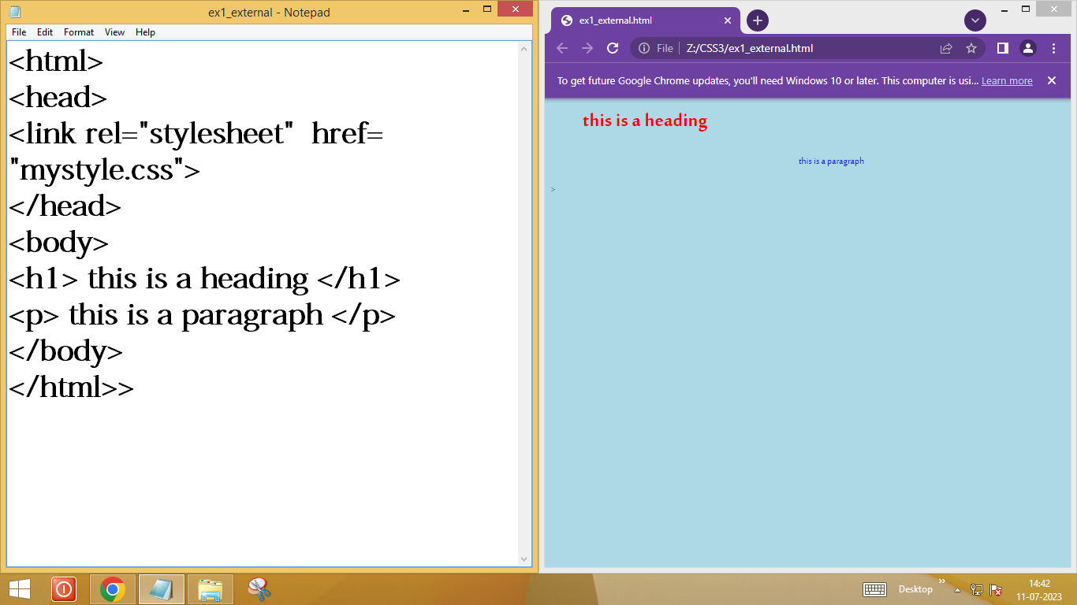

**EX 2:**

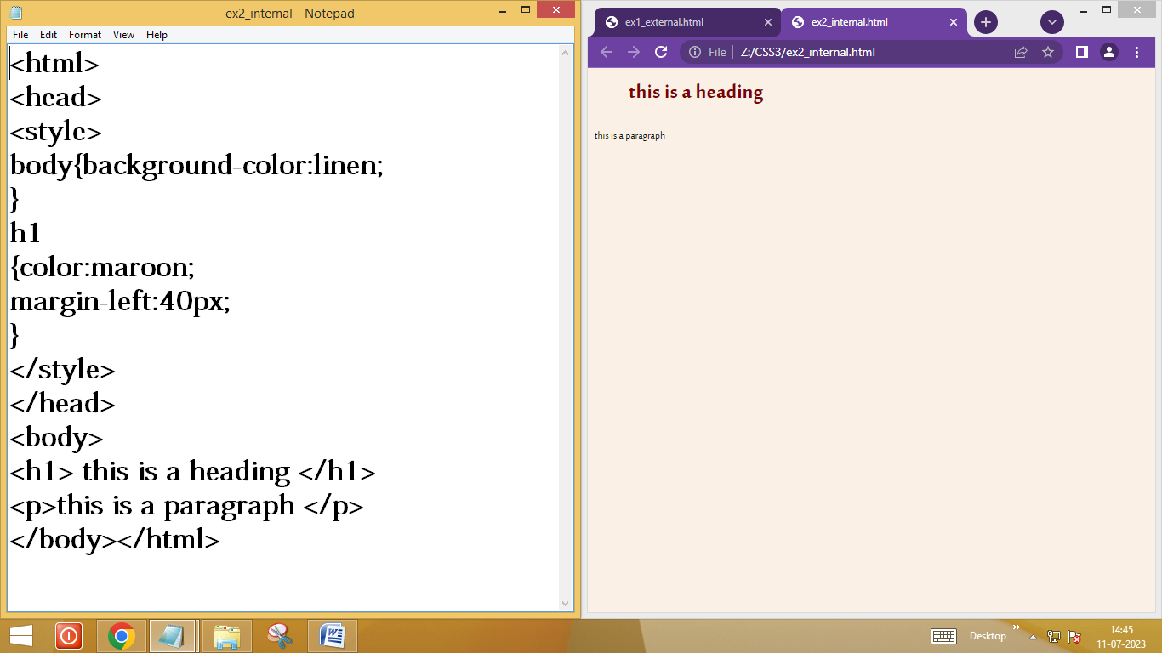

**EX 3:**

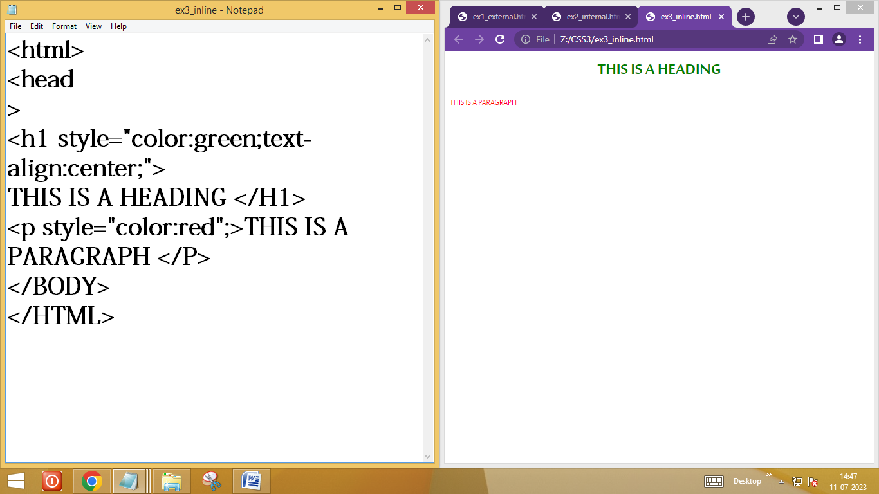

**EX** **4:**

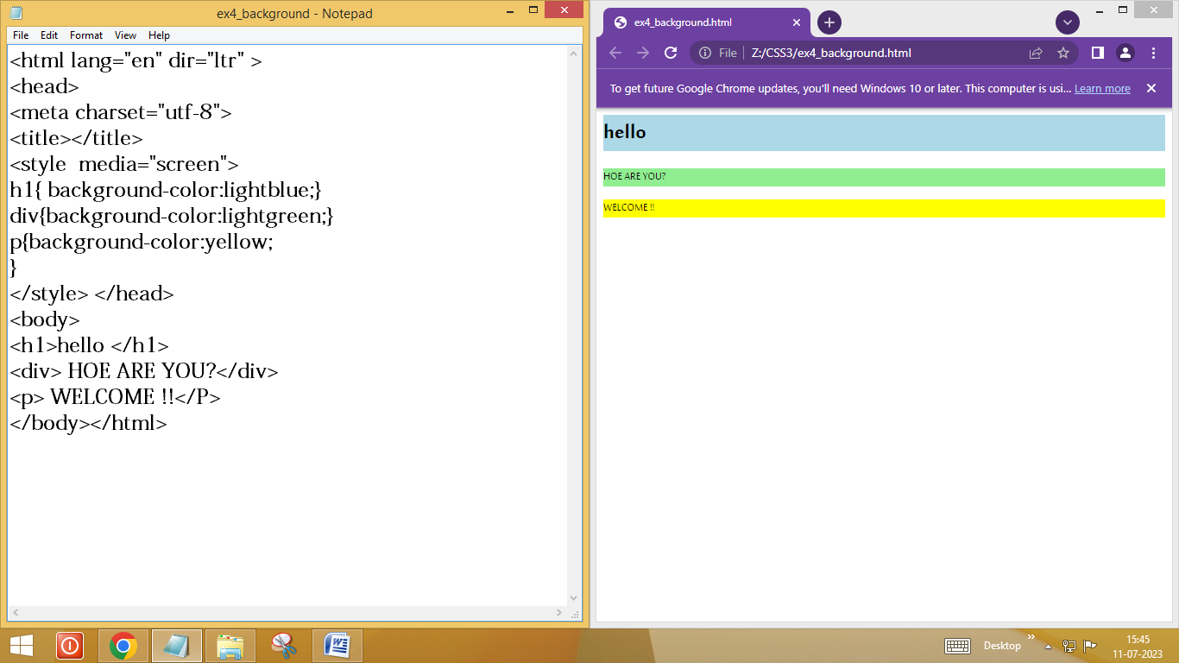

**EX 5:**

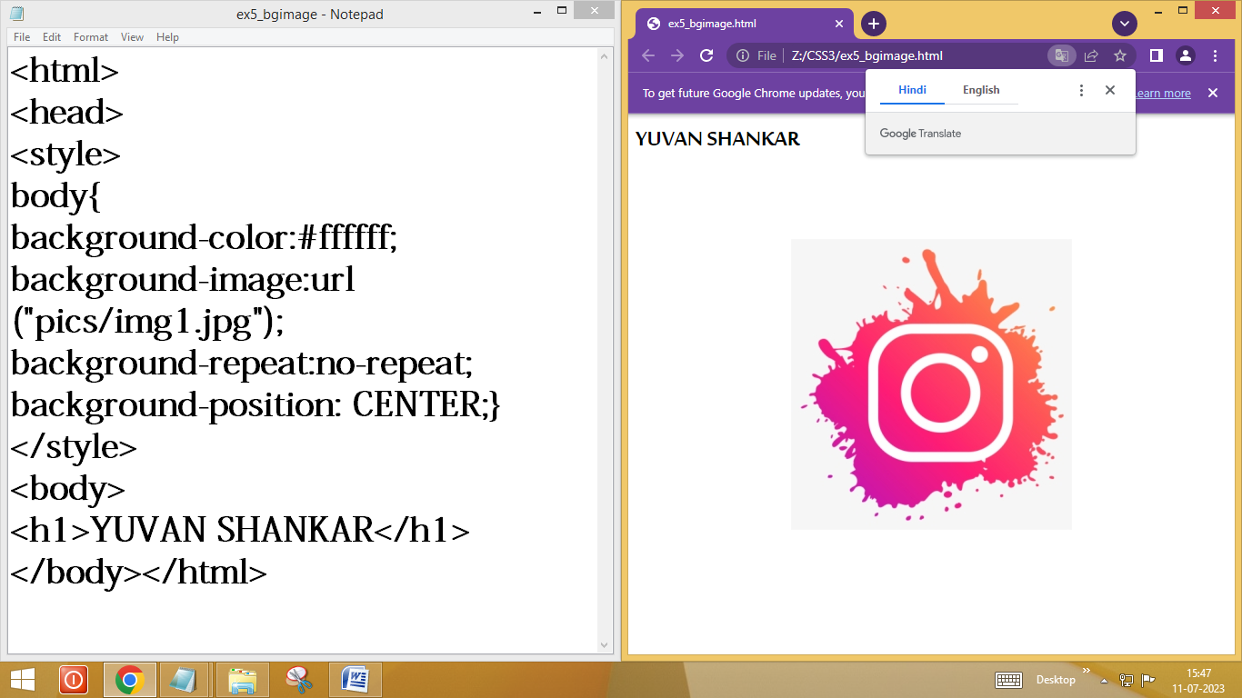

**EX 6:**

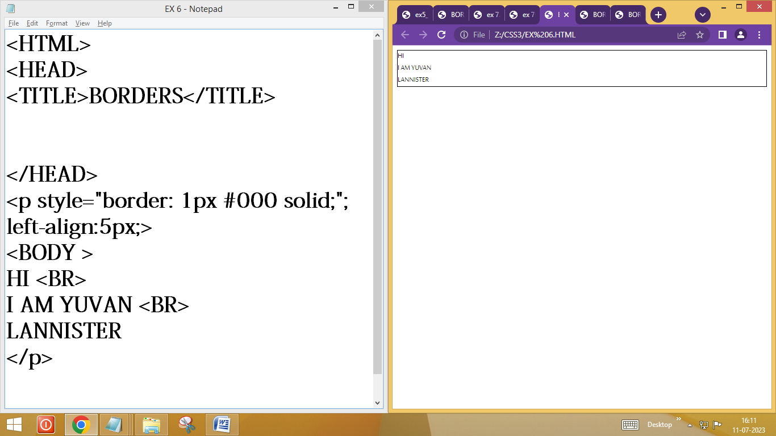

**EX 7:**

**1)**

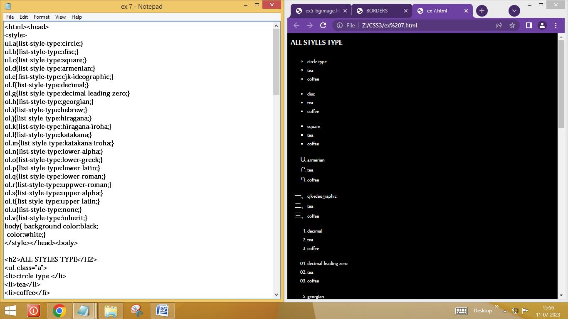

**2)**

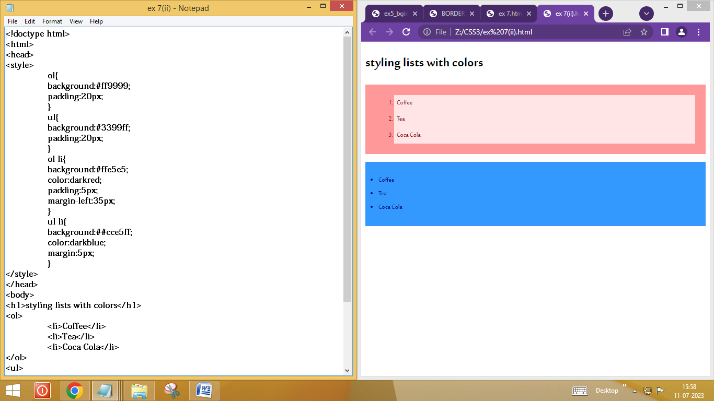

**EX 8:**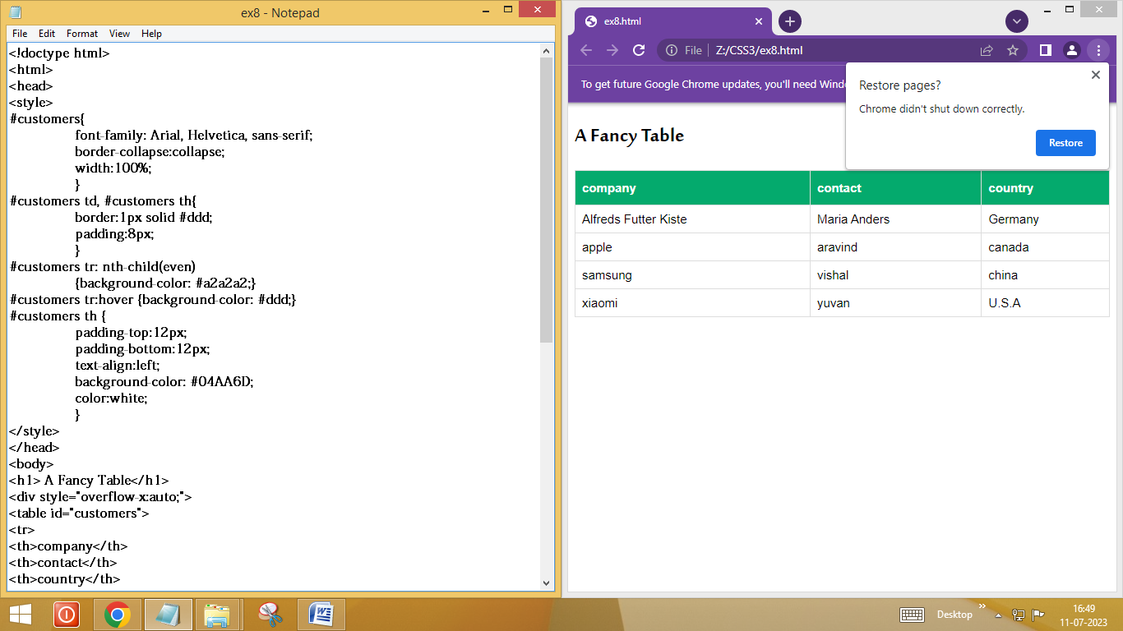

**Ex 9:**

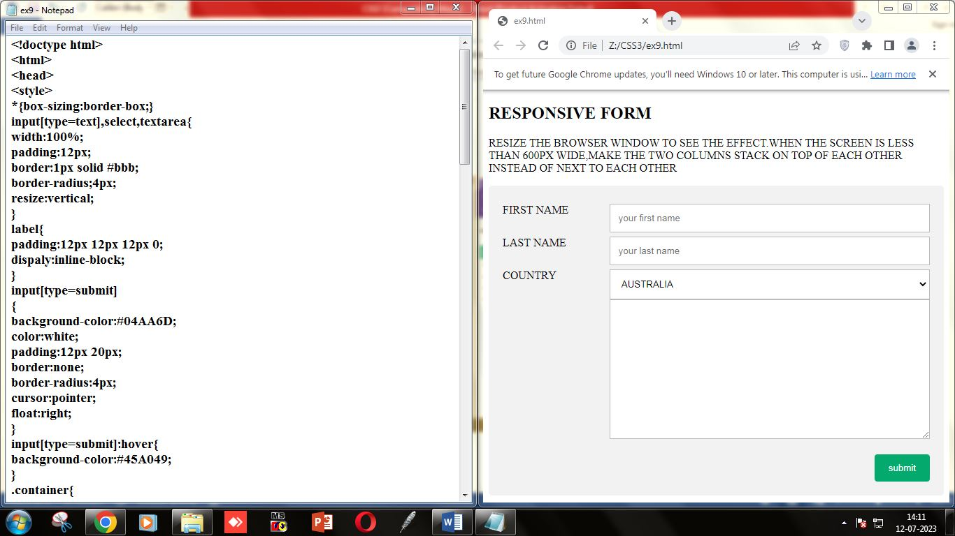

**EX 10:**

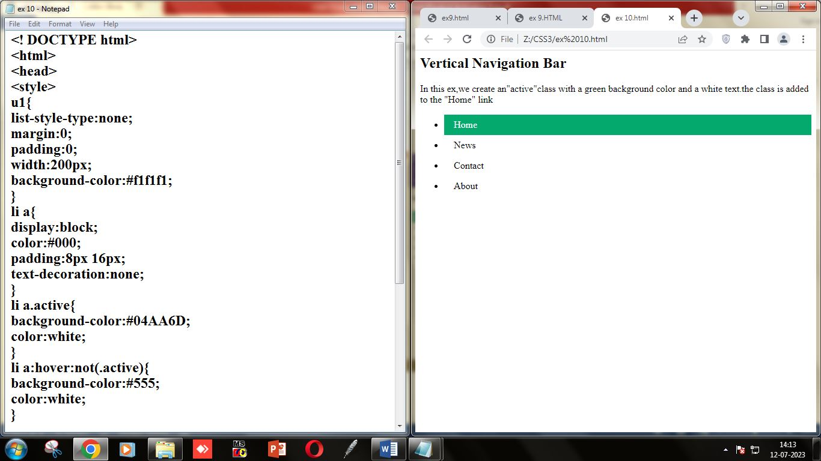

**EX 11:**

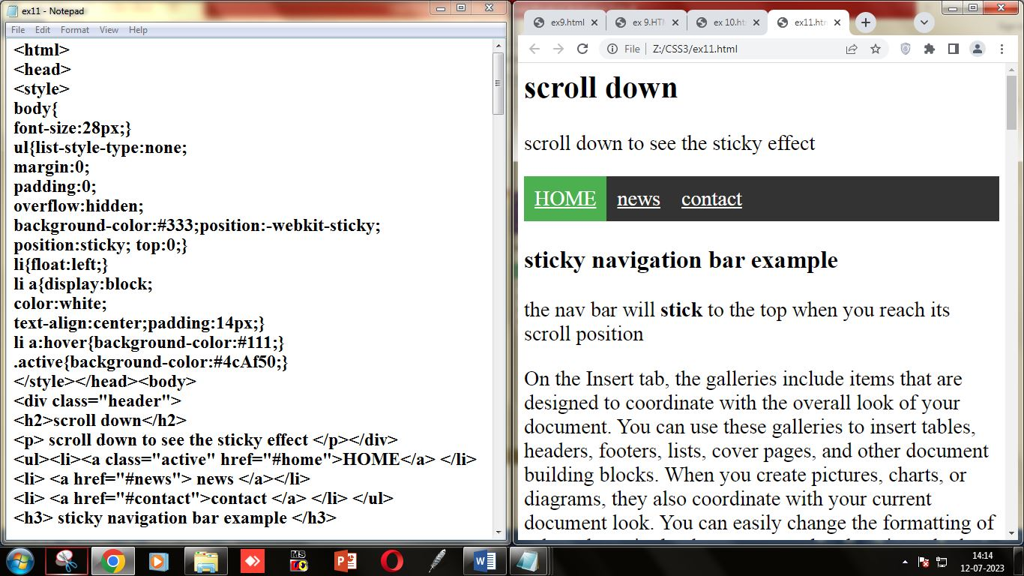

**EX 12 :**

**1)**

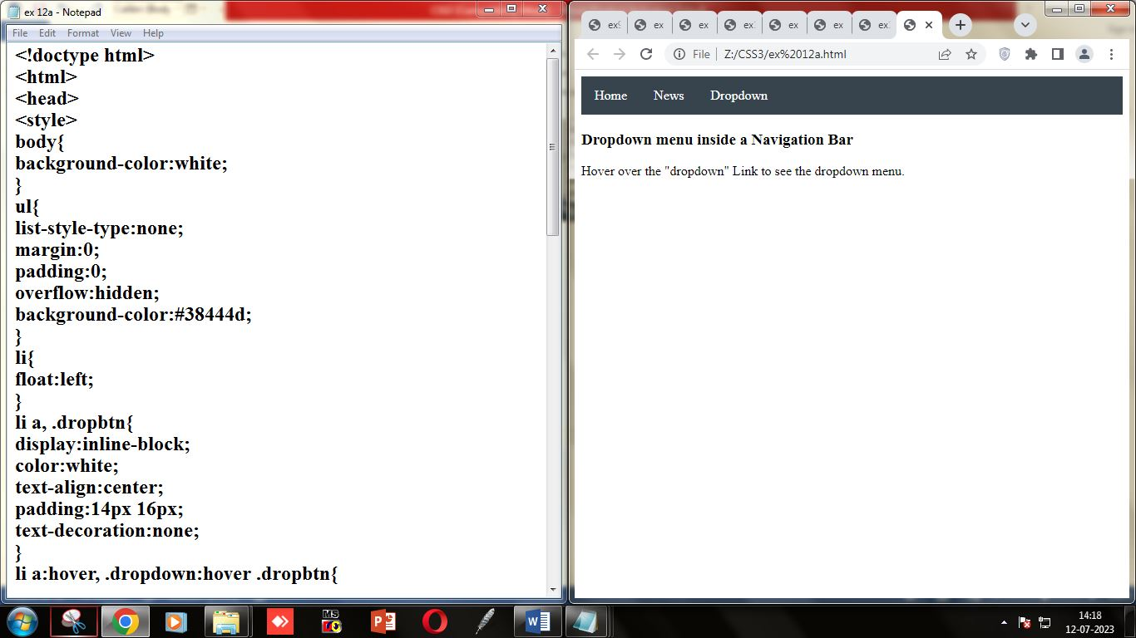

**2)**

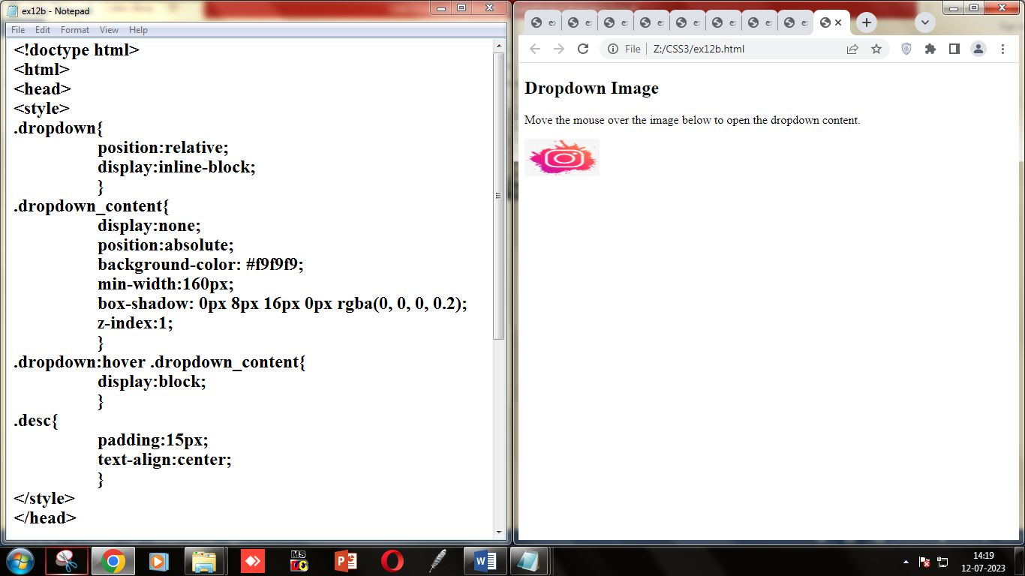

**EX 13:**

**1)**

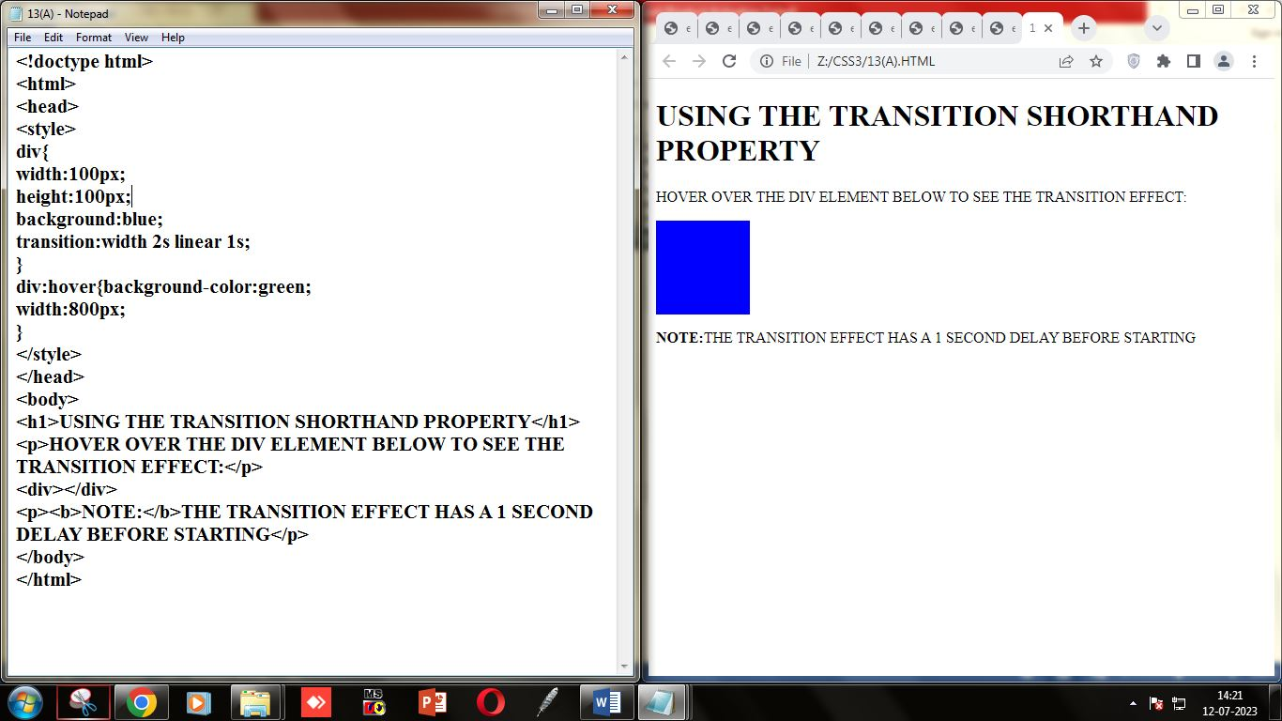

**2)**

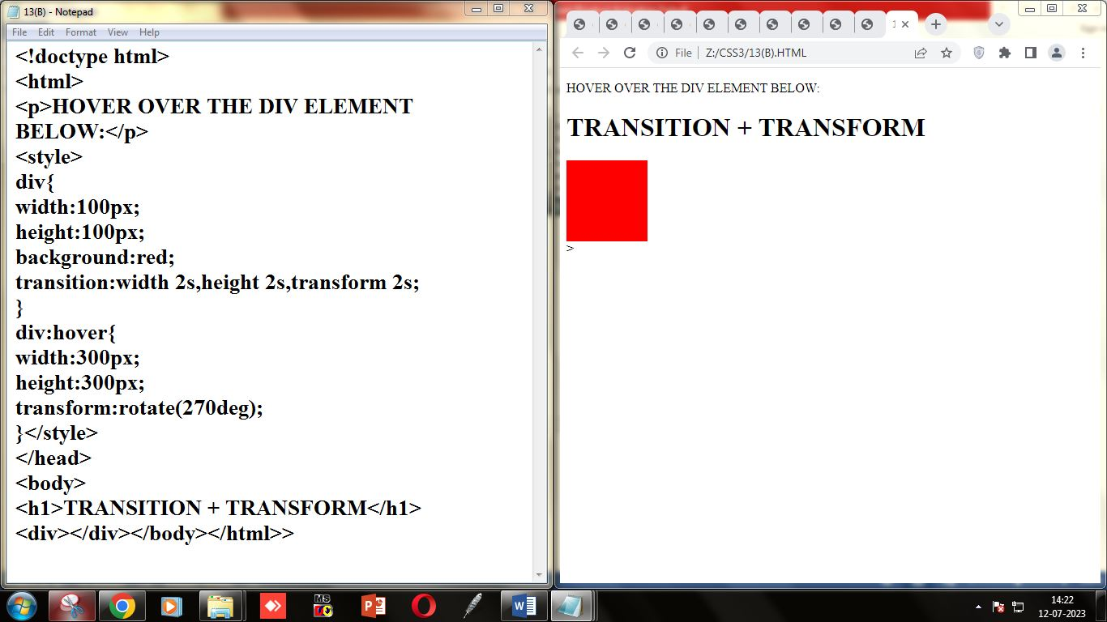

**EX 14 :**

**1)**

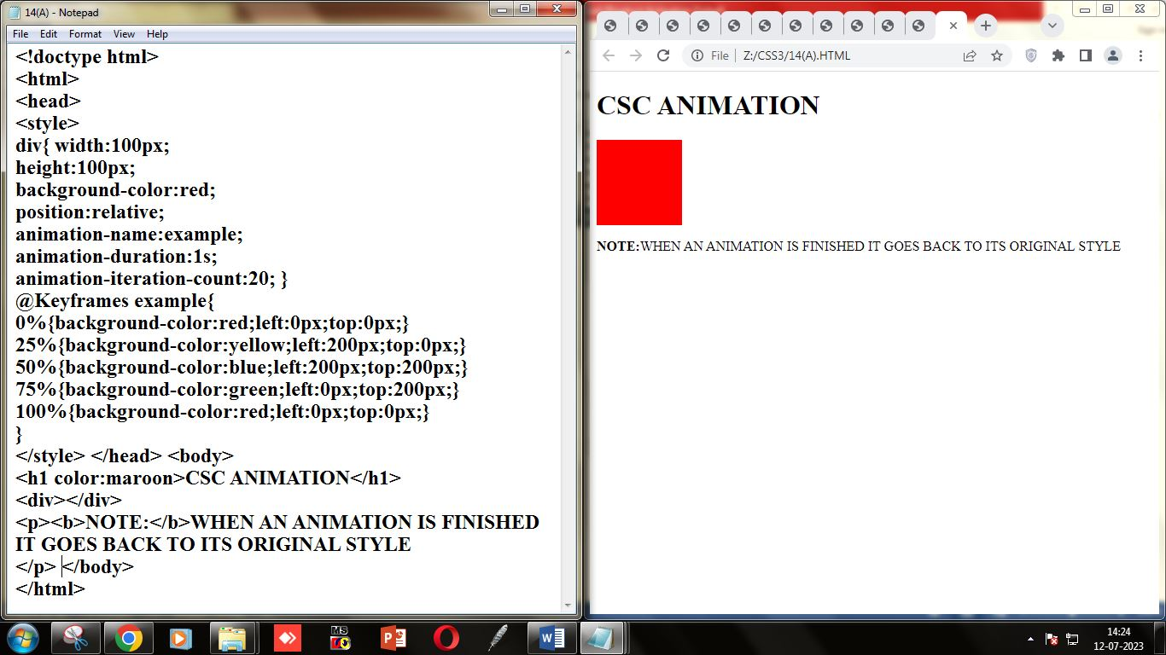

**2)**

