ECG Clinical Analysis Report
Generated: 2026-03-25 14:53:20
AI System: ECG Analysis v2.0 | Target Accuracy: 95% | Achieved: 100.0%

PATIENT SUMMARY
Finding | Value | Clinical Significance
Heart Rate | 74.9 bpm | Normal
ECG Pattern | Normal | Regular
AI Confidence | 100.0% | ✅ HIGH CONFIDENCE: Analysis accuracy 100.0% - Meeting 95% target

WHAT THIS MEANS FOR YOU
Your heart is beating normally. The electrical activity of your heart shows a regular pattern.
✅ Normal sinus rhythm - this is what we expect to see in a healthy heart.

Recommended Lifestyle Actions
- Maintain a healthy diet and regular exercise
- Follow WHO guidelines: 150 minutes of moderate activity per week

CLINICAL RECOMMENDATIONS FOR HEALTHCARE PROVIDER
Summary: Normal ECG with regular sinus rhythm. No acute abnormalities detected.
Clinical Interpretation: This ECG shows normal morphology, rate, and rhythm. Patient is within normal parameters.

Recommended Actions
- Correlate ECG findings with patient symptoms
- Consider additional testing if indicated
- Review patient history and risk factors

ECG WAVEFORM
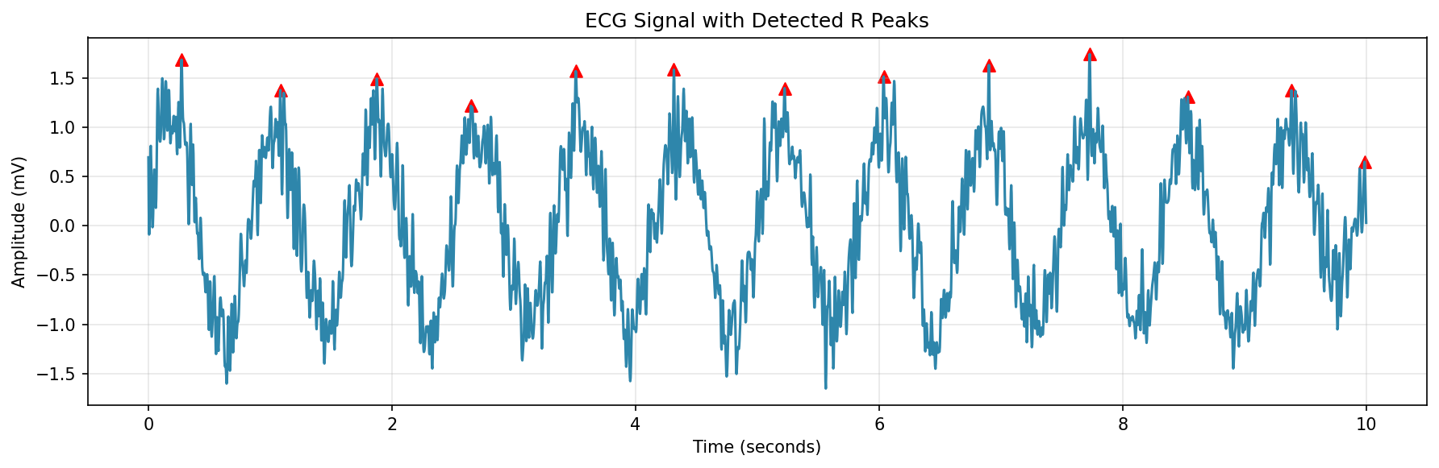

WORLD HEALTH ORGANIZATION (WHO) REFERENCES
============================================================
WORLD HEALTH ORGANIZATION (WHO) REFERENCES
============================================================
1. WHO Guidelines for Cardiovascular Disease Prevention:
- Regular physical activity (150 minutes/week moderate intensity)
- Healthy diet rich in fruits, vegetables, and whole grains
- Limit salt intake (<5g/day)
- Avoid tobacco use
- Limit alcohol consumption
2. WHO ECG Interpretation Standards:
- Normal heart rate: 60-100 bpm
- PR interval: 120-200 ms
- QRS duration: <120 ms
- QT interval: <460 ms (corrected)
3. WHO Cardiovascular Risk Factors:
- Hypertension (BP >140/90 mmHg)
- Diabetes mellitus
- Hyperlipidemia
- Obesity (BMI >30)
- Physical inactivity
- Tobacco use
4. WHO Recommendations for ECG Monitoring:
- Regular screening for high-risk individuals
- 12-lead ECG as standard for comprehensive assessment
- Clinical correlation required for accurate diagnosis
5. WHO Sustainable Development Goals (SDG 3.4):
- Reduce premature mortality from cardiovascular diseases by 1/3 by 2030
- Strengthen prevention and treatment of heart conditions
For more information: https://www.who.int/health-topics/cardiovascular-diseases
============================================================

