1.

(1) true

(2)false. The is-a relationship implemented via inheritance.

(3)false. A Student class has an has-a relationship with the Faculty and Course classes.

(4)true.

(5)true.

2.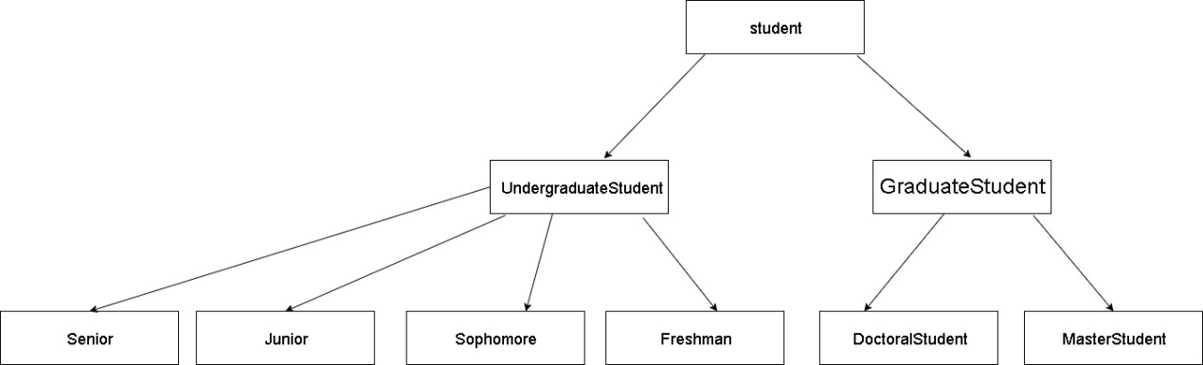

Each array means inheritance.

**UndergraduateStudent** and **GraduateStudent** derive from **Student.**

**Senior**, **Junior**, **Sophomore** and **Freshman** derive from **UndergraduateStudent.**

**DoctoralStudent** and **MasterStudent** derive from **GraduateStudent.**

**UndergraduateStudent** is direct base class of **Senior**, **Junior**, **Sophomore** and **Freshman**.

**GraduateStudent** is direct base class of **DoctoralStudent** and **MasterStudent.**

**Student** is indirect base class of **Senior**, **Junior**, **Sophomore**, **Freshman**,

**DoctoralStudent** and **MasterStudent.**