USLOSS User’s Manual
Version 4.0
Doc 4.0-1, January 11, 2023

Changelog
Version 4.0-1: Removed mention of mmu.h

1. General Description
USLOSS (Unix Software Library for Operating System Simulation) is a library that simulates a simple computer system. USLOSS allows students to experiment with low-level systems programming concepts such as interrupt handling, device drivers, and process scheduling. USLOSS is written in the C programming language to allow fast execution and easy debugging of student programs.
USLOSS implements a single-core CPU with user and kernel modes, a high-level context-switch facility to allow easy switching between processes, interrupts, a memory-management unit (MMU) that allows for virtual addressing and virtual memory, and the following devices: a periodic clock interrupt, a count-down timer device, a system call (syscall) facility, four user terminals, and two disk storage devices.

2. Using USLOSS

2.1 Building from source
Untar the USLOSS tarball, e.g. tar xvzf usloss.tgz.
Change directory to usloss and type ./configure then make install. By default this will install the binaries pterm and makedisk in ~/bin, the library libusloss<version>.a in ~/lib, the library libdisk<version>.a in ~/lib and the header file usloss.h in ~/include. The <version> is the library name is the USLOSS version number, e.g. libusloss4.0.a. You can specify a different installation directory via the --prefix option to configure; type ./configure --help for details.
The next step is to write a C program that uses USLOSS (referred to as the operating system, or OS). All source files must include the file usloss.h. USLOSS defines main and will invoke the following functions when it runs:
test_setup
startup
finish
test_cleanup
The functions test_setup and test_cleanup are used for testing. They set things up for the test then clean up afterwards (e.g. create input files in test_setup and delete them in test_cleanup). The function startup is where you implement the body of your OS. The function finish is called after startup returns (it is used primarily for debugging and is discussed later). Note that test_setup and test_cleanup are part of the test infrastructure and therefore are not defined by the OS, unlike startup and finish which are part of the operating system and therefore are defined by the operating system.
Once the C program has been written, you should create a Makefile to handle compilation. When compiling a source file, use a command of the form:
gcc $(CFLAGS) -c -I<usloss>/build/include osfile.c
The -I option will allow the compiler to find usloss.h (<usloss> is the pathname of the USLOSS source directory). The above command will produce the object file osfile.o.
Assuming your test program is in test0.c use a command of the following form to create the test executable:
gcc $(CFLAGS) -o test0 test0.c -L<usloss>/build/lib osfile.o -lusloss4.00
This will create an executable called test0.
The resulting executable is run just like any other compiled C program. If it is compiled with the -g option, then a standard C debugger such as gdb can be used for debugging (see Section 6).

2.1 Running USLOSS
USLOSS is a library and therefore must be linked with a program that uses it, typically a test case. It does not run by itself. The previous section describes how to build USLOSS and create an executable, e.g. test0. Once you have an executable you can run it from the shell just like any other executable:
> ./test0

The ‘>’ is the shell prompt. The ‘./’ tells the shell to look in the current directory for the executable.

USLOSS has several arguments that control its behavior.

-r Causes USLOSS to run in real time, meaning that USLOSS’s clock progresses at roughly the same rate as a wall clock. This is the default.
-R Causes USLOSS to run in virtual time, meaning that USLOSS’s clock may progress much faster than a wall clock. This allows you to run long-running test cases much more quickly, but may be confusing if you compare USLOSS’s clock against a wall clock.

-v Increases the verbosity of USLOSS’s debugging messages. Specify this option multiple times to increase the verbosity. The verbosity levels are:
0 No debugging output (default)
1 Context creation
2 Context switches
3 All interrupts
4 Change in PSR
-h Print list of arguments and exit.

USLOSS will pass any arguments following ‘--’ to startup, allowing you to add arguments to your OS and test cases.
Examples:
> ./test0 -v -v
Runs test0 with verbosity level 2, meaning that all context creations and switches generate debugging output.

> ./test0 -v -- -x
Runs test0 with verbosity level 1, and passes the -x option to startup.

3. Processor Features
USLOSS simulates a simple single-core CPU, providing kernel/user modes, interrupts, and simple context-switch support.

3.1 CPU Modes
The CPU has two modes of operation: kernel and user. Kernel mode is privileged, in which all USLOSS operations can be invoked. User mode cannot access hardware devices nor invoke certain USLOSS operations; doing so will cause an illegal instruction exception (interrupt). For a complete list of which operations are disallowed while in the user mode, see the command summary at the end of this manual. USLOSS starts up in kernel mode; to switch to user mode the OS must change the mode bit in the processor status register (see Section 3.4).

3.2 Interrupts
The interface to the USLOSS interrupt system consists of an interrupt vector and two functions. When an interrupt occurs, USLOSS switches to kernel mode, disables interrupts, and calls the appropriate routine stored in the interrupt vector. Six different types of interrupts/devices are simulated (symbolic constants are shown in parentheses):
- clock (USLOSS_CLOCK_INT and USLOSS_CLOCK_DEV)
- count-down timer (USLOSS_ALARM_INT and USLOSS_ALARM_DEV)
- terminal (USLOSS_TERM_INT and USLOSS_TERM_DEV)
- system call (USLOSS_SYSCALL_INT)
- disk (USLOSS_DISK_INT and USLOSS_DISK_DEV)
- memory-management unit (USLOSS_MMU_INT)
- illegal instruction (USLOSS_ILLEGAL_INT)
See Section 4 for a detailed description of the device interrupts, Section 3.3 for a description of system calls, and Section 5 for a description of the MMU.
To handle the various interrupts, the OS must fill in the interrupt vector with the addresses of the interrupt handlers. The vector is declared as a global array in USLOSS (USLOSS_IntVec), and is simply referenced by name. The symbolic constants for the devices are designed to be used as indexes when initializing the table. For example, to install an interrupt handler for the clock interrupt, the following statement could be used:
USLOSS_IntVec[USLOSS_CLOCK_INT] = clock_handler;
Thereafter, clock_handler will be invoked whenever a clock interrupt occurs. If an interrupt occurs and the interrupt vector for that type of interrupt has not been initialized, it will generally cause the simulator to print an error message and dump core. Always initialize the interrupt vector before enabling interrupts. Interrupts are disabled when startup is invoked, providing an opportunity to initialize the interrupt vector. The interrupts can subsequently be enabled by setting the current interrupt enable bit in the processor status register (see Section 3.4).
Interrupt handlers are passed two parameters. The first parameter indicates the type of interrupt, allowing the same handler to handle more than one type of interrupt, if desired. The second parameter varies depending on the type of interrupt. Generally, an interrupt handler takes some action and then returns, allowing execution to resume at the point where it was interrupted. In some cases, however, the interrupt handler may execute a context switch, in which case the current machine state is saved and execution is resumed at another point. An interrupt handler that invokes a context switch must be carefully written, as the state of the OS after the switch will almost certainly be different than the state before.

3.3 System Calls
USLOSS treats system calls as a form of interrupt, routing them through the interrupt vector. The function pointed to by USLOSS_IntVec[USLOSS_SYSCALL_INT] is invoked each time USLOSS_Syscall is called. The handler resembles an interrupt handler: USLOSS switches to kernel mode, disables interrupts, and invokes the system call handler with two parameters. The first parameter contains the interrupt number (USLOSS_SYSCALL_INT), which will probably be of little interest. The second parameter is the parameter passed to USLOSS_Syscall, which is a pointer to a USLOSS_Sysargs structure (defined in usyscall.h) containing the system call number and any arguments to the system call.

3.4 Processor Status Register (PSR)
The state of the USLOSS processor is stored in the Processor Status Register (PSR). The bits in the PSR indicate the kernel mode and the state of the interrupts.
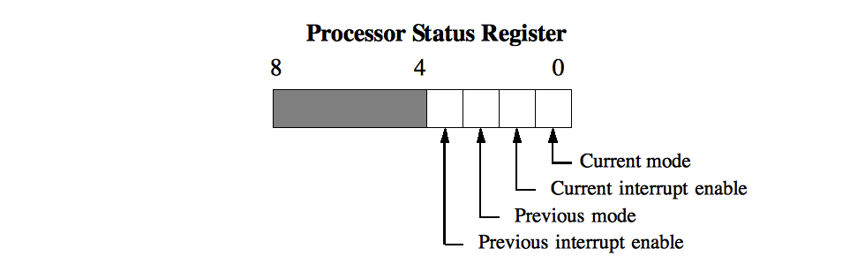
The current mode bit is 1 if the processor is in kernel mode, and 0 otherwise. The current interrupt enable bit is 1 if interrupts are enabled, and 0 otherwise. When an interrupt occurs the processor saves the current mode and interrupt enable bits into the “previous” bits. When the interrupt handler returns the current bits are restored from the previous bits. Thus an interrupt handler can determine which mode the processor was in prior to the interrupt by looking at the previous mode bit. Changing either of the “previous” bits in the interrupt handler changes the value of the “current” bits when the interrupt handler returns. Changing the “current” bits causes the mode and/or interrupt enable to change immediately. The PSR is accessed via USLOSS_PsrSet and USLOSS_PsrGet. Macros are defined in usloss.h for the OS to use in accessing the PSR bits.

3.5 Process Support
USLOSS provides a context-switch mechanism for switching between processes. The context of each process is stored in a structure of type USLOSS_Context (include usloss.h for the definition). The internals of a USLOSS_Context structure should not be directly modified by the OS; only USLOSS_ContextInit and USLOSS_ContextSwitch may do so. Also, each process must have its own stack and own context. The OS can share code between processes, but not stacks or contexts.
Prior to creating a new process the OS must first allocate an unused USLOSS_Context. The OS can allocate the structure statically (as part of a global variable or array) or dynamically (using malloc). Typically, the OS will embed the USLOSS_Context as a field in a process control block (PCB).

3.5.1 Initializing a Context
USLOSS_ContextInit(USLOSS_Context *context, void *stack, int stackSize, USLOSS_PTE *pageTable, void(*func)(void))
The context parameter is the context structure to be initialized. The psr is the initial PSR for the process (see Section 3.4). The func is the address of the initial function the process is to execute. The stack and stackSize define the stack for the process; the stack can be allocated either statically (global variable) or dynamically (malloc). The stack size depends upon the complexity of the process (i.e., the depth of the procedure call nesting and size of local variable declarations), but the stack must be at least of size USLOSS_MIN_STACK, as defined in usloss.h. The pageTable is the address of the page table for the process, if any (see Section 5.1). Note that USLOSS_ContextInit will only initialize the context for the new process; to actually begin executing the process the OS must call USLOSS_ContextSwitch.
The function func must not return, otherwise the stack will underflow. USLOSS will catch this and dump core, but the OS should use a “wrapper” function to detect that func has returned and terminate its context. The wrapper calls func and terminates the context if func returns.
There is an important caveat concerning the creation of new contexts via USLOSS_ContextInit. When the OS calls USLOSS_ContextSwitch for the first time with a new context, USLOSS will jump directly from inside USLOSS_ContextSwitch to the starting function of the new process. Any code that follows the call to USLOSS_ContextSwitch will not be executed in the context of the new process.

3.5.2 Switching Contexts
USLOSS_ContextSwitch(USLOSS_Context*old_context,USLOSS_Context *new_context)
This function performs a context switch, where old_context is a pointer to a context structure in which the state of the currently running process is to be stored, and new_context is a pointer to a context structure containing the state of the new process to be run. The USLOSS_ContextSwitch routine will save the currently running process in the old context, including the PSR, and switch to the process stored in the new context. If the OS doesn’t want to save the current context (e.g. it's starting the first process), then it should pass NULL as the value of old_context.

4. Devices
USLOSS supports several device types: clock, alarm, terminal, and disk. Devices are read using USLOSS_DeviceInput and written using USLOSS_DeviceOutput.

4.1 Clock Device
The clock device invokes the function in USLOSS_IntVec[USLOSS_CLOCK_INT] at regular intervals, the length of which is determined by the resolution of the timer provided by platform on which USLOSS runs. On lectura, this interval is approximately 20 milliseconds, or one fiftieth of a second, and is defined in USLOSS_CLOCK_MS. It should be noted that this clock interrupt is both far more infrequent and irregular than the one that would be provided by a real CPU; nevertheless, it is sufficient to implement multiprogramming and time slicing, as the code should be written in such a way as to be independent of the frequency of clock interrupts.
The clock device has a 32-bit status register that is accessed via USLOSS_DeviceInput. This register contains the time (in microseconds) since USLOSS started running.

4.2 Alarm Device
The alarm device is a count-down timer intended primarily for debugging purposes. It may be set by the OS to send an interrupt a given number of clock ticks in the future. The alarm is set by calling USLOSS_DeviceOutput(USLOSS_ALARM_DEV, 0, n), where n is a number between 1 and 255. The alarm interrupt arrives in between interrupts from the regular clock, so synchronization between the two is unnecessary. Several outstanding alarm interrupts may be scheduled at a time. When an alarm interrupt occurs, the function pointed to by USLOSS_IntVec[USLOSS_ALARM_INT] is called.

4.3 Terminal Devices
USLOSS supports four terminal devices that share a single interrupt (USLOSS_TERM_INT). Each terminal has a 16-bit status register and a 16-bit control register accessed via USLOSS_DeviceInput and USLOSS_DeviceOutput, respectively. An interrupt is generated each time there is a change in the contents of a status register, provided it is not masked by the interrupt mask in the corresponding control register, as described below. When an interrupt is generated the routine pointed to by USLOSS_IntVec[USLOSS_TERM_INT] is called. The second parameter passed to the interrupt handler is the unit number of the terminal whose status changed (the terminals are numbered 0-3). The terminal’s status register should be read immediately using USLOSS_DeviceInput(USLOSS_TERM_DEV,unit,&status), where unit indicates which terminal's status register to read, and status is the location in which to return the status. The contents of the status register are shown in the following illustration. Macros are provided in usloss.h to extract the fields of the status register. The xmit status field indicates the status of the terminal’s transmit capability, while the recv status field indicates its receive capability. The values for these status fields can be one of USLOSS_DEV_READY, USLOSS_DEV_BUSY, or USLOSS_DEV_ERROR, as defined in usloss.h. If the receive status is USLOSS_DEV_BUSY, then a character has been received on the terminal and is stored in the character field of the status register. A status of USLOSS_DEV_READY means that no character has been received, while a status of USLOSS_DEV_ERROR indicates a problem. Each terminal has space to store only a single character, so a failure to read the status register immediately upon receipt of a terminal interrupt may result in the loss of the character when another character is received. The interval between character arrival is at least as long as the interval between clock ticks, so there should be plenty of time to respond to a terminal interrupt.
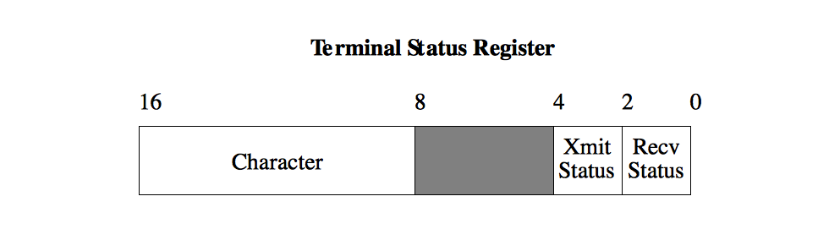

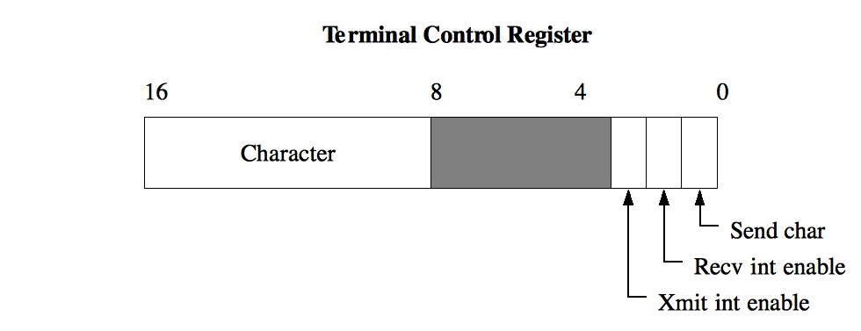
Sending a character is somewhat more difficult than receiving one. To send a character the OS must first ensure that the terminal is ready to send a character, as indicated by the xmit status in its status register. A status of USLOSS_DEV_READY means it’s ok to send a character, whereas as a status of USLOSS_DEV_BUSY means it is not. If you try to send a character while the terminal is busy, the character will be lost. Characters are sent by writing them to the terminal’s control register via USLOSS_DeviceOutput(USLOSS_TERM_DEV,unit,control), where unit is the unit number of the terminal to be written, and control is the value to write to the control register. The format of a control register is shown in the following diagram. To send a character, put the character value into the character field of the control register, and set the send char bit of the register. If the send char bit is not set, the character will not be sent. Characters can be sent at a maximum rate of one per clock tick.
The remaining two bits of the register consist of an interrupt mask for the terminal. If the xmit int enable bit is set, the terminal will generate an interrupt when its transmit status changes, otherwise it won’t. Similarly, if recv int enable is set, the terminal will generate an interrupt when its receive status changes. If the OS doesn't want either of these interrupts, then it shouldn't set the bits in the control registers. In general, the OS should set the recv int enable bit for all of the terminals and just leave them on as a receive interrupt will only be generated when a character is received. The OS should only set the xmit int enable bit when it has characters to transmit on that terminal, otherwise it will get a lot of spurious transmit interrupts that aren’t useful.
There are macros in usloss.h to help the OS access the fields in the status and control registers. You should note that it is possible for a single interrupt to signify both the reception and transmission of a character on a terminal.

4.3.1 Terminal Files
The four terminal devices read their input from the files term0.in, term1.in, term2.in, and term3.in. These files must also reside in the directory in which USLOSS is being executed. If a terminal input file is not present, no input will be received from the corresponding terminal. The terminal input files should be created manually using a text editor. Terminal output is written to the files term0.out, term1.out, term2.out, and term3.out.
A utility called pterm is provided to allow users to use real terminals with USLOSS. To connect a real terminal with the simulator, users must log in to that terminal and change to the directory in which the simulation is being run. Users should then enter a pterm x command, where x is the terminal number to connect to. If an input file for that terminal exists, the user is given the choice of removing the file or aborting. The terminal is switched into cbreak input mode, and every character typed on the terminal is sent to the simulator and simultaneously written into the corresponding terminal input file (this will provide a record of what input was typed after the simulation terminates). Characters written to the terminal by the simulator are displayed on the screen. To exit, the user may strike either the interrupt or stop (ctrl-Z) keys, which will cause pterm to reset the terminal to normal mode and exit.
Normally, characters are read from terminal input files or physical terminals at the maximum rate possible, which is one character from each terminal for every four clock ticks. In some cases, it may be desirable to delay input from one or more terminals for a given interval. This may be accomplished by inserting ‘@’characters in the input files; each ‘@’ character is read by the simulator but does not cause an interrupt and is thus invisible the OS. Each ‘@’ effectively delays the next input character from that terminal by four clock ticks.

4.4 Disk Devices
The disk devices support the following operations: seeking to a given track, and reading and writing a 512-byte sector within the current track. A disk operation is initiated by a call of the form: USLOSS_DeviceOutput(USLOSS_DISK_DEV,unit,request), where unit is the unit number of the disk to be accessed, and request is a pointer to a USLOSS_DeviceRequest structure (defined in usloss.h). This structure has three fields: opr, reg1, and reg2.
The opr field must be one of the predefined constants USLOSS_DISK_READ, USLOSS_DISK_WRITE, USLOSS_DISK_SEEK, or USLOSS_DISK_TRACKS. If opr is USLOSS_DISK_READ or USLOSS_DISK_WRITE, then reg1 should contain the index of the sector to be read or written within the current track, and reg2 should contain a pointer to a 512-byte buffer into which data from the disk will be read or from which data will be written. Note that each track on the disk has 16 sectors. If opr is USLOSS_DISK_SEEK, then reg1 must contain the track number to which the disk’s read/write head should be moved. If opr is USLOSS_DISK_TRACKS then reg1 must contain a pointer to an integer into which the number of disk tracks will be stored.
After a request has been sent to the disk, further requests are ignored until the requested operation has been completed, at which point the function pointed to by USLOSS_IntVec[USLOSS_DISK_INT] is called. The status of a disk device may be obtained by an USLOSS_DeviceInput(USLOSS_DISK_DEV, unit, &status) operation, which will set status to USLOSS_DEV_READY if the request completed, USLOSS_DEV_BUSY if a request is being processed, or USLOSS_DEV_ERROR if the last request caused an error.

4.4.1 Disk Files
The disk device stores the contents of each simulated disk in a file called diskN, where N is the unit number for the disk. USLOSS supports two disks, unit 0 and unit 1. A disk file is updated immediately upon every change to the disk, so no information will be lost should USLOSS terminate abnormally. USLOSS requires that a disk file contain an even number of complete tracks; otherwise, an error occurs upon startup. A utility called makedisk is provided to create disk files. Note that this utility is needed only to create a new disk; as long as the disk file is not corrupted, its contents are preserved when USLOSS reboots. A library named libdisk<version>.a is also provided to allow creation of disks in test cases by calling Disk_Create from test_setup.

5. MMU
The USLOSS MMU maps virtual pages to physical page frames, allowing different processes to have different virtual address spaces. Due to the limitations of running USLOSS in a UNIX process, it isn’t possible for USLOSS processes to have totally separate address spaces; instead the MMU only operates on a single region of the larger shared address space (called the VM region). Accesses outside of the VM region are unaffected by the MMU; accesses inside the VM region are mapped by the MMU to allow processes to see different memory contents.
The USLOSS MMU maps virtual pages to physical page frames, allowing different processes to have different virtual address spaces. Due to the limitations of running USLOSS in a UNIX process, it isn’t possible for USLOSS processes to have totally separate address spaces; instead the MMU only operates on a single region of the larger shared address space (called the VM region). Accesses outside of the VM region are unaffected by the MMU; accesses inside the VM region are mapped by the MMU to allow processes to see different memory contents.
The MMU supports two modes of operation: page table mode, and TLB mode.

5.1 Page Table Mode
In page table mode the USLOSS MMU implements a single-level page table. A page table context is an array of USLOSS_PTE structures, one for each page in the VM region. Each USLOSS_PTE contains four fields: incore, read, write, and frame. The incore field is 1 if the page is in memory (core) and is 0 otherwise. If incore is 1 then frame indicates which page frame contains the page, otherwise frame is not used. If read is 1 then the page is readable, otherwise it is not. Likewise, if write is 1 then the page is writable, otherwise is it not. Note: the USLOSS MMU does not support write-only pages.
The page table for a context is specified when USLOSS_ContextInit is called. The USLOSS MMU will automatically switch page tables in USLOSS_ContextSwitch. The current page table can be obtained via USLOSS_MmuGetPageTable, and set via USLOSS_MmuSetPageTable. Note: if the OS modifies the current page table it must call USLOSS_MmuSetPageTable to notify the USLOSS MMU that the page table has changed; the USLOSS MMU cannot automatically detect changes to the current page table.

5.2 TLB Mode
The following diagram illustrates the functioning of the MMU in TLB mode:
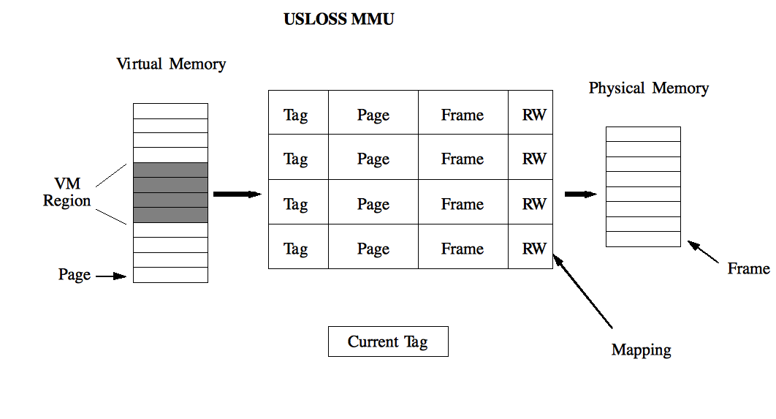
The MMU contains a set of mappings, each of which contains a tag, page number, frame number, and two protection bits (read and write). The MMU uses these mappings to convert addresses in the VM region into physical memory addresses. The MMU performs the following four steps when a process accesses the VM region. First, the MMU determines which page within the VM region is being accessed. Second, the MMU finds all mappings whose tag matches the current tag register. Third, the MMU searches the resulting mappings to find one whose page number matches the page that is being accessed. If a mapping is not found after steps 2 and 3 the MMU will generate an MMU interrupt. This causes the interrupt handler associated with the USLOSS_MMU_INT interrupt to be invoked, allowing the OS to handle the problem. If a mapping is found, the MMU compares the type of access with the protection bits in the mapping. If the access is allowed the frame number from the mapping and the page offset from the virtual address are combined to form a physical address. If the access violates the page’s protection a USLOSS_MMU_INT interrupt occurs.
The size of the VM region, the physical memory, and the number of mappings in the MMU are all specified when the MMU is configured. Varying the relative sizes of the VM region and the physical memory allow the effectiveness of the OS page replacement algorithm to be measured under different workloads and system configurations. Varying the number of mappings in the MME allows the MMU to function as a single-level page table, or as a translation buffer (TB). The former is achieved by configuring the MMU so that the number of mappings is equal to the number of pages in the VM region. This allows the MMU to hold mappings for all of a process’s pages that are currently in memory, so that the lack of a mapping for an accessed page indicates a page fault. If, on the other hand, the MMU is configured so that there are fewer mappings than pages in the VM region, the lack of a mapping for a page does not necessarily imply a page fault. The desired page may be in memory, but not mapped by the MMU because there aren’t enough mappings to go around. In this case the OS removes an existing mapping and adds one for the page that is being accessed.
The tag functionality of the MMU makes it possible for the MMU to store mappings for several processes. The MMU supports USLOSS_MMU_NUM_TAGS different tags, allowing up to that many different processes to simultaneously have mappings in the MMU. The MMU will not store more than one mapping with a given tag and page, so that the maximum number of mappings that can have the same tag is equal to the number of pages in the VM region. Thus the maximum number of mappings that the MMU can hold is USLOSS_MMU_NUM_TAGS multiplied by the number of pages in the VM region. It can, however, be configured to hold fewer as described in the previous paragraph. The advantage of using tags is that a context switch between two processes whose mappings are already loaded in the MMU can be achieved simply by changing the value in the current tag register.
Finally, the MMU supports access bits for each physical page frame. A reference bit is set when the frame is either read or written, and a dirty bit is set when the frame is written. These bits can also be cleared and set in software, allowing the OS to implement a variety of page replacement algorithms.

5.3 MMU Error Codes
Many of MMU interface routines return the following error codes, defined in usloss.h:.
Error Code | Meaning
USLOSS_MMU_OK | No error
USLOSS_MMU_ERR_OFF | MMU has not been initialized
USLOSS_MMU_ERR_ON | MMU has already been initialized
USLOSS_MMU_ERR_PAGE | Invalid page number
USLOSS_MMU_ERR_FRAME | Invalid frame number
USLOSS_MMU_ERR_PROT | Invalid protection
USLOSS_MMU_ERR_TAG | Invalid tag
USLOSS_MMU_ERR_REMAP | Mapping with same tag and page already exists
USLOSS_MMU_ERR_NOMAP | Mapping not found
USLOSS_MMU_ERR_ACC | Invalid access bits
USLOSS_MMU_ERR_MAPS | Too many mappings
USLOSS_MMU_ERR_MODE | Operation is invalid in the current MMU mode
USLOSS_MMU_ERR_NULL | NULL argument was given

5.4 MMU Functions
The following are the USLOSS MMU functions. Functions that are only valid in page table mode are denoted with (p) while functions that are only valid in TLB mode are denoted with (t), otherwise they are valid in both modes (b).
int USLOSS_MmuInit(int numMaps, int numPages, int numFrames, int mode) (b)
Creates a physical memory containing numFrames frames, a VM region containing numPages pages. The mode must be either USLOSS_MMU_MODE_TLB or USLOSS_MMU_MODE_PAGETABLE. In TLB mode the MMU will contain numMaps mappings. Initially the MMU has no valid mappings, and the current tag register is 0. In page table mode numMaps is not used. Returns a standard MMU error code.
int USLOSS_MmuDone(void)(b)
Releases all the resources associated with the MMU. Subsequent accesses to the VM region will result in a segmentation violation. Returns a standard MMU error code.
int USLOSS_MmuGetConfig(void **vmRegion, void **pmAddr,
int *pageSize,int *numPages, int *numFrames, int *mode)(b)
Returns information about the current MMU configuration. vmRegion is the address of the VM region (pages). pmRegion is the address of the physical memory (page frames). pageSize is the size of a page, in bytes. numPages is the number of pages in the VM region while numFrames is the number of page frames in the physical memory. mode is the current mode of the MMU. Returns a standard MMU error code.
int USLOSS_MmuMap(int tag, int page, int frame, int protection)(t)
Stores a mapping in the MMU. USLOSS_MMU_ERR_REMAP is returned if a mapping with the same tag and page already exists. Valid protection values are USLOSS_MMU_PROT_NONE (no access), USLOSS_MMU_PROT_READ, (page is read-only), and USLOSS_MMU_PROT_RW (page can be both read and written). Returns a standard MMU error code.
int USLOSS_MmuUnmap(int tag, int page) (t)
Removes the mapping with the matching tag and page. Subsequent accesses to the page when the current tag is set to tag will result in an MMU interrupt. Returns a standard MMU error code.
int USLOSS_MmuGetMap(int tag, int page, int *framePtr, int *protPtr) (t)
Provides mapping information. If no mapping matches the given tag and page USLOSS_MMU_ERR_NOMAP is returned, otherwise the mapping’s frame is stored in *framePtr, and the protection in *protPtr. Returns a standard MMU error code.
int USLOSS_MmuGetCause(void)(b)
Returns the cause of the most recent MMU interrupt. USLOSS_MMU_FAULT means that the page is not mapped to a frame. USLOSS_MMU_ACCESS means that a mapping was found, but that the protections on the page prohibit the attempted access. USLOSS_MMU_NONE means that an MMU interrupt has not yet occurred.
int USLOSS_MmuGetAccess(int frame, int *accessPtr)(b)
Stores the access bits for a frame in *accessPtr. If USLOSS_MMU_REF is set the page has been referenced. If USLOSS_MMU_DIRTY is set the page has been written. Returns a standard MMU error code.
int USLOSS_MmuSetAccess(int frame, int access)(b)
Sets the frame’s access bits to access. Returns a standard MMU error code.
int USLOSS_MmuSetTag(int tag) (t)
Sets the current tag register to tag. Returns a standard MMU error code.
int USLOSS_MmuGetTag(int *tagPtr) (t)
Stores the current tag register in *tagPtr. Returns a standard MMU error code.
int USLOSS_MmuSetPageTable(USLOSS_PTE *pageTable) (p)
Sets the current page table to pageTable. This routine must also be called when the current page table is updated. Returns a standard MMU error code.
int USLOSS_MmuGetPageTable(USLOSS_PTE **pageTable) (p)
Stores the current page table in pageTable. Returns a standard MMU error code.

5.5 MMU Interrupts
The function pointed to by USLOSS_IntVec[USLOSS_MMU_INT] will be invoked when an MMU interrupt occurs. The MMU interrupt handler has the following definition:
void Handler(int type, void *offset)
type is the type of interrupt (USLOSS_MMU_INT). offset is an integer (cast as a void *) containing the byte offset from the start of the VM region to the address that caused the interrupt.
USLOSS will take care of restarting the offending instruction when the MMU interrupt handler returns. This means that the address that caused the problem will be given to the MMU again for mapping. If there is still a problem another MMU interrupt will be generated. The assumption is that the OS will either enter configure the MMU so that the address will no longer cause an interrupt, or kill the process.

6. Debugging Support
USLOSS provides two printing functions to help with debugging. The USLOSS_Console operation takes printf-style parameters and prints to stdout, and the USLOSS_Trace operation prints to stderr. You should avoid using printf and fprintf as they may cause problems if interrupted.
USLOSS also provides a halt operation, USLOSS_Halt. When invoked, it will cause execution of the finish routine (defined by the OS), and then terminates execution. A core file is produced if the parameter to USLOSS_Halt is non-zero. The OS developer might find it useful to have print statements or error checking code in finish to help in debugging. Lastly, the alarm device may also be used for debugging purposes. It can be set to interrupt at a time that is of interest so that the program status can be examined.
The ‘-v’ argument increases the verbosity of USLOSS’s debugging output. See Section 2.1 for details.
USLOSS can also be debugged using a standard debugger such as gdb. However, be aware that the use of gdb is complicated by USLOSS interrupts which are implemented using the SIGUSR1 signal. By default, gdb catches the SIGUSR1 signal and forces the debugged program to stop. To get around this problem add the following in your .gdbinit file (either in the current directory or in your home directory):
handle SIGUSR1 nostop noprint
Similarly, the OS uses the MMU you should add the following to your .gdbinit:
handle SIGSEGV nostop noprint
handle SIGBUS nostop noprint
The MMU uses SIGSEGV and SIGBUS to implement memory mapping. Note that telling gdb to ignore SIGSEGV and SIGBUS will cause it to ignore segmentation violations and bus errors caused by real bugs in the OS, so be careful ignoring these signals.

7. USLOSS Quick Reference
The following routines are provided by the simulator. Those whose names are in bold can be invoked only from kernel mode.
void USLOSS_Console(char *fmt,...) - Printf-style write to stdout.
void USLOSS_ContextInit(USLOSS_Context*new, void *stack,int stackSize, USLOSS_PTE *pageTable, void (*func)(void)) - Initializes the context new using the memory pointed to by stack of size stackSize (in bytes) as the stack, and the routine func as the starting address. The pageTable points to the page table for the context, which may be NULL.
void USLOSS_ContextSwitch(context *old, context *new) - Saves the current CPU state (including the PSR) in old, and loads state new into the CPU. The old parameter may be NULL.
int USLOSS_DeviceInput(int dev, int unit, int *status) - Sets *status to the contents of the device status register indicated by dev and unit. If dev and unit are valid USLOSS_DEV_OK is returned, otherwise USLOSS_DEV_INVALID is returned.
int USLOSS_DeviceOutput(int dev, int unit, void *arg) - Sends arg to the device port indicated by dev and unit. Depending on the device, arg may be either an integer or a pointer to a structure of type USLOSS_DeviceRequest containing the device request. If dev and unit are valid USLOSS_DEV_OK is returned, otherwise USLOSS_DEV_INVALID is returned.
void USLOSS_Halt(int dumpcore) - Causes execution of the finish routine and then terminates USLOSS. A core file is produced if dumpcore is non-zero.
unsigned int USLOSS_PsrGet(void) - Returns the current value of the PSR.
int USLOSS_PsrSet(unsigned int psr) - Sets the PSR to the value in psr. Returns USLOSS_ERR_INVALID_PSR if psr is not a valid value for the PSR, USLOSS_DEV_OK otherwise.
void USLOSS_Syscall(void *arg) - Causes an interrupt of type USLOSS_SYSCALL_INT and passes arg as the second parameter to the interrupt handler.
void USLOSS_IllegalInstruction(void) - Causes an interrupt of type USLOSS_ILLEGAL_INT.
void USLOSS_Trace(char *fmt,...) - Printf-style write to stderr.
void USLOSS_WaitInt(void) - Suspends execution until an interrupt occurs.
int USLOSS_MmuInit(int numMaps, int numPages, int numFrames, int mode) – Initializes the MMU.
int USLOSS_MmuDone(void)- Releases the MMU.
void *USLOSS_MmuRegion(int *numPagesPtr) - Returns the address and size of the VM region.
int USLOSS_MmuMap(int tag, int page, int frame, int prot)- Stores a mapping in the MMU.
int USLOSS_MmuUnmap(int tag, int page)- Removes a mapping from the MMU.
int USLOSS_MmuGetMap(int tag, int page, int *framePtr, int *protPtr)- Gets a mapping from the MMU.
int USLOSS_MmuGetCause(void)- Returns the cause of the most recent MMU interrupt.
int USLOSS_MmuGetAccess(int frame, int *accessPtr)- Gets the access bits.
int USLOSS_MmuSetAccess(int frame, int access) – Sets the access bits.
int USLOSS_MmuSetTag(int tag) – Sets the current tag register.
int USLOSS_MmuGetTag(int *tagPtr)- Gets the current tag register.
int USLOSS_MmuSetPageTable(USLOSS_PTE *pageTable)- Sets the current page table.
int USLOSS_MmuGetPageTable(USLOSS_PTE **pageTable)- Gets the current page table.
int USLOSS_MmuGetConfig(void **vmRegion, void **pmAddr,
int *pageSize,int *numPages, int *numFrames, int *mode) - Gets the MMU configuration.

