Cancer of the Oral Cavity

René D Herrera

6/4/2020

Dear Dr. Bauman,

I have worked to update the query based on your comments. The information you have requested is in the body of the email. As you pointed out, oral cavity includes:

|  |  |  |
| --- | --- | --- |
| Site Group | ICD-O-3 Site (diagnosed 2001 to present) | ICD-O-3 Histology (Type) |
| Lip | C000-C009 | excluding 9590-9989 |
| Tongue | C019-C029 | excluding 9590-9989 |
| Salivary Gland | C079-C089 | excluding 9590-9989 |
| Floor of Mouth | C040-C049 | excluding 9590-9989 |
| Gum and Other Mouth | C030-C039, C050-C059, C060-C069 | excluding 9590-9989 |
| Nasopharynx | C110-C119 | excluding 9590-9989 |
| Tonsil | C090-C099 | excluding 9590-9989 |
| Oropharynx | C100-C109 | excluding 9590-9989 |
| Hypopharynx | C129, C130-C139 | excluding 9590-9989 |
| Other Oral Cavity and Pharynx | C140, C142-C148 | excluding 9590-9989 |

## By Year and Sex

### Arizona

#### All Races

The following chart and table show the age adjusted incidence rate for cancer of the oral cavity for:

* the entire state of Arizona
* years 1997-2017
* all races
* both female and male sex

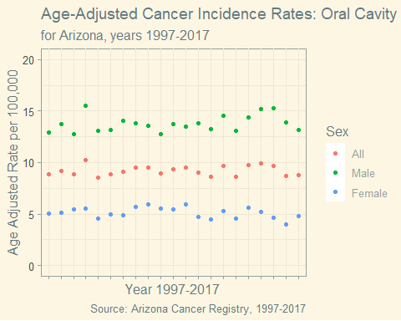

|  |  |  |  |
| --- | --- | --- | --- |
| Year | Male | Female | All |
| 1997 | 12.96 | 5.09 | 8.84 |
| 1998 | 13.76 | 5.12 | 9.17 |
| 1999 | 12.79 | 5.48 | 8.89 |
| 2000 | 15.54 | 5.55 | 10.25 |
| 2001 | 13.08 | 4.53 | 8.53 |
| 2002 | 13.20 | 4.95 | 8.89 |
| 2003 | 14.02 | 4.85 | 9.13 |
| 2004 | 13.78 | 5.66 | 9.48 |
| 2005 | 13.57 | 5.93 | 9.54 |
| 2006 | 12.79 | 5.53 | 8.97 |
| 2007 | 13.75 | 5.47 | 9.37 |
| 2008 | 13.52 | 5.92 | 9.49 |
| 2009 | 13.85 | 4.70 | 9.01 |
| 2010 | 13.27 | 4.51 | 8.65 |
| 2011 | 14.54 | 5.33 | 9.68 |
| 2012 | 13.10 | 4.58 | 8.61 |
| 2013 | 14.41 | 5.58 | 9.76 |
| 2014 | 15.16 | 5.24 | 9.90 |
| 2015 | 15.25 | 4.68 | 9.70 |
| 2016 | 13.91 | 4.03 | 8.71 |
| 2017 | 13.14 | 4.84 | 8.76 |

#### White Non-Hispanic

The following chart and table show the age adjusted incidence rate for cancer of the oral cavity for:

* the entire state of Arizona
* years 1997-2017
* only the race listed as “White, Non Hispanic”
* both female and male sex

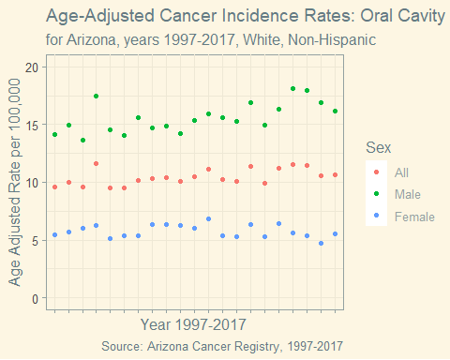

|  |  |  |  |
| --- | --- | --- | --- |
| Year | Male | Female | All |
| 1997 | 14.12 | 5.47 | 9.63 |
| 1998 | 14.91 | 5.73 | 10.04 |
| 1999 | 13.67 | 6.03 | 9.60 |
| 2000 | 17.49 | 6.30 | 11.59 |
| 2001 | 14.54 | 5.10 | 9.53 |
| 2002 | 14.06 | 5.35 | 9.53 |
| 2003 | 15.59 | 5.34 | 10.16 |
| 2004 | 14.73 | 6.32 | 10.30 |
| 2005 | 14.85 | 6.36 | 10.40 |
| 2006 | 14.21 | 6.27 | 10.07 |
| 2007 | 15.39 | 6.02 | 10.45 |
| 2008 | 15.89 | 6.83 | 11.14 |
| 2009 | 15.59 | 5.41 | 10.25 |
| 2010 | 15.31 | 5.28 | 10.07 |
| 2011 | 16.91 | 6.32 | 11.37 |
| 2012 | 14.91 | 5.28 | 9.89 |
| 2013 | 16.34 | 6.47 | 11.19 |
| 2014 | 18.14 | 5.58 | 11.57 |
| 2015 | 17.96 | 5.41 | 11.45 |
| 2016 | 16.92 | 4.69 | 10.55 |
| 2017 | 16.14 | 5.53 | 10.61 |

#### White Hispanic

The following chart and table show the age adjusted incidence rate for cancer of the oral cavity for:

* the entire state of Arizona
* years 1997-2017
* only the race listed as “White, Hispanic”
* both female and male sex

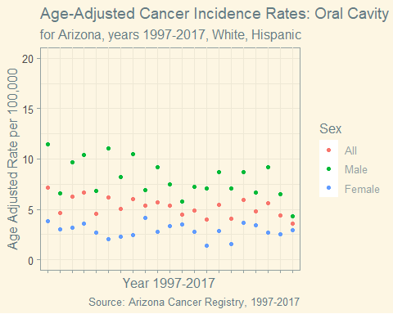

|  |  |  |  |
| --- | --- | --- | --- |
| Year | Male | Female | All |
| 1997 | 11.44 | 3.83 | 7.17 |
| 1998 | 6.56 | 3.02 | 4.65 |
| 1999 | 9.69 | 3.22 | 6.30 |
| 2000 | 10.42 | 3.58 | 6.70 |
| 2001 | 6.82 | 2.71 | 4.54 |
| 2002 | 11.03 | 2.05 | 6.20 |
| 2003 | 8.21 | 2.27 | 5.09 |
| 2004 | 10.49 | 2.45 | 6.03 |
| 2005 | 6.93 | 4.18 | 5.41 |
| 2006 | 9.22 | 2.77 | 5.71 |
| 2007 | 7.45 | 3.37 | 5.39 |
| 2008 | 5.77 | 3.51 | 4.48 |
| 2009 | 7.28 | 2.80 | 4.89 |
| 2010 | 7.04 | 1.40 | 3.96 |
| 2011 | 8.67 | 2.84 | 5.44 |
| 2012 | 7.11 | 1.55 | 4.07 |
| 2013 | 8.69 | 3.65 | 5.94 |
| 2014 | 6.70 | 3.41 | 4.83 |
| 2015 | 9.17 | 2.66 | 5.59 |
| 2016 | 6.52 | 2.56 | 4.39 |
| 2017 | 4.31 | 2.98 | 3.62 |

### Five County Catchment

#### Year and Sex

The following chart and table show the age adjusted incidence rate for cancer of the oral cavity for:

* only the five counties in the catchment; Cochise, Pima, Pinal, Santa Cruz, and Yuma
* years 1997-2017
* all races
* all sexes

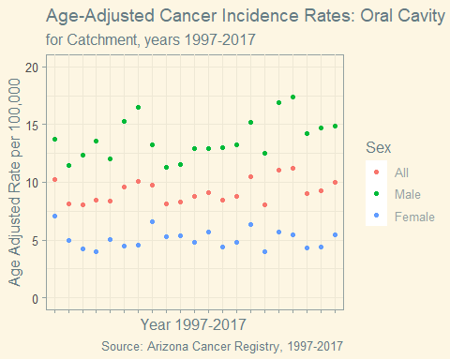

|  |  |  |  |
| --- | --- | --- | --- |
| Year | Male | Female | All |
| 1997 | 13.73 | 7.07 | 10.24 |
| 1998 | 11.45 | 5.01 | 8.10 |
| 1999 | 12.37 | 4.25 | 8.02 |
| 2000 | 13.60 | 3.97 | 8.43 |
| 2001 | 12.03 | 5.08 | 8.35 |
| 2002 | 15.31 | 4.45 | 9.58 |
| 2003 | 16.45 | 4.56 | 10.12 |
| 2004 | 13.23 | 6.60 | 9.74 |
| 2005 | 11.32 | 5.26 | 8.16 |
| 2006 | 11.54 | 5.35 | 8.28 |
| 2007 | 12.95 | 4.83 | 8.75 |
| 2008 | 12.95 | 5.67 | 9.09 |
| 2009 | 12.98 | 4.42 | 8.45 |
| 2010 | 13.27 | 4.79 | 8.80 |
| 2011 | 15.18 | 6.36 | 10.52 |
| 2012 | 12.51 | 4.01 | 8.08 |
| 2013 | 16.92 | 5.73 | 11.02 |
| 2014 | 17.37 | 5.47 | 11.18 |
| 2015 | 14.25 | 4.29 | 9.04 |
| 2016 | 14.68 | 4.39 | 9.29 |
| 2017 | 14.90 | 5.48 | 9.96 |

#### White Non Hispanic

The following chart and table show the age adjusted incidence rate for cancer of the oral cavity for:

* only the five counties in the catchment; Cochise, Pima, Pinal, Santa Cruz, and Yuma
* years 1997-2017
* only the race listed as “White, Non Hispanic”
* all sexes

## Warning: Removed 2 rows containing missing values (geom_point).

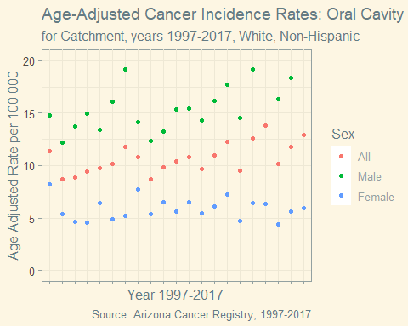

|  |  |  |  |
| --- | --- | --- | --- |
| Year | Male | Female | All |
| 1997 | 14.79 | 8.20 | 11.39 |
| 1998 | 12.21 | 5.41 | 8.71 |
| 1999 | 13.77 | 4.61 | 8.89 |
| 2000 | 14.97 | 4.59 | 9.41 |
| 2001 | 13.42 | 6.43 | 9.77 |
| 2002 | 16.06 | 4.89 | 10.20 |
| 2003 | 19.13 | 5.23 | 11.82 |
| 2004 | 14.16 | 7.76 | 10.81 |
| 2005 | 12.33 | 5.37 | 8.73 |
| 2006 | 13.28 | 6.55 | 9.80 |
| 2007 | 15.37 | 5.61 | 10.37 |
| 2008 | 15.46 | 6.50 | 10.82 |
| 2009 | 14.32 | 5.45 | 9.67 |
| 2010 | 16.13 | 6.13 | 10.96 |
| 2011 | 17.72 | 7.24 | 12.24 |
| 2012 | 14.57 | 4.75 | 9.54 |
| 2013 | 19.20 | 6.45 | 12.57 |
| 2014 | 21.68 | 6.31 | 13.82 |
| 2015 | 16.36 | 4.43 | 10.19 |
| 2016 | 18.39 | 5.64 | 11.79 |
| 2017 | 20.34 | 5.92 | 12.96 |

#### White, Hispanic

The following chart and table show the age adjusted incidence rate for cancer of the oral cavity for:

* only the five counties in the catchment; Cochise, Pima, Pinal, Santa Cruz, and Yuma
* years 1997-2017
* only the race listed as “White, Hispanic”
* all sexes

## Warning: Removed 18 rows containing missing values (geom_point).

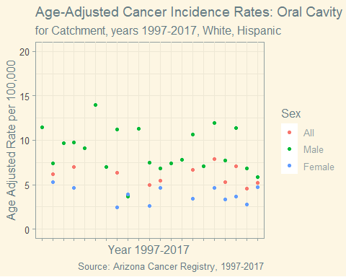

|  |  |  |  |
| --- | --- | --- | --- |
| Year | Male | Female | All |
| 1997 | 11.48 | NA | NA |
| 1998 | 7.42 | 5.28 | 6.22 |
| 1999 | 9.70 | NA | NA |
| 2000 | 9.74 | 4.65 | 7.02 |
| 2001 | 9.12 | NA | NA |
| 2002 | 14.00 | NA | NA |
| 2003 | 7.00 | NA | NA |
| 2004 | 11.25 | 2.45 | 6.33 |
| 2005 | 3.66 | 3.90 | 3.82 |
| 2006 | 11.31 | NA | NA |
| 2007 | 7.49 | 2.62 | 4.93 |
| 2008 | 6.81 | 4.62 | 5.48 |
| 2009 | 7.43 | NA | NA |
| 2010 | 7.81 | NA | NA |
| 2011 | 10.62 | 3.42 | 6.67 |
| 2012 | 7.07 | NA | NA |
| 2013 | 11.95 | 4.61 | 7.90 |
| 2014 | 7.70 | 3.36 | 5.26 |
| 2015 | 11.36 | 3.69 | 7.10 |
| 2016 | 6.80 | 2.76 | 4.54 |
| 2017 | 5.86 | 4.69 | 5.25 |

## By Race

### Arizona

The following chart and table show the age adjusted incidence rate for cancer of the oral cavity for:

* the entire state of Arizona
* all years 1997-2017
* all races
* all sexes

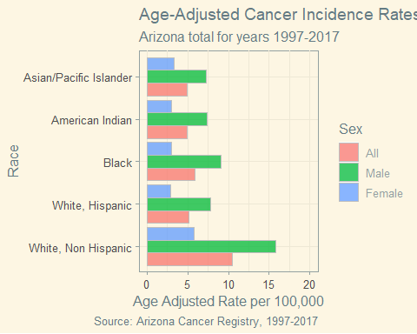

|  |  |  |  |
| --- | --- | --- | --- |
| Race | Male | Female | All |
| All | 13.87 | 5.09 | 9.23 |
| White, Non Hispanic | 15.77 | 5.75 | 10.51 |
| White, Hispanic | 7.75 | 2.84 | 5.08 |
| Black | 9.04 | 2.99 | 5.89 |
| American Indian | 7.40 | 2.98 | 4.96 |
| Asian/Pacific Islander | 7.30 | 3.34 | 4.96 |

### Catchment

The following chart and table show the age adjusted incidence rate for cancer of the oral cavity for:

* only the five counties in the catchment; Cochise, Pima, Pinal, Santa Cruz, and Yuma
* all years 1997-2017
* all races
* all sexes

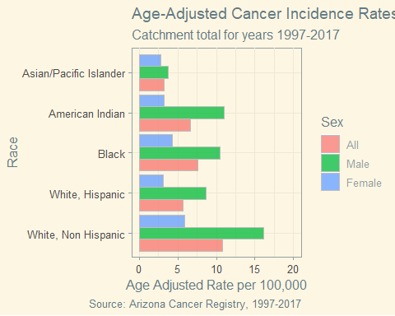

|  |  |  |  |
| --- | --- | --- | --- |
| Race | Male | Female | All |
| All | 13.94 | 5.07 | 9.27 |
| White, Non Hispanic | 16.10 | 5.85 | 10.76 |
| White, Hispanic | 8.70 | 3.07 | 5.61 |
| Black | 10.46 | 4.30 | 7.62 |
| American Indian | 10.95 | 3.21 | 6.58 |
| Asian/Pacific Islander | 3.72 | 2.82 | 3.17 |