CS 340 Project One README

About the Project/Project Title
PyCRUD is a small/lightweight Python module for working with MongoDB collections. It provides a simple, reusable interface for connecting to a database and performing basic create, read, update, and delete operations with error handling and simple method calls.

This project uses PyMongo, the official MongoDB driver for Python. It was chosen because it provides a direct, official, well-supported way to communicate with MongoDB using Python. It’s reliable and widely used, offers access to database and MongoDB functions, and has built-in error handling.

Motivation
This project was created as a learning exercise for CS 340 course and to get familiar with development for MongoDB. Main goal of this project is to build simple, lightweight, and extendable CRUD implementation that can be used both on its own and as a dependency for something more advanced. This software is built on clarity, speed, and modularity principles – all design choices are driven by these three ideas.

Getting Started
To get started, install pymongo module and Jupyter Notebooks (if you intend to run tests) and make sure MongoDB is running and accessible. After that, import the PyCRUD class, create an instance with your database credentials, and begin using it to insert or query documents from your chosen database and collection. For help with database user creation and login refer to screenshots or official MongoDB documentation.

Installation
This project uses Python and MongoDB, along with the pymongo library for database communication. Install the project dependencies, then verify that your MongoDB server is available and that the connection details you provide in your script are correct. PyCharm is a recommended IDE but anything capable of running Jupyter Notebooks will work.

Usage
PyCRUD is designed for simple database tasks like adding new documents, retrieving matching records, updating matching records, and deleting records. You can create an instance of the class, insert a document into a collection, and then query that same collection using a dictionary-based filter. It is small and offers simple method signatures which allows to build any projects on top of it.

The CRUD module allows to configure connection on creation through constructor attributes and exposes four main operations: create, read, update, and delete.

Class attributes
The class keeps the connection information as attributes:
username: MongoDB login name
password: MongoDB login password
host: MongoDB server address, defaulting to localhost
port: MongoDB port, defaulting to 27017
client: Instance of MongoDB client with provided parameters
These values are set once when the class is initialized, so the same instance can be used for multiple database operations.

Provided functions
Create
Inserts a document into the specified database and collection.
Requires the input data to be a non-empty dictionary.
Returns True when the insert is acknowledged, otherwise False.

Read
Retrieves documents from the specified database and collection.
Accepts an optional query dictionary.
If no query is provided, all documents in the collection are returned.
Returns a list of matching documents.
If the query is invalid or an error occurs, returns an empty list.

Update
Finds documents using a query dictionary and updates all matches.
Requires both the query and update data to be valid, non-empty dictionaries.
Uses a multi-document update approach so all matching records can be changed.
Returns the number of documents modified.
If validation fails or an error occurs, returns 0.

Delete
Finds documents using a query dictionary and deletes all matches.
Requires a valid, non-empty query dictionary.
Returns the number of documents deleted.
If validation fails or an error occurs, returns 0.

Code Example

A basic initialization and DB document creation code will look like this:
from CRUD_Python_Module import PyCRUD
db = PyCRUD(username="<your_username>", password="<your_password>")
db.create("aac", "animals", {"animal_id": "TEST-001", "name": "Test Animal"})
results = db.read("aac", "animals", {"animal_id": "TEST-001"})

DB document creation, read, update, and delete will look like this:
# Create
new_animal = {
'animal_id': 'TEST-001',
'name': 'Test Animal',
'animal_type': 'Dog',
'breed': 'Labrador Breed',
'color': 'Mixed',
'age_upon_outcome': '2 years',
'outcome_type': 'Transfer'
}

create_result = animal_shelter.create('aac', 'animals', new_animal)

# Read
query = {'animal_id': 'TEST-001'}
results = animal_shelter.read('aac', 'animals', query)
for document in results:
pprint(document)

# Update
query = {'animal_id': 'TEST-001'}
update_data = {'$set': {'outcome_type': 'Adoption', 'color': 'Golden'}}

update_count = animal_shelter.update('aac', 'animals', query, update_data)

# Delete
query = {'animal_id': 'TEST-001'}

delete_count = animal_shelter.delete('aac', 'animals', query)

Tests
Tests can be run by executing the notebook or script that demonstrates the class methods in action. The test workflow typically includes creating a sample document, reading it back with a query, and confirming that the returned results match expectations. You can also add assertions to validate that create() returns True and read() returns the expected list of documents. An example test creating, reading, updating, and deleting Mongo document can be viewed in ProjectOneTestScript.ipynb.

Screenshots
MongoDB import execution
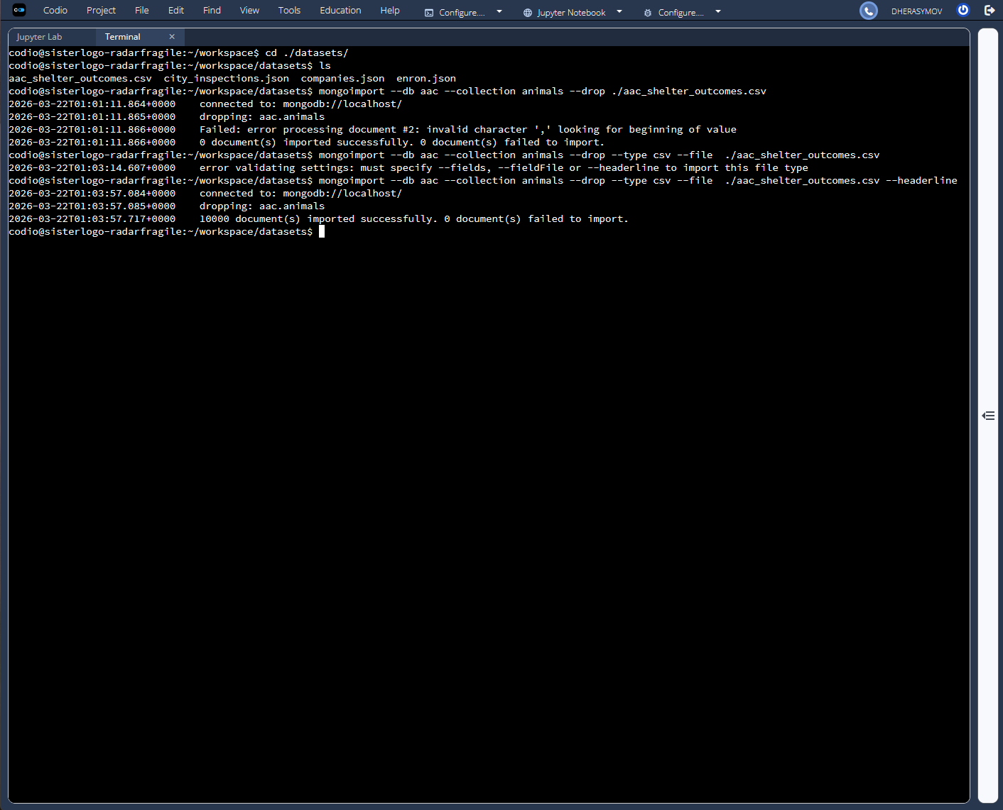
MongoDB user creation
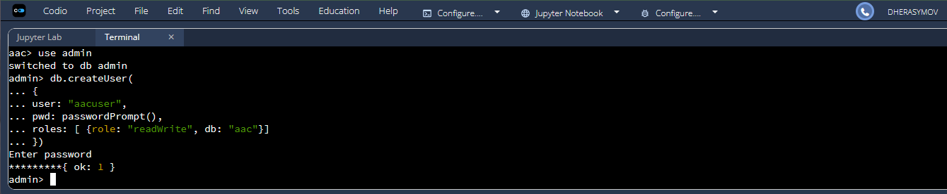
User authentication execution
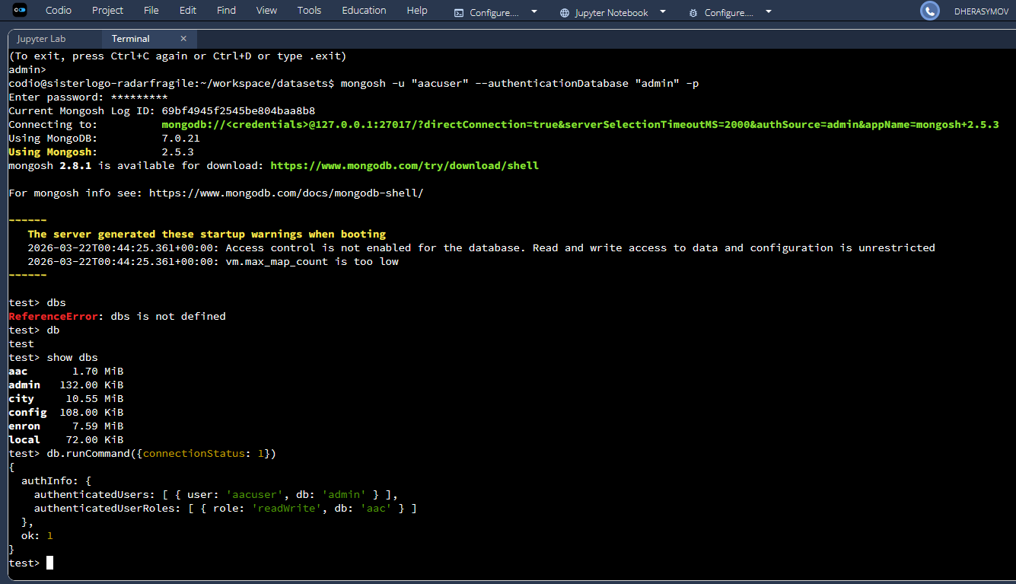
Screenshot of example test
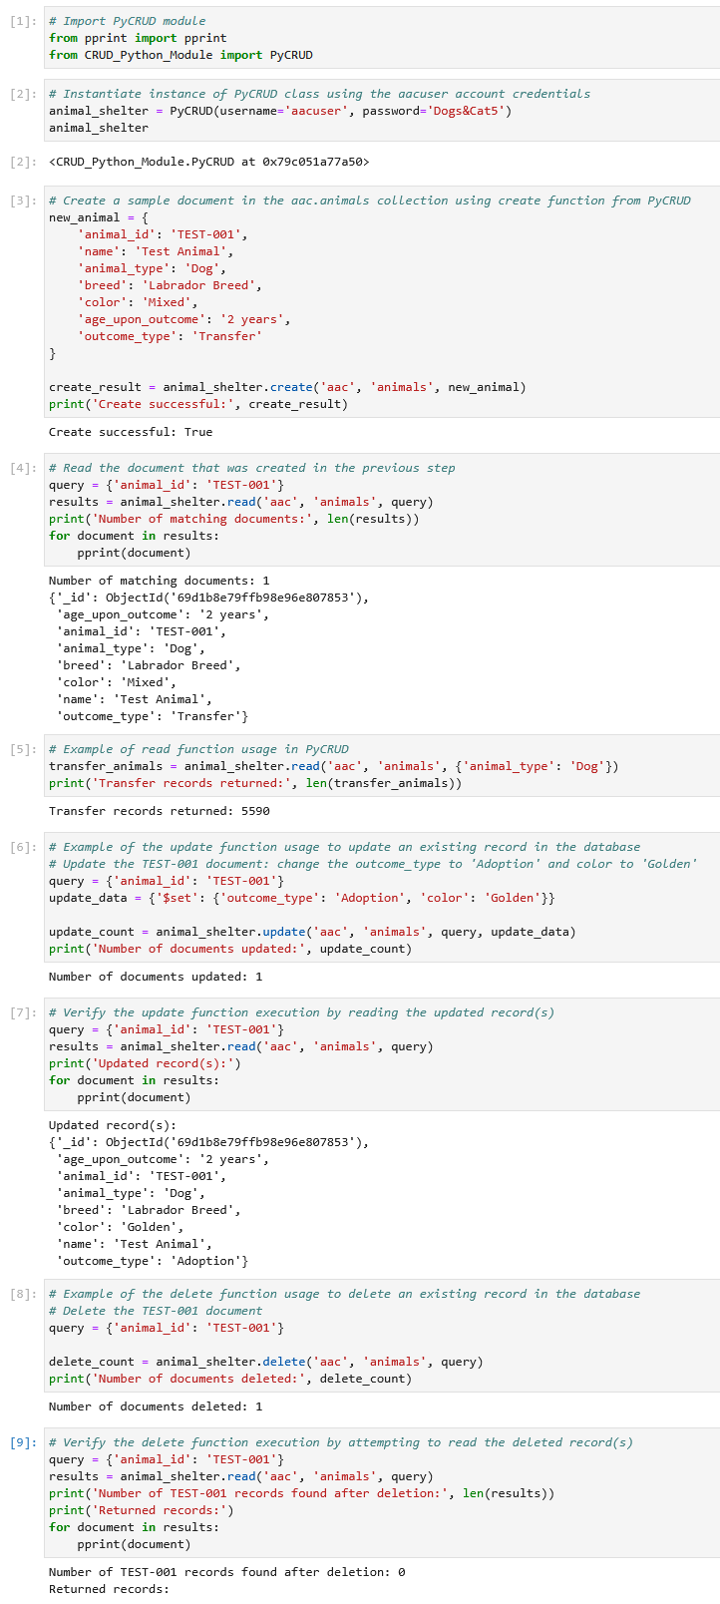

Required Functionality (Client Requirements)
Client requested dashboard that allows users to identify dogs that are good candidates for search-and-rescue training. The dashboard must connect to the Austin Animal Center Outcomes data stored in MongoDB and provide an intuitive, user-friendly interface that reduces user errors and training time. Required features include interactive filters for Water Rescue, Mountain or Wilderness Rescue, Disaster or Individual Tracking, and Reset (returns all widgets to their original, unfiltered state). When a filter is selected, the data table, geolocation chart, and secondary chart (pie chart in this implementation) must update dynamically to match the selected rescue category. Rescue dog filtering should be based on client provided criteria such as breed, sex, and training-age requirements for each rescue type.

Requirements Demo Screenshots

Startup (default state)
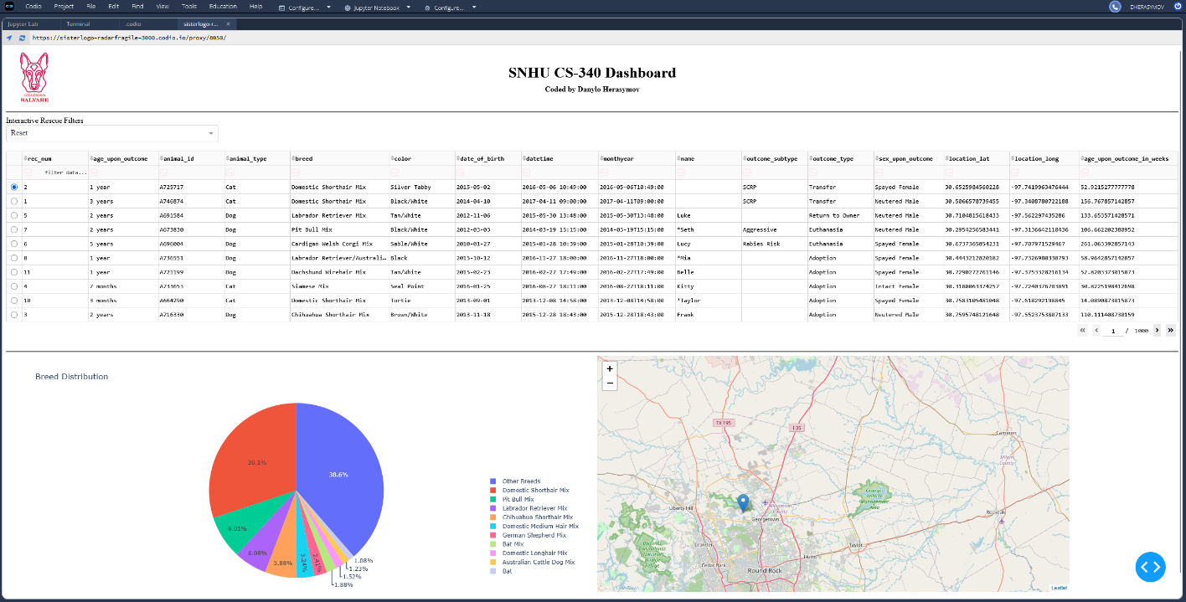

Water Rescue
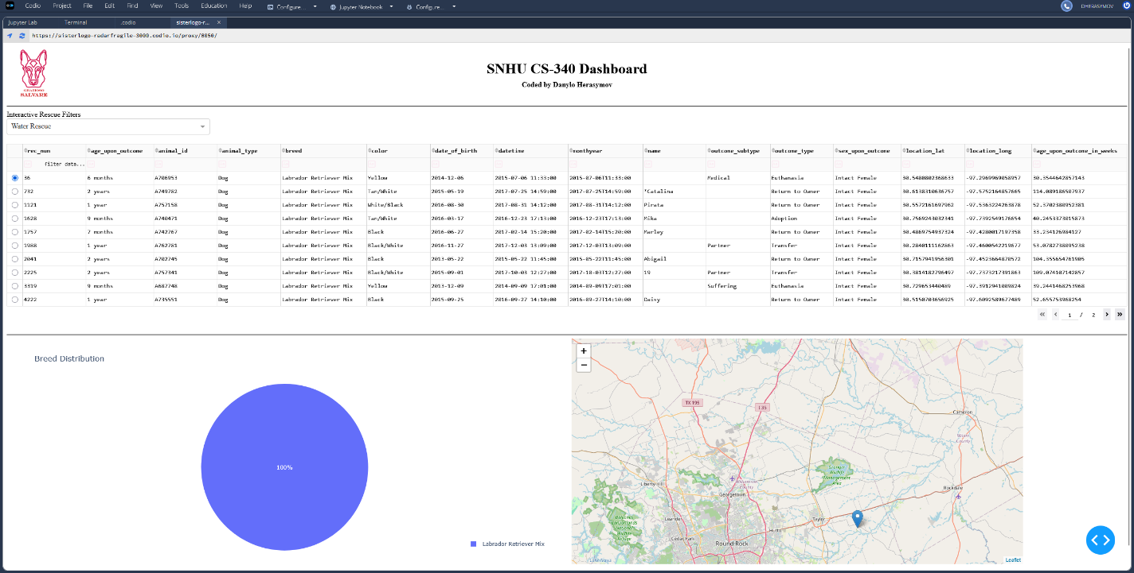

Mountain or Wilderness
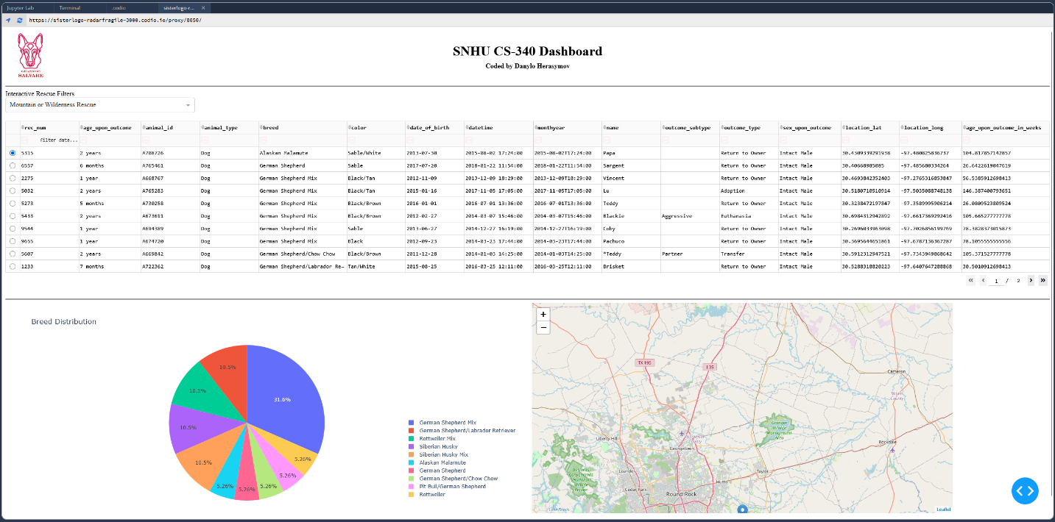

Disaster Rescue or Individual Tracking
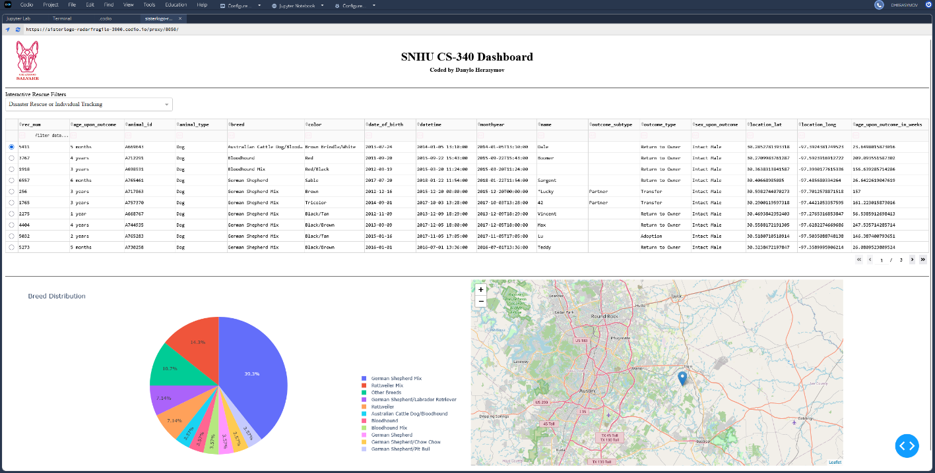

Reset
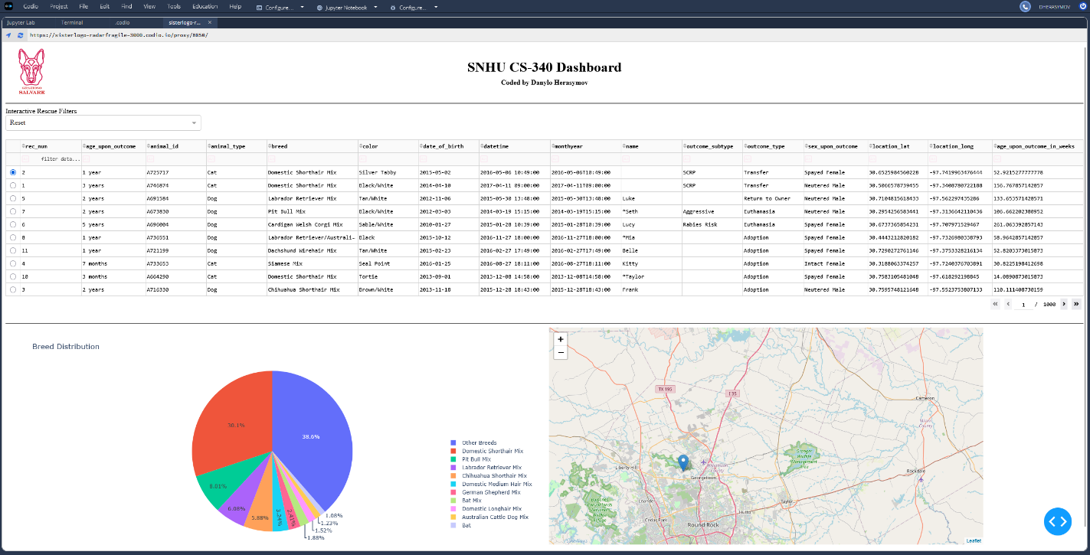

Reasoning behind using MongoDB as the model component
MongoDB was used as the model component because it’s capable of storing the animal shelter data in a flexible document-based format that works well with varied nature of data in multi-species dataset. Additionally, it connects easily with Python through libraries like PyMongo, allowing the application to create, read, update, and filter database records using Python code and Mongo document queries. This makes it a good choice for querying dog data by breed, rescue type, age, sex, and other fields needed by filters in the dashboard. Overall, it’s just a robust solution that fits project requirements and limitations well.

Dash framework for views and controllers
Dash framework provides functionality to quickly and relatively easily build the views and controllers using Python and Jupyter Notebooks. The views are created through Dash provided components such as tables, buttons, charts (geolocation, pie, etc.), while the callback functions allow to implement controller part of the app. Dash callbacks respond to user actions, such as selecting a rescue filter from dropdown or selecting entry from table, and then perform defined actions such as updating the dashboard’s table and charts with the correct data acquired from MongoDB query results.

Used resources and applications
Following resources were referenced during the development:
https://dash.plotly.com/
https://www.mongodb.com/docs/
https://docs.jupyter.org/en/latest/
And PyCharm IDE was used for development and debugging
https://www.jetbrains.com/pycharm/

Steps that were taken to complete the project
Project started with learning MongoDB, setting up the database by loading data into the DB, and creating a user for proper secure access to the data from the model component (PyCRUD). Then, the model component used for interaction with MongoDB, called PyCRUD, was developed in two steps: first, implementing create and read functionality, and second, implementing update and delete functionality. After that, work was focused on creating the initial version of the Dash dashboard with only a table, which was expanded by geolocation and pie charts, along with better design in subsequent updates. The last step was full integration testing and verification of required functionality.

Challenges encountered and their resolution
Overall, development was relatively smooth, and aside from several minor bugs in the dashboard that were quickly resolved, no issues arose throughout development. The biggest challenge encountered was adapting to the project tech stack from the MS SQL and C# combination I’m used to, but through referring to documentation and embracing the strengths of MongoDB and Python, I was able to relatively quickly get up and running even though I’m not as proficient with them. Thoroughly reading documentation and spending enough time with learning materials was enough to successfully implement all the required functionality without major bugs.

Contact
Danylo Herasymov (danylo.herasymov@shnu.edu)

