How to create new virtual Machine (Kali Linux)

1. Download virtualBox and Kali linux .iso file. Save the Kali Linux iso somewhere you can find it. These are found in the resources folder.
2. Open virtualBox.
3. Select “New” in top left corner

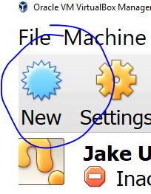

1. Type any name you prefer. Select “Linux” from the “type” drop down. Select “Other Linux 64 Bit” from the “Version drop down. Note, most systems are 64-bit but you should check your personal computer before selecting 32-bit or 64-bit.
2. Select memory in green space. It is helpful to have a large amount of memory available, but not required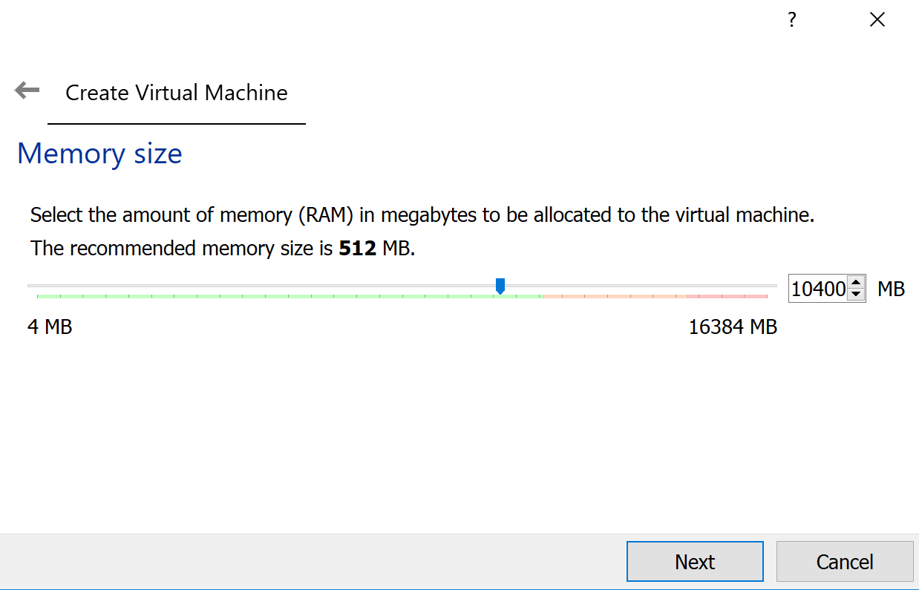
3. On the next screen, make sure “Create a Virtual Hard disk now” is selected. Then click “create.”
4. On the Hard Disk File Type screen, make sure VDI is selected, then click next.
5. On the next screen, make sure dynamically allocated is selected, then click Next.
6. On the “File location and size” screen, do not change the file location. Move the scrolling bar below so that the number at right is greater than or equal to 20 gigabytes (using plenty extra will not hurt, I use around 40 gigabytes). Click create.
7. You have now created the virtual environment. The next step will be to populate it with an operating system. In our case, this operating system will be either Kali Linux or Windows XP, depending on what we are doing. This example shows Kali Linux.
8. Select your new virtual box so that it is highlighted blue like below, then click the settings icon at the top of the window, next to “new.” 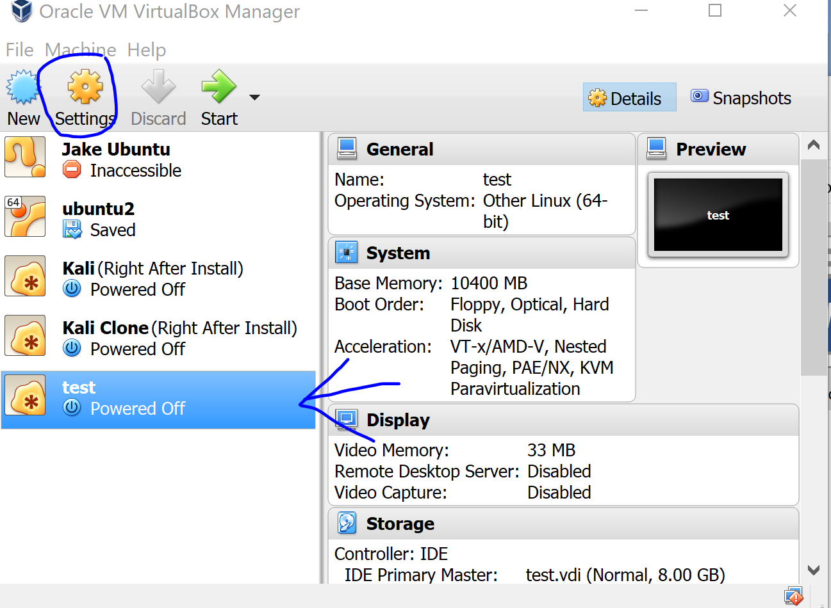
9. Click the “System” section. Once at system select the “Processor” tab. Change your processor slider bar to 2 CPUs (as long as it is still green on your computer as shown below). 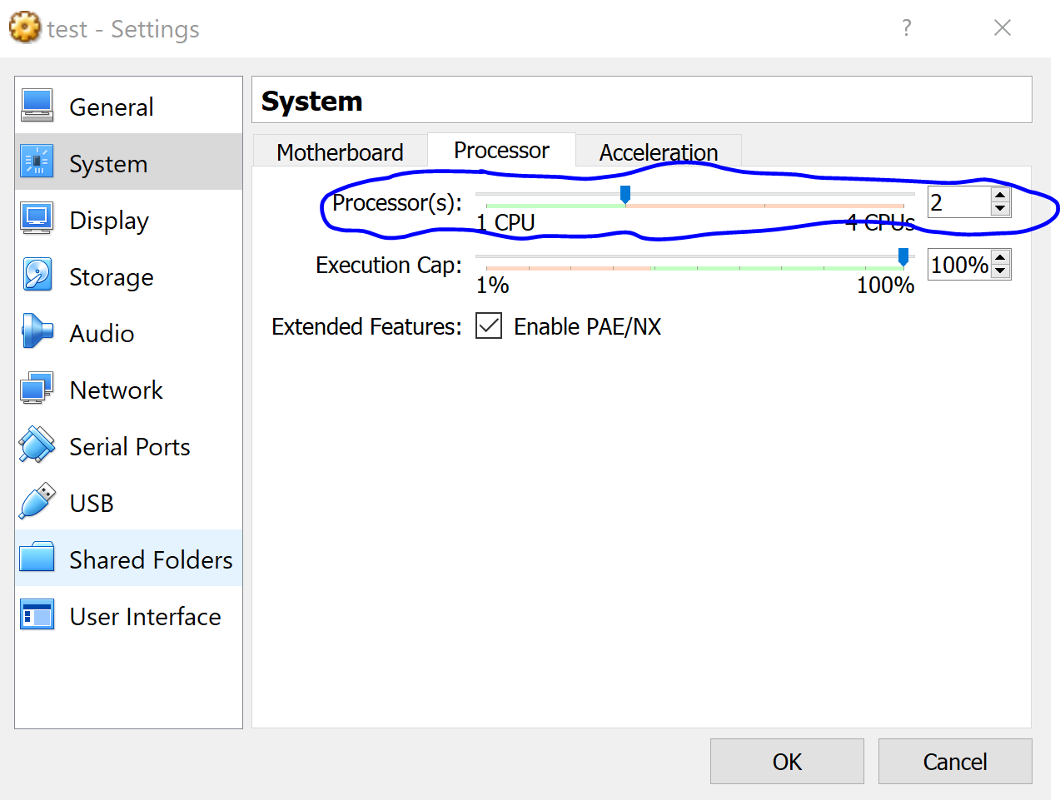
10. Go to the “Display” section. Check the box for “Enable 3D Acceleration. This allows the virtual box to slightly accelerate its speed. 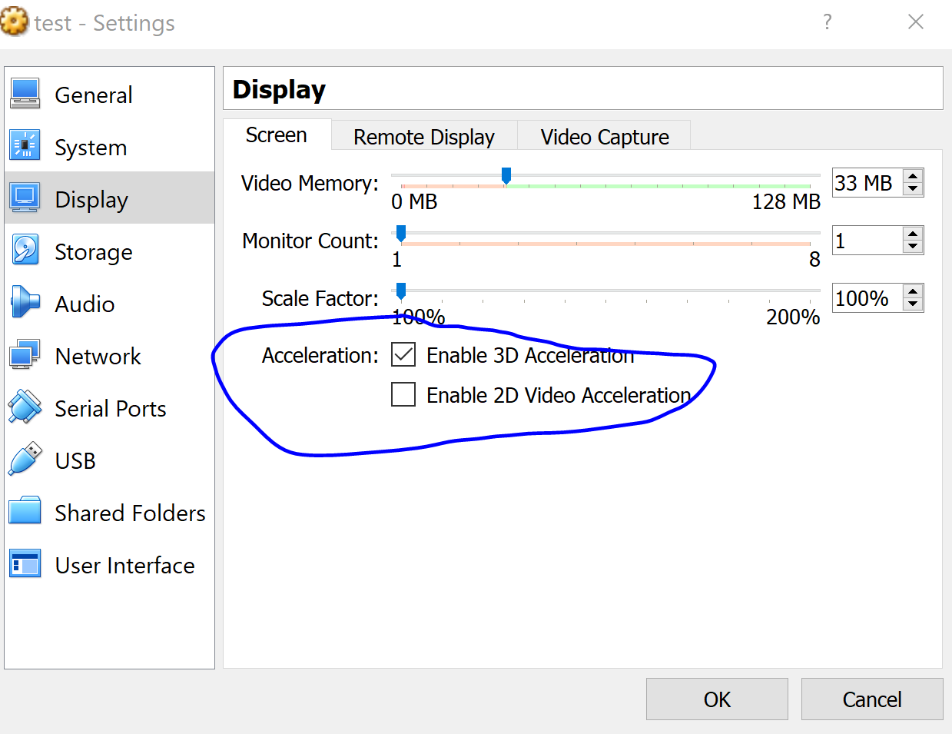
11. Go to the “Storage” section. Click the empty disk image as shown below. Then click the disk Icon at the right of the screen next to the optical drive dropdown box. Select “Choose virtual optical disk file…” then, find the Kali Linux or Windows XP iso file that you downloaded at the beginning of this tutorial. Select it. Then press ok. Demo below. 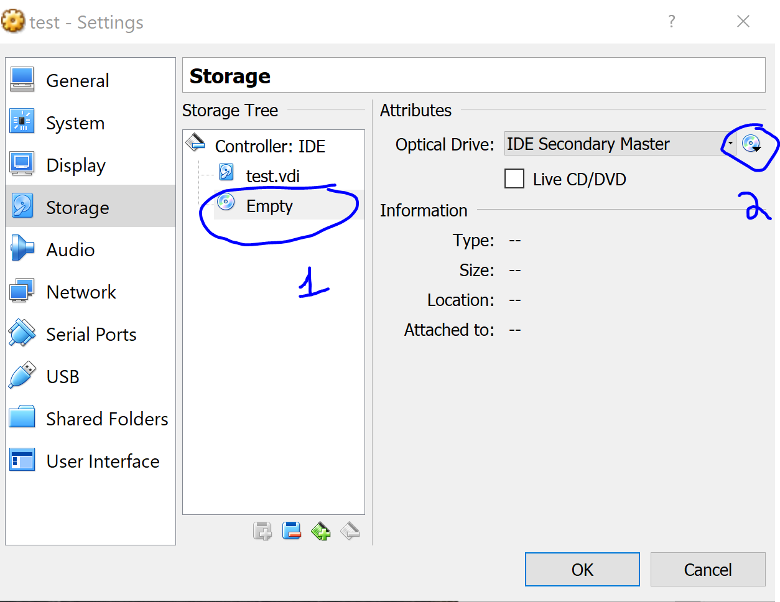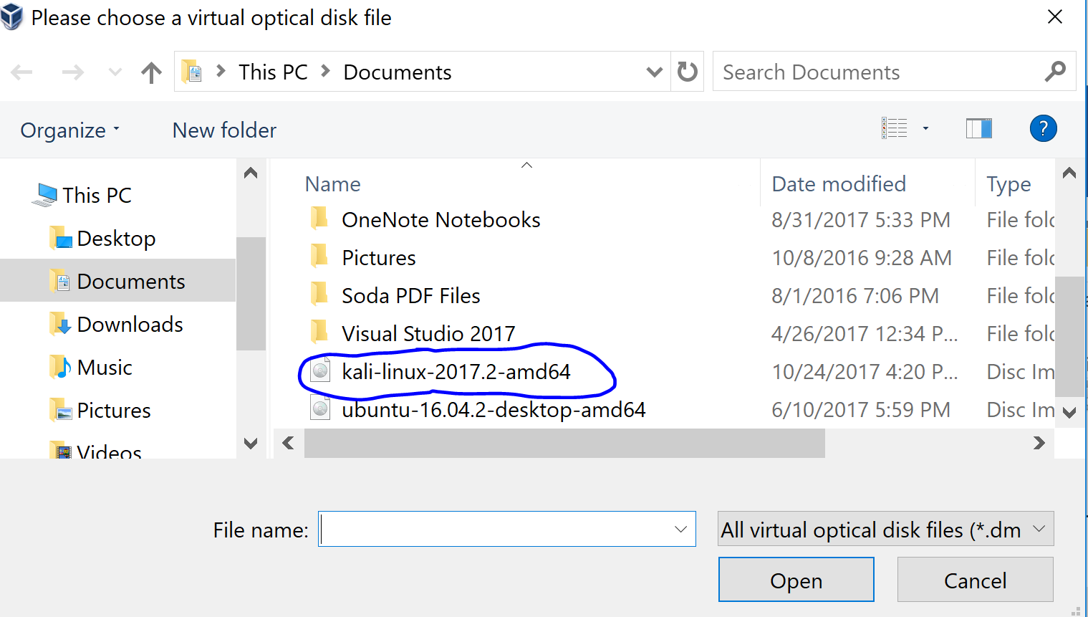
12. You now have a kali linux virtual machine! Select it and click the start button at the top of the virtual box window to jump in. Part II of this guide will guide you through installation, but for now, once the virtual box has been launced, use your key arrows to scroll down to graphical install, press enter, and then follow these instructions found on the following link, starting from page/step 5: https://www.blackmoreops.com/2014/04/08/detailed-guide-installing-kali-linux-on-virtualbox/5/