First Week Assignment

P22.c:
The printf has an unexpected result. C arithmetic works in such a way that the result of the operation is of the "biggest" variable type. Every variable is momentarily promoted to the largest variable type. We are then saving a double inside an int, which is smaller. We will lose the decimal part and hence we will have 14 printed. It is like using C function floor(). In the second case, we will get the expected result, as a double is stored in a double, leading to no lose of information.

P23.c:
The array A in memory would look like:
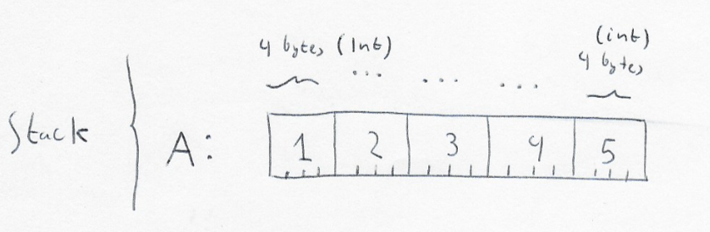

Pablo Collado Soto

