FIT5140 Assignment 3B Design Report

# Introduction

The "Control The World" project built by Qiwei Wang and Kang Meng is an IoT based remote control system. The system supports instant command execution, task scheduling, voice control, and command management. The system uses an iOS application for user input and interaction, the iOS application is connected to the Raspberry Pi via firebase. The overall architecture is shown below.

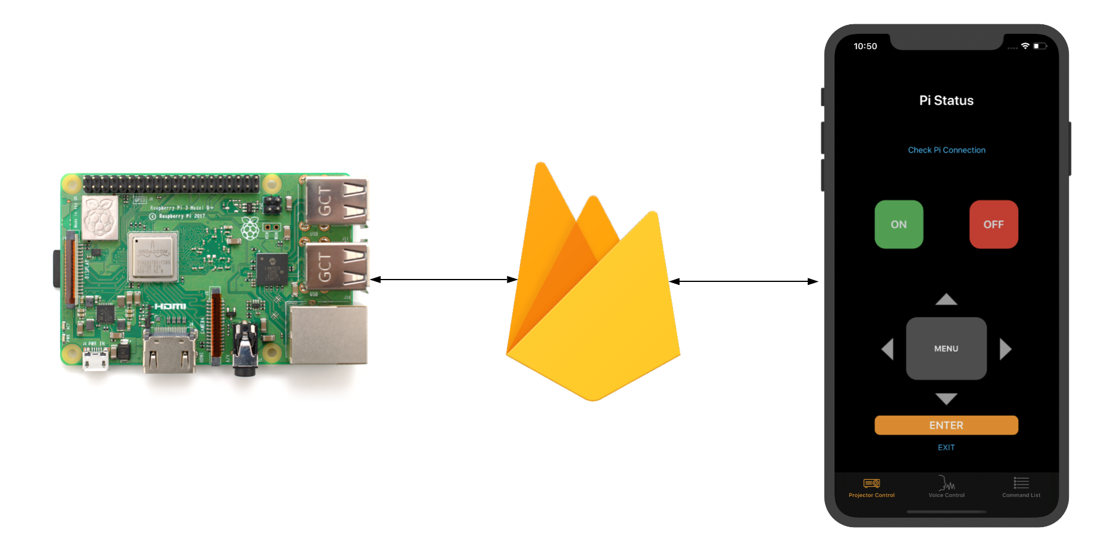

# Raspberry Pi Design

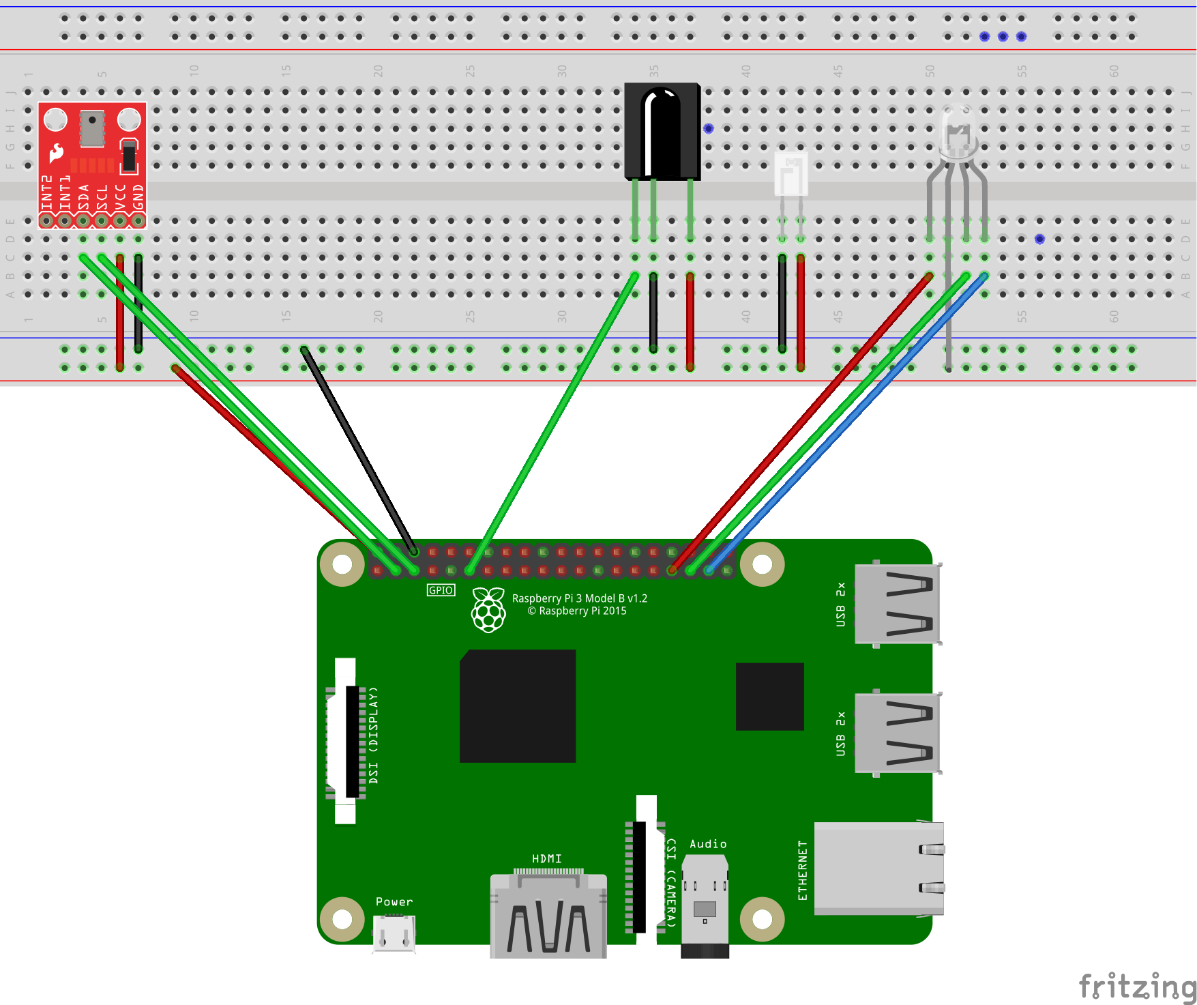

The Raspberry Pi side uses several sensors for input and output. Including:

* MPL3115A2 Altimeter: reading the ambient temperature.
* IR receiver: receiving signals from actual remotes and decode the signals.
* IR transmitter: sending the decoded IR signals.
* RGB LED: Indicating the program’s running status.

# iOS Application Design

The mobile application contains 4 major functionalities of the project.

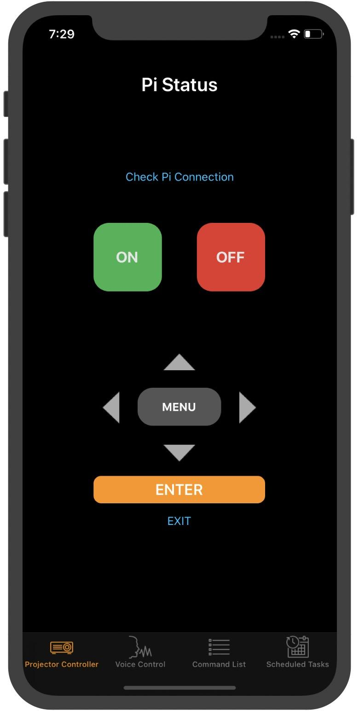

A fully functional remote control for NEC projectors.

Users can also check the communication between the application and raspberry pi.

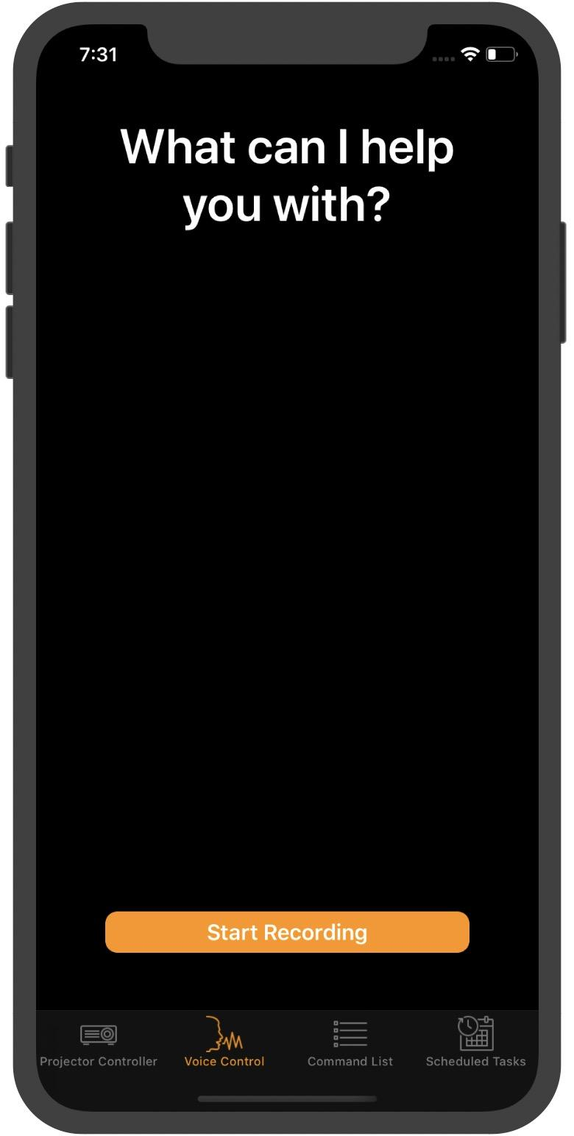

Use voice recognition to execute commands .

The recorded sound will be analyzed by Apple’s Speech Kit, and the recognized text will be used to look up commands stored in Firestore. Should a command found in Firestore, the respective IR signal will be sent by the raspberry pi.

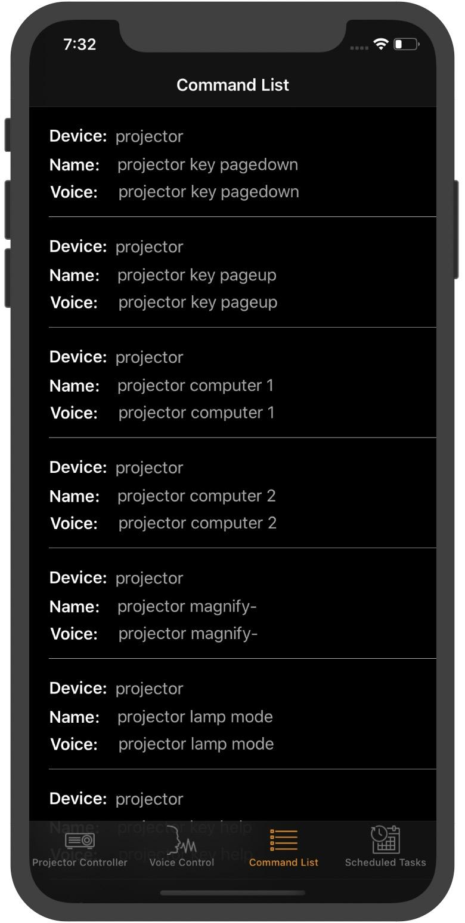

Command management

All remote control commands can be viewed as a list. Users can choose to modify the command’s voice control command.

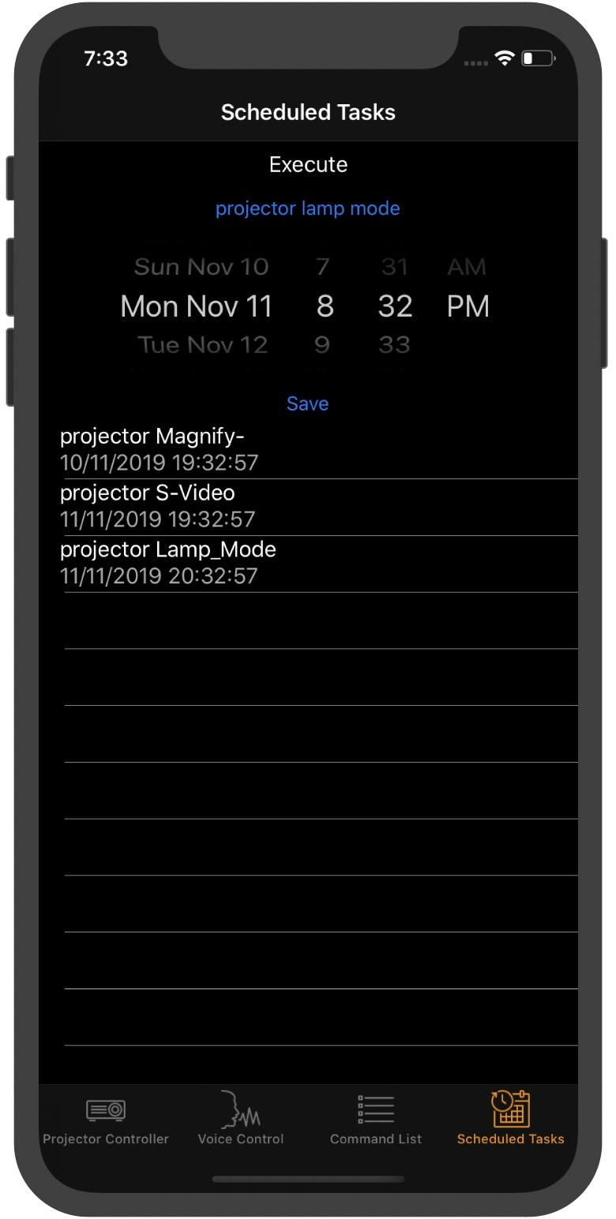

Scheduled tasks

Users can schedule delayed tasks by choosing the desired command and the execution time.

# 

# 

# 

# 

# Libraries

* LIRC: a command-line tool to decode and send infra-red signals. The package is used to record and decode signals from real remote controls as well as transmit recorded commands.
* py_irsend: A Python wrapper for LIRC’s irsend function. The module is used in the raspberry pi side’s Python code to send out IR signals programmatically.
* gpiozero: A interface to GPIO devices with Raspberry Pi. This Python module is used to control the RGB LEB’s color to indicate the status of the program.
* Speech Kit: An iOS development tool kit for audio recording and speech recognition. It is used for the voice recognition function on the application side.
* Threadings: Used to open multiple threadings to handle scheduled tasks. In raspberry pi’s Python code, the threadings are managed in a dictionary, so that the threadings can be retrieved and canceled if the user wishes.