The POSDA DICOM Pseudo Phantom Generator
Introduction
The POSDA Pseudo Phantom generator is a tool used for generation of geometrically ideal DICOM data sets. These data can be used for testing DICOM implementations. The approach used is to define a configuration file format which allows 3D geometric structures to be defined. When the structures are defined, then there is a program which will render a number of DICOM images according to the definitions contained in the configuration files. Currently, this packages allows generating the following kinds of related Series of CT’s and PET’s in the same or different frames of references. It also allows rendering of Spatial Registration objects which translate between different rendered frames of reference. Thus it is possible to render a CT series in one frame of reference, a PET (based on the same structures) in a different frame of reference, and a REG object which registers these frames of reference.
The Pseudo Phantom generator is written in perl, and absolutely no consideration has been given to make it run efficiently. Therefore it runs slowly. Very slowly.
Using the Pseudo Phantom Generator
To use the Pseudo Phantom generator, you first install POSDA (see PosdaInstallation.pdf). The POSDA Installation will include two applications related to Pseudo Phantom Generation:
  - TestPseudoPhantomConfig.pl
  - CreatePseudoPhantom.pl
The first application parses and dumps a configuration file. The second actually renders the Pseudo Phantoms based on the config file. Before attempting to render a set of Pseudo Phantoms using CreatePseudoPhantom.pl, make sure that TestPseudoPhantomConfig.pl can parse and dump the configuration files without producing any error or warning messages.
Quick Start
When you install POSDA, there is a configuration directory installed. This configuration directory contains a number of sample configuration files for rendering Pseudo Phantoms.
Assuming that POSDA is untar’ed in a the $HOME/Posda directory, first edit the file $HOME/Posda/config/test to change the line that says:
base_dir|<base config directory>
to have the full path $HOME/Posda/config. For example, if $HOME is /Users/bbennett, then the line should be changed to:
base_dir|/Users/bbennett/Posda/config
Then do the following:
cd $HOME/Posda
mkdir foo
TestPseudoPhantomConfig.pl $HOME/Posda/config/test $HOME/Posda/foo >out.txt
<note that no warnings or errors are produced - you can also look at out,txt to see what was parsed>
rm -rf foo/*
CreatePseudoPhantom.pl $HOME/Posda/config/test $HOME/Posda/foo
This Phantom Creation takes about 8 minutes on my 12 inch powerbook. YMMV
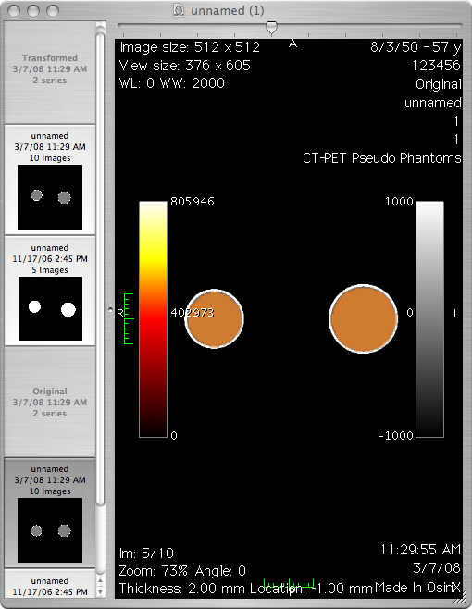
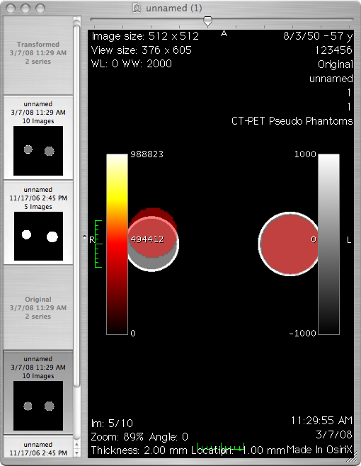
This should create two studies, each of which has a CT series, a PT series and a REG series. The CT series and PT series represent a pair of spheres, one at (-175,0,0) and one at (175,0,0). The sphere on the right (-175, 0, 0) has an outer radius of 70 mm and an inner radius of 65 mm. Between the inner radius and outer radius, the density is that of bone. Inside the inner radius, the density is that of water. The sphere on the left has an outer radius of 60 and an inner radius of 55 mm. The PETs are rendered with a very high number of counts within the inner radius of each sphere. If you fuse the CT and PET in the same frame of reference in OsiriX, then the result should be as shown to the right.

However if you take the PET from the rotated Study and fuse it with the CT from the unrotated study, the 5 degree rotation shows up, as shown to the right,
Understanding the Config file
There are several examples of configuration files in the config directory. There are three types of configuration files:
  - Render config files - the file passed on the command line which specifies what to render
  - Study config files - referenced from the render config file, supplies DICOM header information related to the study being rendered.
  - Series (modality) config files - referenced from the render config file, supplies DICOM header information related to the series being rendered.
Render config files have render commands which are pipe-separated text. The type of command is always in the first field. The following commands are supported:
  - base_uid|<uid> - specifies a UID root to be used for generating UID’s when required during rendering. Running more than once with the same UID root will generate files with the same UID, so be careful.
  - posda_arg|<key>|<value> - if you don’t supply a base_uid, then one will be dynamically obtained from posda.com. This allows you to specify information to be supplied to posda.com about the usage of the UID.
  - base_for|<for name> - Establishes a frame of reference in which objects can be placed.
  - base_dir|<path> - Define the directory in which all config files will be found.
  - named_obj|<name>|<type>|<for>|<parms> - Creates an object with the specified name of the specified type in the specified frame of reference (for). Parameters (parms) vary by type.
    - sphere - |<center>|<radius>
defines a sphere with the specified center and radius.
    - cylinder - |<top>|<bottom>|<radius>
defines a cylinder of the specified radius around a line from top to bottom.
    - rect - |<center>|<height>|<width>|<length>
defines a rectangular solid with the specified center, height, width, and length.
    - cone - |<top>|<bottom>|<slope>
defines a cone. The point is at top, the base is a circle centered at bottom. The radius of the base is the distance from top to bottom multiplied by slope.
  - For what its worth, these objects become objects in the “OO” sense. They are all also HASH objects, and have a hash element “properties”, which is itself a hash containing the object properties (as defined in set_obj_list_prop below).
Each object class has the following methods:
    - new(<variable parms based on class>) - create an object.
    - In(<point>) - Return 1 if the point is inside the object, 0 otherwise.
    - Dist(<point>) - Return the distance to the center of the object
    - XformCopy(<xform>)
    - DumpGuts(<indent>)
  - obj_list|<name>|<list> - creates a list of objects names. Objects exist within frames of references, but lists of names are independent of frames of references. These lists are ordered. Order is important for rendering (the first object encountered may be the only one rendered).
  - combined_obj_list|<name>|<list> - creates a new list of object names from a list of other lists.
  - set_obj_list_prop|<for>|<prop_name>|<prop_value>|<list> - assigns a property to all of the objects in the specified frame of reference with a name which is in the specified object name list. The name and value are arbitrary, but meaningful to various rendering routines.
  - transformed_for|<from_for>|<to_for>|<list> - creates a new frame of reference which is related to an existing frame of reference by the transforms specified in the list. The following primitive operations are supported in the list:
    - shift=(<x>, <y>, <z>)
    - rx=<d>
    - ry=<d>
    - rz=<d>
  - xform_obj_list|<from>=><to>|<list> - Copy objects from one frame of reference to another, applying the appropriate transform so that they remain in the same “ethereal” location.
  - study|<id>|<for>|<config>|<dir>|<desc> - Define a study for rendering objects, with specified id, fame of reference, config file name (in base_dir), and study description.
  - series|<id>|<num>|<config>|<dir>|<type>|<list> - Define a series to be rendered, with the specified study_id (invokes information from study configuration), series number, config file (in base_dir), and specified list of objects (in the frame of reference defined by the study). They type parameter defines what kind of series is to be rendered. The following forms are currently supported:
    - CT(<slice_spacing>,<num_images>,<volume_center>)
    - PT(<slice_spacing>, <num_images>, <volume_center>)
    - REG(<from>=><to>,...)
Rendering Multi-Image Series (CT’s and PET’s)
CT’s and MR’s are both rendered by the function defined in $GenerateSeriesOfImages (in the file include/Posda/PseudoPhantom.pm). This is a “Series Generator”. The set of “Series Generators” is indexed by series type in the hash $SeriesGenerators in the file include/Posda/PseudoPhantom.pm. A “Series Generator” has the following parameters:
  - study_id
  - series_id
The “Image Orientation (Patient)”, “Rows”, “Cols”, and “Pixel Size” elements from the series config file, are used, in conjunction with with the “volume_center”, and “num_images” and “slice_spacing” from the config file to determine the “Image Position (Patient)” of each image in the volume. The pixel data for the image is generated by calling the “Pixel Plane Generator” (if you are into looking at code, look at $PixelPlaneGenerator in the file include/Posda/PseudoPhantom.pm) for the specified modality. The Pixel Plane Generator needs to know the following:
  - $rows - number of rows in the image
  - $cols - number of columns in the image
  - $iop - Image Orientation (Patient)
  - $ipp - Image Position (Patient)
  - $pix_sp - Pixel Spacing
  - $for - Frame of Reference
  - $obj_list - List of Object Names
A Pixel Plane Generator returns four values:
  - $pixel_data - List of Object Names
  - $pixel_representation - List of Object Names
  - $slope - List of Object Names
  - $intercept - List of Object Names
CT Pixel Plane Generator
For each pixel in the volume, the value is calculated by executing the “Density Generator” function for the specified modality (check $DensityGenerators in the file include/Posda/PseudoPhantom.pm).
CT Density Generator
The CT density generator works by going down the object list, in order until it finds the first object that the point is inside of. It returns the ct_density property of this object. If none is found it returns the -1000 (the density of air). It will print a message to STDERR if it encounters an object with no ct_density property.
PT Pixel Plane Generator
For each pixel in the volume, the value is calculated by executing the “Density Generator” function for the specified modality (check $DensityGenerators in the file include/Posda/PseudoPhantom.pm). After the values are generated, they are scaled to the maximum dynamic range, and the slope is from this scaling is returned with the pixel data.
PT Density Generator
The PT density generator works by initially setting counts to zero, and then going down the object list. If the point is inside the object, then counts is incremented based on the “pet_count_center”, “pet_count_inner_attenuation”, and “pet_count_inner_attentuation_type” and counts is returned (no further objects are scanned). Otherwise, counts is incremented based on “pet_count_outside”, “count_outer_attenuation”, and “pet_count_outer_attenuation_type” and scanning of objects continues. If scanning of objects completes (the point is outside all objects, counts is returned (having some presumably small value).
Way over complicated, I was just having a little fun.
Rendering REG’s (Spatial Registration Objects)
The object list doesn’t matter, and needn’t be present. The parameters need to be a list of transformations in the form <from>=><to>, where <from> and <to> identify frames of reference. A spatial registration object will be rendered for each parameter, with a transform from the <from> frame of reference to the <to> frame of reference in the proper place.

