OpenDC-LCA: an open, evidence-gated framework for reproducible life-cycle and climate-performance analysis of data-center cooling
Han Hu and Darin W. Nutter
Department of Mechanical Engineering, University of Arkansas, Fayetteville, Arkansas, USA
Draft for coauthor review. Authorship, order, contributions, target journal, and corresponding-author information must be confirmed before submission.

Abstract
The rapid growth and increasing power density of cloud infrastructure have made cooling architecture a consequential design variable for data-center energy use, water consumption, material demand, and greenhouse-gas emissions. Published life-cycle assessments have demonstrated the potential value of cold plates and one- and two-phase immersion cooling, but independent analysis is limited by heterogeneous data formats, licensed background inventories, confidential equipment data, annual-average operating assumptions, and weak separation between illustrative calculations and evidence suitable for comparative claims. We present OpenDC-LCA, an open-source Python framework that connects traceable lifecycle inventories, public grid and climate data, and laboratory or simulated cooling-performance maps. The framework implements a common functional unit, explicit system boundaries, annualized and discrete replacement models, hourly weather-load-performance integration, uncertainty and sensitivity analysis, and a machine-readable scientific audit that blocks comparative claims when evidence is synthetic or incomplete. As a validation case, OpenDC-LCA reconstructed all 24 normalized totals released with a 2025 Microsoft data-center cooling study; the maximum absolute difference between the reported totals and the sum of their seven released contributions was 1.42 × 10⁻¹⁴ percentage points. For the grid scenario, the released data corresponded to greenhouse-gas reductions of 15.18%, 16.41%, and 20.66% for cold-plate, one-phase immersion, and two-phase immersion cooling relative to air cooling. A second demonstration coupled 8,760 typical-meteorological-year observations for Fayetteville, Arkansas with explicit, hypothetical temperature-PUE curves and an EPA eGRID factor. A third demonstration used complete synthetic load-temperature surfaces to verify bilinear interpolation, uncertainty propagation, and no-extrapolation safeguards. The latter demonstrations are intentionally labeled hypothesis-generating or synthetic and cannot support technology comparisons. OpenDC-LCA therefore contributes not another generic LCA database, but a transparent and extensible interface between data-center cooling physics, lifecycle inventories, temporal operation, and reviewable environmental claims.
Keywords: data center; cooling; life-cycle assessment; PUE; immersion cooling; liquid cooling; reproducibility; open-source software

1. Introduction
Data-center thermal management is changing as compute density increases and operators pursue lower energy and water burdens. Air cooling remains common, whereas cold plates, single-phase immersion, and two-phase immersion shift heat removal toward liquid loops and can alter pumps, fans, heat-rejection equipment, coolants, racks or tanks, building systems, and server configuration. A credible comparison must therefore extend beyond cooling power alone. It must preserve equivalent computational service, apply consistent boundaries, include equipment and fluid lifecycles when they differ, and disclose the conditions under which the cooling system operates.
Alissa et al. used life-cycle assessment (LCA) to compare data-center cooling architectures and showed how design choices, electricity supply, equipment, buildings, servers, and fluids contribute to primary energy, greenhouse-gas (GHG) emissions, and blue-water consumption [1]. Their publication and released model archive provide an unusually valuable reference for transparent data-center cooling research [2]. At the same time, the study illustrates a broader reproducibility problem. Public source tables allow selected results to be reconstructed, but complete independent replication still requires foreground bills of materials, measured operating data, manufacturer information, and background processes that may be licensed or confidential.
General-purpose LCA software, including openLCA, provides process-network modeling, impact assessment, and database interoperability [3]. OpenDC-LCA is not intended to replace these tools. Its role is narrower and complementary: it defines a domain-specific, inspectable bridge between electronics-cooling measurements and simulations, data-center operating conditions, lifecycle inventory factors, and publishable claims. This bridge is important because a generic LCA model does not by itself determine how a cooling-performance map should be sampled, how hourly weather and workload should be aligned, when extrapolation is unacceptable, whether IT service is functionally equivalent, or whether a result derived from synthetic data can be communicated as a technology comparison.
The objectives of this work are to:
- define a transparent data model and calculation boundary for screening the
lifecycle impacts of data-center cooling architectures;
- connect laboratory or simulation performance surfaces to hourly climate and
workload data without hiding interpolation or extrapolation assumptions;
- preserve source identifiers, versions, units, geography, evidence status,
and model version in every analysis;
- reproduce released results from a leading data-center cooling LCA as a
calculation and lineage check; and
- prevent numerical completeness from being mistaken for evidentiary
sufficiency through an automated scientific audit and comparative-claim gate.

2. Framework and methods

2.1. Software and evidence architecture
Figure 1 summarizes the OpenDC-LCA workflow. Evidence may originate from published LCA results, public inventories, grid and climate datasets, laboratory measurements, or simulations. Each source record preserves its provider, persistent identifier, version, geography, reference year, declared unit, system boundary, license or redistribution constraint, evidence status, and local checksum. Harmonization is performed before calculation rather than after results are generated. Scenario JSON and performance CSV files remain human-readable and can be processed through the command line, a stable Python API, or a local graphical interface. All interfaces call the same validated calculation engine.
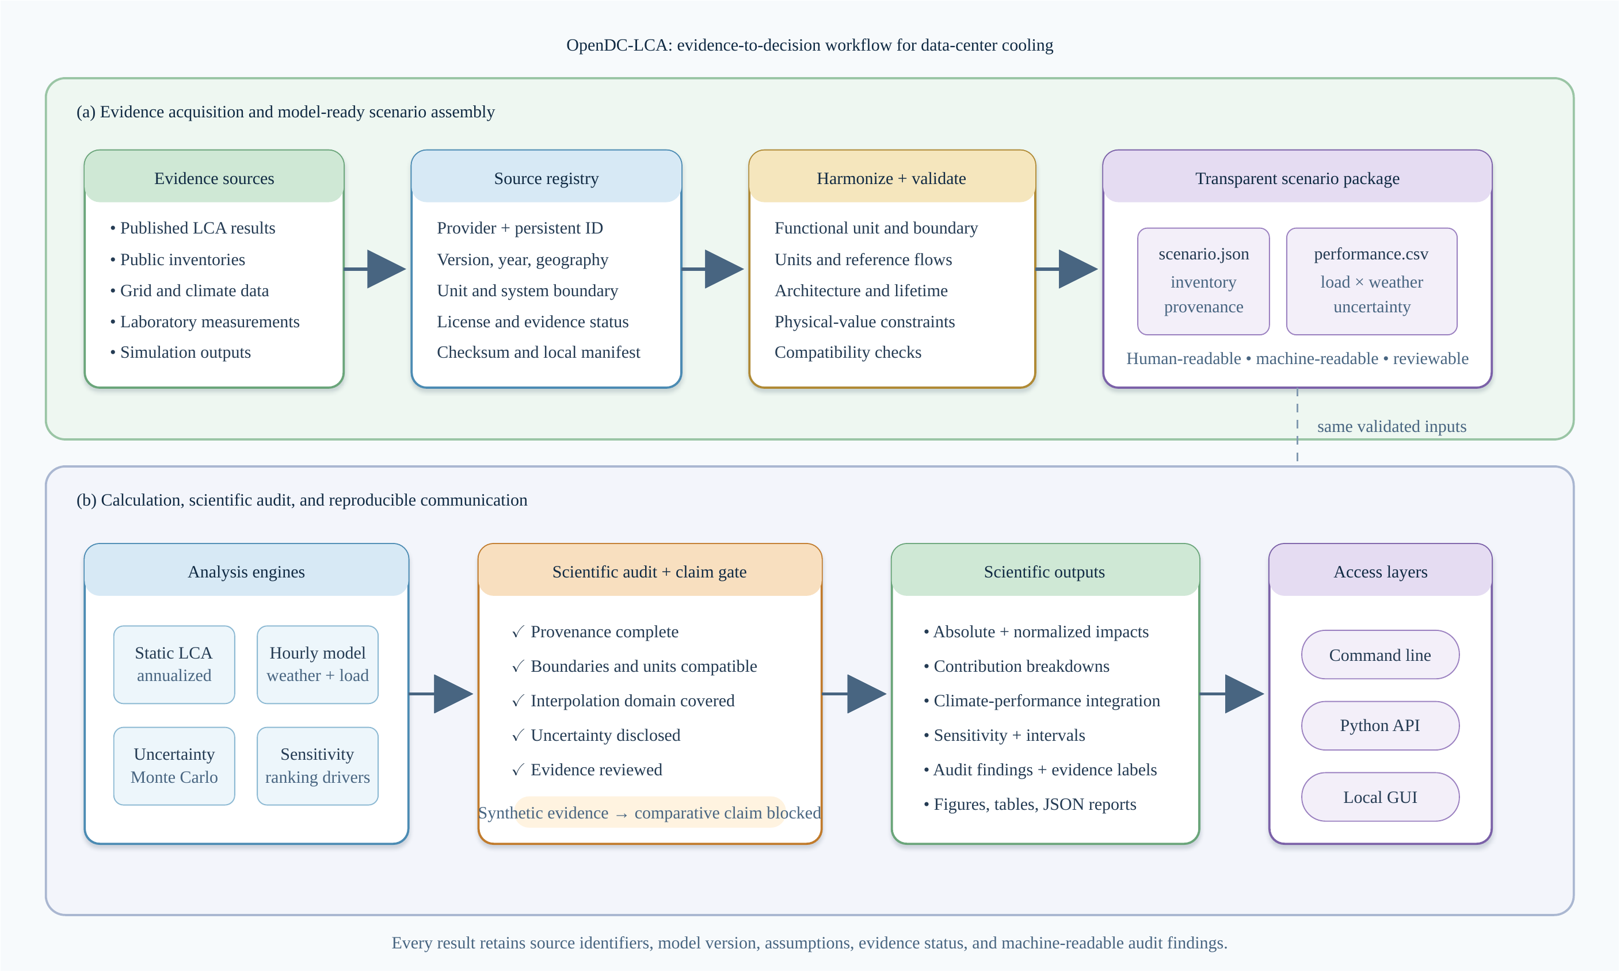
Figure 1. OpenDC-LCA evidence-to-decision workflow. Panel (a) connects heterogeneous published, public, laboratory, and simulated evidence to a registered and validated scenario package. Panel (b) connects the common package to static, temporal, uncertainty, and sensitivity engines; a scientific audit blocks comparative claims when evidence or compatibility requirements are not met.
The framework is implemented in Python 3.10 or later and distributed under the MIT License [4]. Version 1.0 exposes validated scenario analysis, performance-map summarization, scientific audit functions, report generation, and a local browser-based GUI. The GUI binds to the local host by default and does not alter the data model or calculation path.

2.2. Goal, functional unit, and system boundary
The present functional unit is one MWh of electricity delivered to IT equipment (it_mwh). This denominator is valid only when the alternatives provide equivalent computational service, utilization, reliability, and hardware life. If cooling changes compute performance, throttling, server configuration, or replacement, an IT-energy denominator alone is insufficient and absolute results plus a service-based unit should be reported.
The default cooling_system_cradle_to_grave boundary includes cooling and heat-rejection equipment, fluids, represented maintenance and replacement, operation, and end of life. A facility_cradle_to_grave option can include building, electrical, and IT assets. Common systems may be excluded only when their quantities, performance, lifetime, and end-of-life treatment are unchanged between alternatives. Location-based and market-based electricity results are kept separate. On-site water consumption and electricity supply-chain water are also reported separately.

2.3. Static energy and lifecycle calculations
For IT capacity P_IT, capacity factor u, and study duration of one year, annual IT electricity is
E_IT = P_IT u (8760) (1)
Annual facility electricity is
E_facility = E_IT PUE (2)
For an operational impact factor EF_k for category k, the operational impact normalized by delivered IT electricity is
I_k,op = EF_k PUE (3)
Equipment production and end-of-life burdens may be annualized with a discrete replacement model:
I_k,eq = Σ_i q_i ceil(L_s/L_i) (I_k,i^prod + I_k,i^EOL) / L_s (4)
where q_i is component quantity, L_s is the study period, and L_i is component service life. A linearized option is retained for screening. Negative end-of-life factors are permitted only for explicitly documented recovery or substitution credits.
For a cooling fluid with initial mass m_0, facility life L_f, annual loss m_loss, production factor I_k^fluid, and direct GWP GWP_direct,
m_prod,annual = m_0 / L_f + m_loss (5)
I_k,fluid = m_prod,annual I_k^fluid; GHG_direct = m_loss GWP_direct (6)

2.4. Performance-map and temporal integration
Each performance-map row records architecture, test identifier, IT load, heat removed, coolant temperatures, flow, pressure drop, pump power, fan power, CDU power, heat-rejection power, on-site water rate, dry- and wet-bulb temperature, duration, measurement uncertainty, and source identifier. Aggregate metrics are energy-weighted rather than arithmetic averages of ratios.
The measurement-ready interface uses a complete rectangular surface over IT load P and ambient dry-bulb temperature T. For a query point inside one cell of the measured grid, cooling power is evaluated by bilinear interpolation:
Q_c(P,T) = (1-α)(1-β)Q_11 + α(1-β)Q_21 + (1-α)βQ_12 + αβQ_22 (7)
where α=(P-P_1)/(P_2-P_1) and β=(T-T_1)/(T_2-T_1). The same operation is applied to on-site water rate and declared measurement uncertainty. Queries outside the measured domain are rejected; the software does not silently extrapolate.
For hour h, partial PUE and normalized operational GHG are
PUE_h = 1 + Q_c,h / P_IT,h (8)
GHG_op = [Σ_h E_IT,h PUE_h EF_grid,h] / [Σ_h E_IT,h] (9)
The current public-data demonstration uses an annual location-based EPA eGRID factor rather than an hourly or marginal factor. Weather observations are from a NOAA typical meteorological year (TMY) file [5,6].

2.5. Uncertainty, sensitivity, and scientific audit
OpenDC-LCA supports seeded Monte Carlo screening with uniform, triangular, normal, and lognormal distributions for selected continuous parameters. Independent sampling improves reproducibility but does not represent correlation, systematic measurement bias, or model-form uncertainty. One-at-a-time elasticity identifies influential inputs but should not be interpreted as a global sensitivity analysis.
The audit operates on scientific as well as numerical requirements. It checks source completeness, duplicate identifiers, physical values, functional unit, boundary description, evidence status, uncertainty disclosure, and comparative assertion intent. Synthetic or illustrative data must set the comparative assertion to false. A public comparative claim additionally requires decision-grade provenance, consistent boundaries, quantified uncertainty, and independent critical review consistent with the intent of ISO 14040 and ISO 14044 [7,8]. The automated audit supports review but is not an ISO conformity assessment.

3. Data and evaluation cases

3.1. Microsoft/Nature released source data
The validation case used the source data and model archive released with Alissa et al. [1,2]. The tested claim was limited: for each architecture, electricity scenario, and impact category, did the released normalized total equal the sum of the seven released contributions for use phase, building, server, rack or tank, cable, supporting equipment, and cooling fluid? The audit covered four architectures, two electricity scenarios, and three metrics, for 24 totals. It did not independently recreate licensed background inventories, manufacturer data, confidential bills of materials, measured PUE values, or the complete virtual-core model.

3.2. Public grid and climate data
EPA eGRID 2023 supplied the Arkansas state total-output emission rate STC2ERTA, 452.881 kg CO2e per MWh [5]. This annual factor is location-based and cannot be interpreted as marginal, hourly, or market-based. NOAA TMY data for the station nearest Fayetteville supplied 8,760 hourly weather observations [6]. The hourly preview combined these observations with explicit piecewise-linear temperature-PUE hypotheses. These curves are not measurements.

3.3. Measurement-surface software fixtures
Complete air-cooled and direct-to-chip load-temperature surfaces were generated as synthetic fixtures to test input validation, bilinear interpolation, uncertainty bounds, hourly workload-weather alignment, and annual aggregation. Both datasets carry evidence_status = synthetic, and the machine-readable output sets comparative_claim_allowed = false. Their difference is a software test, not a finding about cooling technologies.

3.4. Additional registered evidence
The source registry also documents USLCI v1.2026-06.0, ÖKOBAUDAT 2024-II, Boavizta ICT factors, seven NREL hydrogen datasets accessed through GLAD and the Federal LCA Commons, and USGS watershed data [9-13]. These sources establish future adapters for equipment, building, backup-power, embodied ICT, and water context. Registration does not make datasets automatically compatible; geography, reference year, unit, product system, impact method, and allocation must be harmonized for each study.

4. Results

4.1. Exact reconstruction of released normalized totals
All 24 Microsoft/Nature released totals were reconstructed by summing the seven released contribution categories. The maximum absolute disagreement was 1.42 × 10⁻¹⁴ percentage points, consistent with floating-point representation. Figure 2 summarizes the grid-scenario reductions relative to air cooling.
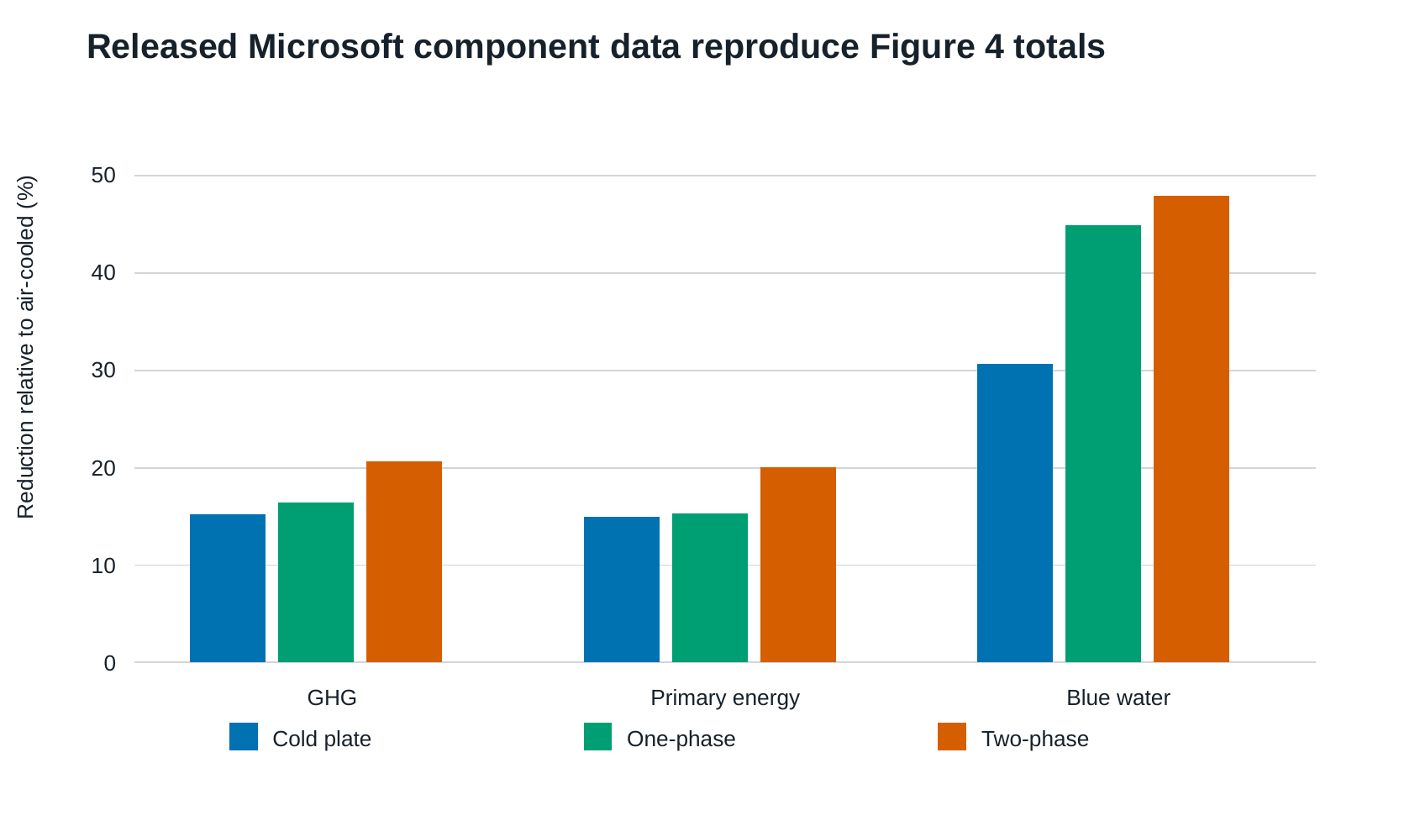
Figure 2. Reconstructed reductions relative to the air-cooled case for the grid scenario in the released Microsoft/Nature source data. Values are derived from published normalized component contributions and validate arithmetic consistency, not proprietary background inventories or foreground bills of materials.
For primary energy, the released data gave reductions of 14.98%, 15.33%, and 20.05% for cold plate, one-phase immersion, and two-phase immersion, respectively. Corresponding GHG reductions were 15.18%, 16.41%, and 20.66%. Blue-water reductions were larger: 30.64%, 44.94%, and 47.88%. Under the released 100% renewable scenario, the normalized GHG results were substantially lower for all architectures, while the relative ranking and contribution mix remained dependent on embodied and non-electricity terms.

4.2. Hourly climate-performance preview
The Fayetteville TMY ranged from cool winter conditions to hot summer conditions, producing distinct monthly means under the assumed temperature-PUE curves (Figure 3). Annual mean PUE values were 1.0907 for air cooling, 1.0529 for cold plate, 1.0406 for one-phase immersion, and 1.0352 for two-phase immersion.
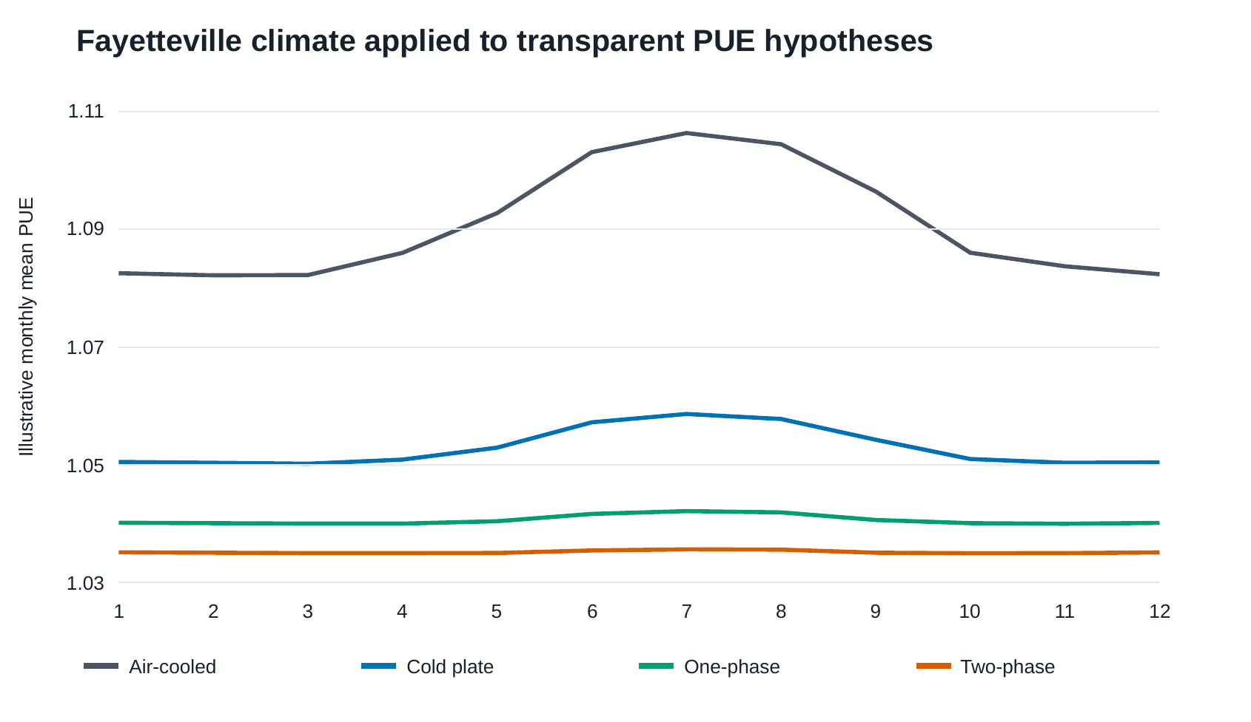
Figure 3. Monthly Fayetteville TMY temperature and mean PUE obtained from explicit piecewise-linear response hypotheses. The curves are not measurements; the figure demonstrates the temporal analysis protocol and defines measurements needed for calibration.
Using the annual Arkansas eGRID factor, the assumed curves produced operational GHG intensities of 493.97, 476.84, 471.27, and 468.82 kg CO2e per delivered IT MWh for air, cold-plate, one-phase, and two-phase cooling, respectively (Figure 4). Relative to the air-cooled hypothesis, the reductions were 3.47%, 4.59%, and 5.09%. These values quantify only the consequences of the stated PUE hypotheses and must not be interpreted as measured architecture performance.
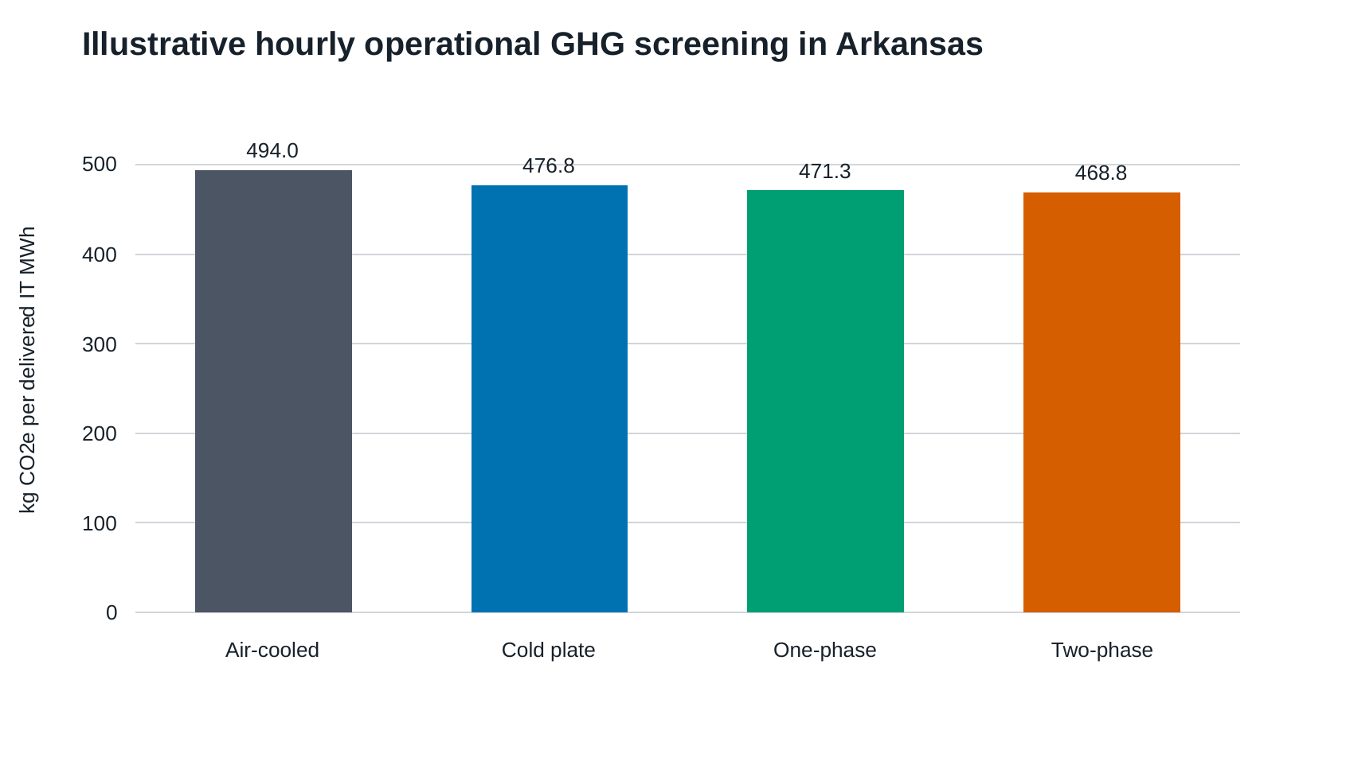
Figure 4. Operational GHG intensity calculated from the Fayetteville TMY, hypothetical temperature-PUE curves, and the EPA eGRID 2023 Arkansas annual total-output factor. Results are hypothesis-generating and exclude embodied impacts.

4.3. Measurement-ready surface demonstration
The synthetic surfaces supplied complete combinations of load and ambient temperature. The engine integrated 8,760 aligned hourly observations without extrapolation (Figure 5). Both fixtures processed 646,050 kWh of IT electricity. The air-cooled fixture produced 47,308.5 kWh of cooling electricity, 8,137.8 L of on-site water, mean PUE 1.07323, and 486.04 kg CO2e per IT MWh. The direct-to-chip fixture produced 26,209.8 kWh of cooling electricity, 2,170.1 L of water, mean PUE 1.04057, and 471.25 kg CO2e per IT MWh. These numbers verify the computational pathway only.
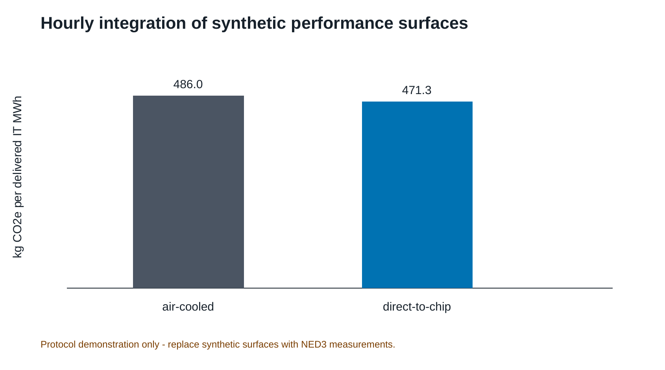
Figure 5. Synthetic measurement-surface demonstration connecting hourly weather and workload to interpolated cooling power, PUE, water, and operational GHG. Comparative claims are blocked because both input surfaces are synthetic.
Declared measurement uncertainty was propagated to cooling power, producing a PUE interval of 1.06957-1.07689 for the air-cooled fixture and 1.03854-1.04260 for the direct-to-chip fixture. Figure 6 visualizes the performance-surface contract and its bounded interpolation domain.
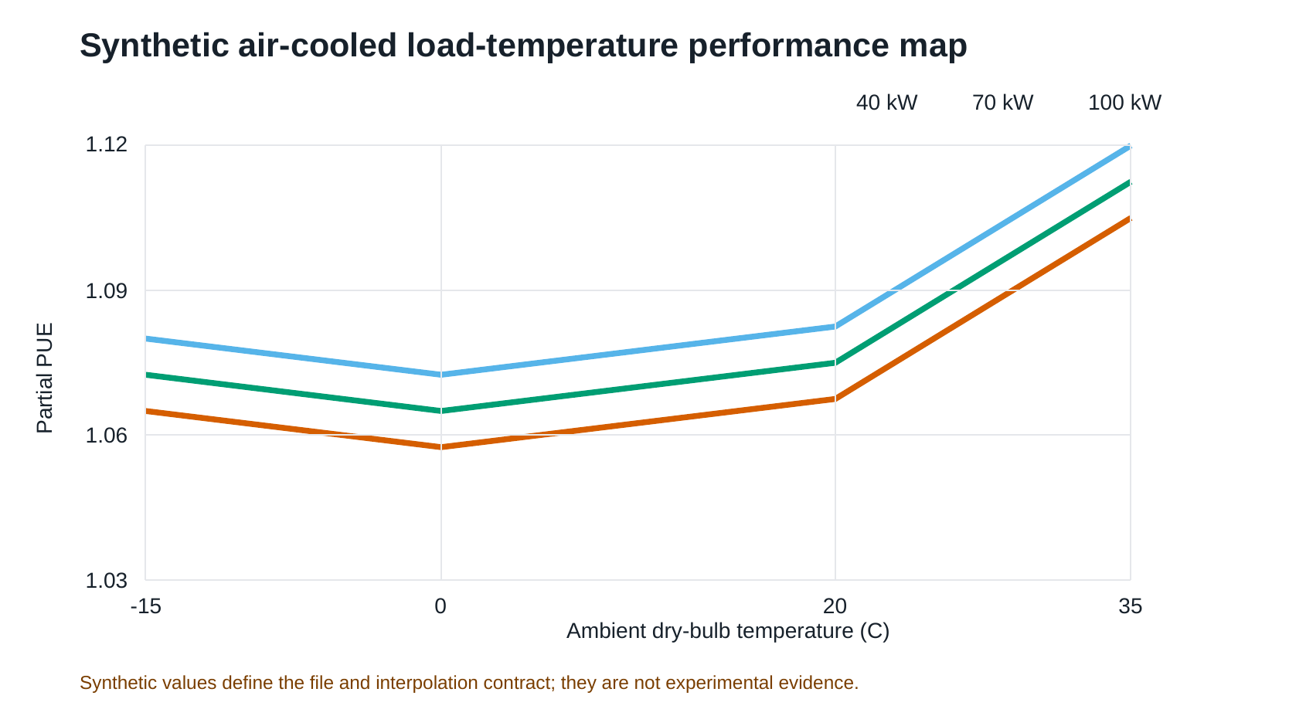
Figure 6. Synthetic load-temperature performance surface used to verify the OpenDC-LCA measurement contract. Bilinear interpolation is allowed only within the complete measured grid; extrapolation is rejected.

4.4. Capability and evidence matrix
Table 1 summarizes the implemented functions and the evidence required for their defensible use. The distinguishing contribution is the continuity from data registration through physics-informed temporal integration to an explicit claim gate. Numerical outputs remain available for inspection even when the audit blocks a comparative conclusion.
Table 1. OpenDC-LCA capability and evidence matrix.
Capability | Input | Method | Output | Evidence requirement | Status
Source registration | Provider, ID, version, geography, unit, boundary, license | Schema validation and checksum manifest | Traceable record | Complete metadata and redistribution review | Implemented
Static lifecycle screening | Energy, PUE, grid factors, equipment, fluids, water | Annual energy balance and lifecycle annualization | Absolute and normalized impacts | Compatible unit and boundary | Implemented
Temporal operation | Hourly weather, workload, grid and cooling response | Hourly alignment and integration | PUE, energy, water, operational GHG | Full coverage and accounting basis | Implemented
Performance surface | Load-temperature grid, uncertainty, source IDs | Bounded bilinear interpolation | Hourly cooling response | Reviewed measurements; no extrapolation | Implemented
Uncertainty and sensitivity | Distributions, seed and perturbations | Monte Carlo and elasticity | Intervals and ranked drivers | Distribution and correlation review | Screening
Scientific claim gate | Scenario, sources, evidence status and intent | Automated blockers and warnings | Reviewable findings | Independent critical review for public claims | Implemented
Access | JSON or CSV | Shared engine through CLI, API and local GUI | JSON, tables, figures and reports | Same model version across interfaces | Implemented

5. Discussion

5.1. Contribution relative to general LCA software
OpenDC-LCA does not compete with openLCA as a process-network editor, database manager, or life-cycle impact assessment platform. Instead, it supplies data-center-specific foreground logic and a reproducibility contract. An openLCA or another LCA tool can generate background factors or complete product systems; OpenDC-LCA can then preserve the factors' provenance and couple them to cooling physics, hourly operating conditions, equipment replacement, and comparative-claim rules. This division allows domain experts to inspect the assumptions that most directly control cooling comparisons.
The framework's first scientific contribution is an explicit bridge between measurements and LCA. Cooling studies commonly report COP, pump power, temperature, flow, pressure drop, or PUE under selected conditions. Lifecycle studies often require annual energy and water totals. The performance-surface contract makes that transformation reviewable and rejects operation outside the tested domain.
The second contribution is evidence-aware computation. The same engine accepts published, public, experimental, and simulated data, but the audit does not treat these evidence classes as interchangeable. This is especially important for software examples: a polished figure generated from synthetic values can look like a technology benchmark. Machine-readable blocking makes the limitation part of the result rather than a sentence that can be accidentally removed.
The third contribution is staged reproducibility. Exact reconstruction of the released Microsoft/Nature component totals establishes arithmetic and lineage consistency. It does not imply an independent recreation of proprietary background datasets. This distinction helps identify the next evidence needed for a deeper comparison: reviewed foreground bills of materials, measured cooling surfaces, equipment lifetimes, fluid losses, and background processes with compatible system models.

5.2. Implications for experimental research
The current package identifies a direct contribution pathway for electronics cooling laboratories. Experiments should span IT load or heat load, ambient or heat-sink temperature, coolant supply temperature, flow, pressure drop, pump and fan power, heat-rejection power, on-site water, duration, and measurement uncertainty. Source identifiers and calibration records should accompany every row. A complete factorial grid is valuable because it supports bounded interpolation and exposes unsupported operating regions.
The highest-value next dataset is a reviewed comparison of air, cold-plate, single-phase immersion, and, where safely feasible, two-phase systems under a shared heat-load emulator and heat-rejection boundary. The experiment should separate IT-integral fan power, facility cooling power, and heat-rejection power; report parasitic power at part load; and quantify uncertainty and repeatability. These measurements would replace the hypothetical and synthetic curves used here without changing the analysis interface.

5.3. Limitations
The validation result is limited to arithmetic reconstruction of released normalized source data. The package does not redistribute or independently recreate licensed ecoinvent or LCA for Experts processes. The hourly preview uses an annual average eGRID factor and hypothetical PUE curves; it does not capture hourly grid variation, marginal emissions, humidity-dependent heat rejection, water scarcity, reliability, server performance, or embodied effects. TMY data describe a representative climate year rather than a specific future year or extreme event.
The synthetic surface demonstration applies independent point uncertainty and does not capture correlated sensor bias, interpolation error, model-form uncertainty, degradation, or failures. The supported functional unit does not yet capture useful computation directly. The audit cannot replace expert critical review, and a model can satisfy automated schema checks while still using scientifically inappropriate factors. Finally, the present framework is a foreground and screening tool, not a complete life-cycle inventory database.

5.4. Development priorities
Four steps would move OpenDC-LCA from a reproducible research framework toward decision-grade comparative studies. First, populate reviewed NED3 load-temperature performance surfaces for multiple cooling architectures. Second, add adapters for USLCI and openLCA exchange formats while retaining provider licenses and process-system metadata. Third, add time-resolved grid factors, humidity-sensitive heat rejection, water-scarcity characterization, and workload-based functional units. Fourth, conduct an independent LCA critical review, including review of allocation, replacement, uncertainty, cutoff, and data-quality choices. Dr. Nutter's review should be recorded as an assessment of the method notes and claim-gate logic rather than a request to answer isolated questions without context.

6. Conclusions
OpenDC-LCA provides a transparent, open-source connection between data-center cooling physics and lifecycle interpretation. Version 1.0 registers evidence, validates functional and physical assumptions, calculates static and temporal impacts, integrates measured load-temperature surfaces, propagates screening uncertainty, and emits machine-readable audit findings through a command line, Python API, and local GUI. The package exactly reconstructed all 24 released normalized totals tested from the Microsoft/Nature study, with a maximum absolute numerical difference of 1.42 × 10⁻¹⁴ percentage points. Its climate and measurement-surface demonstrations show how public data and laboratory measurements can be connected to annual environmental indicators, while their evidence labels prevent synthetic values from becoming technology claims.
The central contribution is thus methodological: transparent calculations are paired with explicit evidence requirements. The framework is ready for community use as a screening, teaching, reproducibility, and experimental design tool. Decision-grade cooling comparisons now require reviewed performance surfaces and compatible lifecycle inventories, not additional software architecture.

Data and code availability
OpenDC-LCA version 1.0 source code, examples, documentation, tests, and derived paper tables and figures are available at https://github.com/UARK-NED3/OpenDC-LCA. Provider-native raw files remain local when redistribution permission has not been established. Released Microsoft/Nature model files are available from Zenodo [2]. EPA eGRID and NOAA TMY data are available from their respective public portals [5,6].

Author contributions
Draft taxonomy for confirmation: Han Hu: conceptualization, methodology, software supervision, thermal-management domain analysis, writing, and visualization. Darin W. Nutter: LCA methodology review, validation, critical review, and manuscript revision. Contributions must be confirmed before submission.

Competing interests
The authors must complete and approve the journal-specific competing-interest statement before submission.

Acknowledgments
Funding, facility, student-contributor, and data-provider acknowledgments must be confirmed before submission.

References
- Alissa, H. et al. Using life cycle assessment to drive innovation for
sustainable cool clouds. Nature 641, 331-338 (2025). https://doi.org/10.1038/s41586-025-08832-3
- Alissa, H. et al. Data and model archive for “Using life cycle assessment
to drive innovation for sustainable cool clouds.” Zenodo record 14268168 (2024). https://doi.org/10.5281/zenodo.14268168
- GreenDelta. openLCA: open source life cycle assessment software.
https://www.openlca.org/
- UARK-NED3. OpenDC-LCA version 1.0.0.
https://github.com/UARK-NED3/OpenDC-LCA
- U.S. Environmental Protection Agency. Emissions & Generation Resource
Integrated Database (eGRID), 2023 detailed data. https://www.epa.gov/egrid/detailed-data
- National Centers for Environmental Information. Typical Meteorological
Year data. https://www.ncei.noaa.gov/access/typical-meteorological-year/
- International Organization for Standardization. ISO 14040:2006,
Environmental management - Life cycle assessment - Principles and framework.
- International Organization for Standardization. ISO 14044:2006,
Environmental management - Life cycle assessment - Requirements and guidelines.
- National Renewable Energy Laboratory. U.S. Life Cycle Inventory Database,
version 1.2026-06.0. Federal LCA Commons. https://www.lcacommons.gov/
- Bundesinstitut für Bau-, Stadt- und Raumforschung. ÖKOBAUDAT 2024-II.
https://www.oekobaudat.de/
- Boavizta. BoaviztAPI data repository.
https://github.com/Boavizta/boaviztapi
- United Nations Environment Programme. Global LCA Data Access network.
https://www.globallcadataaccess.org/
- U.S. Geological Survey. Watershed Boundary Dataset.
https://www.usgs.gov/national-hydrography/watershed-boundary-dataset

