aCaMEL/admixpipe: a reproducible Nextflow pipeline for ADMIXTURE-based population structure analysis
24 September 2026
Tyler K. Chafin¹, Steven M. Mussmann², Bradley T. Martin³, Marlis R. Douglas¹, Michael E. Douglas¹
¹ Department of Biological Sciences, University of Arkansas, Fayetteville, Arkansas, United States
² Abernathy Fish Technology Center, U.S. Fish and Wildlife Service, Longview, Washington, United States
³ Department of Biological Sciences, Seton Hall University, South Orange, New Jersey, United States
Corresponding author: Tyler K. Chafin

Summary
Delineating population structure is fundamental to evolutionary inference and conservation decision-making, where genetically differentiated groups may inform the designation of conservation and management units (Funk et al., 2012; Hohenlohe et al., 2021). Model-based clustering has become a de facto standard for this purpose, initially popularized by STRUCTURE (Novembre, 2016; Pritchard et al., 2000) and subsequently extended to genome-scale datasets by programs such as ADMIXTURE (Alexander et al., 2009). These methods posit K ancestral populations with distinct allele frequencies and estimate each individual’s ancestry as a mixture of contributions from them. Defensible inference, however, requires more than fitting a single model: data must be filtered, models fitted repeatedly across values of K, replicate solutions reconciled, an optimal K selected, and model adequacy evaluated.
aCaMEL/admixpipe automates this analytical sequence. Beginning with a VCF and population map, it filters loci and individuals, conducts replicated ADMIXTURE analyses, reconciles replicates into distinct clustering modes, applies alternative criteria for selecting K, evaluates model fit, and optionally projects ancestry estimates onto geographic maps. Results and analytical provenance are consolidated within a single interactive report. By automating this foundational population-genetic analysis, the pipeline makes it accessible, standardized, transparent, and defensible, thereby broadening its adoption and application.

Statement of need
Population-structure inference is sensitive to decisions made both before and after model fitting. Minor-allele-frequency thresholds (Linck & Battey, 2019) and missing-data filters (Huang & Knowles, 2016) can alter the structure recovered; uneven sampling (Puechmaille, 2016; Wang, 2017) and hierarchical population structure (Janes et al., 2017; Kalinowski, 2011) can bias commonly used criteria for selecting K; and ancestry barplots invite overinterpretation when presented without formal evaluation of model adequacy (Lawson et al., 2018). Because these decisions are seldom reported comprehensively, ostensibly equivalent analyses may not be reproducible. A reanalysis of published STRUCTURE studies, for example, failed to recover the reported number of clusters in 30% of cases (Gilbert et al., 2012).
These limitations are consequential for applied conservation genetics, where analytical results increasingly inform management-unit delineation, listing decisions, and stocking policies. Nevertheless, a persistent divide remains between conservation-genetic research and its implementation (Kadykalo et al., 2020; Klütsch & Laikre, 2021; Taylor et al., 2017). A systematic review identified definable management outcomes in only 49 of 115 applied studies (Tkach & Watson, 2023). Standardized workflows have therefore been proposed as one mechanism for strengthening the connection between conservation science and practice (Holderegger et al., 2019).
aCaMEL/admixpipe addresses these methodological and translational needs for population geneticists, molecular ecologists, agency geneticists, and their contractors. It combines a validated analytical core with scalable execution, explicit parameterization, standardized diagnostics, and provenance-rich reporting.

State of the field
The original AdmixPipe (Mussmann et al., 2020) addresses the absence of standardized pipelines for replicated ADMIXTURE analyses, despite the availability of comparable workflows for STRUCTURE. It accepts a VCF and population map, filters and converts the genotype data, executes ADMIXTURE repeatedly across candidate values of K, summarizes cross-validation error, and prepares replicate outputs for analysis with CLUMPAK (Kopelman et al., 2015). AdmixPipe v3 (Mussmann et al., 2023) retains this functionality while accepting PLINK input, incorporating CLUMPAK directly, distinguishing major and minor clustering modes, summarizing likelihood and cross-validation statistics within modes, and applying evalAdmix (Garcia-Erill & Albrechtsen, 2020) to each replicate. Distribution within a Docker container standardizes its otherwise complex software environment. Both generations nevertheless execute largely as monolithic, single-host analyses, leaving scheduling, fault recovery, and portability among computing environments to the user.
Related software addresses individual components of this process. fastSTRUCTURE (Raj et al., 2014) provides variational inference for large SNP datasets, while principal component analysis offers a model-free representation of genomic variation (Patterson et al., 2006). STRUCTURE HARVESTER (Earl & vonHoldt, 2012) implements the Evanno method (Evanno et al., 2005); CLUMPP (Jakobsson & Rosenberg, 2007) and CLUMPAK reconcile label switching and multimodality among replicates; pong (Behr et al., 2016) and pophelper (Francis, 2017) support visualization; and StructureSelector (Li & Liu, 2018) integrates alternative estimators of K. This functionality remains distributed among programs with distinct inputs and execution requirements, and assembling them into a complete analysis poses hurdles that limit adoption of the best practices they promote.
scalepopgen (Upadhyay et al., 2024) provides a broader Nextflow framework for population-genomic analysis and includes ADMIXTURE, cross-validation summaries, and ancestry visualization. However, it performs one analysis per value of K and does not reconcile replicate solutions, distinguish alternative clustering modes, or evaluate their fit. aCaMEL/admixpipe instead preserves the replicated, mode-aware analysis developed through AdmixPipe and AdmixPipe v3 while re-engineering its execution as a modular Nextflow workflow. It adds SNPio-based preprocessing (Martin et al., 2026), alternative criteria for selecting K, spatial summaries, and integrated reporting without reimplementing the established ADMIXTURE, CLUMPAK, distruct (Rosenberg, 2004), or evalAdmix functionality.

Software design

Workflow framework
The pipeline is implemented in Nextflow DSL2 (Di Tommaso et al., 2017) using the nf-core template (P. A. Ewels et al., 2020) (Figure 1). Its computational burden scales with the product of the numbers of candidate K values and analytical replicates, most of which are independent, long-running tasks. Workflow orchestration therefore enables parallel execution, checkpointed resumption, and consistent behavior across workstations, high-performance computing systems, and cloud environments (Wratten et al., 2021). Nextflow currently supports 18 schedulers or cloud services and seven container engines (Langer et al., 2025).
nf-core provides schema-validated parameters, automated linting, continuous integration with bundled test data, and a library of reusable modules through which research communities can “adopt common standards progressively” (Langer et al., 2025). These conventions operationalize FAIR principles for research software (Barker et al., 2022; Wilkinson et al., 2016).
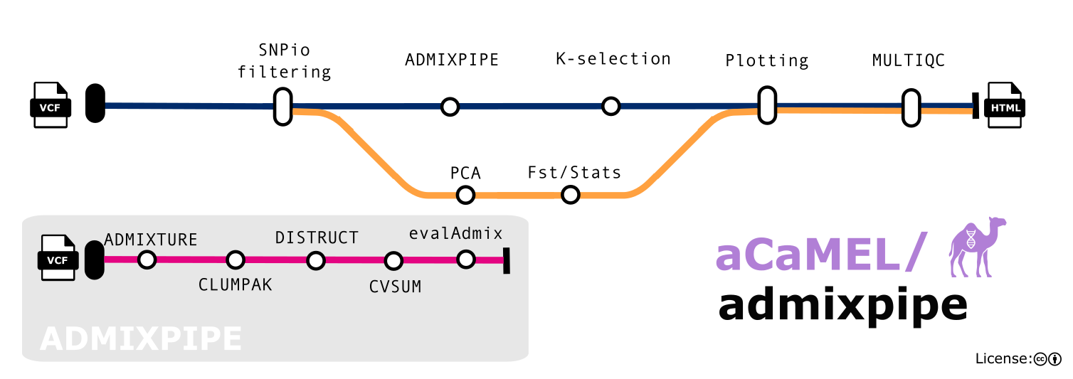
Figure 1: Overview of aCaMEL/admixpipe. The inset shows the analytical steps inherited from AdmixPipe.

Design decisions
- Containers for portability Every process executes within a container (Grüning et al., 2018); the pipeline supports Docker, Singularity/Apptainer, and Podman. This design exchanges package-manager flexibility for a consistent, versioned runtime environment.
- Filtering and QC Variant filtering is integrated via SNPio (Martin et al., 2026) and applied in a fixed order, removing loci with excess missing data in any population, monomorphic loci, loci within a set physical distance of one another, loci and then individuals with excess missing data, and loci below a minor-allele-frequency threshold (Linck & Battey, 2019). Missingness is quantified per individual and population before and after filtering, and locus attrition is attributed to each filter. Pairwise Weir and Cockerham’s F_{ST} (Weir & Cockerham, 1984), with permutation p-values, and a principal component analysis provide model-free comparisons.
- Selection and validation of K Five criteria are implemented: cross-validation error (Alexander & Lange, 2011), Evanno ΔK (Evanno et al., 2005), and the elbow of the mean log-likelihood [$L\left(K\right)$] or of its first- [$L′\left(K\right)$] or second-order [$\left|L″\left(K\right)\right|$] rate of change. The selected criterion determines only which value of K is emphasized. Ancestry barplots, evalAdmix residual correlations, and maps are generated for every candidate value because no criterion performs reliably across all demographic scenarios (Janes et al., 2017; Puechmaille, 2016).
- Standardization and interpretability Filters are applied in a fixed order under documented defaults, and all outputs are consolidated within a self-contained MultiQC report (P. Ewels et al., 2016). The report presents results as fully interactive, publication-ready figures including embedded metadata and can optionally include maps of site-level ancestry over user-supplied vector layers (or a default basemap). An example report for the bundled test dataset is available online (Figure 2). It records the command-line, pipeline and tool versions, configuration profiles, and complete parameter set, while also generating a methods summary with citations for the software used. These features automate the reporting practices recommended by Gilbert et al. (2012), facilitating comparisons among studies and enabling analyses to be audited.
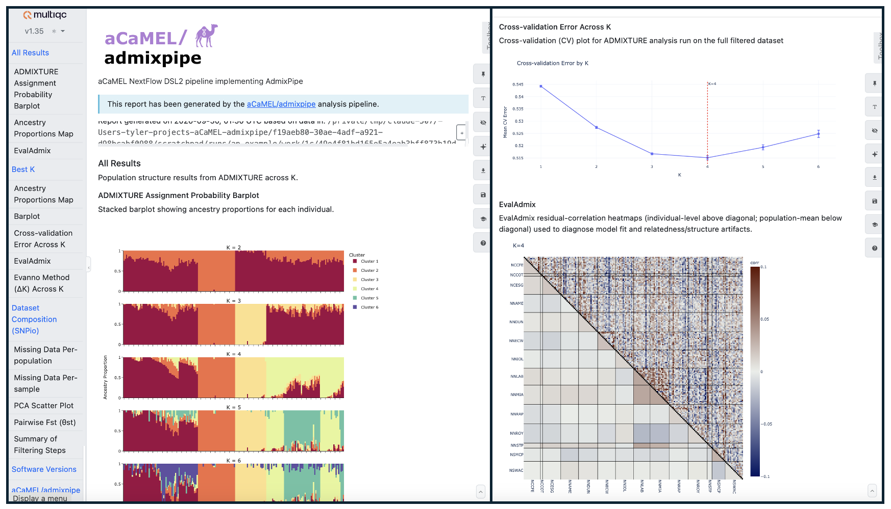
Figure 2: Excerpt from the interactive report for the bundled test dataset. Left: ADMIXTURE ancestry barplots for K = 2–6. Right: cross-validation error across K, with the selected K = 4 marked, and evalAdmix residual correlations for K = 4.

Research impact statement
aCaMEL/admixpipe extends AdmixPipe, which has been in use by multiple research groups already. The Nextflow implementation has already supported agency-funded conservation assessments: it was used to characterize spatial population structure in the endemic Beaded Darter (Etheostoma clinton)(Bruckerhoff et al., 2026), investigating admixture in a genomic assessment of Smallmouth Bass (Micropterus dolomieu)(Douglas, Brewster, Chafin, et al., 2026), and to validate SNP panel selection in Eastern Collared Lizard (Crotaphytus collaris)(Douglas, Brewster, Zbinden, et al., 2026). The release includes a bundled test dataset with sampling coordinates and geospatial data for Neosho Madtom (Noturus placidus)(Zbinden et al., 2025).

AI usage disclosure
Generative AI tools assisted with preparation of the software release and manuscript. Their uses included drafting documentation and the parameter schema, implementing the report’s parameter summary, identifying and correcting workflow defects, verifying references, and assisting with manuscript drafting and revision. The authors reviewed, edited, and tested all AI-assisted contributions, made all scientific and software-design decisions, and accept full responsibility for the software and manuscript.

Acknowledgements
We thank the nf-core community for providing the pipeline template. Applications of the pipeline were supported by the U.S. Fish and Wildlife Service State Wildlife Grants Program through the Arkansas Game and Fish Commission (AR-T-F22AF03392). M.R.D. and M.E.D. acknowledge support from the Bruker Professorship in Life Sciences and the 21st Century Chair in Global Change Biology, respectively, at the University of Arkansas. The funders had no role in the design of the software or preparation of the manuscript.
Links to non-Service websites do not imply official U.S. Fish and Wildlife Service endorsement of the opinions or ideas expressed therein or guarantee the validity of the information provided. The findings, conclusions, and opinions expressed in this article are those of the authors and do not necessarily represent the views of the U.S. Fish and Wildlife Service.

References
Alexander, D. H., & Lange, K. (2011). Enhancements to the ADMIXTURE algorithm for individual ancestry estimation. BMC Bioinformatics, 12, 246. https://doi.org/10.1186/1471-2105-12-246
Alexander, D. H., Novembre, J., & Lange, K. (2009). Fast model-based estimation of ancestry in unrelated individuals. Genome Research, 19(9), 1655–1664. https://doi.org/10.1101/gr.094052.109
Barker, M., Chue Hong, N. P., Katz, D. S., Lamprecht, A.-L., Martinez-Ortiz, C., Psomopoulos, F., Harrow, J., Castro, L. J., Gruenpeter, M., Martinez, P. A., & Honeyman, T. (2022). Introducing the FAIR principles for research software. Scientific Data, 9, 622. https://doi.org/10.1038/s41597-022-01710-x
Behr, A. A., Liu, K. Z., Liu-Fang, G., Nakka, P., & Ramachandran, S. (2016). pong: Fast analysis and visualization of latent clusters in population genetic data. Bioinformatics, 32(18), 2817–2823. https://doi.org/10.1093/bioinformatics/btw327
Bruckerhoff, L. A., Brewster, C. L., Douglas, M. R., Douglas, M. E., Lynch, D., Magoulick, D., Taylor, A., Zbinden, Z. D., & Chafin, T. K. (2026). Habitat associations and population genetic structure of the endemic Beaded Darter etheostoma clinton in the upper Ouachita River system (Final Report, State Wildlife Grants Program AR-T-F22AF03392). Arkansas Game and Fish Commission.
Di Tommaso, P., Chatzou, M., Floden, E. W., Barja, P. P., Palumbo, E., & Notredame, C. (2017). Nextflow enables reproducible computational workflows. Nature Biotechnology, 35(4), 316–319. https://doi.org/10.1038/nbt.3820
Douglas, M. R., Brewster, C. L., Chafin, T. K., Zbinden, Z. D., & Douglas, M. E. (2026). Genomic and geometric morphometric diversity in Smallmouth Bass and their admixtures within the Interior Highlands of North America (Final Report SL4124). Arkansas Game and Fish Commission.
Douglas, M. R., Brewster, C. L., Zbinden, Z. D., Chafin, T. K., Bryant, A., Brinkman, E., & Douglas, M. E. (2026). Genetic monitoring of Eastern Collared Lizard crotaphytus collaris to inform conservation and management actions [Annual progress report]. Arkansas Game and Fish Commission.
Earl, D. A., & vonHoldt, B. M. (2012). STRUCTURE HARVESTER: A website and program for visualizing STRUCTURE output and implementing the Evanno method. Conservation Genetics Resources, 4(2), 359–361. https://doi.org/10.1007/s12686-011-9548-7
Evanno, G., Regnaut, S., & Goudet, J. (2005). Detecting the number of clusters of individuals using the software STRUCTURE: A simulation study. Molecular Ecology, 14(8), 2611–2620. https://doi.org/10.1111/j.1365-294X.2005.02553.x
Ewels, P. A., Peltzer, A., Fillinger, S., Patel, H., Alneberg, J., Wilm, A., Garcia, M. U., Di Tommaso, P., & Nahnsen, S. (2020). The nf-core framework for community-curated bioinformatics pipelines. Nature Biotechnology, 38(3), 276–278. https://doi.org/10.1038/s41587-020-0439-x
Ewels, P., Magnusson, M., Lundin, S., & Käller, M. (2016). MultiQC: Summarize analysis results for multiple tools and samples in a single report. Bioinformatics, 32(19), 3047–3048. https://doi.org/10.1093/bioinformatics/btw354
Francis, R. M. (2017). pophelper: An R package and web app to analyse and visualize population structure. Molecular Ecology Resources, 17(1), 27–32. https://doi.org/10.1111/1755-0998.12509
Funk, W. C., McKay, J. K., Hohenlohe, P. A., & Allendorf, F. W. (2012). Harnessing genomics for delineating conservation units. Trends in Ecology & Evolution, 27(9), 489–496. https://doi.org/10.1016/j.tree.2012.05.012
Garcia-Erill, G., & Albrechtsen, A. (2020). Evaluation of model fit of inferred admixture proportions. Molecular Ecology Resources, 20(4), 936–949. https://doi.org/10.1111/1755-0998.13171
Gilbert, K. J., Andrew, R. L., Bock, D. G., Franklin, M. T., Kane, N. C., Moore, J.-S., Moyers, B. T., Renaut, S., Rennison, D. J., Veen, T., & Vines, T. H. (2012). Recommendations for utilizing and reporting population genetic analyses: The reproducibility of genetic clustering using the program STRUCTURE. Molecular Ecology, 21(20), 4925–4930. https://doi.org/10.1111/j.1365-294X.2012.05754.x
Grüning, B., Chilton, J., Köster, J., Dale, R., Soranzo, N., Beek, M. van den, Goecks, J., Backofen, R., Nekrutenko, A., & Taylor, J. (2018). Practical computational reproducibility in the life sciences. Cell Systems, 6(6), 631–635. https://doi.org/10.1016/j.cels.2018.03.014
Hohenlohe, P. A., Funk, W. C., & Rajora, O. P. (2021). Population genomics for wildlife conservation and management. Molecular Ecology, 30(1), 62–82. https://doi.org/10.1111/mec.15720
Holderegger, R., Balkenhol, N., Bolliger, J., Engler, J. O., Gugerli, F., Hochkirch, A., Nowak, C., Segelbacher, G., Widmer, A., & Zachos, F. E. (2019). Conservation genetics: Linking science with practice. Molecular Ecology, 28(17), 3848–3856. https://doi.org/10.1111/mec.15202
Huang, H., & Knowles, L. L. (2016). Unforeseen consequences of excluding missing data from next-generation sequences: Simulation study of RAD sequences. Systematic Biology, 65(3), 357–365. https://doi.org/10.1093/sysbio/syu046
Jakobsson, M., & Rosenberg, N. A. (2007). CLUMPP: A cluster matching and permutation program for dealing with label switching and multimodality in analysis of population structure. Bioinformatics, 23(14), 1801–1806. https://doi.org/10.1093/bioinformatics/btm233
Janes, J. K., Miller, J. M., Dupuis, J. R., Malenfant, R. M., Gorrell, J. C., Cullingham, C. I., & Andrew, R. L. (2017). The K = 2 conundrum. Molecular Ecology, 26(14), 3594–3602. https://doi.org/10.1111/mec.14187
Kadykalo, A. N., Cooke, S. J., & Young, N. (2020). Conservation genomics from a practitioner lens: Evaluating the research-implementation gap in a managed freshwater fishery. Biological Conservation, 241, 108350. https://doi.org/10.1016/j.biocon.2019.108350
Kalinowski, S. T. (2011). The computer program STRUCTURE does not reliably identify the main genetic clusters within species: Simulations and implications for human population structure. Heredity, 106(4), 625–632. https://doi.org/10.1038/hdy.2010.95
Klütsch, C. F. C., & Laikre, L. (2021). Closing the conservation genetics gap: Integrating genetic knowledge in conservation management to ensure evolutionary potential. In C. C. Ferreira & C. F. C. Klütsch (Eds.), Closing the knowledge-implementation gap in conservation science (Vol. 4, pp. 51–82). Springer. https://doi.org/10.1007/978-3-030-81085-6_3
Kopelman, N. M., Mayzel, J., Jakobsson, M., Rosenberg, N. A., & Mayrose, I. (2015). CLUMPAK: A program for identifying clustering modes and packaging population structure inferences across K. Molecular Ecology Resources, 15(5), 1179–1191. https://doi.org/10.1111/1755-0998.12387
Langer, B. E., Amaral, A., Baudement, M.-O., Bonath, F., Charles, M., Chitneedi, P. K., et al. (2025). Empowering bioinformatics communities with Nextflow and nf-core. Genome Biology, 26, 228. https://doi.org/10.1186/s13059-025-03673-9
Lawson, D. J., Dorp, L. van, & Falush, D. (2018). A tutorial on how not to over-interpret STRUCTURE and ADMIXTURE bar plots. Nature Communications, 9, 3258. https://doi.org/10.1038/s41467-018-05257-7
Li, Y.-L., & Liu, J.-X. (2018). StructureSelector: A web-based software to select and visualize the optimal number of clusters using multiple methods. Molecular Ecology Resources, 18(1), 176–177. https://doi.org/10.1111/1755-0998.12719
Linck, E., & Battey, C. J. (2019). Minor allele frequency thresholds strongly affect population structure inference with genomic data sets. Molecular Ecology Resources, 19(3), 639–647. https://doi.org/10.1111/1755-0998.12995
Martin, B. T., Monaco, D. R., Sharabi, N., Mussmann, S. M., & Chafin, T. K. (2026). SNPio: A Python interface for population genomic data processing. BMC Bioinformatics. https://doi.org/10.1186/s12859-026-06546-5
Mussmann, S. M., Douglas, M. R., Chafin, T. K., & Douglas, M. E. (2020). AdmixPipe: Population analyses in ADMIXTURE for non-model organisms. BMC Bioinformatics, 21, 337. https://doi.org/10.1186/s12859-020-03701-4
Mussmann, S. M., Douglas, M. R., Chafin, T. K., & Douglas, M. E. (2023). AdmixPipe v3: Facilitating population structure delimitation from SNP data. Bioinformatics Advances, 3(1), vbad168. https://doi.org/10.1093/bioadv/vbad168
Novembre, J. (2016). Pritchard, Stephens, and Donnelly on population structure. Genetics, 204(2), 391–393. https://doi.org/10.1534/genetics.116.195164
Patterson, N., Price, A. L., & Reich, D. (2006). Population structure and eigenanalysis. PLoS Genetics, 2(12), e190. https://doi.org/10.1371/journal.pgen.0020190
Pritchard, J. K., Stephens, M., & Donnelly, P. (2000). Inference of population structure using multilocus genotype data. Genetics, 155(2), 945–959. https://doi.org/10.1093/genetics/155.2.945
Puechmaille, S. J. (2016). The program STRUCTURE does not reliably recover the correct population structure when sampling is uneven: Subsampling and new estimators alleviate the problem. Molecular Ecology Resources, 16(3), 608–627. https://doi.org/10.1111/1755-0998.12512
Raj, A., Stephens, M., & Pritchard, J. K. (2014). fastSTRUCTURE: Variational inference of population structure in large SNP data sets. Genetics, 197(2), 573–589. https://doi.org/10.1534/genetics.114.164350
Rosenberg, N. A. (2004). distruct: A program for the graphical display of population structure. Molecular Ecology Notes, 4(1), 137–138. https://doi.org/10.1046/j.1471-8286.2003.00566.x
Taylor, H. R., Dussex, N., & Heezik, Y. van. (2017). Bridging the conservation genetics gap by identifying barriers to implementation for conservation practitioners. Global Ecology and Conservation, 10, 231–242. https://doi.org/10.1016/j.gecco.2017.04.001
Tkach, K., & Watson, M. J. (2023). Publication and use of genetic tools in conservation management applications—a systematic review. Journal of Applied Ecology, 60(8), 1522–1536. https://doi.org/10.1111/1365-2664.14433
Upadhyay, M., Pogorevc, N., & Medugorac, I. (2024). scalepopgen: Bioinformatic workflow resources implemented in Nextflow for comprehensive population genomic analyses. Molecular Biology and Evolution, 41(4), msae057. https://doi.org/10.1093/molbev/msae057
Wang, J. (2017). The computer program STRUCTURE for assigning individuals to populations: Easy to use but easier to misuse. Molecular Ecology Resources, 17(5), 981–990. https://doi.org/10.1111/1755-0998.12650
Weir, B. S., & Cockerham, C. C. (1984). Estimating F-statistics for the analysis of population structure. Evolution, 38(6), 1358–1370. https://doi.org/10.1111/j.1558-5646.1984.tb05657.x
Wilkinson, M. D., Dumontier, M., Aalbersberg, Ij. J., Appleton, G., Axton, M., Baak, A., et al. (2016). The FAIR guiding principles for scientific data management and stewardship. Scientific Data, 3, 160018. https://doi.org/10.1038/sdata.2016.18
Wratten, L., Wilm, A., & Göke, J. (2021). Reproducible, scalable, and shareable analysis pipelines with bioinformatics workflow managers. Nature Methods, 18(10), 1161–1168. https://doi.org/10.1038/s41592-021-01254-9
Zbinden, Z. D., Chafin, T. K., Tiemann, J. S., Edds, D. R., Martin, B. T., Hofmeier, J., Douglas, M. E., & Douglas, M. R. (2025). Historic and contemporary selection define conservation units for a short-range endemic within an anthropogenically-altered riverscape. Global Ecology and Conservation, 62, e03783. https://doi.org/10.1016/j.gecco.2025.e03783

